RISK BENEFIT ASSESSMENT
Module Code: ECEY 5005
Student Number: 2315485
Word Count: 4552

Location / Activity: | An Experiential Adventure in St David’s Garden | Date: | 07-03- 2025
Assessor: | Kate Rowlands | Review date: | 21-03-2025

The boxes in the table below will expand as you type into them; pre-entered text is simply for illustration. You should delete irrelevant items and replace with text relevant to your circumstances.
Your overall risk rating – Low, medium or high – is based on your judgement about whether the BENEFITS of the activity or opportunity outweigh the RISKS.

Experience exploring outdoor space in photograph | How will young people BENEFIT from this activity? | Hazards and associated risks | Who is at risk? | PRECAUTIONS in place to reduce the risk of injury | Overall risk after precautions  RATING: L/M/H
Walking from the second-floor classroom to the woodland garden, negotiating stairs and uneven ground and slopes. | Help the children to become of what their bodies can do. To be aware of how to balance and walk downstairs in a careful and safe manner, with awareness of those around them.  The children get to experience walking on different surfaces, such as paving, grass, mud and leaves, all aiding gross motor development. | Children and adults could trip and fall and may sustain minor injury, possible bruises, cuts and sprains. | Children and practitioners, additional staff and possible volunteers. | Ensure all children and adults are appropriately clothed, in wellies/boots, waterproof suits, long trousers and sleeves, hats and gloves or shorts and sunhats as the season and weather dictate.  Discuss with the children how to walk safely and carefully down the stairs using the handrail and possibly holding the hand of an adult or another child. Emphasise the need to walk in a controlled manner and that it is not acceptable to push and shove other children or adults at any point, but particularly not on the stairs. Make the children aware that the ground outside may be wet and/or slippery and uneven, so walking is advisable enroute. | L
Exploring the outdoor environment in the woodland garden. | The children get to experience all the rocks, trees, plants, flowers and insects and amphibians in the garden. Learning about colour, texture, living creatures and lifecycles and how they themselves fit into this environment. | Possible cuts, bruises and rashes from plants and trees and falling on the uneven ground.  There is also the risk of allergies and poisonous plants should the children put anything in their mouths. | Adults and Children | Ensure that the adults are strategically placed around the garden, aware of potential problems and monitoring the children at all times.  Explain to the children that they should not put anything in their mouths, without checking with/ or directed by an adult (Blackberries) and explain what they can and cannot collect and is safe to play with in the garden.  Ensure hands are washed and clean after playing in the garden. | L
Experiencing the outdoor natural environment -flowers, trees, insets and plants | Exploration of a new environment, all the colours, textures and surfaces.  A curiosity about living creatures and growing plants, stimulating a need to investigate and learn. | Allergies and/or poisonous plants and insects.  Children could potentially ingest poisonous plants and/or stinging insects.  May get small rashes (Ivy) and cuts from plants (spider or palm type plants with sharp leaves) | Adults and children | Explain what is safe/appropriate and not safe to collect (natural items, not rubbish or animal faeces) and that nothing should go in their months, but they are encouraged to touch/ experience the natural world around them.  Ensure thorough handwashing after being outside.  Adults need to be aware of and monitoring the children at all times. | L
The Pond/ playing in the water | Children will learn about the movement and flow of water and experience the different plants and creatures that grow and thrive in the pond, becoming curious about lifecycles.  Will help children express possible trajectory schema, by playing in the running water | Could fall in, getting cold and wet, possible hypothermia.  Possibility of Drowning.  Could slip in the mud and fall onto the rocks surrounding the pond, cuts, scrapes and bruises. | Adults and children. | At least two to three adults in or beside the pond at all times to ensure safety, to prevent children falling in and to immediately evacuate them immediately should they do so. Would be helpful to have an adult in waders in the pond.  All children need to be in fully waterproof clothing to keep dry, warm and happy to engage in the environment.  Ensure each child and adult, if necessary, has a complete change of clothes, if possible, from the parents or setting. | L
The general public in the open garden setting | To develop an awareness of their place in community and society.  How to stay personally safe in the open access outdoor environment.  How public access gardens are managed. Awareness of what is natural and what is not. | Potentially encountering a different range of people from their parents and carers.  Safe and potentially unsafe adults, an awareness of stranger-danger.  Litter and rubbish and possibly unsafe areas. | Children and adults | Ensure the children know to not talk to anyone they do not know and always stay in sight of the adults in charge.  The use of an exchange of code words to ensure safety may be use and helpful for the children here.  Ensure the children stay clear of unfamiliar, dogs and cats as it can be difficult to judge if they are friendly or not and may be a little scary.  A swift litter pick, if possible before the commencement of the activity. Could involve the children, with gloves and litter pickers etc. | L
Cars and the Carpark | Learn road Safety | The movement of cars in the carpark and the adjacent road is hazardous and potentially dangerous as both children and adults could be knocked down and seriously injured. | Children and adults | Provide high visibility vests for all children and adults to wear to ensure they can be seen by cars and exercise extreme caution.  Explain the need to the children to stay in line, holding hands in two’s or three’s. Ensure staff are in front, behind and potentially on both sides of the line of children.  Ask the university if they could limit car movement during the time the children would be walking across the car park area and in the nearby woodland garden. | M
Manmade structures, trees and the woodland area | To learn about different types of and the structure of trees and how to climb and move in a tree, may involve some trial and error! An excellent lesson in balance and gross motor coordination.  The children can play and imagine in the shelters and below the trees and inspect the bug house for living creatures.  Children will use trajectory and orientation schemas and also potentially ordering, positioning, containing and transporting schemas. | Falling from trees, causing injury.  Tripping over logs and loose branches and woodland debris.  Potential splinters from rough cut wood on manmade structures with no bark | Children and adults | Ensure an adult is close and monitoring all tree climbing activity, close enough to intervene if needed, encourage the children to test their capabilities, but make them aware they could get stuck and will need to investigate how to get down and when to ask for adult help. Model how to test branches to show if they will hold your weight. Advise not climbing too high.  If playing in the loose woodland show children how to step safely, to avoid trips and falls, to development excellent balance and coordination.  Ensure staff are First Aid Trained and are competent to remove splinters and deal with scrapes, cuts and bruises. | L
Weather changes | Playing in the environment in all weathers, experiencing sun, rain, wind, snow and mud and grass. | Children may become cold, wet and uncomfortable or may suffer from sunburn and dehydration | Children and adults | Ensure appropriate seasonal clothing, warm and waterproof in winter, autumn and spring and shorts, hats, sun cream and extra water in summer. Always carry a spare change of clothes, for each child, labelled in a rucksack and easily accessible. | L
Children’s needs | If the children’s needs are met the activity is more likely to be useful and successful for the children’s development and progress. | Children may injure themselves in multiple ways as above. They will also get hungry, thirsty and tired playing outside for extended periods of time.  Children may need to go home if there is an emergency, allergy or injury. | Children | All emergency contacts and consent forms to be completed and carried by the principal members of staff.  Ensure all staff are first aid trained and competent and confident to administer help.  Key members of staff to hold outdoor/forest school training and certification.  Packed lunches and snacks and drinks for all children and a comfortable rest/break area as needed.  Access to toilet facilities, accompanied by staff members, may need to bring steps and toilet seats to access adult toilets. | L

An Experiential Adventure in St David’s Garden
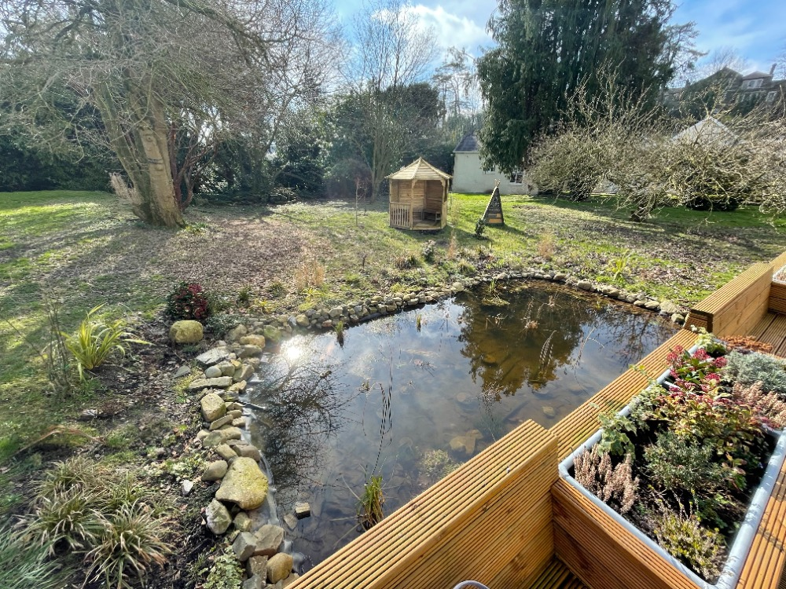

(Source: K. Rowlands, 2025)

A Scaffolding Conversation Between an Adult and Five Children Investigating Frogspawn in the Pond

Setting: A group of five children, aged around 5 to 7, are gathered at the edge of a small pond on a spring day. The adult (the scaffolder) is guiding the children through an exploration of frogspawn. The children are eager to discover, and the adult is encouraging them to observe, think, and ask questions. The goal is to help the children develop their mathematical and scientific thinking through spontaneous guided discovery.
They have with them a collapsible picnic trolley full of, picnic blankets to lie or sit on the ground. Nets and poles for fishing in the pond, a selection of large and small baskets and plastic pots and jars for collecting items. Handheld plastic magnifiers and digital magnifiers that fit on a phone or the small internet enabled tablets, that are also loaded with a range of plant and mini beast identification apps, in addition to nature, scientific and lifecycle investigation apps. They also have books on nature, science and lifecycles at the appropriate level.
The Adult lays the picnic blankets out around the pond and then sits with the children close to the pond. The children both sit and lie, fascinated and engaged by looking into the pond. The children model the adult’s behaviour keeping their centre of gravity close to the ground, so they will not easily overbalance into the pond.

Adult (Scaffolder, Miss Kate): [Smiling as they point to the pond] “Wow! look at all this frogspawn! Have you all seen frogspawn before?”

Child 1 (Liam): “Yes, I saw some last year in my grandma’s garden. But this is more than that.”

Child 2 (Ava): “It’s all squishy! It’s like jelly.”

Adult (Miss Kate): [Nods] “It’s definitely a special jelly-like substance, isn’t it? This is frogspawn. It’s the eggs of frogs, and the jelly protects them until they’re ready to become tadpoles and then frogs. Shall we take a closer look and see what we can learn about it. What do you notice about the frogspawn, Ava?”

Ava: [Looking carefully at the pond] “It’s all clumped together. There’s like… a big blob, and some smaller blobs next to it.”
(Welsh Government, 2020 – Science and Technology)
Adult: “That’s a great observation, Ava, well done. So, why do you think the frogspawn is clumped together like that? Why not spread out everywhere in the pond?”

Child 3 (Emily): “Maybe it’s to keep the frogs safe from being eaten?”

Adult: “Hmm, that’s an interesting thought. So, what would happen if the frogspawn was spread out everywhere instead of being in groups?”

Child 4 (Ethan): “Maybe it would be easier for fish or birds to find them and eat them?”

Adult: “That’s right! So, the frogspawn is clumped together to make it harder for predators to find. What do you think about the size of the blobs. Can you see how some are bigger, and some are smaller?”

Child 5 (Sophia): “Yeah, some are really big, and others are tiny.”
(Welsh Government, 2020 – Science and Technology)

Adult: “Exactly Sophia, super observation. Do you think that all these eggs will develop at the same rate? Why do you think that or why not?”

Liam: “I think the smaller ones might take longer to hatch, or maybe they’re younger eggs?”
(Welsh Government, 2020 – Science and Technology)

Adult: “That’s a smart guess, Liam. Actually, the different sizes might represent eggs that were laid at different times. Some of the frogspawn may have been laid earlier, while others came later. So, if we were to count how many blobs there are, we could start by guessing how many might hatch first. Let’s try counting them in a small section of the pond. Who wants to help?”

Emily: “I want to count! I’ll count in groups of five. It’s easier that way.”
(Welsh Government, 2020 – Mathematics and Numeracy)

Adult: “Great idea, Emily! When we count in groups, that helps us keep track better. How many groups of five do you think are in this section?”

The children count together, making sure to count in groups of five. Emily leads the counting, and the others follow her cue.

Ethan: “There are three groups of five, and two extra ones.”
(Welsh Government, 2020 – Mathematics and Numeracy)

Adult: “Perfect. So how many blobs do we have altogether?”

Sophia: “Three groups of five is 15. Plus, the two extra ones makes 17!”
(Welsh Government, 2020 – Mathematics and Numeracy)

Adult: “Excellent math! You used addition and grouping to count the frogspawn. Now, let’s think about it a bit more. If we wanted to count all the frogspawn in this whole pond, what could we do?”

Liam: “Maybe we could look at a bigger part of the pond and count again?”
(Welsh Government, 2020 – Mathematics and Numeracy)

Adult: “That’s a good approach. If we counted a few sections like this and then multiplied, (counted in groups of five) we could get a pretty good estimate for the whole pond. Let’s try doing that. If we count 17 blobs in one section, and there are 4 sections that are about the same size, how many blobs would that be?”

Ava: “We can multiply, right? 17 times 4 is… uh is a really big number I think”
(Welsh Government, 2020 – Mathematics and Numeracy)

Adult: “Well done, Ava! Figuring out that we need to multiply is amazing! Shall we all figure this out together.
Liam: “Can we all help Ava?”
Adult: “Absolutely Liam.”

Ethan: “We could collect lots of leaves or flowers in the baskets to make lots of groups of five, we could use our hands to count five as we’ve five fingers.
(Welsh Government, 2020 – Mathematics and Numeracy)

Adult: “What a brilliant idea, Ethan.”

The children fetch baskets from the trolley and happily hunt around the garden for stones, flower’s petals, sticks and leaves, using their hands as a guide for groups of five items. Ava and Ethan, help Sophia, Emily and Liam. [Emily and Liam work together with one basket between them] with the groups of five and two more, ensuring they all have 17 items in each basket. All the children enjoy this activity, exhibiting clear collection, containment and transporting schema.
(Welsh Government, 2020 – Mathematics and Numeracy and Science and Technology)

The children then arrange their collections in four groups of five and the extra two each in a line, one below another as the photo below shows:

(Source: K. Rowlands, 2025)

Adult: “Wow, that’s amazing everyone, I can see such clear groups of five and the two extra ones or units and we have four lines, one for each corner of the pond, well done everyone.”
Liam: “Now we can count it all up and get the right multiply number.”
Adult: “That’s right Liam, we can find the answer to our big sum!”

The children and adult then count through each line together, with the adult recording the numbers on a piece of paper attached to a clipboard, so the children can clearly see how each row add up to 17 and how four times each row arrives at the final estimate of 68. The photo below shows this clearly.

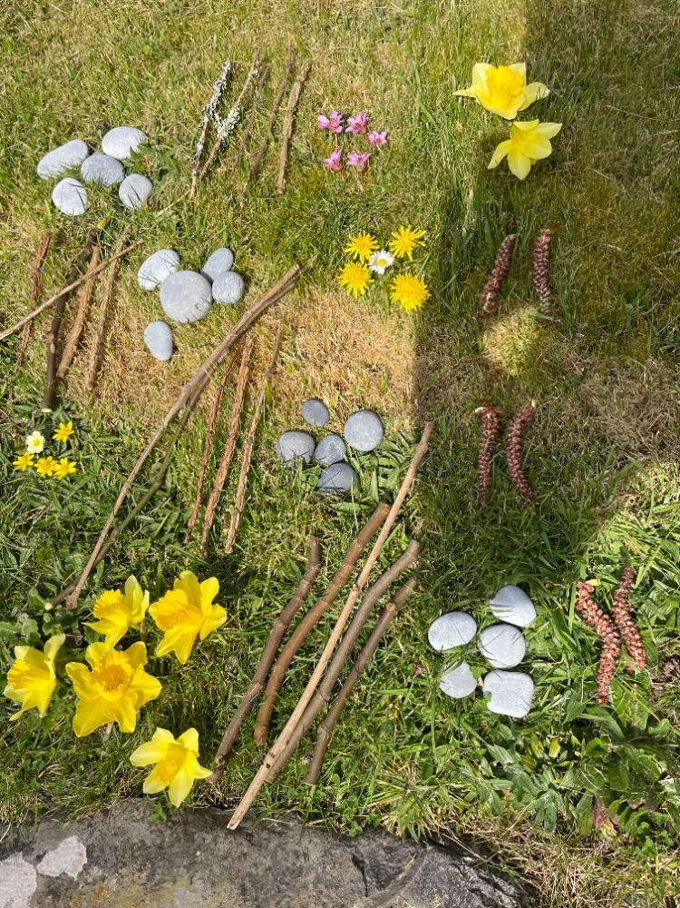

(Source: K. Rowlands, 2025)

Adult: “Wow, that’s amazing everyone, I can see such clear groups of five and the two extra ones or units and we have four lines, one for each corner of the pond, well done everyone.”
Liam: “Now we can count it all up and get the right multiply number.”
Adult: “That’s right Liam, we can find the answer to our big sum!”

The children and adult then count through each line together, with the adult recording the numbers on a piece of paper attached to a clipboard, so the children can clearly see how each row add up to 17 and how four times each row arrives at the final estimate of 68. The photo below shows this clearly.
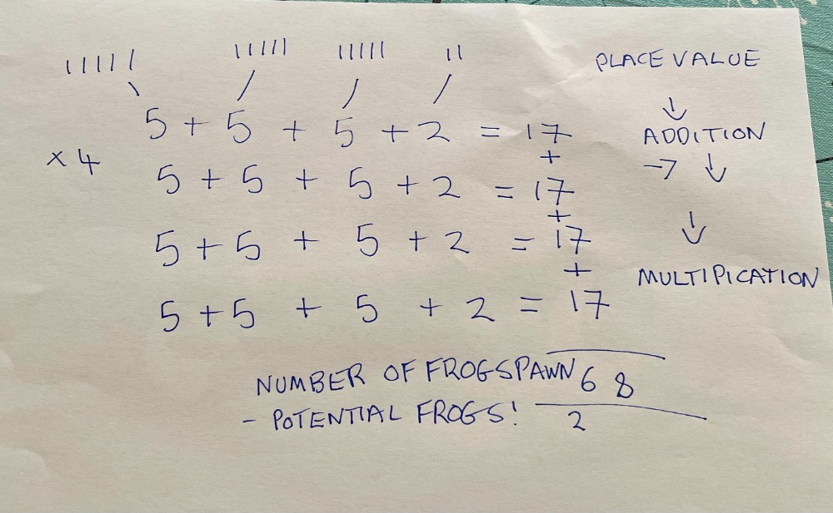

(Source: K. Rowlands, 2025)

Ava: “Wow, our answer is 68!”
The group cheers and dances about, chanting, “yeah we got 68!”
(Welsh Government, 2020 – Mathematics and Numeracy)

Adult: “That’s a great estimate for how many blobs are in the pond. Now, do you think all the frogspawn in the pond will become tadpoles and eventually frogs?”

Emily: “Maybe some of it gets eaten by animals?”

Adult: “Yes, I think that’s probably quite likely. Not all of the frogspawn will survive. Some will get eaten, some might not develop properly, or the weather might be too cold for some of them. But could make predictions about that now. Let’s think about the conditions. What kind of weather do you think the frogspawn needs to grow into tadpoles?”

Sophia: “It’s sunny today, so maybe they need warmth.”
(Welsh Government, 2020 – Science and Technology)

Adult: “Good thinking, Sophia. The frogspawn will need warmth, but it also needs to be in the water for the tadpoles to develop properly. If the water gets too cold, they might not survive. So, the environment plays a big role in how well the frogspawn develops. Let’s test our prediction or hypothesis: What if we measured the temperature of the water today?”

Liam: “How do we do that?”
(Welsh Government, 2020 – Science and Technology)

Adult: “We can use a thermometer. I have one with me. Let’s check the temperature and see if it’s a good temperature for the frogspawn to survive and grow.”

The adult takes out a thermometer from her bag and dips it into the pond. After a moment, they show the reading to the children.

Adult: “It says the water is 15°C. Do you think that’s warm enough?”

Ethan: “I think it’s okay. It’s not too cold.”
(Welsh Government, 2020 – Science and Technology)

Adult: “Yes, it’s actually a good temperature for frogspawn. Most frogs need the water to be between 10°C and 20°C for their eggs to develop into tadpoles. Now, let’s think about something else. Why do you think frogspawn is in jelly? What’s the purpose of the jelly?”

Sophia: “It keeps the eggs safe from being eaten?”

Adult: “That’s one reason, but the jelly also helps to protect the eggs from drying out. It’s a bit like a little shield around them. And the jelly helps the eggs stay together, which keeps them in the right place in the pond. Isn’t it cool how nature has these solutions?”

Ava: “Yeah, it’s like the jelly is their home!”
(Welsh Government, 2020 – Science and Technology)

Adult: “Exactly. Now, we’ve done some great math and science today. We counted the frogspawn, we estimated how many there might be, and we learned about the conditions the frogspawn needs to grow. What do you think will happen next?”

Emily: “They’re going to turn into tadpoles, right?”
(Welsh Government, 2020 – Science and Technology)

Adult: “That’s right! And eventually, those tadpoles will grow into adult frogs. So, the next time we come to check on the frogspawn, we can observe the changes that have happened. What kind of measurements could we take then?”

Liam: “We could measure how big the tadpoles are?”
(Welsh Government, 2020 – Science and Technology and Mathematics and Numeracy)

Adult: “Exactly! And we could also count them and compare how many tadpoles there are to how many eggs we started with. This could help us understand more about what happens to frogspawn as it develops.”

Sophia: “That’s so cool. I can’t wait to see the tadpoles!”

Adult: “Me too. You’ve all done an amazing job today observing, counting, and thinking like scientists and mathematicians. Keep asking questions and making predictions. That’s how we learn more about the world around us.”

As the children continue to examine the frogspawn, they feel proud of their discoveries and mathematical calculation and scientific observations, and the adult ensures the conversation stays open for further questions, fostering a deeper interest in the natural world and the importance of observation, measurement, and mathematical reasoning.
(Welsh Government, 2020 – Science and Technology and Mathematics and Numeracy)

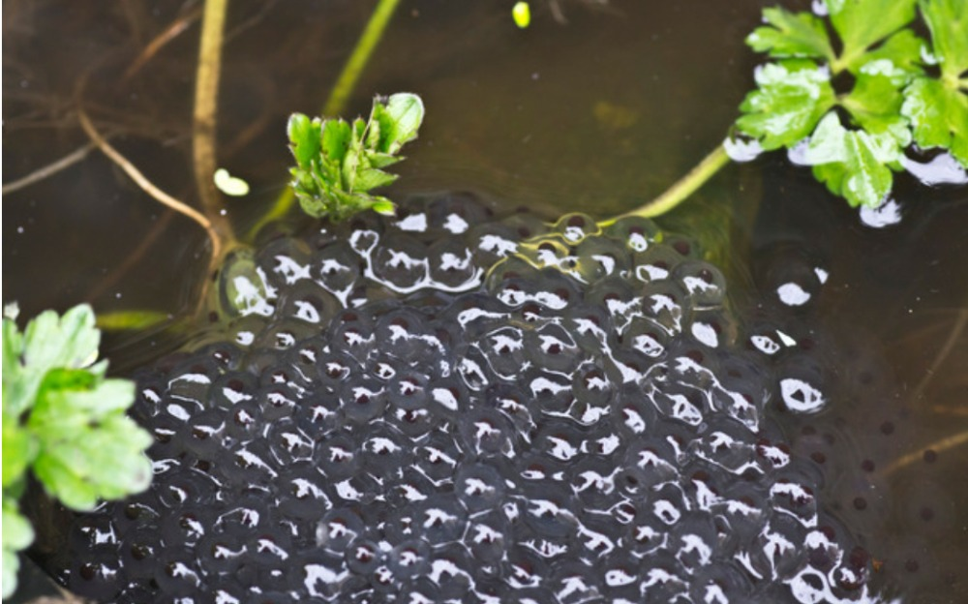
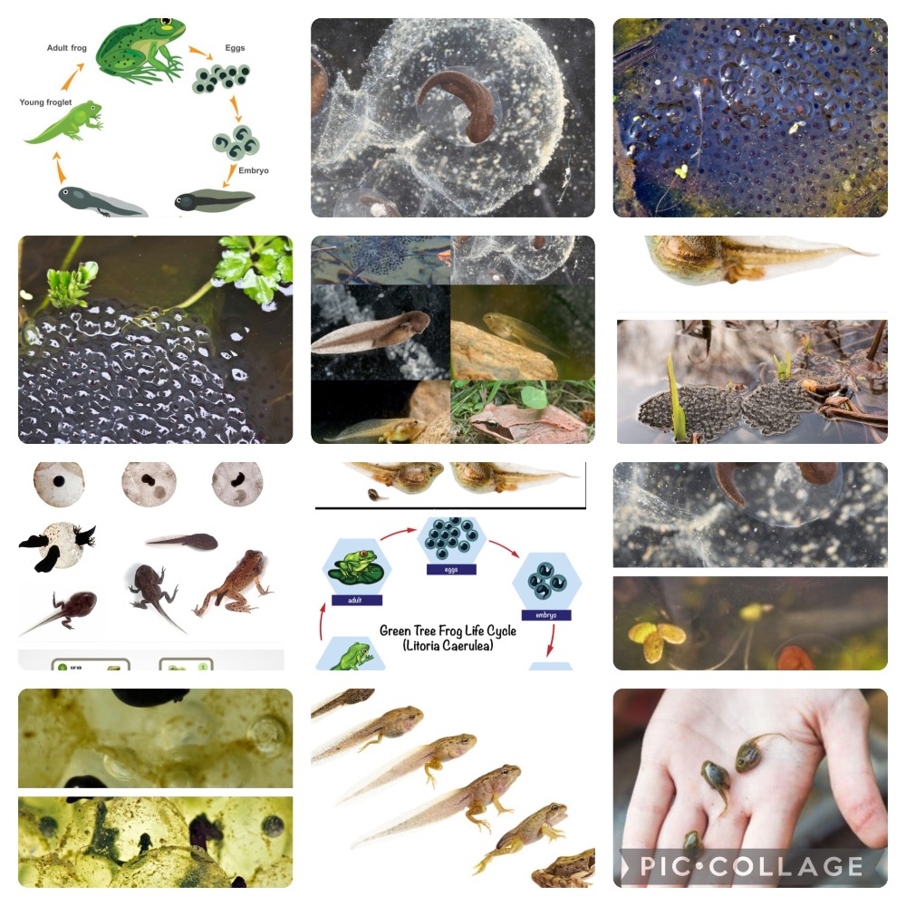

(Source: Alamy Ltd, 2025)

References
Alamy. (2025) Tadpole embryo Stock Photos and Images. Available at: https://www.alamy.com/stock-photo/tadpole-embryo.html?sortBy=relevant (Accessed 21 March 2025)
Rowlands, K. (2025) Trinity St David’s Garden. [Photograph]
Rowlands, K (2025) Flowers, Sticks and Stones. [Photograph]
Rowlands, K (2025) Tadpole Sum. [Photograph]
Welsh Government (2020) Science and Technology – 4. Descriptions of Learning. Available at: https://hwb.gov.wales/curriculum-for-wales/science-and-technology/descriptions-of-learning/ (Accessed 22 March 2025)
Welsh Government (2020) Mathematics and Numeracy – 4. Descriptions of Learning. Available at: https://hwb.gov.wales/curriculum-for-wales/mathematics-and-numeracy/descriptions-of-learning/ (Accessed 22 March 2025)

Fostering Mathematical and Scientific Inquiry Outdoors and The Adult's Role in Early Years
The outdoor environment provides a dynamic and authentic learning space where young children can actively engage with mathematical and scientific concepts. However, the efficacy of these experiences hinges significantly on the quality and nature of adult interaction. This article will evaluate, drawing upon relevant theory and research, how adults working with early years children can effectively support and encourage engagement with mathematical and scientific concepts within outdoor environments, integrating various pedagogical approaches, recent research, and the National Curriculum for Wales.
Theoretical Foundations and Pedagogical Influences: A Modern Perspective
Theoretical perspectives and pedagogical approaches continue to shape our understanding of the adult's role in guiding children's mathematical and scientific explorations outdoors. Vygotsky's sociocultural theory (Vygotsky, 1978) remains foundational, with contemporary research emphasising the importance of dialogic interactions and collaborative learning in outdoor contexts (Alexander, 2020). Adults, as "more knowledgeable others," can facilitate deeper understanding through carefully crafted questions and shared explorations. This aligns with the Reggio Emilia approach (Edwards, Forman, and Gandini, 1998; Kinney and Wharton, 2008: O’Donoghue, 2011; Smidt, 2013; MacBlain, 2021; Tedeschi, Maccaferri and Robotti, 2021) which views the child as a competent learner and the adult as a co-constructor of knowledge, emphasising documentation and reflection as tools for learning. Piaget's constructivist theory (Piaget, 1999; Halfpenny, 2014; Pound, 2014, Koehler, 2021) continues to inform practice, but with a greater emphasis on the role of social interaction and context in shaping children's knowledge construction. Froebel's emphasis on play and nature (Froebel cited in: Wasmuth, Sauerbrey and Winkler, 2023; Bruce, 2020; Tovey, 2023) remains relevant, with contemporary research highlighting the importance of free play and exploration in fostering children's creativity and problem-solving skills in natural settings (Brussoni, Olsen, Pike and Sleet, 2012; Knight, 2011)
Bronfenbrenner's ecological systems theory (Bronfenbrenner and Morris, 2006; Haynes, Halfpenny and O’Toole, 2017) provides a framework for understanding the complex interplay of factors influencing children's development. Adults, as part of the child's microsystem, can create supportive and stimulating outdoor learning environments that foster a sense of connection to nature. Gibson’s ecological approach to perception (Gibson, 1977, 1979 and 2015; Waters, 2013, 2017; Obee, Sandseter and Harper, 2021) remains influential, with research highlighting the importance of providing children with affordance of opportunities to directly experience and interact with their environment (Gibson, 2014).This aligns with the Scandinavian approach, which emphasizes children's direct interaction with nature and the development of a strong connection to the land (Knight, 2016). Montessori's emphasis on sensory exploration and self-directed learning (Lillard, 2019; Lillard, 2023; Suzuki, 2023; Lillard, and Taggart, 2019; Ceciliani, 2021; Lillard, 2011) is applicable to outdoor settings, where children can engage with natural materials and phenomena through hands-on activities. Steiner's focus on rhythm, movement, and imagination (Nicol, 2016; Nicol, and Taplin, 2017; Avison, 2014; Schuberth, and Kuettel, 2014) is also relevant, as outdoor play provides opportunities for children to engage in physical activity and imaginative play.
Te Wariki, a Māori philosophy, promotes interconnectedness with the natural world through concepts like kaitiakitanga (guardianship) and mana whenua (respect for the land), fostering a sense of responsibility and stewardship (Wilkinson et al., 2020; Forster, 2023). Forest School principals, emphasising child-led learning, risk-taking, and connection with nature, provide a practical framework for implementing these theoretical perspectives (O'Brien & Murray, 2006).
National Curriculum for Wales: A Framework for Outdoor Learning
The National Curriculum for Wales (Welsh Government, 2022) emphasises the importance of learning experiences that are authentic, engaging, and relevant to children's lives. It promotes a holistic approach to learning, focusing on the development of skills and knowledge across all areas of learning and experience. Outdoor learning is explicitly promoted within the curriculum, providing a valuable context for developing mathematical and scientific concepts. The curriculum encourages educators to create learning experiences that connect children with their local environment and promote a sense of place.
Supporting Mathematical Concepts Outdoors: Contemporary Applications
The outdoor environment serves as a dynamic and engaging space for exploring mathematical concepts, aligning seamlessly with the National Curriculum for Wales (Welsh Government, 2022). Practitioners play a pivotal role in facilitating this learning. Educators can leverage the abundance of natural objects (e.g., leaves, stones, insects) to foster number sense and counting skills. Aligning with Sinclair and Jackiw's (2019) work on dynamic geometry and digital tools, digital cameras and tablets can be used to capture images of these objects, creating digital collections that children can count and categorise (Sinclair et al., 2016; Hegedus and Otalora, 2023; Jarman, 2020; Schuberth and Kuettel, 2014). Augmented reality (AR) apps can overlay digital numbers onto natural objects, making counting increasingly interactive and engaging. This also aids in subitising or estimating, the ability to instantly recognize the number of items in a small group, a foundational mathematical skill (Mulligan, Mitchelmore, English, Crevensten, 2013; Mitchelmore, Papic, and Mulligan, 2011; Andrews, Xenofontos, & Sayers, 2021).
Research by McCluskey, Kilderry, Mulligan, et al., (2023) and Uhlenberg, and Geiken, (2021) suggest that as the outdoor environment is rich in geometric patterns and shapes, educators can guide children to identify and describe these shapes, using digital cameras to capture and analyse the geometric patterns in nature, such as the hexagonal structure of a honeycomb or the radial symmetry of a flower. Digital drawing apps can then be used in addition to, or alongside traditional artistic endeavours to recreate and manipulate these shapes, further fostering spatial reasoning and geometric understanding. Using GPS devices, alongside basic compasses and simple maps and indeed just stick arrows, during outdoor walks, also enables children to learn about distance, direction and location, and create their own representations of a map in stick, stone, mud and leaves in addition to a simple digital map of their findings.
Practical measurement activities, such as measuring the length of a fallen branch or the circumference of a tree trunk, give meaning to measurement and can be enhanced with digital tools. Digital measuring tools, such as laser distance meters, can provide accurate measurements, and data logging apps can be used to record and analyse data.
Children can use accurate digital scales to weigh different types of natural materials, comparing weights and understanding units of measurement (Fuchs, and Corni, 2024; Campbell, Jobling, Howitt, 2021).
Natural patterns, such as the arrangement of leaves on a stem or the spiral patterns of seashells, provide rich opportunities for exploring pattern recognition and creation.
Digital pattern-making apps can be used again, alongside traditional methods on paper or natural colleges on the ground to create and manipulate visual patterns, allowing children to experiment with different arrangements and transformations.
Using coding applications, children can program robots, such as "Bee-Bots" (Fridberg and Redfors, 2021; Bers, 2017; Merrill, 2023; Kavanagh, 2020), to follow patterns created from natural materials, combining physical and digital learning.

Developing Spatial Awareness and Understanding the Young Child's Place in Nature
Spatial awareness, the ability to understand and interact with the surrounding environment, is a fundamental aspect of early childhood development. The outdoor environment offers rich opportunities for children to develop this crucial skill, fostering a sense of their place within the natural world. Adults can play a significant role in supporting this development through:
Exploration and Navigation

Children naturally explore their surroundings through movement and play, developing a range of schema (Atherton and Nutbrown, 2013). Outdoor environments provide diverse terrains and spaces for children to navigate, developing their understanding of distance, direction, spatial relationships and their own sense of proprioception, a feeling of their own body and their orientation in the world. In addition to developing their Vestibular sense of balance. Which can all be scaffolded through metacognitive spoken language by the practitioner. (Lyons and Ghetti, 2010).
Again, using simple maps, compasses, or GPS-enabled devices, adults can guide children in navigating outdoor spaces, enhancing their spatial reasoning. Recent research emphasises the importance of embodied spatial learning, where physical movement and interaction with the environment are crucial (Newcombe, 2017).
Creating obstacle courses or treasure hunts encourages children to plan routes and navigate simple and potentially complex environments, promoting spatial problem-solving.
Children can create maps of their outdoor explorations, representing their understanding of spatial relationships. This can be done through physical drawings, digital mapping tools, or even building models of their surroundings. Digital tools, such as aerial photography or satellite imagery, can provide children with different perspectives of their environment, broadening their spatial understanding. The use of digital tools for spatial representation aligns with the growing emphasis on digital literacies in early childhood (Prado, 2019; Alkouri, 2022) Using digital cameras, children can take pictures of landmarks, and then organize these images into a digital map, creating a visual representation of their environment.
Outdoor environments provide opportunities for children to understand scale and perspective. Observing large trees, small insects, and distant landscapes helps children develop an understanding of relative size and distance. Using digital microscopes and telescopes, adults can help children explore the microscopic and macroscopic aspects of nature, expanding their understanding of scale. Using Augmented reality (AR) applications, children can observe digital overlays of animal migrations or other large scale natural phenomena, giving them perspective on their place within the wider ecosystem.
Developing spatial awareness is intrinsically linked to a child's sense of connection with nature. By exploring and understanding their environment, children develop a sense of belonging and responsibility towards the natural world. Adults can foster this connection by encouraging children to observe and appreciate the beauty and complexity of nature, and by discussing the importance of environmental stewardship.
By using digital tools to record and share their observations, children can contribute to national science projects, such as the national bird count on the BBC’s Spring Watch, fostering a sense of participation in environmental research. The importance of fostering a sense of place and connection to nature in early childhood is increasingly recognised as crucial for environmental sustainability (Chawla, 2020; McLean 2024; Mansour, Aras, Staarman, et al., 2024; Early Childhood Mathematics Group, 2021; Ernández-Martín, et al., 2022).

Integrating Loose Parts for Enhanced Outdoor Learning
Nicholson's (1971)"loose parts" theory emphasises the value of open-ended materials in fostering creativity and problem-solving. Providing children with a variety of natural loose parts, such as sticks, stones, pinecones, and leaves, encourages them to explore and manipulate their environment. These materials can be used to build structures, create patterns, and engage in imaginative play, further enhancing spatial awareness and mathematical understanding. The incorporation of digital tools can enhance the loose parts experience, for example, children can photograph their creations or use tablets to research natural items they find. The use of loose parts allows children to explore their world in a self-directed way, which is vital for early years development (Nicholson, 1971; Cankaya, Leach and Akdemir, 2024; Gorrie, 2021).
Encouraging Scientific Inquiry Outdoors: Modern Approaches
The outdoor environment provides a natural laboratory for scientific exploration. Practitioners can foster scientific inquiry using a range of methods and pedagogy. Observing and documenting life cycles, such as the metamorphosis of a butterfly or the germination of a seed, or indeed the life cycle of a frog can be enhanced with digital microscopes and cameras, capturing detailed images of organisms and their transformations. Time-lapse photography can be used to document the progression of life cycles, providing a visual representation of change over time. Using online databases and applications, children can compare the life cycles of different organisms, broadening their understanding of biodiversity (Fleer, 2011).
Investigating natural phenomena, such as weather patterns or the water cycle, can be enhanced with weather stations and environmental sensors, which collect and analyse data on temperature, humidity, and rainfall.
Data visualization tools can be used to create graphs and charts of the collected data, helping children to identify trends and patterns. Using digital simulations, children can explore the effects of different environmental factors on natural phenomena, such as the impact of climate change on ecosystems (Waite-Stupiansky and Cohen, 2020; Johnson and Watts, 2018; Tunnicliffe, 2015; Howard and Charlesworth, 2024).

Exploring material and their properties, such as the texture, density, and permeability of natural materials, can also be enhanced with digital tools that analyse the composition and characteristics of these materials. Digital microscopes can be used to examine the microscopic structure of materials, revealing details that are not visible to the naked eye.
Using online resources, children can research the properties of different materials and compare their findings with their own observations. Fostering scientific curiosity and inquiry-based learning, educators can use again digital tools to record and share observations, questions, and simple emergent hypotheses of even very young children.
Digital portfolios can be used to document the scientific inquiry process, showcasing children's investigations and reflections (Plowman, Stevenson, Stephen, & McPake, 2011).
Using online collaboration platforms, children can share their findings with peers and experts, engaging in scientific discourse and knowledge sharing (Siraj-Blatchford, 2009).
The use of AR applications also can enhance the engagement and the learning experience for the children (Kerawalla, Luckin, Seljeflot, et al., 2006; Bower, Howe, McCredie, Robinson, & Grover, 2014). The importance of quality outdoor learning experiences for young children, is also highlighted by White (2014 and 2020).

The Adult's Role: Facilitation and Scaffolding in the Early Years Digital Age
Adults in early years settings are instrumental in guiding children's interactions with the outdoor environment, particularly when seamlessly integrating digital tools. This role encompasses several crucial aspects. Firstly, by creating opportunities and providing access to diverse natural settings, such as gardens, parks, and woodland areas, that form the foundation of outdoor learning (White, 2014).
Again, by integrating age-appropriate digital tools, such as tablets with nature-themed apps or digital cameras, enabling children to capture and explore their discoveries, fostering a sense of agency (Plowman, Stevenson, Stephen, & McPake, 2011).
This approach aligns with early years frameworks that emphasise curiosity, exploration and discovery, such as those that promote children becoming investigators of their world, as outlined in national curriculum guidance (Department for Education, 2024: Welsh Government 2022)
Scaffolding Learning and guiding children's explorations through open-ended questions encourages critical thinking and problem-solving. For example, asking "What do you notice about the leaves?" rather than simply naming them, promotes deeper engagement (Siraj-Blatchford, 2009).
Utilizing digital platforms for collaborative learning, such as creating digital nature journals or sharing photos on secure online platforms, fosters communication and knowledge sharing, essential for social development (Edwards, 2013).
Again, using simple coding apps, like those that drive "Bee-Bots", to navigate outdoors, creating simple pathways, thus combining digital technology with outdoor physical movement and early computational thinking (Fridberg and Redfors, 2021; Bers, 2017; Merrill, 2023; Kavanagh, 2020). Adults should model enthusiasm and demonstrate genuine curiosity and excitement about the natural world, acting as role models for children's learning (Louv, 2013). Incorporating digital resources, such as using apps to identify bird songs or explore weather patterns, can enhance engagement and discovery, making learning more interactive (Kerawalla, Luckin, Seljeflot, et al., 2006; Bower, Howe, McCredie, Robinson, & Grover, 2014). Observing and documenting children's learning and discoveries through photos, videos, and audio recordings provides valuable insights into their learning and developmental progress (Nutbrown, 2011, 2011 and 2023). Using digital portfolios allows educators to showcase children's progress and share their learning with parents and caregivers, fostering a collaborative approach to education (Kurniawan, and Khukmi, 2023). This is very important for early years settings, where observing and recording children's development is a crucial part of the practitioner’s role, as stipulated by early years foundation stage guidelines (Department for Education, 2024: Welsh Government 2022).

Allowing children to take calculated risks, such as climbing trees or exploring muddy puddles, promotes physical development and resilience, crucial for holistic development (Gill, 2007). Again, incorporating digital tools can be used to explore potential outcomes, such as using weather apps to predict rainfall or using digital maps to plan routes, supporting planning and problem-solving skills.
In early years practice, the integration of digital technology should always be purposeful and developmentally appropriate. It's about enhancing, not replacing, children's direct experiences with nature (Falloon, 2023; Myung, Choe, and Baek, 2025). For example: Using tablets to take close-up photos of insects allows children to examine details that they might otherwise miss, fostering scientific observation skills. Digital storytelling apps can be used to create narratives about outdoor adventures, promoting language development and creativity. Adults play a crucial role in ensuring that technology is used ethically and responsibly, promoting digital citizenship from an early age, thus preparing children for the modern world.
Challenges and Considerations: Navigating the 21st Century
Implementing effective outdoor learning experiences presents multiple challenges, including safety, weather, resources, curriculum integration, and adult confidence. Addressing these challenges requires careful planning, collaboration, and the integration of technology, ensuring alignment with the National Curriculum for Wales, (2020)
Conclusion: Embracing the Outdoors for 21st Century Learning
The outdoor environment provides a rich and authentic context for young children to engage with mathematical and scientific concepts. Adults play a pivotal role in facilitating and scaffolding these learning experiences, drawing upon multiple theoretical frameworks, pedagogical influences, contemporary research, and indeed the National Curriculum for Wales. By creating opportunities, modelling enthusiasm, fostering inquiry, and incorporating technology, adults can empower children to become confident, curious, and digitally literate learners in the natural world. In the words of Rachel Carson (1998), ‘If a child is to keep alive his inborn sense of wonder… he needs the companionship of at least one adult who can share it, rediscovering with him the joy, excitement and mystery of the world we live in’. This is our privilege as early years practitioners.

References
Alexander, R. (2020). A Dialogic Teaching Companion (1st ed.). Abingdon, Oxon: Routledge. Available at: https://doi.org/10.4324/9781351040143 (Accessed 15 March 2025)
Alkouri, Z. (2022). Developing spatial abilities in young children: Implications for early childhood education. Cogent Education, 9(1). https://doi.org/10.1080/2331186X.2022.2083471 (Accessed 20 March 2025)
Andrews, P., Xenofontos, C., & Sayers, J. (2021). Estimation in the primary mathematics curricula of the United Kingdom: Ambivalent expectations of an essential competence. International Journal of Mathematical Education in Science and Technology, 53(8), 2199–2225. Available at: https://doi.org/10.1080/0020739X.2020.1868591 (Accessed 25 March 2025)
Atherton, F., Nutbrown, C. (2013) Understanding Schemas and Young Children: From Birth to Three. London: Sage Publications Ltd.
Avison, K. (2014) The Tasks and Content of the Steiner-Waldorf Curriculum. (2nd edn.) Edinburgh, Scotland, UK: Floris Books
Bates, K. E., Williams, A. Y., Gilligan-Lee, K. A., Gripton, C., Lancaster, A., Williams, H., Borthwick, A., Gifford, S. & Farran, E. K. (2023). Practitioners' perspectives on spatial reasoning in educational practice from birth to 7 years. British Journal of Educational Psychology, 93, 571–590. https://doi.org/10.1111/bjep.12579 (Accessed 20 March 2025)
Bers, M.U. (2017). Coding as a Playground: Programming and Computational Thinking in the Early Childhood Classroom (1st ed.). New York: Routledge. Available at: https://doi.org/10.4324/9781315398945 (Accessed 14 March 2025)
Bower, M., Howe, C., McCredie, N., Robinson, A., & Grover, D. (2014) Augmented Reality in education – cases, places and potentials, Educational Media International, 51:1, 1-15, DOI: 10.1080/09523987.2014.889400 Available at: http://dx.doi.org/10.1080/09523987.2014.889400 (Accessed 19 March 2025)
Bronfenbrenner, U., & Morris, P. A. (2006). The bioecological model of human development. In R. M. Lerner (Ed.), Handbook of child psychology: Theoretical models of human development (Vol. 1, 6th ed., pp. 793–828). Hoboken, NJ: John Wiley & Sons.
Bruce, T. (2020) Educating young children: a lifetime journey into a Froebelian approach: the selected works of Tina Bruce. 1st ed. Abingdon, Oxon: Routledge.
Brussoni, M., Olsen, L., Pike, I., & Sleet, D. (2012). Risky Play and Children’s Safety: Balancing Priorities for Optimal Child Development. International journal of environmental research and public health. 9. 3134-48. Available at: 10.3390/ijerph9093134 (Accessed 17 March 2025)
Campbell, C., Jobling, W., Howitt, C. (2021) Science in Early Childhood (4th edn.) Cambridge: Cambridge university Press.
Cankaya, O., Leach, J. and Akdemir, K. (2024) ‘The Journey of Loose Parts across Educational Landscapes and History: The Role of Materials, Relationships, Space, and Time in Children’s Loose Parts Play’, American journal of play, 16(2–3), pp. 210–245.
Carson, R. (1998) The Sense of Wonder. New York: Harper Collins
Ceciliani, A. (2021) ‘Maria Montessori and Embodied Education: current proposal in preschool education’, Ricerche di pedagogia e didattica, 16(2), pp. 149–163. Available at: https://doi.org/10.6092/issn.1970-2221/12195. (Accessed 20 March 2025)
Chawla, L. and Gould, R. (2020) ‘Childhood nature connection and constructive hope: A review of research on connecting with nature and coping with environmental loss’, People and nature (Hoboken, N.J.), 2(3), pp. 619–642. Available at: https://doi.org/10.1002/pan3.10128. (Accessed 20 March 2025)
Department for Education (2024) Early years foundation stage statutory framework. Available at: https://assets.publishing.service.gov.uk/media/670fa42a30536cb92748328f/EYFS_statutory_framework_for_group_and_school_-_based_providers.pdf (Accessed 21 March 2025)
Early Childhood Mathematics Group (2021) Spatial Reasoning in early childhood. Available at: https://earlymaths.org/wp-content/uploads/2021/06/Spatial-Reasoning-Document-new.pdf (Accessed 20 March 2025)
Edwards, C.P., Forman, G.E. and Gandini, L. (1998) The hundred languages of children: the Reggio Emilia approach -- advanced reflections. (2nd edn.) Westport, Connecticut: Ablex publishing.
Edwards, S. (2013) ‘Digital play in the early years: a contextual response to the problem of integrating technologies and play-based pedagogies in the early childhood curriculum’, European Early Childhood Education Research Journal, 21(2), pp. 199–212. Available at: https://doi.org/10.1080/1350293X.2013.789190 (Accessed 14 March 2025)
Ernández-Martín, F.D. et al. (2022) Active Methodologies for the Promotion of Mathematical Learning. MDPI - Multidisciplinary Digital Publishing Institute. Available at: https://doi.org/10.3390/books978-3-0365-4180-8. (Accessed 20 March 2025)
Falloon, G. (2019) ‘Using simulations to teach young students science concepts: An Experiential Learning theoretical analysis’, Computers and education, 135, pp. 138–159. Available at: https://doi.org/10.1016/j.compedu.2019.03.001. (Accessed 18 March 2025)
Fleer, M. (2011) ‘’Conceptual play’: foregrounding imagination and cognition during concept formation in early years education’, Contemporary issues in early childhood, 12(3), pp. 224–240. Available at: https://doi.org/10.2304/ciec.2011.12.3.224. (Accessed 14 March 2025)
Forster, M. (2023) ‘Amplifying the influence of Māori knowledge in environmental management’, Environment and Planning. F, Philosophy, theory, models, methods and practice, 2(1–2), pp. 229–246. Available at: https://doi.org/10.1177/26349825221133095. (Accessed 9 March 2025)
Fridberg, M. and Redfors, A. (2021) ‘Teachers’ and children’s use of words during early childhood STEM teaching supported by robotics’, International Journal of Early Years Education, 32(2), pp. 405–419. Available at: https://doi.org/10.1080/09669760.2021.1892599 (Accessed 14 March 2025)
Fuchs, H.U. and Corni, F. (2024) Primary Physical Science Education: An Imaginative Approach to Encounters with Nature. 1st edn. Cham: Springer Nature. Available at: https://doi.org/10.1007/978-3-031-43953-7. (Accessed 20 March 2025)
Gibson, J. J. (1977). The theory of affordances. In R. Shaw and J. Bransford (Eds.), Perceiv ing, acting, and knowing, toward an eco-logical psychology. Hillsdale, NJ: Lawrence Erlbaum Associates.
Gibson, J. J. (1979) The Ecological Approach to Visual Perception. Hillsdale, New Jersey: Lawrence Erlbaum Associates.
Gibson, J.J. (2014). The Ecological Approach to Visual Perception: Classic Edition (1st ed.). hove, East Sussex: Psychology Press. Available at: https://doi.org/10.4324/9781315740218
Gibson, J.J. (2015) The ecological approach to visual perception. Classic edition. London: Routledge. Available at: https://doi.org/10.4324/9781315740218. (Accessed 15 March 2025)
Gill, T (2007) No Fear Growing up in a risk adverse society. London: Calouste Gulbenkian Foundation. Available at: https://rethinkingchildhood.com/wp-content/uploads/2010/10/no-fear-19-12-07.pdf (Accessed 19 March 2025)
Gorrie, A. (2021) ‘Loose Parts Q and A with Angus Gorrie’, Educating young children learning and teaching in the early childhood years, 27(3), pp. 6–8.
Halpenny, A.M. (2014) Introducing Piaget: a guide for practitioners and students in early years education. London: Routledge.
Hayes, N., Halpenny, A.M. and O’Toole, L. (2017) Introducing Bronfenbrenner: a guide for practitioners and students in early years education. London: Routledge. Available at: https://doi.org/10.4324/9781315646206. (Accessed 24 March 2025)
Hegedus, S.J., Otálora, Y. (2023) Mathematical strategies and emergence of socially mediated metacognition within a multi-touch Dynamic Geometry Environment. Educ Stud Math 112, 289–307.Available at: https://doi.org/10.1007/s10649-022-10170-4 (Accessed 25 March 2025)
Howard, R., Charlesworth, R. (2024) Maths and Science for young Children. (9th edn.) Andover, Hampshire: Wadsworth Publishing Co Inc. Cengage learning
Jarman, R. (2020) Teaching Mathematics in Grades 1-8; Engaging the maths genius in every child. (2nd edn.) Stroud. Gloucestershire: Hawthorn Press
Johnson, J. and Watts, A. (2018) Developing creativity and curiosity outdoors: how to extend creative learning in the early years. First edition. Boca Raton, FL: Routledge, an imprint of Taylor and Francis.
Kavanagh, K. (2020) Can the use of beebots impact on children’s learning of algorithmic thinking? UCL, Institute of Education. Available at: https://bpb-eu-w2.wpmucdn.com/reflect.ucl.ac.uk/dist/6/2307/files/2021/03/Can-the-use-of-beebots-impact-on-childrens-learning-of-algorithmic-thinking-Kellie-Kavanagh.pdf (Accessed 14 March 2025)
Kerawalla, L., Luckin, R., Seljeflot, S. et al. (2006) “Making it real”: exploring the potential of augmented reality for teaching primary school science. Virtual Reality 10, 163–174 available at: https://doi.org/10.1007/s10055-006-0036-4 (Accessed 19 March 2025)

Kinney, L. and Wharton, P. (2008) An encounter with Reggio Emilia: children’s early learning made visible. Abingdon, Oxon: Routledge. Available at: https://doi.org/10.4324/9780203937143. (Accessed 23 March 2025)
Knight, S. (2011) Risk and Adventure in Early Years Outdoor Play: Learning from Forest Schools. Sage
Knight, S. (2016) Forest School in Practice. SAGE Publications.
Koehler, J. (2021) who the Hell is Jean Piaget?: and what are his theories all about? Felixstowe, Suffolk, UK: Bowden and Brazil.
Kurniawan, R., & Khukmi, K. (2023). Digital Portfolio Assessment: A Self-Reflection Way for Teachers and Special Need Students. Journal of ICSAR. 7. 230. Available at: 10.17977/um005v7i22023p230 (Accessed 19 March 2025)
Lillard, A.S. (2019) ‘Shunned and Admired: Montessori, Self-Determination, and a Case for Radical School Reform’, Educational psychology review, 31(4), pp. 939–965. Available at: https://doi.org/10.1007/s10648-019-09483-3. (Accessed 23 March 2025)
Lillard, A.S. and Taggart, J. (2019) ‘Pretend Play and Fantasy: What if Montessori Was Right?’, Child development perspectives, 13(2), pp. 85–90. Available at: https://doi.org/10.1111/cdep.12314. (Accessed 23 March 2025)
Lillard, P. P. (2011). Montessori today: A comprehensive approach to education from birth to adulthood. Kindle Edition. New York: Schocken Books.
Lillard, P. P. (2023) The Montessori Potential: How to Foster Independence, Respect and Joy in Every Child. Chicago, Illinois, USA: Parenting Press.
Louv, R. (2013) Last Child in the Woods: Saving our Children from Nature-Deficit Disorder. New York: Atlantic Books Ltd.
Lyons, K., & Ghetti, S. (2010). Metacognitive Development in Early Childhood: New Questions about Old Assumptions. 10.1007/978-1-4419-6546-2_12. Available at: https://www.researchgate.net/publication/226733829_Metacognitive_Development_in_Early_Childhood_New_Questions_about_Old_Assumptions (Accessed 25 March 2025)
MacBlain, S. (2021) Children’s learning in early childhood: learning theories in practice 0-7 years. London: SAGE
Mansour, N., Aras, C., Staarman, J.K. et al. (2024) Embodied learning of science concepts through augmented reality technology. Educ Inf Technol. Available at: https://doi.org/10.1007/s10639-024-13120-0 (Accessed 20 March 2025)
McCluskey, C., Kilderry, A., Mulligan, J. et al. (2023) The role of movement in young children’s spatial experiences: a review of early childhood mathematics education research. Math Ed Res J 35, 287–315. Available at: https://doi.org/10.1007/s13394-023-00446-0 (Accessed 20 March 2025)
McLean, C. (2024) A Walk in the Woods. VCU Scholars Compass.
Merrill, M.L. (2023). Everyday STEAM for the Early Childhood Classroom: Integrating the Arts into STEM Teaching (1st ed.). New York: Eye on Education. Available at: https://doi.org/10.4324/9781003395614 (Accessed 14 March 2025)
Mitchelmore, M.C., Papic, M.M. and Mulligan, J.T. (2011) ‘Assessing the Development of Preschoolers’ Mathematical Patterning’, Journal for research in mathematics education, 42(3), pp. 237–269. Available at: https://doi.org/10.5951/jresematheduc.42.3.0237. (Accessed 25 March 2025)
Montague-Smith, A., Cotton, T., Hansen, A., Price, A.J. (2018) Mathematics in early Years Education (4th edn.) Abingdon, Oxon: Routledge.
Mulligan, J.T., Mitchelmore, M.C., English, L.D., Crevensten, N. (2013). Reconceptualizing Early Mathematics Learning: The Fundamental Role of Pattern and Structure. In: English, L., Mulligan, J. (eds) Reconceptualizing Early Mathematics Learning. Advances in Mathematics Education. Springer, Dordrecht. Available at: https://doi.org/10.1007/978-94-007-6440-8_4 (Accessed 25 March 2025)
Myung, J., Choe, M., & Baek, J. S. (2025). Enhancing child–nature interactions through design: An empirical study of the emotions, perspectives and experiences of nature among South Korea's urban Generation Alpha children. People and Nature, 00, 1–14. Available at: https://doi.org/10.1002/pan3.70005 (Accessed 19 March 2025)
Newcombe, N. (2017), “Harnessing Spatial Thinking to Support Stem Learning”, OECD Education Working Papers, No. 161, OECD Publishing, Paris. Available at: http://dx.doi.org/10.1787/7d5dcae6-en (Accessed 20 March 2025)
Nicholson, S. (1971). How NOT to Cheat Children: The Theory of Loose Parts. Landscape Architecture, 62(1), 30–34. Available at: http://www.jstor.org/stable/44663886 (Accessed 19 March 2025)
Nicol, J. (2016) Bringing the Steiner Waldorf Approach to your Early Years Practice. (3rd edn.) Abingdon, Oxon: Routledge.
Nicol, J. and Taplin, J.T. (2017) Understanding the Steiner Waldorf Approach: Early Years Education in Practice. Second edition. London: Taylor and Francis.
Nutbrown, C. (2011) Key concepts in early childhood education and care. (2nd edition). London: SAGE.
Nutbrown, C. (2011) Threads of Thinking: Schemas and Young Children’s Learning. 4th edition. London: Sage.
Nutbrown, C. (ed.) (2023) Early childhood education: current realities and future priorities. London: SAGE.
O’Donoghue, L.A. (2011) ‘Moving Onward: Reflections and Re-interpretations of the Reggio Approach’, Canadian children, 36(1), pp. 20-.
Obee, P., Sandseter, E.B.H. and Harper, N.J. (2021) ‘Children’s use of environmental features affording risky play in early childhood education and care’, Early child development and care, 191(16), pp. 2607–2625. Available at: https://doi.org/10.1080/03004430.2020.1726904. (Accessed 15 March 2025)
O'Brien, L., & Murray, R. (2006). A marvellous opportunity to learn: A participatory evaluation of Forest School in England and Wales. Farnham, Surrey: Forest Research, Forestry Commission England. Available at: https://cdn.forestresearch.gov.uk/2006/10/fr0112forestschoolsreport.pdf (Accessed 9 March 2025)
Piaget, J. (1999) Play, Dreams And Imitation In Childhood. Abingdon, Oxon, Routledge.
Plowman, L, Stephen, C, Stevenson, O & McPake, J (2012), 'Preschool children's learning with technology at home', Computers & Education, vol. 59, no. 1, pp. 30-37. Available at: https://doi.org/10.1016/j.compedu.2011.11.014 (Accessed 19 March 2025)
Plowman, L, Stephen, C, Stevenson, O & McPake, J 2012, 'Preschool children's learning with technology at home', Computers & Education, vol. 59, no. 1, pp. 30-37. https://doi.org/10.1016/j.compedu.2011.11.014 (Accessed 14 March 2025)
Pound, L. (2014) How children learn: educational theories and approaches - from Comenius the father of modern education to giants such as Piaget, Vygotsky and Malaguzzi. New and improved edition. London: Practical Pre-School Books.
Prado, J. (2019) Understanding the link between number and space is shedding new light on the potential importance of many toys and games for developing children's mathematical abilities. International Brain Research Organisation, IBE Science of Learning portal, UNESCO Available at: file:///C:/Users/kater/Downloads/the-role-of-spatial-skills-in-early-math-learning-and-how-to-foster-space-number-interactions.pdf (Accessed 20 March 2025)
Schuberth, E., Kuettel, N. (2014) Geometry Lessons in the Waldorf School. Chatham, New York: Waldorf Publications.
Sinclair, N. et al. (2016) ‘Recent research on geometry education: an ICME-13 survey team report’, ZDM, 48(5), pp. 691–719. Available at: https://doi.org/10.1007/s11858-016-0796-6. (Accessed 25 March 2025)
Siraj-Blatchford, I. (2009) ‘Conceptualising progression in the pedagogy of play and sustained shared thinking in early childhood education: A Vygotskian perspective’, Educational and child psychology, 26(2), pp. 77–89. Available at: https://doi.org/10.53841/bpsecp.2009.26.2.77. (Accessed 14 March 2025)
Smidt, S. (2013) Introducing Malaguzzi: exploring the life and work of Reggio Emilia’s founding father. Milton Park, Abingdon, Oxon; Routledge.
Suzuki, K. (2023) The Complete Montessori Method: Nurturing Creativity and Independence in Babies, Toddlers and Preschoolers (0-5) Independently Published.
Tedeschi, M., Maccaferri, E., and Rabotti, A. (2021) ‘The Hundred Languages of Digital in the Reggio Emilia Approach’, Je-LKS, 17(3). Available at: https://doi.org/10.20368/1971-8829/1135592. (Accessed 23 March 2025)
Tovey, H. (2013) Bringing the Froebel approach to your early years practice. Milton Park, Abingdon, Oxon: Routledge. Available at: https://doi.org/10.4324/9780203818374. (Accessed 16 March 2025)
Tunnicliffe, S.D. (2015) Starting inquiry-based science in the early years: look, talk, think and do. 1st ed. London: Routledge. Available at: https://doi.org/10.4324/9781315771908. (Accessed 22 March 2025)
Uhlenberg, J.M., Geiken, R. (2021) Supporting Young Children’s Spatial Understanding: Examining Toddlers’ Experiences with Contents and Containers. Early Childhood Educ J 49, 49–60. Available at: https://doi.org/10.1007/s10643-020-01050-8 (Accessed 20 March 2025)
Vygotsky, L.S. (1978) Mind in Society: The Development of Higher Psychological processes. Cambridge, MA and London, England: Harvard University Press.
Waite-Stupiansky, S. and Cohen, L.E. (eds) (2020) STEM in early childhood education: how science, technology, engineering, and mathematics strengthen learning. 1st ed. New York: Routledge.
Wasmuth, H., Sauerbrey, U., Winkler, M. (2023) Finding Froebel: The Man who invented Kindergarten. London: Bloomsbury Academic.
Waters, J. (2013). Children telling adults of their interest in wild spaces in Wales. In S. Knight (Ed.), International perspectives on Forest School: Natural spaces to play and learn. London: Sage.
Waters, J. (2017) Affordance theory in outdoor play. Sage Publications Ltd.
Welsh Government (2022) Science and Technology: 2. Statements of what matters: Being curious and searching for answers is essential to understanding and predicting phenomena. Available at: https://hwb.gov.wales/curriculum-for-wales/science-and-technology/statements-of-what-matters/ (Accessed 21 March 2025)
White, J. (2014) Playing and learning outdoors: making provision for high quality experiences in the outdoor environment with children 3-7. 2nd ed. New York: Routledge. Available at: https://doi.org/10.4324/9780203105429. (Accessed 19 March 2025)
White, J. (2020) Playing and learning outdoors: the practical guide and sourcebook for excellence in outdoor provision and practice with young children. Third edition. London; Routledge.
Wilkinson, C. et al. (2020) ‘Mātauranga Māori in geomorphology: existing frameworks, case studies, and recommendations for incorporating Indigenous knowledge in Earth science’, Earth surface dynamics, 8(3), pp. 595–618. Available at: https://doi.org/10.5194/esurf-8-595-2020. (Accessed 9 March 2025)

