University of Wales Trinity Saint David
Wales Institute of Science & Art


Design of filter circuit – Technical report
Electrical principles (ACMA4031)

Joshua Ludlow
2517369
April 2026

Contents
1. Abstract………………………………………………………………………………………3
2. Introduction………………………………………………………………………………… 4
3. Circuit descriptions…………………………………………………………………………5
3.1 Simulated circuits……………………………………………………………………..5
3.2 Experimental circuits………………………………………………………………6,7
4. Results………………………………………………………………………………………7
4.1 Low-pass filter…………………………………………………………………………7,8
4.2 High-pass filter……………………………………………………………………..8,9
5. Discussion………………………………………………………………………………….10
5.1 Low-pass filter………………………………………………………………………..10
5.2 High-pass filter……………………………………………………………………..11
6. Conclusion………………………………………………………………………………….12
7. References…………………………………………………………………………………13

- Abstract
The purpose of this report is to compare the results from both low-pass and high-pass filters. The results will be gathered using two methods, the first being an experimental method where the circuit will be set up to an oscilloscope and a signal generator. The second being a simulated method, the circuit will be set up on proteus, and the results will be taken from their oscilloscope and signal generator tool. The results show that the low-pass filter allows low frequency signals to pass through while reducing high frequencies, whereas the high-pass filter does the opposite. The measured cut-off frequencies are similar to theoretical value.

- Introduction
Low-pass and high-pass filters are circuits that control what frequencies pass through. A low-pass filter lets low-frequency signals pass while reducing the higher frequencies, RayPCB (2025) states they are used to reduce noise and are often used in “audio tone controls, RF coupling circuits and simple noise suppression”.
A high-pass filter lets high-frequency signals pass while reducing lower frequencies, this is useful to remove unwanted low-frequency noise. According to audiophiles (2025) high-pass filters are used extensively in audio systems to eliminate rumble and in communication systems to block low-frequency interference and DC offset.
The theories being used in this task include AC circuit theory and signal processing. The AC circuit theory comes from the analysis of how the circuits affect signals over a range of frequencies and the signal processing is linked to the experimental analysis of the output voltage.
The remainder of the report will include what I am evaluating, photographic evidence of results, graphs and circuit set up, what the results show and the reasoning behind why these results are shown.

- Circuit descriptions
Low-pass filter High-pass filter
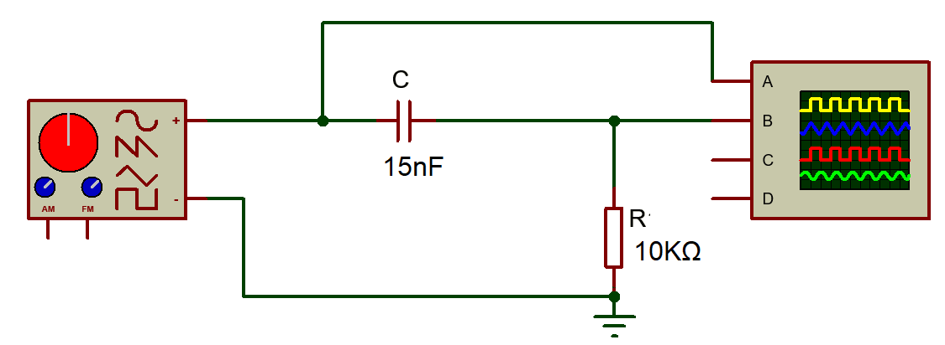
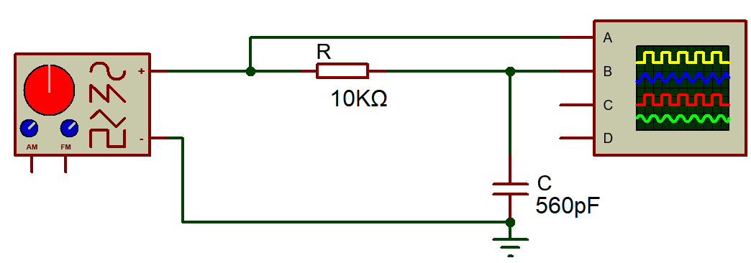

3.1 Simulated circuits
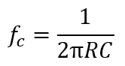
For each circuit I will be evaluating the expected cutoff frequencies, which is the frequency at which the power of the signal falls to half of its maximum value, or the voltage/current amplitude falls to 70.7% of its maximum value. This will be found using the formula . The circuits will be set up to have a 4v input voltage, this value will not change for the whole experiment.

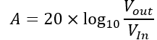
For the low-pass filter, the resistor will have a value of 10k ohms, the capacitor will have a value of 560pF, the frequency will be adjusted from 100hz to 300,000hz, taking closer readings around the expected cut off frequency value and the output voltage will be recorded at each measured frequency using these results I will be able to calculate the attenuation using the formula

For the high-pass filter, the resistor will have a value of 10k ohms, the capacitor will have a value of 15nF, the frequency will be adjusted from 100hz to 300,000hz, taking closer readings around the expected cut off frequency value and the output voltage will be recorded at each frequency, with these results I will be able to calculate the attenuation.

Once the graphs of both the high-pass and low-pass filter are plotted I will use them to find the cutoff frequency from the simulated results.

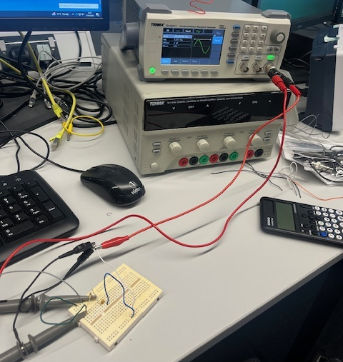
3.2 Experimental circuits
Figure 3: oscilloscope
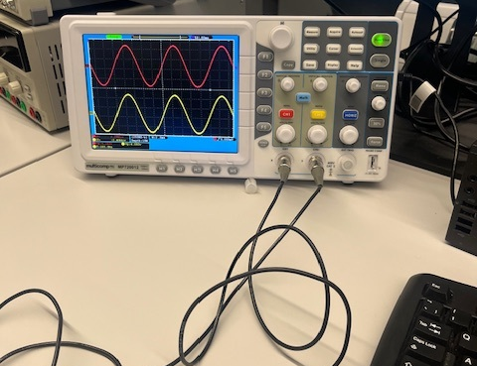
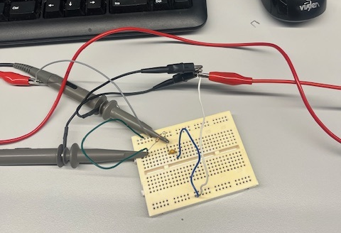
Figure 2: signal generator
Figure 1: breadboard circuit

Figure 1 shows the setup of the Low-pass filter circuit on the breadboard, the resistor and capacitor are connected in series and have been grounded. The output voltage is taken across the capacitor.
Figure 2 shows the signal generator producing a sine wave for both input and output voltage, it is connected to the circuit through two wires, the signal generator is used to measure the peak-to-peak voltage.
Figure 3 shows the breadboard connected to the oscilloscope which will be used to change the input frequency of the circuit. In this experiment the input voltage will remain constant and with the results gathered the cut off frequency and the attenuation can be calculated.

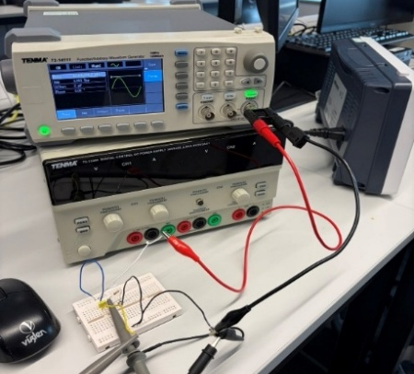
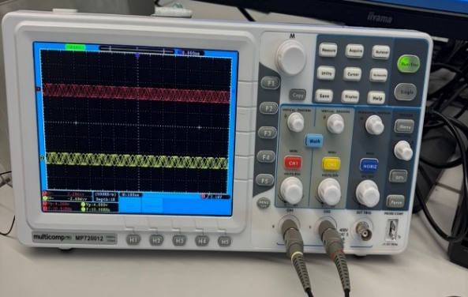

Figure 5: breadboard circuit and oscilloscope
Figure 4: signal generator
Figure 5 shows the setup of the high-pass filter on the breadboard, the capacitor is in series with the input voltage with the resistor connected to the ground, the output voltage is taken across the resistor. The oscilloscope in figure 5 is used to change the input frequency.
Figure 4 shows how the breadboard is connected to the signal generator, this produces a sine wave for both the input and output voltage, with this the peak-to-peak voltage (amplitude) can be measured. With these results the experimental cut-off frequency can be determined along with the attenuation.
- Results
  - low-pass filter
A graph to show frequency (Hz) against attenuation (dB)

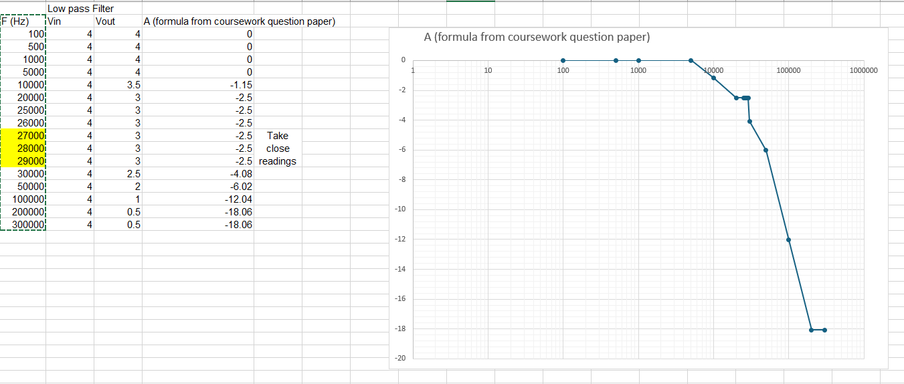
Frequency (Hz)

Attenuation (dB)

Figure 4 – theoretical results and graph
Figure 6: low pass filter simulated results
These results in figure 6 were taken using proteus software, which can’t take closer readings around the cut off frequency, the intervals were only in 1000s, this leads to a discrepancy in the graph as the points close to the cut off frequency weren’t plotted making the line not show where the cut off frequency is. The above graph is a log graph showing attenuation (y-axis) against frequency (x-axis) for the simulated results. With this graph the cut off frequency at the -3dB point and the half amplitude point can be determined.
Theoretical cutoff frequency = 28,400Hz = 28.4kHz
Simulated cut off frequency = 30,000 Hz = 30kHz
Half amplitude point = 1.25V
A graph to show frequency (Hz) against attenuation (dB)

Frequency (Hz)

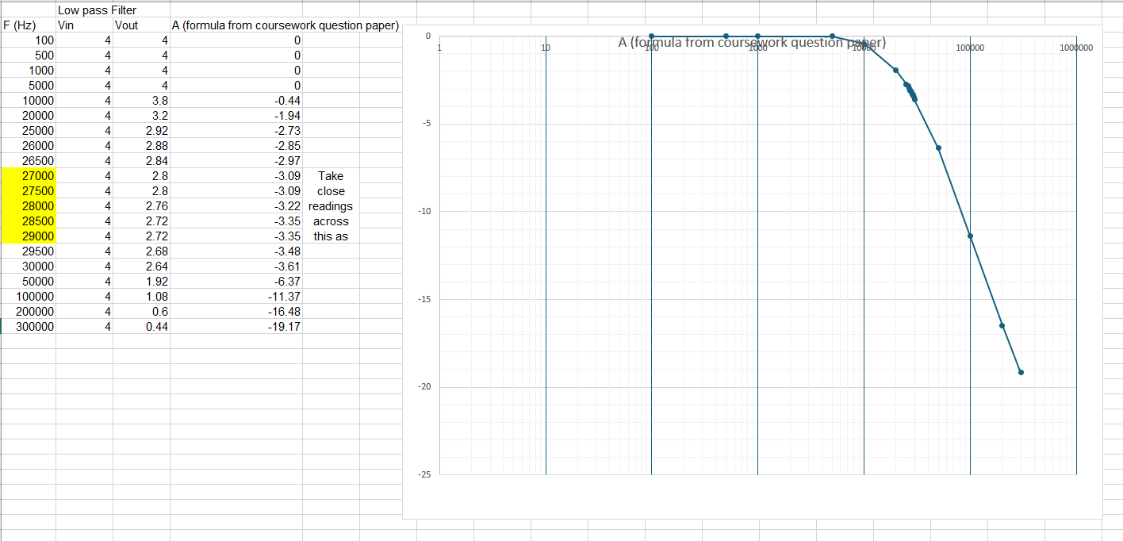

Attenuation (dB)

Figure 5 – experimental results and graph
Experimental cutoff frequency =
Half amplitude point =
  - high-pass filter

Figure 7: low pass filter experimental results
Figure 7 shows the experimental results for the low-pass filter. The above graph is a log graph showing attenuation (y-axis) against frequency (x-axis) for the experimental results. With this graph the cut off frequency at the -3dB point and the half amplitude point can be determined.
Experimental cut off frequency = 26,500Hz = 26.5kHz
Half amplitude point = 1.42V
4.2 high-pass filter
A graph to show frequency (Hz) against attenuation (dB)

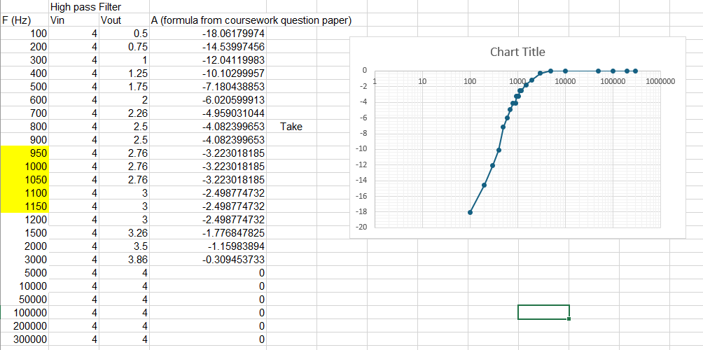
Frequency (Hz)

Attenuation (dB)

Figure 8
Figure 8: high pass filter simulated results

Figure 8 shows the simulated results for the high-pass filter. The above graph is a log graph showing attenuation (y-axis) against frequency (x-axis) for the simulated results. With this graph the cut off frequency at the -3dB point and the half amplitude point can be determined.

Theoretical cut off frequency = 1,060Hz = 1.06kHz
Simulated cut off frequency = 1,050Hz = 1.05kHz
Half amplitude point = 1.38V
A graph to show frequency (Hz) against attenuation (dB)
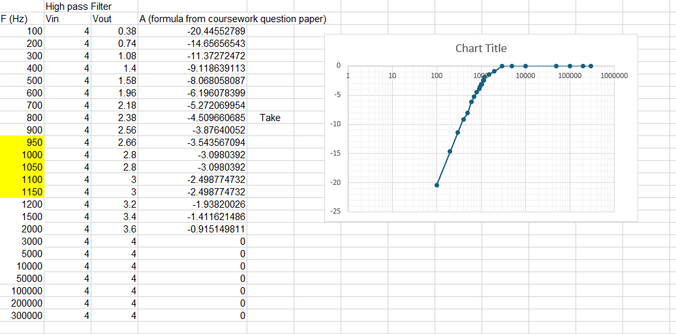
Attenuation (dB)

Frequency (Hz)

Figure 9
Figure 9 shows the experimental results for the high-pass filter. The above graph is a log graph showing attenuation (y-axis) against frequency (x-axis) for the experimental results. With this graph the cut off frequency at the -3dB point and the half amplitude point can be determined.
Experimental cut off frequency = 1,050Hz = 1.05kHz
Half amplitude point = 1.4V

- Discussion
  - Low-pass filter
The results obtained for the low-pass filter showed in figure 6 and 7 produced the expected frequency and attenuation behavior. At low frequencies, the output voltage remains close to the input voltage, which gives a low amount of attenuation (approximately 0 dB). This confirms that the filter allows low-frequency signals to pass through with little to no reduction, which is characteristic of a low-pass filter.

As frequency increases, attenuation rises gradually until a drop is observed at the cut-off frequency. The theoretical cut-off frequency was calculated as 28.4 kHz, while the simulated value was approximately 30 kHz and the experimental value was 26.5 kHz. These values are reasonably close, which shows a good agreement between theory, simulation, and practical results. The range in the values can be put down to the steps the frequency can be increased by for the simulated value, and for the experimental value it can be attributed to the tolerances of the components.

The -3 dB point (cut-off frequency), links to the half-power point of the signal. This is shown in the measured half-amplitude values of 1.25 V (simulated) and 1.42 V (experimental), which are similar. The difference is likely due to the tolerance of the experimental equipment.

At higher frequencies, the attenuation increases rapidly, which shows the filter’s effectiveness in reducing high-frequency signals. At low frequencies the capacitor is at a high value of reactance, so the signal is put through the resistor then to the output which allows the frequencies to pass through with little to no attenuation. At high frequencies the capacitors reactance is low which will cause the output voltage to drop and the attenuation to increase.

Overall, the results gathered agree with the theoretical behavior of a low-pass filter. The close agreement between theoretical, simulated, and experimental cut-off frequencies shows that the setup and result taking were successful. Any differences in the results can be put down to equipment and component tolerances.

  - High-pass filter
The results produced for the high-pass filter shown in figure 8 and 9 show similarities to theoretical expectations. At low frequencies, the output voltage has high attenuation, which shows that the filter effectively blocks low-frequency signals. As the frequency increases, the attenuation decreases until it reaches zero, and the output voltage rises until it reaches the input voltage, showing that higher-frequency signals can pass through the filter.

The cut-off frequency, at the -3 dB point, was calculated theoretically to be 1.06 kHz. Both the simulated and experimental cut-off frequencies were found to be approximately 1.05 kHz. These values being close to each other shows a high level of accuracy in both the design of the filter and the result gathering. Unlike the low-pass filter results, the range is minimal, suggesting that component tolerances and measurement uncertainties had little to no effect.

At the cut-off frequency, the output voltage is linked to the half amplitude point of the wave form. This is shown in the measured half amplitude points of 1.38V (simulated) and 1.4V (experimental). With these results being similar and close to what the theoretical value is it can be said that both experiments were run accurately.

As frequency continues to increase beyond the cut-off point, the attenuation drops to 0 dB, which means the output voltage will have the same value as the input voltage. This shows that the filter allows high-frequency signals to pass with minimal loss. At low frequencies, the capacitor has a high reactance which will block most of the signal getting to the output, this results in a high attenuation value. At high frequencies the high-pass filters capacitors reactance becomes low which allows the signal to pass easily, which is why high frequency signals pass with low to no attenuation.

The small differences between the theoretical, simulated, and experimental results can be put down to variations in resistor and capacitor values. However, these effects are minimal and do not significantly impact the overall performance.

Overall, the high-pass filter results closely match theoretical values, with close agreement across all sets of data. This confirms that the filter has been designed well and results accurately taken, and that it performs as expected in allowing high-frequency signals to pass while attenuating low-frequency waves.

- Conclusion
In this experiment, it has been determined that the low-pass filter demonstrated the relationship between input frequency, cut-off frequency, attenuation, and the half-amplitude point. For the low-pass filter, the theoretical cut-off frequency was calculated as 28.4 kHz, the simulated result was slightly higher at 30 kHz and the experimental cut-off frequency was measured at 26.5 kHz, showing a small variation in results.
Similarly, the high-pass filter results show the opposite behavior, where low frequencies are attenuated and higher frequencies pass through. For the high-pass filter, the theoretical cut-off frequency was calculated as 1.06kHz, both the simulated and experimental cut-off frequency were found to be 1.06kHz. These results being similar confirms the accuracy of the simulated and experimental tests.
Overall, both filters show behavior that aligns with the expected theoretical results, with some minor discrepancies between theoretical, simulated, and experimental values. These differences can be put down to variations in components and limited measurement resolution.

- References

[1]
RayMing, “Low Pass Filter: Types, Applications, and Design Guide [2025] - RayPCB,” RayPCB, May 08, 2025. https://www.raypcb.com/low-pass-filter/
[2]
“High Pass vs Low Pass Filters: Understanding Differences & Applications - Audiophiles,” Audiophiles, 2025. https://audiophiles.co/high-pass-vs-low-pass-filter/

