UWTSD
University of Wales Trinity Saint David
Master of Business Administration
Human Capital Management (LCMB7023)
Designing a Human Capital Architecture for Strategic Renewal:
The Case of Helios Urban Mobility
Assessment Component 1: Individual Report

Student Name: Vedant Mukeshkumar Pandya
Student ID: 2541366

Programme: Master of Business Administration
Module: Human Capital Management (LCMB7023)

Lecturer: Gladius Kulothungan / Eno Maycock
Word Count: 2,630 words
Submission Date: 16 July 2026

Table of Contents
Table of Contents 3
Executive Summary 4
1. Introduction 5
2. Task A: Socialisation, Identity and Business Activism 5
2.1 Traditional Onboarding versus Strategic Organisational Socialisation 5
2.2 Proposed Socialisation Framework for Helios 7
2.3 Cultivating Identification, Ethical Professionalism and the Business Activist Mindset 8
3. Task B: Job Design 9
3.1 Job Design Strategy: JCM, Job Crafting and Skills-Based Architecture 9
3.2 Stimulating Intrinsic Motivation and Innovation 11
4. Task C: Reflective Report 12
4.1 AI as a Decision-Support Tool without Eroding Human Judgement 12
4.2 Personal Capability Development Plan 13
5. Conclusion 14
Reference 15
Appendix A: Human Capital KPI Scorecard 17

Executive Summary
The report is written as an external Strategic Human Capital Advisor to the Board of Helios Urban Mobility (HUM), a 450-person smart-transport start-up based in Europe, with offices in London, Berlin and Singapore. After five years of rapid growth, HUM's human capital infrastructure has not scaled along with HUM's size, resulting in three measurable symptoms: 8 months to ramp-up a new employee; HUM's employee engagement is 54% and disproportionate employee attrition among high-potential graduates. Unless action is taken to address these indicators, HUM's capacity to fulfill client-facing AI infrastructure contracts that rely on stable, skilled teams is at risk.
This report recommends an integrated evidence-based human capital architecture in three spaces, all of which are directly addressing HUM's base metrics. Critically drawing on the socialisation typology of Van Maanen and Schein (1979) and the psychological contract theory of Rousseau (1989), Task A proposes a three-stage framework for organizational socialisation: pre-boarding, first 90 days and year one, along with socialisation mechanisms that foster organizational identification and a mindset aligned with a 'business activist' HR perspective in alignment with Ulrich's (2024) HR business partner model. Task B: Job Design Strategy combines the Job Characteristics Model (Hackman and Oldham, 1976), job crafting theory (Wrzesniewski and Dutton, 2001) and a skills-based internal talent marketplace, to foster intrinsic motivation and innovation, with a critical awareness of acknowledged limitations in each model. In Task C, we consider how AI can be used as a decision support tool in HR practice, but not replace human judgment; identify a human-in-the-loop governance flow; and develop a personal capability development plan.
When put into action, these recommendations aim to cut ramp-up time from eight to about three months, raise engagement to a 72% target, and significantly enhance graduate retention.
.

1. Introduction
Helios Urban Mobility (HUM) is a company that creates systems and smart infrastructure analytics for city governments powered by artificial intelligence. It has grown faster than it can build its human capital capacity, resulting in three related issues that are revealed in its rapid three-year expansion to 450 staff in 3 geographies: slow newcomer integration, drop in engagement and graduate attrition. These are not individual HR issues, but rather a structural mismatch arising from the challenge of a growing, multi-site organisation and an informal people approach driven by the entrepreneur. This report tackles the mismatch in three ways. Task A involves designing a socialisation system to help new people become committed organisational citizens. Task B offers a job design approach to maintain motivation and innovation after embedding. Task C is about the advisor's use of AI as a decision support tool and outlines a personal capability Development Plan. Recommendations are based on well-established principles of organizational behavior and literature which mostly comes from after 2024, and have been adapted specifically to HUM's scale, sector and multi-site structure throughout.

2. Task A: Socialisation, Identity and Business Activism

2.1 Traditional Onboarding versus Strategic Organisational Socialisation
Traditional onboarding sees new employee integration as a paperwork task: systems access, paperwork and a compliance induction focused in the first week. Organisational socialisation theory, on the other hand, sees integration as an ongoing social and psychological journey that the outsider embarks on to learn the facts, skills, and values that will make him or her an insider (Van Maanen and Schein, 1979). Van Maanen and Schein's tactics framework compares and contrasts other dimensions such as formal versus informal, and sequential versus random and serial versus disjunctive socialisation, stating that institutionalised (Formal, sequential, serial) tactics help in quicker identification and role clarity, whereas individualised tactics (informal, random, disjunctive) create more innovative, but less predictable outcomes. The process of a newcomer's role construction takes place during an eight-month period in HUM, which corresponds to a process in which role understanding is developed mostly disjointedly and informally, and in which the newcomer teaches his role to himself, with only limited support from the organization, a pattern that recent meta-analytic evidence directly correlates with lower role clarity and slower adjustment (Bauer et al., 2025a).
This is an explanatory layer provided by psychological contract theory. The psychological contract is a person's expectations of reciprocal relationships with their employer, with lower commitment and engagement levels when early experiences do not meet the expectations of implicit promises (e.g., a graduate who has expectations of mentorship, but receives none). (Rousseau 1989). Newcomer psychological contract breach is significantly mitigated if the employer explicitly invests in these newcomers' technology skills and role-related skills during the process of induction (Bauer et al., 2025b). For HUM, with a high concentration of graduate attrition from high-potential hires, this indicates that the ramp-up issue is more a broken promise issue than it is a training design issue. Building on this, identity construction theory suggests that newcomers don't just learn tasks but construct a professional identity through sense-making processes with peers and managers, which is what stops when interactions are lacking, such as in a fast-growing, informally organized start-up (Bauer et al., 2025b).
The Van Maanen and Schein (1979) model has its shortcomings, and an HUM critical discussion should not simply accept the model as "true" but admit its limitations. The typology was designed for large, relatively stable bureaucracies and its premise that institutionalised tactics are always superior is uncomfortable for a start-up of 450 people exists partly because of agility and 'collaborating outside the box'. The danger of socialisation becoming overly formal is the risk that it becomes yet another sign of rigidity that HUM has avoided so far. The recommendation below is therefore intentionally a mix of formal and serial elements, where evidence suggests it helps address HUM's specific gaps (role clarity, identification), and informal and individualised elements (self-selected involvement in projects, innovation, adaptability) where they are more important than conforming to conventional representations and structures.

The change needed at HUM is summarised below:
.
Dimension | Traditional Onboarding (current HUM state) | Strategic Organisational Socialisation (proposed)
Time horizon | First week only | Pre-boarding through Year One
Tactics (Van Maanen & Schein, 1979) | Disjunctive, informal, random | Serial, formal, sequential
Primary focus | Compliance and systems access | Role clarity, identity and psychological contract fulfilment
Ownership | HR administration | Line manager, buddy network and HR business partner
Table 1: Traditional onboarding versus strategic organisational socialisation at HUM

2.2 Proposed Socialisation Framework for Helios
It makes sense to have a formal, serial and sequential framework over an individualised approach to the newcomer experience, as a formal approach will standardise the experience for newcomers across London, Berlin and Singapore, and it will directly address role clarity and role identification failures that underpin the 8-month ramp up (Bauer et al., 2025a). The framework breaks down the ramp-up into 3 distinct, overlapping phases as seen in Figure 1.
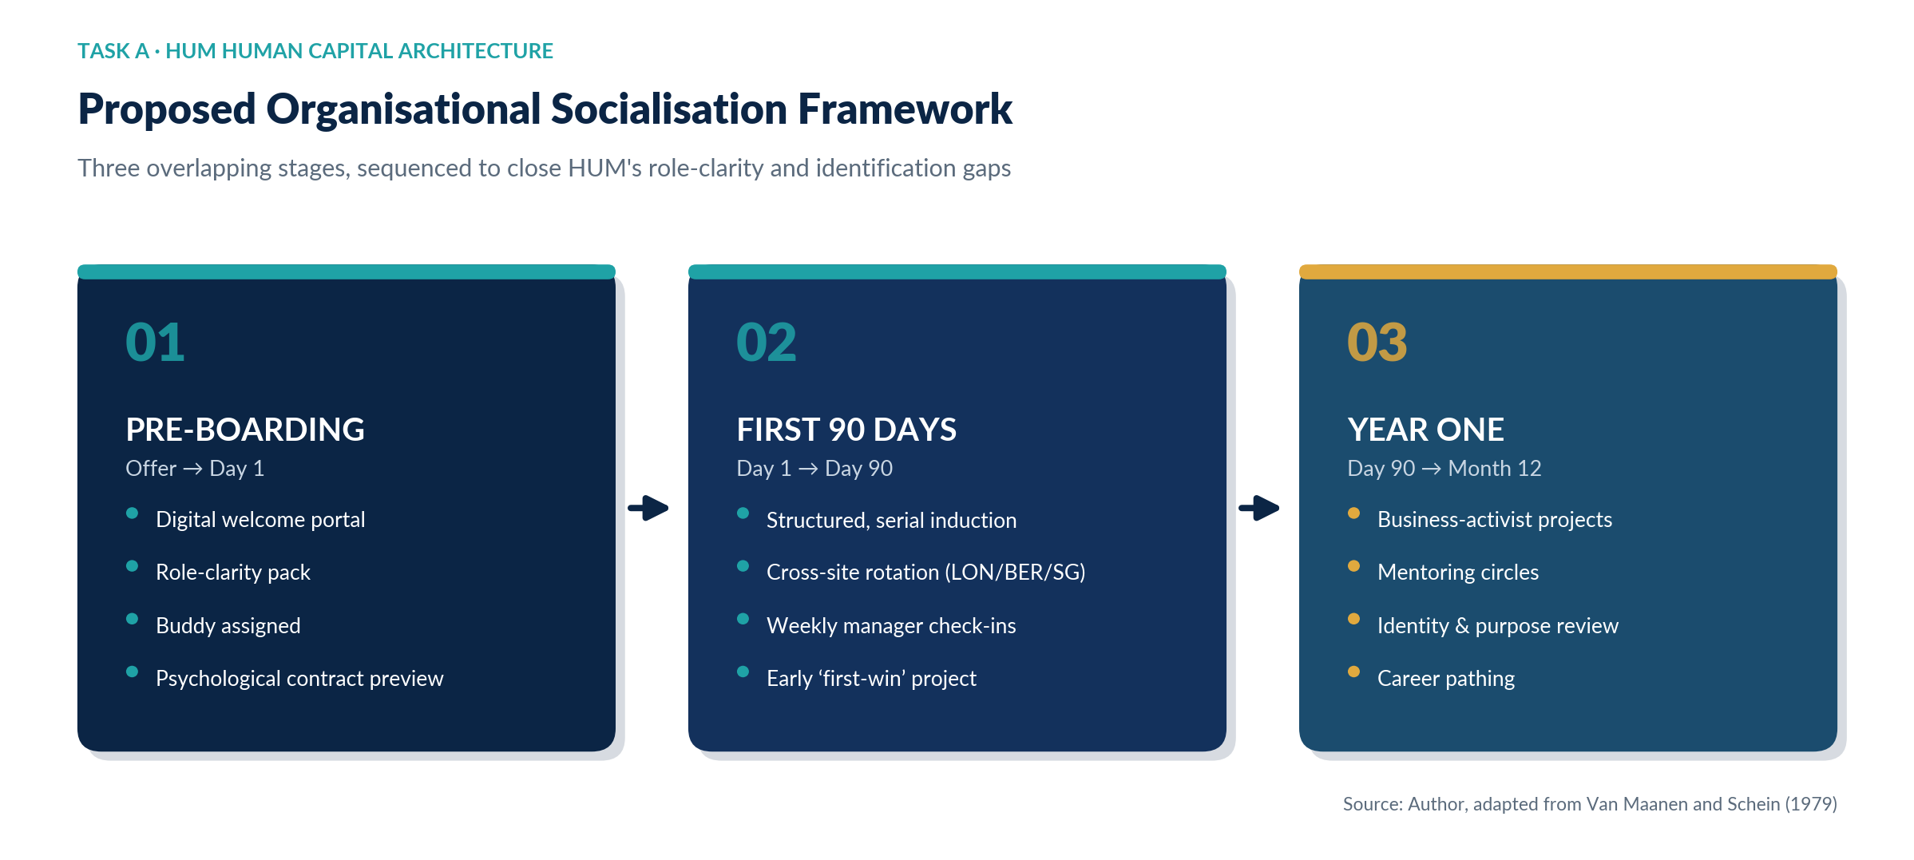
Figure 1: Proposed three-stage organisational socialisation framework for HUM
Pre-boarding starts as soon as the offer is accepted and helps to eliminate uncertainty before day one through a digital welcome portal, a role-clarity pack and a peer buddy, which are the concerns identified by Bauer et al. (2025b) as related to delayed adjustment. The first 90 days are a blend of structured, serial induction and a brief cross-site placement where new employees are introduced to HUM's London, Berlin and Singapore teams, regular team manager check-ins, and an early and visible ‘first win' project which establishes task identity before formal performance review. Early compliance becomes long-term commitment in year one, with the transfer of ownership to the new kid on the block via business-activist projects, mentoring circles and a formal identity-and-purpose review. This makes sense because most of the psychological contract breach is likely to happen during the highest uncertainty period (pre-boarding until day 90) and a year of identification time is needed to stabilise the psychological contract (Van Maanen and Schein, 1979).

2.3 Cultivating Identification, Ethical Professionalism and the Business Activist Mindset
Organisational identification, that is, employees identifying themselves as members of HUM, is fostered by the serial mentoring within the framework and the cross-site rotation, which introduce employees to role models who represent valued behaviour (Van Maanen and Schein, 1979). Embedding HUM's standards on data-governance and AI-ethics into the 90-day induction, a measure more relevant to its business of smart-infrastructure analytics, rather than ethics being a compliance afterthought, reinforces ethical professionalism.
The 'business activist' mindset is based on the ‘value of HR' is no longer limited to internal stakeholders, but extended to external stakeholders, customers, investors, and communities and that HR professionals are not only ‘business administrators', but also ‘credible activists' who are ready to challenge the business, not just administer it' (Ulrich, 2024). If applied to the line managers and HUM's senior graduates, this would entail that the Year One projects would have to explicitly link a people decision (e.g. a rostering or rotation change) to an external stakeholder decision (e.g. city-partner satisfaction or sustainability measures) in line with the stakeholder capitalism perspective underpinning the 2024 update of the model as provided by Ulrich. This takes a fresh approach to onboarding new workers as active participants in HUM's stakeholder value proposition, rather than recipients of culture.
This recommendation should be taken with a pinch of salt, however. The competency, ‘credible activist', has been branded conceptually elastic by the author of the model himself, as it is much easier to name than to operationalise as a measurable behaviour, and ‘activism' can be interpreted very differently in the context of a Berlin works-council than in the context of a management team in London or Singapore, and there is indeed a genuine cross-jurisdictional tension here that the model does not resolve. The tension or conflict of looking at the delivery of the advice and being an advisor versus the expectation that a Board has of objectivity for the external advisor is also an implicit conflict, and the recommendations in this report are therefore presented as testable propositions, with the KPI scorecard in Appendix A linking them.

3. Task B: Job Design

3.1 Job Design Strategy: JCM, Job Crafting and Skills-Based Architecture
According to Job Characteristics Model (JCM) by Hackman and Oldham (1976), high internal work motivation resulting from certain jobs involves three psychological states: experienced meaningfulness, experienced responsibility, and knowledge of results. Currently, at HUM, jobs related to engineering and analytics are very narrowly focused on one mobility product, reducing skill variation and task identity. The first is to reframe key roles for end-to-end problem ownership, such as an analytics engineer who is responsible for the whole dashboard that is presented to a client for a city-partner instead of just a single stage of a pipeline, directly increasing task identity, significance and autonomy.
The second is job crafting, the informal redesigning of the boundaries of one's own job by the employee in their own job through task crafting (changing scope), relational crafting (changing interactions) and cognitive crafting (reframing meaning of the job) (Wrzesniewski and Dutton, 2001). Crafting should not be seen as an uncontrolled variation, but a low-intensity quarterly 'craft review' between employee and manager, which recent evidence from the hospitality sector finds to be linked to increased work engagement, task performance and perceived employability (Nergiz and Unsal-Akbiyik, 2024). The flat, fast-moving culture of HUM is an advantage to this, since it allows employees to use discretion in their day-to-day work, which can be structured by the manager and measured.
The third is a skills-based architecture backed by an internal talent marketplace that pairs employees with temporary projects and rotations according to their skills, not their job title. Research from the industry indicates that businesses that have a well-developed internal mobility program experience significantly improved employee engagement when employees see internal career opportunities, and internal redeployment can also lead to significant cost and time savings over external hiring (Deloitte, 2025; LinkedIn, 2024). Because a significant amount of fundamental competencies in the workforce are expected to shift by the end of the decade, according to the World Economic Forum (2025), a skills taxonomy also future-proofs HUM against the fast pace of technological changes that are now a part of AI mobility systems. These three are combined in Figure 2.
.
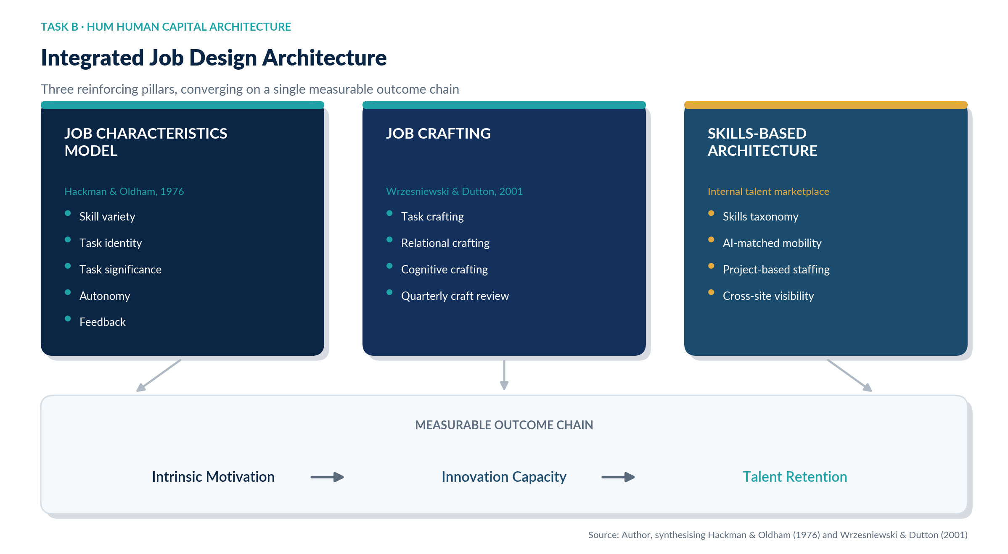
Figure 2: Integrated job design architecture linking JCM, job crafting and skills-based structures to organisational outcomes
The JCM, however, should be used with care and not as a fixed or rigid formula. Based on a review of a century of growth need strength research, Parker, Morgeson and Johns (2017) found weak empirical support for growth need strength as a moderator, and for some of the proposed mediating mechanisms of the model, the support is inconsistent; consistency is found only for the psychological state of meaningfulness. More recently, Hackman and Oldham (1976) concede that in practice, there is a very high correlation between core characteristics such as skill variety and autonomy, and that the model cannot be assumed to work equally across its three sites, but should be validated against real engagement data when redesigning a role.

3.2 Stimulating Intrinsic Motivation and Innovation
These are not stand-alone interventions, but are all interwoven. JCM raises the ceilings on meaningful autonomy available in a role, whereas static job redesigns tend to decrease in effect over time as roles change with the marketplace (Wrzesniewski and Dutton, 2001); and the skills-based workplace ensures that as an employee acquires new skills and capabilities through JCM, it is not lost to attrition but rather can be transferred to another role within HUM. It hits at the two most cited reasons that cause high attrition amongst graduates: limited perceived growth and limited voice over how work is done (365talents, 2025; Radancy, 2025). Also, as hidden internal skills are surfaced by a marketplace for the purposes of innovation in HUM's core business, the use of AI-enabled infrastructure analytics, it is not just a retention tool but it is directly innovation-enhancing, as well.
However, one important caveat is in order. Even industry data admits that talent marketplaces often fail to reach their full potential during poor visibility and when managers are incentivized to keep (not let go) high performers in their own talent pools (365talents, 2025). Additionally, there is the potential, even if not promoted in the promotional rhetoric about skills-based organisations, that on an ongoing basis the internal 'digitation' of jobs subtly undermines the very task identity and role stability that the socialisation framework outlined in Task A aims to establish, especially for newly graduated young people who are still in the process of developing their professional identity within their first year of employment. HUM should therefore not allow first year employees to be constantly re-assigned to it, but allow it to be ring fenced to Year Two and beyond, when socialisation and initial role stability (Section 2.2) are achieved.

4. Task C: Reflective Report

4.1 AI as a Decision-Support Tool without Eroding Human Judgement
In preparing this report I used generative AI, within the boundaries explicitly permitted by the assessment specification, only for proofreading. This is echoed by the broader risk identified in this report for HUM: a lack of critical evaluation and empathy is a consistent danger associated with the use of AI-generated outputs as fact rather than advice particularly in decisions that are consequential, such as promotion or attrition risk (Taslim, Rosnani and Fauzan, 2025). Meanwhile, HR professionals are also seeing AI as a way to increase, not diminish, the importance of human judgment if it is used intentionally and intentionally contained (SHRM, 2025).
My working principle, and the one I recommend HUM adopt for handling people decisions, is that AI can produce options, identify trends in the data, and draft first-cut structures; however, a named human should always have the final say regarding interpretation of context, considerations of fairness, and the ultimate decision, as is found in hybrid decision-making processes where algorithmic recommendations are coupled with required human sign-off (Taslim, Rosnani and Fauzan, 2025). Figure 5 identifies the four-step governance flow that I recommend that HUM formalise for any people decision with the assistance of AI.
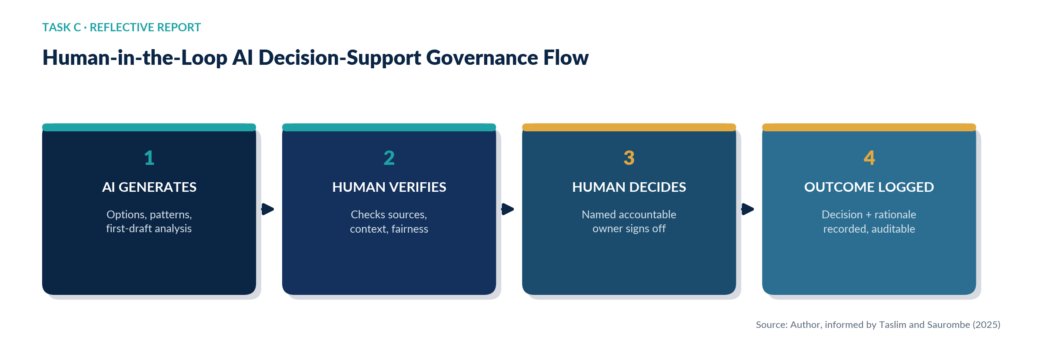
Figure 5: Human-in-the-loop AI decision-support governance flow recommended for HUM HR practice
Concretely, I researched, structured and wrote the report myself, and used generative AI solely to check my own text for grammatical and syntactical errors, accepting or rejecting each suggested correction on my own judgement rather than allowing the tool to alter the substance, which is the same discipline HUM's HR team should apply before acting on any AI-generated workforce recommendation.

4.2 Personal Capability Development Plan
To remain employable as HR and general management practice becomes more AI-augmented, I have identified four priority capabilities and concrete development actions, summarised in Table 2.
Capability | Why it matters | Development action
Data literacy | HR decisions increasingly rest on workforce analytics and AI outputs I must be able to interrogate, not just accept | Complete an applied people-analytics short course; practise interpreting engagement and attrition datasets
AI augmentation in HR | Three-quarters of HR professionals expect AI to raise the value of human judgement, provided it is used deliberately (SHRM, 2025) | Build a personal checklist for verifying AI-assisted HR recommendations before acting on them
Strategic influencing | Credible activism requires influencing senior stakeholders, not just administering policy (Ulrich, 2024) | Seek stretch opportunities to present workforce recommendations directly to non-HR leaders
Global mobility awareness | Multi-site organisations like HUM require sensitivity to cross-jurisdictional employment and cultural norms | Undertake a short cross-cultural management module and seek exposure to at least one non-domestic HR project
Table 2: Personal capability development plan

5. Conclusion
The issues HUM face with onboarding, engagement, and retention have a common cause they are problems with their people architecture that have not grown with their headcount and geographic expansion. The three-stage socialisation process suggested in Task A addresses the three main issues raised: the psychological contract gap resulting from informal and disjunctive onboarding; the three-stage ramp-up period, and graduate attrition. The integrated job design strategy in Task B maintains the motivation that socialisation has initiated, with the structural redesign based on the Job Characteristics Model and the employee-led redesign based on Job Crafting and an internal skills-based marketplace, in order to develop the capacity for organisational innovation. Task C's reflection highlights a theme that permeates the entire report: AI can broaden HUM's analytical capabilities, but only with the proper “red flag” of human accountability in making decisions that impact careers.
But for a truly critical reading of this report, two tensions must be held, not solved, in mind. First, formalising socialisation and job structure can come at the cost of losing the informal agility that has helped HUM stay competitive thus far so far, and so each individual recommendation above is bounded and time-limited, or ring-fenced (the higher level of uncertainty, the sooner it is bound, and pre-90-day was the point at which the talent marketplace was withheld, until Year Two). Second, each of the models underpinning the report Van Maanen's models of socialisation tactics, the Job Characteristics Model, and Ulrich's models of business-activist competencies has known empirical and/or conceptual limitations; the merit in this report is not to argue that one of them is correct, but rather to triangulate across the models and test the resulting design against the KPI scorecard (Appendix A) and to build evidence around them. The recommendations are implemented and monitored on this basis, and provide HUM with a coherent and testable trajectory from the informal architecture of the present to one which will enable sustainable, stakeholder-focused growth through the use of this system of recommendations.

Reference
365talents (2025) Your Ultimate Guide to Skills-Based Organizations. Available at: https://365talents.com/en/resources/guide-how-skills-based-organizations-will-thrive-in-2024/ (Accessed: 2 July 2026).
Bauer, T.N., Erdogan, B., Ellis, A.M., Truxillo, D.M., Brady, G.M. and Bodner, T. (2025a) 'New horizons for newcomer organizational socialization: a review, meta-analysis, and future research directions', Journal of Management. doi: 10.1177/01492063241277168.
Bauer, T.N., Erdogan, B., et al. (2025b) 'The evolving future of work: implications for newcomer adaptability and connectivity during organizational socialization', Human Resource Management. doi: 10.1002/hrm.70008.
Deloitte (2025) 2025 Global Human Capital Trends: Turning Tensions into Triumphs. Deloitte Insights. Available at: https://www.deloitte.com/us/en/insights/topics/talent/human-capital-trends/2025.html (Accessed: 12 July 2026).
Frögéli, E., Jenner, B., Gustavsson, P., Bongomin, F. and Wut, T.M. (2023) 'Effectiveness of formal onboarding for facilitating organizational socialization: a systematic review', PLOS ONE. doi: 10.1371/journal.pone.0281823.
Hackman, J.R. and Oldham, G.R. (1976) 'Motivation through the design of work: test of a theory', Organizational Behavior and Human Performance, 16(2), pp. 250–279. doi: 10.1016/0030-5073(76)90016-7.
LinkedIn (2024) 2024 Workplace Learning Report. Sunnyvale, CA: LinkedIn Learning. Available at: https://learning.linkedin.com/resources/workplace-learning-report-2024 (Accessed: 7 July 2026).
Nergiz, H.G. and Unsal-Akbiyik, B.S. (2024) 'Job crafting, task performance, and employability: the role of work engagement', SAGE Open. doi: 10.1177/21582440241271125.
Parker, S.K., Morgeson, F.P. and Johns, G. (2017) 'One hundred years of work design research: looking back and looking forward', Journal of Applied Psychology, 102(3), pp. 403–420. doi: 10.1037/apl0000106.
Radancy (2025) From Myth to Reality: How Talent Marketplaces Accelerate Internal Mobility and Smarter Hiring. Available at: https://blog.radancy.com/2025/12/05/from-myth-to-reality-how-talent-marketplaces-accelerate-internal-mobility-and-smarter-hiring/ (Accessed: 9 July 2026).
Rousseau, D.M. (1989) 'Psychological and implied contracts in organizations', Employee Responsibilities and Rights Journal, 2(2), pp. 121–139. doi: 10.1007/BF01384942.
SHRM (2025) 2025 Talent Trends: Artificial Intelligence in HR. Alexandria, VA: Society for Human Resource Management. Available at: https://www.shrm.org/topics-tools/research/2025-talent-trends/ai-in-hr (Accessed: 8 July 2026).
Taslim, W.S., Rosnani, T. and Fauzan, R. (2025) 'Employee involvement in AI-driven HR decision-making: a systematic review', SA Journal of Human Resource Management, 23. doi: 10.4102/sajhrm.v23i0.2856.
Ulrich, D. (1997) Human Resource Champions: The Next Agenda for Adding Value and Delivering Results. Boston, MA: Harvard Business School Press.
Ulrich, D. (2024) 'Update on HR business partner model: continuing evolution and relevance', HR Curator, 19 September. Available at: https://hrcurator.com/2024/09/19/update-on-hr-business-partner-model-continuing-evolution-and-relevance/ (Accessed: 11 July 2026).
Van Maanen, J. and Schein, E.H. (1979) 'Toward a theory of organizational socialization', Research in Organizational Behavior, 1, pp. 209–264.
World Economic Forum (2025) Future of Jobs Report 2025. Geneva: World Economic Forum. Available at: https://www.weforum.org/publications/the-future-of-jobs-report-2025/ (Accessed: 5 July 2026).
Wrzesniewski, A. and Dutton, J.E. (2001) 'Crafting a job: revisioning employees as active crafters of their work', Academy of Management Review, 26(2), pp. 179–201.

Appendix A: Human Capital KPI Scorecard
This appendix presents the baseline metrics stated in the HUM case brief alongside illustrative one-year targets implied by the recommendations in Tasks A and B. Targets are directional planning benchmarks for the Board rather than externally validated forecasts, and should be re-based once HUM's own HRIS data is available.
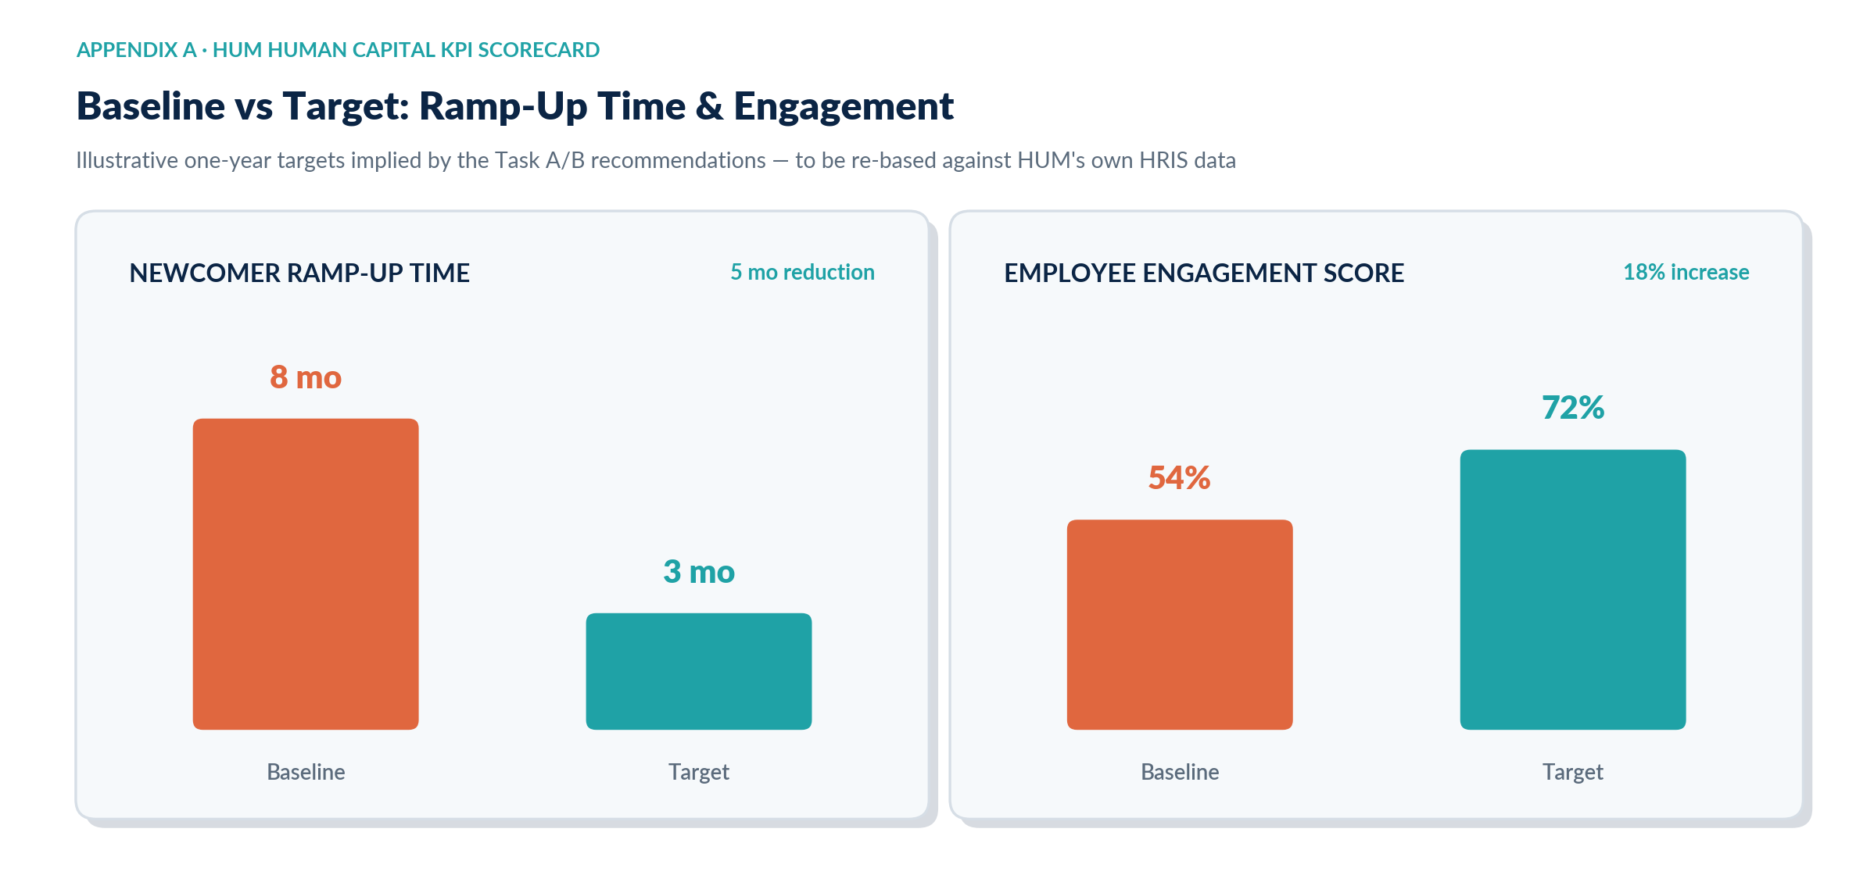
Figure 3: Baseline versus target KPIs for newcomer ramp-up and engagement

Full KPI Scorecard and Primary Levers

KPI | Baseline | Target | Primary Lever
Newcomer ramp-up time | 8 months | ≤ 3 months | Task A Socialisation framework
Employee engagement score | 54% | ≥ 72% | Task A & B Identification + job design
Graduate 12-month retention | Low (qualitative) | ≥ 85% | Task A Psychological contract fulfilment
Internal mobility fill rate | Not tracked | ≥ 30% of vacancies | Task B Skills-based marketplace

