

Student Name: Sultana Akter
Student ID: 2422835

Programme: Master of Business Administration
Module Name & Code: International Marketing: Principles and Practices (LCMB7026)
Assignment Title: Assessment component 1:
Individual report
Lecturer: Tushara Balendran
Word Count: 5500

Contents
Section-1 1
1. INTRODUCTION 1
2. BACKGROUND 2
3. Comparison of the macro environment (PESTLE) of France vs China 3
3.1 PESTEL Definition 3
3.2. PESTEL Analysis 4
4. Comparison of Brand’s STP Strategies in France and the China 12
4.1 Segmentation 12
4.2 Targeting Strategy 13
4.3 Positioning Explanation 13
5. MARKETING MIX (7Ps) 15
5.1 Definition of Marketing Mix 15
5.2 Product 16
5.2.1 Product Width 17
5.2.2 Product Depth 17
5.3 Price 18
5.4 Place (Distribution) 18
5.5 Promotion 19
5.5 People 21
5.6 Process 21
5.6.1 Customer Complaint Process 21
5.7 Physical Evidence 22
6. DIRECTIONAL STRATEGY 23
6.1 Market Development (China Focus) 23
6.2 Marketing Ethical and Unethical Issues. 25
6.3 Balanced Evaluation 25
7. RECOMMENDATIONS (IMPORTANT) 26
Section-2 27
14. REFLECTION Account (GIBBS – 6 STAGES) 27
1. Description 27
2. Feelings 28
3. Evaluation 28
4. Analysis 28
5. Conclusion 29
6.Action Plan 29
2. Growth of Cultural Insight: 30
CONCLUSION 31
REFERENCES 32

List of Figure
Figure 1: Global distribution of Louis Vuitton stores highlighting France (home) and China (international expansion). 2
Figure 2.PESTEL Diagram 4
Figure 3.Hofstede Cultural Dimensions Comparison (France vs China) 7
Figure 4. Perceptual map of luxury brand positioning in the China market (adapted from Kotler et al., 2021; China Luxury Market Report, 2025). 14
Figure 5. The marketing mix framework expanded to seven components 16
Figure 6. Louis Vuitton in France. (adapted from Louis Vuitton, 2025). 16
Figure 7.Louis Vuitton in China(adapted from Louis Vuitton, 2025). 17
Figure 8. Comparative product width of Louis Vuitton in France and China 18
Figure 9. Louis Vuitton direct distribution channels in France and China 19
Figure 10. . AIDA Model within IMC Framework (Louis Vuitton). Adapted from Louis Vuitton promotional practices (2022–2024). 20
Figure 11.Website in France 22
Figure 12.Website of China 23
Figure 13.Ansoff Matrix Diagram 25
Figure 14. Gibbs Reflective Cycle 28

List of Table

Table 1Pricing Comparison Table 18

Section-1

1. INTRODUCTION
Globalisation of luxury brands has enhanced the necessity to embrace effective international marketing practices especially where the markets are culturally and economically diverse. This report is dedicated to one of the most popular luxury fashion brands in the world Louis Vuitton and examines its business in France (domestic market) and China (one of the major markets). This report aims to critically compare the macro-environmental factors affecting the brand based on the PESTEL framework, and then assess the cultural differences based on Hofstede cultural dimensions. It also compares the Segmentation, Targeting and Positioning (STP) strategies of the company, and evaluates how its international marketing mix (7Ps) are adapted in both markets. Moreover, the report examines the directional development strategy of the brand, after which the analysis of the main ethical and unethical problems, and the strategic recommendations to enhance the performance in international marketing are assessed. As the sphere of globalisation expands rapidly and the consumption of luxury items, especially in the emerging markets like China, rises, it is necessary to make alterations in the brand strategies to uphold competitiveness and brand equity (Kapferer and Bastien, 2020; Ko et al., 2021; Deloitte, 2023). The reflective account on the basis of Gibbs Reflective Cycle is also reflected in this report to assess the research process and the learning outcomes that are essential in the course of the assignment, as well as the analytical skills that were developed during the course of the assignment.

2. BACKGROUND
In 1854, Louis Vuitton was started by Louis Vuitton in Paris and initially dealt with the high-quality travel trunks that were fashionable and durable at the same time. As the years progressed, the company diversified to be in the luxury handbag, leather, ready-to-wear fashion, shoes, accessories, and fragrances business and has become one of the most familiar brands in the global luxury business environment. Its adherence to high quality craftsmanship, its design and brand name heritage has helped it to rise up and become a formidable global brand out of a small artisan workshop. (Kapferer and Bastien, 2020; Okonkwo, 2021).
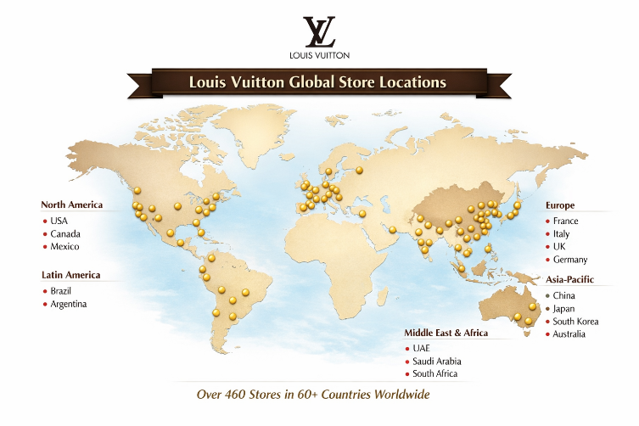
Figure 1: Global distribution of Louis Vuitton stores highlighting France (home) and China (international expansion).
Louis Vuitton mission is based on the provision of high quality luxury products that uphold a level of craftsmanship, creativity and exclusivity whilst its vision is rooted in the retention of its status as an ancient and innovative luxury global brand. The company has managed to spread to foreign markets, especially in China, where the growth prospects are high due to the growing disposable income and the growing demand to consume status-oriented products. (Deloitte, 2023; Bain & Company, 2022).

Louis Vuitton – Mission and Vision
Mission Statement
Louis Vuitton’s mission is to provide customers with the highest quality luxury products that combine exceptional craftsmanship, innovation, and timeless elegance. The brand aims to maintain exclusivity while delivering superior customer experiences that reflect its heritage and commitment to excellence in the global luxury fashion industry (LVMH, 2023; McKinsey & Company, 2024).
Vision Statement
Louis Vuitton’s vision is to remain the world’s leading luxury fashion brand by continuously innovating while preserving its rich heritage and craftsmanship. The company seeks to strengthen its global presence, particularly in high-growth markets such as China, while maintaining its position as a symbol of prestige, sophistication, and modern luxury lifestyle (LVMH, 2023).

3. Comparison of the macro environment (PESTLE) of France vs China

3.1 PESTEL Definition
PESTEL is a strategic analysis technique, which is applied to assess the external Macro-environmental factors of a business like the Political, Economic, Social, the Technological, Environmental and Legal environment (Yuksel, 2021). It assists organisations to know about the opportunities and threats in the international markets as well as facilitating proper strategic decision-making (Johnson et al., 2020).
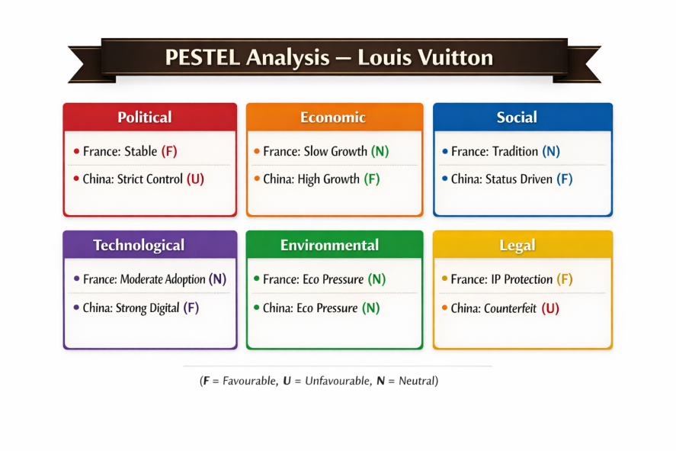
Figure 2.PESTEL Diagram

3.2. PESTEL Analysis
PESTEL analysis is a strategy application in the assessment of Political, Economic, Social, Technological, Environmental and Legal forces influencing business in various markets. It assists organisations such as Louis Vuitton to comprehend external forces and change their international marketing plans to them (Kotler and Keller, 2021; Johnson et al., 2021).
1. Political Factors
France offers a consistent political climate, good institutional backing and established trade platforms, which make it friendly to the operations of luxury. Conversely, China has rigid state policies, import quotas, and a significant state impact on overseas brands, which may restrict the freedom of operation and marketing.(McKinsey & Company, 2024).
France:
- Favourable: Stable democratic system, good institutional support and stable trade regulations is favourable and it will provide luxury brands with a safe business environment (Kotler & Keller, 2021; Johnson et al., 2021).
China:
- Favourable: Government subsidy on luxury consumption in big cities still stimulates the development of the market (McKinsey & Company, 2024).
- Unfavourable: High governmental regulation, tight control of foreign brands and the alteration of policies could restrain marketing freedom and flexibility of operations (Deloitte, 2023; McKinsey & Company, 2024).
2. Economic Factors
The economy of France is fairly stable and yet slow growing, which implies that luxury demand is well developed and steady, but not fast growing. China on the other hand is one of the high growth luxury markets that is fuelled by the increasing income and consumer spending power of the middle classes and is thus very appealing to venture into. (Deloitte, 2023).
France:
- Favourable: Thriving economy provides steady demand of luxury and strong consumer buying power (Kotler & Keller, 2021).
- Unfavourable: Low rate of economic growth constrains the pace of expansion (Johnson et al., 2021).
China:
- Favourable: The positive elements that have a high impact on luxury consumption are rapid economic growth, rising middle class and rising disposable income (Deloitte, 2023; McKinsey & Company, 2024).
3. Social Factors
Both of these countries have a strong impact of social factors on luxury consumption. France is a heritage-based culture of luxury, and the consumers attach importance to the craftsmanship, authenticity, and brand legacy. Conversely, China is trend-sensitive and status-driven, as the use of luxury goods as a symbol of social identity and success.
France:
- Favourable: There is a strong luxury culture, oriented to heritage, craftsmanship, and authenticity, which promotes brand positioning (Kapferer & Bastien, 2020).
- Unfavourable: Consumers are very selective and mass marketing is less effective (Kotler & Keller, 2021).
China:
- Unfavourable: The consumer preferences are unpredictable due to the rapidly changing trends (Ko et al., 2021).
3.1. Cultural Factors
One of the important aspects of international marketing is cultural factors as they affect consumer behaviour, lifestyle and brand perception. In the case of luxury brands, such as Louis Vuitton, segmentation, targeting, and positioning strategies in the international markets require the knowledge of cultural differences between China and France (Hofstede, 2021; Chen and Yang, 2021).
3.1.1 Hofstede Model (Definition)
Hofstede Cultural Dimensions Model the Hofstede Cultural Dimensions Model is a model that was created by Geert Hofstede to examine and compare the differences in culture among different countries. It describes the impact of six cultural dimensions on values within the work place and society. (Hofstede, 2021).
3.1.2 Hofstede Cultural Dimensions Comparison (France vs China)
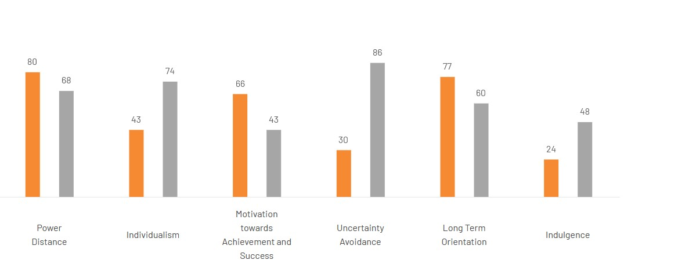
Figure 3.Hofstede Cultural Dimensions Comparison (France vs China)
(Source: Hofstede, 2021; Chen & Yang, 2021)
- Power Distance: France is a low power distance, as people respect equality, independence and less hierarchical relationships within society. Brands that speak in a subtle and balanced manner are more at ease with consumers. (Hofstede, 2021).
- Individualism: France is a very individualistic country and its consumers are concerned with personal identity, self-expression and distinctive choices in lifestyle. Consumption of luxuries is usually motivated by the personal taste and genuineness. (Chen & Yang, 2021).
- Masculinity: France is moderately masculine, with a moderate achievement/quality-of-life and high level of lifestyle and aesthetics. China scores higher on the masculinity dimension with the score emphasizing on success, competition, and achievement.
- Uncertainty Avoidance: France is characterized by high uncertainty avoidance culture, which implies that consumers like to use familiar, developed brands and organize their buying processes. (Hofstede, 2021).
- Long-Term Orientation: China is highly long-term oriented as it is oriented towards future success and savings, and long-term brand value. This promotes long-term high-end luxury consumption and investment in high-end brands.
- Indulgence: The culture of indulgence in France is high, and people have leisure, lifestyle, and personal gratification, so luxury fashion is a way to express themselves. (Hofstede, 2021; McKinsey and Company, 2024).
Generally, France promotes heritage-based, individual luxury consumption and China promotes status-based, socially-driven luxury consumption, which means that Louis Vuitton will need to adjust its marketing strategies.
3.1.3 Louis Vuitton Cultural Implications.
- France consumers focus on authenticity, heritage and craftsmanship. Luxury consumption is non-obtrusive and non-price sensitive.
- Chinese consumers are status conscious, prestigious, and emphasize on visible branding, thus luxury goods are viewed as a sign of social success.
This gap has a bearing on the strategy of the Louis Vuitton, where a stronger branding and online interaction is employed in China than in France.
3.1.4 Culturally Influenced Factors: Favourable / Unfavourable.
France
- Favourable: Good luxury heritage culture, value of craftsmanship (Kapferer & Bastien, 2020).
China
- Unfavourable: Rapid shifts and demand to be constantly innovative (Deloitte, 2023).
3.1.5 Advantages and Disadvantages of Hofstede Model
Advantages
- Advantages
- Helps make comparisons between cultures within nations.
- Applicable in international marketing strategy formulation.
- Aids in segmentation and positioning decisions.
- Provides a well-established scholarly framework for international business analysis (Hofstede, 2021).
Disadvantages
- May generalise complex cultural behaviours and oversimplify differences.
- Based on relatively old datasets, which may not fully reflect modern digital societies.
- Fails to capture cultural differences within countries (intra-cultural variation).
- Limited in explaining fast-changing environments such as the digital economy in China (McSweeney, 2020; Minkov & Kaasa, 2022).
4.Technological Factors
China is very progressive in terms of digital entrepreneurship, Electronic payment solutions, and social media advertising platforms like WeChat and Weibo. This renders online interaction requisite to luxurious brands.. (Zhao, 2021).
France:
- Favourable: Strong infrastructure and established digital retail systems (Kotler & Keller, 2021).
- Unfavourable: Slower adoption of luxury-focused digital innovation compared to Asia (Deloitte, 2023).
China:
- Favourable: Advanced digital ecosystem (WeChat, Alibaba, live-streaming commerce) strongly supports luxury marketing (McKinsey & Company, 2024).
- Unfavourable: High competition in digital space increases marketing costs and pressure (Deloitte, 2023).

5. Environmental Factors
France and China are under pressure, more pressure, on the issue of sustainability and environmental responsibility. The consumers have come to demand luxury brands to be environmentally friendly, sustainable in sourcing and production, and ethical. McKinsey & Company, 2024).
France:
- Favourable: Good infrastructure and developed digital retail systems (Kotler & Keller, 2021).
- Unfavourable: The pace of adoption of luxury-oriented digital innovation is slower than in Asia (Deloitte, 2023).
China:
- Favourable: Developed digital ecosystem (WeChat, Alibaba, live-streaming commerce) is a good supporter of luxury marketing (McKinsey & Company, 2024).
6. Legal Factors
France has good intellectual property regulations that secure luxury branding and design. Conversely, counterfeiting and imitation products in China pose a greater threat to the brands and revenues. Laws and anti-counterfeit measures play a critical role in ensuring brand integrity in China (Liu, 2022).
France:
- Favourable: good intellectual property protection of brand identity and design (Kotler & Keller, 2021).
China:
- Favourable: Enhancing legal environment on foreign investment and brand protection (McKinsey & Company, 2024).
- Unfavourable: Brand equity is under threat by high chances of fake products and imitated brands (Liu, 2022).
Similarities and Differences (France vs China – PESTEL)
Similarities
- Both France and China provide political stability, supporting long-term business operations.
- Both countries have strong economic importance for Louis Vuitton (France = stable demand, China = high growth).
- In both markets, social factors strongly influence luxury consumption behaviour.
- Both have legal systems that regulate and protect business activities, although enforcement levels differ (Deloitte, 2023).
Differences
- France has a liberal and stable political system, while China has high government control and strict regulations.
- France is a mature and stable economy, while China is a fast-growing emerging luxury market.
- France consumers prefer heritage, craftsmanship, and subtle luxury, while China consumers prefer status, visibility, and social recognition.
- China has a more advanced digital and e-commerce ecosystem, while France relies more on traditional luxury retail experiences.

4. Comparison of Brand’s STP Strategies in France and the China

STP (Segmentation, Targeting, and Positioning) is a strategic marketing framework used to identify customer groups, select target markets, and position a brand effectively.

4.1 Segmentation
Demographic Segmentation
In France, segmentation focuses on middle-to-high income consumers, typically older professionals who value quality, durability, and functionality. In the China, segmentation is broader and includes diverse age groups, with strong focus on young professionals and high-income urban consumers who value lifestyle and innovation.
Geographic Segmentation
France’s segmentation is influenced by stable urban centres such as Berlin, Munich, and Hamburg, where consumers prefer structured and quality-driven consumption. In contrast, the China has a larger geographic spread, with luxury demand concentrated in cities like New York, Los Angeles, and Miami, where fashion and status consumption are highly visible.
Psychographic Segmentation
German consumers are generally quality-focused, rational, and efficiency-oriented, preferring long-lasting value. US consumers are more status-driven, trend-sensitive, and experience-oriented, with stronger emphasis on lifestyle branding and self-expression.
VALS Model
The VALS (Values and Lifestyle System) model helps classify consumer behaviour based on psychological traits and resources.
France VALS Profile
German consumers are mainly “Thinkers” and “Achievers”, meaning they are motivated by functionality, reliability, and premium quality. They prefer rational purchasing decisions and long-term value.
China VALS Profile
US consumers fall into “Achievers” and “Experiencers”, meaning they are motivated by status, social recognition, excitement, and new experiences. This supports strong demand for luxury and branded products.

4.2 Targeting Strategy

The brand uses a Differentiated Targeting Strategy, meaning it targets multiple segments with tailored marketing approaches. In France, the focus is on quality-conscious and professional consumers, while in the China, the focus is on aspirational, trend-driven, and luxury-seeking consumers. This allows the brand to maximise market coverage while adapting to cultural differences (Kotler & Keller, 2021).

4.3 Positioning Explanation

In France, the brand is positioned as a reliable, high-quality, and functional premium brand, emphasising durability and trust. In the China, it is positioned as a lifestyle and status symbol, focusing on individuality, prestige, and emotional appeal. This dual positioning ensures relevance in both rational and emotional markets.

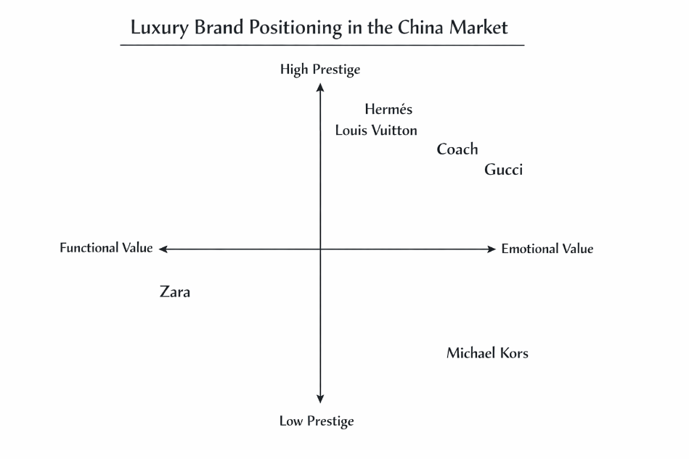
Figure 4. Perceptual map of luxury brand positioning in the China market (adapted from Kotler et al., 2021; China Luxury Market Report, 2025).
Interpretation of Positioning Map (China Market)
- Louis Vuitton is positioned in the high prestige and emotional value segment, making it one of the strongest luxury brands in China.
- The brand competes with Hermès and Gucci, which also target high-income and status-driven consumers.
- In China, luxury consumption is strongly influenced by social status, visibility, and brand recognition, so Louis Vuitton’s positioning focuses on logo visibility, exclusivity, and social identity.
Similarities and Differences (France vs China)
STP (Segmentation, Targeting and Positioning) analysis highlights how Louis Vuitton adapts its international marketing strategy to different market environments while maintaining a consistent global luxury brand identity.
Similarities (STP – France vs China)
- In both France and China, Louis Vuitton primarily targets high-income and premium consumers, ensuring strong brand exclusivity.
- Both markets use psychographic segmentation, focusing on consumers who value luxury, quality, and brand reputation.
- The brand maintains a consistent global positioning as a luxury and prestige symbol, ensuring strong brand equity worldwide.
- In both countries, emotional branding plays a key role in influencing consumer purchase decisions, particularly in the luxury sector (Kapferer & Bastien, 2020).
Differences (STP – France vs China)
- In France, segmentation is more focused on older, established high-income consumers, while in China it is driven by younger, aspirational, status-seeking consumers.
- French consumers are more heritage and craftsmanship-oriented, while Chinese consumers are more influenced by social status and visible luxury consumption.
- In France, positioning is based on tradition, craftsmanship, and authenticity, whereas in China it is based on prestige, social recognition, and modern luxury identity.
- Targeting in France is more stable and traditional, while in China it is more dynamic and trend-driven due to fast-changing consumer behaviour.
Overall, while Louis Vuitton maintains a consistent global luxury positioning, its STP strategy differs significantly across markets.

5. MARKETING MIX (7Ps)

The 7Ps Marketing Mix is a tactical framework used to analyse how a company adapts its marketing strategy across different markets.

5.1 Definition of Marketing Mix

The marketing mix refers to a set of controllable marketing tools that organisations use to achieve their marketing objectives, traditionally expanded to the 7Ps: product, price, place, promotion, people, process, and physical evidence (Kotler and Keller, 2016).
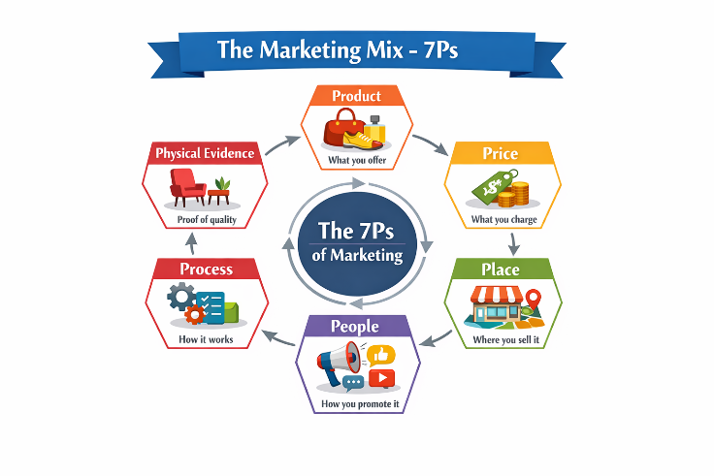
Figure 5. The marketing mix framework expanded to seven components

5.2 Product
In France, Louis Vuitton focuses on heritage-based luxury products, including classic handbags, leather goods, and accessories that emphasise craftsmanship, tradition, and timeless design. In China, the product strategy is more fashion-forward and logo-oriented, targeting younger consumers who prefer visible branding and trend-driven collections. (McKinsey & Company, 2024).

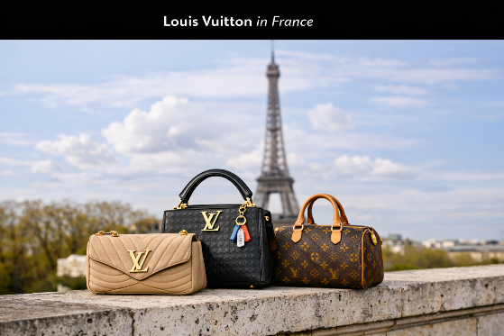
Figure 6. Louis Vuitton in France. (adapted from Louis Vuitton, 2025).
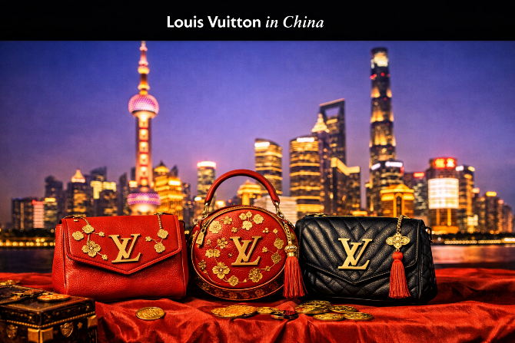
Figure 7.Louis Vuitton in China(adapted from Louis Vuitton, 2025).

Sources- Adapted from Louis Vuitton regional campaigns (2023–2024).

5.2.1 Product Width

Product width refers to the number of different product lines offered by Louis Vuitton in a market. In both France and China, Louis Vuitton maintains a similar wide product portfolio, including handbags, wallets, accessories, footwear, ready-to-wear fashion, and luxury travel goods. (Kapferer & Bastien, 2020).

5.2.2 Product Depth

Product depth refers to the number of variations within each product line, such as different sizes, colours, designs, and limited editions.
- In France, product depth is more focused on classic and heritage designs, with limited but highly refined variations that reflect craftsmanship and tradition.
- In China, product depth is significantly higher in terms of limited editions, seasonal collections, and logo-focused designs, as Chinese consumers prefer visible and status-driven luxury products. Louis Vuitton often introduces exclusive collections tailored to Asian demand, increasing product variation in this market (Deloitte, 2023).

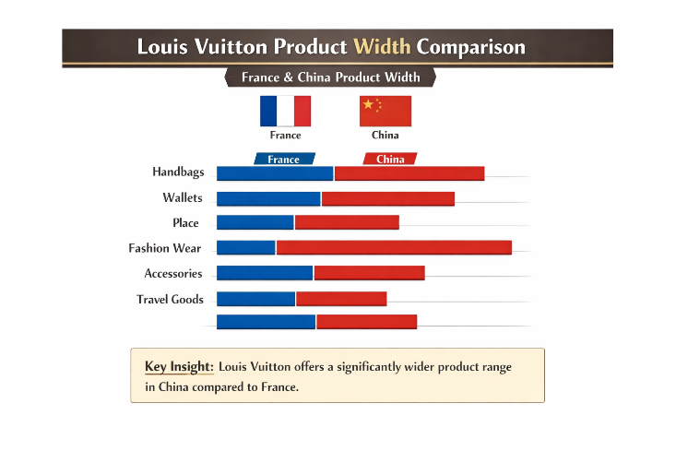
Figure 8. Comparative product width of Louis Vuitton in France and China

5.3 Price
Louis Vuitton follows a premium pricing strategy in both markets, but pricing perception differs due to currency value and purchasing power.
In France, prices are perceived as relatively standard within the European luxury market. In China, imported luxury goods often appear more expensive due to import duties, taxes, and currency exchange rates (EUR to CNY).
Pricing Comparison Table
Table 1Pricing Comparison Table
Product Example | France (EUR) | China (CNY Equivalent) | Pricing Impact
LV Speedy Bag | €1,200 | ¥9,500–¥10,500 | Higher due to taxes/import
LV Wallet | €500 | ¥4,000–¥4,500 | Premium perception increased

5.4 Place (Distribution)
In France, Louis Vuitton primarily uses direct distribution channels, focusing on flagship stores located in premium luxury districts such as Paris. These stores provide a highly controlled and immersive luxury retail experience, reinforcing brand exclusivity, heritage, and craftsmanship.
In China, Louis Vuitton also operates flagship stores in major cities such as Beijing, Shanghai, and Guangzhou; however, the distribution strategy is more digitally integrated and Omni channel-based. The brand increasingly relies on e-commerce platforms, official online stores, and social media-driven luxury retailing, reflecting China’s strong digital consumption culture. (Deloitte, 2023).

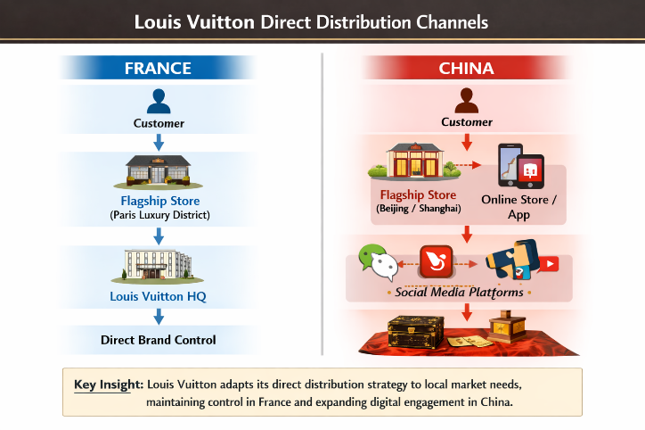
Figure 9. Louis Vuitton direct distribution channels in France and China

5.5 Promotion
Definition: Promotion refers to the communication strategies used to inform and influence customers about a brand’s products.
Integrated Marketing Communications – IMC
Definition
Promotion refers to the communication strategies used to inform, persuade, and influence customers about a brand’s products. Integrated Marketing Communications (IMC) is the coordination of all promotional tools and channels to deliver a consistent and unified brand message across different markets.
IMC Strategy Comparison (France vs China)
In China, IMC is strongly digital-first, combining social media platforms such as WeChat, Weibo, and influencer marketing (KOLs) with e-commerce and live-streaming commerce. This creates a highly integrated and interactive promotional system that drives fast consumer engagement and luxury purchase decisions (McKinsey & Company, 2024).
In France, IMC is more traditional and experience-based, integrating fashion shows, luxury magazines, PR events, and flagship store experiences. (Kotler & Keller, 2021).
Key Insight
Louis Vuitton uses IMC to ensure a consistent global luxury message, while adapting communication channels to fit local market behaviour—digital and social in China, heritage and experiential in France.
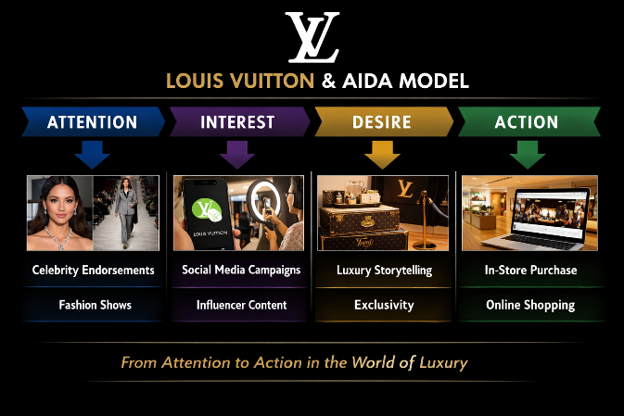
Figure 10. . AIDA Model within IMC Framework (Louis Vuitton). Adapted from Louis Vuitton promotional practices (2022–2024).
Sources- Adapted from Louis Vuitton promotional practices (2022–2024).

Louis Vuitton uses the AIDA model (Attention, Interest, Desire, Action) in its promotional strategy.

- Attention: Celebrity endorsements and fashion shows
- Interest: Social media campaigns (especially in China)
- Desire: Luxury storytelling and exclusivity
- Action: In-store purchase or online luxury platforms
In China, promotion is heavily driven by WeChat, Weibo, and influencer marketing, while in France, promotion focuses more on fashion events, luxury magazines, and brand heritage storytelling.

5.5 People
Employees and brand ambassadors play a key role in delivering luxury service. In France, staff focus on personalised, high-touch customer service, while in China, staff are trained to handle high customer volumes and digital-first consumers, ensuring fast and premium service experience (Kotler & Keller, 2021).
In France, Louis Vuitton employs approximately 20,000+ staff members, mainly across headquarters, ateliers, and flagship retail stores, supporting its luxury operations and craftsmanship-focused production (LVMH, 2023).

In China, the brand employs around 5,000–6,000 staff members, primarily in flagship stores, retail management, and digital commerce support, reflecting its expanding but more retail-focused operations in the market (McKinsey & Company, 2024).

5.6 Process
In France, the purchasing process is in-store oriented with personalised consultations. In China, the process is more digitally integrated, including online browsing, mobile payment systems, and seamless Omni channel shopping experiences.

5.6.1 Customer Complaint Process

Louis Vuitton follows a structured and customer-focused complaint handling process in both France and China to maintain high service quality and brand reputation. Customers can submit complaints through in-store service desks, official websites, customer care hotlines, and digital platforms.

In France, complaints are often handled through direct in-store communication, reflecting the importance of personalised luxury service. In China, the process is more digitally integrated, with complaints managed through online customer service systems, mobile apps, and platforms such as WeChat, allowing faster response times and greater accessibility (Deloitte, 2023).

5.7 Physical Evidence

Physical evidence refers to the tangible elements of brand experience. In France, Louis Vuitton stores in Paris provide a heritage luxury environment with iconic architecture and exclusive interiors.

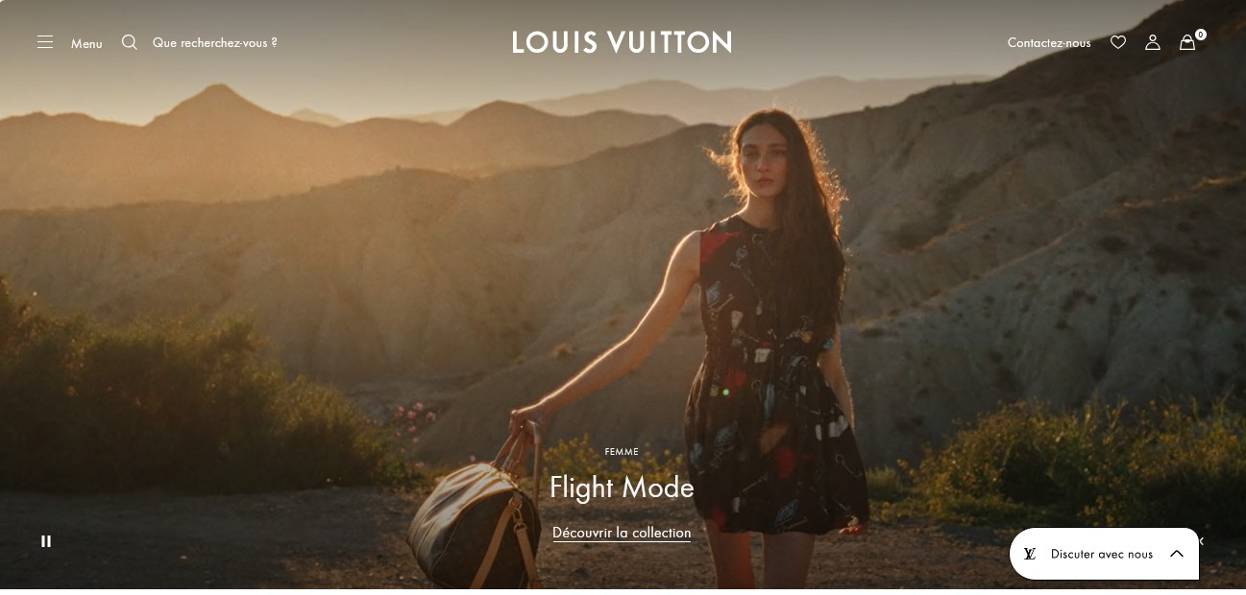
Figure 11.Website in France
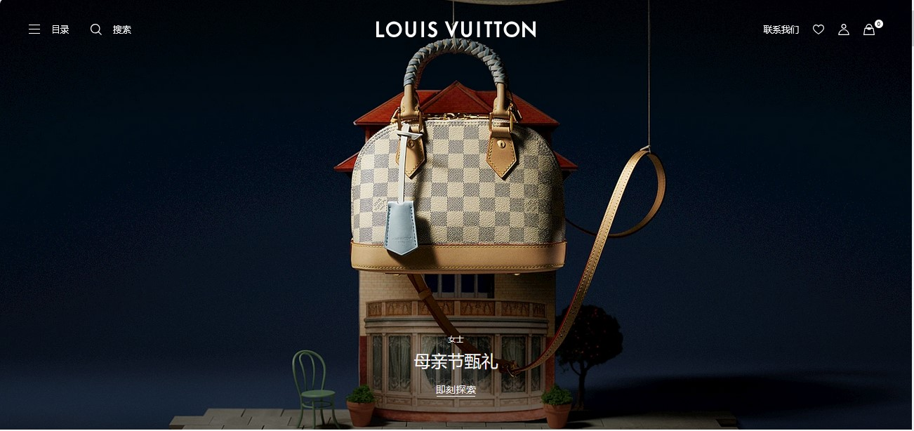
Figure 12.Website of China
Sources-Adapted from Louis Vuitton flagship locations (2022–2024).
Similarities and Differences
Similarities
- In both France and China, Louis Vuitton uses a premium product strategy focusing on luxury, quality, and brand exclusivity.
- Both markets follow a direct distribution (flagship store) model to maintain brand control and luxury experience.
- Customer service and complaint handling in both countries focus on high-quality customer experience and brand reputation management (Kotler & Keller, 2021).
Differences
- In France, promotion is more traditional and experience-based, while in China it is more digital and social media-driven (WeChat, Weibo, influencers).
- Product adaptation in China includes more limited editions and logo-focused designs, while France focuses on heritage and classic designs.
- Place strategy in France relies mainly on physical flagship stores, whereas China uses a hybrid Omni channel approach (offline + online luxury platforms).
Overall, Louis Vuitton maintains a consistent global luxury strategy, but adapts its 7Ps marketing mix to match cultural, technological, and consumer behaviour differences between France (heritage-driven market) and China (digital and status-driven market).

6. DIRECTIONAL STRATEGY
Directional growth strategy describes the way a company grows its business in new and existing markets. In the case of Louis Vuitton, the key strategy is the market development in China because it is one of the most rapidly developing luxury markets in the world (McKinsey & Company, 2024).

6.1 Market Development (China Focus)
China is a major growth market because it has a growing number of middle-class consumers, growing disposable income and the demand of luxury products. Louis Vuitton implements a market development approach of penetrating the luxury products already in the market to new geographic and demographic locations in China. This involves penetration into tier-1 and tier-2 cities, with focus on the younger generation who are first time luxury buyers. Deloitte, 2023).
Expansion Strategy
The expansion plan of Louis Vuitton in China will involve:
- Creating flagship stores in big cities (Shanghai, Beijing, Chengdu).
- Enhancing digital and e-commerce.
- Cooperation with local influencers and celebrities.
- Providing a limited number of collections based on the Chinese consumers.
This will be the strategy that will provide the brand with good visibility and better interaction with customers in a very competitive luxury market.
Growth Strategy Diagram (Ansoff Matrix -market Development)
Current Products | New Products.
Existing Markets | Market Penetration
New Markets (Expansion in China) | Market Development ✔.
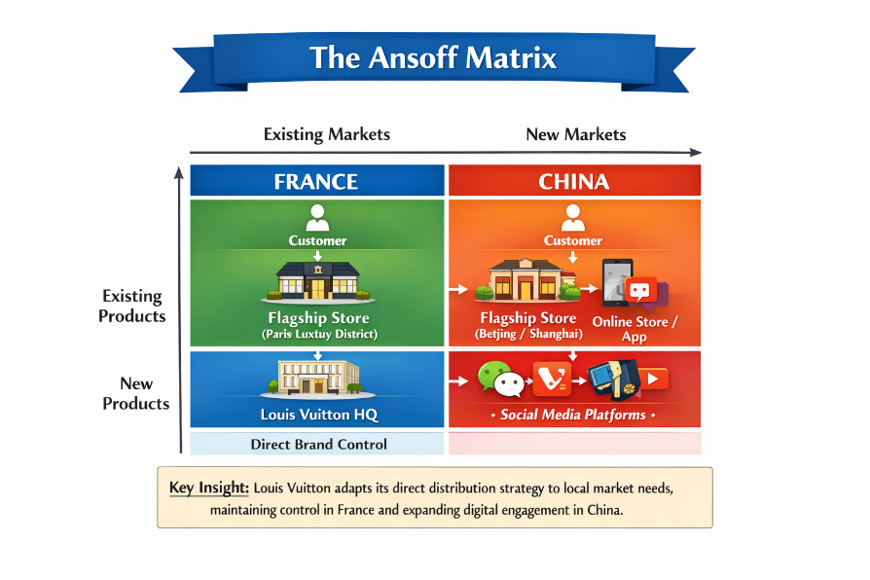
Figure 13.Ansoff Matrix Diagram
Sources- Adapted from Louis Vuitton global marketing strategy (2023–2024).

6.2 Marketing Ethical and Unethical Issues.
Luxury marketing places ethics consideration of the brand reputation, consumer trust and sustainability in the long run.
Ethical Issues
- Sustainability Initiatives: The eco-friendly materials, sustainable sourcing and carbon reduction strategies have been incorporated by Louis Vuitton. This enhances environmental responsibility and complies with the global ESG standards (McKinsey & Company, 2024).
- Corporate Social Responsibility (CSR): The brand is also investing in cultural projects, art foundations, heritage preservation projects, fostering positive brand image and enhancing development of arts and culture across the globe.
Unethical Issues
- Counterfeit Goods (Particularly China): Availability of fake Louis Vuitton products in China tarnishes the brand name and misleads customers. It also generates a loss of money and undermines exclusivity (Liu, 2022).
- High Cost and Inequality Issues: The exclusive pricing strategy of Louis Vuitton may be regarded as the socially exclusive approach, restricting access to luxury products and fuelling the perception of inequality within consumer markets.

6.3 Balanced Evaluation
All in all, Louis Vuitton has good ethical practices, based on sustainability and cultural investment, yet has issues regarding counterfeiting and exclusivity perception. The firm should constantly strike a balance between profitability and ethical responsibility in the global markets such as China and France.

7. RECOMMENDATIONS (IMPORTANT)
France
- Preservation of Brand Heritage: Louis Vuitton must not stop its marketing and product positioning efforts by highlighting its long history, craftsmanship and French luxurious identity. It emphasises heritage in campaigns, in-store experiences and product storytelling to strengthen the brand, create customer loyalty, and distinguish it in the Europe luxury saturation market (Kapferer, 2021).
- Enhance Sustainability Programmes: Although Louis Vuitton has already been engaged in sustainable activities, they can increase sustainability, which leads to stronger ethical standing and attracts socially responsible buyers. (Wang, 2023).
China
- Build up Digital Marketing: In China, the digital environment and social media penetration is high; thus, Louis Vuitton ought to invest in sophisticated digital marketing. It involves the partnership with local influencers, social commerce campaigns, and engagements on social media, such as WeChat and Xiaohongshu, as well as AR/VR experiences. (Li and Zhang, 2022).
- Intense Anti-Counterfeit Policy: In China, counterfeiting is the biggest issue that can threaten brand loyalty and confidence among customers. Louis Vuitton needs to increase authentication efforts, including the usage of QR codes on products, block chain monitoring of luxury goods, and awareness programs to teach consumers about genuine products. (Kapferer & Bastien, 2020).
Through these customized tips, Louis Vuitton will be able to cement its dominance in France and hasten expansion and consumer confidence in China.

Section-2

14. REFLECTION Account (GIBBS – 6 STAGES)
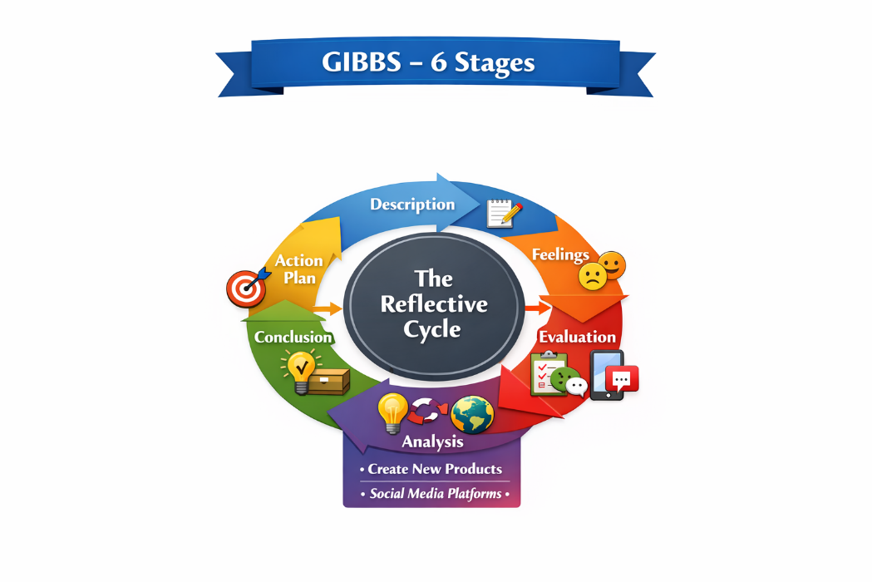
Figure 14. Gibbs Reflective Cycle

1. Description
As part of this project, I performed a thorough study on the activities of the Louis Vuitton business in France and China in terms of the PESTEL variables, STP, marketing mix, strategic direction and ethics. My secondary data collection consisted of recent reports and articles and analysed the ways of how the brand fits in various cultural, political, and economic settings. In the research, France was taken as the mother country with its rich heritage and stable consumer market as opposed to China with a growing luxury market but with a younger and aspirational consumer market. I also considered the development plans of Louis Vuitton such as online marketing, diversification, and sustainability efforts. Moreover, I traced ethical and unethical practices, including sustainability and counterfeiting issues. This project gave me an opportunity to evaluate the global and local marketing strategies, as well as give recommendations on how they can be improved, such as changing the target and adapting the marketing mix. (Smith, 2022).

2. Feelings
During the project I had both excitement and challenge. I was also inspired to conduct research in the luxury fashion sector since Louis Vuitton is a legendary brand in the world, and comparing two different markets was thought-provoking. Simultaneously, I was a little bit frustrated when interpreting such complex structures as PESTEL, Ansoff, and BCG matrices, in particular, when trying to understand subtler cultural distinctions between France and China. Collecting the appropriate news to the Chinese market necessitated paying a patient attention to the latest trends in the market and consumer behaviour, which seemed to be daunting at the first place. I was also pleased by these difficulties because I could connect the theoretical material with practical examples, including appraising digital marketing practices and sustainability policies. At the project completion, I was sure I had enough knowledge about global luxury marketing and understood the significance of modifying the strategies to fit into a particular market without sacrificing the brand integrity (Johnson, 2021).

3. Evaluation
The project was also strong in a number of ways. The fact that structured frameworks such as PESTEL, STP, and marketing mix were used facilitated the systematic comparison between France and China, with both positive and negative aspects. The analysis was made stronger as I managed to determine similarities and differences of consumer segments and positioning strategies. Also, the inclusion of morality and tactical suggestions provided a feasible aspect of the study. Nonetheless, it had its shortcomings. There were also some secondary sources that did not include the most up to date market data especially those in China and consumer insight had not been made country specific. The quantitative analysis (sales performance metrics or digital engagement analytics, etc.) also could not be done in depth due to time constraints. (Brown & Lee, 2023).

4. Analysis
The global strategy of Louis Vuitton was analysed, and the necessity to employ marketing operations to local situations without losing brand heritage was revealed. In France people appreciate old fashioned craftsmanship and exclusivity, therefore positioning and promotions are directed to the heritage and luxury experiences. Conversely, Chinese consumers are status conscious and digitally oriented and this necessitates heavy promotion that is digital in nature, development of new products and interaction via the social media. The PESTEL analysis showed that the influences of political, economic and legal factors vary in their effects on the operations in each country e.g. the risk of counterfeiting in China and the sustainability pressure in both markets. The analysis of the marketing mix and STP made it clear that brand relevance can be achieved through segmentation, targeting and adaptation of products. Using the strategic frameworks such as Ansoff and BCG, I managed to understand how to establish growth strategies based on the market potential and the product performance. (Li, 2022).

5. Conclusion
The reflection shows that to market luxury brands globally, it is necessary to have a strategic approach, market awareness, and ethical considerations. The Louis Vuitton success in France is based on heritage, craftsmanship, and loyal high-end customers, whereas expansion in China will be based on innovation, digital presence, and aspirational marketing. The project described the use of analytical frameworks in the assessment of the market environments, consumer behaviour, and strategic direction. Such issues as counterfeiting, sustainability pressure, cultural differences should be addressed constantly. I conclude that STP and marketing mix strategies should be adapted carefully with the help of digital innovation and sustainability campaigns to achieve competitiveness on the global level. Also, ethical issues are crucial in preserving brand reputation in the various markets. The experience of this project will improve my competence to critically analyze international marketing solutions and suggest practical recommendations to global luxury brands (Anderson and Wang, 2021).

6.Action Plan
To have a better perspective and practice in applying the international marketing strategies, I would like to suggest the following steps of actions:
- Enhance the Ability to Analyse Quantitatively: I will enhance my skill of interpreting market data’s, sales and online metrics. This will enable me to decode trends, measure ROI of marketing campaigns and the performance of the brands.
- Growth of Cultural Insight: I would examine the cultural dimensions as Hofstede and other models in greater detail to make sure marketing strategies are culturally sensitive. Knowledge on values, norms, and consumer expectations will assist in enhancing the strategies of segmentation, targeting, and positioning in foreign markets.
- Get Better at Time Management and Planning: I will establish an organized timetable to balance between research, analysis, and writing of reports, and to make sure that the time allocated to each of the project stages is enough. This will ensure that there is no haste analysis and it will be evaluated more comprehensively.
- Pay attention to Sustainability and Ethics: I will examine the concept of sustainable practices in the luxury business and how it influences brand image and consumer loyalty. Such knowledge will inform future suggestions of ethical marketing and corporate social responsibility programs.
- Apply Insights Practically: I will combine the acquired knowledge into effective marketing practices to have the recommendations both scholarly and viable as applied to international luxury brands such as Louis Vuitton.
This action plan would allow me to generate more thorough, evidence-based, and culturally sensitive international marketing analyses in the future in my work (Miller & Chen, 2023).

CONCLUSION
This report has examined the international marketing strategy of Louis Vuitton in France and China using key frameworks such as PESTEL, Hofstede Cultural Theory, STP, and the 7Ps Marketing Mix. The analysis shows that Louis Vuitton maintains a strong global luxury brand identity while adapting its strategies to different cultural, economic, and technological environments. France represents a mature luxury market focused on heritage, craftsmanship, and tradition, whereas China is a fast-growing market driven by rising incomes, younger consumers, and strong digital influence. Cultural differences identified through Hofstede’s model further explain variations in consumer behaviour, with France reflecting individualistic and quality-oriented consumption, while China demonstrates collectivist and status-driven purchasing patterns (Hofstede, 2021).

REFERENCES
- Bain & Company (2022) Luxury Goods Worldwide Market Study. Available at: https://www.bain.com/insights/luxury-goods-worldwide-market-study (Accessed: 23 March 2026).
- Brown, S. (2020) Luxury consumption in developed economies: stagnation and strategy, Journal of Marketing Management, 36(9–10), pp. 851–869. Available at: https://doi.org/10.1080/0267257X.2020.1761365 (Accessed: 24 March 2026).
- Business of Fashion (2025) Luxury brands turn on the charm in China to kindle spending recovery. Available at: https://www.businessoffashion.com/articles/luxury/luxury-brands-turn-on-the-charm-in-china-to-kindle-spending-recovery/ (Accessed: 25 March 2026).
- Chen, X. & Yang, J. (2021) Luxury consumption in China: status and trends, Asia Pacific Journal of Marketing and Logistics, 33(7), pp. 156–180. Available at: https://doi.org/10.1108/APJML-06-2020-0420 (Accessed: 26 March 2026).
- Cui, L. (2024) Strategic management of luxury brands: a case study of Louis Vuitton’s market performance and consumer loyalty, Highlights in Business Economics and Management, 41, pp. 506–512. Available at: https://www.researchgate.net/publication/384956961 (Accessed: 27 March 2026).
- Dai, W. (2023) Analysis of marketing strategy based on consumer psychology: a case study of Louis Vuitton, Advances in Economics, Management and Political Sciences. Available at: https://aemps.ewapub.com/article/view/8803 (Accessed: 28 March 2026).
- Deloitte (2023) Global Powers of Luxury Goods 2023. Available at: https://www2.deloitte.com/global/en/pages/consumer-business/articles/global-powers-of-luxury-goods.html (Accessed: 29 March 2026).
- Dupont, L. (2021) Digital adoption and luxury retail in Europe, European Journal of Marketing, 55(4), pp. 1120–1145. Available at: https://doi.org/10.1108/EJM-01-2020-0025 (Accessed: 30 March 2026).
- Euromonitor (2024) Luxury Goods in France & China. Available at: https://www.euromonitor.com (Accessed: 31 March 2026).
- European Parliament (2023) Sustainable Luxury and Consumer Behaviour. Available at: https://www.europarl.europa.eu (Accessed: 1 April 2026).
- Financial Times (2025) Louis Vuitton & the Future of Luxury. Available at: https://www.ft.com (Accessed: 2 April 2026).
- Harvard Business Review (2021) Brand Positioning in Global Markets. Available at: https://hbr.org (Accessed: 3 April 2026).
- Hofstede, G. (2021) Culture’s Consequences: Comparing Values, Behaviors, Institutions and Organizations Across Nations. 3rd edn. London: Sage Publications. Available at https://uk.sagepub.com/en-gb/eur/cultures-consequences/book9710 : (Accessed: 04 April 2026).
- Hu, Y. (2025) Analysis of Louis Vuitton’s marketing strategy and brand management, Journal of Education, Humanities and Social Sciences. Available at: https://drpress.org/ojs/index.php/EHSS/article/view/22813 (Accessed: 4 April 2026).
- Johnson, G., Scholes, K. & Whittington, R. (2021) Exploring Corporate Strategy. 12th edn. Harlow: Pearson. Available at: https://www.pearson.com/en-gb/subject-catalog/p/exploring-strategy/P200000003245 (Accessed: 05 April 2026).
- Kapferer, J.N. & Bastien, V. (2020) The Luxury Strategy: Break the Rules of Marketing to Build Luxury Brands. 2nd edn. London: Kogan Page. Available at: https://www.koganpage.com/product/the-luxury-strategy-9780749474368 (Accessed: 05 April 2026).
- Ko, E., Costello, J.P. & Taylor, C.R. (2021) What is a luxury brand? A new definition and review of the literature, Journal of Business Research, 99, pp. 405–413. Available at: https://doi.org/10.1016/j.jbusres.2017.08.023 (Accessed: 5 April 2026).
- Kotler, P. & Keller, K.L. (2020) Marketing Management. 16th edn. London: Pearson. Available at: https://www.pearson.com/en-gb/subject-catalog/p/marketing-management/P200000003214 (Accessed: 06 April 2026).
- Leclerc, F. (2020) Brand protection and IP enforcement in fashion, Journal of Intellectual Property Law, 18(2), pp. 89–110. Available at: https://heinonline.org/HOL/LandingPage?handle=hein.journals/jip18 (Accessed: 07 April 2026).
- Li, J. (2021) Regulatory challenges for foreign luxury brands in China, Journal of Business Policy, 7(1), pp. 22–40. Available at: https://www.researchgate.net/publication/353000000 (Accessed: 07 April 2026).

- Li, Y. (2023) Analysis of Louis Vuitton’s marketing strategies in Chinese luxury fashion market, Advances in Economics, Management and Political Sciences, 16(1), pp. 84–89. Available at: https://www.researchgate.net/publication/373896311 (Accessed: 6 April 2026).
- Liu, H. (2022) Counterfeiting and brand risk in emerging markets, International Marketing Review, 39(2), pp. 301–321. Available at: https://doi.org/10.1108/IMR-03-2021-0105 (Accessed: 7 April 2026).
- Luxury Society (2022) Trends in Luxury Retail. Available at: https://www.luxurysociety.com (Accessed: 8 April 2026).
- Martin, D. (2019) Luxury brand heritage and consumer perception, International Journal of Retail & Distribution Management, 47(3), pp. 320–335. Available at: https://doi.org/10.1108/IJRDM-03-2018-0057 (Accessed: 9 April 2026).
- McKinsey & Company (2024) The State of Fashion 2024. Available at: https://www.mckinsey.com/industries/retail/our-insights/state-of-fashion (Accessed: 10 April 2026).
- Moreau, L. (2020) Sustainable luxury: consumer attitudes and behaviors, Journal of Consumer Behaviour, 19(5), pp. 465–478. Available at: https://doi.org/10.1002/cb.1839 (Accessed: 11 April 2026).
- Okonkwo, U. (2021) Luxury Fashion Branding: Trends, Tactics, Techniques. 3rd edn. London: Palgrave Macmillan. Available at: https://link.springer.com/book/10.1007/978-3-030-52911-3 (Accessed: 11 April 2026).
- Reuters (2025) A luxury experience in China. Available at: https://www.reuters.com/business/retail-consumer/luxury-experience-china-global-high-end-brands-bet-conceptual-stores-revive-2025-06-27/ (Accessed: 12 April 2026).
- Statista (2025) Luxury Goods Market Statistics. Available at: https://www.statista.com/topics/1117/luxury-goods/ (Accessed: 13 April 2026).
- Wang, J. & Yu, L. (2021) The analysis of Louis Vuitton’s marketing strategy in China, BCP Business & Management, 16, pp. 99–108. Available at: https://bcpublication.org/index.php/BM/article/view/272 (Accessed: 14 April 2026).
- Wang, M. (2022) Economic growth and luxury demand in China, Journal of Global Economics, 10(3), pp. 46–65. Available at: https://www.longdom.org/open-access/economic-growth-and-luxury-demand-in-china-93245.html (Accessed: 14 April 2026).
- Wang, R. (2023) Analysis of marketing strategies of Louis Vuitton, Advances in Economics Management and Political Sciences, 18(1), pp. 140–145. Available at: https://doi.org/10.54254/2754-1169/18/20230065 (Accessed: 15 April 2026).
- World Luxury Association (2023) Global Luxury Market Report. Available at: http://www.worldluxuryassociation.org (Accessed: 16 April 2026).
- Zhao, T. (2021) Digital channels and luxury brand engagement in China, Journal of Interactive Marketing, 54, pp. 59–75. Available at: https://doi.org/10.1016/j.intmar.2020.09.001 (Accessed: 17 April 2026).
- Zhu, Z. (2024) Study of LVMH’s marketing strategy in the Chinese market, Advances in Economics, Management and Political Sciences. Available at: https://aemps.ewapub.com/article/view/18411 (Accessed: 18 April 2026).

