
THE IMPACT OF INTEGRATED MARKETING COMMUNICATIONS ON CONSUMER BEHAVIOUR: A CASE STUDY ANALYSIS OF HARRODS
MBA Dissertation
Student: Wafa Wajeeh Nasser -1703942- UWTSD- London
Supervisor: Tushara Balendran
MBA Dissertation
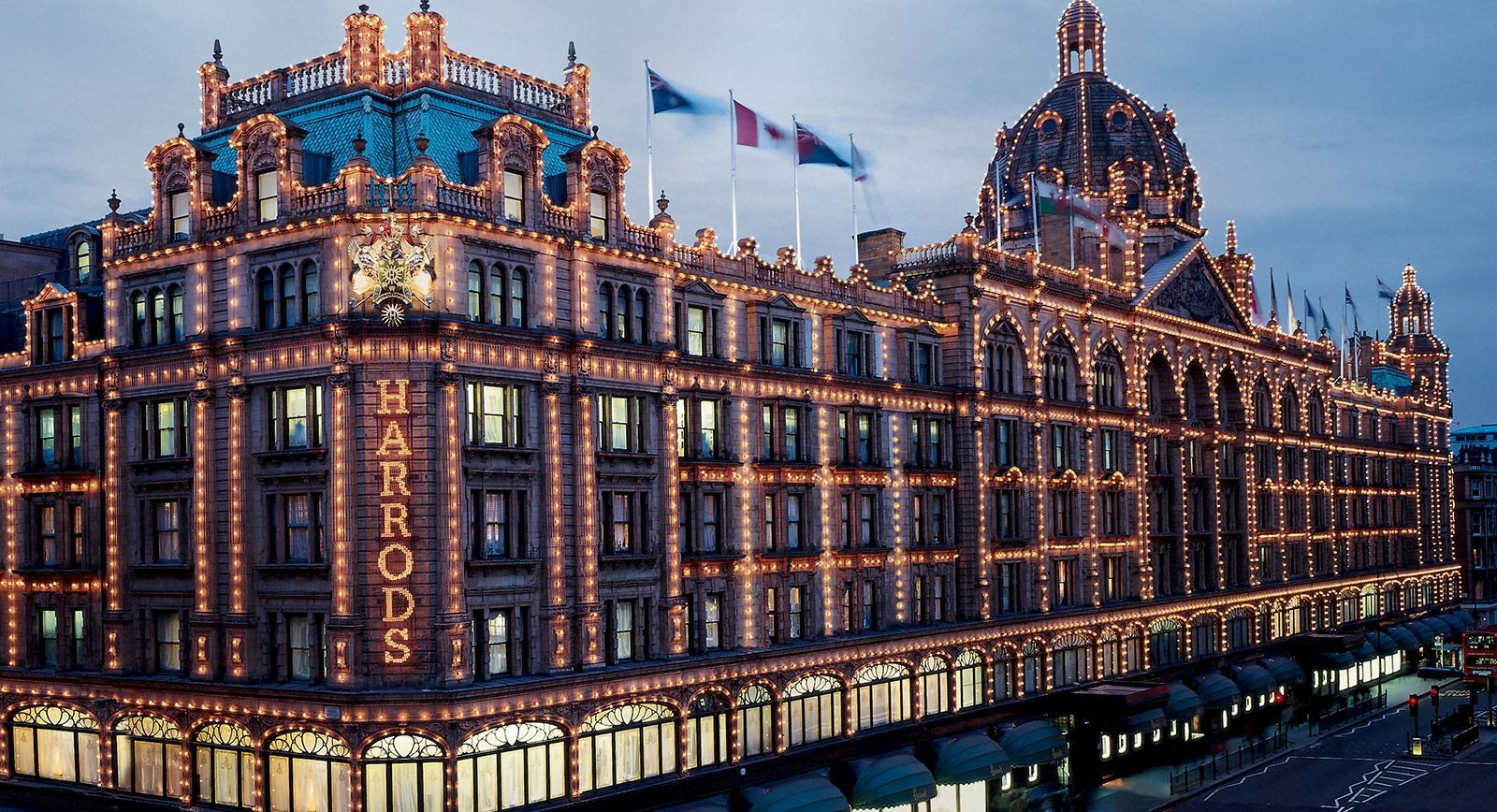


Master’s Degrees by Examination and Dissertation
Declaration Form.
1. This work has not previously been accepted in substance for any degree and is not being concurrently submitted in candidature for any degree.
Signed ……. Wafa Nasser ………………………………………………………
Date ………01/03/2022……………………………………………………………

2. This dissertation is being submitted in partial fulfilment of the requirements for the degree of Master in Business Administration.
Signed ………Wafa Nasser …………………………………………………….
Date ……01/03/2022………………………………………………………………
3. This dissertation is the result of my own independent work/investigation, except where otherwise stated.
Other sources are acknowledged by footnotes giving explicit references.
A bibliography is appended.
Signed candidate: ……Wafa Nasser ………………………………………….
Date: ……01/03/2022……………………………………………….……………

4. I hereby give consent for my dissertation, if accepted, to be available for photocopying, inter- library loan, and for deposit in the University’s digital repository
Signed (candidate)……Wafa Nasser………………………………….…………
Date…01/03/2022…………………………………….…………….……………...
Supervisor’s Declaration.
I am satisfied that this work is the result of the student’s own efforts.
Signed: ……Tushara Balendran ……………………………………………………
Date: …04/03/2022………………………………………………………………...

University of Wales: Trinity Saint David

E-Thesis Deposit Agreement

Details of the Work
I would like to deposit the following item in the digital repository maintained by the University, and/or in any other repository authorized for use by the University:

Title ………The Impact of Integrated Marketing Communication on Consumer Behaviour: Case Study Analysis of Harrods.…………………

This item is a product of my own research endeavours and is covered by the agreement below in which the item is referred to as “the Work”. It is identical in content to that deposited in the Learning Resources Centre, subject to point 4 below.

I agree that the University of Wales: Trinity Saint David may electronically store, copy, or translate the Work to any approved medium or format for the purpose of future preservation and accessibility. The University is not under any obligation to reproduce or display the Work in the same formats or resolutions in which it was originally deposited.

UW: TSD Digital Repository
I understand that work deposited in the digital repository will be accessible to a wide variety of people and institutions, including automated agents and search engines via the World Wide Web.

I understand that once the Work is deposited, the item and its metadata may be incorporated into public access catalogues or services, such as national databases of electronic theses.

I agree as follows:
- That I am the author or have the authority of the author/s to make this agreement and do hereby give the University of Wales: Trinity Saint David the right to make available the Work in the way described above.
- That the electronic copy of the Work deposited in the digital repository and covered by this agreement, is identical in content to the paper copy of the Work.
- That I have exercised reasonable care to ensure that the Work is original, and to the best of my knowledge, does not breach any laws including those relating to defamation, libel and copyright.
- That I have, in instances where the intellectual property of other authors or copyright holders is included in the Work, gained explicit permission for the inclusion of that material in the Work, and in the electronic form of the Work as accessed through the open access digital repository, or that I have identified and removed that material for which adequate permission has not been obtained and which will be inaccessible via the digital repository
- That University of Wales: Trinity Saint David does not hold any obligation to take legal action on behalf of the Depositor, or other rights holders, in the event of a breach of intellectual property rights, or any other right, in the material deposited.
- That I undertake to indemnify the University of Wales: Trinity Saint David against all actions, suits, proceedings, claims, demands and costs occasioned by the University in consequence of any breach of this agreement

Signature …Wafa Nasser………………………………………………….

Date…. 01/03/2022…………

Table of Contents
Acknowledgement 9
Abstract 10
Chapter One: Introduction 11
1.1 Background of the research 11
1.2 Research Rationale 12
1.3 Research aim, objectives, and research questions 15
1.4 Research Significance 16
1.5 Chapter Overview 16
1.6 Literature Gap 18
Chapter Two: Review of literature 19
2.1 Introduction 19
2.2 Concept of integrated marketing communications 21
2.3 Types of promotions in integrated marketing communications 25
2.4 Concept of consumer behaviour and its importance 28
2.5 Types of consumer behaviour 30
2.6 Factors influencing consumer buying behaviour 33
2.7 Impact of integrated marketing communications on consumer behaviour 40
2.8 Literature gaps 45
2.9 Conclusion 46
Chapter Three: Research Methodology 47
3.1 Introduction 47
3.2 Research Onion 48
3.3 Research Philosophy 48
3.4 Research Approach 49
3.5 Research Strategies 50
3.6 Type of investigation 50
Advantages 50
Disadvantage 51
Advantages 51
Disadvantages 52
3.7 Research Design 52
3.8 Research Choice 53
3.9 Data Collection Methods 54
3.10 Data collection Tools and Techniques 54
3.11 Sampling 55
3.12 Time Horizon 56
3.13 Ethical Considerations 58
3.14 Research Limitations 58
3.15 Summary 60
Chapter Four: Discussion 61
4.1 Introduction 61
4.2 Data analysis 62
Chapter Five: Discussion 86
Chapter Six: Conclusion and Recommendation 91
6.1 Conclusion 91
6.2 Recommendations 93
6.3 Future Work 95
References 96
Appendix One: Questionnaire 112
Appendix Two: List of Figures 115

Acknowledgement
My supervisor, Dr. Tushara Balendran has done a lot for me and given me a lot of interesting assignments to work on to boost my knowledge. Her humble demeanour can teach us a lot about science and study. She has helped me in gaining the proper support for my work and have ensured that I am able to accomplish the overall research properly. Her writing style is an excellent example of this method, and I intend to emulate it.
I was able to complete my project because of the Programme Manager: Dr. Gladius Kulothungan assistance and support, thank you for the generous good you spread always.
. I owe a particular debt of gratitude to the Executive Dean of the campus: Dr. Audsin Dhas who was behind the success I achieved, thank you for your endless support and for boosting my moral and always keeping my spirit up in all circumstances and all times.
I extend my greatest gratitude to my university, UWTSD, to every member of its staff and students, and to everyone who contributed to my achievement at this stage.
Because of my parents' spirits that surrounding me in every moment of my journey, I managed to keep a positive outlook on life. Because of their faith in me, I have accomplished so much.
Thank you to my brothers and sisters for always being there for me and providing a sense of stability, despite the long distances.
Finally, I would want to thank my son Yousef. I will be eternally thankful for the constant love and support I received throughout the thesis writing process and on a daily basis. Yousef, the sunshine who has enlightened my life and I was able to complete all the work because of him and for him.

Abstract
The research has primarily focused on the aim of investigating about the integrated marketing communication. This is one of the newest technologies which has been implemented in the recent times that allows the individuals to gain the relevant information regarding the way they should be conducting their business. The research will be focusing on the process of integrated marketing communication within the organisational context of Harrods. This allows them to manage the internal affairs as well as enhance the overall brand image by constantly communicating with the consumers who are present within the overall competitive environment. Harrods Stores Ltd. is one of the renowned organisations that was founded in 1849 to continue the Harrods name. Some of its specialties include jewellery, technology, household goods, and gifts, all of which are under the jurisdiction of the Qatar Investment Authority (QI). The organization has had to adapt to keep up with technological advancements in today's market. Robots and computers are progressively replacing people in today's manufacturing and design processes. As a result, in today's market, communications is the only way to differentiate between different organizations. Further, if Harrods wants to keep and attract customers, it must first create a consistent image of the company, brand, and products. Customers' habits and preferences must be considered while looking for ways to improve a product. The notion of integrated marketing allows for the identification of multiple acts that influence client behaviour. In light of the current epidemic, which has slowed market advancement significantly, integrated marketing communications have emerged as critical instruments for any organization. Firms realize the need for integrated marketing communication as more current marketing tactics emerge. The research will investigate about these aspects and will also be able to gain the necessary information related to the factors which influence the behaviour of the consumers.

Chapter One: Introduction
Integrated marketing communications (IMC) are a concept that are being defined as the systems of communication to help in knowledge transfer strategy for the companies. By focusing on the case study of Harrods this research has been done to evaluate the impacts of integrated communication on the consumer behaviours.

Background of the research
Consumers are being assaulted daily by a multitude of stimuli. The large majority acts as the result of the activities of marketing communication that are being initiated by the organisations. Everything is being reduced to the communications of marketing starting from the TV, communication, internet to the brand-based techniques. The main aim lies in the creation of the unitary image of the organisation, brand, and products with the ultimate objective of retaining and attracting customers. The concept of integrated marketing communication is being inter-correlated with the concept of integrated marketing that helps in the identification of the different activities to help to induce the behaviour of the customers (Duralia, 2018). Modern-day organisations are gradually realising the importance of the programs related to integrate marketing communications. These programs are helping organisations to improve their operational activities. With the presence of the current pandemic situation, the market has been advancing at a slow pace of development and integrated marketing communications gradually evolve as valuable weapons for any organisation. Further, with the evolution of the different modern marketing methods, integrated marketing communication is becoming an effective way to achieve the objectives of the organisations. There is a need to identify the opportunities to improve its impact on the current behaviours of consumers. In this context, the impact of integrated marketing communications on consumer behaviour has been developed with the case-study analysis of Harrods. Harrods is a luxury departmental store in London that specializes in jewellery, electronics, housewares, gift items, owned by Qatar Investment Authority. The company was founded in 1849 and it was started as Harrods Stores Ltd (Harrods 2022). The company has undergone changes in digitization in the current market
The experience of the organisations in developing the value of the products is being replaced in modern times with the manufacture or design assisted by robotics and computers. Thus, in the current market situation, the only useful way through which the organisations can be differentiated is the presence of communications. Integrated marketing communication can help in the development of a real sustainable competitive advantage to the organisations that help to leverage its potential (Valos et al., 2017). The organisations are capitalising slowly on integrated marketing communication in the most effective manner in an economy with high competition. This helps to ensure the maintenance and creation of long-term relationships with both the potential and current customers.

Research Rationale

The competition among the different companies is increasing drastically both in the domestic and international markets (Sinha and Sheth, 2018). The main problem in the current globalised world is that companies tend to fail to attract a large number of customers. In this respect, the integrated communications of marketing can make the organisations competitive in their specific operations through the establishment of the long-term relationships with the customers. The companies also lack the specific measures of communication with the customers to help in the differentiation with the target group. Integrated marketing communication often becomes a complex process that can affect the quality of the relationships of the business between the consumers and company. In the current times, the rivalry among the business entities is exponentially increasing which creates a problem for the companies to select the desired standards of communication. The changing approaches of digitisation and marketing communication and limited attention has been provided by the organisations, like Harrods on how integrated marketing communication tends to influence the behaviour of consumers (Dewnarain, Ramkissoon and Mavondo, 2019). The employees and the managers lack the desired knowledge about the techniques of integrated marketing communication that can help to attract large customers in an uncertain situation. Further, there has been a lack of training programs and activities for the employees concerning the use of integrated communications technology. This is leading to the resistance to change in the organisation by the employees. There is also the lack of software tools to help in the increased collaboration and analysis of customer behaviour. Thus, customer satisfaction through reaching out to them is the only vision of the companies through developing integrated marketing communications.
In the current time, it has been seen that the organisation Harrods has also faced a massive loss in the business due to Covid-19. They also have to stop many physical stores and cut the jobs (Fashionnetwork.com 2020). Hence, increased competition between domestic and international businesses has resulted in a sharp rise in prices (Batat, 2019). Because of today's globalised economy, many businesses struggle to attract an extensive consumer base. By developing long-term relationships with customers, marketing's integrated communications could help businesses become more competitive in their unique operations. Additionally, the organisations do not have the precise measures of customer communication that might help them differentiate themselves from their target market (Bairrada et al., 2019a, 2019b). The complexity of integrated marketing communication might harm the quality of the business's interactions with its customers and clients. Because of the growing competition among businesses, it is becoming increasingly difficult for them to settle on a standard of communication that they could all agree on. Organisations like Harrods have paid a lack of attention to how integrated marketing communication influences consumer behaviour due to the shifting digitalisation and marketing communication (Appel et al., 2020). In an unpredictable market, employees and managers alike lack the necessary expertise in integrated marketing communication tactics that may help them draw in significant numbers of clients (Ahn and Back, 2018a, 2018b). The lack of training programmes and activities for employees on the usage of integrated communications technology is also a problem. This is causing the personnel of the company to be resistant to change. The lack of software tools to collaborate and analyse client behaviour is another issue. In other words, the only goal of producing integrated marketing communications is to satisfy customers (Kuehnl et al., 2019).
It has emerged that Harrods has suffered dramatically due to the Covid-19 crisis. In addition, many physical stores must be closed, and jobs must be slashed (Fashionnetwork.com 2020). As a result of the employment reduction, employees' expectations and satisfaction may be affected, and they may not serve consumers due to this success. As a result, it could be claims that the organisation has dealt with the issues that may impact the purchasing habits and overall pleasure of their customers (Juska, 2021). Because of this research on integrated marketing communication (IMC), Harrods may use this information efficiently to manage customer satisfaction and purchasing behaviour (Ieva et al., 2018).
Companies in a highly competitive global economy are constantly looking for the most effective ways to promote their products and services so that customers understand the value they provide (Govindan et al., 2019). As a result, marketing communications are now an essential component of a company's marketing strategy and overall vision. As a department store, Harrods employs a wide range of marketing communication strategies to sell its merchandise and achieve financial or non-profit goals (Gilal et al., 2019).
In order to accomplish the retailer's stated aims, there is a clear need to boost the impact of Harrods' marketing message. This is possible when all of the marketing strategy's components are merged into a single entity. IMC is a widely disputed topic among scholars today, with views ranging from one extreme to the other. Some claim that IMC is little more than a collection of specific themes from traditional marketing presented in a new manner, while others argue that it was the most significant advance in marketing communications in the last decade of the twentieth century (Dhaliwal et al., 2020).
According to Schiffman and Kanuk (2009), four consumer models could be built based on a basic understanding of how and why an individual acts in a certain way. Customers are portrayed as rational decision-makers who base their judgments only on the cost-benefit analysis of the information they acquire from their searches when seen from an economic standpoint. Consumer researchers have often criticised the rational decision-making process for failing to capture many aspects of buying decisions adequately. It could be seen in several ways (Dewnarain et al., 2019). According to the passive viewpoint, consumers are merely passive victims of marketing and have little control over their purchasing decisions (Chou et al., 2020).

1.3 Research aim, objectives, and research questions
The aim of the present research lies in the investigation of the implication of integrated marketing communication on the behaviour of the customers. The case study of Harrods is being put into use in this respect.
The main objectives of the research include the following
- To explore the different integrated marketing communication methods of Harrods
- To investigate the factors that influence consumer buying behaviour
- To determine the impact of integrated marketing communication strategies on the buying behaviour of consumers
Research Questions
The questions of the research include the following
- What are the different methods of integrated marketing communication at Harrods?
- What are the factors that influence consumer buying behaviour?
- What is the impact of integrated marketing communication strategies on the buying behaviour of consumers?

1.4 Research Significance
The significance of the study lies in the development of the benefits and challenges of integrated marketing communications on consumer behaviour. The greater demand for marketing communications justifies the need for more effective approaches (Krizanova, 2019). The study helps in the exploration of the critical areas in the marketing communication process that can result in improved performance of the organisations. Through the research, the different methods of integrated marketing communication have been identified and the influence of the Integrated marketing communication on the consumer behaviour can be understood. Hence, it can be stated that the research helps in increasing the knowledge on the application of integrated marketing communication and in addition to that it can also significantly help the organisation such as Harrods to enhance the customer loyalty, satisfaction, and intention to purchase their products through the right use of integrated marketing communication.

1.5 Chapter Overview
Chapter 1: Introduction
This chapter provides a brief overview of the research area and helps to understand what has been done in the entire research. This chapter covers the background of the research where the background information about the integration communication has been discussed. Thereafter the rationale of the research has also been given to rationalise the purpose of the research. Followed by rationale the aims, objectives and research questions are also provided in this chapter. Lastly, the significance of the research and an overview of the entire research paper has been described.
Chapter 2: Literature review
The literature review is a chapter where numerous previous research works and articles and journals have been reviewed for the purpose of collecting some of the background knowledge to develop the research. In addition to that, the chapter also helps in building the theoretical perspective on the research area. This chapter covers the concept of integrated marketing communication and its impact on the behaviour of the consumers. In addition to that, the theories on the consumer behaviour as well as the communication and marketing have been used in the chapter to develop the theoretical base of the research.
Chapter 3: Research Methodology
This chapter outlines the methods of the research. The philosophy, approach and research design has been described in the chapter. In addition to that, the ethical considerations during the research have also been explained effectively in the chapter. Apart from these methods for collecting data and analysis of those data has also been discussed in the chapter minutely.
Chapter 4: Data analysis and discussion
This chapter is for discussion of the result and analysis of the collected data. Hence in the chapter initially the collected data has been analysed. Hence, in this chapter, the collected data has been presented and analysed. After the analysis has been done, the results are discussed to understand the outcome of the research. However, how the analysed data are linked with the knowledge and information gathered from the Literature review has also been discussed in the paper.
Chapter 5: Conclusion and recommendation
This is the last chapter of the dissertation where the findings have been concluded. In this chapter, a conclusion based on the research findings has been drawn and following that the sets of recommendations have been developed. In addition to that how the findings are relating to the objectives has also been discussed in the chapter. Lastly, the future scope of the research has also been mentioned here.

Figure 1.1: Research structure with the chapters
(Source: Self-created)

1.6 Literature Gap
This study has not identified the process of integrated marketing communication in the company of Harrods. There has been the lack of research of the impact of Covid-19 on integrated marketing communications of the company. Moreover, the background of integrated marketing communication needs further description and analysis.

Chapter Two: Review of literature

2.1 Introduction
The present chapter covers the review of literature of the given research topic. Literature reviews provide a thorough and in-depth information about a given topic at its various levels of depth based on its research executed by previous researchers and academic scholars (Paul and Criado 2020). The present study is based on the effect of integrated marketing communications on consumer behaviour. There are various concepts, terms, opinions, theories related to the variables of the research topic. An in-depth literature review provides insightful information about these areas and help a researcher or reader to understand the conceptualization before framing the research design.
The meaning of communication lies in the use of signs, words, sounds, behaviours to help to exchange information and express ideas (Coffelt, Grauman and Smith 2019). However, as per Duralia (2018), communication is the accurate replication and transmission of ideas to develop actions that can accomplish organisational goals. To support the view, Abdullayev (2020) developed the fact that communication is the process of exchange of ideas between two people. In this respect, The Shannon and Weaver Model of Communication is being regarded as the mathematical model of communication. The theory states that human communication is related to six important concepts- sender, channel, encoder, decoder, noise, and receiver (Daylight 2017). The message is encoded by sender and the receiver receives it through a technological channel. The message is converted into codes by the sender. In the company of Harrods, the communication related to the operations has been transmitted from the sender to the receiver through the development of announcements and notifications. The encoder is the telephone and website of the company where the announcements are being communicated to the receiver. The channel of communication is being referred to as the medium. Decoder helps in the interpretation of the meaning with the help of computers. The receivers are the persons who can include the shareholders, employees, managers of the company. However, a last concept of feedback has been added to this model as per Duralia (2018). In the feedback stage, the receivers who are the shareholders, managers of the company can share their opinions about the communication of the messages. This model is more interpersonal model of communication rather than mass communication. The receiver plays the passive role in the communication method. The main advantage of this model is that it breaks communication into understandable portions. The main disadvantage is that it does not contain the component of feedback.
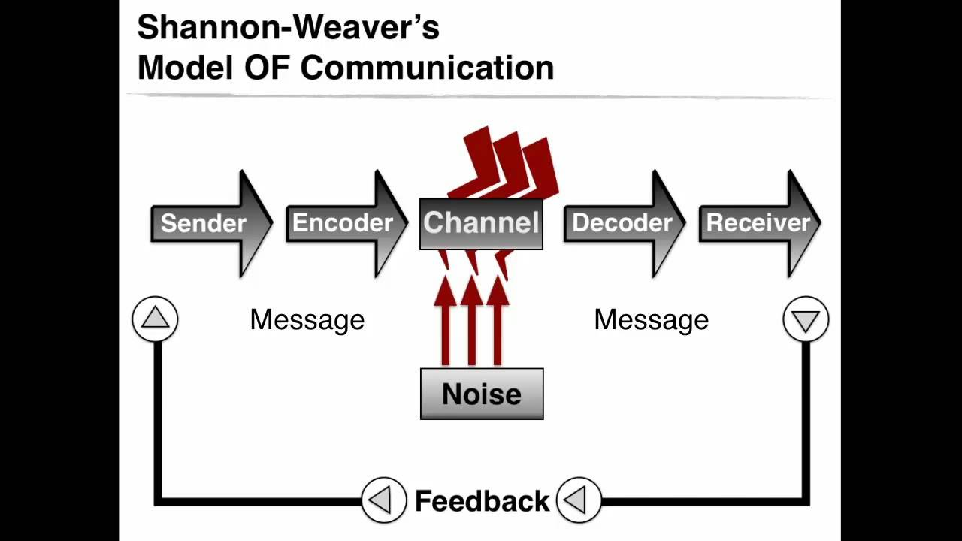

Figure: Shannon and Weaver Model of Communication
Source: Daylight (2017)
As per Ellestrom (2018), Aristotle’s model of communication is a speaker-centred model where the speech and speaker are important. This model is widely divided into speaker, speech, audience, occasion, and effect. At Harrods, the speaker is the CEO and Board of Directors who provides a speech to the audience, the shareholders, the employees. The occasion is to improve the revenue and productivity of the company. The effect lies in the development of two-way communication to improve the quality of luxury production (Medium 2022). The main disadvantage of this model is that this can be used only in public speaking. The advantage is that this model helps to interpret different questions and observations.
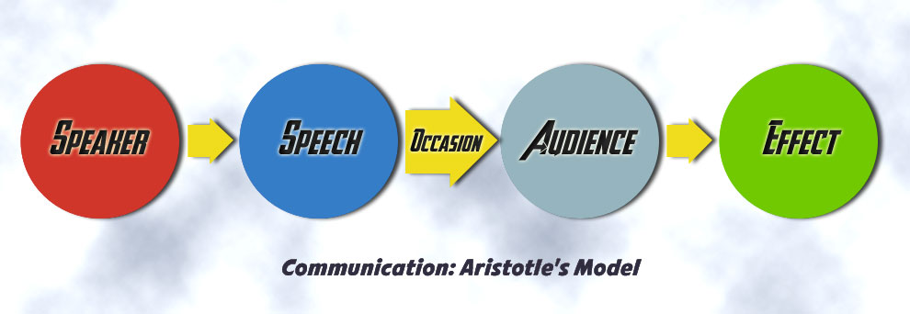

Figure: Aristotle’s model of communication
Source: Medium (2022)
The main difference between Shannon and Weaver Communication Model and Aristotle’s Communication Model is that while in Shannon and Weaver model, both the receiver and sender are equally important, in Aristotle’s Model, only the speaker has achieved importance. The similarity is that in both the models, the speaker sends the messages, and the audiences receive them.

2.2 Concept of integrated marketing communications
Integrated marketing communications or IMC is defined as a systematic process that is employed by businesses to unify multifaceted elements of its marketing communications (Payne, Peltier, and Barger 2017). Some of the most common elements include public relations, principles of business development, social media, advertising, audience analytics, and more. These elements are unified into a strong brand identity that categorically remains constant across various media channels.
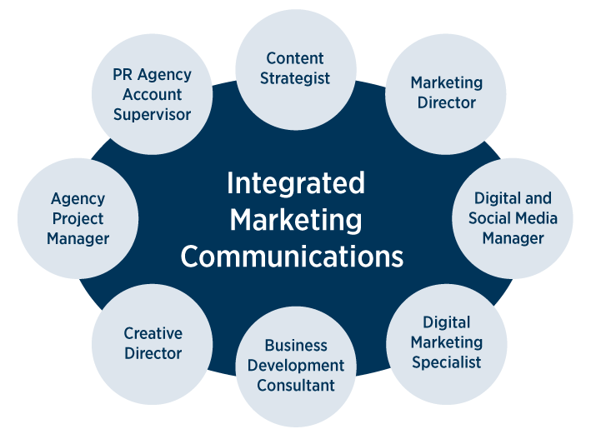
Figure: Dimensions of Integrated Marketing Communications
Source: Themarcomavenue.com (2022)
IMC is often defined to be a multi-disciplinary field that tends to combine both conventional and new media-based practices in the business organization. As the name implies, it is more like a holistic marketing approach that typically considers marketing strategies within a considerably larger organisational context. It significantly enables both private and public organisations to deliver a seamless and engaging customer experience for its products and services. However, in contrast, Oluwafemi and Adebiyi (2018) revealed that IMC helps to optimize the relationship of the business with its prospective stakeholders by which the brand image can be customised and strengthened. Again, as per Procter et al. (2019), IMC is an approach used by the brands to coordinate their efforts of marketing and communication. To support this view, Laurie and Mortimer (2019) states that IMC helps to promote messages through different communication strategies.
Professionals having an experience or background in IMC should pursue their employments through communication and marketing industries (Gardiner 2015). According to the author Lahtinen et al. (2020) Ismagilova et al. (2020b, 2020a), these assumptions are founded on misunderstandings and a reductionist perspective of our time's most pressing challenges. Instead of abandoning the notion, it is recast in a new perspective to highlight its paradoxical implications and avoid reductionism (Muhammedrisaevna et al., 2020). The concept of "beyond human capabilities" demands knowledge of human processes and characteristics (e.g., intelligence, language, abstract thinking, the creation of art and music, emotions, and physical abilities, among others). This simple concept has some faults. Roboticists are unconcerned about what it means to be human, construct sentient machines or the consequences of these divisions. According to the materialist explanation for these disparities, these divisions arise from the actual and repeatable interaction of matter (i.e., these distinctions are based on the most fundamental questions concerning matter) (Juska, 2021).
The computational theory that they accept as a framework for developing robots that approach and transcend human consciousness and emotions, on the other hand, does not explain how such a robot could produce subjective experience or emotions. These hypotheses, often known as "high-level cognitive computers," fall short of providing the computational foundations necessary to confirm or reject the idea Kitchen (2020). When neuroscience approaches fail to give any knowledge regarding simple computer systems such as microprocessors, futurists believe reverse engineering is the most outstanding solution because the technical challenges to building these devices are not trivial. Engineering in reverse (Bairrada et al., 2019a, 2019b). If neuroscientific approaches cannot derive valuable information from microprocessors, we must either conclude that neurons do not act as computers or that everything we know about cells and neurons is incorrect. Reverse engineering cannot be used to learn about the brain, and outcomes in neuroscience linked to mechanistic and computational interpretation are likewise ruled out as viable choices. Some intermediate and fundamental issues must be addressed
before declaring that some computers will match or exceed human skills (Kuehnl et al., 2019).
" In the third section, common conceptions of computation, cognitive computing, and information processing are challenged; in the fourth section, consciousness is discussed as an essential requirement for creating computers with similar human intelligence; and in the following two sections, a new hypothesis on how computers can be made to behave like humans is presented (Eagle et al., 2020). Parallel conversations will be held on the idea of transcending human capacities and constructing conscious machines capable of producing the same paradoxical consequences. A preliminary evaluation of fresh thoughts and ideas will also be carried out to develop them further in future works (Maison, 2018).
Customers are depicted more realistically in the cognitive method as responsive and active participants in data collection and decision making. Even if the emotional method is not entirely correct, it emphasises the importance of feelings and emotions in specific encounters. Harrods demonstrates how impulsiveness, and a lack of consideration could emotionally impact customers (Muhammedrisaevna et al., 2020). Each of these four perspectives must be represented in any model that attempts to capture a buyer's decision-making process. We could study how Harrods customers make decisions when they have limited control over the circumstance using the behavioural impact approach (Nguyen, 2018). According to -, customers' actions could be influenced by their immediate environment, according to the concept of behavioural impact. All problem-solving approaches, no matter how wide or limited, require some level of investigation and argument, but the extent of consumer involvement varies (Juska, 2021).
On the other hand, routine decision-making is based on a high degree of automaticity and low effort. The in-depth study on the impact of marketing communication on customer decision-making processes is lacking in the literature. Through integrated marketing communication, consumers' psychological processes that determine their behaviour could be altered and changed (Gilal et al., 2019).
The term "integrated marketing communication" refers to the fact that communication is included in all four components of the marketing mix: product, price, distribution, and marketing communications (Kuehnl et al., 2019). Market research that facilitates successful market segmentation must be the foundation for this influence. Products are created to fulfil customers' wants, distribution channels are chosen, and marketing materials are created in a manner that reflects these aspects (Llopis-Amorós et al., 2019). The needs of the customers are clearly defined. The integrated communication strategy and plan assist and organise the integrated marketing communication operations. Harrods has positioned itself in the market following its integrated communication strategy, which is based on its goals and communication axis. This implies Harrods be able to choose components that are cost-effective in the context of the overall project.

2.3 Types of promotions in integrated marketing communications
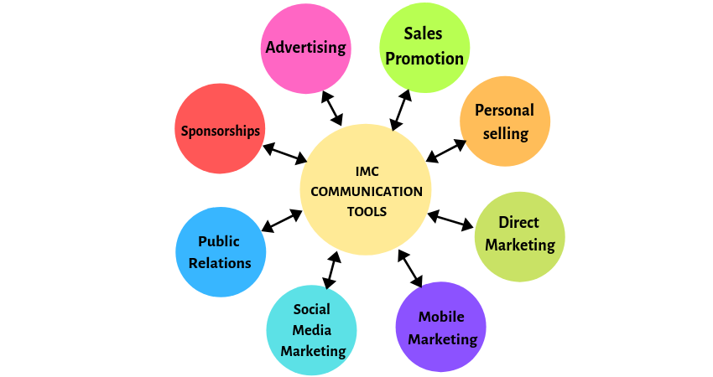
The process of mediating a strong IMC begins with a strategic plan of marketing communication that bifurcates and combines different aspects of sales, marketing, and advertising tools. These tools are majorly used during promotions that entail all aspects of the business ranging from social media marketing to blogs to SEO management, and more (Duralia 2018).

Figure: Major tools for integrated marketing communications
Source: Boisen et al. (2018)

Marketing promotion is a process of communication between the seller and buyer where the buyer persuades the sellers to purchase the products as per Boisen et al. (2018). The different types of promotions used by Harrods include digital promotions, sponsorships, sales promotions, advertising. Harrods tend to develop marketing promotion through sensational marketing campaigns that focuses on customer-centric approach. The company also uses direct mailing to the customers to increase their interests about the innovative luxury products.
Digital promotions: Digital promotions are the promotions found on the internet. These promotions are faster to develop to reach the customers. Harrods tends to use digital promotion in the form of social media marketing. The company helps to select Facebook, Twitter to create an internal social network that tends to provide opportunities to the employees in active engagement with the customers. The digital promotions of the company include online magazine, launching of transactional websites to improve e-commerce customer journeys (Marketing Week 2022).
Sponsorships: Through sponsorship, an organisation provides money and resources to an individual to receive advertising and publicity. Harrods tends to generate sponsorships through creating sponsor pitches for its group of companies, Harrods Estates, Harrods Aviation to help to create advertisements (Sponsorpitch 2022). The other sponsors of the company include Vogue Festival through which an event has been organised where Harrods marketed their products to the customers.
Sales promotion: Sales promotion is a promotion that develops the process of limited period offers. Harrods tends to develop sales promotion through the creation of the Rewards Weekend program that leads to the increased sales of luxury products (Boisen et al. 2018). Harrods sets up different sales programs both in-store and out-store through which the company provides attractive offers and discounts to the customers. As a result, the gross profit of the company worldwide has been 220 million pounds in the year 2020/21 (Statista 2022)
Advertising: Advertising helps the customers to get an idea of the different products that facilitates brand awareness. Harrods tends to create advertisements of their products on its websites, YouTube that can create brand awareness on a large scale (Wixson 2018). The company uses advertising strategies by maintaining a strong online presence. This includes partnerships with the other external companies.
Mobile Marketing: Harrods has developed a mobile application that helps to serve both as an information and map of the locations and luxury products to the customers (Boisen et al. 2018). The company has also developed a transactional mobile site that is helping to develop a long-term growing presence in the global luxury markets.
The AIDA Model is being used here to identify the different stages that an individual passes through during the process of purchasing the products (Ullal and Hawaldar 2018). The full name of AIDA is Awareness, Interest, Desire and Action (Elmo Lewis 1925). However, this model can be used as a communications model to aware the customers with different information.
Awareness: The buyers are made aware by Harrods about its products through the creation of a brand awareness campaign on YouTube, Facebook, and the website.
Interest: The interests of the people tend to be generated by the company through a content strategy that contains all the desired features and prices of the products.
Desire: The Company (Harrods), tends to increase the desire of the people through personal interaction with the customers in online media to create an emotional connection.
Action: Harrods' use of the website search engine optimisation helps inaccessible communication with the customers to help them purchase products (Laurie and Mortimer, 2019).

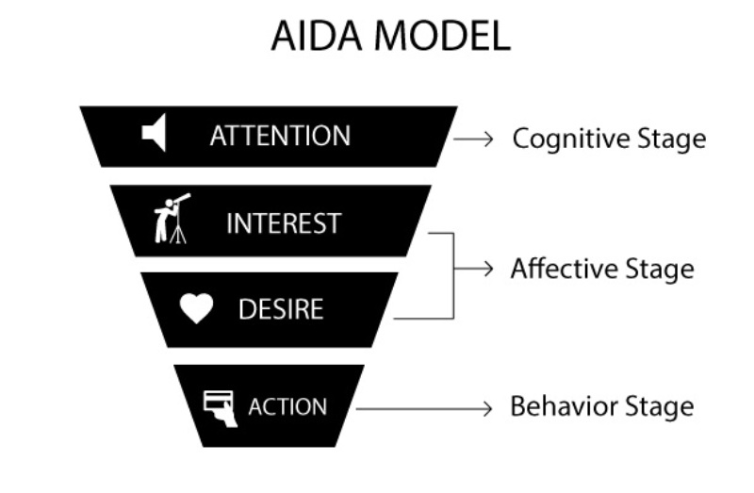
Figure: The AIDA Model
Source: Elmo Lewis (1925)
However, as per the other authors, this model lacks the empirical evidence for the effectiveness and the processes and methods can vary. The main advantage of this model is that all the current activities of marketing can be known, and the main disadvantage is that the process of the purchase decision is not considered after purchase.

2.4 Concept of consumer behaviour and its importance
Consumer behaviour is one of the most important aspects of marketing management. According to Lopez et al. (2021), consumer behaviour depicts the study of how customers or organisations select, specify, purchase, and dispose ideas, products, and services in order to fulfil their wants and requirements. It strategically refers to consumer actions in the marketplace and their underlying intent for those activities. For a marketer, it is very important to understand the patterns and behaviours of customers in the marketplace because the trends followed are to be implemented in the business model. To support the statement, a thorough knowledge of consumer behaviour is the key to reaching and associating the clients and eventually converting them into potential buyers (Kothari and Maindargi 2019). If a marketer can understand how customers behave and what attracts them, it will be easier for him to strengthen his consumer base and eventually his net revenue generations will also increase. A consumer’s behavioural trends and patterns are influenced by multiple dimensions, each of which have substantial impact on people and processes. Again, as per Lopez et al. (2021), consumer behaviour is the study of the individuals or organisations that is being attached with the purchase and use of the services. To support this statement, Nguyen and Johnson (2020) develops the opinion that consumer behaviour is the study of consumers and processes relating to dispose of services and products. To contrast to this statement, Ahmad et al. (2019) said that consumer behaviour includes physical and mental activities to help consumers engage in evaluation of the products.
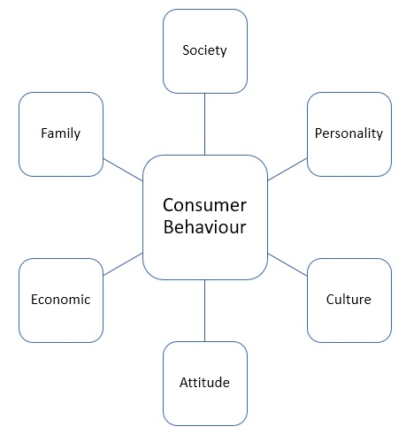
Figure: Elements influencing customer behaviour
Source: Lopez et al. (2021)

Besides, this comprehension is essential for marketers to understand what will influence the buying decisions of customers. Secondly, studying customer behaviour is also helpful for marketers to decide how to offer their business products and service facilities that can generate maximum influence on the customers (Kothari and Maindargi 2019). Many business employers make use of consumer behaviour analysis that reveals the way customers think and mainly how they feel about different alternatives (Foxall 2017). Secondly, it helps the marketing manager to better understand what impacts or influences a customer to select between multiple options.

2.5 Types of consumer behaviour
In the business environment, four major types or categories of consumer behaviour exists that marketers should know.
Complex buying behaviour
When purchasing pricey, infrequently purchased items, customers are more likely to engage in this type of behaviour. Prior to making a final investment decision, the purchasing and consumer research procedures considerably influence investment decision-making. This type of behaviour is more likely to occur when customers are actively involved in the process of completing an online purchase (Kotler et al., 2021). Purchasing a home or a car is one of the most significant investments a person could make. Consumer behaviour, according to experts, could be theoretically split into five groups (Bairrada et al., 2019a, 2019b). These basic client behaviour processes are exploited in genuine marketing as operational endogenous or exogenic aspects, respectively. One of the most significant components of conducting behavioural studies is taking into account the five multi-dimensional critical processes in this block: perception (information/learning), attitude (motivation), and actual behaviour (Gómez et al., 2019).

Impulsive buying behaviour
Impulsive buying encompasses the tendency of a buyer to purchase products or services from the market without any pre-planning (Researchgate, 2022). In other words, it refers to the behaviour of a customer to make unplanned purchases purely based on illogical thinking (Ahmad et al. 2019). Perhaps, customers do not need such things but out of their impulse, they end up spending a considerable part of their income in the process of buying. In many cases, marketers tap this behaviour of consumers in order to boost their sales and profit margins.
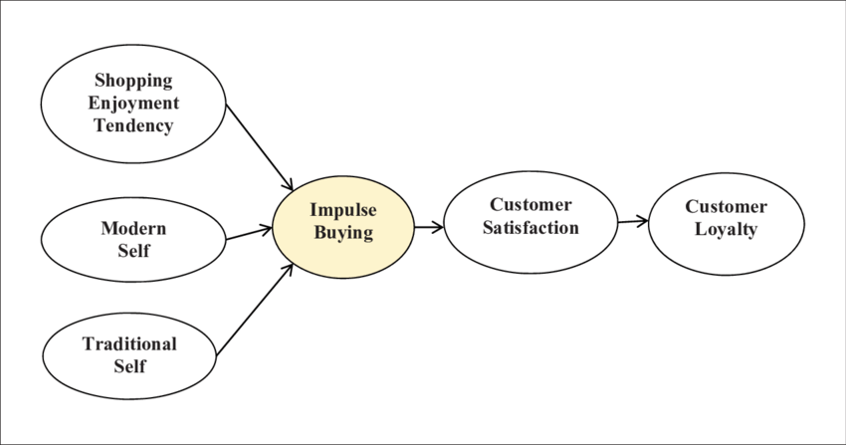

Figure: Impulse purchasing tendencies of customers
Source: Researchgate (2022)

Habitual buying behaviour
Habitual purchases of customers are characterized by their limited involvement in the brand or product category. For example, a customer visits a grocery store and purchases products of their preferred choices. This reflects their habitual patterns, not strong brand loyalties because in absence the brand of his choice, he may also choose another brand which he would need daily for his consumption (Sheoran and Kumar 2021).
Dissonance-reducing buying behaviour
In this type of customer behaviour, although they are very strongly involved with the overall buying process but faces various difficulties and challenges in determining the distinction between various brands (Palalic et al. 2020). Many buyers find it difficult to distinguish between different brands due to their involvement in the entire purchasing process (Ližbetinová et al., 2019). It is usual for buyers to be unsure whether or not they would be content with their purchases, which is referred to as "contradiction (Kotler et al., 2021)." According to marketing pros, customers go through the following processes when purchasing goods and services: recognising needs, gathering information, evaluating possibilities (the "evoked set"), arriving at an assessment conclusion, and finally, post-purchase evaluation. Before making a purchasing choice, consider the product's specifications, the consumer's target market, and the five major consumer behaviour processes (Laurie and Mortimer, 2019).

Variety seeking buying behaviour
In this particular situation, customers buy different product or services, not because the prior purchase had brought to them any dissatisfaction; but it is because they love to go for different varieties. This is one of the most attractive elements for marketers because knowing what type of buyers the store may attract will provide the marketer with a much constructive idea of the customer segmentation in the market (Nagar and Singh 2021).
The variety seeking buying behaviour of consumers is being identified at Harrods. The consumers at Harrods tends to like to shop around the outlets of the company and try out innovative luxury products. They do not focus on the particular product in mind during shopping and thus, they go for experimentation of the varieties of products (Ahmad et al. 2019).

2.6 Factors influencing consumer buying behaviour
Consumer purchasing behaviour can be influenced by different factors. These include motivation, attitudes, culture, social class, liquid assets, lifestyle.
Motivation: Maslow’s model of motivation states that motivation is the outcome of the individual’s attempt to fulfil the five important needs- physiological, social, safety, self-esteem, and self-actualisation (Badubi 2017). However, as per Schunk and DiBenedetto (2020), motivation helps to initiate, guides, maintains objective-oriented behaviour. In this respect, the variety-seeking behaviour of the customers at Harrods leads to improved brand loyalty. In contrast to this, Berridge (2018) is of the opinion that motivation is a combination of actions and motives to bring satisfaction to the customers.
Physiological needs: These are the needs required for human survival, like water, shelter, food (Maslow 1943). To support this view, Hopper (2020) states that physiological needs include self-preserving and basic needs. The physiological needs help the customers at Harrods to thrive for product variety. The manager at Harrods tends to account for the physiological needs of the employees by providing reasonable working hours and a comfortable working environment. The satisfying customers tend to fulfil their basis needs for water and food when they go to the food hall set up by Harrods. This is the basic lower level need that tends to be satisfying.
Safety needs: These needs are related to the safety and well-being of the people (Badubi 2017). To support this, Shaughnessy, Moffitt and Cordova (2018) opined that safety needs lead to financial security which is more important than physiological needs. The safety needs of the customers help them to choose variety of products conveniently with dedicated customer service. The manager of the company can account for the safety needs by providing job security and secured compensation to the employees.
Social needs: Social needs are the needs of acceptance and belonging (Berridge 2018). In contrast to this, Palalic et al. (2020) states that social needs are the basic human needs to prove that they are social beings. The manager at Harrods can account for the social needs of the employees by encouraging cooperative teamwork and supervision. The cafe at Harrods serves as the important place where the customers tend to know each other through product discussion that serves basic social needs.
Ego or esteem needs: These are the needs for respect and self-esteem (Moffitt and Cordova 2018). To support this, Hopper (2020) states that esteem needs need strength, social acceptance, and respect from others. The manager at Harrods can account for the esteem needs of the employees by providing internal promotions and internal recognition. The customers of Harrods tend to have their efforts recognised through purchasing items at luxury stores. Esteem needs will connect into internal and external ego needs that customer will satisfy when they purchase these luxury goods. Thus, it meets their prestige needs.
Self-actualisation needs: As per Badubi (2017), the company can account for this need by engaging in the decision-making and autonomy of the employees. Thus, they provide full attention to the customers and gives the best to them that leads them to seek for variety.
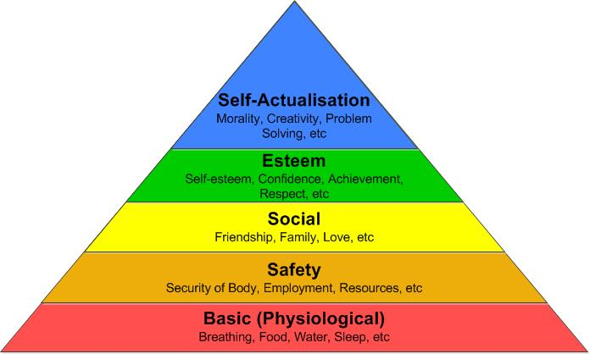
Figure: Maslow’s model of motivation
Source: Maslow (1943)

However, as per Palalic et al. (2020), the need structure of this model is to be revised to promote satisfaction. This model tends to suggest that human beings possess a hierarchy of needs through addressing the basic needs before moving to safety.
Advantages | Disadvantages
Higher employee engagement | Lack of rank-ordering of needs
Proper interpretation of motivation | Lacks validity across different cultures

The main advantage of Maslow’s law is that it serves to interpret motivation through knowing human behaviour. This leads to higher employee engagement in work and lower absenteeism. However, the main disadvantage is that it is too culture-bound that lacks rand-ordering of the needs.
As per Ahn and Back (2018), attitude is the way to feel about someone. In contrast to this, Foxall (2017) states that attitude can be a negative and positive evaluation of events, activities, and objects.
Attitude: The ABC Model of attitude represents the three components of attitude- affective, behavioural, cognitive (Zhang, Zhang, and Zhou 2021). This model helps to evaluate the ideas through the development of attitudes.
Affective: The affectively based attitude results from the creation of values as per Chiu et al. (2019). Again, as per McCauley (2020), affective attitude involves person’s feelings and emotions about the objects. The value is created through offering low prices at Harrods to validate the value systems. The customers get satisfied by the initiatives of the company and they become affective by judging the products.
Behavioural: As per Chiu et al. (2019), behaviour includes people’s change of mind. To support this, Yale University (1960) states that behaviour depicts customer’s attitudes towards products. The marketing team at the company helps to market the products effectively that can influence consumer behaviour to make it favourable for them to seek variety.
Cognitive: This tends to involve the belief of the customers about the company's attitude as per Zhang, Zhang, and Zhou (2021). Again, as per McCauley (2020), cognitive attitude leads to develop customer’s feelings. Harrods tend to create online content for luxurious products to help the customers to seek variety.

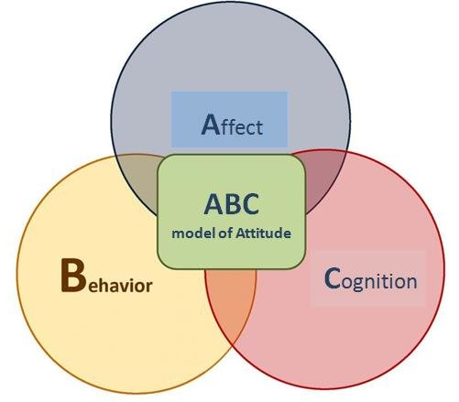
Figure: ABC Model of attitude
Source: Yale University (1960)

This model leads to the development of consistency of the attitudes with the behaviour of the individuals. However, as per Foxall (2017), the potential relationship in the model between the attitudes and behaviours of the persons is understood.
Advantages | Disadvantages
Effective emotional and mental functioning | Misperceived norms
Planned behavioral attitude | Negative associations within the attitude

The main advantage of this model lies in effective behavioural attitude through successful planning to lead to effective emotional and mental functioning. The disadvantage is that there is the coexistence of positive and negative associations within a single attitude that leads to misperceived norms and behaviour (Zhang, Zhang, and Zhou 2021).
Culture: Hofstede cultural dimensions model is a framework to develop cross-cultural communication (Beugelsdijk and Welzel 2018). This theory can be applied to Harrods that can relate the values to the behaviour. The company operates in different countries that help to understand the culture of the people. This helps them in the manufacturing of luxury items as per the choices and demands of the customers in a particular place. However, this theory is used in the domains of human social life through developing internal communication as per Hofstede (1970). This model leads to the generation of a humble climate by caring the customers. People from different cultures seek variety at Harrods by believing in the company's passion for creating new products (Govindan et al., 2019).

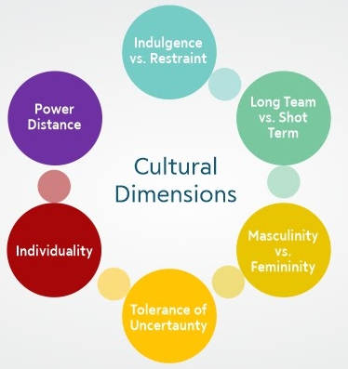
Figure: Hofstede cultural model dimensions
Source: Hofstede (1970)
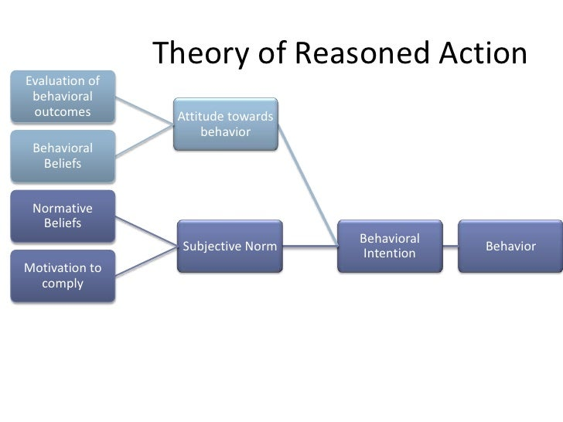
Social Class: To better illustrate the discussion encompassing the main focus of interest in the present study, the theoretical framework of consumer behaviour is important. As per Sheoran and Kumar (2021), the exploration of how individuals make relevant decisions concerning their purchases assist and guide marketers and business employers to capitalise on such behavioural patterns and strengthen the business sales frequency. In this aspect, the theory of reasoned action deserves a special mention. The theoretical framework depicts that specificity is highly solicited in decision-making process as per Fishbein and Ajzen (1975). However, as per Xiao (2020), a customer takes a certain specific action only when there is an equivalent result expected from it. From the time the person decides to act till the time he completes it, he retains his ability to change his mind and eventually decide on a completely different course of action. Marketing managements have many aspects to be learned from this theory. For example, Harrods markets its offering to customers, to relate a purchase with a positive and growing result that is specific. Again, Sheoran and Kumar (2021) state that the theoretical framework also highlights the significance of moving customers across the sales pipeline. The marketing manager of Harrods tends to understand the lags between a customer’s initial intention and the completed course of action that ultimately allows buyers a considerable time to raise concerns about the purchase outcomes. Again, Mishra et al. (2021) state that the theoretical framework also highlights the significance of moving customers across the sales pipeline.
Figure: Theory of reasoned action
Source: Fishbein and Ajzen (1975)

Various other theoretical premises are also there with relevant implications on consumer behaviour; however, this theoretical premise helps to specifically explain why different factors are related or not related to a particular behavioural trend of customers. Besides, this theory also serves as a very effective model as it helps to evaluate whether buyers’ intent to do something is determined by organisational strategies (IMCs in the context of the present research study).
Liquid assets: Liquid assets can be converted into cash easily to create comfort.
Lifestyle: Lifestyle is an attitude in which the individual resides in society.

2.7 Impact of integrated marketing communications on consumer behaviour
In the business environment, marketers need to explore consumer behaviour because it aids them in positioning their business brand well and developing strategic marketing approaches.
IMCs help to make a marketing manager understand the differential aspects of consumer behaviours and what necessary elements are to be implemented in the product line or service range such that the business can entice customer attention largely. By making subsequent use of IMC, a business can raise customer awareness of its products or services (Payne, Peltier, and Barger 2017)
However, in accordance with Duralia (2018), by means of continuous communication, it is possible that a business makes the prospective and potential customers aware of the products’ benefits and helps them to differentiate the products of a particular business from its potential market contemporaries. This helps them to make a specific preference and ultimately contributes to the business profitability. Business brands can potentially ensure that their IMC messages are timely received by their target audience. To support the statement, those communication channels not only influence customer behaviour, but also improve business efficiencies by means of providing a streamlined process of being engaged with the desired set of audience (Procter et al. 2019). Business organisations like Harrods make use of various marketing communication tools by which they can understand and influence buyers’ decision-making process.
IMC Process Model
Integrated Marketing Communication model, abbreviated as IMC model, illustrates the communication process solely related to marketing and associated activities that takes place between the sender and receiver (Butkouskaya, Llonch-Andreu and Alarcón-del-Amo 2021). IMC is the process through which companies accelerate their returns by considering a consumer-centric approach to align their marketing objectives with overall business goals.
In the IMC process model, five key steps are involved. Firstly, organisations identify their customers from behavioural information. Secondly, they undergo a valuation of the target customers. Thirdly, communication with the customers is established through message delivery and incentives. Next, the ROCI (Return on Cost Investment) needs to be estimated by the companies followed by budget allocation, evaluation, and recycling (Mstoner.com 2022). By providing diverse types of information, all IMC components improve customers' acquisition of purchase and consumption knowledge. New information received through reading, conversation, and direct experience constantly reshapes the learning process. One of the most significant purposes of IMC is to influence a person's attitude, which a product's pricing distribution could influence, and marketing messaging and by coming into direct or indirect contact with the attitude object (Mahsan et al., 2020). At the same time, motivation gives the behaviour it motivates a sense of purpose and direction (Govindan et al., 2019). Through its marketing communications component, IMC has the potential to have a global impact on motivation. Identifying the motivations that a product could satisfy is critical in establishing its primary features. In this circumstance, customer objectives and regulatory emphasis on promotion serve as the foundation for motivation. Utilising the appropriate marketing communication channels, IMC could influence this stage by emphasising the good experiences of using the product. Making decisions based on one's mindset is a logical evolution along the same lines. Individuals' heuristics, or generalised impressions and attitudes, may be influenced by all of IMC in some manner (Laurie and Mortimer, 2019).

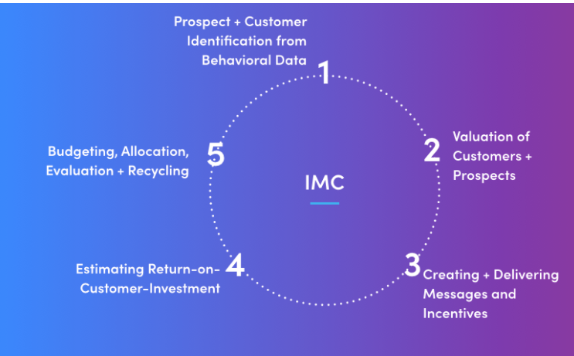

Figure: IMC Process Model
Source: Mstoner.com (2022)
Harrods tends to follow the IMC process model for establishing a friendly bond with its customers. To do so, the company must undertake few initiatives. Firstly, it must recognise its target group of customers from the consumer pool based on the behavioural information. However, in contrast of the above statements, by IMC model, behavioural data of consumers represents their attitude, lifestyle and actions related to purchase (Hewett and Lemon 2019). Again, as per Sulaeman and Kusnandar (2020), once consumers are identified, a financial value for the customer needs to be determined. Marketing goals at Harrods should be formulated therefore considering business goals and objectives. Integrated marketing programs such as advertising, sales promotion, personal selling, or direct marketing are being developed by the company. Thereafter, ROCI needs to be estimated followed by budget allocation (Ližbetinová et al., 2019).
Although the IMC process model is highly acclaimed by marketers, its high costs and overloading information somewhat reduces its effectiveness. Also, ROI estimation can be confounding without proper strategies and resources (Ližbetinová et al., 2019).
Wheel of IMC Model
The wheel of IMC model illustrates the different marketing mix communication elements that can be leveraged by companies to develop marketing communication initiatives (Světlík 2017).
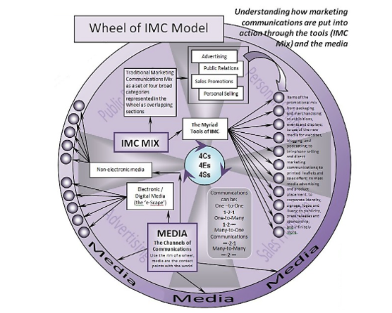

Figure: Wheel of IMC Model
Source: Figshare (2022)
To support this, the wheel of IMC model basically defines the ways in which marketing communications are applied into real-life actions through different IMC tools and media (Zwerin, Clarke and Clarke III 2020).
Harrods can leverage non-electronic as well as electronic media for promoting its marketing communication. This media is considered as the channel of marketing communication. For electronic media, “e-scape” can be used. On the other hand, newspapers or magazines can be used as non-electronic media. By following this model, the communication with the customers can be one-on-one or many-to-many. Henceforth, the purpose of creating an integrated communication program for marketing will be achieved by Harrods (Figshare 2022).
However, the biggest disadvantage of the wheel of IMC model is its complexity as per Boisen et al. (2018). Also, this model did not address issues like miscommunication, lack of resources and diverse corporate culture. Therefore, if any of these issues emerge in the marketing communication, this model will be of no help.
similarities
IMC Process Model | Wheel of IMC Model
- This model is related to integrated process communication in marketing. | - This model is related to integrated process communication in marketing.
Difference
- This model involves consequent steps to allocate budget for customers after targeting a specific group of consumers.  - Marketing objectives are the key considerations of this model. | - This model is concerned with the actions that are needed to undertake marketing communication.  - Marketing mix and media are the tools that are involved in this model.

2.8 Literature gaps
Although the concept and implications of IMC has been documented by various authors in existing literatures over the decades to date, it cannot be said that there is any potential unanimity or consensus in what regards these marketing approaches as encountered in existing academic or literature resources. Moreover, understanding how IMC influences and strategizes customer behaviour in departmental stores is a very promising area of research because not much focus has been given to explore these retail stores and their marketing approaches in a greater detail. Moreover, over time, the business processes of Harrods have undergone significant changes in light of digitalisation. Therefore, the present study aims to address these knowledge and literature gaps and also seeks to study how IMCs have strengthened and influenced customer behaviour for the British departmental store. Though there tends to exist different models of IMC in the study, however, there has been a dearth of information about the luxury market where Harrods tends to operate. Again, the relationship between luxury market and Harrods offerings are missing in the literature. This lack of details has led to the lack of current situation of the luxury market. (Dewnarain, Ramkissoon and Mavondo, 2019). Further, the impact of Covid-19 on Harrods has not been described in detail. This led to the lack of the predicting the current marketing and selling situation of the company in post-pandemic.

2.9 Conclusion
From the discussion through the chapter, it is evident that by administering strong IMCs in the business model, marketing managers are able to boost sales and profit margins all over their business organisations. The current chapter thereby provides a strong and insightful accounts of various concepts and terms related to the given topic of the study. It shows the importance of establishing strong IMC strategies that can maximise the marketplace recognition of business enterprises over various consumer platforms. The present chapter also aligns these concepts based on specific theoretical premise that helps in forming better comprehension of the impact of IMC approaches on customer behaviour. The indicative review additionally helps to identify pertinent gaps in knowledge and literature that will be addressed in the sequence of the present study.

Chapter Three: Research Methodology

3.1 Introduction
The chapter will focus on the methods, procedure, planning and framework required for completing the research. It will highlight every aspect required for conducting the research methodologies that will be focused upon various aspects. Further, the chapter will demonstrate the various research techniques that will be further used while formulating the findings and analysis of the thesis paper (formpl, 2020). The chapter is entirely focused on an in-depth analysis of the research methods that will be further illustrated in the overall study. An extensive analysis of the philosophical aspects of the research will be determined. Further, data analysis tools and techniques will be described comprehending all the ethical considerations for the study. Apart from that, this section will highlight the ethics, limitations, time horizon, sampling determined for the study.

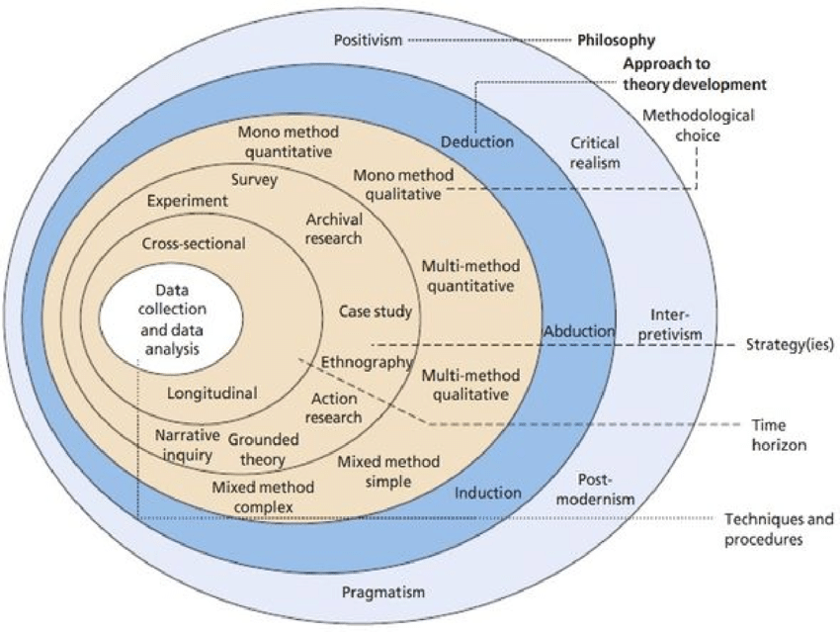
3.2 Research Onion
Figure 1 Saunders Research Onion model
(Source: Melnikovas, 2018)
The guidance model known as the research onion will be followed and applied. The research onion model was introduced in Saunders, Lewis, and Thornhill's book on business research methodology in the year 2007. It demonstrates the various decisions that are needed for developing a research methodology. It is a useful tool that provides an effective understanding of the research design. It has various layers such as philosophy, approach, strategy, choice and different techniques and processes of data collection (Melnikovas, 2018). Further, this strategy is intended to assist students in better understanding the various stages of dissertation preparation. Using the Research Onion model, we can see how several study components could be investigated to arrive at the ultimate study design.
3.3 Research Philosophy
The research data for the thesis has been gathered, reviewed and analysed on the basis of the philosophical aspects. The research philosophy is regarded as the ways through which the data regarding a phenomenon needs to be gathered and used.
There are various types of philosophy that occur, such as pragmatism, interpretivism, realism and positivism. This thesis paper will follow the positivism philosophy to determine the analysis based on the data collection (Žukauskas et al., 2018). Moreover, the positivist philosophy maintains a highly structured methodology that facilitates the hypothesis of the paper. Though the study does not focus on any kind of hypothesis, it will work on the quantifiable observations and obtain a statistical analysis of the study (Moon et al., 2019). Here, the investigator cannot manipulate the data during the collection process, and the results are deemed to be authentic. In this philosophy, the researcher will study the literature review, identify the gaps, and further comprehend through findings and analysis.

3.4 Research Approach
The research approach is regarded as the plan and process that includes the stages of broad assumption along with the detailed procedure of data collection, interpretation, and analysis. Further, the approach is conducted on the basis of the research problem that is needed to be addressed. There are three categories of research approach, namely deductive, abductive, and inductive approaches. The thesis has followed a deductive approach wherein known premises are true conclusions also has to be true (Maarouf, 2019). The approach ascertains the generalising from the specific approach for determining the results of the study. Apart from that, data collection has been used to explore the given phenomenon identification of the patterns and themes for creating a conceptual framework. Further, this approach does not include hypotheses. It starts with aims, objectives and research questions that are required to be achieved within the research procedure (Costa, Soares and de Sousa, 2020). In the deductive approach, the findings will be conducted based on the research questions and based on it, and the analysis will be conducted. Further, the answer to the research question will be determined at the end of the process while implying a new theory in regard to the stated research problem (research-methodology, 2022).

3.5 Research Strategies
For this particular thesis paper, a survey strategy is conducted. In survey strategy, the data is collected from a predetermined group that is regarded as respondents from where information is gained, and insights are acknowledged from various interests (research-methodology, 2022).In this project, a survey strategy will be followed. Survey strategy is regarded as a quantitative approach wherein the information is collected from the respondents through multiple open-ended or close-ended questionnaires. The advantages are its response rates are quite high and less time-consuming. However, one drawback could be that in the survey questionnaire, the respondents can skip questions and depends upon the response of the respondents, which may not be accurate.

3.6 Type of investigation
Primary Research
It is a type of research wherein the investigator takes data directly from the primary source. The data may be quantitative or qualitative information. Further, the survey will be collected from the information gathered from a close-ended questionnaire. The primary research is defined as the accessing to the authentic sources in order to collect required data for the purpose of research. This kind of data collection method is required to develop the research project with the immense contribution from the researcher (qualtrics, 2022).

Advantages
- More contemporary and up to date: The researcher gathers data at the most opportune period.
- It is more current than the preceding phrase. Researchers collect data through observations based on their objectives and inquiries (Bairagi and Munot, 2019)
- Confidential: The data is only accessible to academics. It cannot be used by anybody else unless the owner grants permission.
- It is much easier to manage: Of course, primary research is subject to bias. On the other hand, researchers can sway a small fraction of it in their favour. Consider demographics.

Disadvantage
- Expensive: To gain access to the data, researchers will have to spend more money.
- Time-consuming: The length of time surveys and interviews can be determined by the number of persons who participate.
- Lower calibre: Primary data is information acquired directly from the research subjects. On the other hand, secondary data originates from a variety of sources.
- Sampling Errors: Errors in sampling invalidate all hard work (Chou et al., 2020).

Secondary Research
It is a type of desk research that includes synthesizing the data that is gathered from the internet, journals, peer-reviewed articles, libraries, and others. The secondary research is referred to as the process of analysing the existing data for conducting the dissertation appropriately. The already existing data is randomly analysed and properly arranged for increasing the efficacy level of research (qualtrics, 2022).

Advantages
- A significant percentage of the data utilised in this study is freely available to the public. There are many sites to hunt for data for secondary research rather than needing to start from scratch.
- This technique is both times- and cost-effective because the data required is readily available and does not cost much money provided it is obtained from credible sources. Data can be collected at a low cost (Hinde, 2020).
- Firms and organisations can utilise secondary research data to assess the effectiveness of primary research. As a result, corporations and organisations can formulate hypotheses and assess the costs of undertaking primary research.
- Secondary research may now be carried out more swiftly because of publicly available data. Depending on the extent of the project and the volume of data involved, it may only take a few weeks.

Disadvantages
- Even if the material is readily available, it must still be evaluated for reliability.
- The most recent reports and statistics may not be available from all secondary data sources in all circumstances. This information may be correct, but it may not be up to date to represent the current situation (Savela, 2018).

Secondary research findings are based on primary research findings that have been merged. In-depth primary research has a higher impact on the study's conclusion than secondary research. The advantages of secondary research are that it provides different perspectives of experts and insights. However, many times, researchers find it difficult to determine the exact requirement. The advantage of primary research is it provides accurate information based on the raw data collected. At the same time, it is a time-consuming and high-cost method (Armstrong and Kepler, 2018).

3.7 Research Design
Research design is ascertained for developing the framework of the research methods and techniques that the investigator determines. Further, the researchers' design allows them to incorporate the methods that are appropriate for the study and set up the thesis paper effectively for future endeavours (Armstrong and Kepler, 2018). There are five categories of research design, namely descriptive, correlational, experimental, diagnostic, and explanatory research design. The thesis paper has formulated a descriptive research design for successfully conducting the study. In descriptive research design, the investigator is focused on describing the situation determined from the research study. Further, the theory-based researched design method is demonstrated through analysing, gathering, and presenting the data collection (Dannels, (2018). The researcher is provided with in-depth insights regarding the way the research is to be done. Descriptive designs support for enhanced understanding of the requirement of the research. Further, one hindrance is that if the problem statement is unclear, then explanatory research can be conducted.

3.8 Research Choice
As opined by Oliva (2019), research choice illustrates the step-by-step action plan that provides direction developed based on efforts and enables the demonstration of the research systematically. Further, the schedule produces detailed reporting along with quality results. Four main strategies are followed within research methodology: qualitative, quantitative, and mixed methods (Holtkamp et al., 2019). It further involves the use of case study, survey, interview, action-oriented plan, themes, and others. In the thesis paper, for conducting the qualitative strategy, themes have been developed and determined based on that analysis. Following that, for quantitative choice, primary analysis has been determined (Jenny, 2014). For that, a survey questionnaire will be prepared, and data will be collected within a specific sampling size. The choice has been focused on the mixed research method to identify the gaps within the existing data that will be further evaluated by conducting findings. The quantitative survey is based on the questionnaire to collect the primary data from the respondents on the basis of the population (Sahin and Öztürk, 2019). The mixed-method choice generates a well-defined understanding of the complexities along with the contexts of the experiences for generating a better explanation of the research. Advantages are it provides an enhanced understanding of the issue and can yield appropriate evidence to conduct the research. Further, the validity increases by using this research. The disadvantage is that the findings sometimes become difficult to interpret, and discrepancies can occur during the procedure (Baran, 2022).

3.9 Data Collection Methods
These methods can be described as the way through which the data is collected for the overall research. Further, the data collection methods allow the individuals to conduct the research effectively. This ensures that the overall research is conducted with the help of organised data, and that can be useful for the research. This also helps in maintaining the authenticity of the research (NDUKWU, 2020). Apart from that, there are different kinds of data which is used for the overall research, and this helps in doing the research is authentic. Further, there are two different classifications for the data, which is the primary data as well as the secondary data (Sileyew, 2019). The raw data which is collected from different individuals is termed the primary data. Moreover, the secondary data is the one that is collected from the previous works which relate to the topic of the overall research (Lindgreen et al., 2021). Further, in this research, the author has made use of the primary data, which has been collected with the help of a questionnaire. This type of data helps in utilising the real-time data that is available to the author (Gottlieb and Oudeyer, 2018, pp.758-770).

3.10 Data collection Tools and Techniques
The data collection tools and techniques refer to the process through which the data is collected from the individuals. Further, this is an effective method that allows the individual to conduct the overall research effectively. Apart from that, this is an effective process through which the individuals can manage to categorise the overall data in a systematic way (formpl, 2020). This also helps in managing the overall authenticity of the research. The data which is further collected allows the individuals to further subject it to the hypothesis testing, which eliminates the assumptions while making any kind of proposition for the research. In this research, the author has made effective use of a questionnaire (Gonzalez-Franco and Peck, 2018). The questionnaire has been prepared with the help of nine different close-ended questionnaires. The individuals who will be taking part in the survey will be allocated fifteen minutes to complete the overall research. Apart from that, the data which has been extracted with the help of the questionnaire allows the author of the research to gain the responses from the consumer itself and ensures that the overall research can be more authentic, and the authenticity of the overall research is also maintained (embibe, 2020).

3.11 Sampling
The process of sampling refers to how the individuals can undertake the statistical analysis in which the observations is taken from the large population. Further, this is an efficient process through which the raw data can be converted into a useful source of information and then it can be utilised for the overall research (Berndt, 2020, pp.224-226). This process helps in making the research more authentic, and it allows the researcher to make the author of the research authentically conduct the research, and it ensures that the individuals can sort all the relevant details regarding the research, and they can authentically undertake the research.
Sample size: The sample size refers to the number of observations which has been used to determine the estimations of the given population. This is an effective process through which the individuals are able to gain the necessary benefits within the overall organisation, and they will be able to enhance the overall quality of the research (Brookins, 2017).
Sample Type: The sample type is referred to as the type of population-based on which the overall survey will be conducted. In this type of research, demographic sampling will be used, which will help in enhancing the authenticity of the overall process. Apart from that, the individuals will also be able to gain the necessary information from the overall process. This will also help in managing the authenticity of the research (Brookins, 2017).
Sampling Method: The sampling process is referred to the process through which the samples are selected from the given population. Probability, as well as non-probability sampling, are the two different types of sampling (Pace, 2021). Among the different types of probability sampling methods, the author of this research has made use of random sampling (Berndt, 2020). This is an important type of sampling which ensures that the individuals are able to make statistical inferences about the population. Apart from that, the individuals involved in the research will be able to ensure that the research is accomplished in accordance with the overall data (Quatember, 2019). Apart from that, random sampling is the only way through which the impact of the potential confounding variables is reduced. This helps in maintaining an unbiased attitude towards the research and also allows the author to gather the information randomly from a larger population (Naselaris et al., 2021, pp.45-51).

3.12 Time Horizon
This step of the research methodology helps in creating an effective plan for the activities which are required to be carried out within the overall research. Further, this also allows the researcher to accomplish the research authentically and accomplish all the work within the given timeline (Annuity, 2020). Apart from that, the time horizon is also an effective process that ensures that the plan is capable of helping the author of the research to accomplish the research in a given time frame (Cassella et al., 2021). This aspect of the research ensures that the research can be accomplished within the given timeline. Moreover, two different types of time horizons are generally used in the research and among those, the research has made the effective use of cross-sectional time horizon, which allows the authors of the research to complete all the activities within the given time frame and ensure that the research maintains the authenticity and is capable of answering the research questions (Oh and Wachter, 2022). Apart from that, this type of time horizon helps in making different subsections of the activities and allows the researcher to conduct the research effectively. This also enhances the significance of the research (mmotipsaz, 2020). The data has been analysed through a Microsoft excel and the information gathered has been elaborated through data analysis in the discussion. There are various advantages and disadvantages of conducting a survey. These are mentioned below:
Advantages of survey
1) Surveys provide higher capabilities while representing a wider population range. Thus, it comprehends the relative features of the respondents engaged, as a larger populace responds to the data set. In comparison to the other data collection techniques, surveys determine the actual data from a wider populace (Guo, Wang and Wang, 2019).
2) Surveys are cost effective as the researcher pays for the survey questionnaire only. There are no other additional costs as compared to the other data collecting methods.
3) Through survey, the data can be gathered easily. Survey can also be conducted online, thus, gathering data from the people all over the world.
Disadvantages of survey
1) The survey techniques, used by a researcher, can never be altered during the research. Thus, it is an inflexible design and is one of the, major identified disadvantages of conducting a data analysis through survey (Story and Tait, 2019).
2) While answering the controversial questions, through survey, exact data and information is not gathered.
3) The questions are often standardised; thus, the researchers need to provide questions that covers the entire populace. These questions are sometimes generic and are applicable on all the participants (DeFranzo, 2022).

3.13 Ethical Considerations
Ethical considerations are basically those set of principles which are required to follow while performing any human affairs. In addition, ethical considerations are been explained as one of the most vital part in a research work. Overlapping this part may completely doom the entire research work. As per the concept of Bryman and Bell, there are some factors which are must to get included in the ethical considerations. Factors like consent of the participants, unbiased questions, and formal and acceptable language usage while making the questionnaires and protecting the participant’s privacy are must be there in the ethical considerations (research-methodology, 2022). Ethical principles are the ones that help the individuals to conduct the research without causing any major harm to the individuals who are present at the research site. This is an important part of the research, which helps the research to be more authentic and ensures that the research can be accomplished within the given time. Moreover, this also helps in ensuring the overall success of the research (Fleming and Zegwaard, 2018). Apart from that, the author of the research has also ensured that the research is accomplished by maintaining all the ethical principles. Further, to abide by the ethical research, the author of the research has maintained the overall confidentiality of the research. Apart from that, the well-being of the participants has also not been hurt during the entire research. The consent of the individuals who participated in the questionnaire was also taken. Through this way, the researcher has maintained the authenticity of the research (Brittain et al., 2020).

3.14 Research Limitations
Every research project has its unique set of constraints. Constraints in research design or technique may impede the ability of our study to make definite conclusions. Researchers are typically hesitant to emphasise the study's weaknesses in a report to avoid appearing dishonest in front of their readers and reviewers. Recognising our research's flaws may harm the impact of our paper, but we should be honest with our readers, whether they are journaling editors, other researchers, or members of the general public, about the limitations of our research and how they affect the conclusions that can be drawn from it. Tough, the research has proceeded smoothly while comprehending the mixed method. However, there are many limitations and hindrances that are faced while conducting the research. The initial problem involves financial constraints, as limited money has been provided to conduct the thesis paper. Due to this, various paid articles and journals could not be accessed. Secondly, time was very limited for conducting the study. The topic was quite critical and required extensive analysis, and shortage of time had been a prime issue. Further, the sample size was quite short as vast sampling would be determined a better outcome for the research. Though, implementing the mixed method was beneficial to determine the consumer behaviour to ascertain the impact of integrated marketing communication. Apart from that, the case study analysis of Harrods has been evaluated by using various models and theories. Nevertheless, the survey was conducted online manner due to Covid-19 protocols. As the survey has been conducted through the online platform, the researcher has chosen to distribute the survey forms through email for performing the survey. It has helped the researcher to gather authentic information from the respondents without visiting them physically. While performing the survey, the researcher actually has some health issues while conducting the research process which has restricted the face to face interview methods and the offline survey process. However, face to face interview would have provided a better analysis of the situation in every aspect. Another limitation was the limited set of questions, and data were derived from asking the participants for the thesis paper. All these above limitations have hindered the progress of the study, which could have been sustained for effective outcome. As there were issues regarding the process of offline interviews and surveys, the researcher has visited the online website of Harrods and accessed other secondary findings for gathering suitable and relevant information for the research work.

3.15 Summary
This section of the research has helped in summarising all the steps which have been used to accomplish the research. Further, this also helps in maintaining the overall authenticity of the research, and the individuals can follow the systematic way of conducting the research. In this section, the author of the research has effectively made the use of the research onion model, which helps in accomplishing the research by following a particular framework, and this also ensures that the authenticity of the overall research has been maintained. This also enhances the overall authenticity of the research. Apart from that, the different steps which have been utilised in the overall research to make it more authentic have also been described in this section.

Chapter Four: Discussion

4.1 Introduction
The following section will highlight the different aspects which are necessary for collecting the necessary information regarding the research. This section contains the questionnaire which will help in gaining the answers directly from the survey respondents. Apart from that, the questionnaire is also prepared to gain the positive outcomes of the research. This will also ensure that the individuals can enhance the overall process and the authenticity of the research is also maintained. Further, this also ensures that the individuals can provide the answers to the research which can be used for maintaining the authenticity of the research. The analysis of the data which has been gained from the research has also been presented in this section.

4.2 Data analysis
1. Age Group
Age | Responses
1. 20-30 | 17
2. 31-40 | 24
3. 41-50 | 9

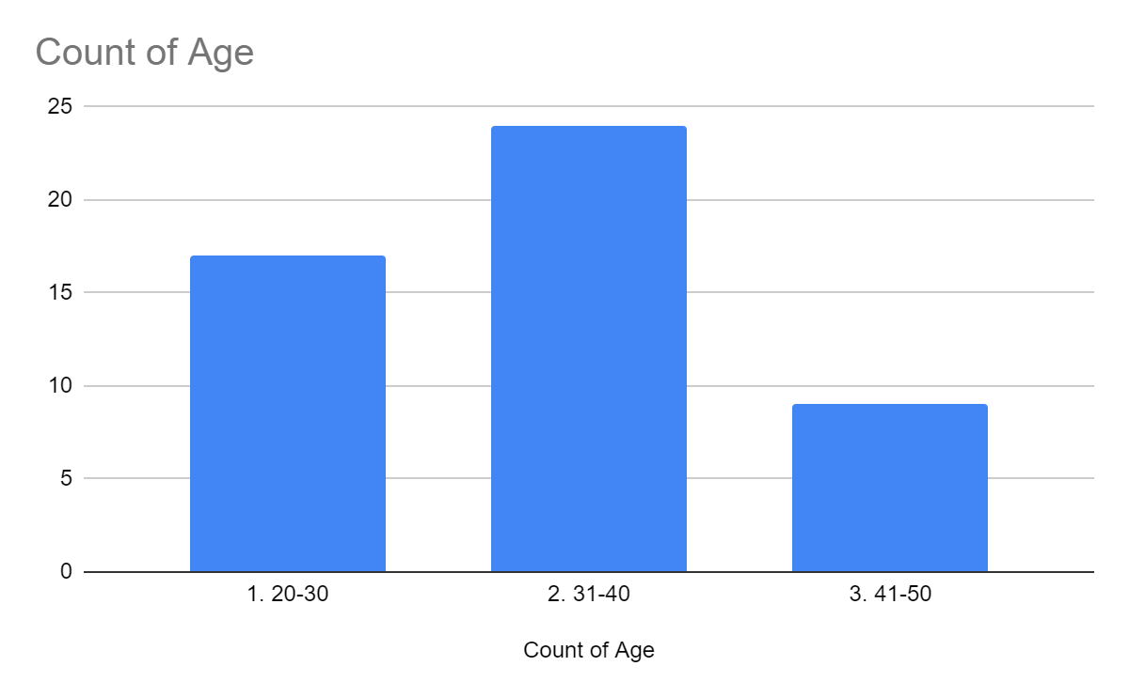
Figure 2
Analysis: From the above graph and table, it can be analysed that the individuals who participated within the questionnaire belonged from age range of about 20 – 50. This is an important aspects which helps in analysing the range of the consumer base of the organisation. Apart from that, it can be said that 48% of the individuals who belonged from the age range of about 31-40 years. Further, the other 34% belonged from the age range of about 20 – 30 years and the remaining 18% belonged from the age range of about 41 – 50.

2. Which social class do you belong to?
Table of Findings:
Which social do you belong to? | Responses
Lower | 7
Middle | 30
Upper | 13

Graphs:
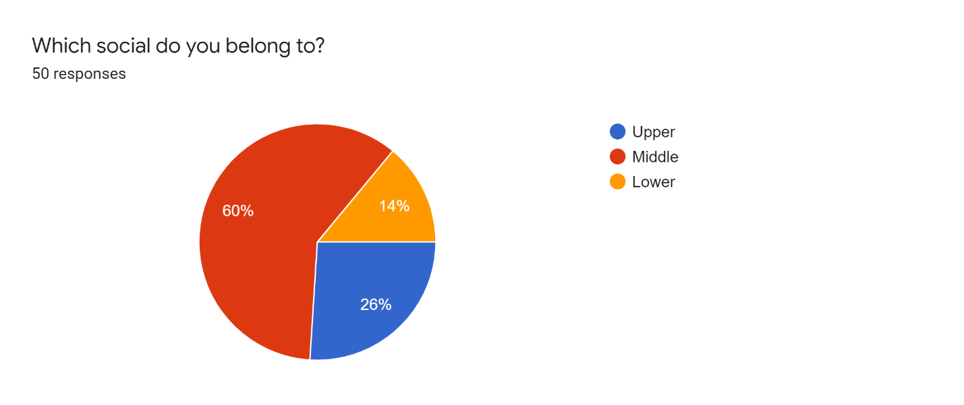
Figure 3
Analysis: The prime aim of management of Harrods is to the implement of an integrated marketing communication on the behaviour of the consumers. In order to know the perceptive of the consumers the management of Harrods has implemented a survey. Through this manner, they can take effective decisions for the organisation. The survey has been conducted among 50 consumers in the market. According to the outcome of the survey, 60% of the employees have stated that they belong to the middle class. Along with this, 20% of the consumers has stated they belongs to the upper class and the rest 14% have stated that they belongs to the Lower class (Rajala and Tidström 2017).
3. What is your gender?
Table of Findings
What is your gender? | Responses
Female | 38
Male | 10
Others | 2
Total | 50

Graph:
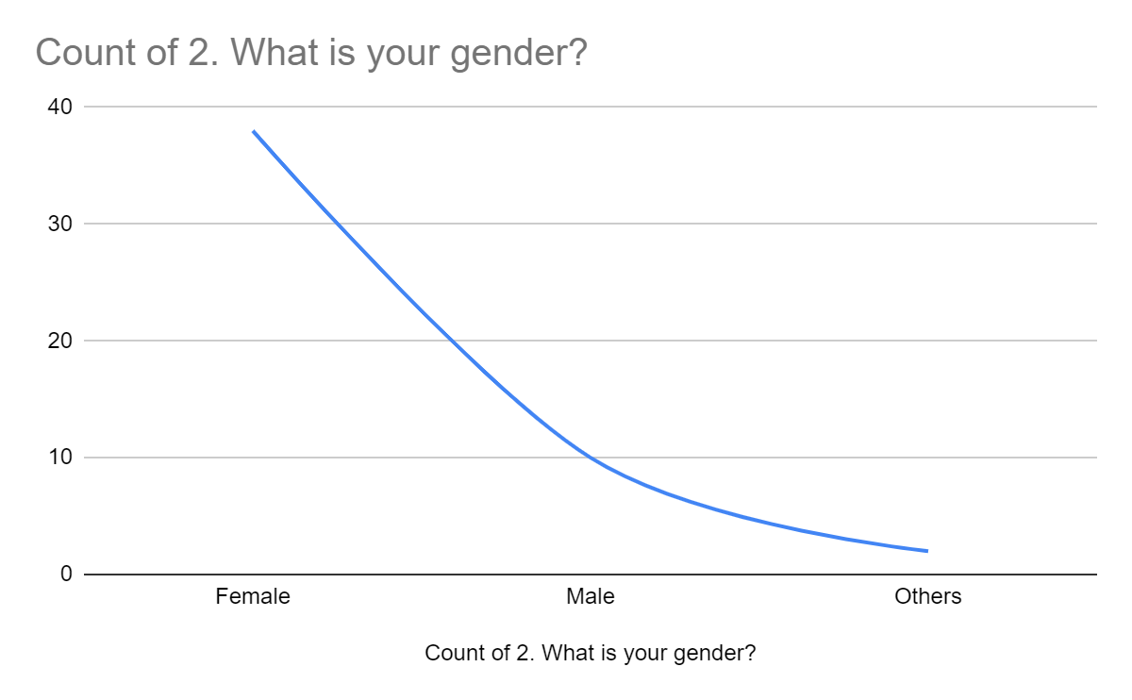
Figure 3
Analysis: The above survey states that the individuals who are engaged with the Harrods were able to give their views regarding the different aspects which are mentioned within the overall organisation. This also assured that the individuals can enhance the overall quality of the research. Apart from that, most of the individuals who were answering this particular question were female. This portrays that the services and the products which were served by Harrods helped in attracting more female consumers than that of males (Jenny, 2014). This is an important aspect that has helped in analysing the customer base of the organisation. This has also allowed the individuals to gain the necessary benefits within the competitive environment. Apart from that, the individuals within the overall organisation had also ensured that the individuals can gain the relevant as well as the detailed answers regarding the overall work which was made within the questionnaire. However, there was a very smaller percentage of men as well who were present while answering the questionnaire and the percentage is almost 20% and near about 10% of the individuals belonged from the others category (Jenny, 2014).

4. Are the management of Harrods able to effectively communicate with its consumers?
Table of Findings:
Are the management of Harrods able to effectively communicate with its consumers? | Responses
Yes | 23
No | 22
Maybe | 5
Total | 50

Graph:
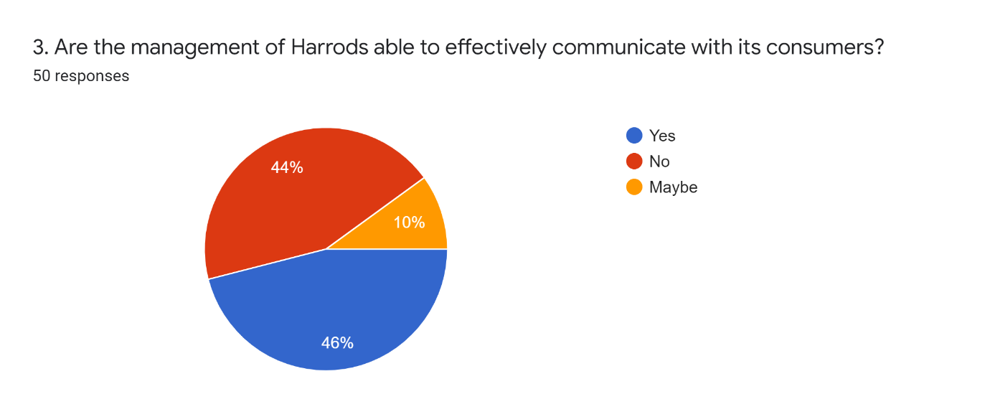
Figure 4

Analysis: The main aim of the questionnaire which was presented to the consumers of the Harrods had helped in answering the relevant question that relates to the topic of integrated marketing communication. This is also a significant aspect that allows the individuals to gain relevant answers from the consumers themselves. These questions in the complete questionnaire relate to the question of communication. From the 50 responses which were collected from the questionnaire, 46% of them suggested that the organisation can communicate effectively with the consumer of the organisation. Further, the other 44% of the consumers did not agree to this and they gave their answers as no. This helps in recognising the customer satisfaction level as well. On the other hand, the remaining 10% of the population were not sure regarding this question and they gave their answers as maybe.

5. What are the strategies used by Harrods to communicate with its consumers?
Table of Findings:
What are the strategies used by Harrods to communicate with its consumers? | Responses
Omni Channel customer communication strategy | 6
Using Chatbots to communicate with consumers | 21
Using visual engagement tools | 23
Total | 50

Graph:

Figure 5
Analysis: This question was regarding the communication strategies which are used by Harrods to communicate with its members. There are different ways utilising which the organisation can effectively communicate with all its consumers (Collins, 2017). Further, as per the responses from the questionnaire, 46% of the consumers have suggested that using visual management tools is the process through which the individuals are able to communicate and get the proper knowledge regarding the grievances which the customers are having with the services as well as the products of the organisations. This can also allow the individuals to enhance their brand value and they will be able to ensure that the organisation can effectively increase its profit margins. Apart from that, the use of chatbot systems is also quite prevalent within the organisation and this has been mentioned by almost 42% of the consumers who had given their responses to the questionnaire. The remaining 12% of the population had suggested that omnichannel marketing is an effective way through which the individuals will be able to communicate with all the consumers within the competitive environment (Manners, 2019).

6. Rate the effectiveness of the communication strategy of Harrods.
Table of Findings:
Rate the effectiveness of the communication strategy of Harrods. | Responses
1 | 0
2 | 0
3 | 1
4 | 1
5 | 2
6 | 8
7 | 4
8 | 12
9 | 7
10 | 15

Graph:

Figure 6
Analysis: The above diagram shows the responses of the consumers regarding the effectiveness of the communication strategy which is implemented by Harrods. They were asked to give the ratings regarding the communication strategies which are implemented by the organisation. From the responses of the consumers, it seems that the individuals are quite happy regarding the communication strategies of the organisation. Almost 30% of the consumers had given 10 out of 10 to the communication strategy of Harrods. On the other hand, 14% of the respondents had given 9 out of 10 to their strategies. 24% of the respondents of the questionnaire had given 8 ratings and 16% of them had given their answers as 6 ratings. 8% of them had given the responses towards the 7 ratings. The remaining 4% had responded for 8 ratings. The remaining 2% and the other 2% had given their responses as 4 ratings respectively (Shpak, 2019).

7. Does the integrated marketing communication process helps Harrods to facilitate the communication process?
Table of Findings:
Does the integrated marketing communication process helps Harrods to facilitate the communication process? | Responses
Maybe | 3
No | 19
Yes | 27

Graph:

Figure 7
Analysis: The above diagram shows the representation of the responses which had been given by the individuals regarding the overall communication process. Further, as per the consumers, the consumers, 55.1% of the consumers had given their responses as yes since they think that the communication process is the one that helps the organisation to facilitate the overall communication process (Collins, 2017). This also helps in managing the overall work within the organisation. On the other hand, 38.8% of the respondents of the questionnaire think that the communication process does not facilitate the overall communication process. The remaining individuals or 6.1% of the individuals were not able to give any proper comments regarding this particular question and they have given their answers as maybe. The IMC is and effective method through which the individuals are able to enhance the communication activities with the organisation and it allows them to manage all their work. This aspect also allows individuals to maintain their overall operational productivity. However, one of the partakers within the questionnaire had skipped this question (Brookins, 2017).

8. What are the benefits of using integrated marketing communication?
Table of Findings:
What are the benefits of using integrated marketing communication? | Responses
Enhanced customer satisfaction | 18
It helps in gaining the customer loyalty | 29
Strengthened customer base | 1
Total | 48

Graph:

Figure 8
Analysis: Different benefits are gained by the organisation with the help of integrated marketing communication. This is one of the tools which is used by the organisation and that helps the organisation to maintain their relationship with that of the consumers. However, as per the responses which have been gained from the questionnaire, 60.4% of the consumers believe that this is an effective process that allows the individuals to gain consumer loyalty. Apart from that, this is also an important process that helps in enhancing the overall customer satisfaction and this has been mentioned by almost 2.1% of the individuals who responded regarding the questionnaire. On the other hand, 2 individuals present within the overall process had not given their answers regarding this particular question (Annuity , 2020).

9. What are the ways in which the consumer behaviour of Harrods is influenced?
Table of Findings:
What are the ways in which the consumer behaviour of Harrods is influenced? | Responses
Personal Factors | 3
Psychological Factors | 15
Social Factors | 32

Graph:

Figure 9
Analysis: Consumer behaviour while purchasing the products is an important feature that allows the individuals to manage the overall process and ensure that Harrods is able to stay competitive and sustain in the market in which they are currently operating. 64% of the responses which was gained from the survey claims that the social factors are an important factor that helps in making an influence upon the consumer behaviour of Harrods. Apart from that, 30% of the consumers feel that their behaviour is influenced by psychological factors which help in managing the overall work within the competitive environment. Thus, this process also helps in making an influence upon achieving the overall organisational goals. The overall activities within the organisation is accomplished in a smoother way and the operations of the organisation is also facilitated. Further, the remaining 6% of the responses which has been gained from the overall survey claims that the personal factors are the ones that allow the organisation to make an influence upon the overall behaviour of the consumers.

10. What impact does consumer behaviour have on the productivity of Harrods?
Table of Findings:
What impact does consumer behaviour have on the productivity of Harrods? | Responses
Enhances the brand value of the organisation | 34
Helps in achieving organisational goals | 2
Increased sales margins | 13
Total | 49

Graph:

Figure 10

Analysis: Consumer behaviour has a major impact on the overall productivity of the organisation. The responses of the questionnaire suggest that 69.4% of the survey responses were in favour of the enhanced brand value of the organisation which is the positive outcome of the consumer behaviour of the individuals involved within Harrods. The consumer behaviour is an important factor which helps the organisation to analyse whether the individuals will be able to enhance their operational value or not. Almost 26.5% of the population involved within the process have given their responses towards this aspect of the organisation that allows the, to bring several significant changes within the overall profit margins of the organisation. The remaining 4.1% believe that consumer behaviour makes an impact while achieving organisational goals. This ensures that the organisation can gain all the advantages out of this particular process.

11. Had the integrated marketing communication strategy helped Harrods to strengthen the customer base?
Table of Findings:
Had the integrated marketing communication strategy helped Harrods to strengthen the customer base? | Responses
Yes | 27
No | 18
Maybe | 5

Graph:
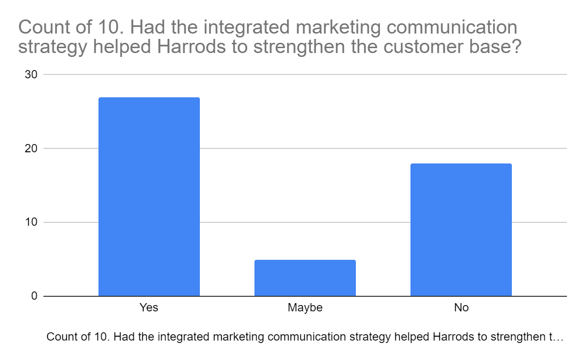
Figure 11
Analysis: The above diagram helps in representing whether the integrated marketing communication allows the individuals to strengthen their customer base or not. The responses which were given through the questionnaire helps in representing that the integrated marketing communication strategy has a major contribution in strengthening the consumer base and this has been supported by almost 54% of the responses which was gained from the questionnaire. On the other hand, the remaining 36% of the population do not think the same way and they feel that this strategy does not have a major influence upon strengthening the consumer base. The remaining 10% are not sure regarding this particular question and hence, they have presented their answers as maybe since they are not able to implement overall communication strategies within the organisation (Annuity , 2020).

12. What influence does integrate marketing communication have on consumer behaviour?
Table of Findings:
What influence does integrate marketing communication have on consumer behaviour? | Responses
Better conversion into sales | 4
Fulfils the requirements of the consumers | 24
Facilitates the decision-making process of Harrods | 22

Graph:
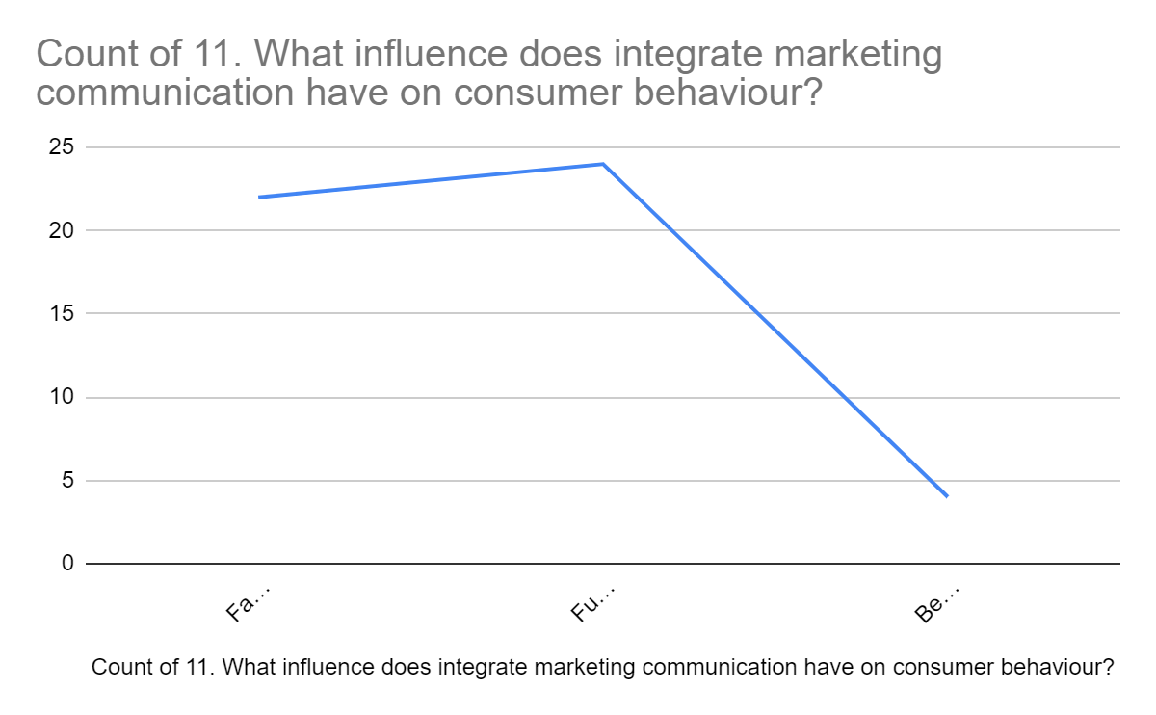
Figure 12
Analysis: The above survey states that almost 48% of the respondents of the questionnaire suggested that the process of integrated marketing communication allows the organisation to fulfil all the requirements of consumers. Further, this is one of the ways through which Harrods is able to create awareness regarding their products and services to a wide range of consumers since it helps them to manage the consumers and get to know about the requirements of the consumers. 44% of the respondents suggested that the integrated marketing communication process allows the individuals to facilitate the overall decision-making process and this help in managing the overall work which is present within the competitive environment. On the other hand, 8% of the responses which was gained from the questionnaire suggest that the organisation

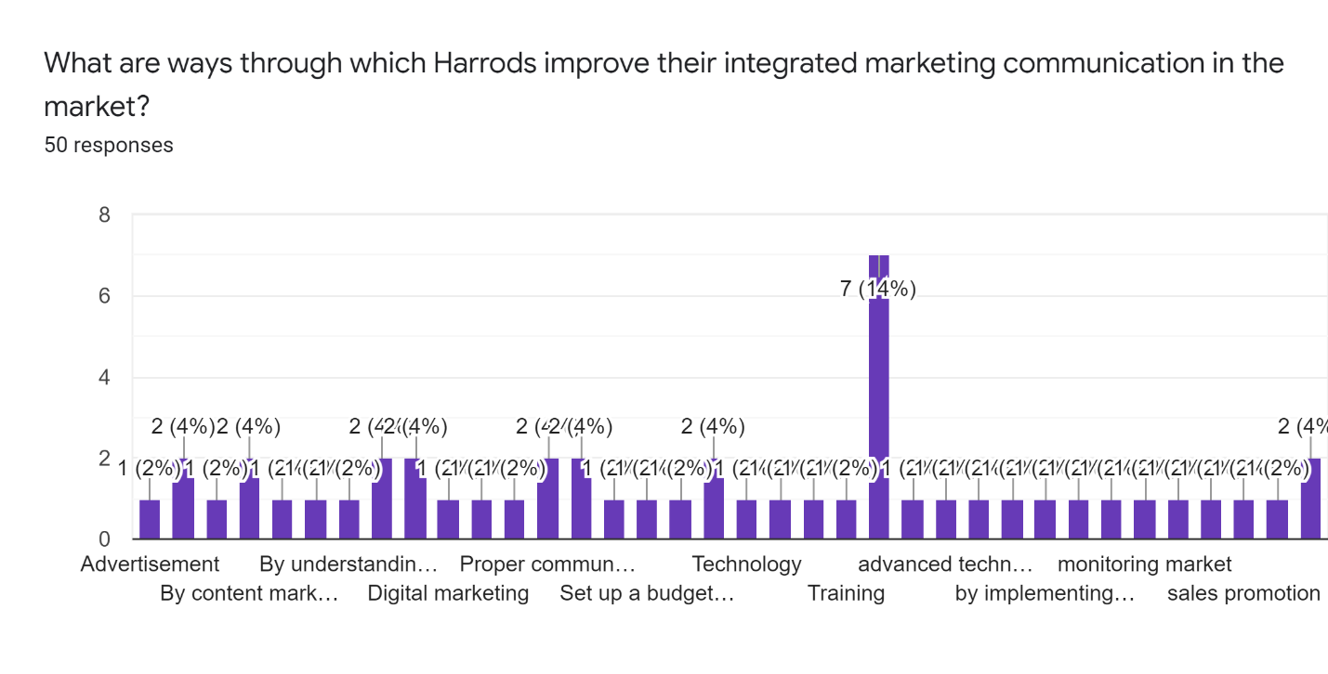
13. What are ways through which Harrods improve their integrated marketing communication in the market?

Figure 13
Analysis
The management of Harrods mainly keep their focus in the integrated marketing communication. Through implementing this, the management can easily gain various kinds of benefits. To know the viewpoints of the consumer the management has conducted a survey among 50 consumers. As far as the outcome of the survey, 4% of the consumers has stated brand awareness is the key way. On the other hand most of the responder 14% stated that with the help of advanced technology the management can easily run their operation in the market. Further, 4% of the consumers has a strong believe that the management must need to conduct sales promotions (Ullal and Hawaldar 2018).

14. In which ways integrated marketing communication influence the competitiveness of Harrods?
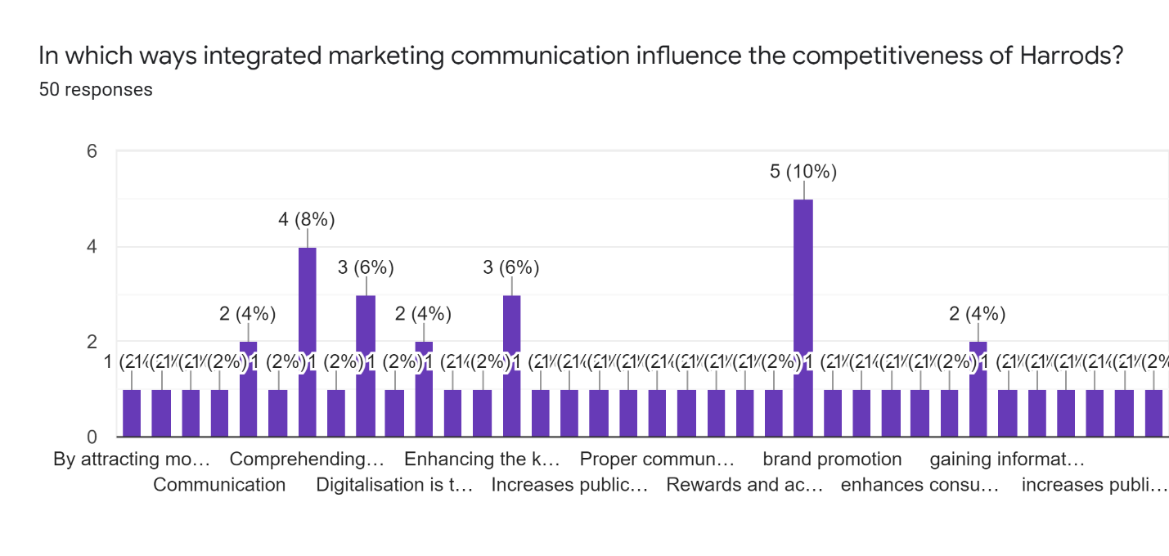
Figure 14
Analysis
A survey was created in order to determine the various ways in of the integrated market that influence the competitiveness of Harrods respectively. Data was collected in which around 10% of the audience has responded for brand promotion whereas, 8% of the respondent has responded for comprehending the target audience. Moving ahead towards the survey, around 6% of the audience has responded for the brand awareness along with the digitalisation as well. Moreover, 4% of the targeted audience has responded for better communication enhancing the public relationship. The other 4% of the audience has responded for the effective training respectively (Coffelt, Grauman and Smith 2019).

Chapter Five: Discussion
The answers drawn from the questionnaire which was conducted among the overall organisation and with the employees of Harrods has helped in gaining the relevant information regarding the overall research. Further, the survey which has been conducted with the consumers of Harrods has been presented. This helps in answering all the questions which are associated with integrated marketing communication. Apart from that, it has been recorded that most of the respondents who had given their responses to the questionnaire were female and they had shared their perspectives along with the other men who were participating in the questionnaire. Integrated marketing communication is an effective marketing strategy that allows the organisation to enhance the communication process and bring a significant change in their profit margins . This is an important strategy that helps in aligning different platforms and communication channels that ensures that the overall process can properly conduct the operations. This is a process that ensures that Harrods can manage the brand messaging and this ensures that the individuals can gain positive outcomes from the market in which they are currently conducting their operations. The IMC is one of the approaches which has been targeted towards achieving maximum brand awareness and enhancing the overall brand value of the organisation. Further, the responses which have been gained from the questionnaire has enlightened regarding this fact. Firstly, the consumers of Harrods feel that the most important thing which is prioritised by the organisation is the communication with the individual can increase the overall brand value of the organisation and the individuals are able to bring significant changes within their performance as well.
Communication is the only way through which organisations can get the proper information regarding the overall competitive environment in which they are operating. The individuals who are present within the organisation will be able to help in satisfying the needs of consumers. Further, the analysis from the questionnaire also suggested that the individuals can bring positive changes within their operational activities and this will allow the individuals to manage the overall activities within the organisation in regards to the enhancement of the customer satisfaction level. This can ensure that the individuals can gain the positive outcomes of the overall research. The consumers of Harrods feel that the employees of the organisation will be able to cater to the needs of the customers which can allow them to bring a positive growth in their profit margins. The chatbot system is one of the new communication tools that is used mostly by the management of Harrods to communicate effectively with the new consumers. A chatbot is important software that helps in stimulating the overall process of human conversation. This software helps the individuals to communicate effectively with the other consumers and they can effectively share their concerns with all the consumers. This allows the organisations to reach a wide range of consumers within a very less time. This helps in enhancing the overall communication process and the individuals can share the issues which they are having regarding the processes as well as the services of the organisation. Apart from that, this is an effective solution to the issues which the consumers face during online shopping with their consumers (Brookins, 2017). This is the significant process through which the customers will be able to solve their issues regarding the problems which they are having within the overall competitive environment. This also allows the individuals to manage the overall customer satisfaction level and the employees of the organisation can work for enhancing the overall profit margins of the organisation. The IMC is also of great importance to Harrods since it allows the organisation to manage all the work and that will ensure that they can create brand awareness within the customers who are present within the UK environment. This is an important way through which individuals can manage to reach a wide range of consumers in a very less time. This will also ensure that the individuals can manage all the work which are related to the consumers within the organisation. Apart from that, the consumers are quite happy regarding the overall communication process and this has been analysed with the help of a questionnaire.
According to the results, the branding and shopping experiences of luxury items significantly affect customers, indicating that luxury brands are essential in their lives and provide value. Individuals react to this impact in a variety of ways. According to a survey performed by Grubor and Jakša (2018), although some luxury shoppers are pleased with the brand, others may have a different opinion about buying high-end things. Nonetheless, as mentioned in chapter one, one of the study's aims is to assess if customer experience and brand associations impact consumer loyalty in the luxury retail industry, among other things. Implementing integrated marketing communication is the first step in understanding its purpose and value as a customer-centred approach. According to experts Ismagilova et al. (2020b, 2020a), integrated marketing communication encompasses everything that helps Harrods advertise its company and position its products in the market. A consistent and well-planned integrated marketing communication campaign is required. Some of the early efforts were published in scholarly publications (Ieva and Ziliani, 2018). Integrated marketing communication began to be practised and quickly became a trendy topic (Hussain et al., 2018). Three areas may be traced back to the roots of integrated marketing communication. First, increased rivalry and risk in markets due to mergers and acquisitions have been required to meet growing customer needs more effectively through innovative business or client-side marketing methods. According to the authors' critical assessment, information technology exposure is eroding conventional advertising and marketing trends, prompting marketers to seek more practical and cost-effective communication methods. According to the customer, frequent changes in his lifestyle have driven marketers to develop more complex and faster response communication methods (Govindan et al., 2019). According to studies Lahtinen et al. (2020), a well-managed and well-designed relational customer database, a focused and customer-oriented attitude toward customers and clients, and a psychologically-driven prospecting strategy for Sales are all essential in the corporate context. According to the company, it starts with product creation and progresses through packaging, pricing, customer relationship management, channel selection, channel management, overall quality management, and so on Lou and Yuan (2019). In addition, experts such as Mishra et al. (2021) and Pandey et al. (2020) believe that shifting communication expenditure away from mass media and conventional advertising has favoured integrated marketing communication in terms of brand recognition and marketing success.
According to research conducted by Pearson and Perera (2018), the notion of integrated marketing communication seems to have become a watch-cry not just for marketing communications but also for many Harrods corporate communication initiatives in a short period. (Gómez et al., 2019). According to a study by researchers such as Weismueller et al. (2020) and Wong and Wei (2018), it has strengthened the impact of communication, improved the efficacy of creative connections, and provided consistency in communication, according to a study by researchers such as Weismueller et al. (2020) and Pandey et al. (2020). According to the authors, integrated marketing communication has progressed through time from awareness to image to functional integration to coordinated integration to consumer-based integration to stakeholder-based integration to relationship management integration (Gilal et al., 2019).
In contrast to this study, Pandey et al. (2020) discovered that it is a promotional tool used in conjunction with other marketing mix components to get a competitive edge over rivals by finding optimum touch-points and thereby achieving the maximum customer satisfaction. The results of Lou and Yuan (2019) and Ismagilova et al. (2020b, 2020a) support the idea that it is a data-driven strategy that use outside-in thinking to uncover consumer insights and strengthen brand-customer interactions via both online and offline channel strategies (Eagle et al., 2020). Consequently, integrated marketing communication acts as the marketing department's voice, increasing brand recognition, communicating information, educating the market, and promoting Harrods' favourable image. Ambience, The findings of Grubor and Jakša (2018) and Eneizan et al. (2019) support the idea that This could be defined as a retailer's provision of an appealing shopping experience sufficient to meet in-store customers' latent sensorial, emotional, and psychological expectations (Dhaliwal et al., 2020) it is discussed in critical constructs such as "interior decoration, customer service, brand heritage), and those variables could be referred to collectively as visual merchandising components. In support, Dwivedi and McDonald (2018) claims that Buhalis and Volchek (2021) assists businesses in creating a solid and favourable image for their shop and the necessary quantity of customer attention and demand. In addition to the statement made by Harrods, luxury customers anticipate a one-of-a-kind, pampered shopping experience when they visit Selfridges or Harrods (Dewnarain et al., 2019). These well-heeled shoppers frequent high-end retail businesses in the most exclusive neighbourhoods to get better service and connect with unique items. These sites abound in interior decorations, artwork, store maps, product displays, and other things. The researcher determined some of the factors that impact the purchase experience at both organisations based on the replies. Interior design, the mood of the retail area, the space itself, and the individuals they interact with while shopping are just a few examples

Chapter Six: Conclusion and Recommendation

6.1 Conclusion
The above thesis has demonstrated the significance of integrated marketing communications wherein the process is used by the companies to promote their brands. Apart from that, IMC coordinates the efforts of marketing with different channels of communication to promote the product in the market. The research has also stated that IMC helps in developing an understanding of consumer behaviour regarding the product. The company Harrods has been highlighted in the research paper and the effectiveness of the use of integrated marketing communication within the company. The overall focus has been to state the use of IMC for determining competitive advantage in the retail market. The aims of objectives developed has been developed keeping in mind the issues and requirements of the company by implementing IMC within the workplace. Based on the analysis, it can be demonstrated that many companies lack the proper knowledge and use of IMC in their operations. Harrods has a lack of specific customer communication strategies that will support them to maintain a leading position in the market. Furthermore, most employees and managerial departments do not have adequate knowledge of IMC procedure that is helpful for increasing the customer base to sustain in the volatile market. The main aim that has been focused on for the research has been conducting an investigation over the implementation of integrated marketing communication towards the behaviour of the customer. Moreover, the pandemic has developed a new paradigm shift in the market in terms of marketing and customer purchasing behaviour. Harrods has faced huge losses due to the pandemic situation that has been a prime reason for shifting towards the new marketing communication procedure to sustain in the market. The objectives that have been derived has been exploring various integrated marketing techniques of communication that can be followed by Harrods. Followed by ascertaining the factor that influences the purchasing behaviour of the customers. Along with that, the impact of the strategies of IMC towards customers' buying behaviour. The literature review has been developed by extensive research of the literary works of different researchers regarding integrated marketing communication procedures.
The secondary research conducted has determined that various communication tools such as digital media such as SEO, magazines, webinars, blogs and other channels o promote the brand. Further, the research also stated that IMC methods help to ascertain customer behaviour through the various communication channel. Moreover, the method is quick, cost-effective and derive great response from the customers. The key elements of this method are search engine optimisation, wherein the website ranks along with the search engines for attracting more visitors to the site. Further, the value proposition is developed through these techniques. The touchpoints show the way the customer can interact with the organisation through a website, person to person, app or any other form of communication. In the literature review, different communication models such as The Shannon and Weaver Model of Communication illustrates the mathematical model. Apart from that, Aristotle's model of communication is regarded as the speaker centred model that Harrods can incorporate for enhancing their communication problems. Nevertheless, the focus on customer behaviour and its significance on the brand has also been illustrated. Moreover, to understand needs, Maslow's Hierarchical needs has been implemented along with the ABC model of attitude to determine the potential relationship of the customer and the organisation. The culture is ascertained through Hofstede's cultural dimension model, which demonstrates cross-cultural communication. However, the gap has been identified where the consumer behaviour based on the luxury market of using the IMC method has been determined. The thesis has used mixed research methods as the research choice for the thesis. The thesis has implemented both primary and secondary analysis. The primary has been conducted through survey strategy by providing nine close-ended questionnaires to the respondents through simple random sampling. The secondary research has been gathered from extensive research of the peer-reviewed articles, portals, books, journals and others.
The gap has been fulfilled through findings and analysis conducted with 50 responses from the customers of Harrods. It has been ascertained that Chatbots is the most effective communication method that can be used for the customers of Harrods. While implementing IMC, Chatbots and omnichannel has been most effective on the basis of the customer communication strategy. Most of the responses has been positive regarding the use of IMC within Harrods. Based on the research, data analysis and interpretations of the study has been evaluated to fill up the gap in the literature. Following that, a suitable recommendation has also been discussed based on the above analysis regarding using integrated marketing communication within Harrods (Brookins, 2017).

6.2 Recommendations
Better communication strategy: It is recommended to the management of Harrods to develop a better communication strategy to effectively interact with their customers. Effective communication is the capability to put forward some information clearly to someone. In Harrods, there must be a more effective strategy to communicate with their customers in order to get information about their problems and needs. By having an Omni-channel communication strategy, Harrods can effectively gather all the channels of communication for connecting one customer. All the points between pre-sales and post-sales, Harrods can see all the activities their customers are involved with. In this way, they can get the knowledge of what products are mostly seen, sold and which are not being sold for a long time (Collins, 2017). Harrods can interact with the customers through different communication channels like phone calls, websites, mobile applications, and many more to know their feedback. By having this strategy Harrods can know about the requirements of the customers and deliver products according to their needs. Omni-channel communication will help Harrods to improve customer experience which will further grow their customer base. Along with this, they can know what their customer segment is and what their wants and demands are. Through this strategy, a better view of data collection can be gained and more people will get to know the brand name. The employees of Harrods will be more efficient by communicating with the customers with the necessary tools. Lastly, an omni-channel communication strategy will provide customers convenience which will further enhance customer satisfaction (Manners, 2019).
Focusing on Social Factors: It is also recommended to the management of Harrods focus on the social factors that can help increase their profit margin. Social factors are the things that influence an individual’s lifestyle. These factors include buying practices, community, religion, trends, population density, education level and many more. Harrods needs to focus on communication with its customers in order to know about their demands. Through effective communication, Harrods will get the knowledge of customer needs. It can be seen that the social factors mainly influence the customers of Harrods. Moreover, by interacting with the customers with several communication channels, Harrods can know what social factors affect the customers. It is important to focus on the social factors in order to deliver the products in accordance with the demands of the customers (bbc, 2022). The products that they sell must be in trend, otherwise, people will not be interested in them. Along with this, they must store the products according to the market needs and based on the desired customer density. In this way, they can deliver the products whenever their customers want. The products that are sold must be accepted by the population irrespective of their religious beliefs, race and other aspects. Moreover, they must promote their products based on the individuals’ education level and income. By knowing these aspects about the targeted market, Harrods can know their customers’ behaviour. The world knows which products are more popular than others and which are not being sold at all. In this way, they can offer the customers more valued products by considering the social factors (Shpak, 2019).
Enhanced financial and human resources: It is recommended that for the implementation of integrated marketing communication, the organisation needs to focus on recruiting more human forces along with financial resources. The development of websites, apps and webinars required the high financial capability of the organisation. Therefore, Harrods needs to focus on incorporating effective recruitment strategies such as attractive job descriptions investing towards artificial intelligence and third-party recruitment agencies to hire qualified individuals (blog.vantagecircle, 2021). Further, Harrods needs to search for more investors to increase their financial capability in the market. For effective execution of the strategic plan through IMC, Harrods is recommended to use its resources appropriately for ensuring the success of the method (Brookins, 2017).
Access of brand to the customer: It is recommended that the brand has to be easily accessible to the customers. Further, it is important that the organisation properly trains and adapts to the advanced marketing techniques. The company needs to focus on new products to attract customers and also change their buying attitude towards the brand. Apart from that, the company needs to focus on developing easy access to the websites to increase the value of the product (Raguseo, Pigni and Vitari, 2021).

6.3 Future Work
Future work would be focused on a different topic and country, research techniques would change, and the quest for identifying and accumulating data and approaches would be different. Qualitative research approaches would be used to get an accurate and authentic picture of the project, making it simpler to analyse and develop the framework for analysing barriers to economic success (Dhaliwal et al., 2020).

References
Books & Journals
Abdullayev, A.A., 2020. System of information and communication technologies in the education. Science and world International scientific journal, 2, pp.19-21 [Available at: http://en.scienceph.ru/f/science_and_world_no_5_81_may_vol_ii.pdf#page=19]
Ahmad, M.B., Ali, H.F., Malik, M.S., Humayun, A.A. and Ahmad, S., 2019. Factors affecting impulsive buying behaviour with mediating role of positive mood: An empirical study. European Online Journal of Natural and Social Sciences, 8(1), pp.pp-17. Available at: https://core.ac.uk/download/pdf/296307544.pdf
Ahn, J., Back, K.-J., (2018a). Influence of brand relationship on customer attitude toward integrated resort brands: a cognitive, affective, and conative perspective. Journal of Travel & Tourism Marketing 35, 449–460.
Ahn, J., Back, K.-J., (2018b). Influence of brand relationship on customer attitude toward integrated resort brands: a cognitive, affective, and conative perspective. Journal of Travel & Tourism Marketing 35, 449–460.
Amawate, V., Deb, M., (2021). Antecedents and consequences of consumer skepticism toward cause-related marketing: Gender as moderator and attitude as mediator. Journal of Marketing Communications 27, 31–52.
Appel, G., Grewal, L., Hadi, R., Stephen, A.T., (2020). The future of social media in marketing. Journal of the Academy of Marketing Science 48, 79–95.
Armstrong, C.S. and Kepler, J.D., (2018). Theory, research design assumptions, and causal inferences. Journal of Accounting and Economics, 66(2-3), pp.366-373.

Badubi, R.M., 2017. Theories of motivation and their application in organizations: A risk analysis. International Journal of Innovation and Economic Development, 3(3), pp.44-51 [Available at: http://www.drbrambedkarcollege.ac.in/sites/default/files/Motivation%20theories%20pdf.pdf]
Bairagi, V. and Munot, M.V. eds., (2019). Research methodology: A practical and scientific approach. CRC Press.
Baran, M.L., (2022). Mixed methods research design. In Research Anthology on Innovative Research Methodologies and Utilization Across Multiple Disciplines (pp. 312-333). IGI Global.
Batat, W., (2019). Experiential marketing: Consumer behavior, customer experience and the 7Es. Routledge.
Berndt, A.E., (2020). Sampling methods. Journal of Human Lactation, 36(2), pp.224-226. Berridge, K.C., 2018. Evolving concepts of emotion and motivation. Frontiers in Psychology, 9, pp.1-24 [Available at: https://www.frontiersin.org/articles/10.3389/fpsyg.2018.01647/full?]
Beugelsdijk, S. and Welzel, C., 2018. Dimensions and dynamics of national culture: Synthesizing Hofstede with Inglehart. Journal of cross-cultural psychology, 49(10), pp.1469-1505 [Available at: https://journals.sagepub.com/doi/pdf/10.1177/0022022118798505]
Bilro, R.G., Loureiro, S.M.C., (2020). A consumer engagement systematic review: synthesis and research agenda. Spanish Journal of Marketing-ESIC
. Boisen, M., Terlouw, K., Groote, P. and Couwenberg, O., 2018. Reframing place promotion, place marketing, and place branding-moving beyond conceptual confusion. Cities, 80, pp.4-11 [Available at: https://asset-pdf.scinapse.io/prod/2767408392/2767408392.pdf]

Brittain, S., Ibbett, H., de Lange, E., Dorward, L., Hoyte, S., Marino, A., Milner‐Gulland, E.J., Newth, J., Rakotonarivo, S., Veríssimo, D. and Lewis, J., (2020). Ethical considerations when conservation research involves people. Conservation Biology, 34(4), pp.925-933.
Buhalis, D., Volchek, K., (2021). Bridging marketing theory and big data analytics: The taxonomy of marketing attribution. International Journal of Information Management 56, 102253.
Butkouskaya, V., Llonch-Andreu, J. and Alarcón-del-Amo, M.D.C., 2021. Inter-Country Customer-Perspective Analysis of Strategic Antecedents and Consequences for Post-Purchase Behaviour in Integrated Marketing Communications (IMC). Journal of International Consumer Marketing, 33(1), pp.68-83. [https://www.tandfonline.com/doi/abs/10.1080/08961530.2020.1731901]
Camilleri, M., (2020). Higher education marketing communications in the digital era, in: Strategic Marketing of Higher Education in Africa. Routledge, pp. 77–95.
Camilleri, M.A., (2018). Integrated marketing communications, in: Travel Marketing, Tourism Economics and the Airline Product. Springer, pp. 85–103.
Camilleri, M.A., (2020). The use of data-driven technologies for customer-centric marketing. International Journal of Big Data Management 1, 50–63.
Cassella, S., Golez, B., Gulen, H. and Kelly, P., (2021). Horizon bias and the term structure of equity returns. Available at SSRN 3328970.
Cheung, M.L., Pires, G.D., Rosenberger III, P.J., (2019). Developing a conceptual model for examining social media marketing effects on brand awareness and brand image. International Journal of Economics and Business Research 17, 243–261.
Chiu, K.C., Chen, C.L., Lin, H.F., Wu, Y.H. and Shih, L.T., 2019, December. A preliminary study on product design of emotional appeal by canonical correlation analysis of public attitudes towards water-saving equipment based on ABC model. In 2019 IEEE International Conference on Industrial Engineering and Engineering Management (IEEM) (pp. 1501-1505). IEEE [Available at: https://ieeexplore.ieee.org/abstract/document/8978948/]
Chou, S.-F., Horng, J.-S., Liu, C.-H.S., Lin, J.-Y., (2020). Identifying the critical factors of customer behavior: An integration perspective of marketing strategy and components of attitudes. Journal of Retailing and Consumer Services 55, 102113.
Coffelt, T.A., Grauman, D. and Smith, F.L., 2019. Employers’ perspectives on workplace communication skills: The meaning of communication skills. Business and Professional Communication Quarterly, 82(4), pp.418-439 [Available at: https://core.ac.uk/download/pdf/237666498.pdf]
Costa, E., Soares, A.L. and de Sousa, J.P., (2020). Industrial business associations improving the internationalisation of SMEs with digital platforms: A design science research approach. International Journal of Information Management, 53, p.102070.
Dannels, S.A., (2018). Research design. In The reviewer’s guide to quantitative methods in the social sciences (pp. 402-416). Routledge.
Dewnarain, S., Ramkissoon, H. and Mavondo, F., (2019). Social customer relationship management: An integrated conceptual framework. Journal of Hospitality Marketing & Management, 28(2), pp.172-188 [Available at: https://www.academia.edu/download/57575462/Social_customer_relationship_management_An_integrated_conceptual_framework.pdf]
Duralia, O., 2018. Integrated marketing communication and its impact on consumer behaviour. Studies in Business and Economics, 13(2), pp.92-102. Available at: https://sciendo.com/pdf/10.2478/sbe-2018-0022
Elleström, L., 2018. A medium-centered model of communication. Semiotica, 2018(224), pp.269-293 [Available at: https://www.degruyter.com/document/doi/10.1515/sem-2016-0024/html]
Eneizan, B., Mohammed, A.G., Alnoor, A., Alabboodi, A.S., Enaizan, O., (2019). Customer acceptance of mobile marketing in Jordan: An extended UTAUT2 model with trust and risk factors. International Journal of Engineering Business Management 11, 1847979019889484.
Fashionnetwork.com, 2020, Harrods sales, profits rose last year but retailer faces huge challenges today, Available at: https://ww.fashionnetwork.com/news/Harrods-sales-profits-rose-last-year-but-retailer-faces-huge-challenges-today,1258739.html, [Accessed on 17th November 2021]
figshare. 2022. Integrated Marketing Communications Wheel of IMC Model. [online] Available at: <https://figshare.com/articles/figure/Integrated_Marketing_Communications_Wheel_of_IMC_Model/4598092> [Accessed 27 January 2022].
Fleming, J. and Zegwaard, K.E., (2018). Methodologies, Methods and Ethical Considerations for Conducting Research in Work-Integrated Learning. International Journal of Work-Integrated Learning, 19(3), pp.205-213.
Foxall, G.R., 2017. Behavioural economics in consumer behaviour analysis., pp.309-315. Available at: https://link.springer.com/article/10.1007/s40614-017-0127-4
Gardiner, P. (2015) Project Management: A Strategic Approach, 2nd ed., Basingstoke, Palgrave [Available at: https://www.academia.edu/37889156/Project_Management_A_Strategic_Planning_Approach]
Gilal, F.G., Zhang, J., Gilal, N.G., Gilal, R.G., (2019). Linking self-determined needs and word of mouth to consumer e-waste disposal behaviour: A test of basic psychological needs theory. Journal of Consumer Behaviour 18, 12–24.
Gómez, M., Lopez, C., Molina, A., (2019). An integrated model of social media brand engagement. Computers in Human Behavior 96, 196–206.
Gonzalez-Franco, M. and Peck, T.C., (2018). Avatar embodiment. towards a standardized questionnaire. Frontiers in Robotics and AI, 5, p.74.
Gottlieb, J. and Oudeyer, P.Y., (2018). Towards a neuroscience of active sampling and curiosity. Nature Reviews Neuroscience, 19(12), pp.758-770.
Govindan, K., Jiménez-Parra, B., Rubio, S., Vicente-Molina, M.-A., (2019). Marketing issues for remanufactured products. Journal of Cleaner Production 227, 890–899.
Grubor, A., Jakša, O., (2018). Internet marketing as a business necessity. Interdisciplinary Description of Complex Systems: INDECS 16, 265–274.
Guo, W., Wang, J. and Wang, S., (2019). Deep multimodal representation learning: A survey. IEEE Access, 7, pp.63373-63394.
Harrods. 2022. About us. [online] Available at: <https://www.harrods.com/en-in/> [Accessed 6 January 2022].
Hewett, K. and Lemon, L.L., 2019. A process view of the role of integrated marketing communications during brand crises. Qualitative Market Research: An International Journal. [https://www.emerald.com/insight/content/doi/10.1108/QMR-10-2016-0097/full/html]

Hinde, A., (2020). Secondary analysis. In Handbook for research students in the social sciences (pp. 248-257). Routledge.
Holtkamp, P., Soliman, W. and Siponen, M., (2019). Reconsidering the role of research method guidelines for qualitative, mixed-methods, and design science research. In Proceedings of the Annual Hawaii International Conference on System Sciences. University of Hawai'i at Manoa.
Hopper, E., 2020. Maslow’s Hierarchy of Needs Explained. ThoughtCo, ThoughtCo, 24 [Available at: http://www.christianworldmedia.com/client/docs/603_1585079540_17.pdf]
Hussain, S., Guangju, W., Jafar, R.M.S., Ilyas, Z., Mustafa, G., Jianzhou, Y., (2018). Consumers’ online information adoption behavior: Motives and antecedents of electronic word of mouth communications. Computers in Human Behavior 80, 22–32.
Ieva, M., Ziliani, C., (2018). The role of customer experience touchpoints in driving loyalty intentions in services. The TQM Journal.
Ieva, M., Ziliani, C., Gázquez-Abad, J.C., D’attoma, I., (2018). Online versus offline promotional communication: evaluating the effect of medium on customer response. Journal of Advertising Research 58, 338–348.
Ismagilova, E., Slade, E., Rana, N.P., Dwivedi, Y.K., (2020a). The effect of characteristics of source credibility on consumer behaviour: A meta-analysis. Journal of Retailing and Consumer Services 53, 101736.
Ismagilova, E., Slade, E.L., Rana, N.P., Dwivedi, Y.K., (2020b). The effect of electronic word of mouth communications on intention to buy: A meta-analysis. Information Systems Frontiers 22, 1203–1226.
John, S.P., De’Villiers, R., (2020). Elaboration of marketing communication through visual media: An empirical analysis. Journal of Retailing and Consumer Services 54, 102052.
Juska, J.M., (2021). Integrated marketing communication: advertising and promotion in a digital world. Routledge.
Kitchen, P.J., (2020). Marketing communications, in: A Reader in Marketing Communications. Routledge, pp. 1–9.
Kothari, P.P. and Maindargi, S.C., 2019. Impact of brand loyalty on consumer behaviour towards grocery trade: With special reference to solapur city. International Journal of Science Technology and Engineering, 5(7), pp.7-14. Available at: https://www.academia.edu/download/58328952/IJSTEV5I7002.pdf
Kotler, P., Kartajaya, H., Setiawan, I., (2021). Marketing 5.0: Technology for humanity. John Wiley & Sons.
Krizanova, A., Lăzăroiu, G., Gajanova, L., Kliestikova, J., Nadanyiova, M. and Moravcikova, D., 2019. The effectiveness of marketing communication and the importance of its evaluation in an online environment. Sustainability, 11(24), pp.1-22 [Available at: https://www.mdpi.com/2071-1050/11/24/7016/pdf]
Kuehnl, C., Jozic, D., Homburg, C., (2019). Effective customer journey design: consumers’ conception, measurement, and consequences. Journal of the Academy of Marketing Science 47, 551–568.
Lahtinen, V., Dietrich, T., Rundle-Thiele, S., (2020). Long live the marketing mix. Testing the effectiveness of the commercial marketing mix in a social marketing context. Journal of Social Marketing.
Laurie, S., Mortimer, K., (2019). How to achieve true integration: the impact of integrated marketing communication on the client/agency relationship. Journal of Marketing Management 35, 231–252.
Lindgreen, A., Di Benedetto, C.A. and Beverland, M.B., (2021). How to write up case-study methodology sections. Industrial Marketing Management, 96, pp.A7-A10.
Liu, X., Shin, H., Burns, A.C., (2021). Examining the impact of luxury brand’s social media marketing on customer engagement: Using big data analytics and natural language processing. Journal of Business Research 125, 815–826.
Ližbetinová, L., Štarchoň, P., Lorincová, S., Weberová, D., Pr\uuša, P., (2019). Application of cluster analysis in marketing communications in small and medium-sized enterprises: An empirical study in the Slovak Republic. Sustainability 11, 2302.
Llopis-Amorós, M.-P., Gil-Saura, I., Ruiz-Molina, M.E., Fuentes-Blasco, M., (2019). Social media communications and festival brand equity: Millennials vs Centennials. Journal of Hospitality and Tourism Management 40, 134–144.
López-Sanz, J.M., Penelas-Leguía, A., Gutiérrez-Rodríguez, P. and Cuesta-Valiño, P., 2021. Sustainable Development and Consumer Behaviour in Rural Tourism—The Importance of Image and Loyalty for Host Communities. Sustainability, 13(9), pp.1-19. Available at: https://www.mdpi.com/2071-1050/13/9/4763
Lou, C., Yuan, S., (2019). Influencer marketing: how message value and credibility affect consumer trust of branded content on social media. Journal of Interactive Advertising 19, 58–73.
Maarouf, H., (2019). Pragmatism as a supportive paradigm for the mixed research approach: Conceptualizing the ontological, epistemological, and axiological stances of pragmatism. International Business Research, 12(9), pp.1-12.
Mahsan, I.P., Harun, M.F., Zulkefli, M.Y., Alim, M.M., (2020). Visual communication on social media advertisement that influence consumer buying behavior on skin-whitening product. KUPAS SENI 8, 11–19.
Maison, D., (2018). Qualitative marketing research: Understanding consumer behaviour. Routledge.
Marketing Week. 2022. Harrods ramps up digital to grow brand. [online] Available at: <https://www.marketingweek.com/harrods-ramps-up-digital-to-grow-brand/> [Accessed 22 January 2022].
McCauley, C., 2020. The ABC model: Commentary from the Perspective of the Two Pyramids Model of Radicalization. Terrorism and Political Violence, pp.1-9 [Available at: https://www.brynmawr.edu/sites/default/files/TPV-Comment.pdf]
Melnikovas, A., (2018). Towards an explicit research methodology: Adapting research onion model for futures studies. Journal of Futures Studies, 23(2), pp.29-44.
Mishra, R., Singh, R.K., Koles, B., (2021). Consumer decision-making in Omnichannel retailing: Literature review and future research agenda. International Journal of Consumer Studies 45, 147–174
. mStoner. 2022. The Five Steps of IMC - mStoner. [online] Available at: <https://www.mstoner.com/blog/marketing-communications/the-five-steps-of-imc/> [Accessed 27 January 2022].
Moon, K., Blackman, D.A., Adams, V.M., Colvin, R.M., Davila, F., Evans, M.C., Januchowski‐Hartley, S.R., Bennett, N.J., Dickinson, H., Sandbrook, C. and Sherren, K., (2019). Expanding the role of social science in conservation through an engagement with philosophy, methodology, and methods. Methods in Ecology and Evolution, 10(3), pp.294-302.
Muhammedrisaevna, T.M., Bayazovna, G.N., Kakhramonovna, D.A., (2020). Goal and objectives of integrated marketing communications. Economics.
Naderi, I., Van Steenburg, E., (2018). Me first, then the environment: Young Millennials as green consumers. Young Consumers.
Nagar, K. and Singh, V.P., 2021. Modelling the effects of materialism, ethics and variety-seeking behaviour on counterfeit consumption of young consumers. Global Business Review, 22(4), pp.996-1009 [Available at: https://journals.sagepub.com/doi/abs/10.1177/0972150918818015]
Nguyen, H.V., (2018). Cash or cashless? Promoting consumers’ adoption of mobile payments in an emerging economy. Strategic Direction.
Oh, S.S. and Wachter, J.A., (2022). Cross-sectional skewness. The Review of Asset Pricing Studies, 12(1), pp.155-198.
Oliva, R., (2019). Intervention as a research strategy. Journal of Operations Management, 65(7), pp.710-724.
Oluwafemi, O.J. and Adebiyi, S.O., 2018. Customer loyalty and integrated marketing communications among subscribers of telecommunication firms in Lagos Metropolis, Nigeria. Journal of Competitiveness, 10(3), pp.1-11. Available at: https://pdfs.semanticscholar.org/5112/66fb01d75222ea6709cc501b8987e6f81959.pdf
Pace, D.S., (2021). Probability and Non-Probability Sampling-An Entry Point for Undergraduate Researchers. International Journal of Quantitative and Qualitative Research Methods, 9(2), pp.1-15.
Pandey, N., Nayal, P., Rathore, A.S., (2020). Digital marketing for B2B organizations: structured literature review and future research directions. Journal of Business & Industrial Marketing.
Palalic, R., Ramadani, V., Gilani, S.M., Gërguri-Rashiti, S. and Dana, L.P., 2020. Social media and consumer buying behaviour decision: what entrepreneurs should know?. Management Decision., pp.1-22. Available at: https://www.emerald.com/insight/content/doi/10.1108/MD-10-2019-1461/full/html
Patti, C.H., Hartley, S.W., van Dessel, M.M. and Baack, D.W., 2017. Improving integrated marketing communications practices: A comparison of objectives and results. Journal of marketing communications, 23(4), pp.351-370. Available at: https://www.tandfonline.com/doi/abs/10.1080/13527266.2015.1027251
Paul, J. and Criado, A.R., 2020. The art of writing literature review: What do we know and what do we need to know?. International Business Review, 29(4), pp.1-17. Available at: https://www.sciencedirect.com/science/article/pii/S0969593120300585
Payne, E.M., Peltier, J.W. and Barger, V.A., 2017. Omni-channel marketing, integrated marketing communications and consumer engagement: A research agenda. Journal of Research in Interactive Marketing., pp.1-12. Available at: https://www.emerald.com/insight/content/doi/10.1108/JRIM-08-2016-0091/full/html
Pearson, D., Perera, A., (2018). Reducing food waste: A practitioner guide identifying requirements for an integrated social marketing communication campaign. Social Marketing Quarterly 24, 45–57.
Procter, L., Angus, D.J., Blaszczynski, A. and Gainsbury, S.M., 2019. Understanding use of consumer protection tools among Internet gambling customers: Utility of the Theory of Planned Behavior and Theory of Reasoned Action. Addictive behaviors, 99, pp.1-22. Available at: https://www.sciencedirect.com/science/article/pii/S0306460319304873
Quatember, A., (2019). Inferences based on Probability Sampling or Nonprobability Sampling: Are They Nothing but a Question of Models?. Survey Methods: Insights from the Field, pp.1-9.
Raguseo, E., Pigni, F. and Vitari, C., (2021). Streams of digital data and competitive advantage: The mediation effects of process efficiency and product effectiveness. Information & Management, 58(4), p.103451.

Rajala, A. and Tidström, A., 2017. A multilevel perspective on organizational buying behaviour in coopetition–an exploratory case study. Journal of Purchasing and Supply Management, 23(3), pp.202-210. Available at: https://www.sciencedirect.com/science/article/pii/S1478409217300250
Sahin, M.D. and Öztürk, G., (2019). Mixed Method Research: Theoretical Foundations, Designs and Its Use in Educational Research. International Journal of Contemporary Educational Research, 6(2), pp.301-310.
Savela, T., (2018). The advantages and disadvantages of quantitative methods in schoolscape research. Linguistics and Education, 44, pp.31-44
. Schunk, D.H. and DiBenedetto, M.K., 2020. Motivation and social cognitive theory. Contemporary Educational Psychology, 60, pp.1-22 [Available at: https://www.sciencedirect.com/science/article/abs/pii/S0361476X19304370]
Shaughnessy, M.F., Moffitt, B. and Cordova, M., 2018. Maslow, basic needs and contemporary teacher training issues. Archives of Current Research International, pp.1-7 [Available at: https://www.journalacri.com/index.php/ACRI/article/download/17469/32499]
Sheoran, M. and Kumar, D., 2021. Conceptualisation of sustainable consumer behaviour: converging the theory of planned behaviour and consumption cycle. Qualitative Research in Organizations and Management: An International Journal., pp.1-14. Available at: https://www.emerald.com/insight/content/doi/10.1108/QROM-05-2020-1940/full/html
Sinha, M. and Sheth, J., 2018. Growing the pie in emerging markets: Marketing strategies for increasing the ratio of non-users to users. Journal of Business Research, 86, pp.217-224 [Available at: https://www.sciencedirect.com/science/article/abs/pii/S0148296317301534]
Sponsorpitch.com. 2022. SponsorPitch - Harrods. [online] Available at: <https://sponsorpitch.com/sponsors/harrods> [Accessed 22 January 2022].
Sulaeman, M. and Kusnandar, H.F., 2020. Integrated Marketing Communication Model in Shaping Brand Equity and Business Performance in the Creative Industries of Embroidery Sector. Budapest International Research and Critics Institute (BIRCI-Journal): Humanities and Social Sciences, 3(4), pp.3798-3805 [Available at: https://scholar.archive.org/work/imafzlxtabf3jhelerpkjb5naa/access/wayback/http://www.bircu-journal.com/index.php/birci/article/download/1444/pdf]
Statista. 2022. Harrods Ltd: gross profit 2021 | Statista. [online] Available at: <https://www.statista.com/statistics/589785/harrods-limited-gross-profit/#:~:text=In%20the%20financial%20year%202020,of%20the%20previous%20year's%20results.> [Accessed 27 January 2022].
Story, D.A. and Tait, A.R., (2019). Survey research. Anesthesiology, 130(2), pp.192-202.
Světlík, J., 2017. Integrating online advertising into integrated marketing communications. Marketing Identity, 5(1/1), pp.206-215. [https://www.ceeol.com/search/article-detail?id=680097]
Ullal, M.S. and Hawaldar, I.T., 2018. Influence of advertisement on customers based on AIDA model. Problems and Prospective in Management (December, 2018) Vol, 16(4), pp.285-298 [Available at: http://www.irbis-nbuv.gov.ua/cgi-bin/irbis_nbuv/cgiirbis_64.exe?C21COM=2&I21DBN=UJRN&P21DBN=UJRN&IMAGE_FILE_DOWNLOAD=1&Image_file_name=PDF/prperman_2018_16_4_26.pdf]
Valos, M.J., Maplestone, V.L., Polonsky, M.J. and Ewing, M., 2017. Integrating social media within an integrated marketing communication decision-making framework. Journal of Marketing Management, 33(17-18), pp.1522-1558 [Available at: https://www.tandfonline.com/doi/abs/10.1080/0267257X.2017.1410211]
Weismueller, J., Harrigan, P., Wang, S., Soutar, G.N., (2020). Influencer endorsements: How advertising disclosure and source credibility affect consumer purchase intention on social media. Australasian marketing journal 28, 160–170
. Wixson, C., 2018. “The Biggest Scoop in Advertising History”: Personality Marketing, GBS, and the Near-Testimonial. In Bernard Shaw and Modern Advertising (pp. 93-132). Palgrave Macmillan, Cham [Available at: https://link.springer.com/chapter/10.1007/978-3-319-78628-5_4]

Wong, E., Wei, Y., (2018). Customer online shopping experience data analytics: Integrated customer segmentation and customised services prediction model. International Journal of Retail & Distribution Management.
Xiao, M., 2020. Factors influencing eSports viewership: An approach based on the theory of reasoned action. Communication & Sport, 8(1), pp.92-122. Available at: https://journals.sagepub.com/doi/abs/10.1177/2167479518819482
Zhang, B., Zhang, Y. and Zhou, P., 2021. Consumer attitude towards sustainability of fast fashion products in the UK. Sustainability, 13(4), pp.1-24 [Available at: https://www.mdpi.com/2071-1050/13/4/1646/pdf]
Žukauskas, P., Vveinhardt, J. and Andriukaitienė, R., (2018). Philosophy and paradigm of scientific research. Management culture and corporate social responsibility, 121.
Zwerin, A., Clarke, T.B. and Clarke III, I., (2020). Traditional and Emerging Integrated Marketing Communication Touchpoints Used in Effie Award-Winning Promotional Campaigns. Journal of Promotion Management, 26(2), pp.163-185.

Websites
Annuity , (2020). Time Horizon. [Online]
Available at: https://www.annuity.org/financial-literacy/time-horizon/
bbc, (2022). External factors. [Online]
Available at: https://www.bbc.co.uk/bitesize/guides/zgfrpbk/revision/4
blog.vantagecircle, (2021). Best Hiring Strategies to Recruit Top Talents. [Online]
Available at: https://blog.vantagecircle.com/hiring-strategies/
Brookins, M., (2017). Barriers to Integrated Marketing Communication. [Online]
Available at: https://bizfluent.com/list-7219491-barriers-integrated-marketing-communication.html
Collins, T., (2017). 5 Reasons Omnichannel Communications is Critical for Enterprises. [Online]
Available at: https://www.atlantech.net/blog/omnichannel-communications-critical-enterprise
embibe, (2020). Data Collection: Definition, Types, and Methods. [Online]
Available at: https://www.embibe.com/exams/data-collection/
formpl, (2020). 7 Data Collection Methods & Tools For Research. [Online]
Available at: https://www.formpl.us/blog/data-collection-method
Jenny, (2014). Phase #2: Clearly Define Your Research Strategy. [Online]
Available at: https://www.mackenziecorp.com/phase-2-clearly-define-research-strategy/
Manners, J., (2019). How To Plan Effective Omnichannel Communications. [Online]
Available at: https://napoleoncat.com/blog/omnichannel-communications/
mmotipsaz, (2020). What Is Your Time Horizon, And Why Is It Important?. [Online]
Available at: https://mmotipsaz.com/what-is-your-time-horizon-and-why-is-it-important/
NDUKWU, D., (2020). 7 Data Collection Methods for Qualitative and Quantitative Data. [Online]
Available at: https://www.kyleads.com/blog/data-collection-methods/
research-methodology, (2022). Research Approach. [Online]
Available at: https://research-methodology.net/research-methodology/research-approach/
Shpak, S., (2019). Social Factors Affecting Retail Business. [Online]
Available at: https://smallbusiness.chron.com/social-factors-affecting-retail-business-71662.html

Appendix One: Questionnaire
Questionnaire:
1. Age Group
20 – 30
31 – 40
41 - 50
2. Which social do you belong to?
Upper
Middle
Lower
3. What is your gender?
Male
Female
Others
4. Are the management of Harrods able to effectively communicate with its consumers?
Yes
No
Maybe
5. What are the strategies used by Harrods to communicate with its consumers?
Using Chatbots to communicate with consumers
Using visual engagement tools
Omni Channel customer communication strategy
6. Rate the effectiveness of the communication strategy of Harrods.
1, 2, 3, 4, 5, 6, 7, 8, 9, 10
7. Does the integrated marketing communication process helps Harrods to facilitate the communication process?
Yes
No
Maybe
8. What are the benefits of using integrated marketing communication?
Enhanced customer satisfaction
It helps in gaining the customer loyalty
Strengthened customer base
9. What are the ways in which the consumer behaviour of Harrods is influenced?
Psychological Factors
Social Factors
Personal Factors
10. What impact does consumer behaviour have on the productivity of Harrods?
Increased sales margins
Enhances the brand value of the organisation
Helps in achieving organisational goals
11. Had the integrated marketing communication strategy helped Harrods to strengthen the customer base?
Yes
No
Maybe
12. What influence does integrate marketing communication have on consumer behaviour?
Facilitates the decision-making process of Harrods
Fulfils the requirements of the consumers
Better conversion into sales
13. What are ways through which Harrods improve their integrated marketing communication in the market?
14. In which ways integrated marketing communication influence the competitiveness of Harrods?

Appendix Two: List of Figures
Figure 1:
Figure 2:

Figure 3:
Figure 4:
Figure 5:

Figure 6:

Figure 7:

Figure 8:

Figure 9:

Figure 10:

Figure 11:
Figure 12:
Figure 13:
Figure 14:

