Sample distribution
step 1 :
install.packages("gapminder")
install.packages("dplyr")
install.packages("ggplot2")
install.packages("ggpubr")
step 2:

library(gapminder)
library(dplyr)
library(ggplot2)
library(ggpubr)

step 3:

library(gapminder)
library(dplyr)

life_data <- gapminder$lifeExp

sample_means <- replicate(
1000,
mean(sample(life_data, size = 30, replace = TRUE))
)

hist(
sample_means,
main = "Sampling Distribution of Sample Mean",
xlab = "Mean Life Expectancy"
)

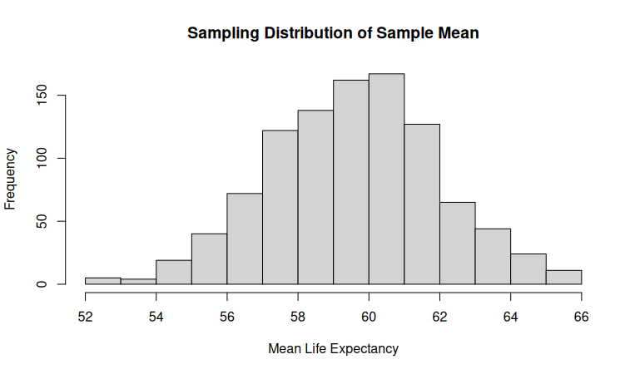

Step 4:
means_10 <- replicate(
1000,
mean(sample(life_data, 10, replace = TRUE))
)

means_100 <- replicate(
1000,
mean(sample(life_data, 100, replace = TRUE))
)

hist(means_10, main = "n = 10")

hist(means_100, main = "n = 100")

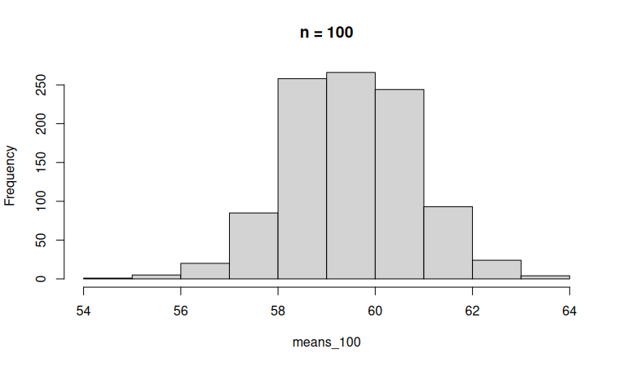

Step 5:

simulate_means <- function(n, reps = 1000) {

replicate(
reps,
mean(sample(life_data, size = n, replace = TRUE))
)

}

sample_sizes <- c(10, 30, 50, 100)

par(mfrow = c(2,2))

for (n in sample_sizes) {

hist(
simulate_means(n),
main = paste("n =", n)
)

}

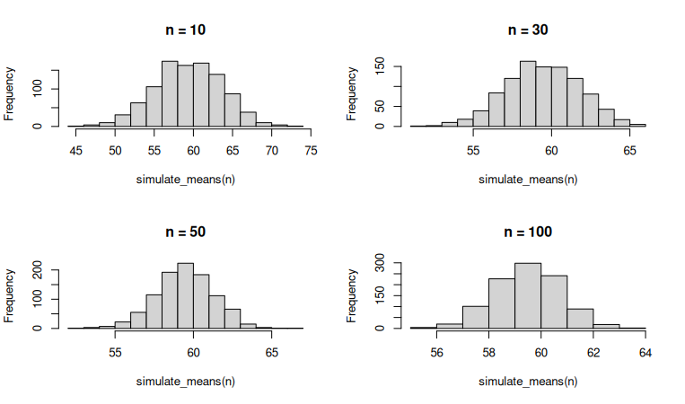

Step 6:

library(gapminder)

head(gapminder)

summary(gapminder)

ggplot(
gapminder,
aes(x = gdpPercap, y = lifeExp)
) +
geom_point()
output: 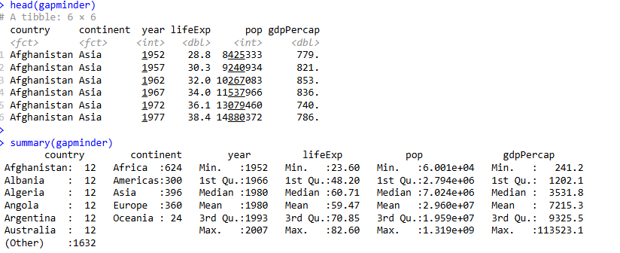
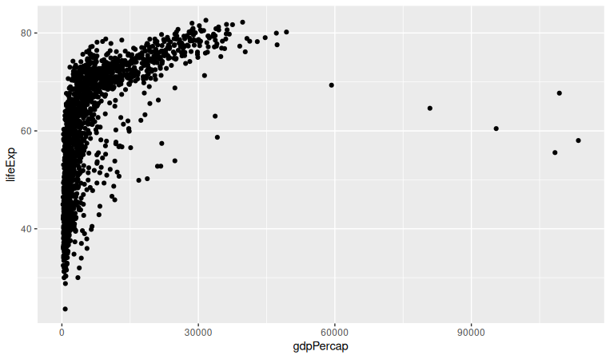

Step 7:

cor(
gapminder$lifeExp,
gapminder$gdpPercap,
method = "pearson"
)

library(ggpubr)

ggscatter(
gapminder,
x = "gdpPercap",
y = "lifeExp",
add = "reg.line"
)
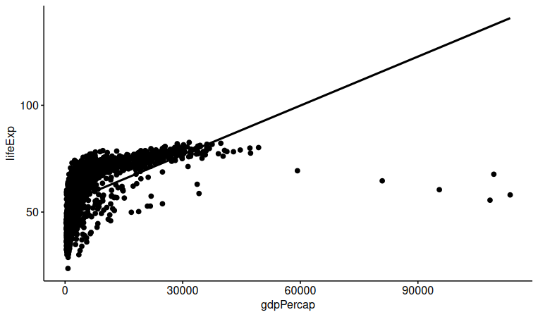

Step 8:

cor(
gapminder$lifeExp,
gapminder$gdpPercap,
method = "spearman"
)
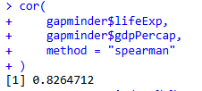

Step 9:

europe <- gapminder %>%
filter(continent == "Europe") %>%
pull(lifeExp)

africa <- gapminder %>%
filter(continent == "Africa") %>%
pull(lifeExp)

t.test(europe, africa)
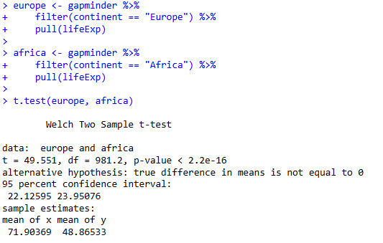

step 10:

model <- lm(
lifeExp ~ gdpPercap,
data = gapminder
)

summary(model)
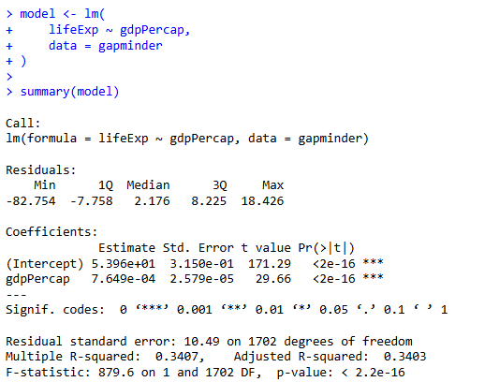

step 11:
model_multi <- lm(
lifeExp ~ gdpPercap + year + continent,
data = gapminder
)

summary(model_multi)
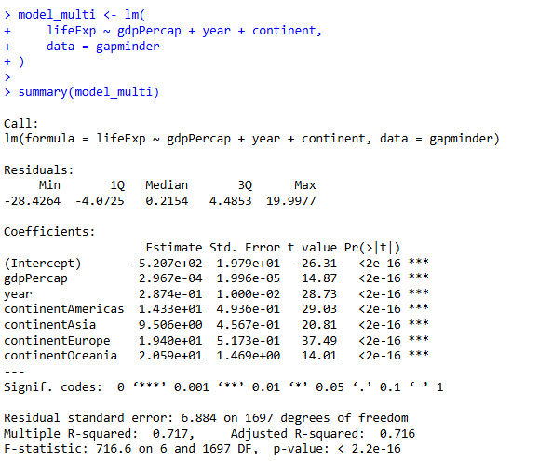

par(mfrow = c(2,2))
plot(model_multi)



