
Deal condition: coupons can’t be combinedor used with another offer. Valid at participating stores only. Please mention when ordering.
Customer service-if you experience any difficulties that the store manager cannot resolve the problem please visit:www.trinityservicesconcern.com
We are happy to accept credit- debit cards sorry, we do not accept cash or cheques. Full T@C applies.
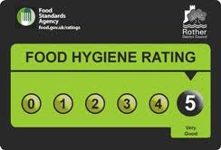
Wines:175 ML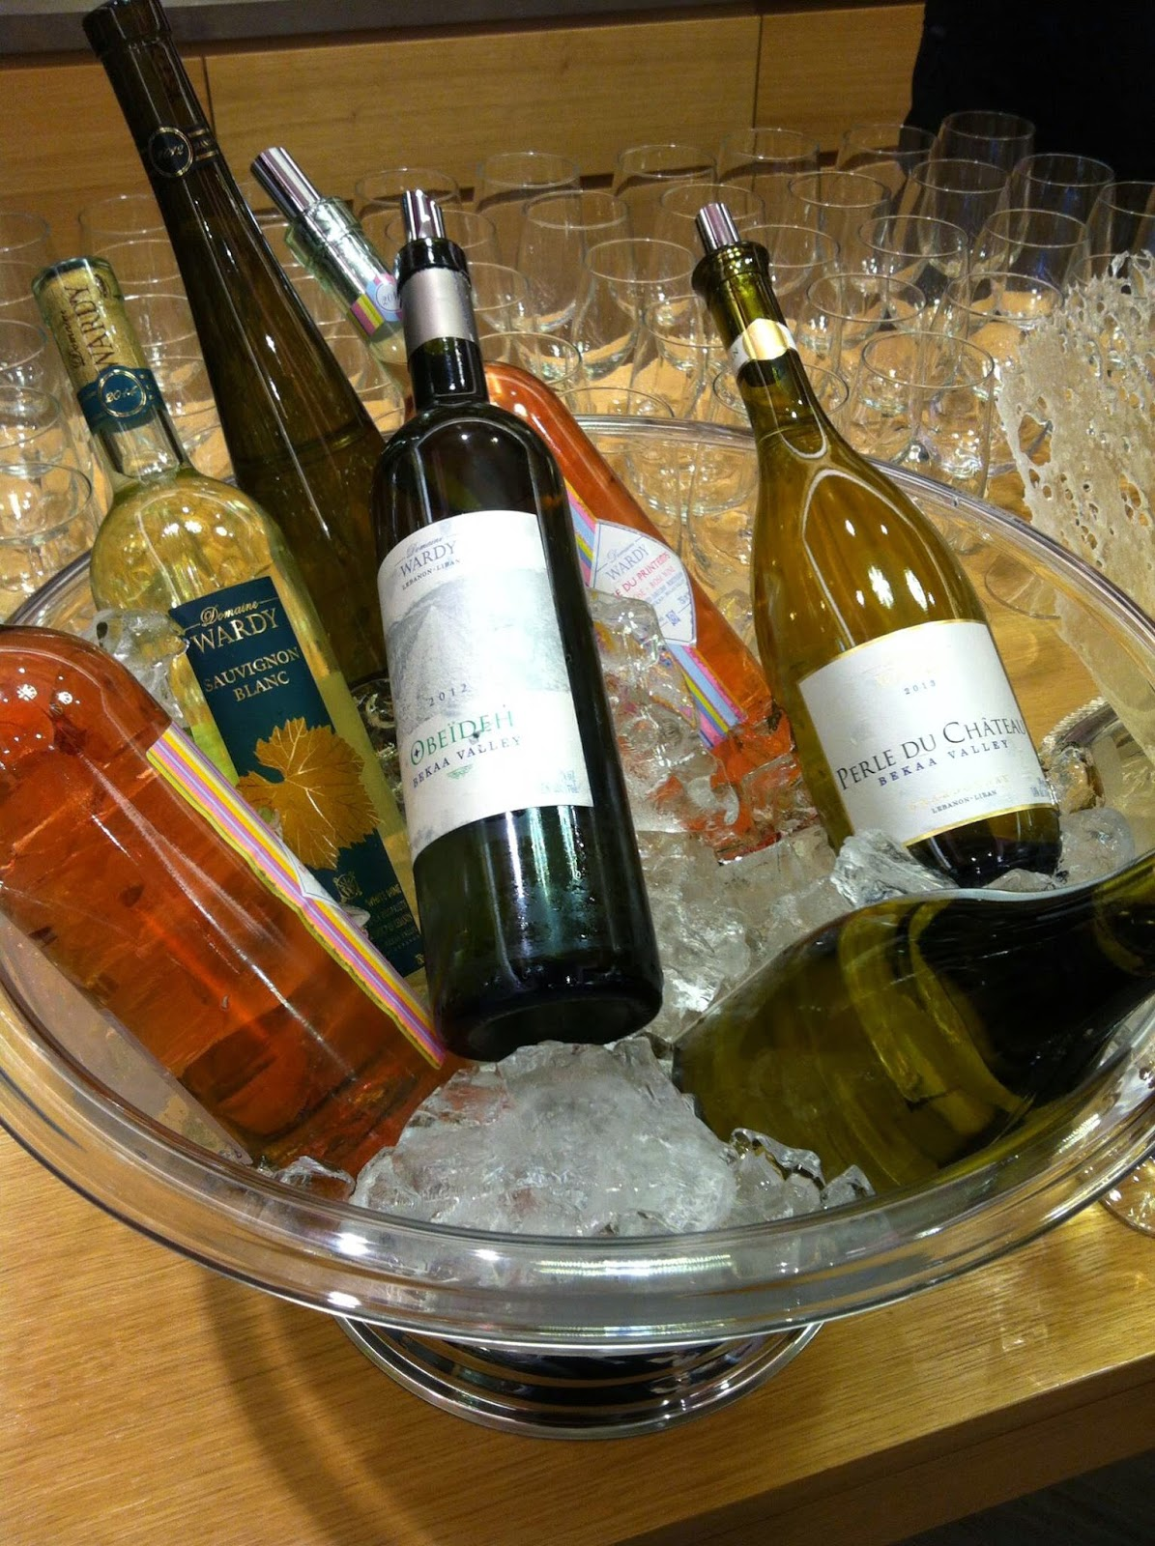
Sparkling wine(from USA) 30
Rich White wine(made with white grapes) 40
Light red wine(best for summer drinking) 45
Rose wine ( incorporates some of the color from the grape skins) 35

vegan option
Starters:
- Baby back ribs (sticky JamesOn, BBQ sauce and garlic dip) 10
- Prawn cocktail (lettuce, prawn crackers) 12.50
Main course:
- Daily fish special (trinity daily fish selection rose wine 20.00
- Lamb kadai(serve with rice ,chapati and beans) 25.00
- Braised short ribs (serve light red wine braised short ribs, potatoes and spinach) 30.00

Dessert:
- Chocolate muffin, apple pie, custard pie 5
- Rice pudding, custard pudding 8
- Pineapple with chocolate cake 10

- Special chicken biryani 30.00
- Trinity special fish dish 25.00
- Special mutton tikka with rice 30.00

Special offer:
- Family meal deal (fish, fries and 1.25 ltr. coke) 25
- Spend 50% when you spend more than 50.

- Lamb kadai (this dish can serve 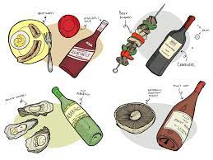with red wine)
- Daily fish special (this dish can serve with sparkling wine)
- Mixed fried rice (serve with eggs, lamb meat and chicken breast)
Drinks:
- Soft drinks 2.50
- Beers 5.00
- Bottle of water 4.00
- Tea/coffee 3.00

Gluten free option is available please order online only.
18
Ch. Combo meal
20
Trinity special dish
15
Grilled seafood platter
10
Fish and chips
44
Veg.soup
Card only
o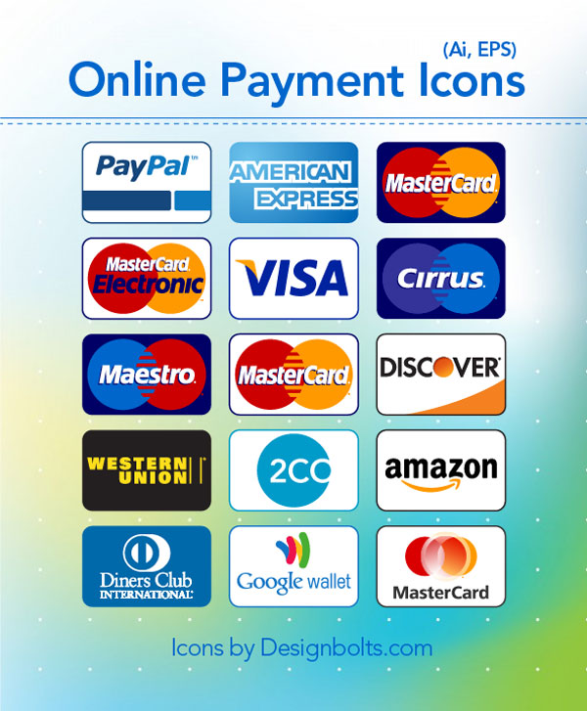
Hotel Trinity, 424 oxford street, south Wales Wa2 9PR PHONE:01248876549. Allergens and good hygiene rating please visit our website:www.allergininformation.trinity.co.uk.

Order now
Open for collection
Open :11¬11

