Managing Projects in the Organization

Name:sumae silva
ID:1605442

Executive Summary:
This assignment deals with managing the project of "Denial & Alisha's wedding" by a popular wedding planner firm of the United Kingdom which is "Rula Parties”. The entrepreneur Rula and her team plan different Weddings, Parties executed with style, sophistication, and glamour. This organization tries to deliver at the highest level of services to its clients as a wedding day is a special day of a person's life. At the planning stage, different types of tools and techniques are measured to evaluate the project properly. The authority of Rula Parties firm will also use the tool of consulting with the stakeholders of this event to find out the associated risks. Based on the project evaluation, I have conducted an analysis of myself to find out my strength and weakness. After that, I have to make a self-development plan to improve my ability so that it will be easy for me to accomplish this wedding event successfully.
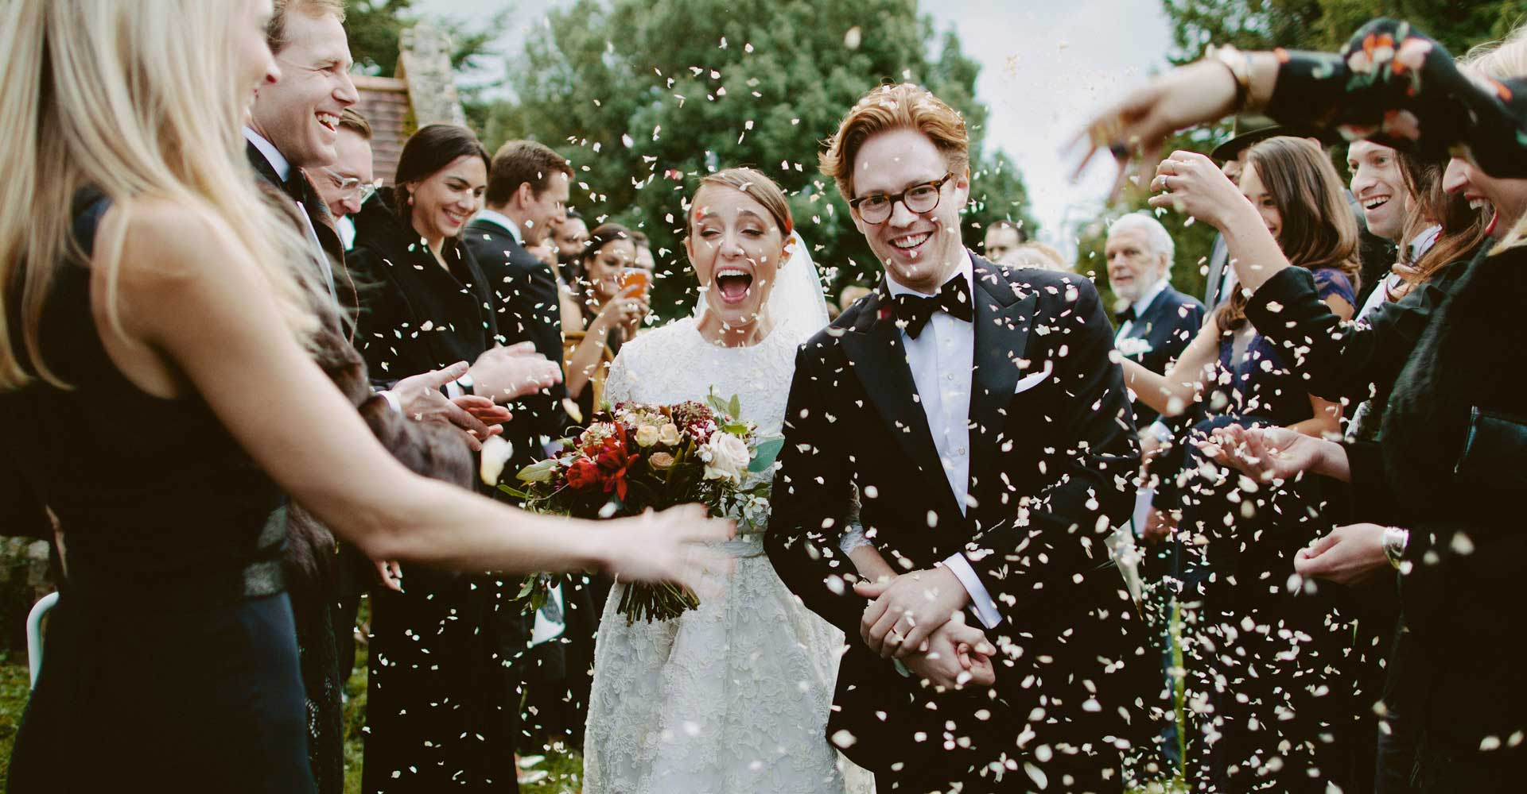

Table of Contents:

Executive Summary: 3
Introduction: 4
Project Charter: 5
Organizational Structure: 8
Project Management Approaches: 10
Project Management Tools and Techniques: 12
My ability to manage this project: 17
Strength: 17
Weakness: 17
Self-Development Plan of myself: 17
Conclusion: 19
References: 20

Introduction:
Project management is a crucial issue in today's business world. If the related party can’t manage their project properly then they may not sustain in the market. In the case of managing a project, there are different types of tools and techniques. The tools are varied because of the size and pattern of the project. Project management is mainly the art of organizing, leading, reporting and completing a project through people (Heerkens, 2015).
For this assignment, I have chosen a project of “Denial & Alisha’s wedding”. To conduct their wedding properly we the “Rula Parties wedding planner firm" will work for 28 weeks along with our teams.
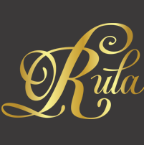
This wedding function will happen in 3 different areas of the United Kingdom. So we are assigned to complete all the tasks related to this wedding as the client wants to do their wedding in a traditional way (Deeprose, 2012). For this reason, we will have to arrange everything so that it will provide a traditional vibe. In the United Kingdom, the “Rula parties” is a popular wedding planner. The entrepreneur Rula and her team plan Weddings, Parties and Soirees with a certain flair, executed with style, sophistication, and glamour. This organization tries to deliver at the highest level of services to its clients as the wedding day is a special day of a person’s life. For this reason, this organization also tries to make it special through its unique decoration and arrangements. This organization mainly works at some of London's most iconic 5-star venues to parties at home. Rula has gained a wealth of experience in managing complex projects. In the project of this assignment, I have worked as the head of this wedding project.

Project Charter:
Title of the project: The title of this project is” Denial & Alisha’s wedding”. This is a wedding project which will take place in different 3 areas of United Kingdom. The time period of this function is around 3.5 months. The duration of the whole preparation is 28 weeks. His assignment mainly deals with the wedding planning activities by a wedding planner firm. Purpose of this project: The purpose of this grand event is to make unity between Denial & Alisha's family in a holy Matrimony.
Objectives of this project: The objective of this project is to accomplish all the activities within the specific time by using the allocated budget (Hobbs, 2013). The success of this project will measure by the whole performance of the authority of Rula Parties wedding planner firm. The success will measure based on the decoration, food, DJ, photography, vehicles, decorators, etc.
Scope of this project: The project of “Denial & Alisha’s wedding: is a big project for Rula Parties firm. The wedding planner authority will cover many issues under this project. Such as- Primary meeting with the related parties, like- parents of both bride and groom to know about their expectation from the planner, Consult with the inspiration board, collecting the photographs of the engagements.
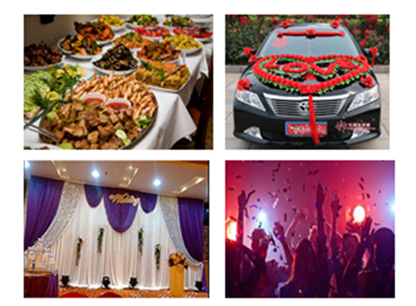
Finding out the best decoration source, booking the flower provider, booking the DJ, booking the photographer, booking the videographer, confirming the venue, reserving the officials who will help the Rula Parties firm to conduct the activities properly, booking the catering house to provide foods, confirming decorator, purchasing stationary items, cake booking, vehicles booking, hotel reservation, making the final list of the guests, making the accumulated miscellaneous cost, arranging some people who will conduct the rest activities after completing the function (Kerzner, 2014).
Exclusion from the scope: There are some issues which are not covered under the scope of this project of Rula Parties firm. Those scopes are- wedding dress of the bride and groom, bridal shower party, the license of the marriage, catering house service, ordering the invitation card, sending an invitation to the guests, booking the parlor artist for makeup and hair set up, booing the honeymoon suits, finalizing the payments.
Deliverables: The deliverables of this wedding project are-
- Primary meeting with the related parties.
- Consult with the inspiration board.
- Collecting the photographs of the engagements. The cost may be £400.
- Finding out the best decoration source.
- Booking the flower provider which costs may be £2000.
- Booking the DJ which costs may be £1000.
- Booking the photographer which costs may be £1500.
- Booking the videographer which costs may be £2200.
- Confirming the venue which proposed cost may be £6000.
- Reserving the officials who will help the Rula Parties firm to conduct the activities properly. The cost may be £1000.
- Booking the catering house to provide foods which costs may be £7300. They also provide drinks (Meredith, 2019).
- Confirming decorator which cost maybe £1300.
- Purchasing stationery items costing £1200.
- Cake booking which costs may be £500.
- Vehicles booking which costs may be £600.
- Hotel reservation which costs may be £750.
- The final list of the guests.
- Make the accumulated miscellaneous cost.
- Arranging some people who will conduct the rest activities after completing the function. Here the cost may be £560.
Constraints of this project: The main constraints of the event are- budget constraint as the budget is limited to £45,000, the number of invited guests are 300+ but 15% of the variation, different types of foods option and the project period of 28 weeks (Patel, 2016).
Different assumptions of this project: There are some assumptions in this project. Such as- May the bride and groom won't fall out of love, the number of guests may increase, the guest will show up, the responsible parties will perform their duties in a proper way, the vendor and venue will perform their duties according to the contracts.
Budgets of this project: This wedding project is a grand project so the budget is high here. As this wedding will happen in a traditional way so the project needs £40,000 to complete. The decoration, catering, DJ, photography everything is included here.
Duration of the project: The total duration of this event is 28 weeks as it is a grand function and they want to do it in a traditional way so it takes more time to accomplish.
Risk management process of this event: At first the authority of Rula Parties wedding planner firm identifies all the potential risks. Such as- management risk, operational risk. To find out those risks, different types of tools are used (Pinto, 2019). Such as- Delphi techniques, SWOT analysis, root cause analysis, checklist, making risk log, etc. the risks which have found are given below along with the solutions. Such as-
- Fire protection: Check the venue properly whether are the fire extinguisher or not. Whether the venue has any risk free certificate provided by the government authority.
- Venue hires: As this is a traditional wedding so the venues should be big.
- Hiring Vehicles: The authority of the Rula Parties firm is assuming that no responsibilities of damaging the vehicles will bear by the hiring firm. so the drivers of the vehicles should be expert in driving so that no accidents can take place. The damages of the vehicles won't happen by the guests. If it occurs when the parents of the bride & groom will compensate for that.
- Jewelry of the bride: The couple has already taken the insurance coverage for any of the damages, loss or theft of their jewelry. But the engagement ring is not included in this insurance coverage as the value of the ring is not that much high. The duration of that insurance is 2 weeks. One week before the wedding takes place and one week after the wedding.
- Contracting with the vendor: As the wedding planner should have to consult with different vendors to find out the best source. It will help them to accomplish their all tasks within their limited budgets. To cancel any vendor, it should also write down in a document so that no problem will occur in the future (Portny, 2017).
- Booking the photographer.
- Confirming the best catering house: As this is a big event and the parents want to make the special for their children so the food should be tasty otherwise the guests may gossip with it.
- Find out the good source of wedding gifts.
- Availability of enough staffs: As it is a grand function so a large m=number of staffs will need to compete for every task in a proper way.
- To protect the uninvited guests: Some uninvited guest may enter into the function so the respective people should be careful about this issue so that such type of people can't get an entry in the function premises (Tinnirello, 2018).
- Make a tasty an attractive cake.
- To maintain the flower in such a way so that they will remain fresh until starting the function.

Organizational Structure:
In the event management industry, it is not common to show the organizational structure to their clients. The event management industry mainly gives more focus on their goodwill and working pattern. They are brand focused and customer focused. The clients choose an event management firm based on their quality of work. As everyone wants to make their wedding day very special so 70% credit goes to the wedding planner of that function. The contract happens between the clients and a specific person of that wedding planner firm. So in this perspective, it is not necessary to engage more people at the time of contract (Rula-parties.com, 2019). In case of completing this project of “Denial & Alisha’s wedding” the authority of Rula Parties will follow the below structure:

Figure: Organizational Structure
Source: self-design
There will be ahead of the event. Under the head, there will be one senior event manager and one junior event manager. Under both managers, there are some event teams who mainly conduct the activities by taking help from different vendors.
The project charter is considered as an outline of the whole project. It depicts the identification of the responsibilities, the objectives of the project, it's budget and time duration, sponsors, manager of the project, the primary and secondary stakeholders. Every issue is described in the project charter in a proper way so that no confusion will arise in between the clients and the event management firm. After consulting with the clients it is hoping that we will be able to complete this event effectively within the specific time period (Deeprose, 2012).

Project Management Approaches:
There are different types of approaches to manage a project. In the case of Rula Parties, they can follow the below approaches to manage their different projects. The findings are described below:
Management Approach | Agail | Process-Based | Sequential | Task Mgt | Team Collaboration | Time Tracking | Easy to use | Correction
Critical Path( CPM) |  |  | √ | √ | √ | √
Critical Chain Project Management (CCPM) |  |  | √ | √ | √ | √
Lean Management |  | √ |  |  | √ | √
Waterfall Process |  |  | √ | √ | √ | √ | √
Serum |  | √ |  |  | √ | √ |  | √
Prince 2
Adaptive project framework (APF) | √ |  |  | √ | √ |  |  | √
Figure: Project Management Approaches
Source: (Rula-parties.com, 2019)
Critical Chain Project Management approach works very effectively as the whole work is allotted in different teams. The Rula Parties firm can follow this approach. This approach depicts that a business organization should run only a project at a time, not several projects. When Rula Party will run only one project then they won't have to share their resources with another project which will be a good issues form them to manage effectively (Wysocki, 2014).
Critical Path management gives more focus on different issues of a project at its planning and execution stages. This method of management helps the firm to find out the critical tasks of the project, the time schedule of the project, the execution place of the project and the necessary resources. If Rula Parties firm follows this management style then they should not have to modify their existing plan. Every firm has to face the scarcity of resources so this critical path method helps them to distribute their scare resources among different projects (Heerkens, 2015).
Lean project management is a very effective management tool for a business firm because it helps a firm to reduce its production wastages, unnecessary activities, and steps of works, holding an adequate number of inventories. This method provides the guideline of a firm to adopt the just in time system so that they don't have to hold an excessive amount of inventory. To run a project, Rula Parties firm has to keep many inventories as they don't know when they will get a wedding planning order. For this reason, this approach will be effective for them in case of maintaining enough inventories.
Today’s business world is so dynamic but the waterfall method doesn't permit a firm to conduct its business activities in a dynamic situation. In the case of a dynamic business world, the authority should have to change many issues to cope up with the changing world. But this method is very rigid so in case of Rula Parties firm, this method is not effective (Hobbs, 2013).
Scrum method is effective for the business that is engaging in creative work. Sometimes this method is unpredictable. For our wedding planning project, this style is suitable though it takes too much time.
PRINCE2 (Projects in Controlled Environments) is a project management method that divides the projects into different manageable and controllable stages so that it will be easy for the firm to manage its projects. The prince-2 method is used in case of managing any complex project. Under the prince 2 method, there are 7 themes of a project which are taken into consideration (Fliedner, 2012).
Adaptive project framework is a flexible method of managing a project. If necessary the firm can change its project plan. In the case of a wedding planner, they have to change their plan continuously based on the client's demand and choices. So this management method is effective for them. In the case of the wedding planning project, the clients don't have any idea about the decoration before consulting with the planner. So the Rula Parties firm can use this project to manage their current wedding plan of Denial and Alisha.
Agile is something like a stand-alone method of project management. It helps the managing team to provide quick and unpredictable responses to the feedback from their clients. By using this method, the Rula Parties firm can assess their current project’s direction during the development cycle (Kerzner, 2014). In case of a wedding planning, the authority of Rula Parties firm should assess their project in regular meetings called sprints or iterations. This process is very empowering which helps Rula Parties to design their wedding plan in the right way.

Project Management Tools and Techniques:
There are different types of project management tools which will help the Rula Parties firm to conduct their current project of "wedding plan of Denial and Aisha". Different types of tools help the firm to complete their every task related to the wedding planning at the right time. Different types of crucial issues are considered at the time of making planning (Meredith, 2019). Besides, the authority also should have to consider the cost and benefits of that project. In the case of this current project, the Rula Parties firm should have to follow the following tools:

- Stakeholders Map: This tool helps the authority of Rula parties to know who their actual stakeholders are. In the case of the current event of "Denial and Alisha’s wedding”, the stakeholders are- bride, groom, their two families, close relatives, and vendors.

Figure: Stakeholders of this event
Source: self-design
- Sponsors: The people or organization that is providing the support to the wedding planner to conduct their activities properly is known as sponsor. In this project of Denial & Alisha’s wedding, the stakeholders of Rula Parties event are- the best man who is accountable for Stage event, the amid of honor is accountable for bridal shower and hen night, the 2 family members mainly contribute in this event as they are hot of the whole event. The close family members will conduct the introduction segment of the function as many people don’t know each other (Patel, 2016).

Figure: Sponsors of the event
Source: self-design

- Stakeholder Power Interest Matrix: This matrix will help Rula Parties firm to know which stakeholders possess how much power and interest of this event. By using this tool, we can identify great stakeholders. After constructing a power interest matrix, it has found that in this event, the primary stakeholder’s are- bride, groom, their parents and close family members of both sides (Pinto, 2019). The secondary stakeholders are- best man, maid of honor, flower girl, Paige boy, etc. the vendors of this event are- flower provider, photographer, make up man, hairdresser, vehicle provider, venue provider, etc.
At the initial stage of the planning of this wedding project, this stakeholder’s analysis has conducted by Rula Parties firm. Wedding is a traditional function. Many parties’ emotions are related to this function so the wedding planner should have to deal with this issue very effectively as it is considered as a sensitive issue. In such type of an event, most of the parties don't have any direct interest. So the project manager should maintain good communication with different parties to complete the event in a peaceful way (Portny, 2017).

Grooms parents
HIGH
LOW

POWER
HIGH
INTEREST
Brides Father
Brides, Groom
Close family, Best man
Brides mom, Maid of honor
Vendors

Figure: Stakeholder Power Interest Matrix
Source: (Hall, 2017).

- RACI Diagram: The RACI diagram stands for responsible, accountable, consulted and informed. This diagram is used to clarify the roles and responsibilities of the different stakeholders of a project. The responsible who mainly conducts the work. The accountable are those persons who mainly take the credit of success and failure of the event. The primary stakeholders are that person who is categorized under responsible and accountable. On the other hand, secondary stakeholders are consulted and informed. The RACI diagram mainly shows the tasks and obligations of different stakeholders. It provides a clear idea of agreed deliverables as well as who is to perform them (Rula-parties.com, 2019). From our RACI diagram, we have found both the parties who are affected financially and non-financially.
- Stakeholders Analysis for Project Communication: The stakeholder’s analysis for project communication tool helps the authority of Rula Parties firm to communicate with the primary stakeholders who are identified from the RACI diagram. In case of any communication, we will get feedback which will help us to re-plan our next steps. Such type of communication helps the wedding planner to know the feedback of the clients and based on that they can make the further move (Tinnirello, 2018).

Stakeholders | Meeting frequency | Communication way | Contact person
Bride | Bi-weekly | Face to face/ Phone | Alisha
Groom | Bi-weekly | Face to face/ Phone | Denial
Parents of the bride | Bi-weekly | Face to face/ Phone | Richard( father)
Parents of the groom | Bi-monthly | Face to face/ Phone | Ferrero ( father)
Close family member | Monthly | Phone | Funke
Caterer | By monthly | Phone/ Email | Johnson
Decorator | 1 month before the event | Phone/ Email | Christina
DJ | 1 month before | Phone/ Email | Sharon
Flower provider | 1 month before | Phone/ Email | Olu
Photographer | 1 month before | Phone/ Email | Istahud
Vehicle | 1 month before | Phone/ Email | Carlos
Guest | Once | Invitation card | John
This communication mainly breaks down the information of RACI diagram. At the planning stage, every project manager should use this tool before making any plan.
To manage a project it is necessary that the head person of that project has enough capabilities. The success of the project mostly depends on the quality, skill, and knowledge of the head person because he supervises the subordinates and other team members (Gorecki and Pautsch, 2015).

My ability to manage this project:
In this project, I have worked as the head of this project. So I have to manage different parties who are related to this project. I also have some strength and weaknesses which may create impediments in my way of workings. At the time of conducting this project, different types of problems may arise so I will have to handle those effectively so that none disappoints. The strength and weakness of me of being ahead of this wedding project are given below:
Strength: I am an efficient communicator which is very important for a project head. I can understand the phycology of people and based on that I deliver my speech so it is easy for me to handle any types of people. In the case of running a project, different types of conflicts may arise as it is a long event. I have the quality of sound judgment so I can manage such types of conflicts in a diplomatic way so that both parties will be happy. I also can pursue people within a short time so it will be easy for me to pursue the vendors (Taghizadegan, 2015). I can make the best decision after performing different judgments.
Weakness: In this event, different parties are involved. If anyone does any fraudulent activities with me then I won’t control my temper. When I notice any types of negative activities I can keep myself clam which may create a negative impact on my performance. I am reactive which sometimes create a problem for me. Besides, I can’t motivate people to perform their duties.

Self-Development Plan of myself:
To complete this project in a proper manner, being ahead of this project, I should have to develop myself so that I can complete this project effectively. This is a lengthy and big project. A large number of people will involve here (Hall, 2017). After finding out my strength and weakness, I am going to make a personal development plan. The plan is given below-

 | Goal-1 | Goal-2 | Goal-3 | Goal -4
Objective | Improve budgeting skill | Considering sustainable managing method | Be proactive | Improving excel knowledge
Action | Doing a basic accounting course | Making a conscious effort | Make a control over myself | Doing an excel course
Resource | Finances | Availability of time to do research | Availability of opportunity to mingling with many people | Finances
Duration | 2months | 1.5months | 2months | 1month
Table: Personal Development Plan
The Excel knowledge help me to develop any customized program to manage the projector set up any template to keep records of all the items of expenses, human resources, materials, etc. in a proper way.

Conclusion:
To manage a project is a big deal so the planner firm and the associated parties should be careful in case of accomplishing any event. In this assignment, there is a wedding project which is Denial & Alisha's wedding". It is a big project consisting of 28 weeks planning so it is necessary for the Rula Parties wedding planner firm to use different approaches, management methods, and tools to conduct this project effectively. Being the head of this project I have to run this whole event. I have assumed some risk factors of this event based on my past working experiences. The tools and techniques are allowed to manage the project completely from every perspective so that at the end we the Rula Parties team will give the best output to our clients. The adaptive project framework is the appropriate style for this new wedding project (Rechenthin, 2016).
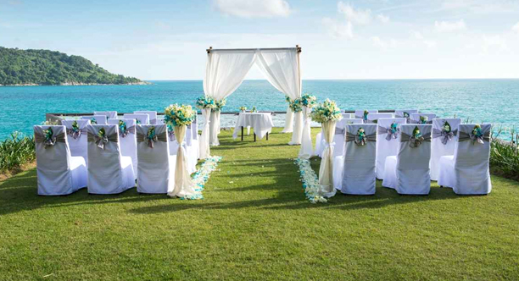

References:
Deeprose, D. (2012). Project management. Oxford, U.K.: Capstone Pub.
Fliedner, G. (2012). Leading and managing the lean management process. [New York, N.Y.]: Business Expert Press.
Gorecki, P. and Pautsch, P. (2015). Lean Management.
Hall, D. (2017). Career development in organizations. San Francisco: Jossey Bass.
Heerkens, G. (2015). Project management. [Place of publication not identified]: Mcgraw-Hill Education.
Hobbs, P. (2013). Project management.
Kerzner, H. (2014). Project management.
Meredith, J. (2019). Project Management. New York: Wiley.
Patel, V. (2016). Project management. Jaipur, India: Oxford Book Co.
Pinto, J. (2019). Project Management. Harlow, United Kingdom: Pearson Education Limited.
Portny, S. (2017). Project management for dummies.
Rechenthin, D. (2016). Project intelligence.
Rula-parties.com. (2019). Rula Parties | About. [online] Available at: http://www.rula-parties.com/about/ [Accessed 28 Apr. 2019].
Taghizadegan, S. (2015). Mastering lean six sigma.
Tinnirello, P. (2018). Project management. Boca Raton: Auerbach.
Wysocki, R. (2013). Effective project management. Hoboken, N.J.: Wiley.
Wysocki, R. (2014). Adaptive project framework. Upper Saddle River, N.J.: Addison-Wesley.

