Assessment 1
Environmental Analysis of an Industry

Module Name: The Global Business Environment
Module Code: LCCB4005
Student name: Vasile Ciprian Alin Diaconu
Student number: 2030168
Table of Contents
Introduction 2
Company overview 2
Evaluating the challenges associated with business environment 3
Internal environment analysis of Land Rover 3
SWOT analysis of Land Rover 3
Strengths of Land Rover 4
Weaknesses of Land Rover 4
Opportunities of Land Rover 4
Threats of Land Rover 5
External environment analysis of Land Rover 5
PESTLE Analysis of Land Rover 6
Political factors 6
Economic factors 6
Social factors 6
Technological factors 6
Legal factors 7
Environmental factors 7
Porter’s Five Forces Analysis 7
Bargaining power of the buyers 7
Bargaining power of the suppliers 8
The threat of substitutes 8
The threat of new entrants 8
Rivalry within the industry 8
Value chain analysis 8
Primary objectives 9
Secondary objectives 9
The competitive advantages that ensure sustainability of Land Rover 10
Conclusion 10
References 11

Introduction
Business is an undisputed subject of human’s life. It is the process of earning profits by selling specific goods or services. Every single entity in the global workforces is somehow associated with business operations (Cuervo‐Cazurra, 2011). Now business organizations have gone across national boundaries and operating business in foreign environment. This globalization of business has made the business functions more critical. Now they are facing various types of challenges while operating business globally. These challenges are even crucial in the automobile industry. Once there were only few automobile brands which were used to dominating the global automobile industry. But, along with the development of technology, many new companies have gained a strong position in the market. Due to globalization and technological development, customers are now facilitated with variety of options. So the automobile brands are now constructing new models continuously to grab customers’ attention by variety of features. This paper is all about to highlight and interpret the challenges associated with a business’s internal and external environment within an organizational context named Land Rover. To do so, it is going to include SWOT analysis, PESTLE analysis, Porters five forces analysis, Value chain analysis, in fine, how their core values help to gain competitive advantages over other industries and ensure sustainability.

Company overview
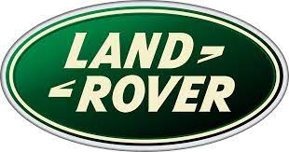
Land Rover is a British automobile manufacturing brand which is owned by Jaguar Land Rover since 2013. It has long history of ownership. Land Rover brand was originated in 1948 by Rover Company and in 1951, it was granted a royal warrant by King George VI. Over the times it had gone through many ownership era, respectively, British Leyland, Rover Group, BMW, Ford Motor company, and Tata motors. In 2013, it has been merged with Jaguar Cars and formed Jaguar Land Rover which is headquartered in Solihull, West Midlands, UK. At present it is running its production houses in Brazil, China, India, Slovakia, and United Kingdom and has become one of dominating brand in the automotive industry of UK as well as all over the world. Land Rover is also contributing in the defense sector of multiple countries. Mostly in British Army and Australian Army.

Evaluating the challenges associated with business environment
Business environment encompasses all the factors that have both direct and indirect impact on business (Kankaanranta, and Salminen, 2013). To operate business successfully, no organization can ignore any of the factors of its environment. The factors are categorized into two category, internal and external.
Every manager of business organizations cannot but have to analyze the environment in which it operates business (Weismann, 2009). Without having a proper knowledge regarding the environment, no manager can make ad hoc decisions. Environment analysis helps the organization in every step of its activities. It also figure out the probable outcome and potential risk related to a plan.
So, to make this report more informative, both external and internal analysis of Land Rover are going to be conducted.

Internal environment analysis of Land Rover
Internal analysis refers to analyze the aspects belongs to the internal environment of the business (Karaszewski, 2010). It helps to find out the problems related to the internal body of the organization. For doing so, SWOT analysis is the best gauge.

SWOT analysis of Land Rover
SWOT analysis is a strategy which identifies and examine the strengths, weaknesses, opportunities and threats associated with the business (Thomas, 2008). The name SWOT is derived from the acronym of the four element of the strategy. Managers conduct this framework to make most favorable decisions. It also assists to make four interrelated strategies like SO strategies, WO strategies, ST strategies and WT strategies. So, SWOT analysis of British giant automobile company Land Rover has been accomplished below.

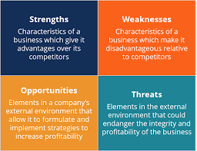

Strengths of Land Rover
Strength refers to the aspects by which a company can get advantages.
- Land Rover possesses a specialized department which researches competitors and new enterers in the market to take competitive advantages.
- It conducts demographic analysis to ensure high level of customers’ satisfaction.
- Having a strong distribution chain, it becomes very easy for it to reach potential customers.
- Continuous innovation of specialized models increases its brand value.
- It’s cash flow is adequate enough.
- It has a large dealer community which helps to operate business globally.

Weaknesses of Land Rover
Land Rover has some lacking within its management. They are,
- In recent times, they are not investing enough to conduct research for bringing latest technology.
- Though they have a strong brand recognition, less focus on promotional campaigns may lead to lose market share.
- Inaccurate budget causes inappropriate distribution of resources.
- Nowadays it is investing much more to train and develop employees’ skill.
- Inadequate research programs hinders the development.

Opportunities of Land Rover
Luck is what happens when preparation meets opportunity. So Land Rover remains cautious to grab profitable opportunities. Some of its opportunities are,
- Due to Covid19, physically selling offerings has been reduced. So it emphasized more on online marketing to protect from facing loses.
- It can reduce transportation costs as well as overall production costs by establishing regional production houses.
- As they have sold automobiles to British army and Australian army, it has opened the opportunity to make contracts with other countries’ defense force.
- Inasmuch the British parliament has bring a new environmental policy in force, Land Rover has also come up with new plans.

Threats of Land Rover
Threats refers to the adversities associated with the business environment. Land Rover has some threats too. They are,
- Lacking in the technological development, Land Rover is falling back comparing with its rivals.
- Inadequate research programs interrupts the innovation of new models.
- Due to globalization and development in communication, automobile industry is becoming more competitive day by day.
- Because of poor promotional campaigns it is facing brand value deterioration.

External environment analysis of Land Rover
The term external environment refers to factors which affects an organization from outside (Ferraro, and Briody, 2017). It encompasses many aspects. All the aspects somehow impact on the business activities. So, analyses of these factors is a crying need for a multination brand like Land Rover. PESTLE analysis is the best method of analyzing an organization’s external environment. As Land Rover operates business globally, it has to face both national and international issues regularly. Because of different countries having different business environment, Land Rover cannot but conduct individual analysis of every regional and international branch. To uphold the environmental forces of Land Rover, PESTLE analysis of its external environment has been conducted beneath.

PESTLE Analysis of Land Rover
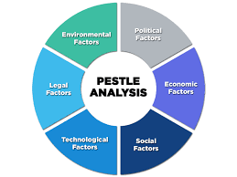

Political factors
Political factors are one of the main influencer behind the changes in an organization’s business functions. These factors directly affects the foundation of a company. As a multinational company, Land Rover has to deal with many government across the world. To operate business successfully, it has to comply with the government policies. Irregular election, strike, inappropriate government policies etc. are some of the highlighted factors of political environment. Recent intercommunal issues of Myanmar prohibited the smooth business performance there. Moreover, Recent Brexit issue has causes a great suffering to Land Rover. Besides these, recent US-China trade war has assisted Land Rover to attain more market shares of those countries’ market.

Economic factors
It encompasses factors like inflation rate, foreign currency exchange rate, tax rate, VAT, economic cycle etc. As a multinational company, it has to consider both national and global economic aspects. Such as, in the third world countries, it may enjoy low labor cost as well as low production costs. Whereas, in the developed countries it has to pay comparatively more labor charge than the third world countries. Besides this, it is establishing local production houses in the operating countries to reduce raw material costs, transportation costs, import-export costs as well as overall production costs.

Social factors
Social factors refer to the social elements which directly or indirectly alter customer preferences (Samiee, 2008). It plays a significant role in the environment of every types of business. As Land Rover operate business globally, it is a must to understand the cultural differences, taste differences, buying capabilities etc. For instance, the people of USA may prefer dashing features within the vehicles, whereas, the people of India may prefer such vehicles which gives more mileage. Along with this, it should offer two wheeler at cheaper costs, inasmuch, maximum two wheeler customers are middle class.

Technological factors
These factors are the most unpredictable elements of business environment. If we analyze the new entrants in the automobile industry, we can see that, the company possessing the most developed technology, has grown more smoothly within a short range of time. As an age old brand, Land Rover has a high reputation in the industry. But during the recent pandemic, it was not focusing properly to the technological infrastructure of the company which causes loses to the company. Now, it is emphasizing more on website development, online marketing etc. to increase sell and regain market position.

Legal factors
Legal factors are a crucial issue for such a business like Land Rover. As the government takes the ultimate market decisions and holds the power to alter it according to need, it affects any business directly. Forasmuch, Land Rover operate business globally, it has to consider the legal factors of every country in which it operates business. For instance, in countries like Bangladesh, the vehicles engine cannot be more than 160 cubic centimeter. If Land Rover is looking forward to expand business in such countries, it has to manufacture automobiles complying with the local law. Some most influential laws are labor law, minimum living wages etc.

Environmental factors
Currently, environmental factors is the most alarming issue for the global communities. It eventually effects the operations of Land Rover. Due to global warming, Land Rover is now emphasizing more on reducing gasoline dependency of the automobile’s engine. In recent years, it has started recycling wastages which is approximately 4000 million tons every year.

Porter’s Five Forces Analysis
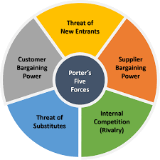
Managers are burdened with leading an organization to its ultimate goal. To do so, it has to accomplish various analysis. Porter’s five forces analysis is a strategy to analyze industry related factors (Dunning, 2006). These five forces are actually five major aspects which define a business. Information gathered through PESTLE analysis are used to find out the five aspects. The five forces have been described below,

Bargaining power of the buyers
Although there are many automobile brands in the industry, very few of them provide such brand value like Land Rover. This improved brand recognition facilitates Land Rover face customers with less bargaining capability. Because of being well known for their aesthetic offerings, customers all over the world don’t bargain much with Land Rover.

Bargaining power of the suppliers
As it is now establishing local factories in the operating countries, it has to go through bargaining sessions with suppliers. But, as it is has enough popularity, it gives advantages even while bargaining with the suppliers. Because, it has many alternatives, and any supplier will wholeheartedly accept deal with Land Rover.

The threat of substitutes
Land Rover is working on reducing the manufacturing costs to expand its market. It faces high competition as it has to compete with both domestic and international brands across the world. Such competition indicates the risks of substitutes. For instance, Chinese automobile brands are now emphasizing more on manufacturing automobiles with battery operated engine, which is a big threat to Land Rover.

The threat of new entrants
If we consider globally, there is a high threat of new enterer. Technology is being developed over the times all around the world. As Land Rover run its business in many countries, new entrants in both domestic and international platform are threats to Land Rover in one way or another. Being aware of these, it has appointed analysts in every domestic and foreign branches. So, it is expected that, even after facing a big threat, Land Rover will be able to compete at both national and international market.

Rivalry within the industry
The worldwide automobile industry is highly competitive. As there are many emerging brands who offers attractive and sustainable offerings, the switching costs of the customer will be reasonable. Toyota, Ford, Mercedes, TATA are the prominent competitors of Land Rover. Even though TATA and Land Rover has business relations, the others are gradually becoming a great threat to the business ranking.

Value chain analysis
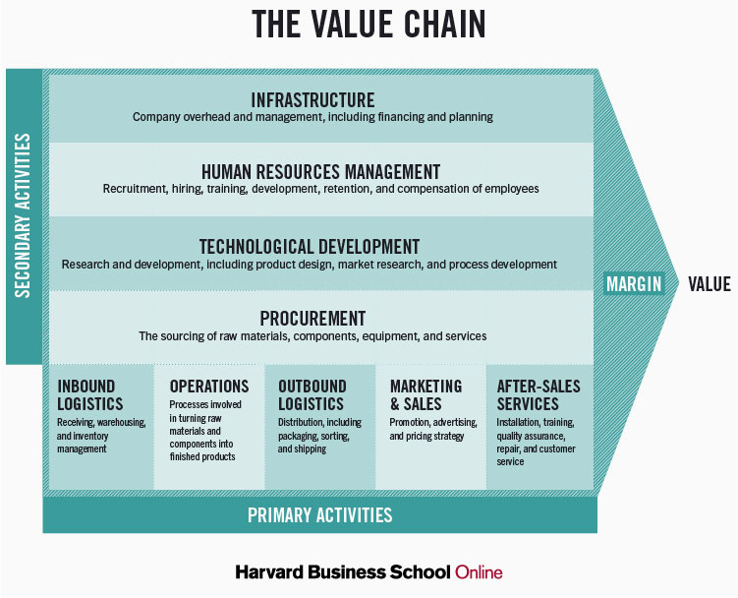
The term value chain refers to the combination of all activities which are required to create a product (Hsieh, 2009). It includes activities from distribution of resources till the product is launched. It is assumed that each activity adds a value in the product. Evaluating each and every activity of the whole supply chain, is known as value chain analysis. It complies with the Porter’s definition and divides the value chain activities into two category, primary activities and supportive activities. Both of these two type adds value to the offerings.

Primary objectives
Primary objectives refers to the activities which are directly related to the production of any specific product or execution of any services.
- Inbound logistics: It indicates the activities associated with receiving, warehousing and inventory management.
- Operations: It includes all the transforming processes which turns raw materials into a finished product.
- Outbound logistics: All the actions related with distribution, packing, classifying, and shipping of product.
- Marketing and sales: Marketing strategies, promotional campaigns, advertisement, pricing methods are the component of this type.
- After-sale services: The actions which are performed after the sale’s being confirmed are called after-sale services. Such as, warranty, exchange deal within 30 days after sale in case of major faults, installment payment.

Secondary objectives
Secondary objectives are the supportive activities of the primary activities. It facilitates to perform the primary objectives more efficiently.
- Procurement: The activities associated with the collection of raw material and necessary equipment are included here.
- Technological development: It encompasses research and development programs which are necessary for designing new products, analyzing market, strategy development etc.
- Human Resource Management: It comprises every single activity related to the workforce of an organization including recruitment, training, compensation, retention etc.
- Infrastructure: Activities which determine the business operations, expansion, organization’s activities are the component of this type of activity. For example, financial budget and organization planning.
Both the primary and secondary activities play significant roles to reduce costs and differentiate business offerings.

The competitive advantages that ensure sustainability of Land Rover
Land Rover is a well-recognized brand in the entire globe. To extinguish the vast demand it is now manufacturing automobiles in five countries. To maintain such an expanded business is has to go through complex management activities. To determine its performance quality Land Rover conducts SWOT analysis. It also develops the internal management. As it is an international brand, it accomplishes PESTLE analysis to find out the favorability and adversities relies in the organization’s external environment. It also have analyzes Porter’s five forces to evaluate business condition in five different aspects which defines a business organization. This analysis tells where the management has to focus more to unsure profit maximization. In fine, value chain analysis categorized all the activities that add value to the business offerings. It finds out the activity in which resources are being misused and assists to take corrective steps. In such ways, by using the strategies Land Rover enjoys competitive advantages over the industry.

Conclusion
We are at the age of globalization. Continuous innovations of new technologies has caused the reckless development of automobile industry (Braithwaite, and Drahos, 2000). To compete at both domestic and international levels, Land Rover has to understand both internal and external forces of a business which affects the business not only directly but also indirectly. To monitor the environment it has administrated various analyses – SWOT analysis, PESTLE analysis, Porter’s five forces analysis, Value chain analysis. These analyses provides all kinds of information regarding the business environment, so that the management authority finds it easy to take necessary decisions quickly and accurately. By doing so, Land Rover has ensured it’s sustainable future and strong brand value.

References
Braithwaite, J. and Drahos, P., 2000. Global business regulation. Cambridge university press.
Cuervo‐Cazurra, A., 2011. Global strategy and global business environment: The direct and indirect influences of the home country on a firm's global strategy. Global Strategy Journal, 1(3‐4), pp.382-386.
Dunning, J.H. and Dunning, J.H., 2006. Alliance capitalism and global business. Routledge.
Ferraro, G.P. and Briody, E.K., 2017. The cultural dimension of global business. Routledge.
Hsieh, N.H., 2009. Does global business have a responsibility to promote just institutions?. Business Ethics Quarterly, 19(2), pp.251-273.
Kankaanranta, M. and Salminen, L.L., 2013. " What language does global business speak?"-The concept and development of BELF. Ibérica: Revista de la Asociación Europea de Lenguas para Fines Específicos (AELFE), (26), pp.17-34.
Karaszewski, R., 2010. Leadership in global business environment through a vision creation process. The TQM Journal.
Samiee, S., 2008. Global marketing effectiveness via alliances and electronic commerce in business-to-business markets. Industrial Marketing Management, 37(1), pp.3-8.
Thomas, D.C., 2008. Cultural intelligence: People skills for global business. ReadHowYouWant. com.
Weismann, M.F., 2009. The Foreign Corrupt Practices Act: The failure of the self-regulatory model of corporate governance in the global business environment. Journal of Business Ethics, 88(4), pp.615-661.

