
Skills for the Workplace
Module Assignment Submission
Student Name: | NATASHA MITCHELL
Student Number: | 2116387
Module No: | BMSK4005
Module Title: | Professional Career Development

Statement of Confirmation of Authenticity
By the act of making this submission, the student declares that this is the work of the student named above. The work has not, in whole or in part, been knowingly presented elsewhere for assessment, or where assessment has been built on a previous assessment, this has been identified. Where materials have been used from other sources it has been properly acknowledged. If this statement is untrue, the student acknowledges that an assessment offence has been committed.
Attention is drawn to the plagiarism and unfair practice policies of both the University and of ILM.

Table of Contents
Section 1: Know how to identify development needs 3
1.1 Identify learning styles for self and another 3
1.2 Use a simple technique for identifying development needs for self & another 4
1.3 Identify potential barriers to learning for self and another. 5
1.4 Explain how these barriers to learning can be overcome. 6
Section 2: Know how to develop self & others to achieve organisational objectives 6
2.1 Analyse learning/development options to meet needs of self & another. 6
2.2 Identify support mechanisms for the development of self & another 6
2.3 Prepare development plans for yourself and another person 7
2.4 Method used to monitor the development of self & another. 8
Section 3: Know how to prepare for the recruitment process 8
Reflection on the recruitment process 8
3.1 Description 8
3.2 Feelings 9
3.3 Evaluation 9
3.4 Analysis 9
3.5 Conclusion 9
3.6 Action Plan 9
References 10
Appendix A 10
Appendix B 10
Appendix C 10
Appendix D 10

Section 1: Know how to identify development needs

1.1 Identify learning styles for self and another

During this topic of learning styles, I have learnt varies ways of identifying how myself and others may prefer to learn. Honey and Mumford and V.A.R.K are two different questionnaires which give a result on which learning style you prefer, these styles I have investigated and taken part in myself I found both had a similar result on the style in which I prefer to learn, or which style we have a preference to, these questionnaires were created to give employers, teachers, tutors an idea in how their staff or students learn. These questionnaires don’t define a person and weren’t created to label someone.
The honey and Mumford questionnaire was created by Peter Honey and Alan Mumford in 1986, they created this question upon information on Kolb’s learning styles model. While creating this they found that there were four learning types these are reflector, activist, theorist and pragmatist. They believed that each one of us follows either one or two ways that were learn. With this information they generated the honey and Mumford questionnaire for people to take to see what their results would be again this all depends on how honest you answer. (john, 2021) please see appendix A for my results.
The V.A.R.K questionnaire was developed by Neil Fleming in 1987, the V.A.R.K questionnaire focuses on how people like to receive and give information. This questionnaire is based on decisions and choices the individual makes, to get their results the meanings on of the V.A.R.K results I have broken down below. (copyrightofvark2021, n.d.)
When it comes to staff training these tests an establish a format in which the individual prefers to and help them understand and grasp the technics and understanding they need for the job. As a trainer myself, I go around loads of different offices training new staff, and from previous experience of training multiple staff everyone has a different way of doing something. I have then had to adapt the way I do things for them to understand, if I was aware of these tests when I started my journey in my career, I would have got them all to fill one in so from the get-go so I can adapt my teaching technics to suit everyone.
Some of my results were very close and will change person to person depending on how honest you answer.
Activists– these types of learners will get stuck in have a go, without any preparation, these people are most keen to just “do”.
Reflectors – reflectors prefer to listen and observe before participating in meetings, or group gatherings. They also like to analyse the situation around them, before putting themselves out there.
Theorists – these people like facts, figures and solid proof before acting on anything. They review and analyse everything beforehand.
Pragmatists – are keen to apply any new knowledge, ideas into real life practical situations.
Visual – prefer to actual see results they thrive off maps, chart, diagrams.
Aural – these leaners prefer discussions, lectures group charts, they absorb information better though listening.
Read/write – like to learn or learn information though writing notes reading up on the topic.
Kinaesthetic – these types of people learn better by being hands on, they learn by doing the task rather than reading, writing and listening to how it’s done.

After taking the two questionnaires myself my results I find are accurate, and describes how I prefer to learn, this is in a work-based environment and within university setting.
My results were honey and Mumford – a reflector, this really describes my preferred learning style as I am quite a held back person, I do like to listen to see what being said or happening before participating in the activity. (honey and mumford, 1986)
My V.A.R.K questionnaire result was – read/write, I can really relate to this result, I love a list, I constantly write down the process of things. How to do something new that’s cropped up in work. So, I can relate to it later. I like a paper copy of anything. (neil d flemming, 1987)

My colleagues result for honey and Mumford – is an Activist, which he found to be very true as he likes to be hands on with a task whatever it maybe. (honey and mumford, 1986)
The V.A.R.K results were split between a Kinaesthetic and read/write, which again he found to be like him as much as he likes to get stuck in, he does like to read and analyse things beforehand. (neil d flemming, 1987)

1.2 Use a simple technique for identifying development needs for self & another

SWOT person 1
STRENGTHS  - Good at time keeping.  - Planning and organising.  - Promotion from post office clerk to Manager  - Having the knowledge and experience I have now from doing my current job. | WEAKNESSES  - Doubting myself always checking over things to make sure it’s right.  - I panic when things go wrong but then quickly think of a solution.
OPPORTINITIES  - A further promotion to an area manager.  - A better job with varies companies. | THREATS  - Someone higher educated than me gets a position I apply for.  - Not being able to commit to the job role.
SWOT person 2
STRENGTHS  - Great communication skills  - Able to complete tasks on time  - Loves new challenges in and outside of work. | WEAKNESSES  - Struggles with self-belief always doubts themselves  - Don’t talk about what’s bothering them.  - Lack of family support.
OPPORTINITIES  - Gain a degree in counselling  - Open up own practice.  - Start work in a brilliant practice. | THREATS  - Someone with more experiences gains the job position.  - Unable to finish degree due to financial difficulty
Looking at the two S.W.O.T analysis I have completed, I can see that I have thing I have to work on, my weakness are not a bad thing as it make me who I am but it’s something to work towards to try and improve them. I must realise some things are out of my control, and there is nothing I can physically do about them. I seem to think it all lies with me and I try to fix everything. On a positive note my strengths out way my weaknesses, and with me continuing to progress my strengths, my opportunities will hopefully happen and during this time I hope to be able to turn my weaknesses to strengths.

1.3 Identify potential barriers to learning for self and another.

There are two different types of barriers that we may come across when trying to achieve something, these are external and internal barriers, these barriers can consist of lack of help from family, work, lecturer. Some of the barriers you may be facing could be personal, as in your level of knowledge may not be where it needs to be to complete this task, you may have behavioural barriers. You could also be faced with your own personal barrier the feeling you can’t achieve this task / goal.
Barriers to learning, whenever we think if a barrier we think of a big rock or wall blocking the road we are on that road we call our goal. From time to time during our studying journey or everyday life we will be faced with barriers, these barriers can be internal or external barriers. (Anon., n.d.) (iiiphd, 2020)
Some examples of internal barriers are.
- Anxiety
- Fear
- Financial
- Educational barrier
- Disability
- Self-doubt
- Communication (language)
For the purposes of this assignment, I will talk about 3 internal barriers, self-doubt – this is one I can relate to personally, this is when you feel you can’t do something for whatever reason. You may not have any evidence that you can’t achieve a task, however big or small, but your mind just won’t let you. Financial- this one again can have a massive impact on learning, can I afford this? Am I able to reduce my current working hours to be able to achieve this qualification? This last one is a big one, one that’s not mentioned to often but communication, a communication barrier. A communication barrier can be a barrier for learning, this could be unable to speak the language that they are being taught in. it could also be they lack in communications skills, as in a disability, or confidence.

Examples of external are: -
- Lack of childcare support.
- Lack of support from your workplace.
- No tutor support.
- Travel
- Work commitments
- Time
- Resources
These are 3 external explanations of barriers for learning, lack of child support, this I can relate to being a mother of four, and working full time, finding the time to study is hard. Now between me and my husband we have a routine in place which seems to be working, we have no other family support except my mother-in-law but she’s in her 60’s and don’t have the best health. Time is another finding the time we all have busy working lifestyles, looking after children, homes, Evan having a social life.

These are just some factors you may find some have more to add or some may not apply at all, but whenever some talks about a barrier weather it’s there or not, it’s always negative you’ll always assume the worst. No one seems to think “how can I change this”, or “yes I can do this”.
Every barrier has the option to become non-existent and it will be hard at times, it’s a working progress, there are ways to try and cater for everyone.
For example, getting extra support from family or a tutor, getting work on your side with regards to flexible hours to help with your study or even financial support towards childcare.

1.4 Explain how these barriers to learning can be overcome.

All these different types of barriers can be over come help and support from your work placement, from friends or family, university or collage tutor. Not all barriers can be solved but there are people out there that are willing to help, charities that are willing to listen if you need to talk to someone. To help financially there is student finance which are able help with living costs and childcare costs while you’re studying. (student finace , 2021). If you need help with your anxiety of fear, there are charities that can listen. (mind, n.d.), these are just some examples of the help and support you can get when you need it, but it does one down to one main resource and that’s you, you are responsible for seeking the help and support, no one can do that for you. Overcoming barriers, to try and overcome what barriers your faced with, can seem quite difficult at the time, and you may not see any way you can get around it, change it or achieve that goal. A few things that you can do is try to seek help and support from your current employer or your lecture. A positive mind set can also help you overcome barriers, can make you feel more positive about the situation, whether it’s you get offered more time to hand that assignment in, more time in a face-to-face environment, or more training in work to help you with your role.
To overcome the barriers I have mentioned above, self-doubt, this may be the hardest to overcome, because it’s all about you and your own mind set. Some of the things you can try are keeping a diary, writing down things you have done or what’s happened this will help you reflect. (calm sage, 2021).
Time management is also a barrier which comes can be overcome this is with careful planning and structure, prioritise the important tasks first you could even list them and importantly don’t forget you can always seek help from someone, whether that’s a work college, course tutor friend or family member. (kelly cannon, 2016)

Section 2: Know how to develop self & others to achieve organisational objectives

2.1 Analyse learning/development options to meet needs of self & another.

There are a few different options when it comes to learning and development options, there are a few different ways to analyse and plan development, the types of learning and development options are,
- In house development – work activities given within the organisation, to staff members rather than having someone from outside the establishment to conduct training. (collins dictionary, 2005) (maud, 2012)

- Coaching by mangers – can help coach employees by giving them the tools and knowledge to help them do the job a manger cannot coach someone they do not believe is suitable for the position. (dan mccathy, 2018)

- On the job training- this method I find works for me, this is where you learn your job while doing the job. Get told how to complete tasks, and shown in a one-to-one environment, step by step.

- Job shadowing / secondments – job shadowing is where an employee would follow an experienced member of staff around for a period of time, taking in information about their new role. Secondments are where you are placed into a new role for a period of time to see if you are able to do the job before getting that official promotion to take that role on full time. You may get a secondment on a temporary bases to over sickness or maternity leave, but then you would have gained experience in that role for when the opportunity arises.

- External workshops – this is where you are sent off to complete various courses to enable you learning about your new job or excel in your existing role.

- E-learning – is a set of online courses or tasks that you must complete before your able to start your role, I know a few employers have started these. As part of your mandatory training.

Each one of these learning types only suit certain people, you will find some will struggle with some of these learning types, for example the older generation may not be so good with technology, or if you’re a very nervous person having a mentor or shading something is going to take you out of your comfort zone being constantly watched. By using the honey and Mumford or V.A.R.K questionnaires you can obtain some sort of knowledge about this new employee before any training sessions begin.

2.2 Identify support mechanisms for the development of self & another

Support mechanisms for development can done in a few different ways, one of the ways could be to create a personal development plan tailored to yourself or another, this will give them a focus on what they need to try and achieve this should be done using smart objectives, this then will give you or them what they are looking at achieving, make sure that it is always realistic goal to hit and a realistic time scale. (S.M.A.R.T)
This has been known to boost an employee’s mural as it gives them something to fight for something to achieve.
We could also go about using a mechanism called reflective learning log, this is a bit like a diary or a communication book. This is where a senior member off staff would write comments of support in and areas to look at where improvement Is needed. This then would give the employee a chance to write down their views to see if it’s because they need more training or lack in confidence.
There is also one other this could be used if you were looking to progress within your current employment, it’s about keeping a list of all your competences up to date, this would look at your strengths and any weaknesses you may have and look on how to improve these for the future.

2.3 Prepare development plans for yourself and another person

Part 1: Personal Analysis
See SWOT Analysis in 1.2

Part 2: Setting Goals

What do I want to learn? | What do I have to do? | What support and resources will I need? | How will I measure success? | Target Date for Review
Leadership and management degree qualification | Attend all classes, make sure assignments are done on time. | Class tutor, texted books, students. | On a monthly basis to make sure I don’t fall behind and I’m getting all the work done. | Jan 2022
Expend my current job roles knowledge. | Listen, engage in meetings and online courses. | Online classes, literature. area manager. | In my 3-month work review, will tell me if I’m doing it correctly. | March 2022
Understand the figures and sales reviews of each office | Print reports and seek help from a senior member of staff | Area managers for post office ltd, area manager within company | The sales for my offices should go up if I’m doing my job correctly. | March 2022

Part 3: Personal Objectives

Short Term Goals (next 12 months)
Pass my level 4 leadership and management skills course.
Medium Term Goals (2-3 years)
Gain my degree in leadership and management.
Job promotion to area manager.

Long Term Goals (3-5 years)
Possibly do a master’s degree in leadership and management. Or be able to get a better paying job with my current employer.

2.4 Method used to monitor the development of self & another.

Some methods used to monitor ourselves and others are check list, graphs and a personal development plan these types of strategies can be used on people of all ages, and they are used to keep a record of your progression, and what parts you need to develop. These development plans would be agreed with a manager or team leader and reviewed every so often on a realistic time scale. We can also monitor development by having some in house training on a monthly basis and having feedback from not just the employer but the employees as well so they can define where they think they are struggling or what they what to improve on. For example, I currently oversee sales in offices for the post office, I can tell when people are on holiday or the people that just don’t care. It maybe that’s not the case as some people may need more training on the product or topic, so they are able to offer customers the best service because they are knowledgeable about it. So, this is where I go and see them give them the knowledge and training, they need them monitor future sales, to look for an improvement, or no improvement. If that fails, I then look at a different approach into how to get that member of staff to improve their development.

Section 3: Know how to prepare for the recruitment process

Reflection on the recruitment process
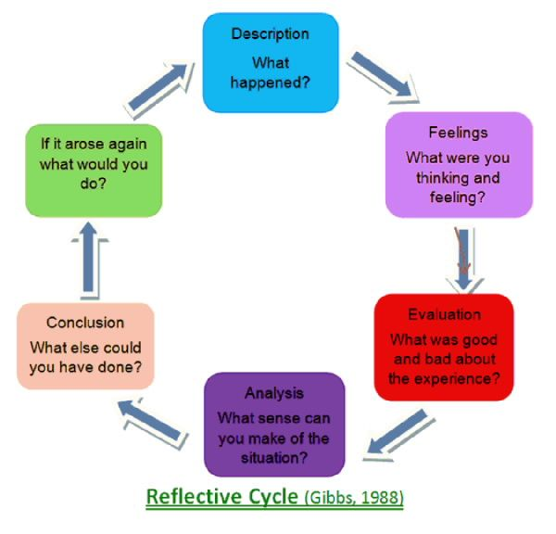
(gibbs, 1988)

‘It is not sufficient simply to have an experience in order to learn. Without reflecting upon this experience, it may quickly be forgotten, or its learning potential lost. It is from the feelings and thoughts emerging from this reflection that generalisations or concepts can be generated, and it is generalisations that allow new situations to be tackled effectively.’ (Gibbs 1988) (Gibbs.g, 1988)

The Gibbs reflective cycle is used to reflect on an experience, describing in detail of the events, your thoughts and feelings at the time. It allows you to reflect and analyse the experience, and reflect on what went good or bad and how you could improve on it, what would you have done differently if you could do it again.

3.1 Description
I have had many interviews over the years, and everyone has been different one of the worst ones would have been after I went back to employment after having children, after having been out of work for a few years it was time to get back out there. I sent off many CVs, telephoned around businesses asking for work. I will admit my CV weren’t the best, probably explains the lack in call back I went around shops asking for work, got given loads of applications to fill in. I also found there was a lot of part time temporary jobs going but during that stage of my life having a young family I needed something permanent, so the likely hood of me trying for so long is down to me being picky on what job I would like to do. But I kept on trying. After weeks of waiting and applying, I finally had an interview call back, at this point I was excited, nervous and scared and ill be honest not too sure about what job it was for because I had applied for so many.
So, after finding out when and where this interview was, I started my preparation, someone told me years ago to research the company beforehand. Gives the potential employer the indication that I mean business and I want to work for them. So that’s what I did I googled them, read up on they who industry what they sell, how and why its important, and scrubbed up on my knowledge about them. I even went as far as looking at company reviews to see what past employee thought of the company.
So, I felt I was ready to take on the interview I knew my stuff I had previous experience in retail and customer facing roles. I was on to a winner.
Interview day, I was so nervous, and I didn’t know why was it because it’s my first interview in years, would they like me, would I like them? would we get on? would I chat a lot of rubbish to them, would I have to take tests I’m no good at tests under pressure. I had all this running thought my mind.
I got through the interview ok I thought, answered all the relevant questions, talked about my knowledge of the company. I asked them questions about shift pattens and pay dates and rates, is the room for growth, it was a pert time sales assistant vacancy I always like to feel I can progress within a company. I always like to leave with a “I look forward to hearing from you” because I like to know either way some people don’t get back to you.
After a few days I heard from the company, and they had offered me the job which was great. I had my official start date and company forms to fill in, and training dates to attend. It was in house training which was led by an experienced manager on product knowledge, and it went well I had feed back from them on how I was doing, my sales were ok not the best, but I had only just started and there was room for improvement.
I took the feedback on board and worked on my sales approach giving the customers the benefits of the product before the price. I also went on to arrange open nights for schools and clubs for events. After a few months of working there all my hard work and dedication had paid off I was promoted to senior supervisor other wise know as an assistant manager. Again, this involved more training, and a load more reasonability, which is good I enjoyed it. Working for them company gave me experience in multiple roles, taught me ways of doing things some I still do know as all skills can be projected in different workplaces alongside their current procedures.

3.2 Feelings
My feeling towards this experience is good because I’ve learnt from them, I’ve learnt it takes time to progress you can’t do it over night. I must work on my nerves though as they can sometimes get the better of me but that can happen to anyone, I have felt sine this experience I have grown as a person and taken more control of my actions and workload, I don’t try and do it all which I will admit I’m terrible for it does happen somethings now.

3.3 Evaluation
Evaluating the experience from job hunting to job interview to job offer, was stressful, tiring and nerve raking, as you want something so bad when you don’t hear from people or you get that rejection email it can dishearten you, and make you feel why do I bother. One of the best things I did during the whole experience was I put myself out there, I phoned around sent of C. Vs sent back applications, I dint give up. Not all of them worked but I tried and sometimes that’s the best you can do. After all that it did end up with me having and interview and gaining a job, which then excelled toa job promotion. So, it was all worth it.

3.4 Analysis
The things that went well was I researched the company beforehand I had some sort of background knowledge on them before going to the interview I didn’t walk in blind, which is what they liked, nothing worse when asked “what do you know about us as a company” and you say, “um no idea.” I also think this is one of the reasons I was given the job, not only for my previous experience in retail, and my nervous chatty self, but I had already made myself knowledgeable on their products which when it came to the in house training it wasn’t all new knowledge it was a refresher.

3.5 Conclusion
My conclusion, what could I have done differently, I could have made my C. V more professional, put more of my skills in there made myself more employable. The things learnt about myself in this experience is I don’t give up, which I don’t I work hard for what I have and have achieved. I put myself out there when needed and try to get good results from it what ever it may be.

3.6 Action Plan
My action plan is to keep my cv up to date, regularly analysis my skills and weakness to improve on them, get feedback from managers and work colleagues on how they think I am doing my training strategies. Keep working on myself there’s always room for improvement. I also need to build on my confidence and not self-doubt myself so much.

References
Anon., n.d. s.l.:s.n.
calm sage, 2021. calm sage. [Online]
Available at: https://www.calmsage.com/how-to-overcome-self-doubt
[Accessed 21 08 2021].
collins dictionary, 2005. collins. [Online]
Available at: https://www.collinsdictionary.com/dictionary/english/in-house-training
[Accessed 01 10 2005].
copyrightofvark2021, n.d. vark. [Online]
Available at: https://vark-learn.com/introduction-to-vark/
[Accessed 01 12 2021].
dan mccathy, 2018. the balace careers. [Online]
Available at: https://www.thebalancecareers.com/how-managers-can-become-awesome-coaches-2275926#:~:text=How%
[Accessed 14 december 2018].
Gibbs.g, 1988. In: learning by doing. s.l.:oxford further education unit.
gibbs, 1988. gibbs model of relection. [Online]
Available at: https://essaywritingserviceuk.co.uk/advice-and-guidance/gibbs-model-of-reflection#:~:text=What%20is%20Gibbs%20model%20of%20reflective%20practice%3F%20Gibbs,to%20understand%20specific%20areas%20which%20may%20require%20improvement.
honey and mumford, 1986. honey and mumford. [Online]
Available at: 🌱Free Online Mumford and Honey Learning Styles Questionnaire (mint-hr.com)
[Accessed 1986].
iiiphd, 2020. iiphd. [Online]
Available at: phdessay.com/inclusive-education-the-intrinsic-and-extrinsic-barriers-to-learnin
[Accessed 08 04 2020].
john, 2021. the training and development company. [Online]
Available at: tdtc.co.uk/honey-and-mumford-learning-styles/
[Accessed 1 december 2021].
kelly cannon, 2016. the its girls. [Online]
Available at: www.thesitsgirls.com/inspiration/time-management-obstacles/
[Accessed 27 september 2016].
maud, a., 2012. certificate in higher education skills. In: certificate in higher education skills for the workplace student handbook. s.l.:cipd, pp. 340-341.
mind, n.d. mind charity. [Online]
Available at: https://www.mind.org.uk/
neil d flemming, 1987. vark. [Online]
Available at: https://vark-learn.com/the-vark-questionnaire/
[Accessed 1987].
student finace , 2021. student finace wales. [Online]
Available at: https://www.studentfinancewales.co.uk/further-education-funding/

Appendix A
LEARNING STYLES QUESTIONNAIRE - SCORING
(Honey & Mumford 1986)

 | 2  4  6  10  17  23  24  32  34  38  40  43  45  48  58  64  71  72  74  79 | 7  13  15  16  25  28  29  31  33  36  39  41  46  52  55  60  62  66  67  76 | 1  3  8  12  14  18  20  22  26  30  42  47  51  57  61  63  68  75  77  78 | 5  9  11  19  21  27  35  37  44  49  50  53  54  56  59  65  69  70  73  80
TOTAL | 7 | 17 | 12 | 12
 | Activist | Reflector | Theorist | Pragmatist

Appendix B 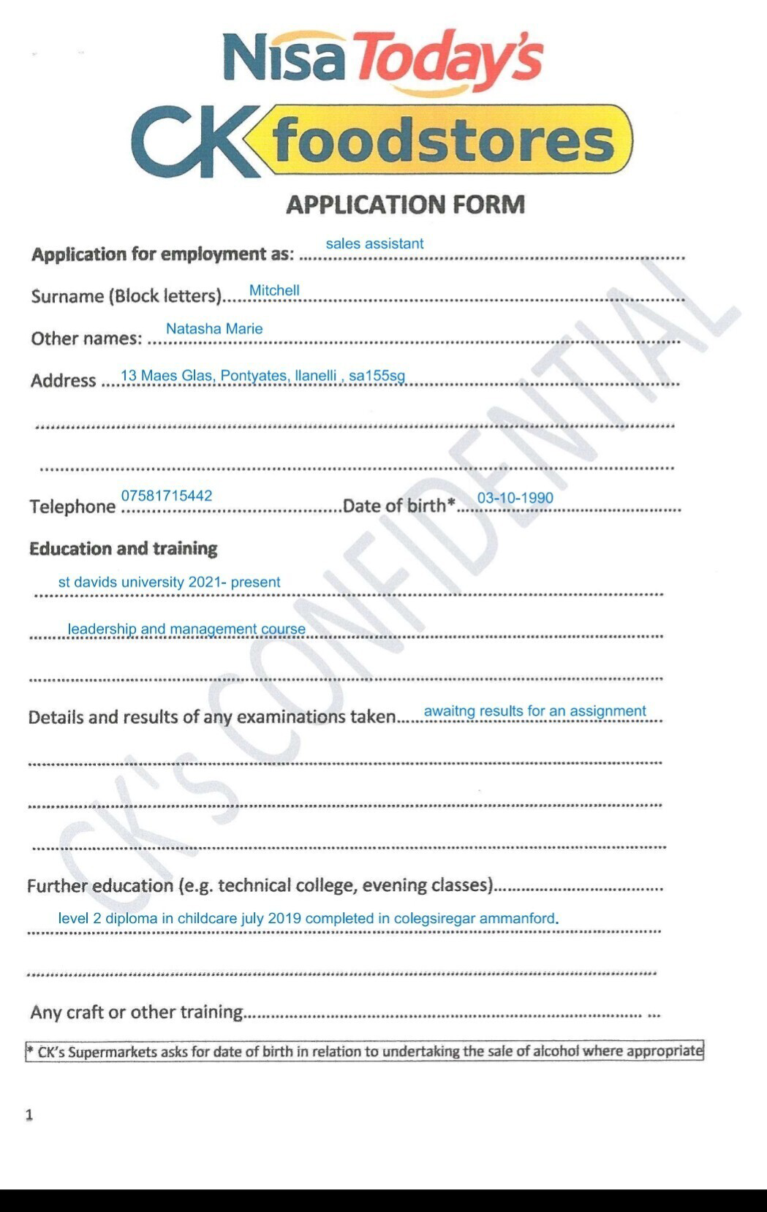
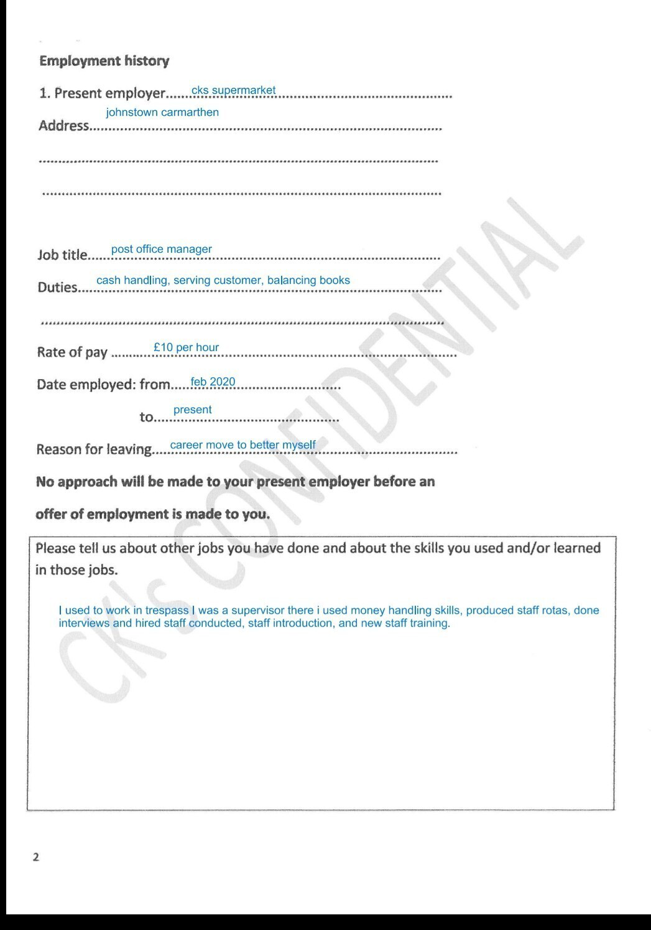
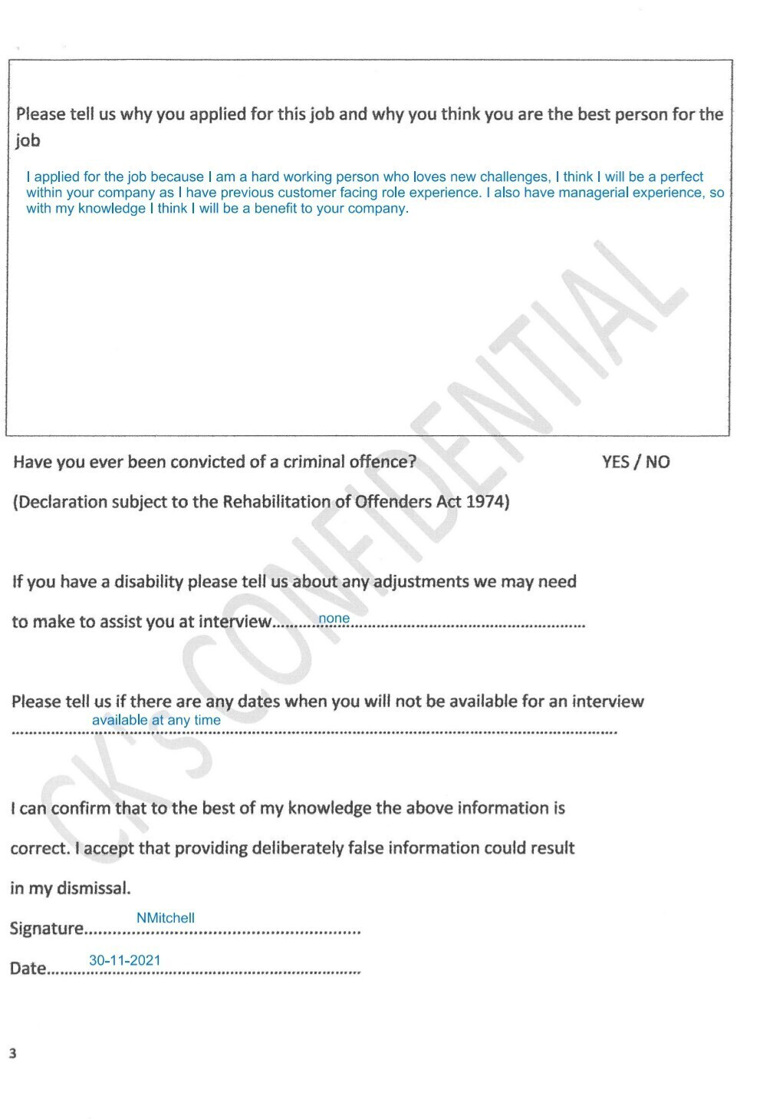

Appendix C

Natasha
Mitchell
OBJECTIVE  I am a trustworthy person, I am also very reliable, I am a mother to 4 children, so I am very good at multitasking and time management. I also have a wide experience of the working world and not afraid of any had work or tasks that may appear.  ADDRESS  13 Maes Glas, pontyates, sa155sg  PHONE  07581715442  EMAIL  tashamitchell1990@gmail.cokm |  |  | EXPERIENCE

Feb 2020 – present

Post office MANGER/ relief banker, ck’s supermarkets
To assist customers with processing parcels offering them the best service for their items, money handling helping customers to withdraw and deposit their money safely into and from their bank accounts. Keep a record of the cash holdings we have in branch, rem money out rem money in. look into and losses or gains and investigate and discrepancies that occur.
To bank the shops taking and make sure all the figures match up check the lottery reconciliation makes the sales and prizes.

august 2018 –F eb 2020

sales assistant, Lewis brother ltd
Money handling while serving customers on the tills, serve and process lottery tickets. Cash up my own till at the end of the shift. Help with putting out the delivery.

Diploma level 2 childcare, Colegsirgar Ammanford
I completed this course in july2019. I had to complete 250 hours of voluntary placement and be assessed on several topics and learning activities designed for children to learn through play.

 |  |  | skills
- I am a great team player, I also work well alone, which makes me versatile to adapt to any environment.
- I am also a quick learner, which is great when a new learning strategy comes out.
- I am happy to try new skills and techniques.
- I am good at communication efficiently with others whether that’s other colleges or customers.

 |  |  | REFERENCES
 |  |  | [Available upon request.]

Appendix D

13 Maes Glas
Pontyates
Llanelli
SA155SG

19th June 2021
Alun Littlejohn’s,
Director CK’s supermarket
Embankment road
Morfa
Llanelli
SA15 2BT

Dear Alun,
i would like to apply for the relief PO manger and banker position that’s become available at cks, as you are aware I have had extensive experience within the post office, starting when I joined the team In Pontyberem back in 2020.
Whilst I am happy in my current role having the opportunity to visit other branches, help with the running and development of them and staff training is more in line with, my long-time career goals and my ambition one day is to progress running an area.
My skill set matches are beneficial to this organisation, I am reliable, and a hard worker and I also value the mission of CK Supermarket. I also have great communication skills, good with people and an adapt my leadership skills, to any situation. I have supported the business previously in opening the branch at Swansea, I am already familiar with the staff at Swansea branch, and I believe I am the right person to join the team and fulfil the role at Swansea store.
Since starting with ck’s I have developed excellent sales skills, honed my communication skills by working closely with a diverse range of customers and helped my department generate an increase of 45% on renumeration year on year. I am very well organised, and sales driven.
I have been advanced through progressively more responsible positions in store and Post office and became the Post office manager back in June 2020. Which is something I am very proud and grateful of having that opportunity.
I believe I have demonstrated my ability to wok to a high standard, not only as a team player but with store managers across the company, by stepping up to help other offices with losses, covering sickness at short notice and just recently helped with the setting up and opening of the new store / Post office in Johnstown Carmarthen. These are just a few examples of what I have achieved and contributed while being with the company, and I look forward to many more challenges.
I conducted research on your company, and it’s incredible how successful it’s become to have currently 28 stores open in Wales alone, from opening one store in Llandeilo back in 1988. and I would love to become a part of such a successful community driven team.

Thank you for taking your time to read this, I will look forward to hearing from you.

Yours sincerely

Natasha Mitchell
Tashamitchell1990@gmail.com
07581715442

