
Harbour hotels - marketing plan and future strategy


Charlotte jOYNER (1650411)
University of Wales Trinity Saint David
Marketing Management (BMMB7012)

Executive summary

This report will evaluate the current marketing activities within the Harbour hotels, highlighting what the group is currently doing well but also identifying where there are areas of improvement. The predominate focus is on the digital marketing activities within Harbour hotels, such as how they have revamped their website and the effectiveness of their social media posts. There are specific examples from social media, such as their current and trendy posts around the new Barbie movie. However, the report will address how engaging the content is and if their 25k of followers are actually viewing this content.
The marketing strategy of Harbour hotels will be linked to other competitors such as the Q hotels to see if their activities are allowing them to sustain a competitive advantage. Additionally, the strategy will be linked to Ansoff’s Matrix to analyse how their current marketing strategy is reflective of marketing penetration but a recommendation for the long term could be to consider market development.
Finally, other conclusions and recommendations within this report will be providing advice as to how they could focus on improving engagement from their social media posts and this should be the short term objective for Harbour Hotels.

Table of Contents
Executive summary 1
Introduction 3
Overview of digital marketing at Harbour Hotels 4
Current marketing activities at Harbour Hotels 5
Harbour hotel website upgrade 7
Conclusion 9
Recommendations 10
Reference list: 12
Appendix A : 14
Appendix B: 15

Introduction

Harbour Hotels boast 14 properties in their hotel collection and were awarded ‘Hotel Group of the Year’ in 2018/19 in the AA Hospitality Awards (Harbour Hotels, 2023). The hotel group is relatively new , with only being founded in 2003 by Mike Warren and an aim to be the most recognisable niche hotel group (Harmer, 2015). The portfolio of properties can be found in the south of the UK and each location shows off their unique features and boutique image (Harbour Hotels, 2023). The hotel group has active social media accounts on the key platforms such as Twitter, Instagram and Facebook whereby they post fairly regular updates on events or upgrades happening across each of their properties. It is the responsibility of Kirstie Dyke to coordinate the content posted across the hotels digital platforms as the digital marketing and communications manager (Linkedin, 2023). Although, within the groups marketing team, each marketing coordinator holds responsibility for consistently posting across platforms for their allocated property as each hotel also has their own social media page (Escape, 2023). The hotel also possess a newly revamped website which they use a tool of communication for consumers and it the responsibility of Kirstie team to ensure communication is relevant and up to date.

Overview of digital marketing at Harbour Hotels

The Harbour Hotel group has a dedicated marketing team that will produce and publish all communication that reaches their customers (Escape, 2023). With the growth of digital platforms and social media, the hotel group also has team members that solely focus on digital marketing, allowing Harbour Hotels to be active across the key social media platforms. According to Tate (2023) the role of digital marketing became one fastest growing areas since the pandemic as consumers turned to viewing online marketing, rather than traditional methods. The role can include creating content or enhancing web development to allow for an optimal user experience (Simplilearn, 2023). The growing importance and demand for digital marketing resulted in many companies employing their own digital marketing coordinators, rather than using agencies (Tate, 2023). This was true of Harbour Hotels who have a team of digital marketers that are allocated an individual property within the collection to focus on. A vital part of the role is to keep up to date with emerging trends and new technologies as this will allow the content to stand out from competition and not get lost within large proportion of posts seen on many platforms (Simplilearn, 2023).
On one hand, the outlook of Harbour Hotels social media pages is positive as they have approximately 25k of followers on Facebook and on Twitter (Harbour Hotels, 2023). This is vastly more than their close competitors the Qhotels collection who are similar in size to the Harbour hotel group but only attract around 18k of followers (Qhotels Collection, 2023) Therefore, the digital marketing team are able to reach a larger audience when creating social media posts, in the hope this will attract more consumers to one of their properties. However, appendix A shows that many of the Harbour hotel social media posts do not achieve much engagement. The level of engagement can be measured by looking at the amount of likes, comments of shares a post has achieved (Eckstein, 2021). Additionally, engagement is also important as it can influence the perceived image of a company and become a contributing factor to customer decision making (Kotler et al, 2016). Therefore, although Harbour hotel has managed to achieve a considerable amount of followers on their social media platforms, questions could be raised as it whether the level of engagement is substantial enough to influence decision making or gain a competitive advantage.

Current marketing activities at Harbour Hotels

According to Weber (2023), in order to elevate your social media marketing presence it is important to post consistently across the companies chosen platforms. This is not always the case for Harbour hotels as on some platforms they post almost daily, whereas elsewhere it can be months before an updated post reaches customers (Harbour Hotels, 2023). This could be due to a breakdown in communication amongst the digital marketing team or a lack of clarification as to who is responsible for each social media site. It could be suggested that periods of inactivity can cause Harbour hotels to lose the interest of potential consumers and when reviewing competitors such as Qhotels and The Hoxton Group , it appears they are behind their competitors with how frequently posts are reaching followers.
However, according to Ennis (2022) it is more important for a business to focus on the quality of the content posted of social media channels, rather than flooding a page with repetitive posts. This is supported by Battistino (2021) who suggests that although creating a lot of content can increase the ‘online traffic’, it is actually the quality of the content posted that retains the audience, rather than having potential followers who do not return.
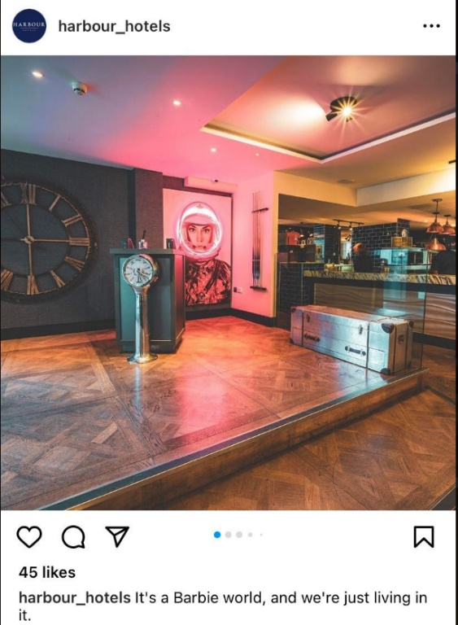
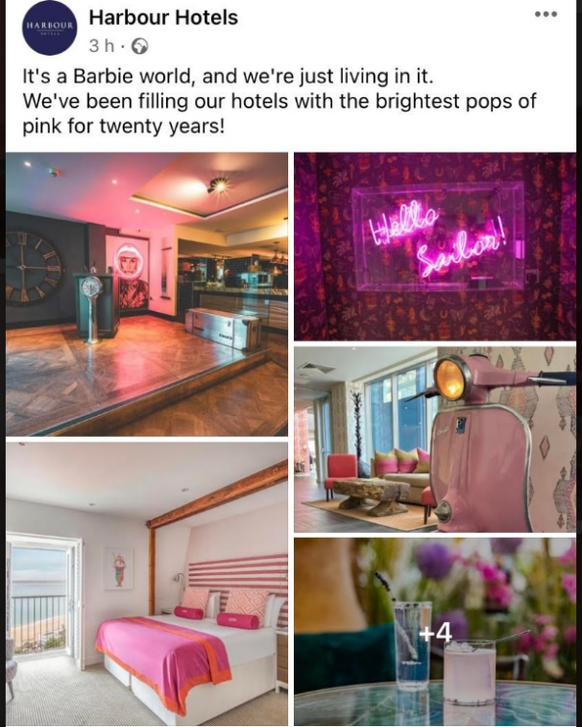
Below is an example of Harbour Hotel most recent post on both their Facebook and Instagram page:

Source – Facebook (2023) Source – Instagram (2023)
Firstly, there is consistency shown across two channels to ensure consumers get the same user experience. Moreover, the content posted is very relevant, topical and the hotel group have been successful in addressing a popular consumer trend with the new release of the Barbie film. Weber (2023) suggests that to build a successful social media marketing strategy, it is important to set up a content calendar as this will support a marketing team to create timely posts and address relevant trends. It can also create a talking point and lead to more shares as the audience is likely to relate to the post (Evans, 2021). There is evidence throughout Harbour Hotels social media pages of marketing team using a calendar to maximise the quality of their post. For example, when it was ‘National Wine Week’ they posted wine discounts to customers or ‘International Chocolate Day’ there was evidence of chocolate options on the menu (Harbour Hotels, 2023). This could support the claim that Harbour hotel focus on the quality of their social media content, rather than the quantity of posts that potentially their competitors are aiming for.

Harbour hotel website upgrade

The concept of digital marketing encompasses all marketing activities that take place online, which is not just about social media but can also be about emails and website connections (Alexander, 2022). Upon winning the hotel of year accolade in 2018, Harbour hotel allocated some investment into improving their website and appointed The Escape group to support with this project (Escape, 2023). The Escape are a digital marketing agency that offer support to businesses in areas such as content creations, web development and branding (Escape, 2023). Harbour Hotels put emphasis on improving their online presence to enhance the user experience and support the objective of retaining the title for hotel group of the year.
Appendix B displays the fresh new look of the Harbour hotel website, that allows for consumer engagement and encapsulates the unique feature of many of the properties in their portfolio. Harbour hotels experienced success in this marketing strategy to improve their website as the new look resulted in the ‘bounce back’ rate dropping by 50% and a 30% increase in direct bookings (Escape, 2023). It is important to reduce the bounce back rate as it means viewers are looking into more of the website, rather than leaving after just viewing the first page (Zantal-Wiener, 2022). This positively resulted in a better level of engagement from potential customers and directly increased the level of bookings for Harbour hotels. The outcome also shows positive cooperation between the internal marketing team at Harbour Hotels and the Escape project team as the end result of the website is still reflective of the luxury hotel brand Harbour hotels want to be perceived as (Escape, 2023).
The Harbour hotels use their website in a similar way to many hotel companies as it flaunts all that the group has to offer in terms of properties, facilities and experiences (Harbour Hotels, 2023). However, they do manage to stand out from competitors in the way they include lots of videos and hotel tours as a more interactive way to engage the audience in viewing beyond the front page of the website. This is more memorable than the larger hotel chain websites such as Hilton or Marriott that solely rely on just photos to engagement consumers (Sickel, 2018). The use of video tours demonstrates that Harbour hotels are making the most of new technology to enhance the quality of their website and keeping up with current technological trends Evans (2021) claims is vital to elevating a company’s online marketing strategy.
However, the investment Harbour hotels have made into modernisation their website has not fully been reciprocated onto their social media platforms as the post made here often rely on generic images of properties to promote their hotels (see Appendix A). This could be due to a lack of knowledge or a lack of investment into their social media pages because of a minimal budget. According to Sanders (2022), due to the growth of Tik Tok, many marketers are using short videos to capture the attention of their target audience. Video marketing has seen a huge growth with the vast majority of marketers investing in this within their marketing strategies to attempt to produce viral content (Bretous, 2022). In order to create more uniformity across all Harbour Hotels online platforms, the marketing team could look at ways of including more short videos on their social media channels to increase engagement. They could expand upon the knowledge gained from Escape to produce videos of similar quality and style to those that appear on their website. Also, Weber (2023) suggests that it is important to ‘humanise your brand’ and so sharing short videos on social media of the staff or current events taking place could enhance the connection consumers have with the hotel brand. Furthermore, it could increase the engagement of the hotel social media posts and be another contributing factor that increases hotel bookings.

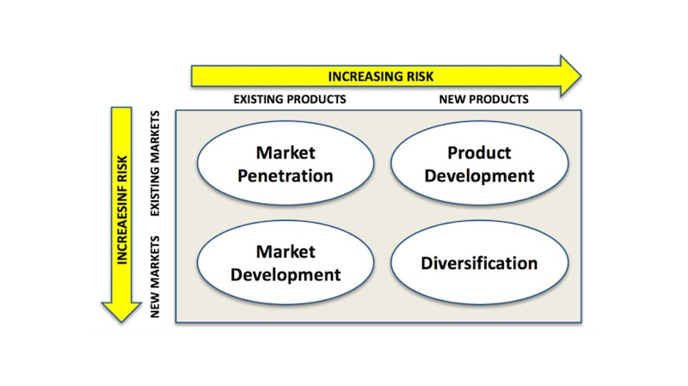

Ansoff Matrix – Tutor2u (2021)
The investment into revamping the website could display evidence of market penetration from Ansoff Matrix. Market penetration is when a organisation uses their marketing strategy to focus on how they can get existing customer to purchase more (Tutor2u, 2021). After winning hotel of the year, Harbour hotel would want to capitalise on this and try to increase their market share. Therefore, marketing penetration aims to increase usage of existing customers and can be achieved by dedicating more resources to advertising and sales promotion (Peterdy, 2022). The updated website clearly shows off all the different aspects of the Harbour Hotel groups, going beyond just offering a hotel room. There is separate tabs, videos and pictures that flaunts their wedding facilities and spa packages (Harbour Hotel, 2023). Although, many of the Harbour hotel properties would have had these features available before the website revamp, readvertising and promoting the offering can result in an increased expenditure per paying customer (Johnston, 2023). This could further lead to existing customers contemplating more than just a room stay, with could be reflected in the improved bounce back rate Harbour hotel have experienced since the new website launch. Nevertheless, this marketing strategy is a safer option for Harbour hotels as they continue to operate in a familiar market, targeting familiar customers which will require less investment than other strategies (Tutor2u, 2021).

Conclusion

In conclusion, the marketing activities on display from the Harbour hotel group are effective as there is evidence of a direct correlation between their actions and an increase with bookings. The decision to invest in a new website and use the digital marketing agency Escape had supported Harbour hotels with enhancing their online presence and capture a luxury image (Escape, 2023). The decision to invest in this after winning hotel of year was clever timing and could be also a contributing factor to the 30% increase in bookings. Additionally, the marketing activities have been positive in enabling Harbour hotels to be above competitors in terms of followers, with the difference of 7000 followers between Qhotels and Harbour Hotels (Harbour Hotels, 2023). On one hand, this implies the group is thriving with their social media presence. However, the lack of engagement from many posts could suggest the content that Harbour hotels is posting is not reaching its full potential in capturing the attention of the audience and so could be reviewed to ensure all online posts are reaching their maximum outreach (see appendix A).
Furthermore, it has been suggested that Harbour hotels has adopted a safe approach to their marketing strategy as they are trying to increase the spending of existing customers within an existing market. This is evident of market penetration in Ansoff’s Matrix as the hotel group seems to focus on what its knows, rather than trying to take risks and expand into another market segment (Tutor2u, 2021). The marketing activities on display could be considered effective due to them being safe and not too dissimilar to competitors. However, in order to retain a competitive advantage, Harbour hotels could looks at alternative ways of posting content , such as using more short videos to capture the audience’s attention. Weber (2023) highlights the importance of humanising your brand and maximising technological trends, which could influence the next marketing strategy for Harbour hotels in order to ensure continued effectiveness of marketing activities.

Recommendations

It is encouraging that Harbour hotels already have a strong foundation in place with their marketing activities and a dedicated marketing team that focus on allocated properties within their portfolio. Creating a specific role for digital marketing implies Harbour hotels understand the importance of producing effective content online and provides Kirstie with an important role within the group (Linkedin, 2023).
However, I think the Harbour hotel group are beginning to blend in with other hotel groups and this could be evidenced with the lack of engagement experienced from their posts. Therefore, one recommendation for their future marketing strategy needs to be to consider how they can create more engaging and trendy social media posts. After revamping their website in 2018, Harbour hotel have made very little process with their online presence. Harbour hotel could exploit the connection they have already made with Escape and create a project team that focuses on boosting their social media presence. Escape has the knowledge and expertise to help with content creation, plus have the data available to analyse if the new content has had a direct impact on bookings (Escape, 2023). On one hand, outsourcing social media content creation to an agency could be costly for Harbour hotels but they need to weigh this again the potential increased revenue the group could experience. Moreover, they could set up a short term project team with Escape to enhances there knowledge of content creation and effective social media posts and then in the long term use this knowledge to manage the sites in house with their dedicated digital marketing team.
Furthermore, in the longer term the Harbour hotel group could look at different marketing techniques to increase their market share and enhance growth. The marketing strategy needs to work in conjunction with the overall business aims and objectives, whilst also providing a clear sense of direction for the marketing department (Barone, 2023). For example, it could be suggested that Harbour hotel currently adopt an undifferentiated marketing approach. This strategy involves a company having one marketing mix for the whole organisation, rather than differentiated for each segment (Fahy and Jobber, 2019). In contrast, the Marriott adopts a differentiated marketing strategy whereby they target several different segments of the hotel industry and have a different marketing mix for each (Fahy and Jobber, 2019). This strategy suits Marriott as they have a variety of brands within their portfolio from Moxy in the budget segment to Ritz Carlton in the luxury segment (Hollander, 2022). However, it could be suggested that this strategy is not currently applicable to Harbour hotels as their 14 properties are all targeted at a more luxury market and they do not currently possess properties across different segments.
Nevertheless, as a long term vision Harbour hotel might look to increase their portfolio or find ways to expand into new markets. This approach would require a new marketing strategy , of which the group could exploit market development in Ansoff’s Matrix. Market development is a growth strategy used by companies who seek to sell their existing product in a new market (Tutor2u, 2021). For Harbour hotels, they could maximise their knowledge of the hotel industry and invest in a new property within a different segment of the market. For example, they might need to invest in budget properties or even expand into new geographical locations (Tutor2u, 2021). This growth would bring about the need for a new marketing strategy to ensure Harbour hotels are attracting the right target audience and the expansion is successful. On one hand, this might be considered a big risk for Harbour hotels as their currently marketing activities focus on the uniqueness of their luxuries properties and so expanding into other segments might detract from this niche. However, it would be dependent upon how ambitious the owners of Harbour hotels groups are and if they see themselves expanding in more diverse directions.
Overall, the realistic vision for Harbour hotels should be to firstly focus upon improving their social media engagement to ensure they maximise the views from their 25k followers or expand beyond this figure. This marketing plan will also be important for future proofing as technology is continually enhancing and so it is vital to keep up with digital trends. However, if Harbour hotels do have a long term strategic vision to expand into new markets, then it would be imperative for the marketing team to review their current strategy to reduce the risks and increase its effectiveness.

Reference list:
Alexandar, L. (2022) The who, what, why & how of digital marketing. Available from: The Who, What, Why, & How of Digital Marketing (hubspot.com) [Accessed 22nd July 2023]
Barone, A. (2023) Marketing strategy: What it is , how it works, how to create one. Available from: Marketing Strategy: What It Is, How It Works, How To Create One (investopedia.com) [Accessed 22nd July 2023]
Battistino, A. (2021) Social Media: Quality vs Quantity. Available from: Social Media: Quality vs Quantity | The Concept Stadium [Accessed 22nd July 2023]
Blythe, J. and Martin, J. (2019) Essentials of Marketing. 7th ed. United Kingdom: Pearson.
Branson, S (2022) 6 short form video trends marketers should watch in 2022. Available from: 6 Short-Form Video Trends Marketers Should Watch in 2022 [New Data] (hubspot.com) [Accessed 22nd July 2023]
Bretous, M. (2022) 6 short form video trends marketers should watch in 2022. Available from: 6 Short-Form Video Trends Marketers Should Watch in 2022 [New Data] (hubspot.com) [Accessed 22nd July 2023]
Brown, E. (2012) Working the Crowd - Social Media Marketing For Business. 2nd ed. United Kingdom: The Chartered Institute For It.
Eckstein, M. (2021) Social Media engagement: Why it matters and how to do it well. Available from: Social Media Engagement: Why It's Important and How To Do It Well - The Buffer Blog [Accessed 22nd July 2023]
eDirect (2023) Case study – Harbour hotels. Available from: Harbour Hotels Case Study | Digital Marketing Agency Bournemouth (edirect.uk) [Accessed 21st July 2023]
Ennis, G. (2022) Why quality of posts matters more than quantity on social media. Available from: Quality of posts matter more than quantity on social media | NS Design [Accessed 22nd July 2023]
Escape (2023) Making waves with a new website for the hotel group of the year. Available from: Harbour Hotel Group | Marketing Strategy | The Escape (the-escape.co.uk) [Accessed 21st July 2023]
Evans, D., Bratton, S. and McKee, J. (2021) Social Media Marketing. Indiana: Wiley.
Fahy, J. and Jobber, D. (2019) Foundations of Marketing. 6th ed. London: McGraw-Hill Education.
Harbour Hotels (2023) Harbour Hotels. [Facebook]. Available from: https://www.facebook.com/HarbourHotels/ [Accessed 21nd July 2023]
Harbour Hotels (2023) Latest News. Available from: Harbour Hotels named AA Hotel Group of the Year 2018-19 [Accessed 21st July 2023]
Harbour Hotels (2023) Our hotels & specialist venues. Available from: Hotels & Venues Across the UK | Harbour Hotels Group [Accessed 21st July 2023]
Harmer, J. (2015) The Caterer Interview: Mike Warren, Harbour Hotels. Available from: The Caterer Interview: Mike Warren, Harbour Hotels - The Caterer [Accessed 21st July 2023]
Hollander, J. (2022) All of Marriott’s hotel brands explained. Available from: All of Marriott's Hotel Brands Explained (hoteltechreport.com) [Accessed 22nd July 2023]
Johnston, K. (2023) The advantages of an increase in promotion & advertising. Available from: The Advantages of an Increase in Promotion & Advertising (chron.com) [Accessed 22nd July 2023]
Kotler, P., Keller, K.L., Brady, M., Goodman, M. and Hansen, T. (2016) Marketing Management. 3rd ed. United Kingdom: Pearson.
Peterdy, K. (2022) Ansoff Matrix. Available from: Ansoff Matrix - Overview, Strategies and Practical Examples (corporatefinanceinstitute.com) [Accessed 22nd July 2023]
Qhotels Collection (2023) The Qhotels collection. [Facebook]. Available from: https://www.facebook.com/TheQHotelsCollection/ [Accessed 21nd July 2023]
Sickel, J. (2018) Comparing Hilton’s & Marriott’s hotel apps. Available from: Comparing Hilton's & Marriott's Hotel Apps | Business Travel News [Accessed 22nd July 2023]
Simplilearn (2023) Digital Marketing job description: Responsibilities and skills in 2023. Available from: Digital Marketing Job Description: Responsibility and Skills Required in 2023 (simplilearn.com) [Accessed 22nd July 2023]
Tate (2023) Digital marketing manager job description. Available from: Digital Marketing Manager Job Description I Tate Recruitment [Accessed 22nd July 2023]
Tuten, T. (2017) Social Media Marketing. 3rd ed. United Kingdom: Sage.
Tutor2u (2021) Ansoff Matrix. Available from: Ansoff Matrix | Business | tutor2u [Accessed 22nd July 2023]
Voramontri, D. and Klieb, L. (2019) Impact of Social Media on Consumer Behaviour. International Journal of Information and Decision Sciences. 11 (3), pp. 209-233.
Weber (2023) 15 Social Media tips to elevate your marketing strategy. Available from: 15 Social Media Marketing Tips to Elevate Your Strategy (socialpilot.co) [Accessed 21st July 2023]
Zantal-Wiener, A. (2022) What is bounce rate? How can I fix mine? Available from: What Is Bounce Rate? (And How Can I Fix Mine?) (hubspot.com) [Accessed 22nd July 2023]

Appendix A :
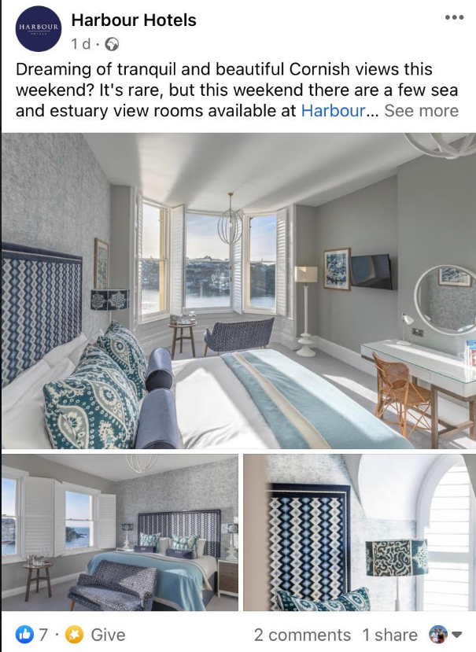
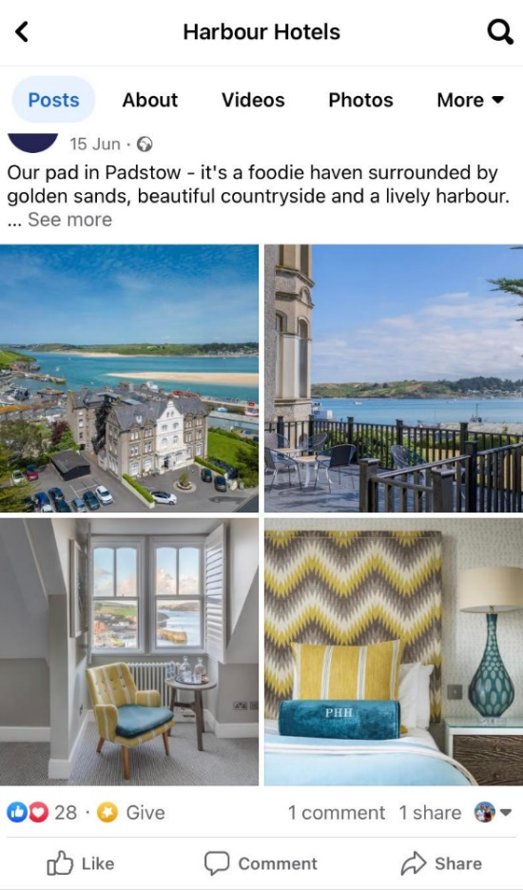

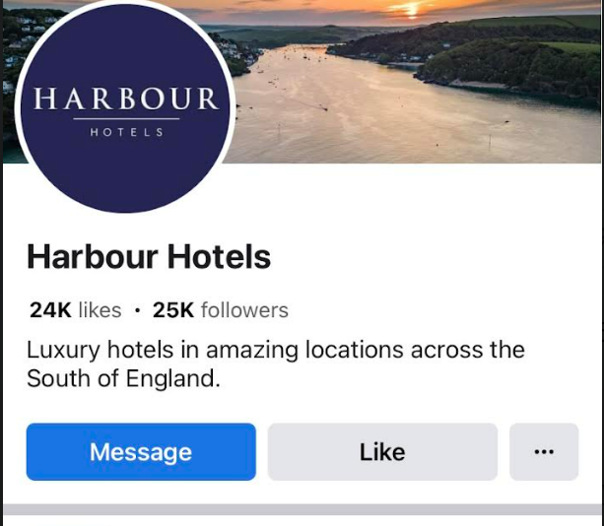
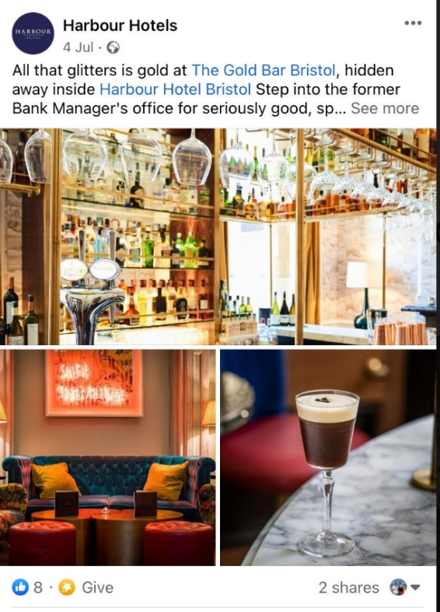

Appendix B:
https://www.harbourhotels.co.uk/


