Managing Projects in the Workplace

Submitted by: MURNESHAMNDA MWANDA

INTRODUCTION
Managing Projects in the Workplace is considered as a powerful basis and in it effectively managed and control by a manager with support of suitable alignment of project scope, defined deadline, assess different resources that is available, creation of planning, communication within team, delegation of work as per according to respective skills and knowledge, document every aspect and monitor the progress so that sustainable changes are attained in timely frame (Abashah and et. al., 2021). The project management basically assist the business to scale up the performance so that effective building and sustainable changes are attain to improvised and achieve best working practices. It is also supported through effective learning and efficient working through which adequate improvisation is attained over stipulated period of time.
The report below is based on a “project management plan for a nursery” and it is based on a fact that government of UK has been advices to open the work from home due to surge of childcare services. Thus it is considered as a perfect start-up business and in this entrepreneur is able to identify and fulfil the demand for nursery as it never drop off as per basis of childcare cost along with suitability of places as per ongoing issues for working parents. This below is the project management plan so as to set up a nursery business

MAIN BODY

PART One

A basic project outline / description / scope based on project
The project is based on “project management plan for a nursery” and it is based in UK along with this it is related to provide effective and efficient childcare services with this sustained growth is attained with stipulated period of time. The learning experience also considered as essential aspect and it is often considered as primary stage of childcare and their development (Attaran, Attaran and Kirkland, 2019). The children’s are able to learn and experience so that many things from nursery and with this there level of understanding and initial phase of growth is perceived with prominence. The starting own business in UK and it development is based on suitable planning and it assist to achieve success and development both over long term. The plan the nursery business it is required to organise and develop suitable understanding about requirement of parents and make actual usage of same with support of actual road map as it follows up through a lifespan of business.
The project of nursery is to maintain well target toward children as it is a age where they need support to advance or explore different things with this they’re learning capability and level of understanding both get achieved in balanced frame. It is also supported through effective utilisation of resource and with this sustainable and reliable changes are attained within timely frame. The life or living standards of parents is much busy as they both have worked and have own timetable to follow. In this to provide basic education or to build suitable base of education is much essential aspect and for this parents also needed to find nearby nursery business so that they are able to learn more and improvise business relevance with effectiveness (Carlisle, 2021). The requirement of business is even more essential within pandemic as due to pandemic people have to face many of challenges and in this it is required to make suitable changes in balanced frame. Due to pandemic era working correspondence of all get affected as people have to follow many of restrictions in order to survive and in this living standard of children, their learning and education affected the most.
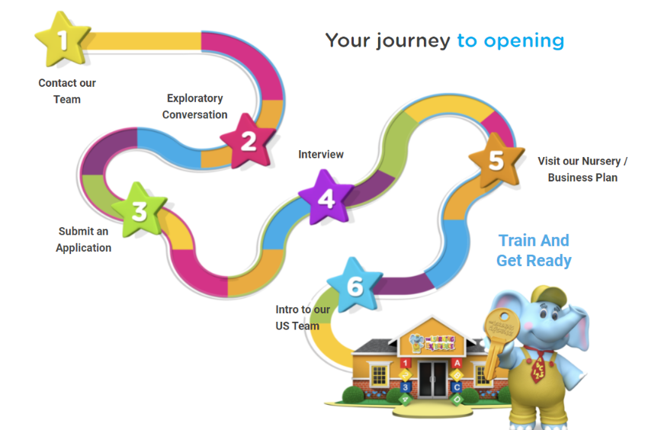
The scope of “project management plan for a nursery” is to provide necessary education and basis with this reliable and relevant changes are implemented as in timely frame. The pandemic era affects the living correspondence and learning basis of children the most and in this nursery business is considered as equivalent support through which parents are able to relive the change and let their children to learn and explore the world with suitability (Delecourt and Fitzpatrick, 2021). Thus with this scope business is able to achieve long term goal and sustainable benefits in beneficial manner. In this business is able to target particular audience and it is specially based on a area that is having a lot of children’s as with this parents also feel free to drop their children and feel safe and secure as from their side. In addition, business also ensure to provide specialised services with this direct focus is maintained to achieve respective project as from niche of market and it tends to generate maximised of sales and profitability in organised manner.

Stakeholder analysis
The Stakeholder analysis is considered as most specific and effective approach to manage and control financial basis of business as with this reliable and relevant changes are achieved with effectiveness. The maximisation of shareholders is used to advance working correspondence as by managing all the criticism as it is related to social reason for business. Stakeholders is considered as a group or an individual who is having an interest in stake or in operation of an organisation along with this they also get affected due to business activities and its correspondence (Lam and et. al., 2020). The internal stakeholders consist of employees, department, division and the external stakeholders consist of business partner, customers, suppliers and wider group of society as well and it consist of media, pressure group and government.
Stakeholder analysis is considered as a process of identifying the interest and influence of stakeholders as per assess of specific influence and its impact over organisation. In this appropriate strategies are used so as to enhance and develop specific relationship with others. The strategic level of business is used to take informed actions and reliable strategy or objective setting so that working operations and functions both get supported in reliable manner.

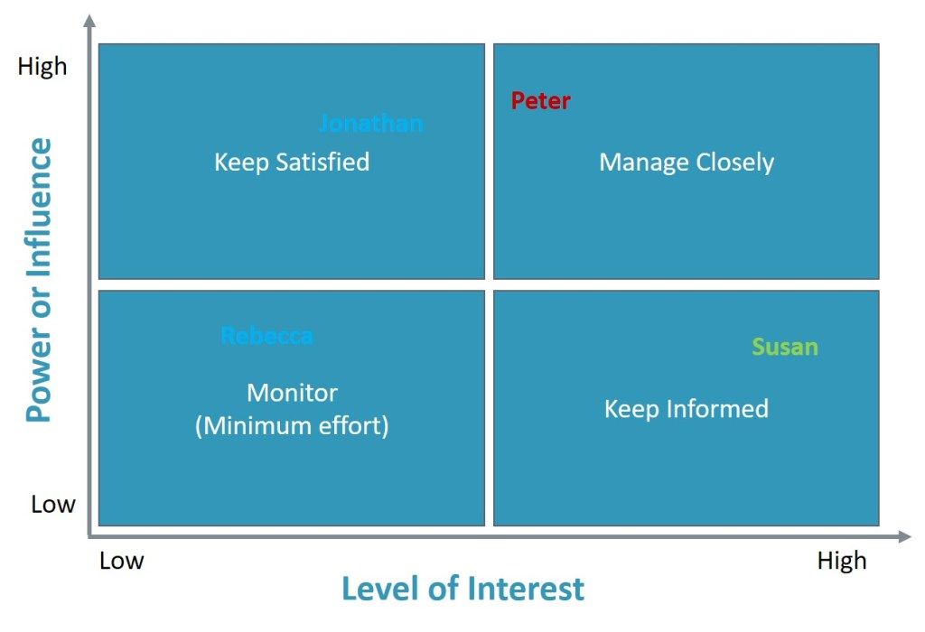

Internal stakeholders: These are the stakeholder of business who is worked within an organisation and induce respective effect as well over working correspondence.
Employees: These are the internal stakeholders and induce wider impact over working of nursery business as they are the one who performed the entire relevant task and provide appropriate learning to children (Roberts, 2019). The employees induce higher influence and higher level of interest and for this business provide them regular information and keep them satisfied so that they are able to acknowledge the change and enhance working standards in effective manner.
Department: It is a stakeholder that is related to different of department of nursery business as there are different of department that work to enhance working preference. There are numerous of department such as of language teaching, game zone, and of many subjects as well. Thus induce wider impact as they have higher interest and higher influence thus business ensure to keep them informed.
Division: The division of stakeholder is considered as essential aspect of learning of children but induce higher interest but lower influence thus business kept that informed as of timely basis so that they are aware about the respective changes and its effectiveness with ease.
External stakeholders: These are the stakeholders those are having presence in outside the business and also affect the working suitability of business on both direct and indirect manner.
Business partner: The business partner of nursery business is having higher interest and higher influence thus nursery business manages them closely. It is due to the fact that they provide relevant source and assist the business to spread the working operation and awareness at wider scale so that more and more people are targeted with suitability.
Customers: The customers are higher influence and higher power as they are considerably known as parents who send their children for childcare services (Walker and Lloyd-Walker, 2019). Thus nursery business keep them informed about all the information so that they aware about respective education that is provided to them over specific period of time.
Suppliers: These are considered as a stakeholders those provide different equipment, machinery and other required material as per according to need and requirement of business. Thus they have higher level of interest and lower level of influence thus nursery business provide them relative information as per according to need and requirement.
Group of society: The society induce direct influence over working correspondence of business and it is due to the effect that they perform mouth to mouth marketing and with this reliable understanding is achieved. The stakeholders is having lower level of interest and higher level of influence thus to provide them respective information business is able to provide specific information as per requirement.
Media: The media is a source that is having lower level of interest and lower level of influence and nursery business also make use of it to spread appropriate information in marketplace (Simmers and McMURRAY, 2019). Media is considered as source to spread more awareness in marketplace thus business uses this to circulate appropriate advertisement and in this sustainable changes are attained as per requirement.
Government: The government is having lower level of interest but higher level of influence and to keep them satisfied nursery business ensure to follow up all the respective protocols and other working standards of business with relevance and in this sustainable changes and appropriate understanding is achieved with relevance.

Stakeholder engagement
It is related to systematic analysis, identification, implementation and planning of actions that is used to design or to influence the stakeholders with this working suitability and operational basis both get advances in better way. The engagement of stakeholders is used to develop and design appropriate strategy so that appropriate identification of key groups and its sponsor get developed in beneficial manner. The engagement also assists to induce vital role and in this business also ensure to meet and fulfil respective need and demand of business with effectiveness. It is basically considered as core of sustainability with this reliable and relevant changes are implement as per according to requirement and demand of situation (Powell, Gillett and Doherty, 2019). In addition, nursery business is able to maintain transparency within working correspondence with this able to build suitable effort so that appropriate changes are implemented as per requirement.

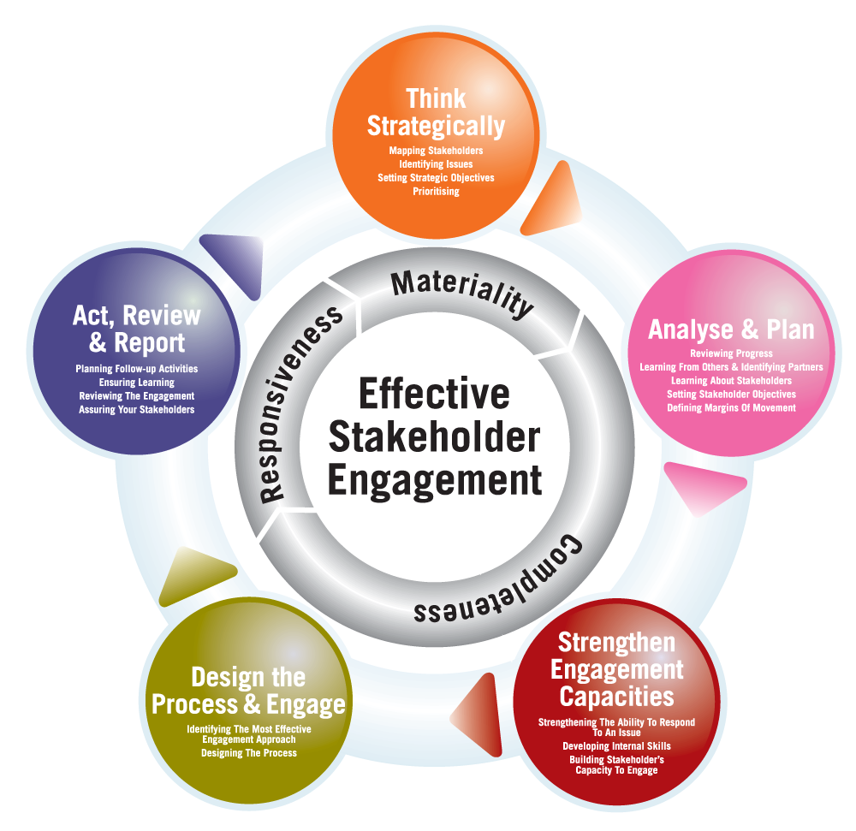

Think strategically: In order to engage or attract the stakeholders it is required that business must have thing strategically with this specific vision and appropriate mission or objective is developed that is used to seek and implement valuable changes (Alsharef and et. al., 2021). In this stakeholders are able to identify the both short and long term goals of business and the able to connect with them as per appropriateness,
Analyse and plan: It is related to specific reviewing of program with this learning, setting objective, identify partner and analysis of margin of movement get analysed with prominence. In this business is able to analyse the requirement of market and then make respective planning accordingly.
Strengthen engagement capacities: In this business is able to strengthen the capacity of engagement as by providing regular and effective based services with this internal skills and competence both get analysed in better way.
Design the process and engage: In this nursery business is able to identify the effective as well as appropriate designing of process so that reliable and relevant changes are attained (Fittipaldi, 2020). In this a clear presentation is presented through which stakeholders are able to take their decision as per own understanding.
Act, review and report: In this business review and report all the operational functions and with this ensure to make adequate advancement as per according to need and requirement of business so that long term goals is achieved with perfection and in timely frame as well.

Work Breakdown Structure
The work breakdown structure is used to segment overall activity into different slots so that project manager is able to complete one activity as per end of another. In this appropriate change is accomplished with complete removal of risk credibility’s.

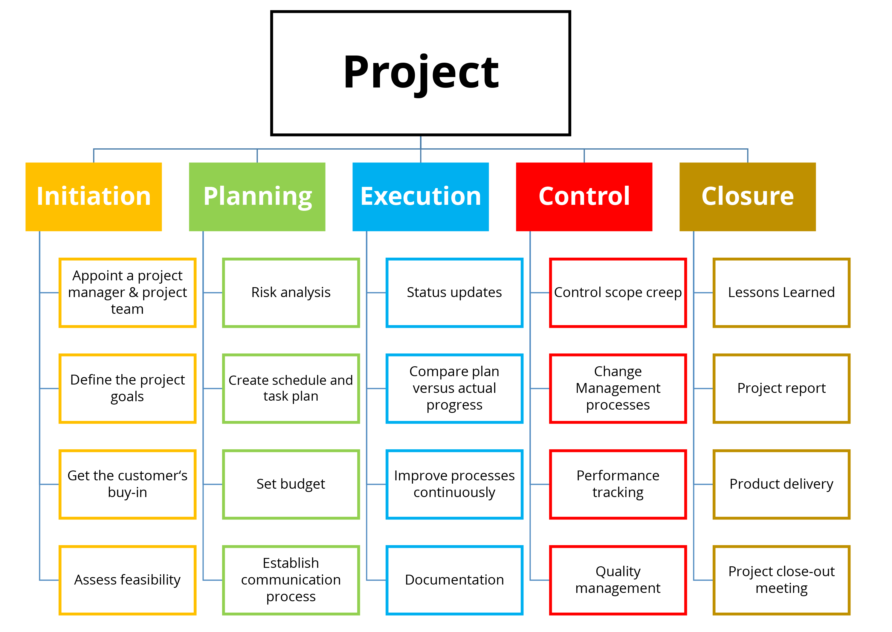

The work breakdown structure of nursery business is dependent over five stages and it is related to initiation, planning, execution, control and closure with this reliable and relevant information is collected or gather as per according to need and requirement. In the process of initiation manager is able to appoint a team, define goal, get customers and assess feasibility (Chen, 2019). In planning business ensure to analyse risk, create schedule, set budget and create process of communication while in execution manager is able to take update of change, compare plan, and improvise and documentation. Thus in this reliable and relevant changes are achieved and it collectively makes the project success with prominence.

Consideration of resources
The required resources for project management planning of nursery business is sports ground, landscape garden, license for operating a child care services home or at centre, license requirement, daycares planning, insurance of daycares, development of facilities, policies and procedure, hire staff that help to run daily services.

Gantt chart
It is used in project management so as to access reliable understanding about each and every activity that is performed to accomplish preferred sales and objective as per accomplishment of project.
TASK  NAME | 15 December 2021 | 20 December 2021 | 23 December 2021 | 25 December 2021 | 28 January 2021 | 01 January 2022
Planning
Research
Design
Implementation
Follow up

A Risk Assessment
The risk assessment is used to make possible changes within working standards as with this effective and prior changes are implementing to achieve long term sustainability over regular period of time.

Risk | Description | Likelihood | Consequences | Risk level | Measure | Risk minimisation measure | Likelihood | Consequences | Risk level
Strategic risk | It is related to strategic goals that are based on decision making of business and affect child care centre as well. | 3 | 4 | 3 | It is based on selection of wrong location as in this it is difficult to attract more customer. | In this prior understanding is developed about selection of appropriate location so that business seems to attract many of parents (Barak, 2022). | 1 | 2 | 2
Financial risk | It is a risk that is based on financial losses that affect working of child care service. | 4 | 3 | 4 | It affects the working correspondence of business and induce negative impact over working suitability as well. | In this business must have made use of property liability exposure and maintain effective utilisation of cash flow so that allocation of funds get place with prominence. | 1 | 2 | 1

CONCLUSION
It has been concluded from the above that managing of a project planning is based on many of deliverables as with this it is required to implement additional values with this management is able to accomplish respective changes and objectives in timely constraint. The project management plan provide suitable scope baseline, scope plan, management planning, cost, deliverable, resource, time, cost management and cost baseline as well. The project planning of nursery business is considered as an opportunity and with this long term and stabilised changes is attained and for this it is required to make optimised utilisation of resource so that balanced and appropriate changes are induced as in timely frame. In addition, there are many of challenges and limitations that affect the business working consequences through which it is required to attain reliable understanding and for this project management tools are used. It makes easy to find deliverable scope and base with effectiveness and in this long term benefits are attained in timely manner.

REFERENCES

Abashah, A. and et. al., 2021, May. Parents satisfaction towards the childcare service centre: Does babysitter’s matter?. In AIP Conference Proceedings (Vol. 2339, No. 1, p. 020152). AIP Publishing LLC.
Alsharef, A. and et. al., 2021. Early impacts of the COVID-19 pandemic on the United States construction industry. International journal of environmental research and public health, 18(4), p.1559.
Attaran, M., Attaran, S. and Kirkland, D., 2019. The need for digital workplace: increasing workforce productivity in the information age. International Journal of Enterprise Information Systems (IJEIS), 15(1), pp.1-23.
Barak, M.E.M., 2022. Managing diversity: Toward a globally inclusive workplace. Sage Publications.
Carlisle, C., 2021. Pandemic Spotlights Critical Links Between Childcare and the Economy. American Bankers Association. ABA Banking Journal, 113(2), pp.40-41.
Chen, Y.Z., 2019. Exploring identities and practices of Taiwanese men working in family day care: A tentative typology. Journal of Gender Studies, 28(8), pp.883-894.
Delecourt, S. and Fitzpatrick, A., 2021. Childcare matters: Female business owners and the baby-profit gap. Management Science, 67(7), pp.4455-4474.
Fittipaldi, D., 2020. Managing the dynamics of group projects in higher education: Best practices suggested by empirical research. Universal Journal of Educational Research, 8(5), pp.1778-1796.
Lam, K.Y. and et. al., 2020. How does Job Satisfaction Affect the Job Performance of Employees?. Asia Pacific Journal of Management and Education (APJME), 3(2), pp.22-32.
Powell, M., Gillett, A. and Doherty, B., 2019. Sustainability in social enterprise: hybrid organizing in public services. Public Management Review, 21(2), pp.159-186.
Roberts, D., 2019. The digital social workplace, people over process. In Leading the Project Revolution (pp. 188-198). Routledge.
Simmers, C.A. and McMURRAY, A.J., 2019. Organisational justice and managing workplace innovation: How important are formal procedures?. International Journal of Innovation Management, 23(03), p.1950026.
Walker, D. and Lloyd-Walker, B., 2019. The future of the management of projects in the 2030s. International Journal of Managing Projects in Business.

Part Two

Proposal pitch
Project outline / description / scope based on project:
The project is based on “project management plan for a nursery” and it is used to target the parents those are required to want and have a need of childcare services. In this business is able to provide respective services to the children so that they are able to learn different things through many of activity and it is used to enrich the working values with effectiveness. The scope of project is to provide valuable information to the parents so that they are able to connect with project and send or drop their children for respective development.
Stakeholder analysis:
The stakeholder analysis is used to analyse optimised change and with this reliable and appropriate information is collected or gathered as about stakeholders. In this information grid is analysed and it is based on power and influence with this stakeholders are able to enrich working values and added more value in business and its working standards as well. In this nursing business is able to make improvised changes and maintain specific target towards both internal and external stakeholders such as employee, customers, department, government, society and others as well.
Work breakdown structure:
It is used by project manager so as to maintain appropriate knowledge and respective information to attain long term sales and profit with appropriateness. In this manager is able to segment overall task into different slot with this risk assessment also get processed and in this long term goals are achieved with attentiveness.

Project success criteria:
The success criteria of project is based on accomplishment of change with appropriateness and in this reliable and relevant changes are induced as per according to different situation. The success is based on prior accomplishment of goals and objective within suitable cost, time, deliverable, scope, resource capability, stakeholder satisfaction, business goals with prominence.

Project deliverables:
The project deliverable is based on both tangible and non tangible goods and services that are basically produced so as to attain preferred outcome and in this effective services are delivered as directly to customers. The deliverable is based on progress of report and in this management ensures to maintain target toward initial design, time tracking, project budget and progress. It is also related to effective services that are provided to childcare services and with this relevant and authentic change is implementing as per requirement and maintain smooth flow of services with regularity.
Risk assessment:
The risk assessment is used to maintain adequate flow of services as with this management ensure to capitalise the efficiency of working operation. In this direct target is maintain over project management tool and in this relevant changes is implemented with suitability. The risk assessment is used to assess prior change and with this tools also assist to segment overall information into different segment and in this sustainable change are attained with perfection.
Assumptions:
The project of nursing business used to create more of opportunity with this business is able to maintain sustainability as by attaining long term success and growth in organised manner. The business is able to capture market opportunity as government also tends to unlock the work from home and with this effective recovery is initiated. The pandemic affects the living standards of all and as after work from home parents need a childcare service so that children’s are able to attain long term success. Thus business is able to maintain regular based success with attentiveness.
Challenges and limitations that would hinder the progress of project:
There are many of challenges that is related to progress of project of nursing business and it consist of strategic risk as it is required that manager must have target appropriate location. It is most essential aspect as business requires knowing more about specific market so that they are able to collect with more and more people. The financial risk is considered as another challenge as for an entrepreneur it is required to maintain balance in between equity and debt so that profit and loss both gets controlled. In order to control and manage the same business ensures to make optimised utilisation of resource so that long term goals are achieved with effectiveness.

Question and Answers
Q1) what is the project is all about?
Ans) The project is based on opening a new business and it is related to opening a nursing business so as for childcare services. The business is considered as wider opportunity within market as due to pandemic it is hard for parents to manage their own work and children learning and as government advices to stop work from home thus childcare services is much essential for parents and in this business is able to achieve possible growth in effective manner.
Q2) what is the scope of project management plan?
Ans) the scope of project is based on target the parents those are likely engaged within services and want a childcare service for their children. Thus business is able to provide the same so that learning, working and mind development of children get improvised in balanced manner.
Q3) what is the deliverable of project?
Ans) The project deliver suitable childcare services as with this children are able to know more about the different things and it lead to induce positive impact over mind development of children and it is considered as prior stage of development.
Q4) what are the different parameters that is used to resist the risk credibility?
Ans) In order to control the risk credibility business make use of project management tools as work breakdown structure and Gantt chart that furthermore assist to achieve balance in between working suitability. In support of these tools, nursery business is able to maintain balance in between accomplish of preferred activities as one after the other as with reliable understanding with this risk credibility get removed.
Q5) what is the importance of stakeholder engagement in this project?
Ans) Stakeholder engagement is considered as essential aspect for any of project but considerably in this project, engagement with stakeholders plays essential role as they are able to create possible market opportunities with this reliable and relevant changes are accomplish as per requirement.

