Report of CAD CAM assessment

Wenbo Wang (1804634)

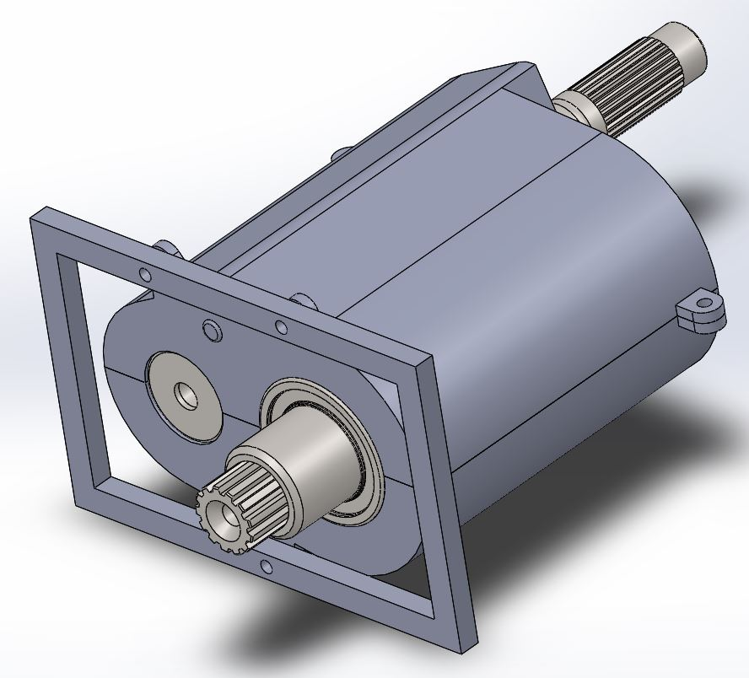

Introduction
Three-dimensional Computer Aided Design and Manufacturing (CAD & CAM) software, Motion Simulation and Finite Element Analysis (FEA) technology are widely applied to design, production and processing in many industries.
This report is constructed of three parts. In the first part, it is a brief summary of the process that was performed while doing CAD and CAM assessment. The second part is the review on the background of Motion Simulation and FEA technology. The last part mainly covers the application of the two technologies referred to recently published literature.

Part 1: Summary of the assessment completion process.
While assembling the components of the Gearbox together, the first problem is finding out the right dimension between the primary and output shafts. According to Childs (2013), the center distance of two gears meshing correctly is equal to the sum of the radius of their pitch circles. In addition, pitch circle radius is equal to the gear modulus multiplied by the number of teeth. Formulas are given as follows.
a = (d1+d2)/2
d = m z
In the formulas, a stands for the center distance, d stands for the pitch circle diameter, z stands for the number of teeth.
Based on my calculation, the dimension between the two shafts should be 71mm.
After finishing the assembly of the gears and bearings, the Casing is created and the whole system, which is consisted of top and bottom parts and is fixed on the frame by bolts, and the thickness of the Casing is 4mm.
A motion simulation is run by Solidworks to find the velocity variation on the output shaft while shift, and the system showed that the mates redundancy is zero. The result of plot is shown by figure 1.
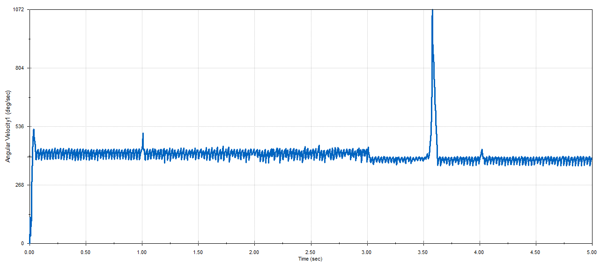
Fig 1. The result of plot
It is clear to see that during the shift between 3s and 4s, the velocity has an abrupt change which seems not reasonable. Through careful observation of simulated animation, a defect motion within the synchronizer feature is noticed. The top faces on the synchronizer bumped together when the shift started, and it took about half second to force the synchronizer sliding into the meshing position. That is the reason why the motion simulation showed a dramatic velocity change. It is interesting to find out that if rotate a bit of the starting angle of the gear before the simulation starts, there will not be able to get the abrupt change in the result plot.

Part 2: Background of Motion Simulation and FEA technology
FEA, originally known as matrix approximation method, has been applied to structural strength calculation of aircraft, and its convenience, practicability and effectiveness have aroused great interest of scientists engaged in mechanical research. With the rapid development and popularization of computer technology, the FEA has rapidly expanded from strength analysis and calculation of structural engineering to almost all scientific and technological fields. It has become a widely used and practical and efficient numerical analysis method.
FEA is a digital technology for structural analysis and has become the leading CAE method for structural research. It can analyze the behavior of any elastic or plastic objects with supports (Ebrahimi, 2012). FEA uses mathematical approximation to simulate real physical systems (geometric and load conditions). By using simple and interactive elements, a finite number of unknowns can be used to approximate the real system with infinite unknowns.
FEA replaces complex problems with simpler ones and then solves them. It regards the solution domain as composed of many small interconnected sub-domains called finite element, assumes a suitable (simpler) approximate solution for each element, and then deduces the general satisfying conditions (such as structural equilibrium conditions) for solving the domain, so as to obtain the solution of the problem. Because the actual problem is replaced by a simpler one, the solution is not an exact solution, but an approximate one (Prantil, Papadopoulos and Gessler, 2013). Because most of the practical problems are difficult to get accurate solutions, and the finite element method not only has high accuracy, but also can adapt to various complex shapes, so it has become an effective means of Engineering analysis.
While the computer aided engineering (CAE) method has been used for the first time in design engineering since the 1980s, finite element analysis (FEA) has become the first widely used simulation tool. Over the years, the technology has helped designers save a lot of time in studying the structure and performance of new products. Due to the increasing complexity of mechanical products, the increasing competition has accelerated the speed of new design schemes to enter the market. Designers urgently feel that simulation must go beyond the limits of FEA. In addition to using FEA to simulate structural performance, the kinematics and dynamics performance of new products need to be determined before building physical prototypes. Motion simulation (also known as rigid entity dynamics) provides a simulation method for solving these problems and has been widely used.
Motion simulation is a mechanism motion model established by means of three-dimensional comprehensive software, just like the actual mechanism motion; with the help of mechanism motion simulation, it can be convenient to analyze and verify whether your design is reasonable and analyze and optimize (Chang, 2019). It supports assembly clearance checking, interference checking, physical attribute calculation of zero/component, dynamic simulation checking of assembly process and dynamic simulation checking of motion state of mechanism. It enables designers to find problems in design in digital prototype, reduces users' multiple samples and reduces research and development costs.
In general, FEA is used for structure study, motion simulation is applied to mechanism. The difference between structure and mechanism is that the structure deforms under load, and there are strains and stresses; the mechanism has rigid body motion under load, without deformation.

Part 3: the application of motion simulation and FEA
Motion simulation can provide complete quantitative information on the kinematic performance (including position, velocity and acceleration) and dynamic performance (including driving force, feedback force, inertia force and power requirements) of all parts of a motion mechanism (Chang, 2019). More importantly, motion simulation results can be obtained without spending more time. Because everything needed to perform motion simulation has been defined in the CAD assembly model, it is only necessary to transfer it to the motion simulation program.
Motion simulation can also be used to check interference, which is quite different from using CAD assembly animation to check interference. Motion simulation manages interference inspection in real time and provides precise spatial and temporal positions and precise interference volumes for all components (Chang, 2019).
Another important application of motion simulation is to simulate the collision and contact between parts, so as to study the possible gap between parts and obtain the accurate results of the mechanism.
FEA can study the displacement, strain, stress and vibration of objects under static or dynamic loads. Therefore, Combining Motion Simulation and FEA in mechanism simulation can be a promising approach to get advantages in design competition. Under static load, objects will deform and will not change to a certain extent; under dynamic load, they will vibrate around the equilibrium position. As for the rigid entities, motion simulation can be applied to study the speed and force. After completing motion simulation, by utilizing FEA, the vibration of the objects can be analyzed, and deformation and stress analysis of any elastic or plastic components can be calculated.
Recently, FEA is widely used in topology optimization. Additive manufacturing methods (3D Printing) provide a very popular manufacturing method to producing complex structural components that classical methods are almost impossible to achieve (Saralegui, et al., 2017). Topology optimization technology can calculate structures with complex shapes which require as little material as possible and meet the mechanical constrains exactly. The research fields of topology optimization are mainly divided into continuum topology optimization and discrete structure topology optimization. No matter in any field, it depends on the results of FEA (Bendsøe and Sigmund, 2003), as the results are the constrains of topology simulation. Continuum topology optimization is to discretize the material in the optimization space into finite elements. Discrete structure topology optimization is to establish a basic structure consisting of finite beam elements in the design space, and then determine the elements in the design space according to the algorithm (Su, Gui and Fan, 2009). The remaining elements constitute the final topology scheme, so as to realize the topology optimization.
A typical application of FEA in topology optimization is shown as follows. The first step is meshing the object into elements. Then, conduct FEA by setting up the boundary conditions (like supports and forces). The last step is applying the FEA results into topology optimization as the constrains so that it can calculation the structure which can meet the requirements with less possible martials. As shown by figure 2, the structure obtained from topology optimization is impossible to be produced by traditional manufacturing methods, which is the reason it is usually combined with Additive manufacturing methods to achieve the optimal structure.
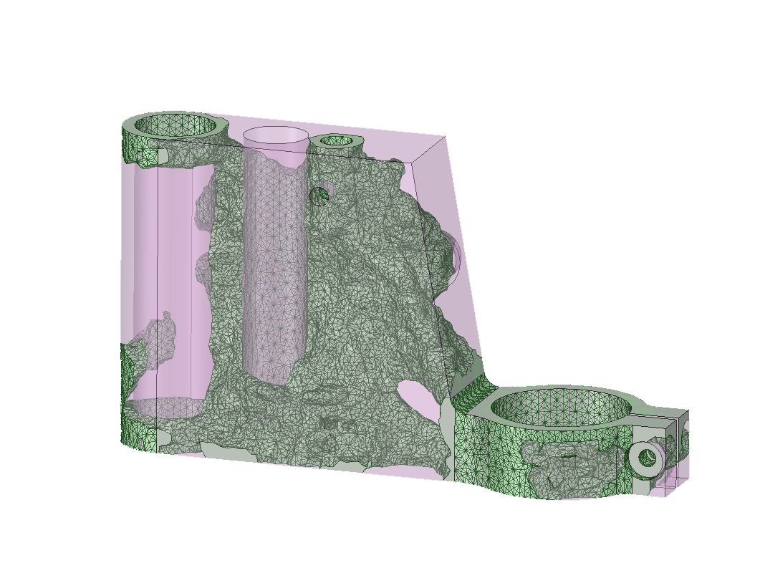
Fig 2. Comparison of the original design topology result

Reference
Bendsøe MP and Sigmund O.,2003, Topology optimization: theory, methods and applications. Springer, Berlin.
Chang, K.H., 2019. Motion Simulation and Mechanism Design with SOLIDWORKS Motion 2019. SDC publications.
Childs, P.R., 2013. Mechanical design engineering handbook. Butterworth-Heinemann, Oxford.
Ebrahimi, F., 2012. Finite Element Analysis-Applications in Mechanical Engineering. InTech, London.
Prantil, V.C., Papadopoulos, C. and Gessler, P.D., 2013. Lying by approximation: The truth about finite element analysis. Morgan & Claypool, London.
Saadlaoui, Y., Milan, J.L., Rossi, J.M. and Chabrand, P., 2017. Topology optimization and additive manufacturing: Comparison of conception methods using industrial codes. Journal of Manufacturing Systems, 43, pp.178-186.
Su, R., Gui, L. and Fan, Z., 2009, August. Topology and sizing optimization of truss structures using adaptive genetic algorithm with node matrix encoding. In 2009 Fifth International Conference on Natural Computation (Vol. 4, pp. 485-491). IEEE.

My OneDrive link:
https://uowtsd-my.sharepoint.com/:f:/g/personal/1804634_student_uwtsd_ac_uk/Ej5syRJXibFLlLulTHOIzsIBrGVCjmfiAG4byN8kXBJ7ew?e=OZqHKb

