Business Information Systems
Business & Change Management
Business & Web Management
Runa Bibi (1702463)
11/01/2019

Table of Contents

1. Introduction 2
2. Change Management 5
3. Conclusions & Recommendations 17
3.1 Conclusions 17
3.2 Recommendations 17
4. References 19
5. Appendices 25

Table of Figures
Figure 1 – Kondratieff Wave Theory……………………………………………………………………………………………….....2 Figure 2 – Lewin’s Force Field Analysis....................................................................................................6 Figure 3 – easyJet drone..........................................................................................................................7 Figure 4 – easyJet Force Field Analysis....................................................................................................8 Figure 5 – Kubler-Ross Change Curve......................................................................................................9 Figure 6 – Longaker’s 4 Stages of Grief.................................................................................................10 Figure 7 – Kotter’s 8 Step Model...........................................................................................................12 Figure 8 – Leadership vs Management..................................................................................................13 Figure 9 – Software Development Life Cycle.........................................................................................15 Figure 10 – Waterfall Method...............................................................................................................15 Figure 11 – Rapid Application Development.........................................................................................16

1. Introduction

Change management is the process of advancing an organization from its present state to one which is desired for its future [1]. Continuous improvement is a part of change management and can be achieved through an incremental process or an “innovative breakthrough” [2]. It is a continuing progression to improve processes, products or services which are part of an organization [2]. A case study of continuous improvement being successful is Danaher Corporation who use a strategic seven-step method referred to as Hoshin Kanri, a Japanese idea used to keep track of improvement of processes and deliver strategic objectives to employees [3]. Continuous improvement is vital for organisations who see the importance of improving the quality of products, customer satisfaction and increasing productivity, profits and efficiency [4].

Socio-economic development integrates public opinion when economic initiatives and social policy are being developed [5]. The end result is continual improvement for the community as a whole and an increase in standard of living by increasing human assets and so improving the technology [5]. According to the Kondratieff wave theory, technological innovation causes long-term cycles of economic prosperity [6]. We are currently in the information communication wave and are planned to be in the holistic health wave as shown below in Figure 1 [7].

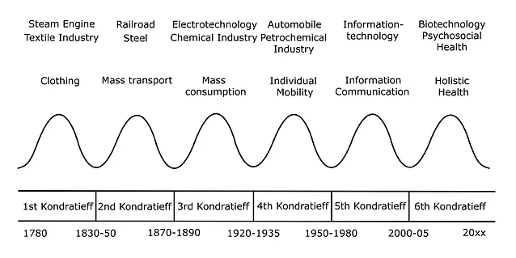
Figure 1 – Kondratieff Wave Theory
I have chosen the organisation easyJet to analyse. The following is a SLEPT analysis of the organisation.

Social Factors

- Airlines need to work to be inclusive of everyone and so in 2017 easyJet had over 519,000 customers that required special assistance [8].
- Support for passengers with physical disabilities have been in practice since 2012 [8].
- Constant flight disruptions may cause mistrust in the airline so easyJet provides flight updates via their Flight Tracker app which now includes reasons for disruptions and course of action to take next [8].
- People’s interest in foreign travel is also a factor for easyJet and the trend has seen to be increasing since 2017 with 72.8 million UK residents travelling overseas [9].

Legal Factors

- Along with its competitors, easyJet plans to start a legal complaint towards the European Commission due to the large amount of air traffic control strikes [10].
- These strikes have caused many flight cancellations according to easyJet and boss Johan Lundgren believes EU law is being infringed as the Commission not sorting out the issue is breaching Europeans freedom of travel [10].
- easyJet were fined for breach of contract by a London county court judge for around £10,671 in a compensation claim by a passenger who was not allowed to board with no refund or compensation [11].

Environmental Factors

- Laws involving environmental pollution [12].
- Climate change and attitudes regarding renewable energy [12].
- Tighter regulations on aircraft construction materials to make them safer means an increase in costs [13].

Economic & Competition Factors

- easyJet have three main competitors: RyanAir, AirBerlin and AirFrance [14].
- Their cost advantage compared to these airlines means they can provide cheaper fares [15].
- Oil price increase means not all airlines will survive; easyJet bought 20 new aircrafts to manage the demand [16].

Political Factors

- After the EU referendum UK travellers face higher holiday costs due to lower worth of sterling [17].

Technological Factors

- easyJet need to work hard to stay up-to-date with aircraft technology to be better than competitors and be as safe as possible.

Technological Developments

easyJet use technology to be the leading airline in the industry with web, operational, digital and engineering innovations:

- They use cutting-edge technology to help run their aircraft fleet of Airbus A319 and A320 [18].
- Panasonic Toughpads replaced printed navigational charts and laptops in all their cockpits in 2014. Thus, removing 27kg of paper per aircraft per flight which totals over 20,000 tonnes of CO2 emission being reduced per year [18].
- Trials have started of Sony’s e-paper technology meaning a paperless aircraft [18].
- Their mobile app allows customers to check in for their flights, book flights, get real-time information on flights and mobile boarding passes [18].
- They were the first airline worldwide to team up with Flightradar24 to “integrate live aircraft tracking” in their app [18].
- One of the first airlines in Europe to allow Apple Pay to passengers [18].
- Passport details can be scanned using any iOS or Android device camera enabling easier check-in [18].
- AVOID (Airborne Volcanic Object Imaging Detector) which is ash detection technology is planned to be installed on an aircraft in coming months; it uses infrared technology to take images allowing pilots to see 100km ahead for any ash clouds so they can slightly change the flight path [18].

2. Change Management

Whelan-Berry et al say change drivers are “events, activities or behaviours that facilitate the implementation of change” [19]. The following are internal and external change drivers for easyJet.

Internal:
- Wanting to have competitive advantage
- Want to be the safest they can be [20]
- Technology becoming outdated and wanting to have the best available
- Wanting to have a more efficient system for aircraft inspection and construction
- Wanting to be inclusive for passengers with disabilities

External:
- Increased demands to improve customer service and experience [21]
- Laws involving climate change and pollution [12]
- Tighter travel laws
- Tighter regulations involving aircraft construction materials [13]
- Demands for cheaper flights

Lewin’s force field analysis suggests that a proposed change is maintained by forces which drive change and forces that resist change, as represented in Figure 2 [22]. The driving forces must be stronger and resisting forces should be lessened [23].

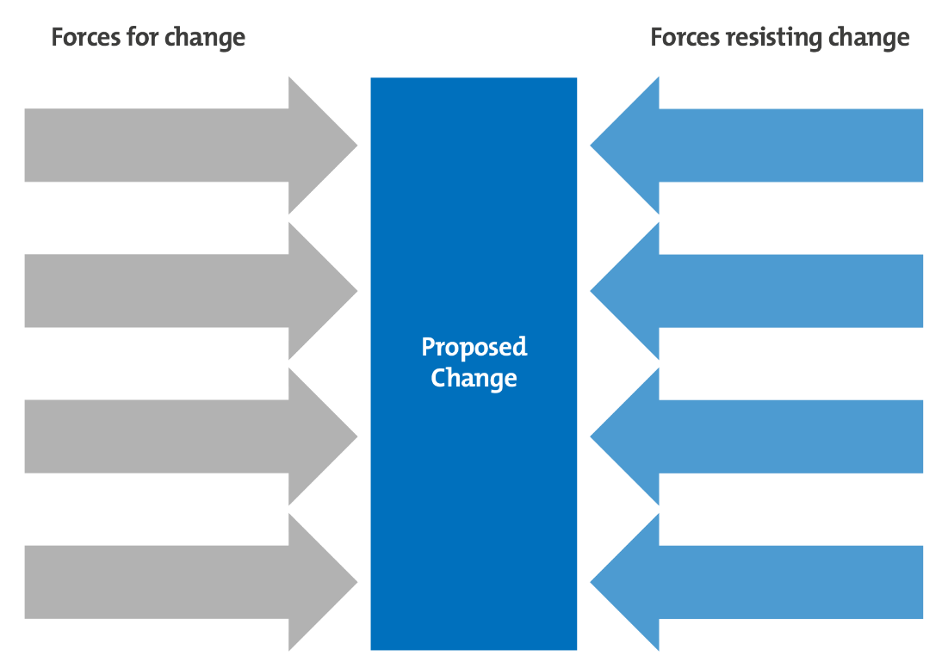
Figure 2 – Lewin’s Force Field Analysis

The following are steps to take when considering Lewin’s force field analysis:

- Define the goal you have for the future [24]
- Brainstorm the driving forces [24]
- Brainstorm the resisting forces [24]
- Evaluate all forces and possibly rate them from 1-5 [24]
- Review them and decide which are flexible for change [24]
- Strategize ways to strengthen driving forces and weaken resisting forces [24]
- Decide which action steps will have the biggest impact; resisting forces are easier to reduce than strengthening driving forces [24]

I have chosen the change area for easyJet of using drone and robotic technology to inspect aircraft as shown below in Figure 3.

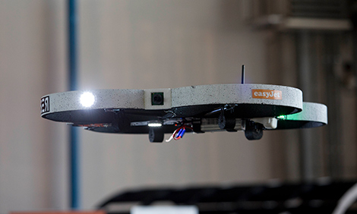
Figure 3 – easyJet drone

The following are driving forces and resisting forces for this change:

DRIVING FORCES | RESISTING CHANGES
Reduces inspection time | Cost
May find problems that the human eye would not i.e. more accuracy | If they stop working more work will be needed to fix them. This in turn may slow down any fixes that need to be done to the aircraft which may result in flight delay/cancellation i.e. loss of money
Competitive edge | If it is hacked could be used to gather information and images for rival companies
Support available as it is building on existing technology | Engineers may be worried about their jobs
More efficient system | Business will be disrupted by trials

Below is a Lewin’s force field diagram showing strengths of the forces.

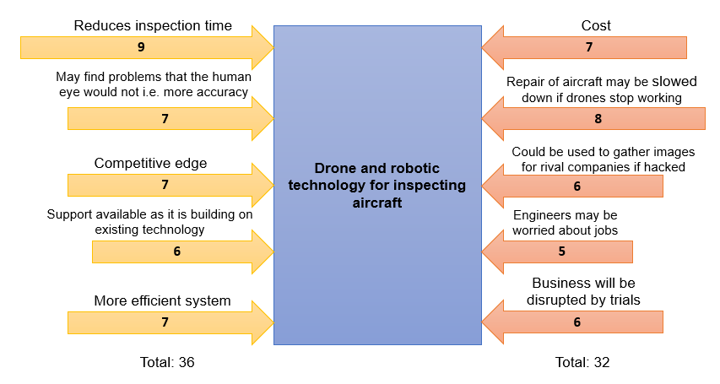
Figure 4 – easyJet Force Field Analysis

As there is already support available for the technology any damage to the drones should be able to be fixed in time for there not to be disruption to flights. Security measures can be put in place for preventing any hacking of the drone system. Engineers should be part of the decision of the drones going forward and, in the end, they will still be the ones physically fixing the aircraft; the drones will only do the inspection beforehand. As long as they get sufficient training their job will be made easier. While the trials may partially disrupt business and the technology will be expensive the benefits outweigh the resisting forces.
Change management is what we use in preparation and support of individuals to adopt change in an organisation and fulfil successful outcomes [25]. There are numerous change management models including Lewin, Kotter and Carnall and each one takes a different approach [26].

Lewin’s Freeze Phase model includes three steps: unfreezing, changing and refreezing [27]. He believes for a change to be carried out people need to believe a change is needed, work towards the desired change and then make the change part of the new normal [27]. Each step is further explained below:

- Unfreezing – The organisation needs to see that the current status quo needs to change to help the organisation [28]
- Changing – Members of the organisation look to find new ways to do things and carry out the change [28]
- Refreezing – The organisation accepts the change and infiltrate it into its daily workings [28]

The Kubler-Ross stages of grief can be applied to change management with employees’ reactions to change [29].

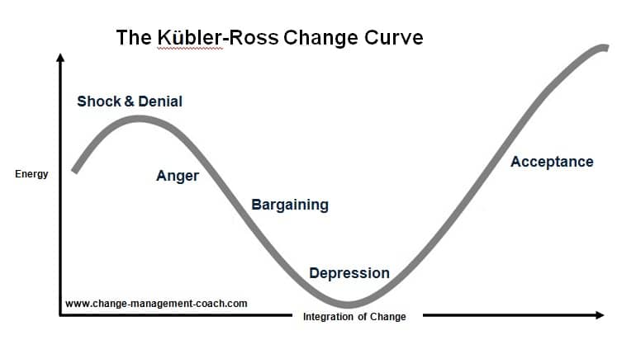
Figure 5 – Kubler-Ross Change Curve

The first stage is shock and denial where employees will deny any change is needed and employers should help them understand why this change is needed [30]. The second stage is anger when the employee may become angry at the situation and look for someone to blame [30]. The next stage is bargaining when employees realise a change is taking place and need find a way to adapt to the situation and employers should carry out training, so the change goes well [30]. Depression is the stage where morale may be low as the change has been realised to be genuine and employees can feel anxious and their performance may lag [31]. The final stage is acceptance where employees stop resisting the change and start to work with it [31]. Longaker’s 4 stages of grief model is similar to the Kubler Ross model as shown below in Figure 6 [32].

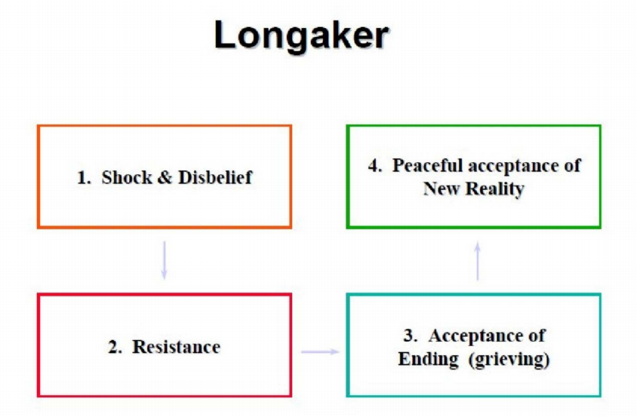
Figure 6 – Longaker’s 4 Stages of Grief

The Prosci ADKAR change management model focuses on an individual’s needs before a change can take place [33]. ADKAR determines if an individual is ready for the change and can be used to plan change management activities [33]. It stands for:

- Awareness that a change is needed [34]
- Desire to partake in the change [34]
- Knowledge being provided to employees about the change [34]
- Ability to show the required behaviours and skills needed [35]
- Reinforcement to maintain the change [35]

The Beckhard-Harris change equation is like the Prosci ADKAR model in that it determines the conditions needed for a change to take place [36]. The formula is
D x V x F > R [36]. The D is the dissatisfaction of the current condition, V is the shared vision of the future, F is the first steps towards the change and R is the resistance to the change [37]. In order for change to persist the first three factors have to be more powerful than the resistance [37].

The William Bridges 3 phase change management theory describes the three psychological changes people experience when change happens, similar to Kubler Ross and Longaker [38]. The stages are:

- Ending, Losing and Letting go [38] – Mentally preparing people to move on losses [39]
- The Neutral Zone [38] – Helping people get through it and inspiring them to be innovators [39]
- The New Beginning [38] – Helping people discover their new sense of purpose as the change starts to work [39]

One change management strategy is Kotter’s 8 step model [40] as shown below [41].

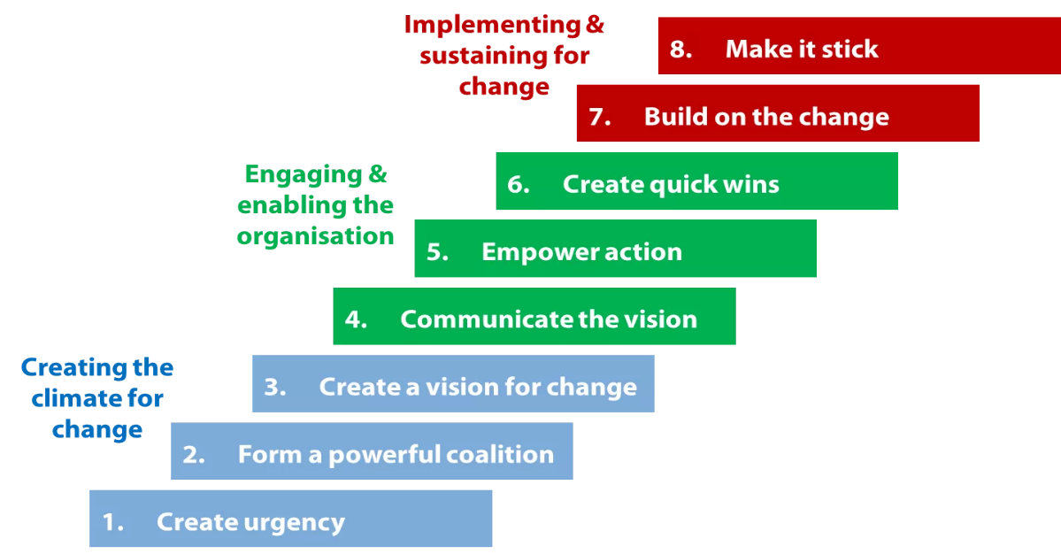
Figure 7 – Kotter’s 8 Step Model

- This step could include discussions regarding current issues and giving reasons for them [42]
- This can be done by forming a change coalition team including people from different levels and departments of the organisation [42]
- The core values and ultimate vision are determined [42]
- The vision is shared and any concerns are addressed [42]
- Remove any barriers of the change and reward people who endorse the change [43]
- Set and reward short-term targets that are met [43]
- Find success stories and continue to improve [43]
- Ensure the change is an integral part of the organisation [43]

The McKinsey 7-S model is another change management strategy [44]. In contrast to Kotter, this one focuses on different aspects of the company and how they affect each other [44]. Seven areas are looked at:

- Strategy is assessed [45]
- Structure is looked at [45]
- Systems are analysed [45]
- Shared values are recorded [45]
- Style is noted [45]
- Staff is listed [45]
- Skills of the staff are assessed [45]

This model is good for when you do not know where to start, but for evaluating the viability of a specific change a smaller scope model would work better [46].

For a change to be carried out successfully contemporary leadership and management styles need to be considered. Employees need to be motivated which are internal and external factors to reach a goal [47] and employers should give them the desire to act a certain way to achieve this change [48]. For employees to be invested in change they need to be committed to the organisation [49] and have an emotional connection which influences their effort into their work [50].

Leadership is motivating people to accomplish a specific goal [51] and exuding an attitude of seeking something different [52]. One thing said to be shared by leaders is creating a vision [53]. Management is the coordination of activities to achieve a goal [54]. Pietri, Mosley and Megginson define management as “working with human, financial and physical resources to achieve organizational objectives by performing the planning, organizing, leading and controlling functions” [55] Below is a table I compiled showing the differences [56].

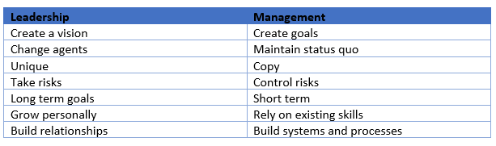
Figure 8 – Leadership vs Management

Mayo’s management theory is based on the Hawthorne experiments where he observed employee productivity under different conditions and found that relational factors e.g. co-workers and attention affected motivation much more than environmental and monetary factors [57].

One leadership style is visionary. Visionary leaders are inspiring in their vision and help others see how they can reach this vision [58]. These types of leaders are said to be emotionally intelligent i.e. aware of their emotions and empathic, open minded, persistent, collaborative and optimistic [59]. This can be used with Kotter’s 8 step model for easyJet. Inspirational leadership involves creating excitement for employees regarding a change and giving them a sense of direction [60]. Some qualities these leaders have is unerring positivity, appreciation for their team, good communication, a clear vision and trustworthiness [61]. This can also be used with Kotter’s 8 step model for easyJet.

Situational leadership involves the leader adjusting their style to fit the level of the employees they are influencing [62]. The leader must adapt their style for their followers, the followers should not have to change their style to meet the leaders [63]. Similar to this is transformational leadership where the leader “focuses on the needs of others” and helps the employees be aware of their purpose and their role for the good of the group [64]. A case study from Zwingmann et al shows employees under transformational leadership had better health than those under laissez-faire leadership [64]. Change leadership must be differentiated from change management as change leadership is influencing the change and change management is the processes needed to achieve the change [65].

When developing new software as easyJet is doing there is generally a certain framework used. This is the Software Development Life Cycle and defines the steps taken during software development [66]. The steps are shown below in Figure 9 [67]. The steps are further explained in the Appendices.

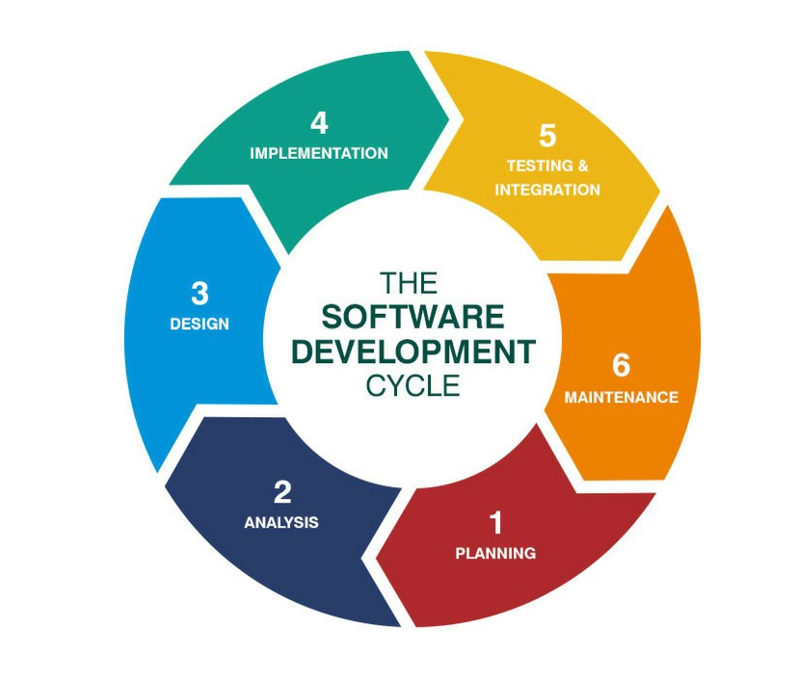
Figure 9 – Software Development Life Cycle

A Waterfall model involves each phase having to be completed before the next one can start with no overlapping [68]. The steps are shown below in Figure 10 [69].

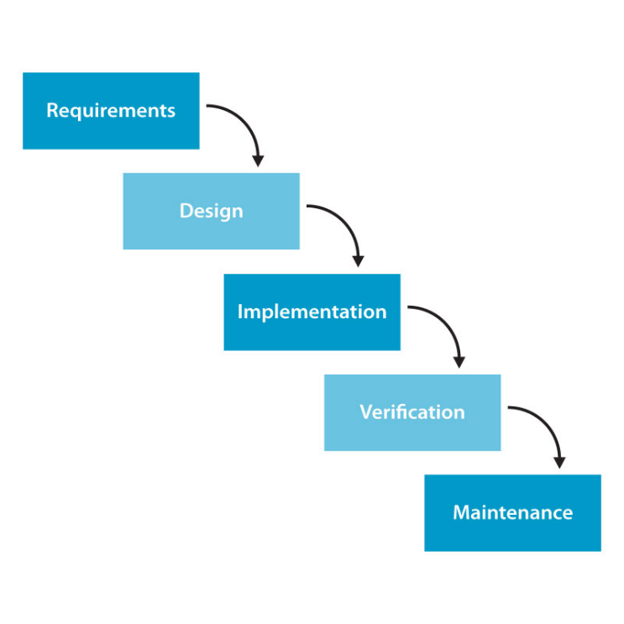
Figure 10 – Waterfall method

Below are some advantages and disadvantages of the Waterfall method:

Advantages | Disadvantages
Simple to use and manage [70] | Not good for complex projects [70]
Useful for smaller projects [70] | Working software not produced until late in the cycle [70]
Cost easy to estimate [71] | “Lack of flexibility” [71]
Timescales clearly defined and kept [71] | Project kickoff greatly delayed as all requirements need to be known [72]

Another software development model is RAD (Rapid Application Development) which focuses on iterative delivery and rapid prototyping [73]. The steps are shown below [74].

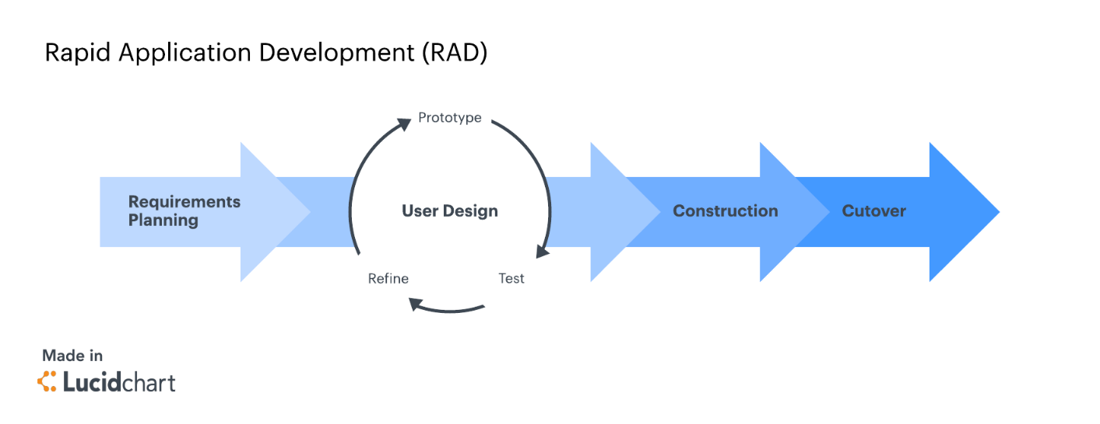
Figure 11 – Rapid Application Development

The steps are further explained in the Appendices. Agile methodology is another software development model. It focuses on delivering pieces of the software and not the final application [75]. Some principles of the agile manifesto are to satisfy the customer with continuous software delivery, welcome changing requirements, daily work between employees and developers, the primary measure of progress is working software and a self-organising team [76]. In contrast to the waterfall method, RAD and Agile allow for flexibility.

3. Conclusions & Recommendations

3.1 Conclusions

From everything I have found it is important to consider change drivers in an organisation when a change is being considered and whether the driving factors outweigh the resisting factors. If not, strategies need to be formed to carry this out. A change cannot take place until the driving factors overshadow the resisting factors. Once this is done change management theories and strategies need to be looked at and the one that is appropriate for your specific organisation’s change should be chosen. These can help with reducing employee resistance to change as they help to understand people’s reactions to change and the steps that can be taken to assist them accept and eventually appreciate the change.

A suitable change leadership style should be chosen to ensure the change is influential for employees. Change leaders need to emphasise that the change is essential for the progression and success of the organisation. Change management style should also be decided which will help layout the processes that will take place during the change. An appropriate change management model will make sure the change becomes an integral part of the organisation. While one model may work for one change it is important to note that the process should not be repeated for all changes within an organisation unless it is determined to be useful and work for that specific change.

3.2 Recommendations

For easyJet to implement their change successfully I believe Kotter’s 8 step model would be a good strategy along with Lewin’s freeze model so that the employees will see a change needs to be made and the vision can be started. I would recommend in the first step of creating an urgency for the person in charge of the change to discuss with employees the benefits of the change and show that the drones will greatly help with business. Step 2 has already been started as easyJet are working with Bristol Robotics Laboratory, Coptercraft and Measurement Solutions to “modify existing technology” for the drones to inspect the aircraft [18] so a strong coalition has already been built between the organisation and stakeholders. A visionary leader would work well with this model as they can create the vision and inspire the employees to reach the vision through strong communication, as in step 3 and 4.

Any concerns for the vision can be discussed with the engineers and barriers for the change can be overcome. The small goals resulting in rewards will boost employee morale and help them become accustomed to the change. As in step 7, some employees will adapt to the change quicker and those stories should be looked at and shared to help fellow employees also accept the change and see it as good. Once the change has been implemented it needs to be accepted should easyJet want it to be successful. The final step is where the change becomes integral to the business and it becomes routine for the drones to inspect the aircraft. I also believe rapid application development would work best as it is flexible and will allow employees to understand how it will work step by step via the prototypes and the working model should be bug free, so business can start running quicker.

4. References

[1] | Association for Process Management, “Change management,” Association for Project Management, [Online]. Available: https://www.apm.org.uk/body-of-knowledge/delivery/scope-management/change-management/. [Accessed 4 October 2018].
[2] | S. Ray, “Continuous Improvement Business Strategy – A Quick Guide,” ProjectManager.com, 30 May 2018. [Online]. Available: https://www.projectmanager.com/blog/continuous-improvement-business-strategy-quick-guide. [Accessed 11 October 2018].
[3] | B. Wilkins, “What is Continuous Improvement and Why is it Important?,” EON Solutions, 31 October 2017. [Online]. Available: https://www.eonsolutions.io/blog/what-is-continuous-improvement-and-why-is-it-important. [Accessed 11 October 2018].
[4] | F. J. Reh, “The Benefits of Continuous Improvement in the Workplace,” The Balance Careers, [Online]. Available: https://www.thebalancecareers.com/planning-for-continuous-improvement-in-the-workplace-2275281. [Accessed 11 October 2018].
[5] | H. Rahman, “Network Deployment for Social Benefits in Developing Countries,” in Encyclopedia of Multimedia Technology and Networking, Second Edition, IGI Global, 2009, p. 7.
[6] | W. Kenton, “Kondratieff Wave,” Investopedia, 27 February 2018. [Online]. Available: https://www.investopedia.com/terms/k/kondratieff-wave.asp#ixzz5SycvOKPh. [Accessed 18 October 2018].
[7] | L. Nefiodow and S. Nefiodow, “The Sixth Kondratieff,” Kondratieff.net, 2018. [Online]. Available: https://www.kondratieff.net/the-sixth-kondratieff. [Accessed 18 October 2018].
[8] | easyJet plc, “Our customers,” easyJet plc, [Online]. Available: http://corporate.easyjet.com/corporate-responsibility/our-customers. [Accessed 25 October 2018].
[9] | Office for National Statistics, “Travel Trends: 2017,” Office for National Statistics, 17 August 2018. [Online]. Available: https://www.ons.gov.uk/peoplepopulationandcommunity/leisureandtourism/articles/traveltrends/2017#uk-trips-abroad-and-visits-to-the-uk-continue-to-rise. [Accessed 25 October 2018].
[10] | J. Denton, “Easyjet launching legal challenge to the European Commission over air traffic control strikes after taking £25m hit but still ups profit forecast,” 18 July 2018. [Online]. Available: https://www.thisismoney.co.uk/money/markets/article-5965491/Easyjet-launching-legal-challenge-air-traffic-control-strikes-taking-25m-hit.html. [Accessed 25 October 2018].
[11] | Z. Shine, “EasyJet ordered to pay more than £10,000 over denied boarding,” 10 February 2016. [Online]. Available: https://www.telegraph.co.uk/travel/advice/easyjet-ordered-to-pay-10000-over-denied-boarding/. [Accessed 25 October 2018].
[12] | Fern Fort University, “Easyjet Plc PESTEL & Environment Analysis,” [Online]. Available: http://fernfortuniversity.com/term-papers/pestel/nyse4/6765-easyjet-plc.php. [Accessed 25 October 2018].
[13] | Business Case Studies, “External environment theory,” Business Case Studies, [Online]. Available: https://businesscasestudies.co.uk/business-theory/external-environment/slept-analysis.html. [Accessed 25 October 2018].
[14] | MBASkool, “EasyJet SWOT Analysis, Competitors & USP,” MBASkool.com, [Online]. Available: https://www.mbaskool.com/brandguide/airlines/5134-easyjet.html. [Accessed 25 October 2018].
[15] | easyJet plc, “Strategy,” easyJet plc, [Online]. Available: http://corporate.easyjet.com/about/strategy. [Accessed 25 October 2018].
[16] | Google Sites, “The Challenges Faced by EasyJet,” [Online]. Available: https://sites.google.com/site/economicenvironmentandbusiness/the-challenges-faced-by-easyjet. [Accessed 25 October 2018].
[17] | easyJet plc, “Annual Report and Accounts 2016,” 2017. [Online]. Available: http://corporate.easyjet.com/~/media/Files/E/Easyjet/pdf/investors/result-center-investor/annual-report-2016.pdf. [Accessed 25 October 2018].
[18] | easyJet plc, “Innovating the travel experience,” easyJet plc, [Online]. Available: https://www.easyjet.com/en/orange-spirit/innovation. [Accessed 25 October 2018].
[19] | K. S. Whelan-Berry and K. A. Somerville, “Linking Change Drivers and the Organizational Change Process: A Review and Synthesis,” Journal of Change Management, vol. 10, no. 2, pp. 175-194, 2010.
[20] | easyJet plc, “What we do,” easyJet plc, [Online]. Available: http://corporate.easyjet.com/about/what-we-do. [Accessed 1 November 2018].
[21] | tutor2u, “Lewin's Force Field Model (Change Management),” tutor2u, [Online]. Available: https://www.tutor2u.net/business/reference/models-of-change-management-lewins-force-field-model. [Accessed 1 November 2018].
[22] | The Mind Tools Content Team, “Force Field Analysis,” Mind Tools, [Online]. Available: https://www.mindtools.com/pages/article/newTED_06.htm. [Accessed 1 November 2018].
[23] | A. Capatine, G. Bleoju, F. Matos and V. Vairinhos, “Leveraging intellectual capital through Lewin’s Force Field Analysis: The case of software development companies,” Journal of Innovation & Knowledge, vol. 2, no. 3, pp. 125-133, 2017.
[24] | M. Connelly, “Force Field Analysis - Kurt Lewin,” Change Management Coach, 24 April 2017. [Online]. Available: https://www.change-management-coach.com/force-field-analysis.html. [Accessed 1 November 2018].
[25] | Prosci, “What is Change Management?,” Prosci Inc., [Online]. Available: https://www.prosci.com/resources/articles/what-is-change-management. [Accessed 8 November 2018].
[26] | APM, “Change Management,” [Online]. Available: https://www.apm.org.uk/body-of-knowledge/delivery/scope-management/change-management/. [Accessed 8 November 2018].
[27] | Study.com, “Lewin's 3-Stage Model of Change: Unfreezing, Changing & Refreezing,” [Online]. Available: https://study.com/academy/lesson/lewins-3-stage-model-of-change-unfreezing-changing-refreezing.html. [Accessed 8 November 2018].
[28] | Mind Tools Content Team, “Lewin's Change Management Model,” Mind Tools, [Online]. Available: https://www.mindtools.com/pages/article/newPPM_94.htm. [Accessed 8 November 2018].
[29] | M. Connelly, “Kubler-Ross Five Stage Model,” Change Management Coach, 30 August 2018. [Online]. Available: https://www.change-management-coach.com/kubler-ross.html. [Accessed 8 November 2018].
[30] | Anastasia, “Understanding the Kubler-Ross Change Curve,” Cleverism, 24 June 2015. [Online]. Available: https://www.cleverism.com/understanding-kubler-ross-change-curve/. [Accessed 8 November 2018].
[31] | University of Exeter, “The Change Curve,” [Online]. Available: https://www.exeter.ac.uk/media/universityofexeter/humanresources/documents/learningdevelopment/the_change_curve.pdf. [Accessed 8 November 2018].
[32] | S. Warrilow, “Christine Longaker,” [Online]. Available: http://www.strategies-for-managing-change.com/christine-longaker.html. [Accessed 8 November 2018].
[33] | Prosci, “Prosci Change Management Methodology,” Prosci Inc., [Online]. Available: https://www.prosci.com/resources/articles/change-management-methodology. [Accessed 15 November 2018].
[34] | S. A. Z. Kazmi and M. Naarananoja, “Collection of Change Management Models – An Opportunity to Make the Best Choice from the Various Organizational Transformational Techniques,” GSTF Journal on Business Review (GBR), vol. 3, no. 3, pp. 1-14, 2014.
[35] | Education Business Articles, “ADKAR Change Management: creating change in Individuals,” [Online]. Available: https://www.educational-business-articles.com/adkar-change-management/. [Accessed 15 November 2018].
[36] | Pastatenaacp.org, “The Beckhard-Harris Change Model (DxVxF>R),” [Online]. Available: http://pastatenaacp.org/wp-content/uploads/2017/03/Beckhard-Harris-Change-Model-DVF.pdf. [Accessed 15 November 2018].
[37] | BusinessBalls, “Beckhard-Harris Change Equation,” [Online]. Available: https://www.businessballs.com/change-management/formula-for-change/. [Accessed 15 November 2018].
[38] | Mind Tools Content Team, “Bridges' Transition Model,” Mind Tools, [Online]. Available: https://www.mindtools.com/pages/article/bridges-transition-model.htm. [Accessed 15 November 2018].
[39] | S. Warrilow, “William Bridges,” [Online]. Available: http://www.strategies-for-managing-change.com/william-bridges.html. [Accessed 15 November 2018].
[40] | V. Webster and M. Webster, “Successful Change Management — Kotter’s 8-Step Change Model,” Leadership Thoughts, [Online]. Available: https://www.leadershipthoughts.com/kotters-8-step-change-model/. [Accessed 22 November 2018].
[41] | Tremolada, Gary, “John Kotter’s 8 Step organisational Change model pt1,” 8 February 2016. [Online]. Available: https://frontlinemanagementexperts.wordpress.com/2016/02/08/john-kotters-8-step-organisational-change-model-pt1/. [Accessed 22 November 2018].
[42] | Management Study Guide, “Kotter’s 8 step Model of Change,” [Online]. Available: https://www.managementstudyguide.com/kotters-8-step-model-of-change.htm. [Accessed 22 November 2018].
[43] | Kotter International, [Online]. Available: https://www.kotterinc.com/8-steps-process-for-leading-change/. [Accessed 22 November 2018].
[44] | B. Mulholland, “8 Critical Change Management Models to Evolve and Survive,” Process.st, 24 July 2017. [Online]. Available: https://www.process.st/change-management-models/. [Accessed 22 November 2018].
[45] | Strategic Management Insight, “McKinsey 7s Model,” [Online]. Available: https://www.strategicmanagementinsight.com/tools/mckinsey-7s-model-framework.html. [Accessed 22 November 2018].
[46] | D. Chaffey, “E-marketing-Chapter 25,” in The Marketing Book, 2008, pp. 502-525.
[47] | Business Dictionary, “Motivation,” [Online]. Available: http://www.businessdictionary.com/definition/motivation.html. [Accessed 29 November 2018].
[48] | Leadership-Central, “Motivation Definition,” [Online]. Available: https://www.leadership-central.com/motivation-definition.html. [Accessed 29 November 2018].
[49] | CustomInsight, “What Is Employee Engagement?,” [Online]. Available: https://www.custominsight.com/employee-engagement-survey/what-is-employee-engagement.asp. [Accessed 29 November 2018].
[50] | Business Dictionary, “employee engagement,” [Online]. Available: http://www.businessdictionary.com/definition/employee-engagement.html. [Accessed 29 November 2018].
[51] | S. Ward, “Leadership definition,” 22 August 2018. [Online]. Available: https://www.thebalancesmb.com/leadership-definition-2948275. [Accessed 29 November 2018].
[52] | Gamelearn, “What Is Leadership? 10 Ways To Define It,” 1 December 2016. [Online]. Available: https://www.game-learn.com/what-is-leadership-ways-to-define/. [Accessed 29 November 2018].
[53] | M. Rouse, “leadership,” [Online]. Available: https://searchcio.techtarget.com/definition/leadership. [Accessed 29 November 2018].
[54] | Business Dictionary, “management,” [Online]. Available: http://www.businessdictionary.com/definition/management.html. [Accessed 29 November 2018].
[55] | Management Study HQ, “What is Management?,” [Online]. Available: https://www.managementstudyhq.com/what-is-management.html. [Accessed 29 November 2018].
[56] | W. Arruda, “9 Differences Between Being A Leader And A Manager,” Forbes, 15 November 2016. [Online]. Available: https://www.forbes.com/sites/williamarruda/2016/11/15/9-differences-between-being-a-leader-and-a-manager/#561120b46096. [Accessed 29 November 2018].
[57] | J. Dininni, “Management Theory of Elton Mayo,” Business.com, 16 May 2017. [Online]. Available: https://www.business.com/articles/management-theory-of-elton-mayo/. [Accessed 29 November 2018].
[58] | Money-zine, “Visionary Leadership Style,” [Online]. Available: https://www.money-zine.com/definitions/career-dictionary/visionary-leadership-style/. [Accessed 29 November 2018].
[59] | S. Jeffrey, “10 Attributes of Visionary Leadership for Change Agents and Outperforming Entrepreneurs,” CEOSage, [Online]. Available: https://scottjeffrey.com/visionary-leadership/. [Accessed 29 November 2018].
[60] | National Research Council Canada, “Inspirational leadership (core competency),” [Online]. Available: https://www.nrc-cnrc.gc.ca/eng/careers/behavioural_competencies/mg_inspirational_leadership.html. [Accessed 29 November 2018].
[61] | M. Newlands, “7 Characteristics of Inspiring Leaders,” 9 December 2015. [Online]. Available: https://www.entrepreneur.com/article/252916. [Accessed 29 November 2018].
[62] | L. Anthony, “Define Situational Leadership,” 30 June 2018. [Online]. Available: https://smallbusiness.chron.com/define-situational-leadership-2976.html. [Accessed 6 December 2018].
[63] | P. Guy, “Situational Leadership,” in Leadership: theory and practice 6th ed., Thousand Oaks: SAGE, 2012, pp. 14-20.
[64] | Investors In People, “Transformational leadership: what is it?,” 4 August 2017. [Online]. Available: https://www.investorsinpeople.com/transformational-leadership-what-is-it/. [Accessed 6 December 2018].
[65] | Accipio, “Change Leadership vs Change Management,” [Online]. Available: https://www.accipio.com/eleadership/mod/wiki/view.php?id=1704. [Accessed 6 December 2018].
[66] | Techopedia, “Software Development Life Cycle (SDLC),” [Online]. Available: https://www.techopedia.com/definition/22193/software-development-life-cycle-sdlc. [Accessed 6 December 2018].
[67] | J. Pinheiro, “Software Development Life Cycle (SDLC) phases,” 11 April 2018. [Online]. Available: https://medium.com/@jilvanpinheiro/software-development-life-cycle-sdlc-phases-40d46afbe384. [Accessed 6 December 2018].
[68] | ToolsQA, “Waterfall Model,” [Online]. Available: http://toolsqa.com/software-testing/waterfall-model/. [Accessed 6 December 2018].
[69] | SOFTWARE TESTING TUTORIALS - MANUAL AND AUTOMATION QUESTIONS ANSWERS, “What is Waterfall model and list its advantages, disadvantages,” [Online]. Available: http://jobsandnewstoday.blogspot.com/2013/04/what-is-waterfall-model.html. [Accessed 6 December 2018].
[70] | Tutorials Point, “SDLC - Waterfall Model,” [Online]. Available: https://www.tutorialspoint.com/sdlc/sdlc_waterfall_model.htm. [Accessed 6 December 2018].
[71] | P. Kienitz, “The pros and cons of Waterfall Software Development,” DCSL Software, 27 February 2017. [Online]. Available: https://www.dcslsoftware.com/pros-cons-waterfall-software-development/. [Accessed 6 December 2018].
[72] | Lvivity, “Waterfall Methodology: Advantages, Disadvantages And When to Use It?,” 15 March 2018. [Online]. Available: https://lvivity.com/waterfall-model. [Accessed 6 December 2018].
[73] | A. Powell-Morse, “Rapid Application Development (RAD): What Is It And How Do You Use It?,” Airbrake, 23 November 2016. [Online]. Available: https://airbrake.io/blog/sdlc/rapid-application-development. [Accessed 6 December 2018].
[74] | Lucidchart Content Team, “4 Phases of Rapid Application Development Methodology,” Lucidchart, 23 May 2018. [Online]. Available: https://www.lucidchart.com/blog/rapid-application-development-methodology. [Accessed 6 December 2018].
[75] | M. Rouse, “Agile Software Development,” TechTarget, [Online]. Available: https://searchsoftwarequality.techtarget.com/definition/agile-software-development. [Accessed 6 December 2018].
[76] | M. Beedle, “Principles behind the Agile Manifesto,” [Online]. Available: https://agilemanifesto.org/iso/en/principles.html. [Accessed 6 December 2018].
[77] | A. Ghahrai, “Software Development Life Cycle – SDLC Phases,” 12 December 2018. [Online]. Available: https://www.testingexcellence.com/software-development-life-cycle-sdlc-phases/. [Accessed 13 December 2018].

5. Appendices

Software Development Life Cycle steps:

- Requirements Analysis – The requirements for the software are discussed with the stakeholders [77]
- Design – Technical architects and developers start the design of the system and software that fits the requirements [77] Different parameters e.g. risks, constraints, budget and time are discussed with stakeholders and the best design route is chosen [77]
- Implementation – Developers start coding the software following the requirements and design [77]
- Testing – The system is tested against the requirements and any defects are looked for as well as whether the system works as expected [77]
- Deployment and Maintenance – Once the system is mostly bug free then it can be deployed for use by the organisation and a maintenance team is usually available to deal with any issues that arise post-release [77]

Rapid Application Development steps:

- Requirements Planning – Goals are communicated between team members and finalised with stakeholders [74]
- User design – Development is started right away with the user design being built out by many prototype iterations and clients work with developers to ensure their requirements are being met [74]
- Rapid construction – The prototypes are turned into the working model as most problems were addressed during the design phase the final working model can be constructed more quickly and the client can still suggest changes [74]
- Cutover – The final model goes to launch and is tested along with user training [74]

