Project Management

Managing a Hardware/Software Project for Disaster Recovery

ACDA5004

Helen Frey

P131560

Lecturer: Sue Maw
Contents
Project Initiation Document: Lifeline 3
Background 3
Objectives 3
Scope 4
Exclusions from Scope 4
Assumptions 4
Deliverables 5
Constraints 5
Risk 5
Authority 5
Resources 5
Stakeholders 6
Project Milestones 6
Appendix 7
Task Schedules in Microsoft Project 7
Bibliography 10

Project Initiation Document: Lifeline

Background
“Kansas is notorious for its rampant tornadoes. Nestled in a part of the country known as tornado alley, the region is one of the most active for such natural disasters in the world. A staggering 3,927 tornadoes have blown through Kansas from 1950 to 2014. According to the National Weather Service, the late '90s saw a marked uptick in tornado occurrences, culminating in more than 180 sweeping through the state in 2008. That annual number has since declined substantially, though Kansas ranks third in terms of most tornadoes per 100 square miles with a rate of 4.4.” [1]

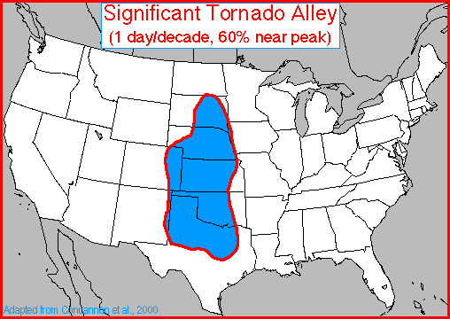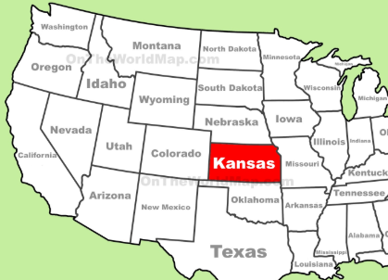
Figure 1 - Map of Tornado Alley[2] Figure 2 - Kansas in relation to Tornado Alley[3]

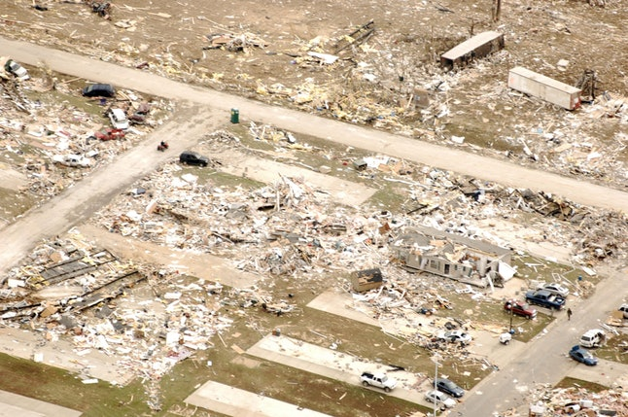
Figure 3 - Devastated area following a tornado -Melanie Blanding/Getty Images News/Getty Images

Objectives
The project is based around the provision of an all-terrain truck, equipped with satellite/ wireless local area network using Wi-Max[4] in the aftermath of a tornado when cell towers have been destroyed. The truck would move through the streets of Kansas City at about 5 mph sending out a siren which could be heard by residents, letting them know that they can use their telephone/smart device.

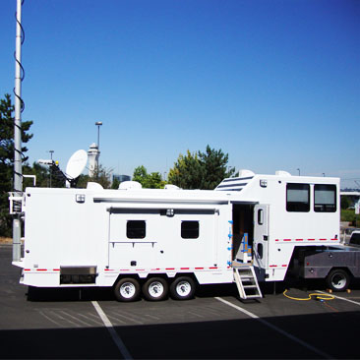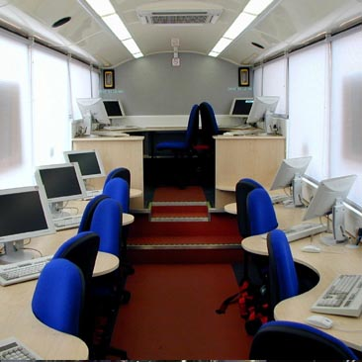
Figure 4 - satellite/network enabled truck[5] Figure 5- example of inside the truck[5]
The truck would allow any trapped survivors, via their telephone/smart device, to contact the emergency services to let them know their precise location and problem. Residents could use this opportunity to telephone or contact family/loved ones to let them know they are safe.

If they had pre-registered with Kansas City Council they would be given a code that would link into a database (via and API) belonging to the Kansas City emergency team which would give details of any pre-existing medical conditions eg dialysis machine, wheelchair, pregnancy etc that would allow for initial triage/prioritisation.

This project will be considered successful if:
- Emergency services can locate victims quicker;
- Rescue workers are able to prioritise victims in an easier manner;
- Local resources have to spend less time dealing with concerned relatives seeking information.

Scope
Must: a truck equipped with satellite access.
Must: networking devices to support Wi-Max.
Should: a database via and API for the emergency services.
Should: local personnel to operate Project Lifeline once in place.

Exclusions from Scope
Physically helping the survivors.
Keeping database information (either initial collation or keeping it updated).
Internet access for any other purpose than emergency contact detailed above.

Assumptions
- Kansas City is being used as a model for cities in Tornado Alley.
- That survivors of the tornado have access to a mobile device.
- Citizens have already registered with Kansas City database.
- The truck and networking equipment will be delivered to Kansas City.
- Funding has already been obtained and donations have been made available against advertising on the truck.
- Project leaders will arrive in Kansas to set up truck/wireless local area network.
- Accommodation, flights, visas and work permits have already been put in place.
- Local personnel will be trained by project leaders when they arrive to set up truck.

Deliverables
- A truck with a satellite and Wi-Max installed ready to network – 18 January 2019
- A database of residents (proof of concept) - 18 January 2019.

Constraints /Risk
- Safety concerns of going through a devastated area with debris[6].
- Getting the truck to the site of destruction in a timely manner.
- Getting detailed information to find out the exact path of the tornado and best placement for truck[7].
- Although Wi-Max[8] suggests it can be used out of line of sight to approximately 18 miles radius - with all the dust, the loss of signal due to refraction would limit this distance to approximately 1 mile radius[9].
- Ability of database to be constructed in a timely manner.

Authority

Department of Homeland Security, the Federal Emergency Management Agency (FEMA) Division[10].
State and local authorities: KCMO LEOP (Kansas City Missouri: Local Emergency Operations Plan)[11].
Kansas City Mayor.
Project Manager: Sue Maw.

Resources
Julie Millard
Helen Frey
Nicholas Hinder
Cisco (networking)
Ground Control (satellite and truck)

Stakeholders

- Team members: network engineers, database creator and project manager
- Kansas City citizens and their families /loved ones
- Department of Homeland Security[10]
- Federal Emergency Management Agency “FEMA”[12]
- Kansas City Mayor and Council
- Local management rescue agencies [10]:
    - State Emergency Management Agency “SEMA”
    - (Primary) Emergency Operations Centre “EOC”
    - Fire Department
    - Police Department
    - Water Department
    - Finance Department
- Local Hospitals
- Funding organisations/bodies: Cisco / Ground Control / Kansas City
- Other rescue agencies - competitors

Project Milestones
Initial Project Plan: 18 November 2018
Truck:18 January 2019
Database: 18 January 2019
Report: 25 January 2019

Appendix

Task Schedules in Microsoft Project

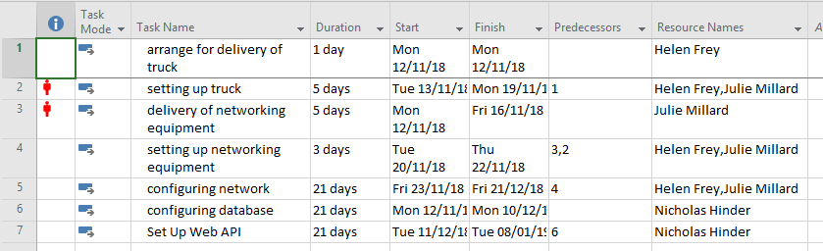
Figure 6 - List of Tasks

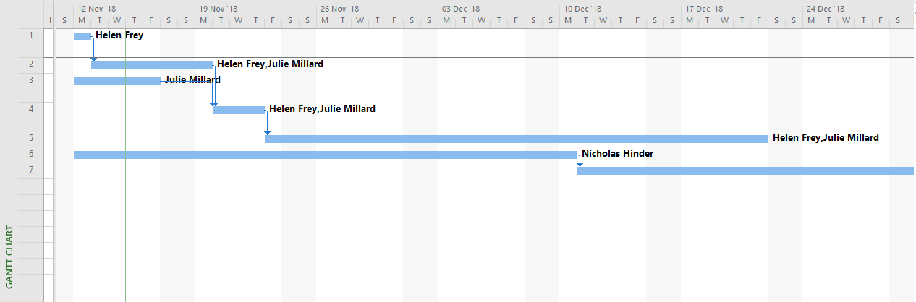
Figure 7 - Gantt Chart 1
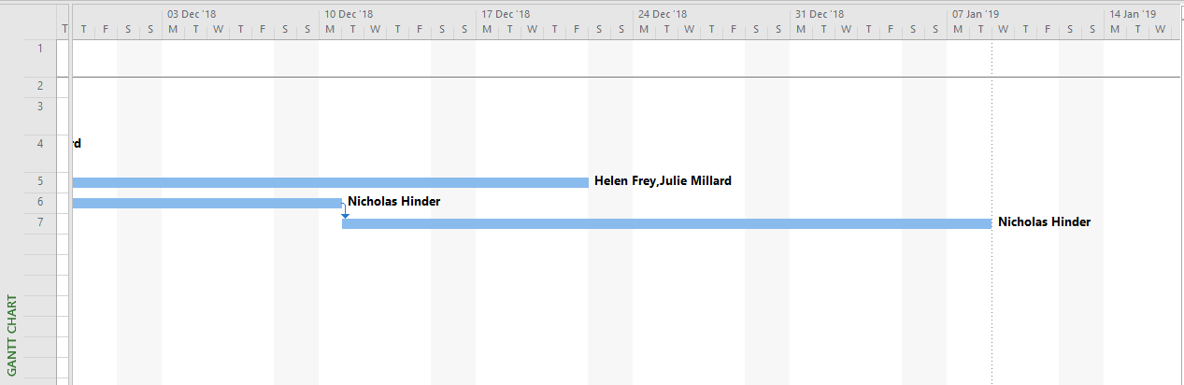
Figure 8 - Gantt Chart 2

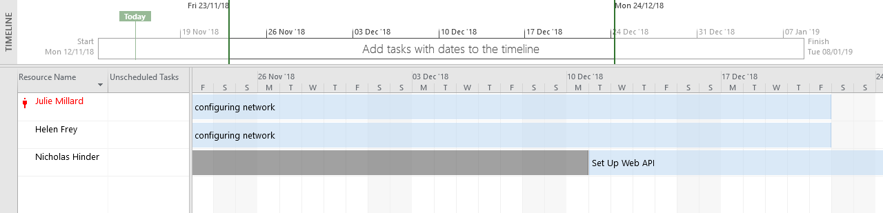
Figure 9 - Timeline 1
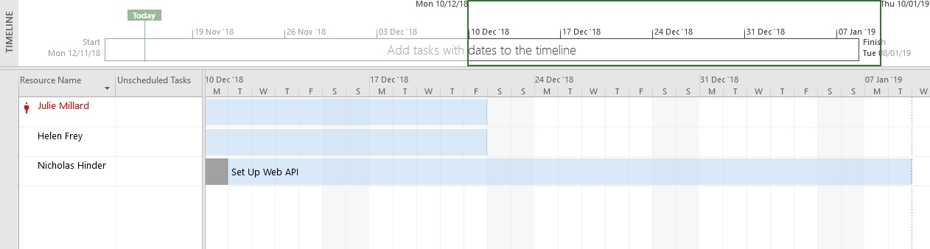
Figure 10 - Timeline 2
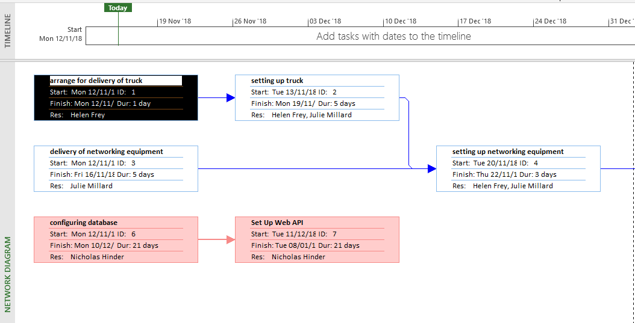
Figure 11 - Network Diagram 1
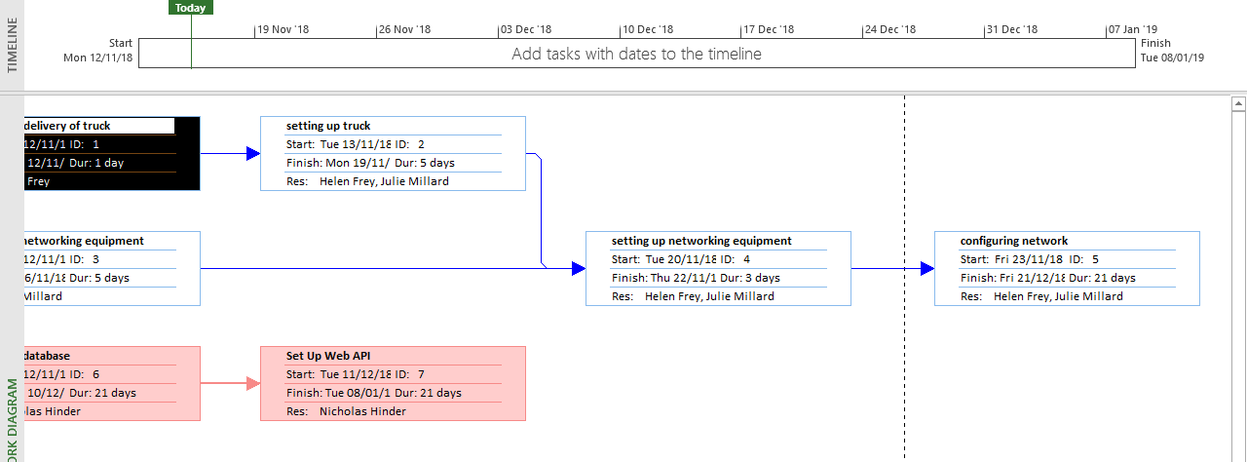
Figure 12 - Network Diagram 2
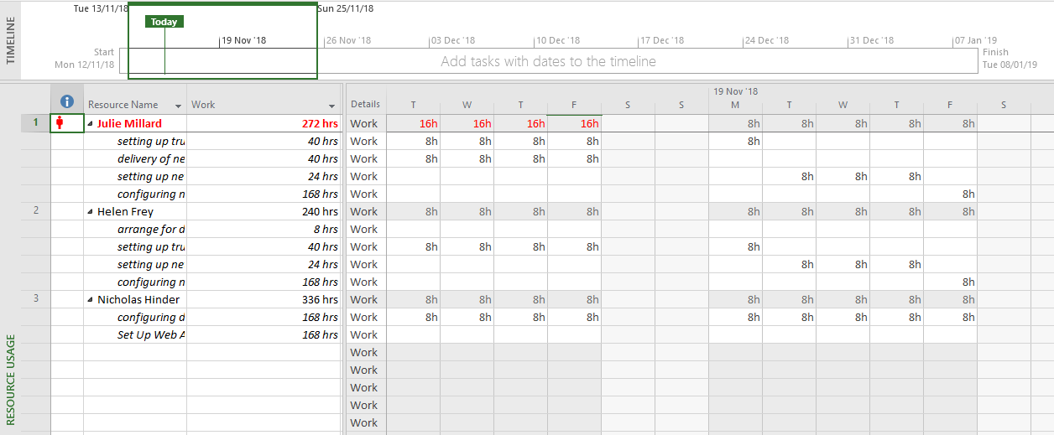
Figure 13 - Resource Usage 1
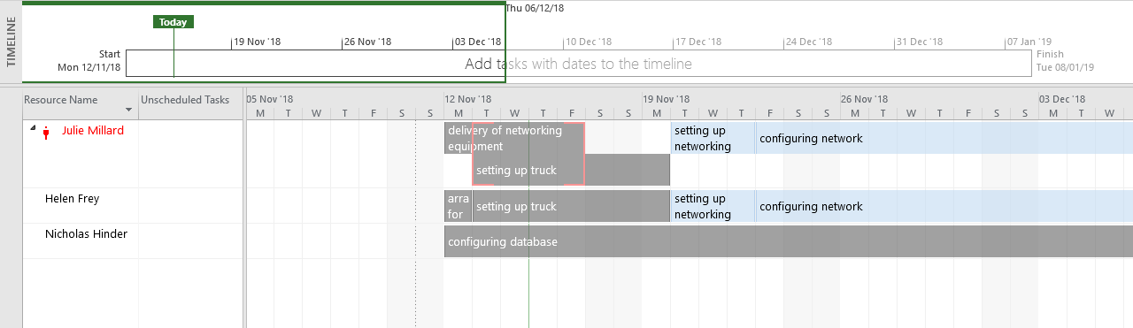
Figure 14 - Resource Usage 2

Bibliography
[1] “Worst Natural Disaster In Each State, Because You Can Never Be Too Prepared.” [Online]. Available: https://www.bustle.com/articles/105664-worst-natural-disaster-in-each-state-because-you-can-never-be-too-prepared. [Accessed: 07-Nov-2018].
[2] “Tornado Alley | National Centers for Environmental Information (NCEI) formerly known as National Climatic Data Center (NCDC).” [Online]. Available: https://www.ncdc.noaa.gov/climate-information/extreme-events/us-tornado-climatology/tornado-alley. [Accessed: 22-Oct-2018].
[3] “map of kansas city - Google Search.” [Online]. Available: https://www.google.co.uk/search?q=map+of+kansas+city&source=lnms&tbm=isch&sa=X&ved=0ahUKEwjM6PvjitveAhWNJ1AKHV-qBIAQ_AUIDygC&biw=1280&bih=864#imgrc=Z8c2b9tNUFHbtM: [Accessed: 17-Nov-2018].
[4] “WiMAX Advanced | WiMAX Forum Initiative.” [Online]. Available: http://wimaxforum.org/Page/Initiatives/WiMAX-Advanced. [Accessed: 22-Oct-2018].
[5] “Emergency Communications via Satellite. EMS, First Responders, Public Safety Communications Solutions.” [Online]. Available: http://www.groundcontrol.com/Mobile_Command_Communication.htm. [Accessed: 12-Nov-2018].
[6] “After a Tornado|Tornadoes.” [Online]. Available: https://www.cdc.gov/disasters/tornadoes/after.html. [Accessed: 31-Oct-2018].
[7] “Being Prepared (Part 1)|Tornadoes.” [Online]. Available: https://www.cdc.gov/disasters/tornadoes/prepared.html. [Accessed: 31-Oct-2018].
[8] “WiMAX Coverage and Speed | HowStuffWorks.” [Online]. Available: https://computer.howstuffworks.com/wimax2.htm. [Accessed: 31-Oct-2018].
[9] P. Maina, G. Chandra Manna, and N. Sahayam, “VALIDATION STUDY OF PATH LOSS MODELS ON WIMAX AT 2.6 GHZ FREQUENCY BAND IN SUBURBAN ENVIRONMENT FOR CELL SIZE PLANNING,” Int. J. Next-Generation Networks, vol. 6, no. 2, 2014.
[10] “U.S. Disaster Relief at Home and Abroad | Council on Foreign Relations.” [Online]. Available: https://www.cfr.org/backgrounder/us-disaster-relief-home-and-abroad. [Accessed: 07-Nov-2018].
[11] “Kansas City , Missouri Local Emergency Operations Plan September 2014,” no. September, 2014.
[12] “U.S. Disaster Relief at Home and Abroad | Council on Foreign Relations.” [Online]. Available: https://www.cfr.org/backgrounder/us-disaster-relief-home-and-abroad. [Accessed: 12-Nov-2018].

