

Module: (LCBB4005) Global Business Environment

Student’s Name: Madalina Ana Maria Ochesel
Student ID: LCBB4005\2114285
Lecturer’s Name: Mr. Akinseye Aluko
Due date: 14\01\2022

Introduction

During the pandemic many changes have been taken place for people in terms of shopping, travel, and work. COVID-19 have had a huge impact on many organisations in different industries. As the pandemic tornado hits, the automotive industry went into decline, as the car selling went down by -97.3% in April, the United Kingdom car industry went into a massive fall. (Conway, 2020)

Most of the productions have been stopped because there were shortages on components and almost all dealerships had to close the doors because of safety measures. Many customers had to deal with cancellations.

The following case study will undertake the factors that the brand Mercedes-Benz has faced during lockdown and how aggressive the pandemic was for them.


Mercedes-Benz had to deal with a lot of trouble when everything started all the sudden. The brand faced a massive downfall in the United States of America with an amount of 750.000 cars on recall of the delay of the components and the cars couldn’t be ready on time.

As the pandemic has taken place, the number one priority for Mercedes-Benz was their customers, by taking extra care of sanitising surfaces that they have been in contact with and wearing gloves all the time; and the comfort of their customers by delivering the vehicle directly to their houses.

The pandemic and chip shortage had a big impact on the production for many automakers. For Mercedes-Benz the demand was high, so that the wait list went longer than it usually was, the customers waiting more than a year for the vehicles to be delivered, as for the period of waiting was bigger was pointed at the chip shortage. Most of automakers continued their procedures and to produce the cars but left away as the important components required to operate were missing. The company believes that the shortages will continue in 2023 as well, but the impact will not be that massive.

The auto industry is connected, and the pandemic has just exposed the bond between the countries and how big that is. The companies were hit by the missing parts and components to cars so the cars could not be delivered, as explained before due to chips shortages. Many of the companies had to change their manufacturing and organize the supply chain.

During these hard times of the lockdown, car sales went down to 80% comparing with the year before.

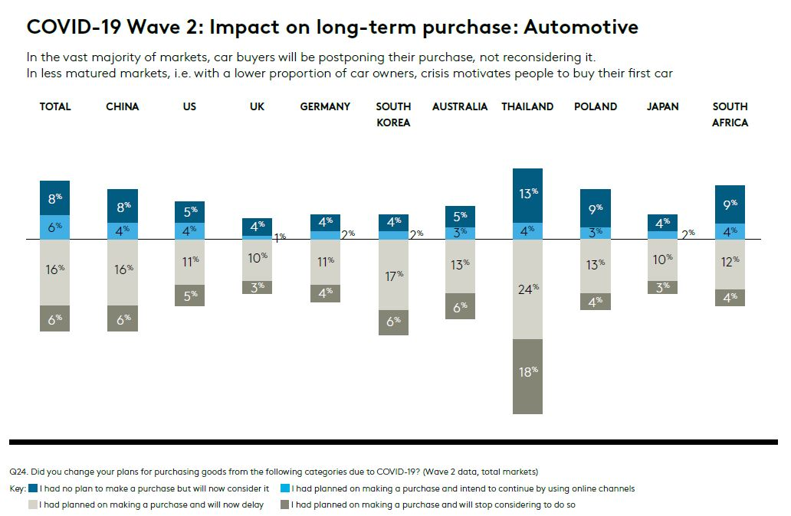
Available at https://www.kantar.com/inspiration/mobility/automotive-mobility-challenges-brought-on-by-covid-19

The major impact on the supply chain brought by the pandemics, was disruption, showing off how vulnerable the industry is, the production was not the only factor who, but also the parts on back order, the prices went bigger.

Due to lockdowns all around the world the companies in the automobile industry were short of parts, and the suppliers were not able to provide the essentials to produce the cars, the supply was short for the big demand. The pandemic has taken a turnaround for most of the companies in new technology and developing the hybrid cars, for a cleaner and not so polluted environment.

Auto suppliers rely heavily on immigrant labour, and their absence is expected to further delay post-lockdown restoration, resulting in a major effect on the assessment chain.

The automobile in on the front line as a result of the outbreak, which has disrupted as normal and thrown the financial situation down. The manufacturing, as the important connections in the supply chain is the most affected. The crisis of workforce, supply chain and finance are the most important issues. Some countries, like Japan, China and South Korea have been drastically affected by the fast spread of the virus. Companies in the main countries like Spain, Italy and France, met severe disruptions, by delaying the production.

The scourge of the COVID-19 beside the resultant financial uncertainty may anticipate decreased client necessities within the term. The intrusion of the car supply chain may capture cash that may well be used to show worker help and capacities.

The Indian car industry had been secure with deals lost in 2019 but 2020 took a turn or more regrettable. The COVID-19 brought lockdowns which damaged buying estimation, causing the decrease. The deficiency of semiconductors affected vehicle generation and expands the holding up period up to six months, a major concern for car developers.

The companies should be more effective in further risks to protect their businesses, taking in account individuals who can observe potential dangers.

Reference List

Conway, G. (2020) ‘Drive to reopen car dealerships’, Available at: https://www.driving.co.uk/news/drive-reopen-car-dealerships/ Accessed on 14th of January 2022

Saint, G. (2020), ‘How can automotive brands handle the impact of COVID-19?’, Kantar Available at: https://www.kantar.com/inspiration/mobility/automotive-mobility-challenges-brought-on-by-covid-19 Accessed on 13th of January 2022

Washington-Reuters, (2020), ‘Nearly 750,000 Mercedes cars recalled in US’, Available at: https://www.hurriyetdailynews.com/nearly-750-000-mercedes-cars-recalled-in-us-150621 Accessed on 13th of January 2022

McGlaun, S. (2021), ‘High demand at Mercedes-Benz means long waits’, Available at: https://www.slashgear.com/high-demand-at-mercedes-benz-means-long-waits-25692458/ Accessed on 13th of January 2022

Mercedes-Benz, ‘Stay safe at home. We’ll come to you’, Available at: https://www.mercedes-benz-mena.com/en/passengercars/covid-19/stay-home-new.module.html Accessed on 14th of January 2022

Miller, J. (2021), ‘BMW and Daimler pledge to keep prices high when chip crisis ends’ Available at: https://www.ft.com/content/f55a1d96-1146-4e17-88a9-1a0fbaf57de6 Accessed on 13th of January 2022

Kitzen, K (2021), ‘COVID-19 & the automotive industry’ Cruising through the pandemic with the check engine light on, Available at: https://storymaps.arcgis.com/stories/610d081f3f92478d8f8ad55f017e0bf7 Accessed on 14th of January 2022

MRL, (2020), ‘How COVID 19 has impacted the automotive industry, Available at: https://www.mrlcg.com/latest-media/how-covid-19-has-impacted-the-automotive-industry-250899/ Accessed on 14th of January 2022

Jones, S. (2020), ‘COVID-19 pandemic accelerates expansion into green vehicle production’, Available at: https://ihsmarkit.com/research-analysis/covid19-pandemic-accelerates-expansion-into-green-vehicle-prod-oct20.html Accessed on 14th of January 2022

Nayak, J., et al. (2021), ‘An impact study of COVID-19 on six different industries: Automobile, energy and power, agriculture, education, travel and tourism, and consumer electronics’ Available at: https://www.ncbi.nlm.nih.gov/pmc/articles/PMC8014102/ Accessed on 14th of January 2022

Buckley, J, (2020) ‘How coronavirus plagued the UK car market in 2020’ Available at: https://www.driving.co.uk/news/features/coronavirus-plagued-uk-car-market-2020/ Accessed on 13th of January 2022

Times Drive Desk, (2021), ‘Semiconductor shortage easing but will persist till mid 2022: Mercedes-Benz India’, Car News, Available at: https://www.timesnownews.com/auto/car-news/article/semiconductor-shortage-easing-but-will-persist-till-mid-2022-mercedes-benz-india/833443 Accessed on 13th of January 2022

