Marketing plan written for

_____________PREMIER INN__________

Student Name

_______________________GHEROGHITA IFRIM___________________________

Student ID number
_________2208455__________

Marketing Essentials BMIH4005

Lecturer

____________LUCIANA SUARDI___________

Introduction

The goal of this marketing plan it is to attract new clients in the current climate that has been set as the result of the pandemic and Brexit. This marketing plan it is therefore prepared for the Premier Inn hotel, a British chain of hotel from the UK. Premier Inn is a British budget hotel chain and the UK's largest hotel brand, with over 800 hotels and over 75,000 rooms across the UK and Ireland.(Ellis,2020)
For this marketing plan there will be utilize different frameworks and analysis such as PESTEL, 4PS, SWOT Analysis.
Situation Analysis

Segmentation: Premier Inn it will break down the market based on their needs:travellers,people that have a busy lifestyle,people that are looking for quality services,business people.(Ellis,2020)
Geographic : UK and all its cities
Demographic: both man and woman, medium-high social income
Psychographic: busy people, interest in travel, to visit, to explore
Behavioural: high loyalty, high interest in travelling.
Differntiatiated targeting: standards rooms as price points, (midscale)
Positioning: how Premier Inn will be perceived in people minds: having positive feelings, being very excicited to stay with Premier Inn because of high quality services.
Subjectivise positioning: tangible dominant: economy brand “Premier Inn has been successful in stressing the ‘quietness’ of their hotel bedrooms, so that a ‘good night’s sleep’ can be guaranteed”.(Dash,2016)
Positioning strategy: against Ibis hotel, or Holiday Inn Express.Have a competitive advantage compared with rivals: strong digital marketing.

Premier Inn

POTER FIVE FORCES:

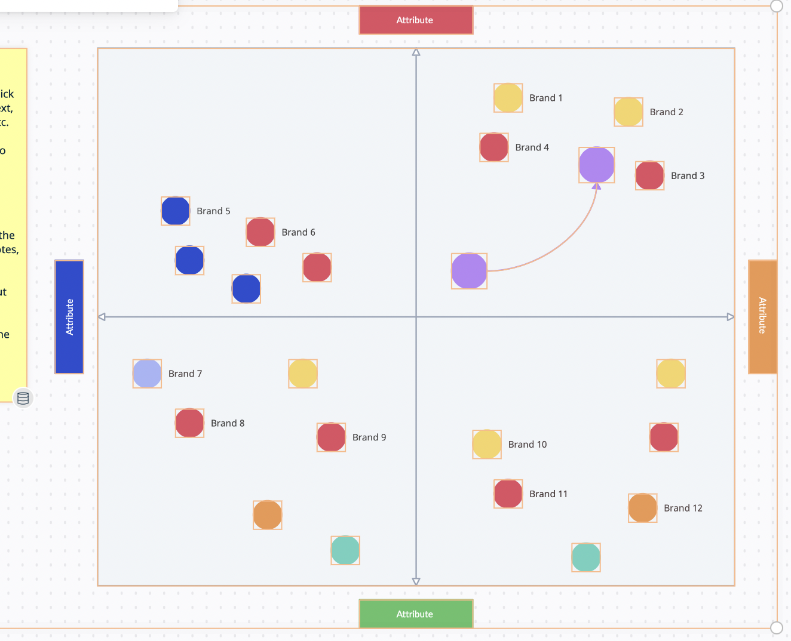
Bargain power of suppliers: LOW
-There are a lot of suppliers in the UK In this area, so hotels can switch very easily.
(Horani,2020)
Premier Inn has a lot of rivals: HIGH
Ibis, Minor Hotel, Fabhotels, Travelodge
The company needs to focus more on growth, differentiating strategies.
Bargaining powers of buyers: high
There are a lot of customers in this are so they can switch very easily from one to another.(Ellis,2020)

Threat of new entrants: low
There are a lot of barriers in terms of high costs,
required a lot of time, a lot of investment,
fixed costs in terms of employment,
and also, it is an intensive marketing
(Gareche et.al 2019)
Substitute goods: medium
Has appear different short time rental ways such as Airbnb
However, hotels are still offering other services rather than this such as: room service, cleaning.(Otley,2021)

-Collaborators:

Premier Inn Hotel intend to form and maintain relationship marketing. This will be done through developing relationships with guests, peers, suppliers, and partners, to maintain their loyalty to the business (Evans, 2004). The hotel endeavour to maintain a high level of communication with these parties to understand their needs and expectations. It also intends have strategic partnerships with specific brands that resonate with ours and get into franchising arrangements with the same (Martijn, 2019). It is important that it differentiate its product offering by building a unique brand that stands for specific values.

Political | Economic | Social | Technological | Legal | Environmental
Employment law | Interest rates | Lifestyle | Internet connectivity | Consumer law | Weather
Environmental law | Exchange rates | Emphasis on safety | Security | Health and Safety Law | Pollution
Health and Safety law | Recession | Social classes | Automation | Employment law | Workplace efficiency
Competition regulation | Inflation | Attitude toward customer service | Wireless charging | Post pandemic restrictions | Environmental related laws

3. PESTEL
Premier Inn Hotel's policies, economy, society, regulations, and environment must be examined to assess its management efficiency. These factors affect decision-making, sales, and service supply (Frue, 2019). Increased migration laws and BREXIT hurt business politically. Travel limitations lower demand.
Due to inflation and weak currency, Premier Inn Hotel is in a recession. The company meets social standards and client preferences (Research, T. and Consultancy 2021).
SOCIAL: The corporation should follow e-commerce, sustainability, and other industry developments. Premier Inn should embrace these trends to attract customers. (Diamond,2015)
The company uses technology to maintain customer databases, engage clients, and run social media ads. Internet marketing is key to its success.
PREMIER INN FOLLOWS NATIONAL AND INTERNATIONAL ENVIRONMENTAL STANDARDS Solar energy and electric automobiles reduce climate change and pollution. (Ellis,2020)

(Ellis,2020)

SMART:
Specific: Intend to leverage on social media platforms to increase digital presence and gain market traction of products and services. This means an ever-growing presence of the brand in the digital space,
Measurable: In the moment, Premier Inn will have a lot of followers on Instagram, Facebook and Twitter and high interaction with its customers.
Attainable:It is possible as it will be utile a marketing channel which is social media marketing: building content that enable clients to share it with other.(Mintz and Currim,2013)
Vital: trusted sources.(Ingram,2007)
Relevance: More and more interactions are becoming virtual. It is imperative upon to use the digital platforms available for maximum benefit if it seeks to be ahead of the curve in the industry.
Time-boundedness: 4 May 2023:

Strategy
Premier Inn promises customers a high-quality stay. "Aims to build client loyalty by gratifying and anticipating their requirements while keeping team members happy (and loyal)." (Ellis,2020)
Premier Inn used Bowmans Strategic Clock to examine differentiation and positioning strategy. We're going hybrid. This means we'll offer moderate pricing in accordance with BAR and modest differentiation (Jefferson, 2021).
This strategy focuses on adding value to the customer experience in the hotel's lounges, rooms, and garden. These include ambiance enhancers that give clients a homey sense. This along with our dedication to CSR will put us ahead of the curve. The extra value will allow us to charge cheaper prices than our competitors in the same segment. (Ellis,2020)
This hybrid strategy will attract clients by offering reasonably priced products and services with product distinction Premier Inn's competitors don't offer (Daily Mirror, 2010). This will convince guests that the hotel delivers good value for the money.

Tactics
PRODUCT: Premier Inn it has in UK, so the destination is the British one. In order to attract its customer, Premier Inn should deliver on online platforms different things that will motivate people to travel to the UK and stay with them. British countries it is offering a lot of locations and traditions that are attracting people from all around the world such as “British iconic landmarks, breath-taking coastal views, world-class restaurants or international music festivals”. (Gareche et al., 2019).
PLACE: Premier Inn will use social media marketing , having a large engagement on Twitter, Facebook and Instagram and of course they will use digital partnerships with different types of influencers from social media.In the past, Premier Inn has relied heavily on its physical presence to draw in customers. In the post-COVID era, Premier Inn should look to expand its digital platform and create an online presence to reach customers. This can involve creating a website, setting up a social media presence, and using search engine optimization (SEO) to maximize visibility (Papagiannis, 2020). Additionally, Premier Inn can expand its reach by partnering with other companies and utilizing its networks. (Tempest,2008)
Price: The pricing strategy is offering the Best Available Rate. This is a hybrid strategy that seeks to position the Premier Inn in the middle to high income range, where the clients pay a reasonably fair price for a unique and differentiated experience. Based on the value to the customer, they will find this very affordable with enhanced value for money. Psychological pricing: will be utilized.
Promotion:
Premier Inn should not use conventional marketing but should focus more on digital one.
Premier Inn seek to promote the products and services offered by the hotel through t digital platforms as well as through franchises and our booking agents.
RACE advertising model includes.(Horani,2020)
Reach: This will basically involve increasing sites visits and brand awareness building. This will be both online and offline.
Act: This will involve interaction with site visitors with the view of persuading them to take the next step and book for a product or service. Here the specific goals and dashboards to help the staff to know exactly what to go for in trying to convince the prospective clients that that the hotel can meet their expectation.(Horani,2020)
Convert: Here the staff gets the audience to become paying customers whether through online Ecommerce platforms or through offline channels. The hotel will provide both payment options for the benefit of the customers (Prideaux, B., 2006).
Engage:Premier Inn seek to develop and maintain a long-term relationship with the clients. Making sure that we communicate to them new product offerings, discounts and any other events and amenities that may be suitable for them based on the preferences and propensities.(Diamond,2015)

Action
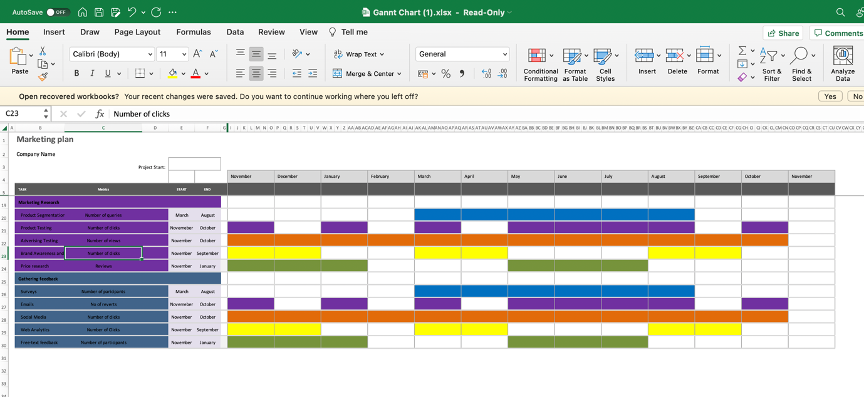
(there is also in the appendix in the format excel)
Number of views has been utilize to measure digital marketing effectiveness as each view and clicks suggests the interest and engagement with the specific digital channel.

Control
Premier Inn unique selling proposition includes a unique ambience that gives a homely feeling and exquisite customer experience that is unrivalled. This will keep our customers coming in, both now and in the future. This will be the emphasis in spending and advertising. The thought is to not only advertise the products and services but rather the experience associated with the visit to the hotel.(Mintz, and Currim,2013)
This USP is the differentiation point of value addition at an affordable price. Such ambience creates a unique environment for social connections, individual downtime and romantic settings for couples.(Horani,2020)

Conclusion

In conclusion, the Premier Inn Hotel business has effective marketing plans to advertise its locations, products, prices, and promotions to the best possible extent. Its establishment and high recognition in the UK for its provision of products and services serve as its major strength. It would be important for the business to maintain its market share by improving its weakness and curbing the possible threats since the unstable political and economic environment can reduce its revenues. The firm is good at marketing to maintain and add value to its products and services and improve customer satisfaction and experience. Its digital marketing is effective and forms a major tool to retain and attract more clients through the highly influencing website and social media.

References

- Dash, G. (2016) Services Marketing Mix. 1st edn. LAP LAMBERT Academic Publishing.
- Diamond, S. (2015) Content Marketing Strategies For Dummies. 1st edn. Wiley.
- Lockyer, T. (2007) The International Hotel Industry. 1st edn. Taylor and Francis.
- Ellis, D. 2020, "Premier Inn", Business traveller Middle East, , pp. 14.
- Otley, T. 2021, "Premier Inn London Southwark (Southwark Station)", Business traveller Middle East, , pp. 62.
- Horani, L.F. 2020, "Identification of target customers for sustainable design", Journal of cleaner production, vol. 274, pp. 123102.
- Ingram, H. (2007) Business of Hotels. 4th edn. Taylor and Francis.
- Gareche, M., Hosseini, S. M., & Taheri, M. (2019). A comprehensive literature review in competitive advantages of businesses. International Journal of Advanced Studies in Humanities and Social Science, 6(4), 312-329.
- Mikalef, P., Boura, M., Lekakos, G., &Krogstie, J. (2019). Big data analytics and firm performance: Findings from a mixed-method approach. Journal of Business Research, 98, 261-276.
- Mintz, O. & Currim, I.S. 2013, "What Drives Managerial Use of Marketing and Financial Metrics and Does Metric Use Affect Performance of Marketing-Mix Activities?", Journal of marketing, vol. 77, no. 2, pp. 17-40.Kogan Page.
- Papagiannis, N. (2020). Effective SEO and content marketing: the ultimate guide for maximizing free web traffic. John Wiley & Sons.
- Tempest, G. (2008). The development and launch of Premier Inn. Hospitality Review, 10(4), 5-11
- Upadhyay, A. et al. (2016) Case Study: Sustainability in the Hotel Industry. 1st edn.
- Yazdanifard, R. (2014) Developing an Internet Marketing Mix Mix. 1st edn. LAP LAMBERT Academic Publishing.

APPENDIX:



