Assignment Title | Assessment of Practical Tasks (Menu Engineering)
Student Name | Muhammed Karim
Student Number | 2208392
Module Code | BMIH4002
Module Title | Food and Beverage Operations
Lecturer Name | Tristan Hawkins, Ffion Cumberpatch, Laurence Blake, Rohan Dubrey
Assignment Wordcount | 233


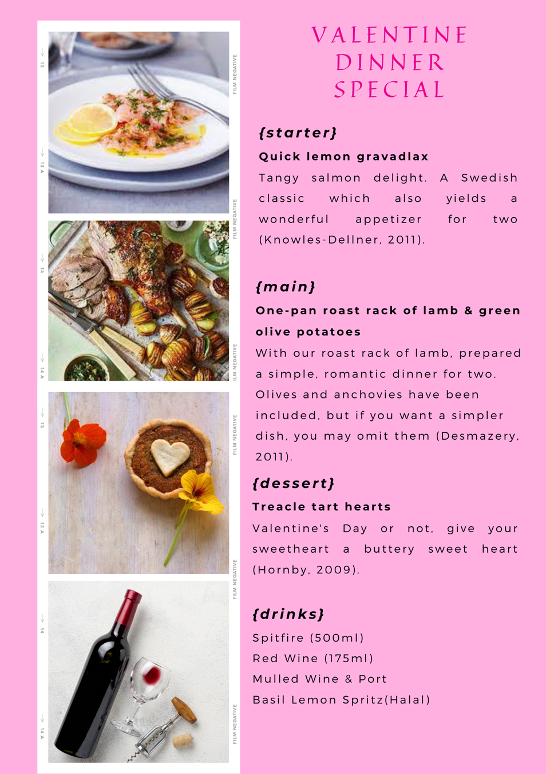
Reference
Hornby, J. (2009) “Treacle tart hearts,” BBC Goodfood. BBC. Available at: https://www.bbcgoodfood.com/recipes/treacle-tart-hearts (Accessed: February 17, 2023).
Knowles-Dellner, S. (2011) “Quick lemon gravadlax,” BBC Goodfood. BBC. Available at: https://www.bbcgoodfood.com/recipes/quick-lemon-gravadlax (Accessed: February 17, 2023).
Desmazery, B. (2011) “One-pan roast rack of lamb & green olive potatoes,” BBC Goodfood. BBC. Available at: https://www.bbcgoodfood.com/recipes/one-pan-roast-rack-of-lamb-green-olive-potatoes (Accessed: February 17, 2023).

