AC1.1
In a tightening labour market, as highlighted in the CIPD Labour Market Outlook (Spring 2025), ParcelCare faces rising competition from both new parcel delivery firms and other sectors such as retail, warehousing, and logistics competing for similar skillsets. The report highlights the ongoing recruitment and retention issues in most sectors, as nearly two-thirds of employers reported hard-to-fill vacancies, especially in lower-paid operational roles. ParcelCare must respond strategically now to differentiate itself and become an employer of choice (CIPD,2025).
To remain competitive in the industry, ParcelCare should conduct a comprehensive analysis of competitors’ salaries, benefits, and working conditions to identify factors that enhance their attractiveness to employees. Key offerings among competitors include same-day pay, retention bonuses, and access to employee discounts or fuel cards. It is essential for ParcelCare to benchmark its salary structure to ensure alignment with industry standards, particularly in light of insights from the Labour Market Outlook, which highlights ongoing salary competition, especially within the operational and logistics sectors (CIPD, 2025).
In contrast, a competitive labour market, salary alone is insufficient. The CIPD Labour Market Outlook (2025) highlights the growing importance of benefits, flexibility, and employee wellbeing. ParcelCare can strengthen its Employee Value Proposition (EVP) by offering guaranteed minimum hours, retention and referral bonuses, enhanced benefits, and career development opportunities. Research by Taylor and Woodhams (2022) underscores that a strong EVP is essential in high-turnover sectors, helping organisations align their offerings with workforce expectations.
To establish itself as an employer of choice, ParcelCare must foster a positive workplace culture and ensure job security (CIPD, 2025). Fair scheduling, predictable earnings, and adequate rest time are essential to supporting employee wellbeing. Additionally, clear career progression pathways, from driver to supervisor or area manager, will strengthen long-term engagement (McCartney, 2017).
Recruitment Initiatives with local communities and job centres can further attract and retain talent. Taylor & Woodhams (2022) highlights that achieving employer-of-choice status requires an integrated approach, balancing reward, development, leadership, and organisational culture which is critical for providing stability and dignity at work, particularly in the logistics sector where gig roles often lack security.
AC1.2
A tight labour market occurs when the demand for workers exceeds supply, leading to low unemployment and recruitment challenges as businesses compete for limited talent. In contrast, a loose labour market arises when labour supply surpasses demand, often during economic downturns or periods of higher unemployment, making it easier for employers to recruit and fill vacancies (ONS, 2025).
A tight labour market occurs when there are more job vacancies than available workers to fill them. This typically occurs when unemployment is low and job vacancies are high, making it difficult for employers to fill roles (Conboye et al., 2022).
Additionally, a loose labour market arises when the supply of labour outpaces demand, often during periods of economic uncertainty or high unemployment. (team, 2025)
In a tight labour market, organisations must compete for limited talent, often leading to increased recruitment costs, wage inflation, and a stronger focus on retention and employer branding (Hr-inform.co.uk, 2024).
For instance, companies may need to offer additional incentives, streamline their hiring processes, or consider flexible and non-traditional working arrangements to attract candidates (CIPD, 2022). Conversely, in a loose labour market, employers have greater access to a broader pool of candidates, enabling them to be more selective, keep recruitment costs lower, and focus on hiring for long-term fit.
As labour market conditions shift due to economic trends, demographic changes, or policy decisions organisations must adapt their resourcing strategies accordingly. A tightening market may prompt rapid recruitment and retention efforts, while a loosening market may provide an opportunity to strengthen internal talent pipelines and improve workforce planning. (UK Parliament, 2022)
To support this strategic agility, ParcelCare should regularly undertake a PESTLE analysis assessing the Political, Economic, Social, Technological, Legal, and Environmental factors that may influence their ability to attract, retain, and deploy staff effectively. (CIPD, 2025) For example, Increasing wage demands, driven by inflation and rising living costs, may result in higher staff turnover or greater pressure to raise pay. At the same time, volatility in fuel and operational expenses could prompt ParcelCare to consider automation or adjust workforce allocation to maintain cost efficiency.
AC2.1
According to CIPD, (2024) workforce planning involves aligning the available talent pool with organisational demands to ensure efficiency and long-term success. It requires assessing the current workforce, forecasting future needs, identifying gaps, and developing strategies to bridge them. The goal is to position the right individuals with the necessary expertise in appropriate roles at the optimal time, under suitable employment conditions, to support an organisation’s objectives.
Effective workforce planning is essential as it enhances operational efficiency, strengthens customer satisfaction, and supports long-term sustainability. Without a strategic approach, the organisation may face challenges such as understaffing during peak delivery periods, excessive staffing during quieter times, or skill shortages in critical areas like logistics, customer service, and route planning (Syedain, 2010).
A well-structured workforce strategy enables ParcelCare to adapt staffing levels to match business demands. By anticipating changes in parcel volumes, particularly during major events like Black Friday, Christmas, and promotional campaigns, the company can hire temporary drivers or reassign the workforce to high-demand regions, maintaining seamless delivery operations. Furthermore, careful workforce management helps minimise labour costs by reducing unnecessary overtime, optimising agency staff usage, and preventing inefficiencies linked to overstaffing and employee turnover (CIPD, 2024).
Beyond immediate operational benefits, effective workforce planning also supports talent management and succession planning. Identifying future skill requirements which allows for upskilling and reskilling, reducing reliance on external hiring (Alberto, 2024).
Moreover, maintaining an appropriately scaled workforce improves employee experience, leading to manageable workloads, reduced burnout, and higher retention rates. Employees also benefit from enhanced development opportunities and clearer career pathways, fostering a motivated and engaged workforce CIPD (2024).
Additional benefits of workforce planning enable ParcelCare to operate more efficiently by matching staffing levels to delivery demands, and to have the right people with the right skills in place at the right time and at the right cost by reducing delays and resource gaps. It enhances customer satisfaction through reliable service and builds agility to respond quickly to market changes or disruptions. By ensuring legal compliance and maintaining a skilled, well-managed workforce, ParcelCare strengthens its competitive position against larger rivals while minimising risk.
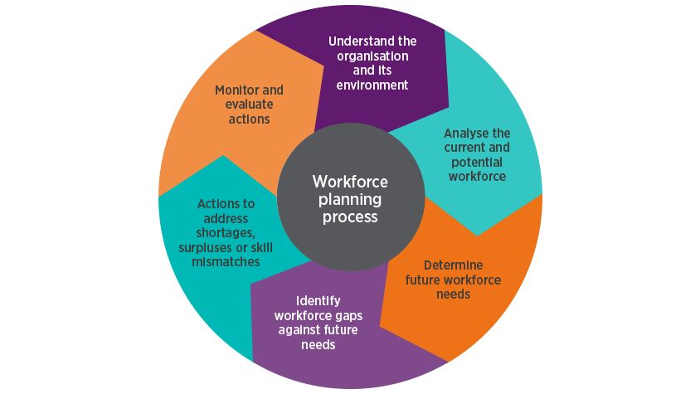
Figure 1

A successful example of workforce planning can be seen in Carmarthenshire County Council’s Waste and Recycling Services. Facing increasing recycling targets set by the Welsh Government and a growing demand for waste collection, the council undertook a comprehensive workforce planning exercise to improve service delivery and staff management. Through data analysis and operational forecasting, the council identified peak collection periods, high-demand routes, and staffing shortfalls. In response, they restructured collection rounds, introduced flexible shift patterns, and created a pool of trained relief staff to cover absences and seasonal pressures. This proactive approach not only ensured compliance with national recycling targets but also improved operational efficiency, reduced missed collections, and enhanced employee morale. (Workforce Planning Toolkit for Managers, 2021)
AC2.2
Workforce planning and data analysis is the structured examination of internal HR metrics, including employee numbers, attrition rates, demographic profiles, and attendance patterns to guide future decision-making. It provides a clear picture of current workforce strengths and anticipated requirements; it serves as a foundation for strategic workforce planning (CIPD, 2025). Hard workforce planning covers numbers and skills, while soft planning focuses on engagement, leadership, and culture together, they ensure the right people fill the right roles.
There are many advantages to workforce data analysis and Taylor and Woodhams (2022) highlights that effective workforce planning is increasingly data-driven, enabling organisations to make informed, strategic decisions that align human capital with business goals. According to the CIPD (2023), workforce data analysis can identify developing challenges like rising turnover or absenteeism, allowing for proactive measures and effective resource allocation. Additionally, the National Audit Office (2022) reported that data-led workforce planning in UK public services allowed more efficient allocation of human resources, reducing unnecessary agency costs and improving service outcomes.
However, there are many disadvantages of workforce data analysis that can also lead to limitations if not managed correctly.
Gallacher, (2023) cautions that numerous organisations continue to face challenges with disjointed or low-quality HR data, which can result in ineffective workforce planning. Taylor and Woodhams (2022) acknowledge that analytical capability is often underdeveloped in HR departments, requiring significant investment in tools and training.
Another technique used to support workforce planning is a skills gap analysis which is a strategic tool in workforce planning that pinpoints the mismatch between the skills employees currently have and those the organisation will require going forward. It provides valuable insights to guide initiatives in training, hiring, internal movement, and planning for future leadership (Indeed, 2024).
A skills gap analysis is an important tool for helping organisations align their workforce capabilities with business needs. It enables leaders, HR teams, and training departments to pinpoint where employees' current skills fall short of future demands. This process offers insight into staff expertise, guiding decisions around role suitability and performance improvement. It also supports learning and development by identifying training priorities and helping employees grow in their careers. (Hayden, 2024)
From a recruitment perspective, it strengthens hiring decisions by revealing skill deficiencies that new talent can fill. Additionally, it lays the groundwork for strategic planning, ensuring the workforce is equipped to adapt to upcoming changes and challenges. (McKinsey & Company, 2021).
Arguably, disadvantages of skills gap analysis include, it can be time-consuming and require skilled HR professionals to undertake the role. Taylor & Woodhams (2022) mentions that “The effectiveness of skills audits largely depends on having accurate competency frameworks and well-defined job roles”.
To conclude, reviewing workforce data and identifying skills gaps allows businesses to pinpoint talent shortages and plan targeted recruitment and training, ensuring the workforce can meet present and future business demands.
AC 2.3
There are many recruitment methods ParcelCare could use to attract new talent, such as “refer a friend” scheme. A "refer a friend" scheme can serve as a powerful tool for both recruitment and marketing when implemented effectively. Its key advantage is the element of trust, individuals are significantly more inclined to engage with a brand or consider a job opportunity when it is recommended by someone they know personally.
According to Rolfe, (2019) individuals who come through referrals often align well with a company's culture. They usually have some insight into the organisation through the person who referred them, and they're more likely to share similar values, work styles, and attitudes. He also suggests, internal recruitment allows organisations to reduce the expenses associated with hiring new employees, particularly when agency fees are typically involved. Even when offering referral bonuses to existing staff, the overall cost is often lower than initiating a full external recruitment process.
In contrast, these schemes may introduce biases and favouritism, potentially bypassing fair and objective hiring processes (Linkedin.com, 2023).
Using recruitment agencies in the UK offers advantages such as specialised expertise, access to a wider talent pool, time savings, and flexible staffing solutions, making them particularly effective for urgent or hard-to-fill roles (Indeed, Career Guide, 2023).
However, their services can be costly, often charging 15–30% of the candidate’s salary, and relying heavily on agencies may limit the development of internal recruitment skills (Recruitment Insight, 2019).
Additionally, agencies can dilute direct employer branding and sometimes lack in-depth organisational insight, potentially affecting candidate fit and experience. Therefore, while recruitment agencies are valuable, organisations should strategically balance their use with strong in-house recruitment capabilities to optimise cost-efficiency and candidate quality (CIPD, 2024).
In terms of selection methods, ParcelCare could benefit from assessment centres. These bring together a range of tasks including group discussions, role-playing scenarios, situational judgement tests, and in-tray activities that mirror real workplace challenges (CIPD, 2023).
For ParcelCare, and their delivery driver roles, these centres are designed to assess how well candidates collaborate, communicate, make decisions, and manage priorities when under pressure. This method offers a broader perspective on a candidate’s potential, going beyond traditional interviews to pinpoint those best equipped to succeed in a dynamic, customer-driven setting. However, assessment centres demand considerable resources such as skilled assessors, various assessment activities, appropriate venues, and a significant time commitment from candidates. This can lead to high costs, particularly for smaller organisations or when hiring large numbers of employees (www.linkedin.com, n.d.).
A further selection method which could be considered for ParcelCare is a work trial. This offers candidates the chance to carry out real job duties or realistic simulations for a brief duration, usually anywhere from a few hours up to a couple of days (CIPD, 2023).
ParcelCare roles, involves specific physical and technical skills, such as safe driving, loading/unloading parcels. A work trial gives employers the chance to observe candidates performing these tasks in real-world scenarios. However, with the proposed Employment Rights Bill, if candidates are unpaid during trials or work beyond legal limits, there could be legal issues around worker rights or employment status for ParcelCare to consider. Clear policies are required to avoid misunderstandings.
(AC 3.1)
Avoidable turnover occurs when an employee leaves a job for reasons that could have been addressed by the employer. Common causes include ineffective management, limited career opportunities, uncompetitive pay, or a negative workplace culture.
Additionally, unavoidable turnover happens due to circumstances outside the employer’s controls, such as retirement, moving away, chronic illness, or family commitments (Armstrong and Taylor, 2021).
Alternatively, according to the CIPD Good work Index 2024, employees are more likely to stay with organisations where they feel appreciated, well-supported, and have opportunities for personal and professional growth. Strong working relationships with colleagues and managers, competitive pay, flexible work arrangements, and a clear sense of purpose all contribute significantly to retention. However, external influences such as the state of the labour market can affect decisions during periods when job openings are limited (a loose labour market), individuals may choose to stay even if they are not fully satisfied in their current roles (CIPD, 2024).
Employee turnover is influenced by a combination of push factors that drive people away from their current job and pull factors that attract them toward a new opportunity.
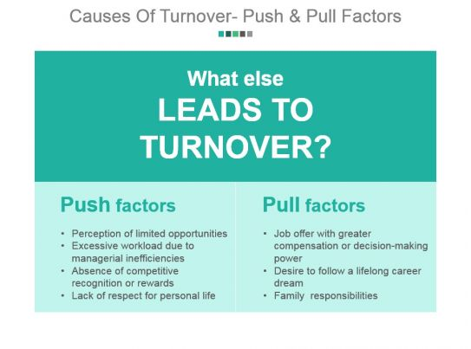

Push factors in the workplace refer to negative issues that drive employees to leave their jobs. These include poor management, limited opportunities for career growth, and a lack of meaningful or engaging work. Employees may also be discouraged by inadequate pay and benefits, a toxic work environment, and poor work-life balance. Additionally, job insecurity such as fear redundancies can prompt individuals to seek more stable and fulfilling employment elsewhere (Allas, 2022).
Pull factors are the positive aspects of alternative job opportunities that attract individuals to leave their current roles. These may include higher pay, better benefits, and clearer prospects for career progression. A supportive and inclusive workplace culture, flexible working options, and greater job security also play a key role. Additionally, roles that offer a shorter commute, better location, or more interesting and meaningful work can be especially appealing to those seeking change (CIPD, 2025).

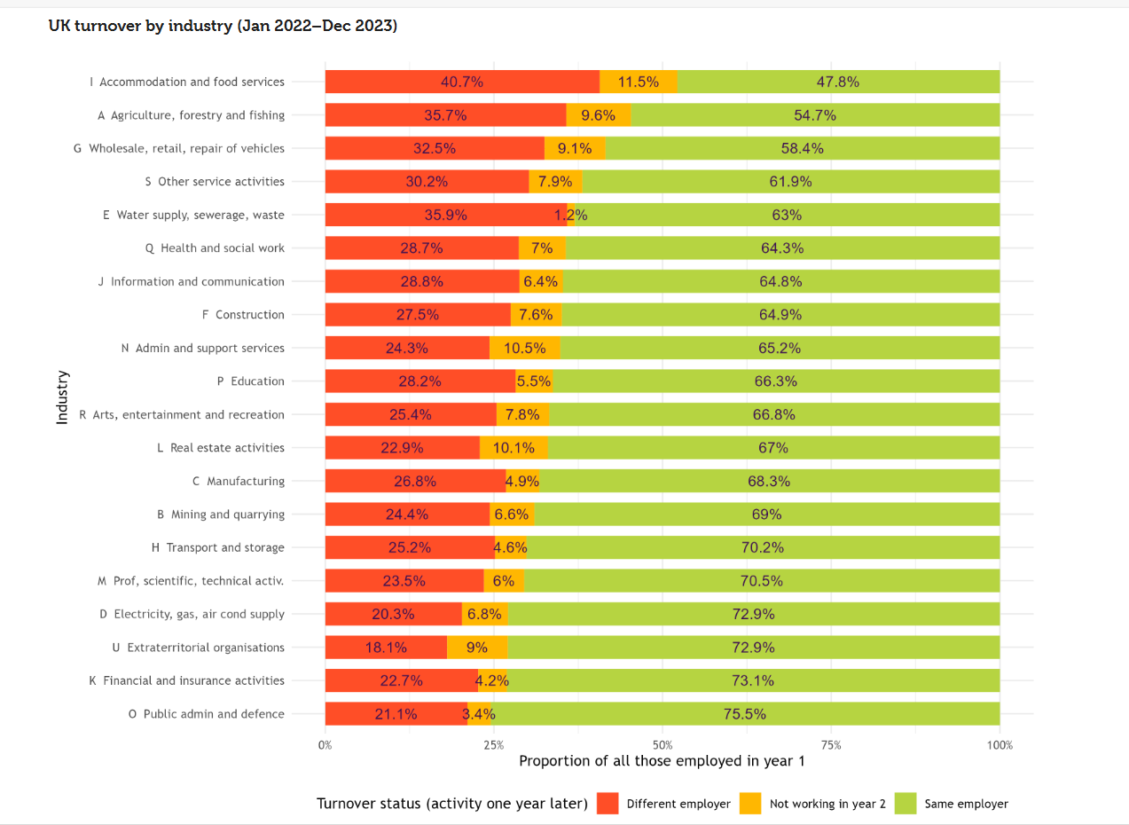

According to CIPD, (2024), as highlighted above, 25.2% of employees moved to a different employer within a year within the transport industry, 4.6% were no longer working in the second year and 70.2% stayed with the same employer.
(AC 3.2)
A Realistic Job Preview is a recruitment and retention tool that provides candidates with a clear and balanced understanding of a job’s responsibilities before they accept an offer. It presents both the positive aspects such as career progression and team support and the more challenging elements like high workloads or unsociable hours. RJPs can be delivered through various formats including job shadowing, videos, workplace tours, or staff testimonials. By setting accurate expectations, RJPs help reduce early staff turnover, improve job satisfaction, and support a stronger match between the employee and the organisational culture(Robson, 2024).
Induction, or onboarding, is a structured process designed to welcome and integrate new employees into an organisation, beginning before or on their first day and continuing through the early stages of employment(ACAS, 2015).
It aims to familiarise new starters with the organisation’s culture, policies, and expectations, while also providing clarity around their role and responsibilities.
Effective induction supports early engagement by helping individuals feel valued, informed, and confident, which in turn reduces the risk of early leavers often caused by uncertainty or lack of support. Key elements include introductions to colleagues, explanation of duties, training, and opportunities for feedback. Overall, a well-managed induction promotes trust, boosts morale, speeds up integration, and plays a crucial role in improving staff retention(Armstrong and Taylor, 2023).
Job enrichment motivates employees by increasing their responsibilities and adding variety to their roles, giving them more control over their work. This taps into their natural desire to perform well and contribute to the organisation’s goals (Indeed Career Guide, 2024).
While pay raises have traditionally been used as motivators, many employers now recognise that feeling valued, challenged, and appreciated can be just as effective and less costly (Valier, 2025).
Job enrichment involves creating meaningful jobs through feedback, support, communication, and autonomy. Managers focus on promoting a positive work environment and work-life balance that encourages intrinsic motivation. The goal is to build a culture of psychological safety where employees feel confident to take on more responsibility and grow professionally (Mindtools, n.d.).
The North Yorkshire Police case study demonstrates job enrichment by using a strengths-based approach and innovative technology to increase autonomy, responsibility, and engagement, resulting in improved staff motivation and retention (CIPD, n.d.).
Reward encompasses both financial and non-financial incentives that organisations use to recognise and motivate employees. It aims to acknowledge contributions through pay, bonuses, benefits, and other rewards linked to performance, skills, or behaviour (CIPD, 2025).
These rewards can include salary increases, recognition, career development opportunities, flexible working, and meaningful work.
Effective reward strategies boost job satisfaction and commitment, reduce turnover by offering competitive packages, encourage high performance, and strengthen employer branding to attract and retain talent (www.forbes.com, n.d.).
In relation to ParcelCare induction is the most effective retention approach overall. It provides new drivers with the essential knowledge, skills, and confidence needed to perform safely and efficiently, reducing early turnover and building long-term engagement. While it requires some time and effort from HR and managers to deliver training and introduce new starters, these costs are relatively predictable and one-off per employee. It can be scaled easily as the company grows without significant increases in cost per employee.
(AC 3.3)
Dysfunctional employee turnover refers to the loss of high-performing or highly skilled employees and when they leave the business it negatively impacts the organisation. Unlike functional turnover, where underperformers leave, dysfunctional turnover can be particularly damaging (Bovers, 2024).
Direct costs associated with dysfunctional turnover can be substantial. Replacing top talent often involves significant recruitment expenses, including advertising, agency fees, and the time invested by internal colleagues. Once a new hire is selected, additional resources are required for training and onboarding to bring them up to the performance level of their predecessor. In the interim, organisations may need to rely on temporary staff via agencies or pay existing employees’ overtime to cover the workload, both of which can be inefficient and costly solutions (Thomas, 2013).
The indirect consequences of losing high-performing employees can be deeply disruptive and costly. When experienced staff leave, they often take with them valuable expertise and institutional knowledge, leading to knowledge gaps and reduced innovation. This could cause a noticeable dip in team productivity, especially if the individual held a pivotal role. Morale among remaining employees may also decline, particularly if the departed colleague was well-respected or seen as a cultural anchor (Team, 2024).
Additionally, the departure of high-performing employees places a significant administrative strain on HR and management teams. Exit procedures such as conducting interviews, completing paperwork, and revoking system access require time and coordination. In addition, managers must redistribute the departing employee’s workload, which can overwhelm remaining staff and increase the risk of burnout (Hall, 2019).
(AC 4.1)
According to Labour Laws UK, In the United Kingdom, a permanent contract represents a stable and ongoing employment arrangement. It is a formal agreement between an employer and an employee that does not specify an end date. This type of contract reflects a mutual commitment to a long-term working relationship, which can only be ended for legitimate reasons.
Permanent contracts offer employees a sense of security and continuity in their roles. They typically include benefits such as paid holidays and entitlement to sick pay. For employers, these contracts help maintain a consistent and reliable workforce, supporting long-term planning and productivity.
Permanent contracts provide several strategic benefits for employers. They support a stable and dependable workforce, which is crucial for maintaining core service delivery. Employees on permanent contracts are often more committed and aligned with the organisation’s long-term vision, which can result in lower turnover and stronger team collaboration. These contracts also promote compliance with UK employment law, ensuring rights such as holiday pay, sick leave, minimum wage, and pension contributions are upheld (Indeed, 2023).
However, there are also drawbacks to consider. Permanent contracts create ongoing financial obligations, including fixed salaries, staff benefits, and employer National Insurance contributions, regardless of business volume. This can reduce operational flexibility, particularly during seasonal peaks or quiet periods when staffing needs change. In addition, managing a permanent workforce demands greater administrative resources, from monitoring performance and managing absences to ensuring up-to-date legal compliance (Lesiuk, 2020).
Using agency drivers offers several advantages, particularly in terms of flexibility and administrative ease. ParcelCare can quickly scale their workforce to meet seasonal demands or cover unexpected absences without the burden of recruitment, payroll, or HR management, as these are handled by the agency. The fixed hourly cost also aids in short-term budget planning, and the arrangement provides a low-risk opportunity to evaluate drivers before offering permanent roles (Indeed, 2024) .
However, there are notable drawbacks. Agency drivers typically come at a higher hourly cost due to agency fees, and their temporary status may lead to lower engagement and inconsistent performance. Their unfamiliarity with company-specific routes and systems can reduce efficiency, and over-reliance on temporary staff may harm the company’s reputation if service quality declines. Additionally, under the Agency Workers Regulations 2010, agency staff are entitled to equal treatment after 12 weeks, which adds further complexity when using agency workers (www.tuc.org.uk, n.d.).
Zero-hours contracts give employers flexible staffing, allowing quick adjustments to meet changing demand especially useful in sectors which have peaks and troughs during busy periods. They help control costs by paying only for hours worked. For workers such as students or carers, this flexibility suits varied schedules. They’re also useful for covering short-notice absences, offering operational agility (Acas, 2024).
Despite their flexibility, zero-hours contracts often cause income instability and make financial planning hard for workers. This can lower engagement and loyalty, especially in customer-facing roles. Employers may struggle with scheduling if workers refuse shifts, risking coverage gaps. Legal and reputational risks also arise, as public concern over precarious work grows and many workers remain unaware of their rights (Webber, 2022).
It’s important for ParcelCare to consider with the upcoming Employment Rights Bill, zero‑hours models may become less viable especially after workers qualify for guaranteed hours and shift notice (GOV.UK, 2024).
(AC 4.2)
According to CIPD, (2025) a well-structured onboarding process plays a vital role in welcoming new employees and helping them integrate smoothly into the organisation. It equips them with the essential knowledge and tools needed to start their role confidently and contribute effectively from the outset.
Effective onboarding delivers far more than just a warm welcome on day one. When engagement begins early during the application or offer stage, it sets a positive tone and builds excitement about joining the team. This proactive approach helps new hires feel recognised and included even before they officially start, laying the groundwork for a strong connection with the organisation from the very beginning (Snowdon, 2025).
Kosinski, (2023) states that an effective onboarding experience helps new employees grasp the organisation’s culture and expectations from the start. By clearly outlining values, behaviours, and goals, it enables new hires to see where they fit within the broader mission. This early alignment suggests smoother integration and boosts confidence as they begin their journey with the company.
The benefits of a positive onboarding process are that it creates a positive and supportive experience for new employees, helping them feel welcomed, valued, and confident in their role from the outset. By connecting employees early to the company’s mission and values, onboarding strengthens a stronger engagement and emotional investment. This early support also leads to higher retention rates, as employees are more likely to stay with an organisation where they feel prepared and included. With clear guidance and timely training, new hires become productive more quickly, which in turn drives better business performance. Finally, a strong onboarding reputation enhances employer branding, making it easier to attract top talent in a competitive job market (Mundey, 2023).
A poor onboarding experience can undo the benefits of even the best recruitment process. It increases turnover risk, lowers engagement, reduces productivity, and can ultimately damage the organisation’s performance and reputation (Lingard, 2018).
In the Work Institute 2019 Retention Report, it's noted that 43 out of every 100 new employees left the organisation within their first 90 days (Snyder and Bottorff, 2023).

