The concept of family and how the notion of how it has evolved and been reconstructed on a macro-scale has been a crucial ideology for those who deal with academia and the research of education. Such investigations have derived from the striking changes that have been adapted in the core media and entertainment industry, thus connotations of a family unit will have been affected depending on the country, census, individual and whether it can be accepted with alacrity (Sharma, 2013). Suggestions have been made as far back as 1969 to whether the word for family should be replaced as it is, erroneous (Laslett, 1969) and individuals have only recently shown erudition on this subject matter – as evident in different instructional books for parents, social workers and educational staff members (Cohen, 2017) - therefore this portfolio will demonstrate all the ways in which a family can be interpreted in modern society – within the realm of cinema and television.
The first image to be used to solidify the abstraction that is family, will be a still from the Greatest Showman (2017). A film which purports to be about the foundations for the beginning of, what is now known in the modern era to be a circus, with P.T Barnum’s life broadcasting throughout every musical number. Nonetheless, that component is overshadowed by the explicit injection of sham families, all the while amplifying the idea that a family is what you choose to make of it. It demonstrates that a family can be accepting of a uniqueness and celebrate every flaw to find strength. Together this team have had their genetics betray them but found a solidarity in each other (The Greatest Showman, 2017).
Image 1: The Greatest Showman Opens in Theatres
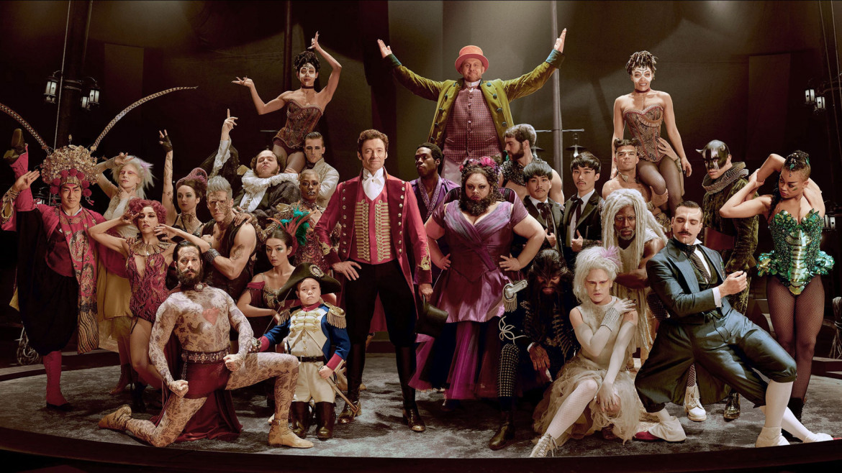

(20th Century Fox, 2017)
This ostracised group help provide exposure for the redefined family units who thrive from the use of material and emotional gain without being confided to nothing more than a living space (Hodgson and Birks, 2002). The use of every single person in the photo having their own individual identity based on the clothes they wear and outward appearance, knowing that they can stand tall, have the upright posture position and almost look as if they are proud of where they belong is because, in this film, it strips back people’s superiority and the leader wants to pursue the idea of everybody being loved and adored. The circus family is more likely to expand if people evince a mixture of pleasure and satisfaction from watching the ‘family’ camaraderie. Aiding this supposition comes the Uses and Gratifications theory. According to Aubrey et al (2012) the consumption of any entertainment that is broadcasted, can provide entertainment, thereby society may interpret this family as a form of escapism and a place to seek self-actualisation. This non-stereotyped family showcases its anachronism hypnosis that transcends to 2018; biological factors should not co-exist with a superior family and as long as individuals are given even the basic of needs, such as: food, shelter, warmth which can enable a course of progression to self-esteem (Ryckman, 2012) then, that should be all that is a necessity to a home. Object Relations Theory ties in with this stance, but it must start from within. It is simplistic in its theoretical framework: It recognises that individuals base their entire lifespan on relationships – externally and internally. People will seek to find sexual partners and spouses who predominantly resemble qualities of their mother or father (Jacobsen et al., 2004). Interweaving this theory – which was firstly, emphatically used by Ronald Fairbairn in 1952 – to families and to the film representing the idea, it maintains that the self is of the upmost importance to one’s existence. Every fantasy coined, desire, dream, however negative or positive, will be shaped from mental representations made from others that betide in one’s actuality (Berzoff, Flanagan and Hertz, 2016). Klein, a British psychologist gave strength to this by the imposing suggestion of how one’s conceptualities themselves being dependant on the strength of their unconscious psyche. If one can see themselves as loved then they shall find an ‘object’ which corresponds to the feelings, if they cannot accept themselves then they are not experiencing libertarianism but rather, determinism because they have left their life to a predestination; finding someone that will endorse the idea that they are undeserving or will treat them as they view themselves (Clarkin, Yeomans and Kernberg, 2007). Therefore, if an individual can accept that a family who happen to perform and live every night on the road, is enough to warrant the term, they must predict people’s behaviours will also allow the same acceptance from an outsider’s point of view.
In society, it is a possibility for this type of contemporary family to be tethered towards the label of exclusion because of the Social Vulnerability Model. In anthropological terms, the ability to be resilient within society means yielding to a ‘strong family unit.’ In context of this family, research studies imply that the family will be unable to withstand and have interest in long viability if they have not got a mother or father figure (Hung, Wang and Yarnal, 2016). Society will exclude them because they do not have the ‘normal’ functions that make a family work P.T Barnum and his sidekick must act as the heads of the family; being nurturing and also providing firm and fair rules in order for the family to run smoothly. Although they act as a substitute, society would still interpret this cautiously and make the illogical deduction that there would be a ‘family’ breakdown. The exposure of an actual absent mother role, or indeed, father role would lead to consequences of poor wellbeing and a valid education and poor relationships (Bandy and Ottoni-Wilhelm, 2012). Some studies argue that because they are basically all homogenous despite electing those family roles, that they will not adhere to implemented commands later in life (Ranci, 2010). They are all equal within their own world and yet society wants there to be a sense of inequality to put forward rules and regulations that they need for guidance and survival.
Furthermore, to advance on the point made above, from reviewing the family in its natural context, it has been counter-argued that the head of the family does not allow an opportunity for autonomy and rather, his motive for portraying such a protective family-oriented image is to psychologically prey on their emotional vulnerability and exploit them for financial gain (Gleiberman, 2018). With the ‘us vs them’ narrative, it is easy to place P.T Barnum as an outcast for not being particularly of wealth however, in the same way a sexual predator would lure somebody in for sexual favours, he uses his oddities to galvanise the audience into joining or supporting. He has no background in disability but due to his tone of voice, his charisma and charm, he is able to seduce the performers into an unconventional lifestyle instead of following traditions and letting society give them omission (Lopez, 2017). While these claims are mostly championed by secondary sources and film reviews, it is worth remembering that we are of a decade that is aware of hypocrisy, political issues and discriminations that still happen in today’s civilisation (Groszhans, 2017) and the fact that an interpretation such as this is highly published just allows active audiences to be self-aware of dangers that are embedded, even within family friendly films. ‘Neglect’ and ‘emotional abuse’ are categorised as culturally relativist terms. It is extremely dependant on individual cases. Action for the Rights of Children (2001) state that western societies support the idea that emotional abuse can happen from ‘complex interplay of three different factors’ and that often a characteristic is somebody who has material deprivation (Critical Issues: Abuse and Exploitation 2001, p.46). This reinforces ideas that even people who prescribe to people’s better interests, do not always seek to provide happiness but rather use the misfortune and turn it into profit and therefore, it might be better to accept the self than to continuously seek for others who will appease the need to accepted in other forms – which also goes back to Object Relations Theory.
Family can be formed in unlikely circumstances and the following BBC television series – broadcast from 2004 through until 2012 – captures the essence of what it means to establish a group that is diverse in their upbringing but that can become a family through mutual interests. This is situational, and this type of family is exponential in the 21st century (Hepp and Hasebrink, 2018). Image 2 is a promotional photo from the long-running series Hustle, and the primary focus is the leader who, shortly after being released from prison, recruits some old friends to form a group in charge of the ‘long con’. The show challenges stereotypes, focuses on the characters backgrounds, especially the new additions who have a blood relationship but also only grew up with themselves for company because they were too afraid of the system. The show glamorises a life of crime whilst balancing their loyalties for each other and guile for the greedy and rich (Hustle, 2004).
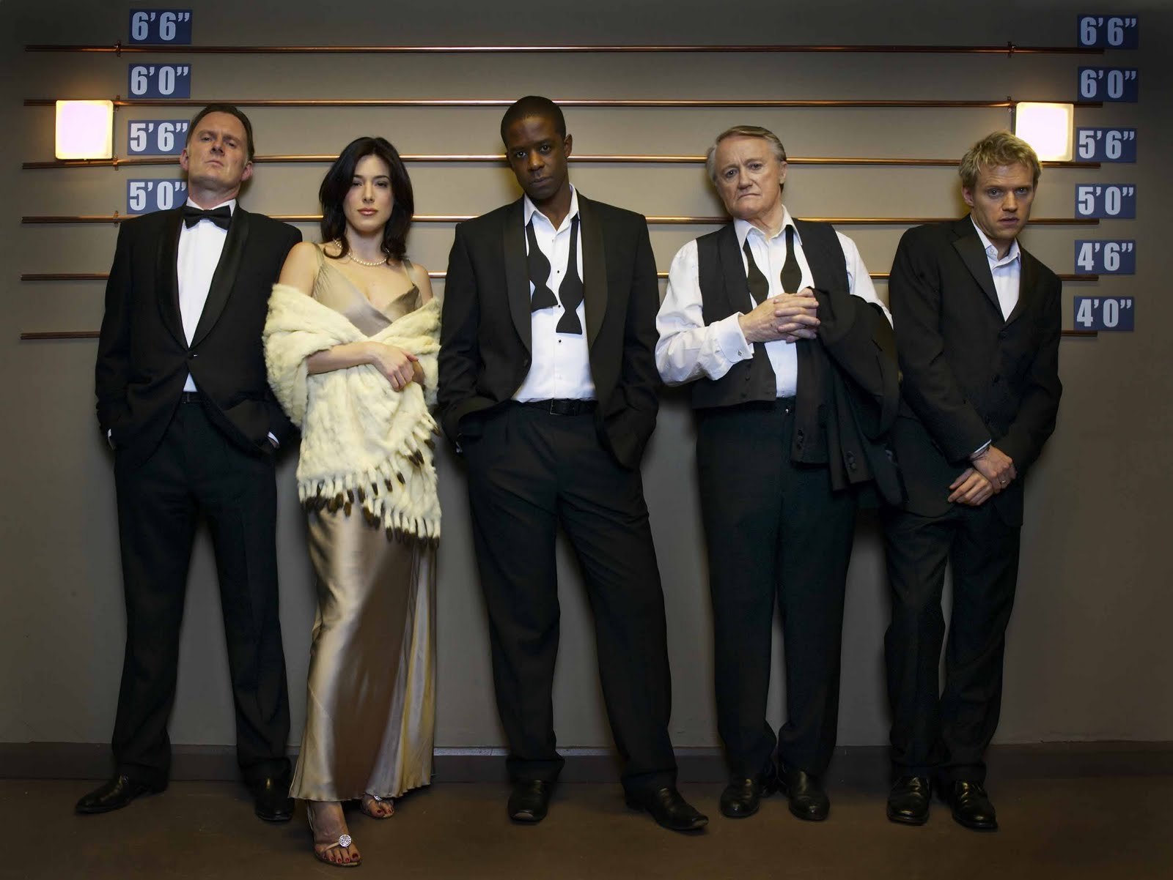
Image 2: BBC Series Hustle Series 2 Promotional Photo
(BBC Pictures, 2005)
In a television series, how society views crime is quite insignificant but in actuality, it is monumental. The simulacrums individuals have on crime and criminals is extremely narrow-minded and often, not correct (Middleton and Levi, 2015). Hustle divulges into the group and their recalcitrant temperaments, but the inference feels stereotypical at times. As image 2 denotes, the group are standing in a police station having their mugshot taken and have probably grown tiresome of being met in the same location; in a time of austerity, society is quick to be judgemental on offenders, almost waiting for them to repeat their inevitable cycle, like Social Expectancy (The UK's Young Reoffenders: Rule Britannia (Part 2/2), 2014). The reasons for a life of crime are equivocal and defining why criminology exists is pragmatic (Case et al., 2017) however, it does pave the way for ‘family’ roots to be connected and usually they have their own moral code to never ‘rat out’ one another to the police (Hustle, 2004). The cogitated reasons as to why a person may behave delinquently relates to non-rudimentary theories of: Sutherland’s Differential Association Theory and Akers’ Social Learning Theory. In 1947, Sutherland promulgated principals that reinforce criminal behaviour as justifiable either through interaction and behaviour or because it is easy to conform to; the latter is because an adolescent would have been pre-exposed to such behaviours in association with others. There will be shared experiences where individuals will rationalise their attitudes and they will create ideal role models where future criminals will then aspire to (Akers, 2017). Akers extended these by suggesting that imitation must happen and not seldomly; the updated premise is not merely reduced to the parents not being able to sanction the disobeyed behaviour (Cole, 2002), but criticism has been made about the empirical validity of the theory. Nevertheless, it measured to be worthy of an additional sociological theory called Strain Theory, coined by Robert Merton in 1938. It places heavy impact on negative relationships in the adolescent years that unleash emotions, namely anger and frustration which eventually turns into cold emotions for ‘goal achievement’. Individuals may challenge the anger they have about the system (which relates to the show), or feel hurt by the isolation they feel, that they turn to gangs or crimes of a certain fashion; like a self-fulfilling prophecy (Agnew, 1992).
Interpretations are made about criminals and their appearance and yet, a criminal does not have a perfect description and is often somebody classified as ordinary, as demonstrated on many criminal listings where people speak of their shock as ‘normal’ citizens transform into the most wanted (Hogue, n.d.). Society is negligent and because of news reports or TV shows such as: Jeremy Kyle, often pigeonhole criminals. When Hustle was first broadcast it was a rarity that the characters broke the fourth wall and revealed their motives for conning and why it was obvious that police would always target them. However, in the current year, the media have introduced a realistic portrayal of criminal activity in the form of ‘The Assassination of Gianni Versace’. There is not a criminal that is not true to form just to be tokenistic, but rather, a demonstration of how society can misconstrue a person to believing somebody would not have the capabilities to commit homicide (FX, 2018). That show reflects on negative relationships with parents and upbringings that tailor to the beginnings of their idiosyncrasies which is reinforced from the theories mentioned prior to this paragraph. There must be a humane trait to begin with, that society forsakes. Furthermore, so that the argument is not convolute, although one more than the other, both these programmes helps subversions of stereotypes to signify that criminal offenses can come in many patterns and society should not always deem criminals as uneducated or disgusting (O’Neal, 2001). The characters from Hustle do not comply with the outward form of a gang or a ‘chav’ which is typically associated with violent or harmful crime (Advice to Parents and Carers on Gangs, 2014). They feed millionaires greed and the desire to be ruthless in gaining omnipotence. They share a ‘family’ bond that is best explained through dichotomies: the bond is created due to a talent for feigning emotions to aid their predatory instincts that only insiders can appreciate the art of and then juxtaposing that to being nurturing towards one another, and the leader, Mickey taking stewardship. They appreciate the poetic justice that they used to be chained confined to only one room, to seven digits in their bank and extravagant destinations to visit – breaking free of their shackles while the ‘victim’ is bankrupt and exploring a mundane life (Frankel, 2012); thus, making them a contemporary family for their love of con artistry.
Subsequently, after embarking upon the unorthodox lifestyle choice, they are part of a group that is enigmatic, therefore putting themselves at risk of exclusion from social conventions, such as: starting their own families or getting married. A state of eudaimonia, providing a child shelter and safety and living on the outskirts of the law are not mutually exclusive (Fardal, 2014). This reason prompts con artists to find deal-breaker marks that can help them retire because they cannot afford to be seen in employment of a normal sense, thus being unable to be independently social away from the ties of other criminals and additionally, start a new life on their own, leading them to be social excluded by their own inner group and live a life in isolation. Regardless of how society judges them, a common factor of a con artists’ personality is that they also judge normal people’s lives as too boring after experiencing thrills such as there’s, this is highly studied again by Frankel (2012).
The final image – image 3 – is from the television movie The Normal Heart, which was an adaption of the screenplay which it shares the title. The protagonist of the film thinks himself an arbiter for the gay community at the time of the AIDS epidemic in the 1980’s. The gay community are depleting in both this film and in the entertainment industry until most recently where focus has shifted from a desegregated view into a normal convention for representation. The film depicts the lack of knowledge about LGBT and whether AIDS was only a gay disease and saw many authorities shy away from giving financial aid or publicising the virus (The Normal Heart, 2014). Hospitals would leave food under the door out of fear of catching the illness if to step inside, they would not hold funerals for anybody who had died from the disease – going as far as having relatives have to pay thousands to get ashes returned as most of the bodies would be left in rubbish bags, which would not happen in a sustainable country today as policies have been introduced to parts of Canada, the United Kingdom and America all have ‘Nine Public Health Goals’ which range from the need for supportive recognition to sexual identities and sexual orientation, crisis hotlines and inclusive services that would operate with the same functions (psychological counselling after surgery and also advanced training to aid staff to effectively support and prevent health and safety threats (Mule et al., 2009). The UK have strategies to stop ‘unhealthy attitudes’ and this is found on their NHS website which includes monitoring and sharing case studies which would further educational knowledge of treatments. (Improving Lesbian Gay Bisexual and Trans (LGBT) equality across the NHS: a paper for the Equality and Diversity Council, 2015)
Image 3: The Normal Heart – Tragic Hospital Scene
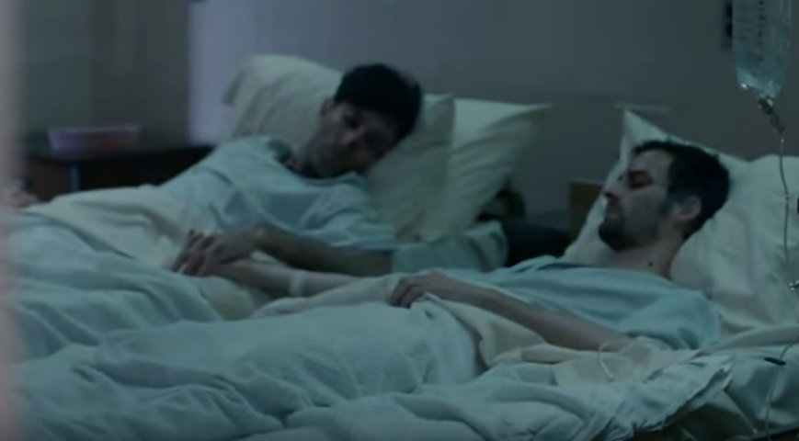

(The Normal Heart, 2014).

Despite moving forward in 1973, where gay identification was removed as a diagnostic mental health issue from the Diagnostic and Statistical Manual (DSM), because arguments were gathered as to whether ‘gay’ in terminology could be counted just because it was an atypical choice (Drescher, 2015) - it is still a marginalised group. There are ongoing prejudices that differentiated orientations are previsions or a sin and, in the context of the movie, choosing to have sex with other males is sealing their own fate to the illness. However, unable to concur with this is Morrison, Kenny and Harrington (2005) who encapsulates that gay men bring upon their own marginalisation as they choose to utilise discrimination and continuously preach about it.
The gay/AIDS community are living in a world of straight people’s ethnocentrism and still find strength to be magnanimous – especially the central character Ned who puts himself into a homosexual paradigm that his heterosexual brother can contemplate. His brother represents families of a certain era who found it easier to help the struggle of homosexual marriage then fight for any basic human rights. When putting a homosexual lifestyle in the context of a heterosexual one, it is easier for straight people to gain clarity because they still have the dominant ideology (Juntunen, 2016).
Moreover, even amongst their own gay community they are prohibited from expressing their own harsh reality. It is not only tackling their parental or sibling acceptance, but acceptance from others in a comparable situation – particularly of a superlative quality. They are shunned because of their disease and other gay people do not feel comfortable expressing the tribulations they are facing from the outsiders. The stigma attached is one of shame. There is research to cement the doctrine that men still have the hegemonic masculinity status: abusive vocabulary and mockery by using ‘pussy’ or the phrase ‘real men do not cry’ and thus, the ill wording becomes detrimental to their health (Reed, 2013). They feel like society would see them unable to conform to usual stereotypes because they could not handle psychical pain and possibly then induce psychical violence (Gonsiorek, 1991). The question marks over the issue of the decline in numbers for check-ups in relation to prostate cancer is because of these conflicts; they are already socially excluded.
Over the course of the portfolio, it is evident that the 21st century still harbours discriminating thoughts and it is something to be witnessed in employment, peer groups, recreational activities and religious sectors. While there have been government improvements to help protect members of society, such as The Equality Act, there are still hurdles that need to be overcome. There is literature growth from all these well-established families; Benefit Street and Love Simon (which is the first film to centre around a homosexual love interest and a best friend of a different ethnicity) prove that cultural construction is now in a state of flux (Goltz, 2010).

Reference List:
20th Century Fox (2017). The Greatest Showman. [image] Available at: https://www.intofilm.org/news-and-views/articles/the-greatest-showman-new-release [Accessed 5 Mar. 2018].
Advice to parents and carers on gangs. (2014). [ebook] Home Office, pp.3-4. Available at: https://www.gov.uk/government/uploads/system/uploads/attachment_data/file/345337/AdviceParentsCarersGangs14.pdf [Accessed 19 Mar. 2018].
Agnew, R. (1992). FOUNDATION FOR A GENERAL STRAIN THEORY OF CRIME AND DELINQUENCY*. Criminology, 30(1), p.49.
Aubrey, J., Olson, L., Fine, M., Hauser, T., Rhea, D., Kaylor, B. and Yang, A. (2012). Investigating Personality and Viewing-Motivation Correlates of Reality Television Exposure. Communication Quarterly, 60(1), pp.81-82.
Bandy, R. and Ottoni-Wilhelm, M. (2012). Family Structure and Income During the Stages of Childhood and Subsequent Prosocial Behavior In Young Adulthood. Journal of Adolescence, 35(4), p.1024.
BBC Pictures (2005). Promotion picture of Hustle: “Eye of the Beholder”. [image] Available at: https://podas.info/tag/portrait/#jp-carousel-1543 [Accessed 18 Mar. 2018].
Berzoff, J., Flanagan, L. and Hertz, P. (2016). Inside Out and Outside In: Psychodynamic Clinical Theory and Psychopathology in Contemporary Multicultural Contexts. 4th ed. London: Rowman & Littlefield, p.124.
Case, S., Johnson, P., Manlow, D., Smith, R. and Williams, K. (2017). Criminology. 1st ed. New York: Oxford University Press, p.538.
Clarkin, J., Yeomans, F. and Kernberg, O. (2007). Psychotherapy for borderline personality. 1st ed. Washington: American Psychiatric Pub, p.300.
Cohen, P. (2017). Families Are Changing — And Staying the Same. Educational Leadership, 75(1), p.47.
Cole, S. ed., (2002). Criminological Theories: Bridging the Past to the Future. California: SAGE Publications, p.138.
Critical Issues: Abuse and Exploitation. (2001). 2nd ed. [ebook] Geneva: UN Refugee Agency, p.46. Available at: http://www.unhcr.org/3bb81aea4.pdf [Accessed 18 Mar. 2018].
Drescher, J. (2015). Out of DSM: Depathologizing Homosexuality. Behavioral Sciences, 5(4), p.565.
Frankel, T. (2012). The Ponzi Scheme Puzzle: A History and Analysis of Con Artists and Victims. 1st ed. New York: Oxford University Press, p.133.
FX (2018). American Crime Story Season 2: The Assassination of Gianni Versace RED BAND Trailer (HD). [video] Available at: https://www.youtube.com/watch?v=Kos2EtBdg_M [Accessed 19 Mar. 2018].
Gleiberman, O. (2018). The Greatest Showman. Variety, (13), p.11.
Goltz, D. (2010). Queer Temporalities in Gay Male Representation. New York: Routledge, p.4.
Gonsiorek, J. ed., (1991). Homosexuality: Research Implications for Public Policy. Newbury Park: SAGE Publications, p.60.
Groszhans, C. (2017). Romantic or Sexual Assault? Ambiguity of Sexual Consent in the Media and How Yes Means Yes Legislation Can Help. University of Louisville School of Law Legal Studies Research Paper Series. Louisville: University of Louisville School of Law, p.6.
Hepp, A. and Hasebrink, U. (2018). Researching Transforming Communications in Times of Deep Mediatization: A Figurational Approac. In: A. Hepp, A. Breiter and U. Hasebrink, ed., Communicative Figurations: Transforming Communications in Times of Deep Mediatization. Cham: Palgrave Macmillan, p.29.
Hodgson, R. & Birks S. (2002). Statistics New Zealand’s definition of family, its implications for the accuracy of data and effectiveness of policy targeting. Student Paper No. 4. Centre for Public Policy Evaluation, Palmerston North.
Hogue, J. (n.d.). 15 "Regular Guys" Who Were In Fact Psycho Serial Killers. [online] TheRichest. Available at: https://www.therichest.com/rich-list/most-shocking/15-regular-guys-who-were-in-fact-psycho-serial-killers/ [Accessed 18 Mar. 2018].
Hung, L., Wang, C. and Yarnal, B. (2016). Vulnerability of families and households to natural hazards: A case study of storm surge flooding in Sarasota County, Florida. Applied Geography, 76, pp.185-186.
Hustle, (2004). [TV programme] 1: BBC.
Improving Lesbian Gay Bisexual and Trans (LGBT) equality across the NHS: a paper for the Equality and Diversity Council. (2015). [ebook] Manchester: NHS, pp.3-4. Available at: https://www.england.nhs.uk/wp-content/uploads/2015/11/edc1-lgbt-equal-pap-20-10-15.pdf [Accessed 20 Mar. 2018].
Jacobsen, V., Fursman, L., Bryant, J., Claridge, M. and Jensen, B. (2004). Theories of the Family and Policy. [ebook] Wellington: New Zealand Treasury, p.35. Available at: http://www.treasury.govt.nz/publications/research-policy/wp/2004/04-02/twp04-02.pdf [Accessed 15 Mar. 2018].
Juntunen, J. (2016). Mainstream AIDS Theatre, the Media, and Gay Civil Rights: Making the Radical Palatable. Abingdon: Taylor and Francis, p.43.
Laslett, P. (1969). Size and Structure of the Household in England Over Three Centuries. Population Studies, 23(2), p.202.
Middleton, D. and Levi, M. (2015). Let Sleeping Lawyers Lie: Organized Crime, Lawyers and the Regulation of Legal Services. British Journal of Criminology, 55(4), p.650.
Morrison, T., Kenny, P. and Harrington, A. (2005). Modern Prejudice Toward Gay Men and Lesbian Women: Assessing the Viability of a Measure of Modern Homonegative Attitudes Within an Irish Context. Genetic, Social, and General Psychology Monographs, 131(3), p.220.
Mule, N., Ross, L., Deeprose, B., Jackson, B., Daley, A., Travers, A. and Moore, D. (2009). Promoting LGBT health and wellbeing through inclusive policy development. International Journal for Equity in Health, 8(1), p.8.
O'Neal, S. (2001). Interviewing Self-Confident Con Artists. FBI Law Enforcement Bulletin, 70(3), p.17.
Ranci, C. (2010). Social Vulnerability in Europe. Basingstoke: Palgrave Macmillan, p.271.
Reed, K. (2013). Beyond Hegemonic Masculinity: The Role of Family Genetic History in Men’s Accounts of Health. Sociology, 47(5), p.908.
Ryckman, R. (2012). Theories of Personality. 10th ed. Wadsworth: Cengage Learning, p.319.
Sharma, R. (2013). The Family and Family Structure Classification Redefined for the Current Times. Journal of Family Medicine and Primary Care, [online] 2(4), p.306. Available at: http://www.jfmpc.com/temp/JFamMedPrimaryCare24306-5763929_160039.pdf [Accessed 12 Mar. 2018].
The Greatest Showman. (2017). [film] Directed by M. Gracey. New York: TSG Entertainment Finance LLC.
The Normal Heart. (2014). [DVD] Directed by R. Murphy. Little Italy, Manhattan: HBO.
The UK's Young Reoffenders: Rule Britannia (Part 2/2). (2014). [video] Directed by M. O'Mara. Abingdon: VICE UK.

Appendix 1: The Greatest Showman Official Trailer
Available at: https://youtu.be/jr9QtXwC9vc
Appendix 2: Hustle Series 2 Promo Trailer
Available at: https://www.youtube.com/watch?v=rAgsA3u0FCk
Appendix 3: The Normal Heart First Trailer
Available at: https://www.youtube.com/watch?v=fZxR9XHS0H8

