University of Wales Trinity Saint David
School of Engineering

Piston, Conrod and Crankshaft Assemblies
M6X00410

Aidan Chapman
P149661
10/02/2020

Contents
1 Contents ii
2 Introduction 1
2.1 Aims 1
3 Methodology and Results 2
3.1 Gudgeon Pin 2
3.2 Conrod 5
3.3 Conrod Bolts 7
3.4 Modified Bolts 11
3.5 Crankshaft Assembly 13
4 Analysis 16
4.1 Gudgeon Pin 16
4.2 Conrod Critical Section A 17
4.3 Conrod Critical Section B 17
4.4 Conrod Critical Section C 18
4.5 Conrod Bolts 19
4.6 Crankshaft Assembly 20
5 Conclusions 22
5.1 Aim 1 22
5.2 Aim 2 22
6 References 23
7 Appendix 24
7.1 Appendix 1 – Net Forces 6000rpm 24
7.2 Appendix 2 – Q1 full Results 25
7.3 Appendix 3 – Q2 full Results 26
7.4 Appendix 4 – Q3 full Results 27
7.5 Appendix 5 – Q4 full Results 30

Figure 3-1: critical rod sections measured 5
3-2: Peterson's Stress Concentrations (Prieto, 2018) 6
3-3: SolidWorks Drawing of M8 Thread 9
3-4: Stress Concentrations in a Notched Bar (Link, et al., 2006) 10
3-5: Modified Bolt Design 13
3-6: Crankshaft Cross Sections 14
3-7: Crankshaft stresses, ranges, and FSF 15
4-1: Goodman Diagram - Gudgeon Pin 16
4-2: FSF of Gudgeon Pin 16
4-3: Goodman Diagram - Conrod A 17
4-4: Goodman Diagram: Conrod B 17
4-5: FSF of Conrod point A & B 18
4-6: Goodman Diagram - Conrod C 18
4-7: FSF at points A, B & C 19
4-8: Goodman Diagram- Conrod Bolts 19
4-9: FSF of Bolts 20
Figure 4-10: Goodman Diagram – Crankshaft 20
Figure 4-11: FSF at Crankshaft 21

Table 1: Maximum Forces experienced by Gudgeon Pin (6000rpm) 3
Table 2: Gudgeon Pin Moments (6000rpm) 3
Table 3: Combined Min and Max Stress (6000rpm) 4
Table 4: Fatigues Safety Factors of all RPM ranges 4
Table 5: Conrod Critical Masses 5
Table 6: Minimum and Maximum Stresses (6000rpm) 6
Table 7:Fatigue Safety Factors of Conrod (6000rpm) 6
Table 8:Table of Young's Modulus and Stiffness Ratio 7
Table 9: Table of Length and Stiffnesses 7
Table 10: Table of Bolt inertia, forces, stretch and Load (6000rpm) 8
Table 11:Table of Frictions and Resistive Torques (6000rpm) 8
Table 12: Stress Concentration Factor at 6000rpm 10
Table 13: Stress Ranges, Means, limits and Safety Factors (6000rpm) 10
Table 14: Modified Bolt Stiffness 11
Table 15: Modified and Standard Bolt FSF 11
Table 16: Crank Measurements 14
Table 17: Moments around point A and B 15

Introduction
This Report will review the forces, moments and stresses acting through and around the conrod, Gudgeon pin and crankshaft assembly on a ford sigma 1.6 GDI engine. A mixture of recorded data and live measurements will be utilised to perform a stress analysis on the required parts, to determine the associated stress concentrations and fatigue safety factors. From this, new bolts will then be designed to withstand the forces generated by an ‘uprated’ engine design, running at higher rpm’s than the current engine, and comments will be drawn on the practicality of such a design.

Aims
To investigate the stresses acting through the conrod, Gudgeon pin, Bolts and Crankshaft and determine relevant and realistic safety factors associated with said parts.
To analyse how the modification of the stock bolt can affect the performance of such a part, and comment on its practicality within the real world.

Methodology and Results
Prior to calculations, all necessary measurements were gained by measuring the respective areas with a Vernier calliper and measuring any respective weights, either by hand or through SolidWorks.
Prior to the analysis of the aforementioned parts, the angular acceleration of the engine assembly must be calculated using the first and second order, using the equation:
$$α=Rω^{2}\cos{θ}+\frac{R}{L}Rω^{2}\cos{2θ}$$
(3-1)
Where R is the crank radius, L is the conrod length, and ω is the angular velocity.

Gudgeon Pin
Using equation (3.1) The inertia experienced on the exposed section of the Gudgeon Pin can be found:
$$F_{inetria-pin}=Mα$$
(3-2)
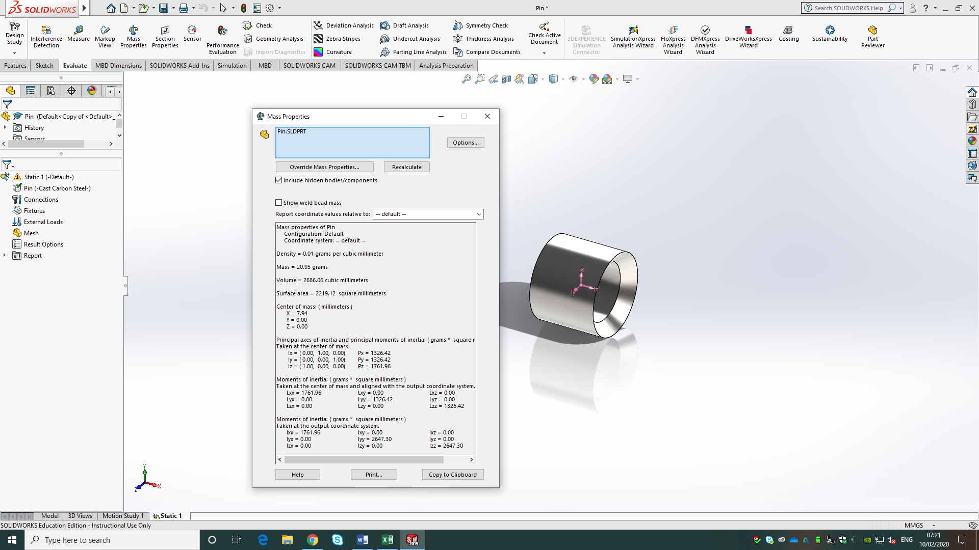

Where M is the mass of the ‘exposed’ section of the pin, found through SolidWorks, and defined as the section free from the conrod (appendix 8.1). From the Inertia and Gas forces, the Net force can be calculated across the entire cycle:
$$F_{net-pin}= F_{inertia-pin}-F_{gas}$$
(3-3)
Where any Positive Net forces are considered Compressive, and negative forces are considered Tensile. From taking the maximum Net value from the cycle, the max net Tensile force was found, this value was divided by 2, as only the RHS was being evaluated. Then, the maximum Compressive force was found from the Inertia column.
Table 1: Maximum Forces experienced by Gudgeon Pin (6000rpm)
Max Net Tensile Force | 23230.43641 | N
Max Net Compressive Force | -438.86 | N

Using the Maximum values above, the Bending moments around point A can be found:
$$M_{A-Tensile}= F_{Net-Tens}*L_{1}$$
(3-4)
$$M_{A-Compressive}= F_{Inetria-pin}*L_{3}$$
(3-5)
Where L₁ is the length from point A to the central point of the downward Force, measure to be 13.875mm; And L₃ is the length to the centre of Mass of the exposed section, which was found through solid works to be 7.94mm. (appendix 8.1)
Table 2: Gudgeon Pin Moments (6000rpm)
Moment A Tens | 322322.31 | Nmm
Moment A Comp | -3484.55 | Nmm

From the results, The Maximum normal and sheer stresses were calculated under each load scenario:
$$σ=\frac{M{*L}_{2}}{I}$$
(3-6)
$$τ=\frac{F}{Cross Sectional Area}$$
(3-7)
Where L₂ is the distance from point A to the midplane, which in this case is the outer diameter, and I is the Second Moment of Area, calculated using:
$$I=\frac{π\left(D_{1}^{4}-D_{2}^{4}\right)}{64}$$
(3-8)
Where D₁ is the outer Diameter, and D₂ is the inner. The Combined Von Misses Stress can then be calculated using:
$$σ_{combined}= \sqrt{σ^{2}+{\left(2τ\right)}^{2}}$$
(3-9)
Table 3: Combined Min and Max Stress (6000rpm)
Combined Stress Max | 579.77 | N/mm²
Combined Stress Min | 7.73 | N/mm²

From the Combined Stresses, The Mean Stresses and Range can be calculated:
$$σ_{Mean}= \frac{σ_{Max}+σ_{min}}{2}$$
(3-10)
$$σ_{Range}=σ_{max}-σ_{min}$$
(3-11)
Using the UTS of 1110, (ASM, 2020), and the Endurance Limit (taken as 0.45*UTS) of the material, the allowable range of stress can be calculated:
$$A.R=2*E.L*(1-\frac{σ_{mean}}{UTS})$$
(3-12)
The Fatigue Safety Factor is then calculated from:
$$F.S.F= \frac{A.R}{σ_{Range}}$$
(3-13)

Table 4: Fatigues Safety Factors of all RPM ranges
RPM | FSF
6000 | 1.28
5700 | 1.29
5500 | 1.33
5000 | 1.44
4500 | 1.51
4000 | 1.49
3500 | 1.54
3000 | 1.60
2500 | 1.69
2000 | 1.81
1700 | 2.03
1500 | 2.38
1000 | 3.11

Conrod
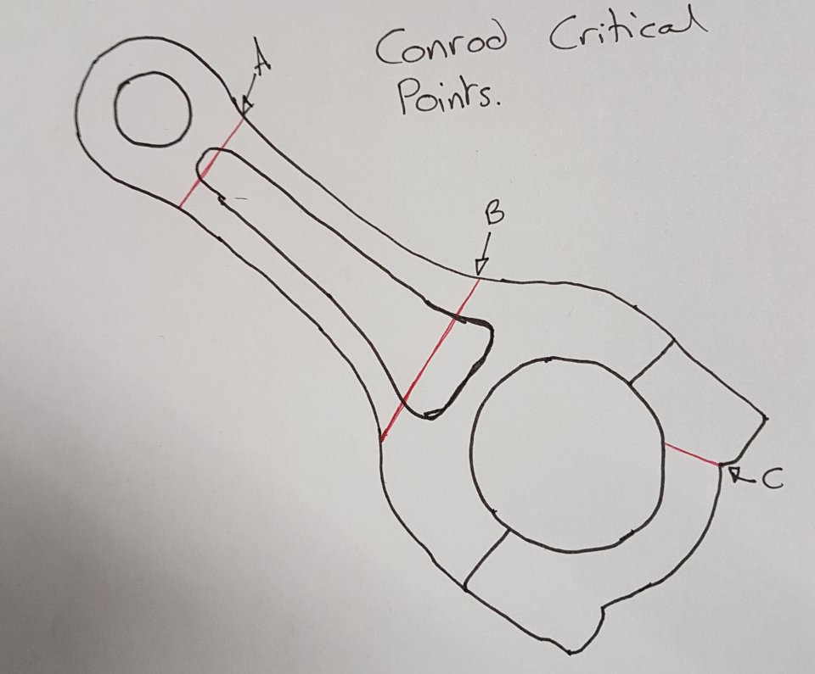
Figure 3-1: critical rod sections measured
Firstly, The Mass was calculated for the 3 critical Rod sections outlined, using the equations:
$$M_{A}= M_{rec}+\frac{M_{rod}}{20}$$
(3-14)
$$M_{B}= M_{rec}+{\frac{1}{3}M}_{Rod}+M_{Pin}$$
(3-15)
$$M_{C}={\frac{2}{3}M}_{rod }-M_{cap}$$
(3-16)
The addition of 1/20th of the conrod in Mass A, allows for the weight of the area from which the measurements were taken.
Table 5: Conrod Critical Masses
Mass_{A} | 0.364 | Kg
Mass_{B} | 0.520 | Kg
Mass_{C} | 0.250 | Kg

The Inertia forces for A and B can then be calculated for each section using the acceleration from (3-1), along with the respective masses; The inertia at C was calculated using:
$$F_{Inertia C}= M_{rec}*Rω^{2}\left(1-\frac{R}{L}\right)+M_{C}*Rω^{2}$$
(3-17)
The Net forces were then calculated using (3-3).
Then, from finding the Max Compressive and Tensile forces, the stresses can be calculated using the equations, noting that Point C doesn’t experience any compressive stresses:
$$σ=\frac{F_{{Max}/{Min}}}{Cross Sectional Area}$$
(3-18)
Table 6: Minimum and Maximum Stresses (6000rpm)
6000rpm | σ Max (N/mm²) | σ Min (N/mm²)
Point A | 15.49 | -98.22
Point B | 42.45 | -164.07
Point C | 78.88 | N/A

From This point, utilising equations (3-10) to (3-12) can be used to find the Fatigue Safety Factors at each point, with the exception of Point C, which utilises a stress concentration factor that reduces its endurance limit.
Firstly, the ratio between the thickest and thinnest sections is calculated, to find which curve to use, which was found to be 1.5. From here, the ratio between the radius of the fillet and the thickness of the thinnest part is calculated to find the x-axis value, which was found to be 0.25.
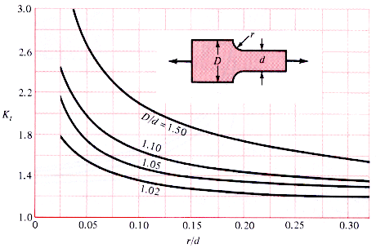
3-2: Peterson's Stress Concentrations (Prieto, 2018)
From assigning these values to the graph above, the Peterson’s stress concentration factor Kt is found to be 1.65. Using this, the Endurance limit at point C can be found:
$$Final E.L= \frac{E.L}{Kt}$$
(3-19)
Utilising the Final Endurance Limit at point C, the allowable range and FSF can be found. The stress concentrations at point A and B were considered to be negatable, due to the value gained from r/D resulting in large numbers that didn’t fit within the stress range. As the graph doesn’t continue up to these points, it is unknown how Kt is affected, or if utilised at all.
Table 7:Fatigue Safety Factors of Conrod (6000rpm)
6000rpm | FSF
Point A | 5.49
Point B | 2.82
Point C | 4.91

Conrod Bolts
Firstly, the Bolt area was calculated using the average thickness of the bolt, taken as 7.5mm. The Rod Cap area was calculated, ensuring the area of the bolt hole was negated from this. Taking the values of Ecap as 170N/mm² and Ebolt as 210N/mm², the stiffness ratio can be calculated:
$$ST.R=\frac{E_{cap}A_{cap}}{E_{bolt}A_{bolt}}$$
(3-20)
Table 8:Table of Young's Modulus and Stiffness Ratio
E cap | 190000 | N/mm²
E bolt | 210000 | N/mm²
Stiffness ratio | 2.797153743
Finding the length of the threaded bolt section to be 37.5mm, and thus the length ‘L’ to the 2nd engaged thread was measured to be 25.5mm. With these values, the stiffness of the cap and bolt can be found:
$$K_{n}= \frac{E_{n}*A_{n}}{L}$$
(3-21)
Table 9: Table of Length and Stiffnesses
Length to 2nd thread | 25.5 | mm
Kb | 363824.1492 | N/mm
Kc | 1017672.08 | N/mm
Using the Inertia calculated at point C, by use of equation (3-17), and the gas force generated at TDC exhaust, the net force can be calculated to give the highest Net Tensile Force. From this, the extra force experienced by the bolt can be calculated by means of 3 equations:
$$F=\frac{1}{(1+\left(\frac{K_{cap}}{K_{Bolt}}\right)}*\frac{F_{Net}}{2}$$
(3-22)
$$F= \frac{0.5F_{Net}}{1+(\frac{E_{cap}A_{cap}}{E_{bolt}A_{Bolt}})}$$
(3-23)
$$F= K_{b}*x$$
(3-24)
Where x is the stretch, defined by:
$$x= \frac{{F_{Net}}/2}{K_{b}+K_{c}}$$
(3-25)
By utilising the answer form these equations, the maximum alternating Load can be found:
$$Alt.Load=\frac{F}{K_{b}}$$
(3-26)
Table 10: Table of Bolt inertia, forces, stretch and Load (6000rpm)
Inertia Force bolt | 14882.969 | Kg/m²
Gas Force | 1330.068138 | N
Net Force | 13552.90087 | N
Extra Force Eq1 | 1784.613132 | N
Extra Force Eq 2 | 1784.613132 | N
Extra Force Eq3 | 1784.613132 | N
Stretch (x) | 0.004905153 | m
Alternating Load | 40.39537798 | N/mm²
Taking the bolt UTS to be of 1100N/mm², the effect of tightening to 90% yield lowers this to 990N/mm². Taking Axial Stress to be 60% of this (594N/mm²), clamping force and Nominal Stress at thread root can be calculated using:
$$F_{Clamp}=σ_{axial}*A_{bolt}$$
(3-27)
$$σ_{Nominal}= \frac{F_{Bolt}}{Minimum Area}$$
(3-28)
The frictional forces can then be calculated, using a μ-Head of 0.12, and a μ-Thread of 0.18, using:
$${Fr}_{Head}= F_{Clamp}*μ_{head}$$
(3-29)
$${Fr}_{Thread}=F_{Clamp}*μ_{Thread}$$
(3-30)
From there, the resistive torques can be calculated using:
$$T_{Head}= \frac{Av. Seating Force Diameter}{2}*{Fr}_{Head}$$
(3-31)
$$T_{Thread}=\frac{Av. Thread Diameter}{2}*{Fr}_{Thread}$$
(3-32)
$$T_{Total}= T_{Head}+T_{Thread}$$
(3-33)
Table 11:Table of Frictions and Resistive Torques (6000rpm)
Bolt UTS | 1100 | N/mm²
90% yield | 990 | N/mm²
60% axial | 594 | N/mm²
Nominal Stress | 23.18612256 | N/mm²
Clamping Force | 26.24211613 | N
μ head | 0.12
μ thread | 0.18
F head | 3.149053936 | N
F thread | 4.723580904 | N
Res.T head | 16.53253316 | Nmm
Res.T thread | 17.71342839 | Nmm
Required Torque | 34.24596156 | Nmm

The minimum stress is calculated as 90% of the yield stress, taken as 990. Therefore, the minimum stress was found to be 891N/mm². The maximum stress can be found by:

$$σ_{max}= σ_{min }+σ_{Nominal}$$
(3-34)

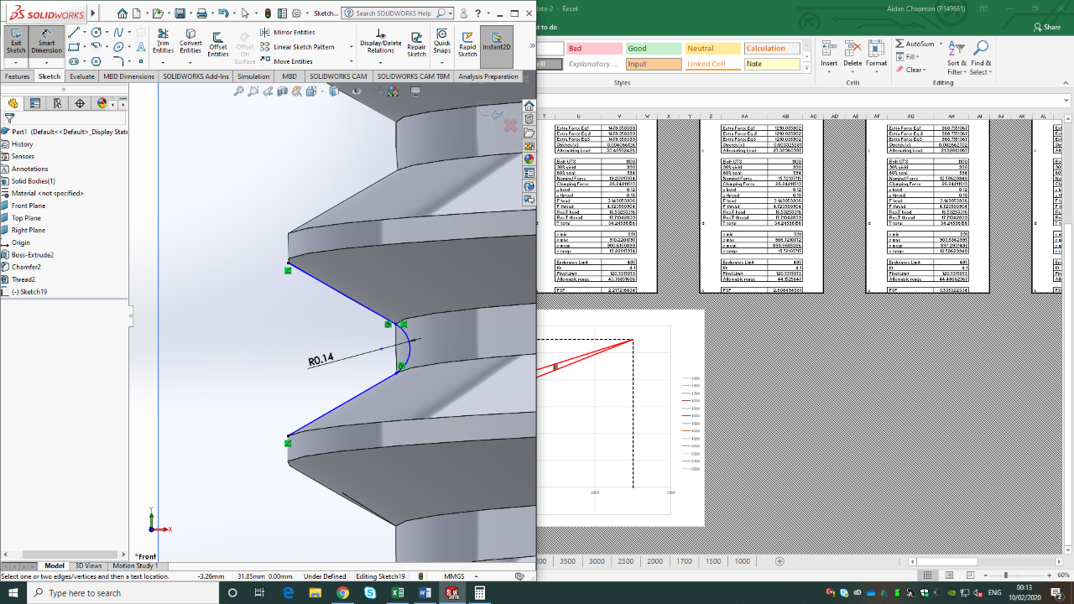
3-3: SolidWorks Drawing of M8 Thread
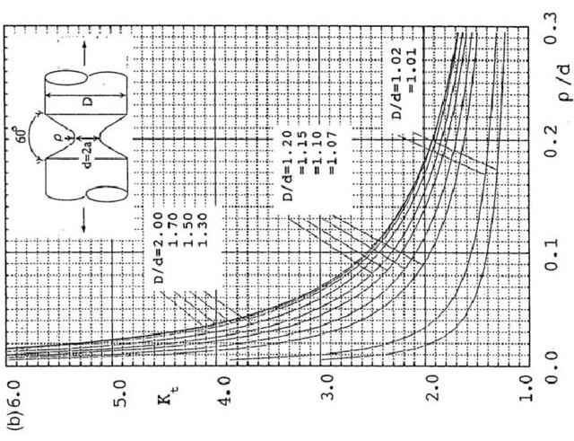
3-4: Stress Concentrations in a Notched Bar (Link, et al., 2006)

Table 12: Stress Concentration Factor at 6000rpm
D/d | 1.14
r/d | 0.02
Kt | 4.1
Equations (3-10) and (3-11) can be used to calculate the mean and range stresses, whilst (3-19) can be used to calculate the Final Endurance Limit, calculated above after using SolidWorks to design the M8 x 1mm bolt thread, the inner radius of the thread was found.
The F.E.L allows the use of equation (3-12) to gain an allowable range, with (3-13) gaining the Fatigue Safety Factor.
Table 13: Stress Ranges, Means, limits and Safety Factors (6000rpm)
σ min | 891 | N/mm²
σ max | 914.1861226 | N/mm²
σ mean | 902.5930613 | N/mm²
σ range | 23.18612256 | N/mm²
Endurance Limit | 495 | N/mm²
Kt | 4.1
Final Limit | 120.7317073 | N/mm²
Allowable range | 43.33323045 | N/mm²
FSF | 1.868929586

Modified Bolts
With the Standard Bolt, the engine was unable to be taken to the modified rpm band of 9000, as the safety factor dropped to 0.7. Therefore, the bolt had to be redesigned to accommodate for the increased performance.
Firstly, the bolt material was changed to 8640 Chrome Moly Steel, which has a UTS of 1370Mpa (Headlee, 2020), and a Young’s Modulus of 190Mpa (AZoM, 2012). These properties would allow the bolt to stretch slightly more, but also reduce the stiffness.
Then the Bolt design was altered to accommodate a thinned shank. The Diameter of the shank was reduced down to 5mm, which generated a stiffness reduction of more than ½ over the original threaded section. As the Total combined stiffness of the bolt calculates to be lower than any singular section, the stiffness was further reduced to 165000N/mm². A 3mm section at the head of the bolt containing a diameter of 8mm to sit flush with the mating face is also included, to allow the bolt to remain straight and prevent a potential bending moment from being created.
The stiffnesses were calculated along each individual section of bolt, then combined in the equation:
$$\frac{1}{K_{B}}=\frac{1}{K_{1}}+\frac{1}{K_{2}}+\frac{1}{K_{3}}$$
(3-35)

Table 14: Modified Bolt Stiffness
Kb1 | 4196971.4 | N/mm
Kb2 | 181982.5 | N/mm
Kb3 | 3183480.6 | N/mm
Kb av | 165359.7 | N/mm
Kc | 1017672.1 | N/mm
From here, the same equations utilised beforehand were used to calculate through to the new safety factor of the modified bolt. Once initially calculated, lengths of each section were modified until the safety factor closely matched the standard bolt at 6000rpm.
Table 15: Modified and Standard Bolt FSF
 | 9000RPM | 6000RPM
Inertia Force bolt | 33486.68026 | 14882.969 | Kg/m²
Gas Force | 1662.585172 | 1330.068138 | N
Net Force | 31824.09509 | 13552.90087 | N
Extra Force Eq1 | 2224.125783 | 1784.613132 | N
Extra Force Eq 2 | 3888.963394 | 1784.613132 | N
Extra Force Eq3 | 2224.125783 | 1784.613132 | N
Stretch (x) | 0.013450228 | 0.004905153 | mm
Alternating Load | 50.34390932 | 40.39537798 | N/mm²
Bolt UTS | 1370 | 1100 | N/mm²
90% yield | 1233 | 990 | N/mm²
60% axial | 739.8 | 594 | N/mm²
Nominal Stress | 28.89637652 | 23.18612256 | N/mm²
Clamping Force | 32.68336282 | 26.24211613 | N
μ head | 0.12 | 0.12
μ thread | 0.18 | 0.18
F head | 3.922003539 | 3.149053936 | N
F thread | 5.883005308 | 4.723580904 | N
Res.T head | 20.59051858 | 16.53253316 | Nmm
Res.T thread | 22.0612699 | 17.71342839 | Nmm
T total | 42.65178848 | 34.24596156 | Nmm
σ min | 1109.7 | 891 | N/mm²
σ max | 1138.596377 | 914.1861226 | N/mm²
σ mean | 1124.148188 | 902.5930613 | N/mm²
σ range | 28.89637652 | 23.18612256 | N/mm²
Endurance Limit | 616.5 | 495 | N/mm²
Kt | 4.1 | 4.1
Final Limit | 150.3658537 | 120.7317073 | N/mm²
Allowable range | 53.96747087 | 43.33323045 | N/mm²
FSF | 1.867620697 | 1.868929586

The use of higher Torque ARP bolts is a more than acceptable and practical way of achieving the relative safety factors necessary within the engine. However, due to the increase of static tension, the conrod big-end tunnel will need to be re-bored as the increased force would distort the tunnel shape. This method would remove Mass from the critical sections of the conrod, and would in turn change Inertia forces relevant to the design of the bolts, and would require re-balancing. Therefore, this balancing of time and resources would be more suited towards mid-high tier racing teams with the available R&D divisions capable of handling such work. For lower level teams, this workload could prove to be too costly or time consuming, and could be better spent on other design areas.
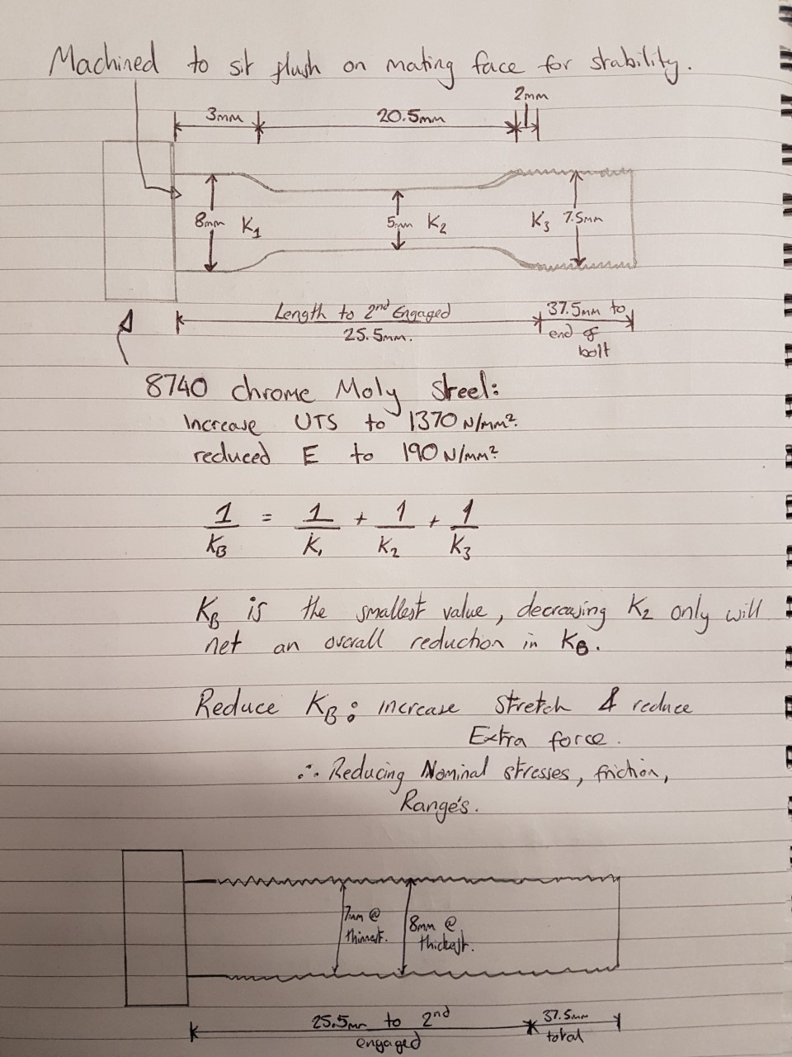
3-5: Modified Bolt Design

Crankshaft Assembly
Firstly, crank measurements were taken at the critical section:
Table 16: Crank Measurements
crank D | 47.6 | Mm
Crank L | 22.94 | Mm
Crank d | 43.14 | Mm
effective width (B) | 45.37 | Mm
Length AB | 22.7 | Mm

Where D is the Crank Journal diameter, L is the length of the Journal, d is the crank pin, the effective width is the mean diameter, and the length AB is the weak section.
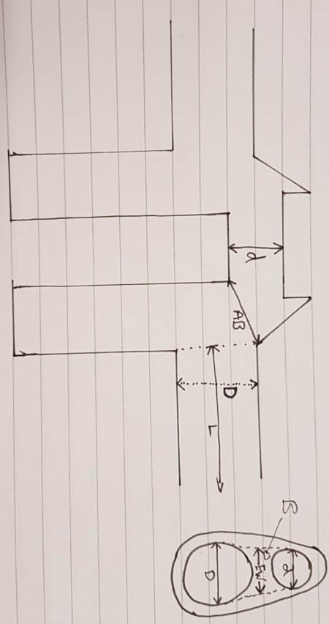
3-6: Crankshaft Cross Sections
From these measurements the Second Moment of Area can be calculated using:
$$I=\frac{Bd^{3}}{12}$$
(3-36)
Lengths L1 and L2 can be found my finding the lengths from A and B to the centre of the crank journal respectively. The Maximum Compressive and tensile forces can be found from F-rod and the inertia around point C respectively.
From this point, the Nominal Pressure can be found using the equation:
$$P_{Nom}=\frac{{0.5*F}_{Comp}}{D*L}$$
(3-37)
And the moments at point A and B can be found:
$$M_{A}={0.5*F}_{comp}*L_{1}$$
(3-38)
$$M_{A}= 0.5*F_{comp}*L_{2}$$
(3-39)
Note only F-comp is used, as this is the highest value generated, and would provide the largest bending Moment.
Table 17: Moments around point A and B
Second Moment of Area | 44224.72 | mm⁴
L1 | 14.7 | mm
L2 | 33.5 | mm
Frod max Compressive | -19340.7 | N
Frod Tensile | 7441.485 | N
Nominal Pressure | -17.7122 | pa
Moment point A | -284309 | Nmm
Moment point B | -647914 | Nmm
From the calculated moments, its clear that point B provided the Largest value, and therefore, this is the value that is taken forward. The Bending and sheer stresses can then be calculated from this:
$$σ_{bending}=\frac{{(M}_{B}*y)}{I}$$
(3-40)
$$τ= \frac{{0.5*F}_{Comp}}{\frac{πd^{2}}{4}}$$
(3-41)
From These, the maximum and minimum stresses can be calculated:
$$σ_{max}= \sqrt{σ^{2}+{\left(2τ\right)}^{2}}$$
(3-42)
$$σ_{min}= \frac{F_{Tensile}}{F_{Compressive}}*σ$$
(3-43)
The mean and range of stresses can then be calculated, again using equations (3-10) and (3-11). Furthermore equations (3-12) and (3-13) ca be used along with an E.L of 0.45*UTS to gain the allowable ranges and Fatigue Safety Factors, by using Kt = 2.
3-7: Crankshaft stresses, ranges, and FSF
Max Stress | 168.3759 | N/mm²
Min stress | -63.9787 | N/mm²
Range Stress | 232.3545 | N/mm²
Mean Stress | 52.19861 | N/mm²
UTS | 750 | N/mm²
EL | 337.5 | N/mm²
Final EL | 168.75 | N/mm²
Allowable Range | 314.0106 | N/mm²
FSF | 1.351429

Analysis

Gudgeon Pin

4-1: Goodman Diagram - Gudgeon Pin
From the graph, we can clearly see the Mean stress, as expected, is increasing from 1000rpm up to 6000. Along with this, the allowable range that the pin can experience decreases as the mean increases, therefore, as the Pin experiences a higher average stress, it is unable to undergo as much fluctuation as it would at a lower average. However, the large starting range means that increased mean values through the RPM ranges create a much larger decrease in the allowed range than a material with a smaller starting range.

4-2: FSF of Gudgeon Pin
The graph shows a rough exponential decrease in the Fatigue Safety Factor of the Gudgeon pin as the RPM of the engine increases. It shows that the Pin won’t fail under the current RPM range, however the continuous decrease gives reason to assume the Pin will likely fail if the current loading is exceeded much more after 6000.

Conrod Critical Section A

4-3: Goodman Diagram - Conrod A
The Conrod, measured at section A, has a very tight spread of mean stresses, thus resulting in very little change between the allowable range of each RPM. This would give confidence that this section would be unlikely to fail of its own accord.

Conrod Critical Section B

4-4: Goodman Diagram: Conrod B
Section B shows a much larger range of mean values, and includes a larger spread of results than section A. The increased stresses, due to increased inertia Loads through larger Mass, would mean that it would be expected for section B to fail much faster than that of Section A.

4-5: FSF of Conrod point A & B
Plotting the FSF of points A and B backs up the previous statements made. The lower FSF of point B shows that this section is closer to failure than that of point A. Whilst both parts remain out of the zone of failure, it can be concluded that under increased loading, point B will most likely fail first.

Conrod Critical Section C

4-6: Goodman Diagram - Conrod C
The Mean stresses of section C all appear to be low and relatively closely spaced. This would be down to the conrod only experiencing inertial loads at this section, as compression does not act at this point. The higher stress concentration, and thus lower starting allowable range, whilst not effecting the outcome at lower RPM’s, could cause a problem at higher RPM’s.

4-7: FSF at points A, B & C
Figure 4-7 clearly shows that, whilst at low RPM’s, the FSF at point C is much greater than the others, the values quickly reduce as the inertia of the engine increases with RPM. As point C has the largest amount of mass acting through it, the inertia at this point is expected to be much larger than other areas of the Conrod, and therefore is the most likely to be affected by RPM increases. Coupled with the much lower allowable ranges, it can be assumed that there is high potential for point C to fail first.

Conrod Bolts

4-8: Goodman Diagram- Conrod Bolts
Graph 4-8 shows a zoomed version of the Goodman diagram. Due to the bolts starting in 90% yield, the mean stresses all occupy the upper quartile of the Goodman diagram, where very small allowable ranges occur. This means that the bolts have a very strict tolerance to stress, however mean changes produce near negatable effects on the allowed range of stress within the bolt.

4-9: FSF of Bolts
The Safety factors within the bolt start very high, at values above 110, showing that the actual range of stress experienced within the bolt is very minimal. However, this value quickly decreases as the RPM increases and the inertia load has a greater effect on the operational stresses in the system.

Crankshaft Assembly

Figure 4-10: Goodman Diagram – Crankshaft
Figure 4-10 again shows the same trends as displayed by the previous results, with the mean stress increasing through the RPM range, and as a result, the allowable range showing a decrease. The medium width initial range means that whilst the crank starts with less allowable range than that of the rod, the decay over each RPM bands is much smaller.

Figure 4-11: FSF at Crankshaft
The safety factors at the crank show similar exponential trends to that of the other parts of the assembly, however the exponential decay as this section is much slower, and values show strong similarity to those of the Gudgeon Pin. Whilst the Crankshaft has much smaller values to those found in the rod, the slower decay would provide basis for the assumption that the Rod is still more likely to fail before that of the Crankshaft assembly.

Conclusions
Overall the experiment was a success. The values found were realistic and expected, and the calculations completed provided accurate results from the base data provided.

Aim 1
From the Experiment, the results obtained all showed similar trends towards failure at high RPMs. Whilst parts like the Gudgeon Pin and Crankshaft provided lower Net values for the safety factors, the Critical Rod section C, and conrod Bolts showed the highest amount of exponential decay through the bands. From these values it can be concluded, that either the bolts, or section C are the most likely points to fail under high loads.
Due to the Plotting of the Goodman diagrams, it could be further backed up that the Bolts will likely be the first to fail, as the Mean stresses experienced within the bolt, provide very low allowable ranges. This coupled with the likely increase in actual range observed at high RPM loading, would likely lead to total failure within the bolt, prior to any other part failing.

Aim 2
The improved shank bolt made from 8740 Chrome Moly proved to be a great improvement over the traditional bolt. With the decrease in stress observed, due to a large reduction in bolt stiffness, the design was able to withstand the increased loading, whilst also obtaining the same safety factors observed in the standard bolt at lower loading.
The only downside to the design, is the knock-on effect of static loading. As the bolts used increase static loading, the original big-end tunnel would require a re-bore. This could provide further effects in the form of having a now unbalanced crank due to the lower weight, and having a smaller net inertial gain.
Therefore, outside of the realms of big automotive/Motorsport Manufacturers, this process could prove to be impractical or too costly for the potential available gains.

References
ASM, 2020. Aerospace Specification Metals Inc.. [Online]
Available at: http://asm.matweb.com/search/SpecificMaterial.asp?bassnum=MTP641
[Accessed 2020 2 07].
AZoM, 2012. AISI 8740 Alloy Steel. [Online]
Available at: https://www.azom.com/article.aspx?ArticleID=6766
[Accessed 06 02 2020].
Headlee, J., 2020. an in depth look at what puts arp up on top. [Online]
Available at: https://www.rocketindustries.com.au/tech-articles/16-hoses-fittings-fasteners/63-in-depth-look-at-what-puts-arp-up-on-top#.XkCxJjH7SUl
[Accessed 06 02 2020].
Link, R., Takase, Y. & Noda, N.-A., 2006. Stress Concentration Factor Formulas Useful for All Notch Shapes in a Flat Test Specimen Under Tension and Bending. International Journal of Fatigue, 28(1), p. 151–163.
Prieto, J. M. R., 2018. Mesh Size Influence on the Mechanical Stress Concentration. [Online]
Available at: https://www.simscale.com/blog/2016/12/mesh-mechanical-stress-concentration/
[Accessed 08 02 2020].

Appendix

Appendix 1 – Net Forces 6000rpm
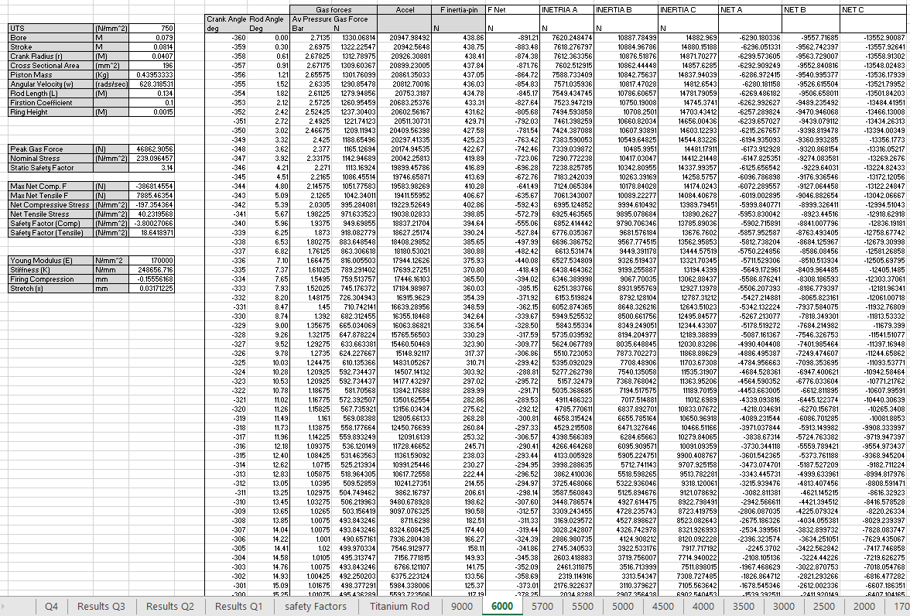

Appendix 2 – Q1 full Results
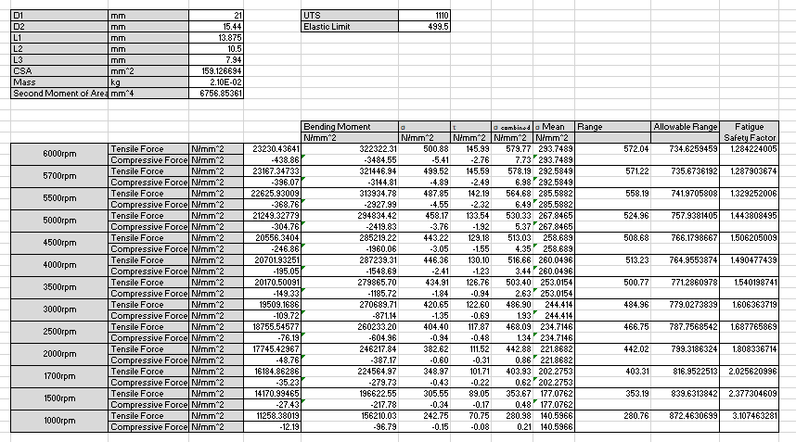

Appendix 3 – Q2 full Results
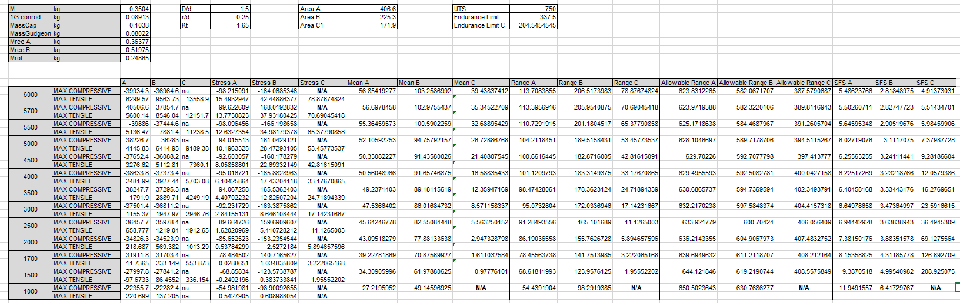

Appendix 4 – Q3 full Results
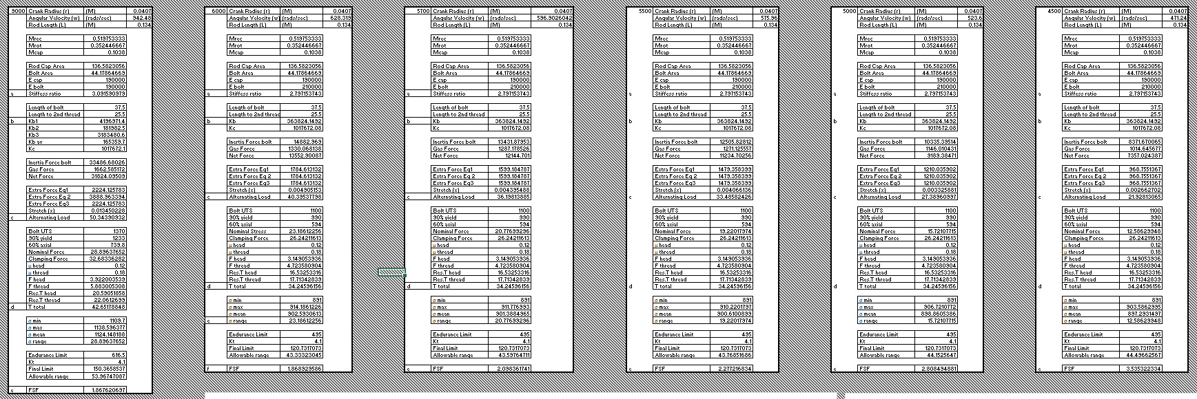
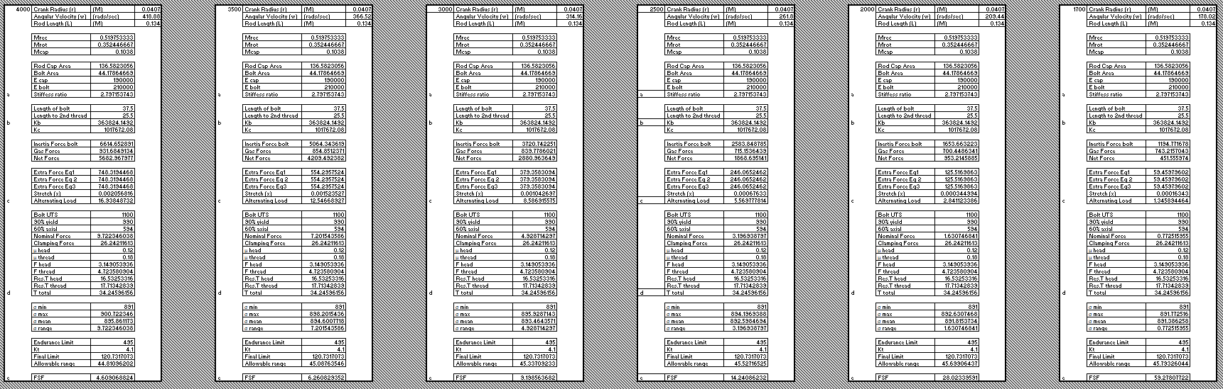
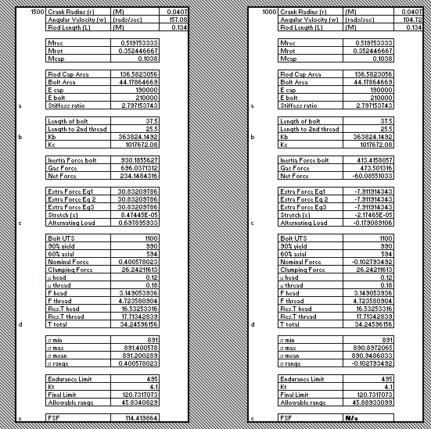

Appendix 5 – Q4 full Results


