Tahiya Ahmed | 1919719 | Psychology for Health and Social Care | BMHP4019| Rebecca Kavanagh
- Children are ready to discover the world from newborn to their early years. Children aged 0-5 years progress rapidly when they have a confident and caring relationship with adults who are informed and supportive towards the child’s education and progresses.
- This poster highlights a child’s experience from the moment they are born up to the age of 5 years and how it will influence them for the rest of lives.
- According to research some of the positive or negative events that take place in a child’s life can influence the way they grow up (Abdullah, 2019).
- Genetic factors, environmental factors, child’s abilities, and experiences during prenatal life all can influence child development.
- Child development is the sequence of language, physical, opinions and emotions that change in a child from newborn to the start of adulthood and the different kind of abilities achieved over their lifetime.

Psychological theories
Introduction
A child’s experience between the ages 0-5 years will affect the rest of their lives.
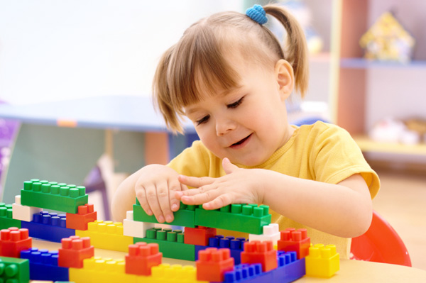
- Psychological theories in psychology are applied to give the knowledge of human behaviour through models. Many philosophies suggest clarifying and calculate numerous characteristics of human actions (Cherry, 2020).
- Two psychological theories that are related to this age group that will be explained further is:
- Piaget’s theory of cognition development
- Vygotsky’s theory of social constructivism
- As a parent/s it is important to help your child in developing their skills for them to reach their full potential in school and in life. A few practical ideas linked to psychological theories, to support your child’s development will be discussed further down.

Piaget’s theory of cognitive development
Figure 1, Little girl playing with blocks (Ellis, 2011).
- In 1967, Jean Piaget a psychologist was born in Switzerland.
- Piaget started a theory of intellectual development that has four stages. Two important psychological theories that relate to children aged 0-5years.
- The Sensorimotor stage: (Birth to 2 years):
- The child will experience imitation and nature using their five senses, looking, grasping, sucking, listening, and tasting will assist the child in gaining vital skills about the world.
- At 8 months old a child is object permanence, conscious that if an item is hidden then it still is there (Mcleod, 2020).
- The Preoperational stage: (Ages 2 to 7 years): .
- A child trusts objects and toys to have feelings and a life like a human and creates words/images to describe the world.
- Phases appear in order.
- Children do not avoid phases but succeed them.
- There are noticeable transformations from one phase to another.
- Each phase is like a building block with one piece from the last phase (Kurt, 2020).
- On the word of Piaget, children participate and reproduce their cognitive developments across many styles of play: productive play, practical play, symbolic/imaginary play, and games that include rules (Wardle, 2015).
Vygotsky’s theory of social constructivism
- Lev Vygotsky’s was called “The Mozart of psychology”.
- Vygotsky’s access to child development is a method of social constructivism. Vygotsky was passionate about the importance of culture and communication in the development of cognitive skills (Mahn, 2012).
- Vygotsky formed a very popular theory (1979), Zone of proximal development (ZPD).
- Vygotsky explained the zone of proximal development is the space amongst what the child knows and does not know (Vygotsky, 1978).

- Mental improvement such as thinking, language and process are progressed through social connections. Vygotsky expresses that culture and environment effects an individual’s progress (Brown, 2017).
- He summarized three key ideas in relation to cognitive development:
- Culture is important in knowledge.
- Language is the origin of culture.
- Individuals study and grow inside their part in the public (Kurt, 2020).

- Teachers and parents can assist children in conquering their oral language skills by reading a book to them and foster scaffold children’s play across role play such as play kitchen, shop keeper or restaurant play. Mediating, shaping, training, recommending and the most vital is delivering enough time to play (Scharer, 2017).
- Allow children to use their imaginative skills for example, you could use a paper to make a flying airplane or origami flowers and be certain children understand the rules of the games (Scholastic, 2020).
- A child will ride the bike with training wheels to make sure the bike is safe. Once the wheels have come off and parents stand by their side helping them keep their balance. Lastly, the parent will move away once their child can do it on their own (Vinney, 2019).
- All above goes in with Vygotsky’s theories as he argued to evaluate individuals based on what they can do rather than what they are.
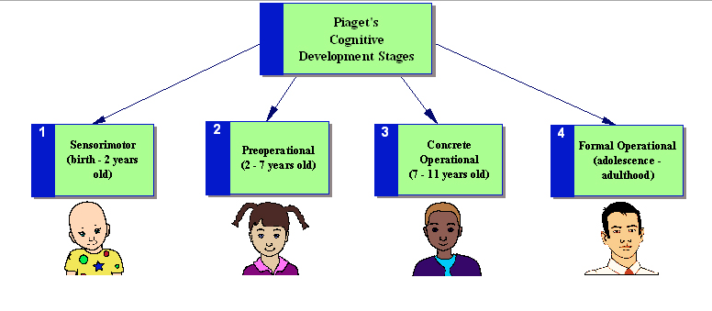
Figure 2, Stages of cognitive development (Firstdiscoverers, 2020).
- The following are activities to support your child’s development:
- Peek-a-boo (widens object permanence).
- Container play (gaining object permanence and creates cause and effect thinking).
- Sensorimotor activities like sensory bottles, sticks and bags (builds up a strong and healthy physical body).
- Stacking play like building blocks/Lego (improves fine motor skills and problem-solving skills).
- Vygotsky’s theory insists that instead of assessing what people are doing, people should be understood in of what they can do with the suitable help. This tactic to teaching has also been agreed by educators.
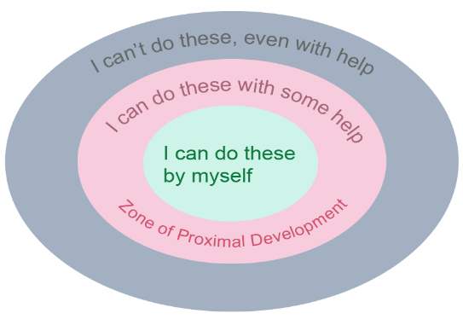

Figure 3, Vygotsky’s sociocultural theory of cognitive development (The Psychology notes headquarters, 2021).
Annotated Bibliography

Astington, JW., (2010), The development of theory of mind in early childhood, [Online], Available at: http://www.child-encyclopedia.com/social-cognition/according-experts/development-theory-mind-early-childhood, (Accessed: 21/02/2021)
This article was written by Astington, PhD who defines the first five years of a child’s school and home life and the explanations of the consequences. This article was from the encyclopaedia on early childhood development which is a reliable paper.

Biography.com, Editors., (2014), Jean Piaget biography, [Online], Available at: https://www.biography.com/scientist/jean-piaget, (Accessed: 14/02/2021)
This biography article was used to gain knowledge of who Jean Piaget is and why he developed essential such theories and how benefits them.

Brown, D., (2017), Educational learning theories: Chapter 4 required reading, [Online], Available at: https://libguides.daltonstate.edu/c.php?g=722740&p=5486084, (Accessed: 20/02/2021)
Brief facts have been discussed such as Piaget’s and Vygotsky’s theories.

Cherry, K., (2020), A biography of Lev Vygotsky, one of the most influential psychologists, [Online], Available at: https://www.verywellmind.com/lev-vygotsky-biography-2795533, (Accessed: 24/02/2021)
This obtains Vygotsky’s history of findings and reasons behind his creation of theories as it is his biography.
This source carefully clarifies the origin of the zone of proximal development, the roles, and the meaning of it. It aided me in providing the accurate practical examples of ways children can be helped.
Cherry, K., (2020), Child development theories and examples, [Online], Available at: https://www.verywellmind.com/child-development-theories-2795068, (Accessed: 22/02/2021)
This source was similar to another source which the author, Cherry has composed (Psychological theories).
This holds facts on Piaget’s and other famous psychologist’s theories and cognitive development theories.
This was an essential article to study as it was related to the aims of my poster.

Cherry, K., (2020), Developmental psychology, [Online], Available at:
https://www.verywellmind.com/developmental-psychology-4157180, (Accessed: 22/02/2021)
The author, Cherry related this with children aged from 0-5 years old and has many other similar sources available. All her sources are very credible.
Cherry, K., (2020), How genes influence child development, [Online], Available at:
https://www.verywellmind.com/genes-and-development-2795114, (Accessed: 23/02/2021)
This resource gave a clear understanding to the affects of genes in development.
The source is a reliable source as author, Cherry has composed many articles around the same topic.
This aided in forming practical activities for parents to help progress their child’s developments.

Cherry, K., (2020) Types of Psychological theories, [Online], Available at: https://www.verywellmind.com/what-is-a-theory
2795970#:~:text=In%20psychology%2C%20theories%20are%20used,It%20must%20describe%20a%20behavior, (Accessed: 12/02/2021)
Cherry, an educational consultant who delivers knowledge on psychology for students elaborates on the education theories. Trustworthy and reliable source of information provided.

Figure 1:
Ellis, K., (2011), Lessons to teach while playing with blocks, [Image], Available at: https://www.sheknows.com/parenting/articles/844895/lessons-to-teach-while-playing-with-blocks, (Accessed: 23/02/2021)
In this article, Ellis, authors about parenting, fashion, beauty, and alternative lifestyle subjects.
The facts instruct on the way children can improve problem – solving skills and shape other cognitive, emotional, and social competences.

Figure 2:
Firstdiscoverers., (2020), Cognitive development, [Image], Available at: https://www.firstdiscoverers.co.uk/science-childcare-cognitive-development/, (Accessed: 24/02/2021)
The image of Piaget’s stages of cognitive development was used to explain the stages in detail. Reliable and useful site for parents/carers.

Figure 3:
The psychology notes headquarters., (2021), Vygotsky’s concept of zone of proximal development, [Image], Available at: https://www.psychologynoteshq.com/vygotsky-theory/, (Accessed 25/02/2021).
This article emphasis the impression of zone of proximal development and on cognitive development which takes place early in a child’s life and is proceeded via social connections. This is a reliable source as the author did exceptional work in the field of education. This image was useful to my research as I have learnt to ride a bike, and this was very interesting information.
Ginsburg, H.P., (2016), Piaget’s theory of intellectual development, [Online], Available at: https://www.spc4erp.com/uploads/about-1471606029-piagets-theory-of-intellectual-development.pdf, (Accessed: 23/02/2021)
Ginsburg’s source explains single childcare information. Outlines the vital reasons that can influence child development and demonstrates what intellectual development consists of.

Kid sense., (2020), What is child development?, [Online], Available at: https://childdevelopment.com.au/areas-of-concern/what-is-child-development/, (Accessed: 13/02/2021)
In this paper its distillates on children’s progression and the results of not meeting them milestones.
Kurt, S., (2020), Jean piaget’s theory and stages of cognitive development, [Online], Available at: https://educationaltechnology.net/jean-piaget-and-his-theory-stages-of-cognitive-development,
(Accessed: 20/02/2021)
This source was scripted by Dr. Kurt enlightening the phases of Piaget’s theories in cognitive development. This assisted in illuminating the key points for my research. This source is reliable as its educational and mostly used by students/educators.

Leon, A., (No date), 1930s: Vygotsky, [Online], Available at: https://iastate.pressbooks.pub/parentingfamilydiversity/chapter/1930s-vygotsky/, (Accessed: 25/02/2021)
In this source, Leon, the author talks about the alterations of child growth and progression. It highlights the vital steps needed to advance child development. This article was beneficial to my examination as it explains both theories of Vygotsky, scaffolding and ZPD, zone of proximal development.
Lumen learning., (No date), Piaget’s theory of cognitive development, [Online], Available at: https://courses.lumenlearning.com/teachereducationx92x1/chapter/piagets-theory-of-cognitive-development/, (Accessed: 19/02/2021)
This educational paper illustrates piaget’s type of aptitude and in what way all alterations related was associated to behaviour changes on an individual.

Lumen learning., (No date), Social constructivism – Vygotsky’s theory, [Online], Available at: https://courses.lumenlearning.com/edpsy/chapter/social-constructivism-vygotskys-theory/, (Accessed: 24/02/2021)
This educational paper demonstrates Vygotsky’s theory of social constructivism and in what way all alterations related was associated to behaviour changes on an individual.

Marcin, A. (2018) What are Piaget’s stages of development and how are they used?, [Online], Available at: https://www.healthline.com/health/piaget-stages-of-development,
(Accessed: 13/02/2021)
This was used to gather knowledge on each phase of Piaget’s theory and how they can be expended. Credible source as its to do with health.

Mcleod, S., (2020), Piaget’s theory and stages of cognitive development, [Online], Available at: https://www.simplypsychology.org/piaget.html, (Accessed: 18/02/2021)
This was adopted to learn and recognize child development.
This was an effective source as it clarifies the early cognitive development that builds upon certain events.
This was applied to collect the accurate dates and sources for my poster.

Scharer, J., (2017), Supporting young children’s learning in a dramatic play environment, [Online], Available at: https://www.researchgate.net/publication/321636037_Supporting_Young_Children%27s_Learning_in_a_Dramatic_Play_Environment, (Accessed 2/02/2021)
This source talks about the ways in which we can progress a child’s development using role plays. It is an education site therefore reliable.

Scholastic., (2020), Pioneers in our field – Lev Vygotsky – Playing to learn, [Online], Available at: https://www.scholastic.com/teachers/articles/teaching-content/pioneers-our-field-lev-vygotsky-playing-learn/, (Accessed: 20/02/2021)
The author built in understandings of Vygotsky’s conception and how it can be applied to play.
The author gained data through educational technology.

The Open University., (2020), 5 Social constructivism, [Online], Available at: https://www.open.edu/openlearn/education/educational-technology-and-practice/educational-practice/exploring-childrens-learning/content-section-5.1, (Accessed: 21/02/2021)
It is a credible source as it is from the open university therefore it is an educational website aiming to bring awareness to students like myself.

Vinney., (2019), What is the zone of proximal development? Definition and examples, [Online], Available at: https://www.thoughtco.com/zone-of-proximal-development-4584842, (Accessed: 25/02/2021)
This source highlights the vital of culture and connection in the progress of cognitive abilities. In depth description of Piaget’s theory, zone of proximal development and scaffolding.
This talks in detail of Vygotsky’s early life and his profession and concepts which was beneficial.

Wardle, F., (2015), The importance of constructive play, [Online], Available at: https://www.communityplaythings.com/resources/articles/2015/constructive-play, (Accessed: 24/02/2021)
This source focuses on the significance of constructive play and how it is an advantage for child’s school and home life. The paper aims at audience that have children or may care for. It outlines on certain tasks that can be applied by parents/carers.
This source highlights cognitive development in depth.

