Using models to design biological surveys

Martyn Hart 2008947

22/03/2021

Contents
1 Introduction 1
2 Methodology 2
3 Results and Discussion 3
3.1 Field Voles 5
3.2 Tadpoles 6
4 Conclusion 8
5 References 9

Table of figures
Table 3-1- LP estimate variations when amount of time lapsed is doubled. 3
Table 3-2- Difference in field vole population estimates when positive/negative experience is selected. 3
Table 3-3- Data showing average tadpole population estimates when using different estimate equations 4

Introduction

The aim of this experiment is to determine the population sizes of two species, field voles (Microtus agrestis) and frogs (Rana temporaria) that are present at Waun Tylluan by using a model simulation. In order to increase biodiversity of the heavily farmed area, it is important that prey species are present to provide sustainable food sources for local predatory species, in this case they are barn owls (Tyto alba) and otters (Lutra lutra).

Due to the way that the three fields were previously used, they each have a slightly different landscape. This results in the field voles using a variety of ways to navigate each part of the farm. As they would rarely be seen out in the open, using grass as cover from airborne predators would be essential to their survival. In the Corral field, there are thick patches of vegetation but also bare ground, this changes the navigational path the voles would follow when compared to the Haymeadow, which has an even height of grasses spread throughout. The Top Field is the largest of the three, and although is covered evenly with grasses, they do vary in height.

To gather information on the common frog, tadpoles will be counted as they are all in one place. Frogs are semi aquatic and hibernate in the winter so it would be almost impossible to get an accurate estimate of the population (Common frog | The Wildlife Trusts, no date). There are three ponds of different sizes, one in each field. Variables include the size of the net used, population size, and what method, either ‘sampling with removal’ or ‘mark and recapture’ is carried out.

Methodology

For the field vole model, the traps were laid out in a diamond shaped pattern (see figure 1), and then then opened for eight hours. After marking voles and releasing them, the method was repeated again. Results should show a Lincoln-Petersen estimate that is as close to the actual population figure as possible.

The LP estimate the model provides for the vole simulation, involves only using the traps twice. Once for the original capture and marking, and again for the recapture.

In the case of the tadpole model, the mark and recapture method was repeated. As the LP estimate data was not present in the model, two different equations were used to compare data.

An example of the LP estimate equation used is:

$$N= \frac{Kn}{k}$$

An example of the Chapman estimate variation used is:

$$N_{c}=\frac{\left(K+1\right)\left(n+1\right)}{k+1} -1$$

In my results I expect to see that using the largest net regardless of the size of the pond, should contribute to a more accurate population estimate than using the small or medium sized nets.

*For more information on the equations used see (Chapman, 1951)

As shown in table 3-3, I took three samples with each net, for each population size and took an average figure to improve the accuracy of the data.

Results and Discussion

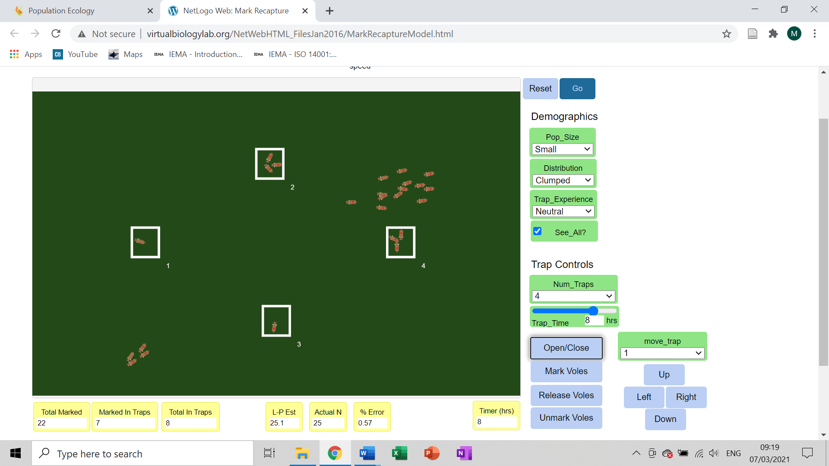
Figure 3-1- Shows the results of the experiment conducted on the Corral field, and the layout of the traps used in all fields.
Table 3-1- LP estimate variations when amount of time lapsed is doubled.
Field Name | The Corral |  | Haymeadow |  | Top Field
Hours traps open | 4 | 8 | 4 | 8 | 4 | 8
LP Estimate | 30 | 25.1 | 68.6 | 52.7 | 86 | 101.7
Error % +/- | + 20 | + 0.57 | + 37.14 | + 5.4 | - 14 | + 1.74

Table 3-2- Difference in field vole population estimates when positive/negative experience is selected.
Field Name | The Corral |  | Haymeadow |  | Top Field
Positive/Negative trap experience | Positive | Negative | Positive | Negative | Positive | Negative
LP Estimate | 20.8 | 38 | 44.3 | 87.4 | 96.1 | 154.7
Error % +/- | -16.89 | +52 | -11.31 | +74.86 | -3.94 | +54.67

Table 3-3- Data showing average tadpole population estimates when using different estimate equations.

Field Voles

After conducting the experiment, it was found that the amount of time the traps are left open does have a substantial impact on the final result. When using the same pattern design but only leaving the traps open for four hours, the LP estimate was consistently estimating over or under the actual population figure. To combat this, the amount of time traps were open was changed from four hours to eight hours, this made a significant improvement to the LP estimates all round which is evident in table 3-1. The diamond shape pattern was used as it is similar to a grid trapping layout, an alternative to the line trapping layout, as this has been found to be more appropriate for the measuring of populations rather than the distribution (Flowerdew et al., 2004).

The method used in this experiment is fairly practical and easily repeated in a real-world environment, as the use of only four traps means that it is not too expensive to acquire the amount of equipment needed, striking the balance between having enough traps to gain accurate information and affordability. With the model showing that eight hours is the amount of time the traps need to be open for, this means that the area being surveyed is left undisturbed for a long enough period that any wildlife startled by the initial setting up of the traps, sensing predatory odours or temporary disturbance of their habitat, should have returned to normal behavioural patterns (Apfelbach et al., 2005). As the method used involves erecting traps twice, it is possible to complete the two surveys within a 48hr period, leaving time between for marking and reintegration. As field voles are active both day and night, there are no time restrictions in regards to trap setting, making it a time efficient experiment.

Advantages of using models to conduct experiments include being cost effective and time efficient due to the ability to conduct many experiments using different methods and over different time periods in a short space of time. When compared to the real-world alternative, saving money on the wages of multiple people, the time it would take for them to set traps and check their effectiveness, along with marking the field voles that were trapped, there are questions as to why you wouldn’t use models instead altogether.

Some of the disadvantages with using models are that they cannot replicate real world variables accurately. In the model used there is no way to take into account the weather, or if it is day or night. For example, heavy rain or freezing conditions would almost certainly have some bearing on a real-world experiment. Field vole populations fluctuate various times throughout the year, with population figures reaching highs every three to four years, this will have a significant impact on any studies conducted on population size (Arriero et al., 2017). Another external factor to take into consideration is that field voles with a higher protein intake in their diets also have higher reproductivity rates, which is a variable unable to be replicated in this model simulation (Forbes et al., 2014). Models also lack the physical evidence that would affect trap placement. It has been found that field voles like to navigate via a network of runs / tunnels through the grass to get to their burrows (Field vole | The Wildlife Trusts, no date). This evidence would be key to determining the placement of your traps.

The LP estimate used with this particular model works accurately when it is assumed there is a ‘closed population’, meaning there are no deaths / births, or migratory influences. But it also limits the number of times you can mark / recapture otherwise the estimation equation will not work. The practicalities of waiting for the first marked samples to re-join the rest of the population and become thoroughly integrated, cannot be catered for in a real experiment as there are too many factors. For example, we do not know how long it would take, and if an individual being marked changes the group’s behaviour towards it temporarily or permanently. There is also the possibility that the population have migrated, and is in fact an ‘open population’, this would require different estimation methods (Link and Barker, 2010).

The use of the mark and recapture method on the field voles is deemed as the most reliable due to the easily identifiable way to tell which individuals have already been caught. It has been used regularly, and proven to work reliably in other studies that involve the capture and release of small mammals/rodents (Flowerdew et al., 2004). Common ways of marking include shaving a patch of fur or using a non-toxic dye (Jung, Boonstra and Krebs, 2020). The captured individuals are then released back into the same target area, although this is seen as a less intrusive method compared to ‘sampling with removal’, it does mean that there is a likelihood of some of the field voles being captured multiple times. This is where ‘positive or negative trap experience’ needs to be considered. If a field vole is captured and has a positive trap experience because it favours the food that was used as bait, when it comes across another trap in the future, it is more likely to enter based on its past experience (Pottie, Canal and Camacho, 2017). As well as having an impact on the LP estimate, (see table 3-2) it is impossible to predict or influence in real experiments. The neutral trap experience option was used for this experiment.

Tadpoles

With the tadpole model, there were two methods available to use. Sampling with removal, which involves removing specimens from the pond and keeping them in a holding pen, removing any possibility of capturing the same individuals twice. The other method is mark and recapture, the same used in the field vole model.

The method decided on was the mark and recapture method, this was chosen because the sampling with removal method involved the use of various equations becoming too complicated mathematically to carry out (Hayne, 1949). Although this is a personal restriction and not a universal issue. The pros of mark and recapture in this model include less disturbance of the immediate habitat and pond environment when compared to sampling with removal. If you were to dip nets multiple times in the same area, there is a risk of stirring sediment and disturbing underwater habitats of non-target species, such as aquatic flora. Also, the element of temporarily holding the specimens in a suitable container while counted is removed, applying less stress to the tadpoles. One of the cons of using the mark and recapture method with this model is the actual marking of the specimen. If applied to a real-world experiment, every tadpole would have to be marked with a dye, the dye would then fade placing a time restriction on gathering the relevant information (Jung et al., 2002).

The number of variables in this model design mean that more data was needed to gain an accurate representation of the population estimate. As shown in table 3-3 the variables were the size of the population and the size of the net used to take the sample. The use of both the Lincoln-Petersen estimate and the modified Chapman estimate to compare data was decided as research had suggested that the LP estimate could be biased when used for smaller numbers (Chapman, 1951). Samples were taken and repeated three times so that an average figure could be taken.

The results show that the most accurate way of determining an accurate estimate of the tadpole population is to use the Chapman estimate, as there were more occurrences of the average data produced being nearer to the actual population figure. This does not mean all of the data was accurate though. The averages worked out by both estimates in the medium pond section with a large population using a large net were significantly overestimated (table 3-3), producing incredibly inaccurate average estimates.

Although all variables were taken into consideration, and average populations calculated for all, tadpole populations have been shown to be directly influenced by their environment, a small pond will most likely harbour a small population etc (Jung et al., 2002). This removes one of the variables, population size, and only requires the experiment to find which size net is most efficient. The results show that the large net size is the one that has proven to be the best to use for this model, by gathering a larger quantity of specimens seems to produce a more accurate population estimate. Conversely, using the small net in all situations provided inaccurate, underestimated data. In some cases when dipping the net, it was not gathering any individuals at all, further reducing the average population estimate.

Conclusion

In summary, it has been shown that using the mark and recapture method for both species yields the best population estimates. In the tadpole’s case, using a variable of the LP estimate, the Chapman estimate provided more accurate data, especially with the higher numbers. The use of a large net in all ponds should provide the best population of tadpoles. The grid trapping layout, and low amount of traps used should be easy and cost effective to replicate in a practical experiment, and should also gather accurate information in relation to field vole population numbers in the area.

References
Apfelbach, Raimund, Caroline D Blanchard, Robert J Blanchard, R. Andrew Hayes, and Iain S. McGregor. ‘The Effects of Predator Odors in Mammalian Prey Species: A Review of Field and Laboratory Studies’. Neuroscience & Biobehavioral Reviews 29, no. 8 (1 January 2005): 1123–44. https://doi.org/10.1016/j.neubiorev.2005.05.005.

Arriero, Elena, Klara M. Wanelik, Richard J. Birtles, Janette E. Bradley, Joseph A. Jackson, Steve Paterson, and Mike Begon. ‘From the Animal House to the Field: Are There Consistent Individual Differences in Immunological Profile in Wild Populations of Field Voles (Microtus Agrestis)?’ PLOS ONE 12, no. 8 (17 August 2017): e0183450. https://doi.org/10.1371/journal.pone.0183450.

Chapman, D. G. Some Properties of the Hypergeometric Distribution with Applications to Zoological Sample Censuses. Berkeley, 1951. http://hdl.handle.net/2027/wu.89045844248.

Flowerdew, John R., Richard F. Shore, Simon M. C. Poulton, and Timothy H. Sparks. ‘Live Trapping to Monitor Small Mammals in Britain’. Mammal Review 34, no. 1–2 (2004): 31–50. https://doi.org/10.1046/j.0305-1838.2003.00025.x.

Forbes, Kristian M., Peter Stuart, Tapio Mappes, Katrine S. Hoset, Heikki Henttonen, and Otso Huitu. ‘Diet Quality Limits Summer Growth of Field Vole Populations’. PLOS ONE 9, no. 3 (12 March 2014): e91113. https://doi.org/10.1371/journal.pone.0091113.

García‐Díaz, Pablo, Thomas A. A. Prowse, Dean P. Anderson, Miguel Lurgi, Rachelle N. Binny, and Phillip Cassey. ‘A Concise Guide to Developing and Using Quantitative Models in Conservation Management’. Conservation Science and Practice 1, no. 2 (2019): e11. https://doi.org/10.1111/csp2.11.

Hayne, Don W. ‘Two Methods for Estimating Population from Trapping Records’. Journal of Mammalogy 30, no. 4 (1949): 399–411.https://doi-org.ezproxy.uwtsd.ac.uk/10.2307/1375218

Jung, Robin E., Gage H. Dayton, Stephen J. Williamson, John R. Sauer, and Sam Droege. ‘An Evaluation of Population Index and Estimation Techniques for Tadpoles in Desert Pools’. Journal of Herpetology 36, no. 3 (2002): 465–72. https://doi-org.ezproxy.uwtsd.ac.uk/10.2307/1566191

Jung, Thomas S, Rudy Boonstra, and Charles J Krebs. ‘Mark My Words: Experts’ Choice of Marking Methods Used in Capture-Mark-Recapture Studies of Small Mammals’. Journal of Mammalogy 101, no. 1 (21 February 2020): 307–17. https://doi.org/10.1093/jmammal/gyz188.

Link, William A., and Richard J. Barker, eds. ‘Chapter 11 - Open Population Models’. In Bayesian Inference, 239–70. London: Academic Press, 2010. https://doi.org/10.1016/B978-0-12-374854-6.00014-4.

Pottie, Jaime, David Canal, and Carlos Camacho. ‘Lifelong Effects of Trapping Experience Lead to Age-Biased Sampling: Lessons from a Wild Bird Population’. Animal Behaviour 130 (1 August 2017): 133–39. https://doi.org/10.1016/j.anbehav.2017.06.018.
Field Vole | The Wildlife Trusts. Accessed 20 February 2021. https://www.wildlifetrusts.org/wildlife-explorer/mammals/field-vole.

Common Frog | The Wildlife Trusts. Accessed 27 February 2021. https://www.wildlifetrusts.org/wildlife-explorer/amphibians/common-frog.

