Name: Gheorghe Alui-Gheorghe
Student number: 2018577
Module code and title: Managing Projects in the Organization | BMSW5104
Lecture’s name: Alfred Mensah
Assignment title: Managing Projects in the Organisation.

Executive Summary
Projects are often complex and involve numerous stakeholders; thus, a project management plan is essential to keep everyone on the same page for success. A successful project ensures the client is satisfied and helps solve a need. In this context, as a group of four project experts, we will design and implement a project to solve the catering problem at the Ford Dagenham Company. Ford Dagenham Company is a Fort Motors Company branch in Dagenham, London. The company is experiencing excess staff movements during lunch hours, causing congestion in the local areas. This is also affecting the productivity of the company. The company also wish to improve the employees’ lifestyles by offering healthy meal plans and easy accessibility of breakfast and lunch services for its staff. Based on the issue facing Ford Dagenham Company, we will open Ford Dagenham Restaurant in the company’s vicinity. This project will be expected to be completed in six months starting from 1st April this year and will need a budget of around £200,000. The project will undergo four main phases (initiation, planning, implementation and closure). At each phase, the various team members will place assigned responsibilities. The project team will include the sponsor, project director, project manager, budget and finance officer, and project planning officer & operations officer. Different tools and methods will be employed at each phase to ensure project success.

Table of Contents
Executive Summary 2
Introduction and Case Overview 4
Project Scope 5
Stakeholder Analysis 6
Deliverables and Acceptance Criteria 7
Project Exclusions, Constraints and Assumptions 8
Work Breakdown Structure 9
Cost Plan (Budget) and Control 13
Resource Plan 14
Project Schedule 18
Risk Assessment 18
Quality Management Approach 20
Closing the Project 21
References 22
Appendices 24

Introduction and Case Overview
Over the years, research has been carried out on the importance of making food provisions for employees at the workplace daily and the benefits thereof through surveys, interviews, and questionnaires approach. For instance, the International Labor Organization (ILO) found that workers' health and productivity suffered when provided with subpar food options (Maria et al., 2018). This indicates that for employees to be productive, there is a need to have better and healthy nutrition programs in the workplace. Ford Dagenham Company, a branch of Ford Motors Company, faces the challenge of managing workers during lunch breaks. The company's workers create congestion issues in the local area during lunchtime, worrying the company about how to reduce these movements. The company also faces a higher absenteeism rate due to the employees' strain during lunch hours. Thus, due to the current congestion issues in the area, the company may wish to reduce workers' movement during lunch hours. As part of its CSR initiatives, it is in the company's best interest to encourage healthy habits among workers to reduce employee sick days. Therefore, this project aims to open Ford Dagenham Restaurant inside the company's vicinity to solve the current issue. The table below summarises the business and project objectives. It also indicates the project title and the project stakeholders.
Business Objectives (Ford Dagenham Company)  - To reduce the number of employees leaving the building at lunchtime, causing congestion in the local area.  - Aid workers in making positive lifestyle changes will help reduce absenteeism. | Project Title  Opening of Ford Dagenham Restaurant for Ford Dagenham Company’s Staff
Project Objectives  - To develop a 6-month plan for opening Ford Dagenham Restaurant to reduce congestion issues caused by Ford Dagenham staff.  - To create an engaging experience for Ford Dagenham staff to sample the restaurant's food and drinks for health benefits.  - To achieve Sponsor/Client satisfaction after the project’s completion. | Project Stakeholders  - Ford Dagenham (Owner/sponsor)  - Name (Project director)  - Name (Project manager)  - Name (Budget and finance officer)  - Name (Project planning officer & Operations officer)

Project Scope
The scope of a project is all the features and functions of the product that have been planned out, as well as the total amount of work necessary to finish the project (Shirazi, Kazemipoor and Tavakkoli, 2017). Collecting the data required to start a project, such as the features of the final product that must meet the expectations of the project's stakeholders. Our project aims to open Ford Dagenham Restaurant near Ford Dagenham Company. The project with take six months, beginning on 1st April 2023 and ending on 9th September 2023 and will reduce congestion issues caused by Ford Dagenham staff. This project aims to create an engaging experience for Ford Dagenham staff to improve their health and lifestyle by quickly accessing quality meals during lunch. We want to satisfy our sponsor by delivering a high-class restaurant that will serve the entire staff fraternity of the company. This project is valid since it will solve the catering issue at Ford Dagenham Company. The project will reduce the movement of the company’s staff in the local area during lunch hours, thus reducing their congestion in the area. The project will also improve the health and lifestyles of the company’s staff.
We plan to work within a budget of £200,000. We will use various methods and documents at various stages of this project. The project’s core stakeholders will include the owner/sponsor, project director, project manager, budget and finance officer, and project planning officer & operations officer. These parties will be assigned various responsibilities at various stages of this project. The product requirements or deliverables for this project will include a fully furnished restaurant with a functional kitchen, dining area, beverages area and reception area, among other sections of a restaurant. For the project to succeed, we will ensure that it is completed within the set timeframe (6 months) and the budget (£200,000) while delivering a high-quality product.

Stakeholder Analysis
The table below is a stakeholder analysis for this project. With the information in the table, we can identify the many parties having a vested interest in the project's success and learn how to best include and interact with them throughout the project (Kennon, Howden and Hartley, 2009). The project's core stakeholders will include the sponsor, project director, project manager, budget and finance officer, and project planning officer & operations officer.
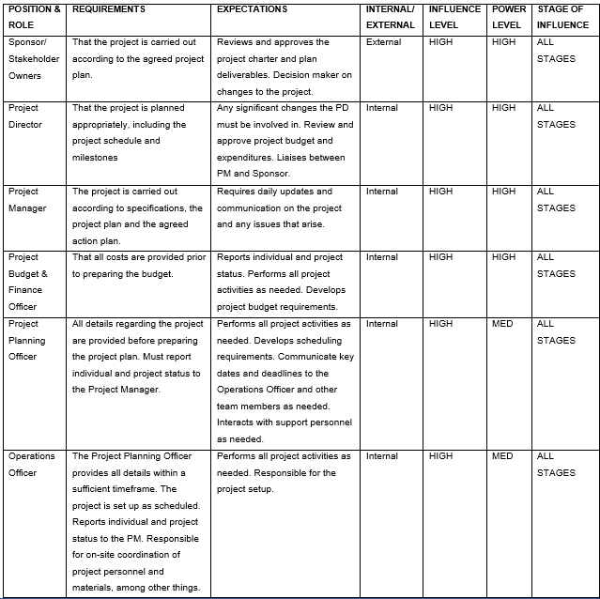

Deliverables and Acceptance Criteria
- Deliverables
We will divide deliverables into two primary categories. The first category will be project deliverables, whereas the second will be product deliverables. The project deliverables will include the project charter, requirements, budget, schedule, resources, scope, risk assessment and other management plans & reports. The Product deliverables will include; high quality and well-furbished restaurant with a fully functioning kitchen, dining area, washrooms, beverages area, and readily available meals and drinks, among other sections of a high-class restaurant.
- Acceptance Criteria
Each phase of the project development will be delivered to the customer in accordance with the agreed-upon schedule as part of the acceptance criteria for the project deliverables. The project's author, manager, and director will sign off on each development milestone before submitting it to the customer for final approval. A customer's permission and signature are required at each phase of the project's development in line with the Work Breakdown Structure.
It was agreed that weekly progress reports would be the primary tool for monitoring and approving each item for the product delivery acceptance criteria. Every week, the project manager and project sponsor will get a status report detailing how well the delivery and receipt of each item are tracked per the procurement management plan. The project manager and project sponsor will get weekly reports on the progress of the work in the last days before the major event, and the preparation of each component will be evaluated against the schedule baseline.

Project Exclusions, Constraints and Assumptions
- Exclusions
- We will not provide the foodstuffs and drinks as the sponsor will provide them. Also, the sponsor will provide full-time workers for the restaurant.
- We will not ensure the quality of the after-project products such as foodstuffs, drinks and the employees. The sponsor should provide these items.
- The project sponsor shall also describe the prices of the expected products.
- Constraints
The table below shows the constraints and limitations this project might face.
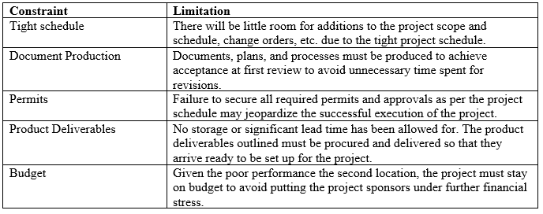
- Assumptions
- The sponsor will provide the Ford Dagenham Restaurant's workforce, including cashiers, chefs and waiters. This means that we need to quickly recruit and train new employees whom we will work with until the project is over.
- The sponsor will give free samples of their delicious food, and beverages, among others. However, if we need more materials for the project, we must purchase from a different firm, which contradicts the project's goals.

Work Breakdown Structure
- WBS
Project managers often use a WBS to successfully execute complex projects with many working components. By dividing the project into manageable chunks, a WBS may help you keep track of the project's budget, timeline, and outputs in one convenient place (Burghate, 2018). This is the WBS that was used for this project.
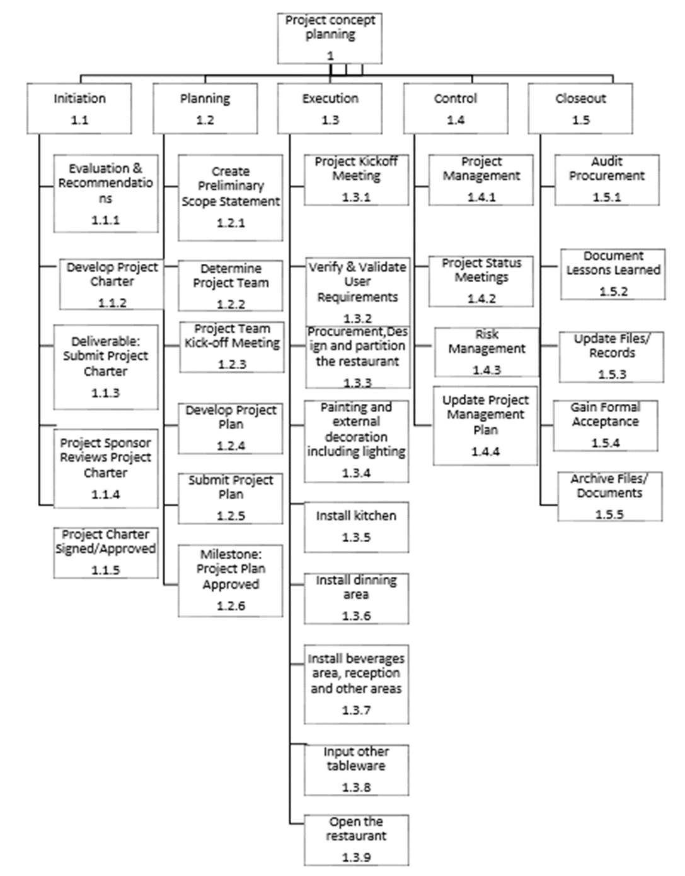
- WBS Dictionary
A WBS dictionary contains the specifications of the WBS's activities, tasks, and outputs (Sanghera and Sanghera, 2019). Using the WBS as a foundation, the following section will detail the specifics of each task and how much labour goes into it.
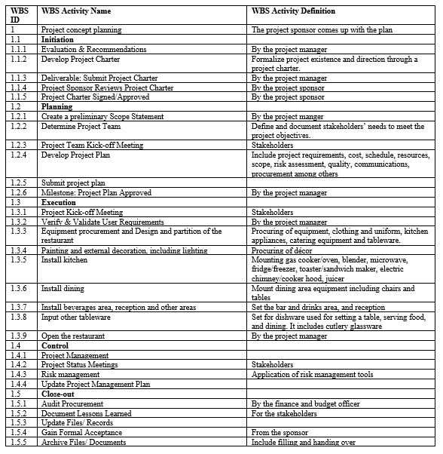

Cost Plan (Budget) and Control
The final cost plan for the Ford Dagenham Restaurant will be delivered on 9th September 2023 and will include a description of all the resources, space, material, and equipment required to finish the project. As a baseline, we have allocated £200,000 for this project. The Project Budget & Finance Officer will be accountable for cost management. He will provide tracking sheets with every quote and invoice the project team generates. He also is in charge of adding each expense to the cost baseline. The officer will use many tracking methods, such as earned value management, to track budget, earned, and actual spending. A system will be put in place to track all costs. The budget breakdown is as follows;
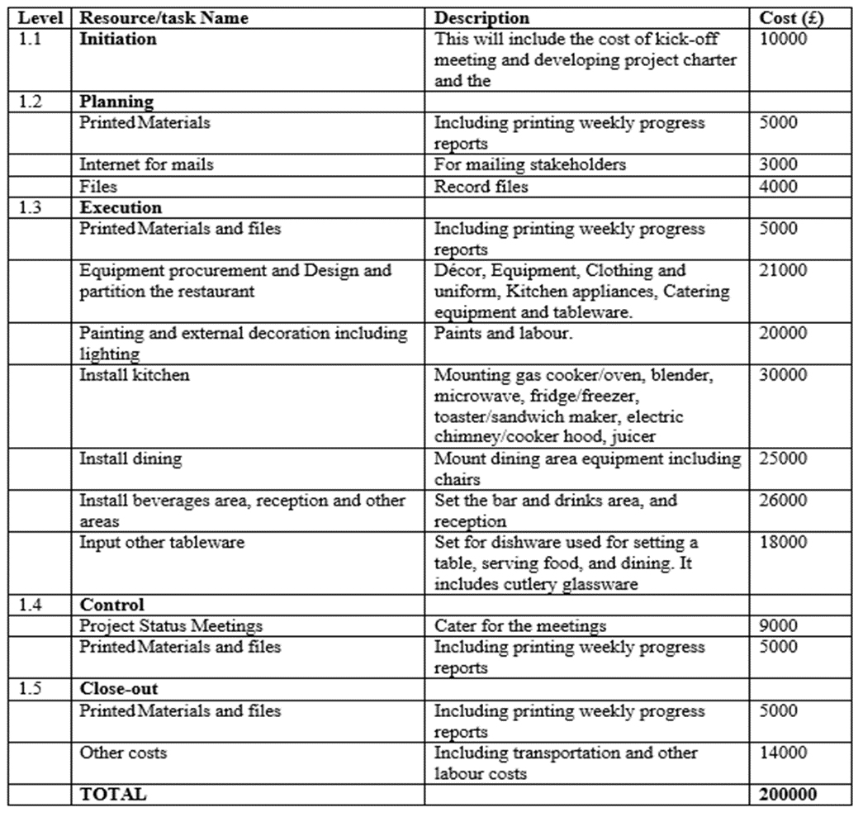

Resource Plan
- Human Resources Plan
The following is a comprehensive rundown of the roles and responsibilities everyone involved on the team and in the project should play. The member is in charge of the portion of the project that corresponds to the member's position. Members' ability to make decisions, access project resources, and provide permission is contingent on the level of power they have been granted. Team members' obligations to carry out specific tasks to accomplish their duties are their responsibilities (Mahapatro, 2022). Ford Dagenham ReProject'st Project success relies on everyone doing their part to carry out their responsibilities. Each team member needs a clear grasp of their role and how to proceed with the project. The following responsibilities have been established for the project team during the planning phase of the Ford Dagenham Restaurant Project:
Project director (1 position). Ford Dagenham Restaurant’s project director will approve all costs before they may be incurred. The director will be responsible for green-lighting that fit within the scope of acceptable deviations from the project's acceptance requirements. He/she will report progress according to the established communications management plan. He/she must assess each team member's work and share that information with the managers in charge of the appropriate departments. The project director's skillset will include leading and managing others effectively, planning and managing finances, prioritising tasks, and communicating orally and in writing.
The Project Manager (1 position). The Project Manager will be in charge of determining what needs to be done at each stage of the project, setting realistic goals, creating a detailed plan, and keeping an eye on the four critical factors that may derail even the best-laid plans: time, money, scope, and quality. Submits and implements change requests to handle the influx of new information that inevitably arises throughout the project.

Project Budget and Finance Officer (1 position): He/she will provide an update on the person's and the project's current status. He/she will take care of everything that costs doing the project and more. Costs must be included in the project's overall funding.
Project Planning Officer (1 position): He/she will plan, design, and produce all events for the project. He/she will spread information, implement plans, and monitor progress. The Project Planning Officer will oversee the event's setup and execution, from venue logistics to entertainment, transportation, equipment, and advertising. He/she will report to the Project Manager on the project's progress in accordance with the communications management strategy for the project.
Operations Officer (1 position). Will be in charge of event operations and will ensure that all health and safety, legal, and insurance bases are covered. The Operations Officer will be in charge of detailing the required workforce, organising operations, and communicating extensively with the marketing department. He/she will handle problems as they arise, handle problems that arise on the day of the event, assess the project's success both during and after completion, and report the findings.
The following responsibility assignment matrix (RAM) graphic depicts the relationship between the project's responsibilities and the team members' participation in those responsibilities. Any changes to the duties of the project must get the director's permission beforehand. If changes are needed, they will be proposed to adhere to the project's established protocol for handling such alterations.
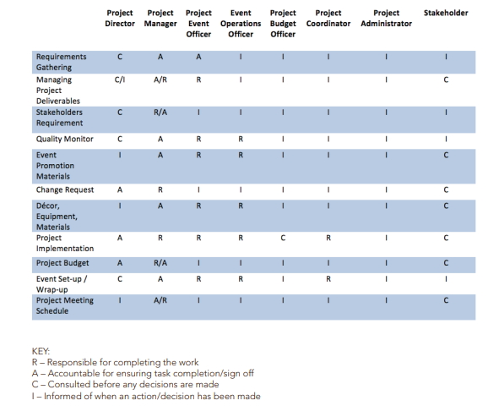
Resource Calendar
Year: 2023- hours | Concept (3 days) | Development (23 days) | Implementation (73 days) | Project Close-Out (21 days)
Project Director | 24 | 0 | 0 | 168
Project Manager | 24 | 184 | 584 | 168
Project Planning Officer | 0 | 0 | 584 | 0
Operations, Project Team, Project Coordinator | 0 | 0 | 584 | 0

Project Schedule
The schedule (see appendix 1) outlines the key events, tasks, and deliverables that make up a project and when they are expected to get underway and wrap up. The schedule is planned as linkages between activities and dependencies based on resource allocation and duration. Timeline components are tightly linked to the organisational framework for completing the work.

Risk Assessment
Once risk is identified, it is evaluated on two-dimensional conditions using a qualitative assessment of the probability of the occasion happening and the gauge of the likely magnitudes (Burkov et al., 2018). This system of assessment offers an excellent graphical depiction of in what way the risk is serious. The risk examination offers evidence critical to assess what risks should be treated and what dangers are mitigated.
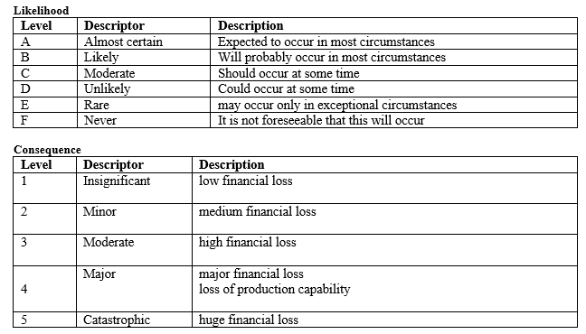
Risk Register
Risk | Likelihood | Consequence
Risk of competition | E | 2
Risk of lacking suppliers | C | 4
Risk of lacking the project's physical space | F | 1
Risk of failures such as mechanical and electricity | D | 3
Risk of getting poor-quality employees | D | 3
Risk of the client not accepting the project result | D | 3
Risk of poor project planning | E | 2
Risk of communication breakdown | E | 2

Probability Impact Matrix: This is a matrix of risks taken from the Risk Breakdown Structure and ranked according to how likely they were to happen. Risk levels are represented by red, yellow, and green, with green indicating the lowest risk.
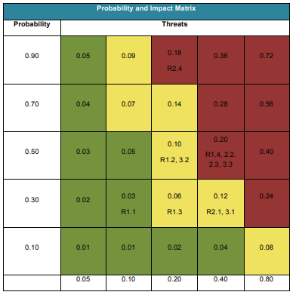
Risk Control
Each risk associated with the event prompted the Project Manager and the Project Team to brainstorm possible preventive actions. When more information about possible threats becomes available, an updated risk assessment and strategy for mitigating such threats will be established and included in the event's ongoing preparations. All project risks will be managed and controlled within the triple constraints (time, scope and cost). Time is the most significant constraint that may be imposed on the four highlighted risks. The project team will analyse each new risk that arises to determine whether or not the current mitigation strategy is still the best option. The Project Manager will be informed of any risks and keep the Stakeholders up to date as necessary. Preventative actions that reduce the likelihood and impact of the risk will be identified and implemented as soon as the project begins. At each stage of the project's execution, we will assess the situation, identify possible threats, and implement protective measures to mitigate their effects. If funds permit, mitigation actions and costs for possible action will be identified to reduce the likelihood and seriousness.

Quality Management Approach
To ensure that the product and the process are of high quality, the team will work together to create a plan for quality control. Success for this project depends on meeting its quality requirements. An integrated quality approach will be utilised to establish benchmarks for quality, measure quality, and enhance quality over time. Quality control for this project will be based on the company's already established norms and requirements. The project's deliverable is the focal point, and the utilised standards and criteria will ensure that the output meets the stated quality standards and the client's needs. While evaluating the success of this project, focus on the methods that will be used to create the final product. In order to ensure that the product is delivered successfully, it is essential to develop process quality standards to ensure that all activities are taken in line with an organisational standard. In collaboration with the Quality Group, the project team will create and document all product and process quality criteria for the organisation and the current project. All quality documentation will be included in the Project Plan and handed over to operations after completion.

Closing the Project
The Project Manager will compile a Project Close-Out Report for each team member throughout the project’s fourth phase. The Project Manager may utilise this report as an opportunity to provide helpful feedback to team members based on their performance throughout the phase of the project lifecycle being reported on. The specific needs for this input will be discussed in further depth in the next paragraph. The Project Manager will discuss the individual's impressions of the project, how it met or failed to meet its professional development goals, and how it would recommend the individual for future work. The project will end by signing the client acceptance/completion form.

References
Burghate, M., 2018. Work breakdown structure: simplifying project management. International Journal of Commerce and Management, 3(2), pp.453–461. Available at: https://www.ijcams.com/wp-content/uploads/2018/11/WBS-2.pdf
Burkov, V., Burkova, I., Barkhi, R. and Berlinov, M., 2018. Qualitative risk assessments in project management in construction industry. In MATEC Web of Conferences (Vol. 251, p. 06027). EDP Sciences. Available at: https://doi.org/10.1051/matecconf/201825106027
Kennon, N., Howden, P. and Hartley, M., 2009. Who really matters? A stakeholder analysis tool. Extension Farming Systems Journal, 5(2), pp.9–17. Available at: https://ageconsearch.umn.edu/record/294276/files/EFS_Journal_v05_no_2_02_Kennon.pdf
Mahapatro, B.B., 2022. Human resource management. PG Department of Business Management. Available at: http://portal.belesparadisecollege.edu.et:8080/library/bitstream/123456789/253/1/24%202010.pdf
Maria, N., Budiningsih, S., Kusumadewi, D., Werdhani, R.A. and Adriani, A., 2018. The Effect of Snack Intervention toward Working Duration among Helper Workers in Container Company. Journal of the Indonesian Medical Association, 68(12), pp.462-469. Available at: https://openresearch.lsbu.ac.uk/download/e1e8e730bae4195ae9c072221f992e83e91fcd9cb1ab65cfeb367103ea61edb8/280316/Paper_CIB_W099_2020.pdf
Sanghera, P. and Sanghera, P., 2019. Planning Project and Scope. PMP® in Depth: Project Management Professional Certification Study Guide for the PMP® Exam, pp.115–153. Available at: http://dspace.vnbrims.org:13000/jspui/bitstream/123456789/4296/1/PMP%C2%AE%20in%20Depth%20Project%20Management%20Professional%20Certification%20Study%20Guide%20for%20the%20PMP%C2%AE%20Exam.pdf
Shirazi, F., Kazemipoor, H. and Tavakkoli, M. R., 2017. Fuzzy decision analysis for project scope change management. Decision Science Letters, 6(4), pp.395-406. Available at: http://m.growingscience.com/dsl/Vol6/dsl_2017_3.pdf

Appendices
Appendix 1: Schedule
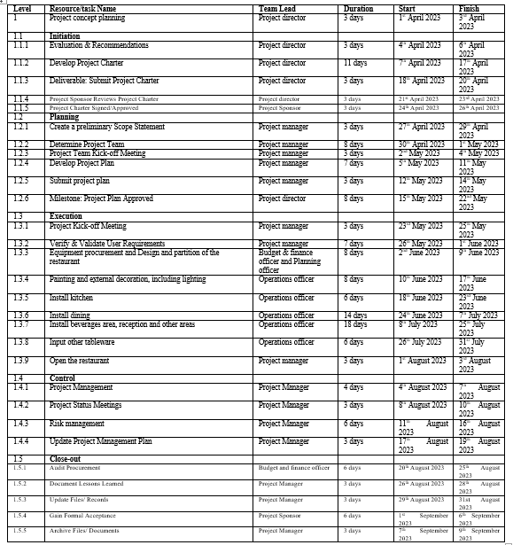
Appendix 2:
Task 1- Pitching of Project Management Plan (Group Presentation)


