
MODULE CODE: Digital Skills for Personal Development and Business Growth BMSW4008

ASSESSMENT COMPONENT: PORTFOLIO

STUDENT NAME: Ivelina Spirova

STUDENT NUMBER: 2507826

LECTURER: Philipa Fitzgerald

DATE: 12th December 2025

I confirm that I have not presented any AI generated materials as my own work.
I confirm that I have copies of my drafts, notes, and other resources I used, which I may be asked to provide in evidence.

Contents
Task 1 4
Assessment of Digital Skills 4
References 6
Task 2 7
LinkedIn Learning Certificates for Office365 7
Task 3 8
Essay on Relevance of Excel in professional and personal life. 8
References 11
Task 4 12
7 Minute Reflective Presentation 12
References 12

Task 1

Assessment of Digital Skills
Screen shot of my JISC report
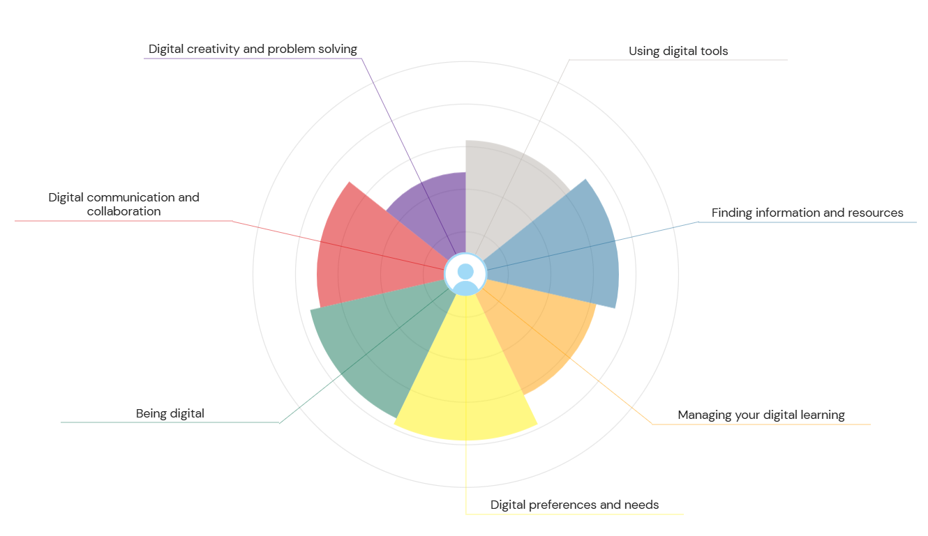
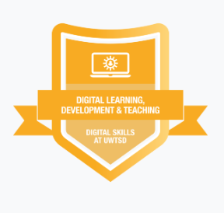

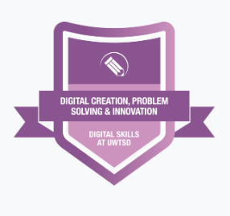
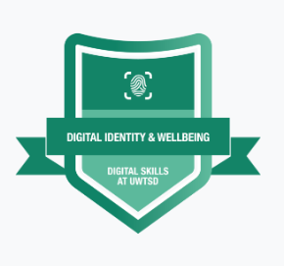
These are my badges I completed:

Strong digital skills are a must have if you want to succeed both in education and employment in today's society. Digital skills can help with your career growth and recent employers are looking for candidates who have good knowledge of using digital tools (digitalhill,2025). They are also taught in schools. Students get to use different digital tools such as PowerPoint and Word, which are the most common one’s used in education. Digital skills means students get used to challenges such as problem solving, since some programs sometimes require them to deal with troubleshooting (Collegenp, 2024).
The author completed the JISC Digital Skills Assessment to find out her current weaknesses and strengths. Her JISC report shows that her highest strength is being digital, which for her is a big advantage, as this course requires students to use a lot of digital skills. Another strength of hers is finding information and resources. This is another important thing , as this module requires a lot of research for referencing purposes. One of her column is digital creativity and problem solving. What this means for her, is that she is able to use digital tools to complete tasks and organise her work appropriately.
However, this report also showed her the weaknesses she has. One of them is digital communication and collaboration. She feels confident in using basic communication tools, but group projects such as Teams makes her feel a bit unsure. Working in this skills will make feel more confident when she has group projects and she’ll be able to communicate in a professional manner.
The second weakness she needs to work on is managing digital learning. This involves organising her study material and keeping track of her deadlines, such as this assignment. By improving this area, she will be able to stay on to of her work and be on time with her assignments by not leaving them for the last minute. Improving these skills, will help her with her learning, as this will help her keep on track with her deadlines. Improving these skills will not only help her in her studies but also prepare her when it comes time to go into the workplace.
By building and learning from her strengths and weaknesses, she will continue to adapt new digital skills. This will enable her to adapt to new technologies, be successful in her studies and have a successful future career.
One great weakness of digital skills is distraction, which is very relevant to the author. The presence of social media and games can divert students attention. One minute, they could be so engrossed in studying and the next they will be on their phones scrolling through social media. Multitasking can have a huge impact on students learning (educatly, 2024).

References
Digihill. (2025) Importance of Digitall Skills in Todays Workplace. Avaialble at: https://www.digitalhill.com/blog/importance-of-digital-skills-in-todays-workplace/ (Accessed 12th December)
Collegenp (2024) 10 Importance of Digital Skills for Students. Available at: https://www.collegenp.com/article/importance-of-digital-skills-for-students (Accessed 12th December)
Educatly (2024) Unpacking the Disadvantages of Technology in Education. Available at : https://www.educatly.com/blog/477/unpacking-the-disadvantages-of-technology-in-education (Accessed 12th December)

Task 2

LinkedIn Learning Certificates for Office365
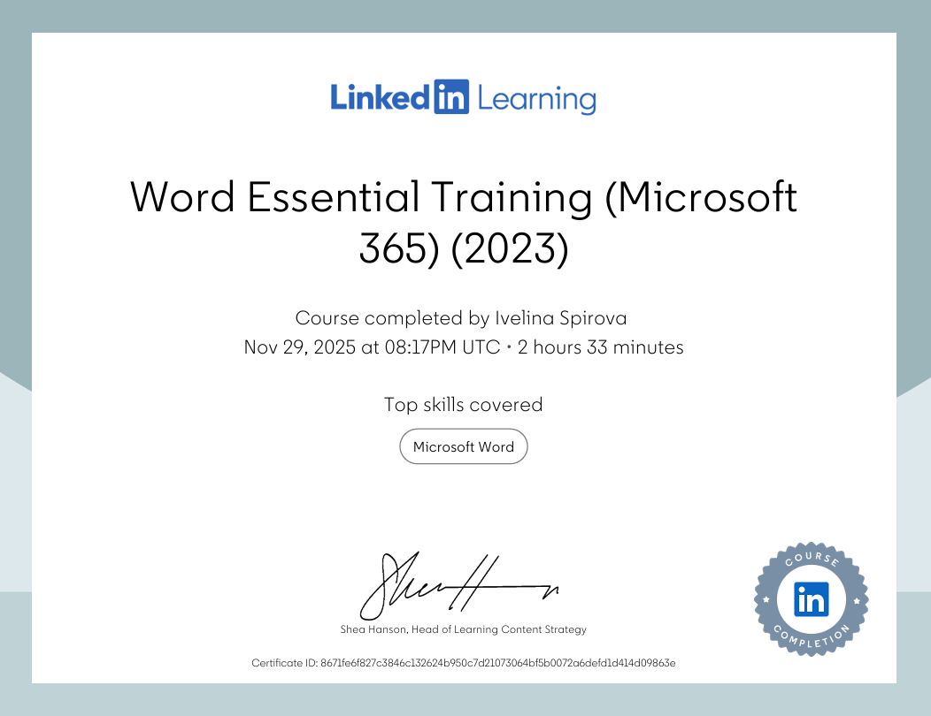
Certificates from LinkedIn learning

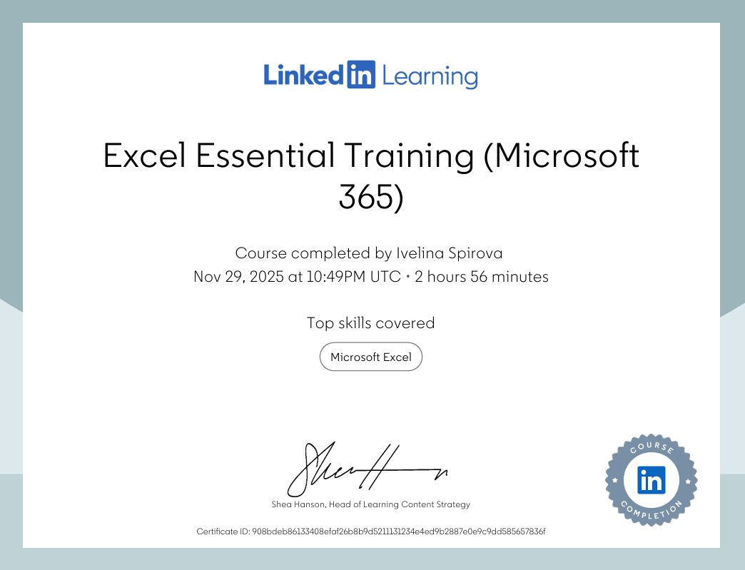

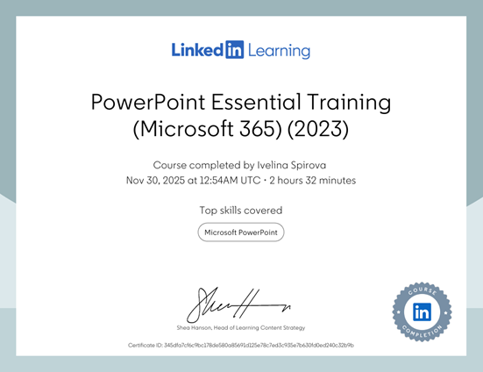

Task 3

Essay on Relevance of Excel in professional and personal life.
Microsoft Excel is widely known Microsoft programme and it’s a part of the Office 365 software. It has been around since 1985. Excel helps business manage, analyse and organize data. It's made up of structured grid containing rows and columns, which form separate cells where than the user can input numbers, text, formulas and fractions (Gillis, 2021). By filling the cells with data, it allows you to do anything from basic calculations to complicated data analysis. There are many features to Excel which can be used to make calculations easier. One of them is the future Quick Analysis, this feature allows you to select your data, click it and access the Quick Analysis menu. Then based on the data you input you will preview of the charts, tables, formatting and tools you could use depending on your choice (ExcelHelp, 2021).
Excel is a popular tool that is used in businesses. With the grid layout and sorting feature it allows employees to handle and arrange big sets of data. By using Excel to input information on there, it becomes easier to access, more structures and easier to analyse. A real life example of this would be the sales team using Excel for customers sales data for quick access and analysis (GeeksforGeeks, 2025). There also are basic functions and formulas that can be used when making calculations that every accountant must know. One of the most known ones is SUM, using this formula will let the user find out the total amount for the month. Another one is FUNCTION. This formula is used to find out the average income for the year. If the spendings go over the budget, the accountant could use the IF formula to check if the transactions are over the budget. Using these formulas will not only make it easier for the user but also save their time of typing a sum of numbers (Admin, 2025).
Excel has become a huge part in education as well. Teachers can use the programme to keep attendance and monitor student details like grades. For example, they can use formulas to input the final grades which then will refresh automatically as they get new grades. Inputting data into an Excel spreadsheet will enable you to convert the data into graphs and charts which makes it easier for users to understand the trends and patterns. For example, it could be used in science to show the growth of plants and species under different lights. It could also be used to assign tasks and set deadlines. This teaches students project management skills (FasterCapital, 2025). By getting used to using Excel, students get confident in using it and can set up budgets and track expenses for their future financial goals. Students can use Excel to play around with different variables and create scenarios to see visible results (Jasaitis, 2025). Getting them used to this programme will make their lives easier when they transfer to their career and it will be easier for them to work with large sum of numbers.
While Excel is used a lot in businesses and education, it could also be used in your personal lives as well. You can use Excel spreadsheet to note down your personal finances to create a detailed budget and sort out your expenses like groceries and utilities. Using formulas could help you to find out your total expenses and create pie charts and graphs to show help you see your spending trends and spot the areas on where you could save (Williams, 2024). For example, below is a household income and spendings spreadsheet she created using the Excel programme. She made the spreadsheet as reaslistic as possible to for a typical household of two people living together. She didn’t use her income as she is not working currently so she made it relevant for a couple living together. While setting up the spreadsheet she organized the income section on the left and the expenses to the right. The title of the columns are bolded to make the categories stand out clearly. To make the spreadsheet clearer and easier to read she added background colour to the header cells to separate them from the main data. To add all the income and expenses she used the SUM formula. This function helped her find out the monthly balance without needing to calculate them each separately. She made sure each figure was in its correct respective row to keep the spreadsheet accurate. Overall, she made sure her Excel spreadsheet is effectively presenting financial information in a clear, organized and professional way.
In conclusion, Excel’s value and flexibility makes it a must have tool. Using Excel, you can calculate, organize and analyse data, making it handy for personal and work-related needs, and it also saves you time with the calculations. Whether it’s keeping track of your household expenses or helping with your business, Excel will help you to handle all that information with ease. With its mix of formulas and formatting options, users can make fast decisions based on the results. According to Acuity Training (2025) 57 % of people have intermediate Excel skills. Given that Excel is widely used in today’s society, knowing that 1 out of 10 people only have beginner skills. Overall, this shows us how important it is to develop further Excel skills. The more people get used to Excel and its features, the better they get in analysing and organizing data. It will help your data be more accurate by cutting down human mistakes and will boost efficiency. Being able to use Excel is very important as technology keeps changing since it can be used for anything as simple as grocery shopping to keeping track of business financial reports.
To wrap it up, Excel is a programme that enables users to make smart decisions. The importance of it shows that in today's modern world having skills like being able to use Excel confidently is not just useful, but also an investment for your future opportunities.

My spreadsheet:
Income | Amount per month £££ | Expenditure | Amount per month £££
Wage 1 | 1800 | Rent/Mortgage | 750
Wage 2 | 1800 | Council tax | 110
Trust Funds | 0 | Electric | 150
Stocks/Share payouts | 0 | Gas | 150
Universal credit | 0 | Water rates | 50
Student Finance | 0 | Food | 250
Other | 0 | Car insurance | 90
 |  | Car Tax | 15
 |  | Fuel | 200
 |  | Child Care Costs | 0
 |  | Loans/credit cards | 0
 |  | Other eg Birthdays/savings/holidays | 600

Embed your excel here

References
Alexander S. Gillis. (2021) ‘What is Excek?’, Tech Target. Available at: https://www.techtarget.com/searchenterprisedesktop/definition/Excel (Accessed 11th December 2025)
ExcelHelp. (2021) Surprising Excel Facts You Didn’t Know. Available at: https://www.excelhelp.com/microsoft-excel-expert-excel-facts/ (Accessed 11th December 2025)
GeeksforGeeks. (2025) Importance of Microsoft Excel in the Workplace. Available at: https://www.geeksforgeeks.org/excel/importance-of-microsoft-excel-in-workplace/ (Accessed 11th December 2025)
Admin. (2025) Step-by-Step Guide on Excel Accounting and Finance. Available at: https://basicexceltutorial.com/guide-for-accounting-and-finance/ (Accessed 11th December 2025)
FasterCapital. (2025) Excel for Teachers: Classroom Innovations: Excel Applications for Educators. Available at: https://fastercapital.com/content/Excel-for-Teachers--Classroom-Innovations--Excel-Applications-for-Educators.html (Accessed 11th December 2025)
Algirdas Jasaitis. (2025) How To Get Excel for Free as a Student, WPS Blog. Available at: https://www.wps.com/blog/how-to-get-excel-for-free-as-a-student-step-by-step-guide/ (Accessed 11th December 2025)
Ethan Williams. (2024) Best Uses of Excel in Daily Life, Your Excel Buddy. Available at: https://yourexcelbuddy.com/best-uses-of-excel-in-daily-life/ (Accessed 12th December)
Acuity Training. (2025) Excel Statistics: Facts and Figures. Available at: https://www.acuitytraining.co.uk/news-tips/new-excel-facts-statistics/
(Accessed 12th December)

Task 4

7 Minute Reflective Presentation
Embed PowerPoint here

References
RedSquid.(2018) 10 Things You Didn't Know You Could Do with Microsoft Outlook. Available at: https://redsquid.co.uk/blog/10-things-you-didnt-know-you-could-do-with-microsoft-outlook/ ​
Kelley, K. (2025). 11 Key Benefits of Microsoft 365. IntermediaIntelligent Communications. ​

