0

  - Certificate in higher education in the workplace
  - Business report

Student name kirsty pinder
Student number 1814431
Lecture Name dr yohan

Module code BMSK4002

Module name effective team working and communication

End date 9/08/2019


kirsty pinder 1814431 Dr yohan
1

Table of contents

Cover page ………………………………………………………………………………………………….1
Table of content ……………………………………………………………………………………………..2
Introduction …………………………………………………………………………………………………..3
Main body …………………………………………………………………………………………………….4
Conclusion ……………………………………………………………………………………………………5
References …………………………………………………………………………………………………...6

2

Introduction

Here in this report you will see how effective communication skills are in a workplace, and also for the continued success of an organisation in this report you will see how effective communication skills in a workplace and on how its very important you will see from case study that I have re’searched about tells us how communication skills in the workplace effect us and how it can improve our communication skills within the workplace so im going to show you why communication skills are effective and how it can keep the company growing in this report you are going to here about another company who is ran by Susie was hoping to get a bit more help from other companys and you will see that there is different types of communication so please if need be look at some of the references and that will explain in more depth communication is one of our most important skills as that’s how we retrive information and by giving information out to other peers this is how we get jobs and also run a business and also day to day life we learn communication skills as its part of who we are in this report you will see how there are different forms of communication and different ways

- What is the definition of communication

The definition of communication is (Definition of Communication, n.d.) by merriam:webster these resources have got a clear and fully understanding of what communication means im just going to put a few bullet points to show what ways you can use as a form of communication.

- Signs
- Faical exspressions
- Body langaue

These are just a few that have been named so you have got a bit more of a clear understanding of what communication skills is and you will see why it has to be effective in a company as communication does need to happen in order for her business to run smoothly communication is one of the big factors you need in running a good business here is another source who is also validating what this means (Ferguson, Lennox-Terrion, Ahmed, & Jaya, 2014) were also going to see why effective communication in a workplace is important.

- Main body.

- Why effective communication is important for the continued success of organization.

This is very important in a company as without this there company wont run smoothly these are some people that have researched other organization (Neal, 2010) this is why without good communication and clear communication things could go down hill for Susie.

- The importance of two way communication.

In this report you will see why its very important to have two way conversation from reading the case study Susie for one hasn’t got a lot of collegues Susie only took 20 people and from reading it half of them weren’t there or of for maternity leave and you have also got some doing overtime which no doubt wont be happy but from having the two way communication you do have a bit more understanding and im sure if this helps because you have got a lot of different cultures , people who cant understand English , from the information im reading its much better if its face to face communication as you can understand and see how these people are because with a business you need to try and be quite confident ,sharp but also have a good tone and demeaner (Morreale, Osborn, & Pearson, 2000) have even done there research on why its so important.

- Effective methods of communication in the case study.

I found that by reading Susie case study is that she did start of 20 employers and half are not there some are doing overtime and there is only 2 managers I understand that it sounds like ive only a few employers left but if I talk to them face to face and do staff meetings if there is a problem im hoping that it will get resolved but I do believe that she can keep a good business going you just need the write staff and partner that is equal with you and everyone in your company because one wrong move and potentionaly Susie business can go bad but seen’s tho she asking for advice my advice would be have a few more extra workers for the 1 that went on maternity leave as someone would need to fill there space and then theres the overtimers I would do a little incentive for them like extra pay if this was my company I would promote it anywhere I could do staff meetings every morning and I would only take on as many as I really needed but just a few extra as my emergency backup I know Susie has done well because as it says in her case study she has got another little business so Susie has got decent managering skills which is what people need as with marketing communication goes I was just esearching what for of communication skills they use in there workplace (Armstrong, 1980) im hoping that buy looking at some of the brainstorm gives you a lot more understand on how communication in a workplace needs to be very affective for everyone to achieve there own companys one day.

- What is the significance of non verbal communication to an employers.

The importance of non verbal communication isn’t good as you would be aware that by not bein able to talk to your employers they wont know what to do as a job so it would be better to do verbal communication instead (Tidwell, n.d.)this is another source that I have researched on to see how non verbal communication don’t and cant work this is how everyone in the world gets and feeds information because without that know one would know what they are suppose to be doing I have put a picture here so you have got abit more of a clear understanding about this report if , in this brainstorm it showing you different forms of communication and to be non verbal to your employer says a lot about you as a person because if that was my employer I would wanna talk to them face to face not no face at least with face to face communication you can see what there saying as there rappor and demeanour would tell you if there happy, sad , and belive it or not even eye contact tells you a little about what there thinking which is mad.

by showing you this reference you will understand the meaning of this (Wark, 1997)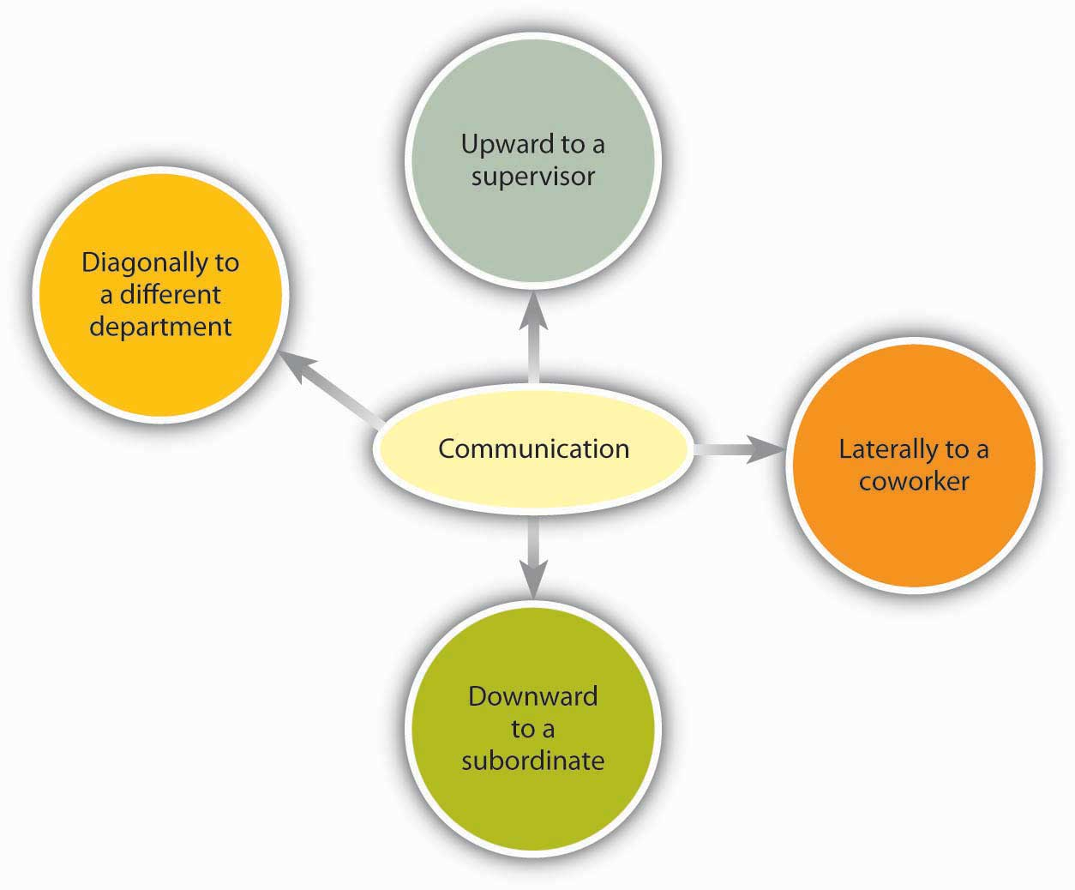
This Photo by Unknown Author is licensed under CC BY-SA-NC
- Conclusion

Here in this report you will see that we have had to research about different type of communication skills in the workplace and I did manage to get most of them looked about the same content but looking at the research I have put some down so if you need to you can just type in the citation that ive put down and it will show you there definition of communication which we all use everyday this is how Susie the case study I was working on was able to manage her company and also make another one from the research I did I found that face to face communication is a lot more healthier as you get to meet them in person and you also get a chance to talk to them my advice to Susie was try and explore and get a couple more staff because at least then if there is any problems within the company you know how to improve on it see that different way of thinking can on improve your business as you’ve said you got a little company so you have got good communication skills as if you didn’t your business will be going down hill im hoping that one day if I ever get my own business at least ive got some tools to do it as ive done my home work but a lot of it you should know anyway as this is an everday thing from the minute you wake up im hoping this information can assit you in what your doing im not sure if this is what your asking of me to do I sure hope so ive wrote the meanings of the communication skills and the most impact it can have on your business to be honest with you I think its amazing how life works as a whole for me anyway but like I said it depends on the person I believe from what I learnt first impression counts as you are an employer at the same time you don’t wanna leave as by one person going I have also seen it go aswell which isn’t very nice exspcially if you have made this business from the ground up and by the sounds of it you’ve done ok because you’ve managed to run another business put a little smaller

5

References

biBLIOGRAPHY
Armstrong, J. S. (1980). Bafflegab Pays. Psychology Today, 12. Retrieved 8 8, 2019, from http://qbox.wharton.upenn.edu/documents/mktg/research/Bafflegab%20Pays.pdf
Communication. (n.d.). Retrieved 8 8, 2019, from http://www.businessdictionary.com/definition/communication.html
Communication. (n.d.). Retrieved 8 8, 2019, from http://www.k12.wa.us/CurriculumInstruct/Communications/default.aspx
Definition of Communication. (n.d.). Retrieved 8 8, 2019, from Merriam-Webster: http://www.merriam-webster.com/dictionary/communication
Ferguson, S. D., Lennox-Terrion, J., Ahmed, R., & Jaya, P. (2014). Communication in Everyday Life: Personal and Professional Contexts. Oxford University Press. Retrieved 8 8, 2019, from https://books.google.es/books?id=HZFXngEACAAJ
Morreale, S. P., Osborn, M. M., & Pearson, J. C. (2000). Why Communication Is Important: A Rationale for the Centrality of the Study of Communication. Journal of the Association for Communication Administration, 29(1), 1-25. Retrieved 8 8, 2019, from http://natcom.org/uploadedfiles/more_scholarly_resources/chairs_corner/making_the_case_for_and_advancing_the_discipline/pdf-atd-jaca-why_communication_is_important_ rationale_for_centrality_of_the_study_of_communication.pdf
Neal, S. (2010). LibGuides: Interpersonal Communication: Interpersonal Communication. Retrieved 8 8, 2019, from http://libguides.butler.edu/interpersonalcommunication
Wark, M. (1997). The Virtual Republic. Allen & Unwin, St Leonards. Retrieved 8 8, 2019

