
Professional Carer Devlopment
By Papia Russell

March 29, 2018
University of Wales Trinity Saint David

Executive Summary

This report aims to draw reflection from experience develop from the learning from professional career development module studied at class.
The purpose of this report will be assessed to showing my own development during this journey and how I have managed to develop new and existing skills and the extent to which I understand myself and my learning.
The report analysis will be well designed to cover the different stages and will be made with suitable research, theory and models that would be act as supporting evidence accumulated from the module.
This report will also look at what the recruitment process is for a primary teaching role. It will break down the process and what can be expected from start to finish.

Table of Contents
Executive Summary 1
Contents Page 2
Introduction 3
Findings 5
Conclusion 23
Recommendations 23
Bibliography 24
Appendices 25

Introduction

Professional development is important because it certify you continue to be efficient in your profession. It is an extant process and ongoing throughout a professional career. Continuing professional development helps you become more effective in the workplace. Professional development helps you to improve your career and progress you to new position where you can lead, manage, influence and mentor others. (Continue professional development, 2014).
To be successful in the role and make you eligible to apply for a job you need to show a mix of employability skills. Employability skills are the foundation part of your career development building. Good interpersonal skills entitle you to make a decision, manage your time efficiently, take responsibility, problem solving, critical thinking, become strong communicator for the organisation and work effectively with other employees. (Skills you need, 2011)
In this report I will be looking at my professional development, by conducting a SWOT analysis, GOMAD and other such methods of testing myself. These tools will help guide me, show me where I am strong and where I need to take appropriate action.
Communication skill show leadership skills, it is how you present yourself to your audience. It could be verbal communication or non-verbal communication. You need to be loud and clear when getting your massages across. You need to be think about your body language and how it can be read by your audience. Employers will always look for a presentable person who has good communication skills, good communicators generally prove to be good leader. (Communication theory, 2018).
Time management is an essential skill for success at work and in general life. It is the ability to control our use of time to such an extent that we are able to plan and manage what we do without undue stress or tension. Time management skills show how you an individual looks at the task in hand, how you break the task down and prioritise each section. What kind of planning you are carryout and a vital part of time management is how you perform under pressure, this will show the employer how reliable and efficient you are. (Morgan, P 2017).
A process of searching prospective employees and stimulating them to apply jobs in an organisation. For example, identification of existing sources of applicants and developing them. Also, certain of new sources of applications, stimulating the candidates to apply for jobs in an organisation and striking a balance between internal and external source. Selection is a process of ascertaining the qualifications, experiences, skills, and knowledge skills of an applicant with a review to appraising his/ her suitability to a job appraising. (Torrington et al, 2005).
The last part of the report will be focused on the recruitment process and how a suitable candidate is selected. In doing this part of the report it will also help me personally to understand how the process works and what kind of criteria the employers look at before selecting the candidate. This will help set myself up in the right path and make me more employment ready.

Findings

Part 1. Reflection of the learning journey.
SWOT:
What is SWOT Analysis: SWOT analysis is a strategic planning technique used to help a person or organisation identify the Strengths, Weaknesses, Opportunities, and Threats related to business competition or project planning. It is intended to specify the objectives of the business. (Mind Tools Essential Skills For An Excellent Career ,2018)
Swot analysis is also applied to find out an individual’s strength, weakness, opportunities and threats. Once these facts are uncovered it can help the individual to take positive action and ready themselves for any threats.
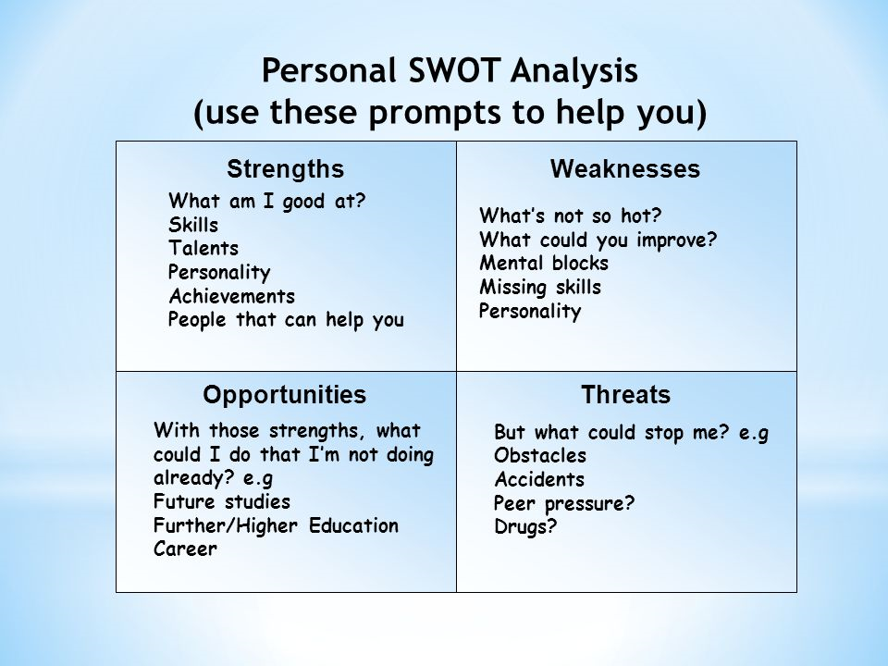
Personal SWOT:
Strengths:
I am an extremely focused individual who will always push myself to achieve my goals. Persistent in what I am doing until I feel I have done what was require of me to a high standard. I like to plan things out and I will do everything possible to stick to the time line and the plan. My main goal is to work with children in the highest position possible, over the past few years I have been taking steps towards that goal. I have qualifications in childcare and health and safety amongst others which is giving me a grounding and a solid foundation. People I work with or have worked with will always tell you, that I am good organiser who always like to have a major input in the task in hand. (Mind Tools Essential Skills For An Excellent Career ,2018)
Team player with leadership skills. I am proud of a lot of my achievements but the main one is while studying I have been able to bring up three beautiful children, proving to me that I can manage and work around anything to achieve my goals. It is very important to stay focused, always remember what I am doing all this for. I am an understanding person who is always willing to learn. (Mind Tools Essential Skills For An Excellent Career ,2018)
Weaknesses:
I need to build on my confidence levels which are very low, though I have self-belief when it comes to working in a crowded place or forward my plans to people I do not know already I can be quite hesitant. I know that is down to lack of practice and will change in due time with more practice. People around me will tell you I stress too much and sometimes, I should just take a deep breath and step back a little. Educationally I am learning and progressing my skills but one area I think I have a weakness is putting my thoughts and plans in writing but again I know this and am doing my best to solve this. Though my family are my strength I know I always have to plan and work around everything this sometimes will mean I have to take more slower steps towards my goals. (Mind Tools Essential Skills For An Excellent Career ,2018)
Opportunities:
My industry will always have plenty of opportunities simply due to the fact working with children there will always be a job where ever you go in the world. I have people I worked with also family members who work in a variety of roles working with children, so whenever I need advice or guidance that support is always there. One area I would like to focus on is children’s technology, I feel there is an opportunity to do something different and speak in a language the children will appreciate and take interest in learning, this I feel is missing in a lot of childcare but in this day and age, is very important. (Mind Tools Essential Skills For An Excellent Career ,2018)
Threats:
There is not what you call direct threats in my industry due to the fact the children will always require care and guidance. Outside influence could prove to be a threat such us my personal family life might change, I might be involved in a life changing accident or maybe my partner. Such issues can arise in life and cannot be helped. Other thing that could be a threat unless kept in check is technology knowledge and keeping up to date with the latest tech. (Mind Tools Essential Skills for An Excellent Career ,2018)
These threats can be taken care of, firstly family and friends, as you probably have noticed they are a big part of my strength to, should such threats arise as mentioned above then I have a large circle of friends and family who are always willing to step in and help out, so these factors will not be an issue.
Secondly the threat of technology moving on, simply I must take appropriate action and stay up to date and turn it into my strength, by means of external courses if need be.
Go Mad
This is the think process/tool for someone who wants to make a difference, does not matter if it is a small or a big one. It is for someone who has a goal they have set for themselves, with good reasons for setting that goal. That is not enough they also need to have the motivation to carry out the process, through the planning stages, right through to the action stage making sure they get the desired result. Setting a goal and heading straight into the action stage without the planning required will most likely end up in undesired result/failure. This is why you would use the Go Mad theory.

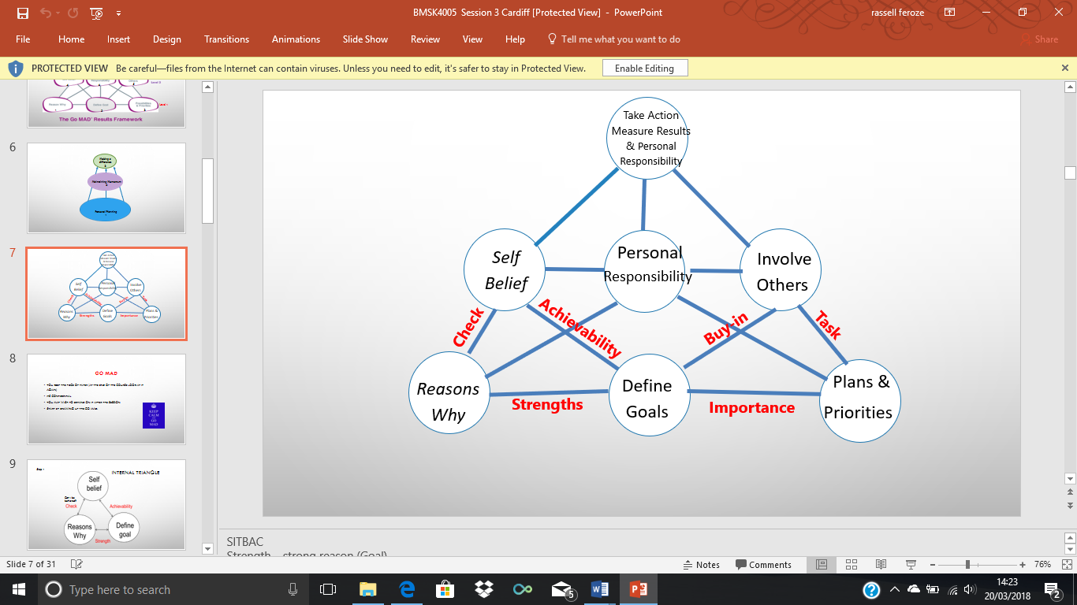

Personal Go Mad
My personal goal is to get a job in the teaching field. To gain relevant skills that a required to achieve my goal I will need a minimum of Diploma if I would like to teach primary school.

Reasons why I am choosing this is, as I am already working in a play group and I have the qualification NVQ L2 in early years. Other reasons why I am doing this is for a better life for me and my family, I like working with children and that fact I will be improving myself in areas such a communication and my confidence, getting that self-satisfaction. (GO MAD Thinking, 2018)
I need to stay focused and, on the plan, take notes be prepared at all times. Break my studies down to manageable tasks and making sure of prioritising which tasks needs more urgent attention, making sure I keep to deadlines. (GO MAD Thinking 2018)
I have the self-belief in my ability to work with children/pupils and other adults, I know I am hard working, patinate, motivated and will do whatever is required to a high standard. I have worked with some extent of challenging behaviour and I know I can with in that area if required. Always willing to learn/teach and better myself and others around me. (GO MAD Thinking 2018)
I will face many personal responsibilities during to achieve my goal , such as attending teaching Diploma course on time, revision for tests. I need to improve on my reading and writing skills, studying the mistakes I am making and learning from them. (GO MAD Thinking 2018)
I have a good network of people around me, who will always help and guide me during each stage be it my colleague’s, teachers or my family. (GO MAD Thinking 2018)
Finally, to stay on top of what I am doing I will need to keep eye on my progression at each stage, look at the results and take action accordingly. I will be extremely proud of my achievements if I am able to complete teaching Diploma course and get good results. (GO MAD Thinking 2018)
Honey and Mumfords Learning Style.
Learning styles were developed by Peter Honey and Alan Mumford, based upon the work of Kolb, and they identified four learning styles or preferences Activist, Theorist, Pragmatist and Reflector. To understand your particular learning style Honey and Mumford have developed a Learning Style Questionnaire, armed with this information you are in a much better position what works for you as an individual.
After completing Honey and Mumford’s (1992) learning style questionnaire, my highest score was reflectors and second highest score was theorists. This indicate that my strengths and learning styles are those two reflector and theorist and my weakness are as activists who do not review learning achievements and opportunities and prefer solitary work and pragmatist learning style. In addition, my personal results of Honey and Mumford’s (1992) learning survey point out that I like watching and thinking rather than be doing which effectively indicate that I am a theorist style learner more than the reflector learner. Additionally, learning styles can be developed to expand the variety skills obtained for learning purposes. (Honey and Mumford’s 1992)

VARK Learning Strategy.
VARK stand for Visual, Aural, Read/Write and Kinesthetics, it is a questionnaire that helps your learning by suggesting the strategies you should be using.
It is an individual distinctive approach to learning based on strength, weakness and preference with a mixer of various learning style. I carried out VARK learning style online questionnaires and the best score come out the way I learn as visual and verbal learner. Visual learners learn better with physical rather than explanation word. (VARK2018)
My last result was reflective learning and I think this is a very fair assessment of the way I learn as I am more into the critical analysis of a subject or concept. I prefer studying on my own rather than in a group and thinking things thoroughly first on my own. (ukessays, 2018)
The view that learning styles are a dynamic process are shared by Kolb(1984)who stated that learning is not a fixed trait and changes slightly from situation to situation and Honey and Mumford’s (2000) who believe that learning style can be adapted to suit the circumstance. (ukessays, 2018)
Personal Development Plan for at least one key learning objective.
My key learning objective is to gather the necessary qualifications to work with children as a teacher. Next step is to complete teaching diploma course with good marks and gathering more knowledge.
As it has been pointed out to me that my style of learning (according to Honey and Mumford’s learning style) is a Theorist which tells me that I need to take time to take in information, prefer to read lots of materiel, think about something before applying it. As the course is already broken down into two modules, which is further broken down in reports, coursework and presentations for each module. My personal development plan needs to be to break each of these parts of the modules into smaller sections, set a plan and a timetable, doing regular self-assessments and very important is also to get feedbacks to my work at regular intervals, taking action as required. The key to effective formal feedback is to have a process and manage it. (Honey and Mumford’s 1992)
As my desired role is to become a teacher, I would like to get more practice doing presentations, writing reports, get involved in group discussions. The main reason being is to build my self-confidence, be comfortable in these scenarios, where I will have to talk to an audience, guide them and show authority. Developing in other areas are going to be important to, such as my communications skills, verbal and non-verbal. (Communication theory, 2018)
Also getting an idea how to break larger projects down to manageable task, how to prioritise the task in hand is vital. For me these are the goals and the main objectives from this course, to improve myself, better my understanding and knowledge of key skills that are required in the work place. Make myself a more rounded, confident individual who can adapt and manage any task that are set. (Skills you need, 2018)

Objective | Process | Action | Desired Outcome
Presentations | Planning.  Structuring.  Working in a group where required.  Compiling the findings. | Carry out the presentation. The more presentation I do the stronger I get. | Be full of confidence, no matter who or how many people are in the audience.  Be able to get my message across clearly and with plenty of energy.
Report Writing | Formatting.  Collect relevant information.  Putting the data together in the correct way.  Time management. | Keep to the time scale.  Get regular feedback.  Stick to the objective of the report.  Reference all the work as and when required. | Make report writing second nature, understand the set objectives and break it down into smaller task.  Time management and planning come automatically. Juts be more assured and more efficient.

Part 2. Recruiting and selection process for a job.
Recruitment is for a primary school teacher (in Wales). This part of the report will be looking at what steps need to be taken and the whole process, how it all works and comes together to find the right candidate for the job.
Recruitment Process.
Job description.
A career as a primary school teacher offers one the chance to teach the basics in a variety of subjects and to get pupils into learning for their future.
Primary school teachers support, observe and record the progress of pupils aged 7 to 11. Teaching the national curriculum, the candidate will plan lessons in order to meet the set objectives, with the aim of encouraging the pupils to take interest into learning. (Sage Advice,2018)
Teachers must keep up to date with any developments, new resources, methods and national objectives. They will be required to work with other teachers, parents and carers in order to make sure the objectives are met. (Sage Advice, 2018)
Responsibilities.
Being a primary school teacher, you will require to do the following:
- Plan and deliver lessons to the class working to the objectives that are set in the national curriculum.
- Marking work, give feedback and keep records of pupil's progress and how they developing.
- Select and use a range of different learning resources and equipment.
- Making sure keeping the atmosphere in the class is good, handling misbehaviour in the correct way.
- Supporting pupils on an individual basis through academic or personal difficulties.
- communicate with parents and carers over pupils' progress and participate in teacher’s meetings, parents' evenings and whole school training events.
- supervise and support the work of teaching assistants, trainee teachers and newly qualified teachers.
- Up to date teacher training. (Job Responsibilities, 2018)

Salary.
Newly qualified teachers Wales start on the main pay range, which rises incrementally from £22,467 to £33,160.
Working hours.
Thirty-nine weeks of the year are allocated for teaching but teachers often use time within the 13 weeks’ holiday for marking, planning and preparing. Hours vary between schools but are usually from 8.30am until 3.30 or 4pm. Most teachers are in school before the school day starts and remain after school is finished. Marking and preparation are usually done at home. They often teach five periods a day. (Job Profile, 2018)

A typical personal specification for a primary school teacher:

 | Essential | Desirable
Qualifications | Qualified Teacher status. | Evidence of continuous INSET and commitment to further professional development.
Experience | The Class Teacher should have experience of: teaching at Key Stage 2 especially Years 5 & 6. | In addition, the Class Teacher might have experience of:  Teaching across the whole Primary age range.  Working in partnership with parents.  Working in a Church School. Teaching mixed classes.
Knowledge and understanding | The Class Teacher should have knowledge and understanding of:  The theory and practice of providing effectively for the individual needs of all children (e.g. classroom organisation and learning strategies).  Statutory National Curriculum requirements at the appropriate key stage. The monitoring, assessment, recording and reporting of pupil’s progress.  The statutory requirements of legislation concerning Equal Opportunities, Health & Safety, SEND and Safeguarding Children.  The positive links necessary within school and with all its stakeholders.  Effective teaching and learning styles. | In addition, the Class Teacher might also have knowledge and understanding of:  The preparation and administration of statutory National Curriculum tests. The links between schools, especially partner schools.
Skills | The Class Teacher will be able to:  Promote the school’s aims positively and use effective strategies to monitor motivation and morale.  Develop good personal relationships within a team. Establish and develop close relationships with parents, governors and the community.  Communicate effectively (both orally and in writing) to a variety of audiences. Create a happy, challenging and effective learning environment. | In addition, the Class Teacher might also be able to:  Develop strategies for creating community links.
Personal characteristics | Approachable Committed. Enthusiastic Able to motivate self and others. Calm under pressure.  Well organised.  Work in a team.

(Ask Teacher Job, 2018)

APPLICATION FORM FOR TEACHING POST

Applicants, please note:

- If the advertisement states that electronic applications will be accepted, the Application Form should be emailed to the dedicated email address provided in the advertisement and only to that address.

If applications are required to be submitted by post, the Application Form must be sent to the Chairperson’s address as specified in the advertisement.

- The completed form must arrive at the dedicated email address/specified postal address on or before the date and time stated in the advertisement. Late applications will neither be accepted nor considered.

- Canvassing will disqualify.

- If completing this form in handwriting, please use black ink.

The successful candidate will be required to present original documents in relation to teaching/other qualifications prior to appointment.

Office use only | Received by: | Date: | Time:

Applicant’s Personal Details
Name (as per Teaching Council Register)
Correspondence Address | Mobile Phone No
Correspondence Address | Landline No
Correspondence Address | E-mail Address (please print clearly if completing in handwritten format)
Qualification to Teach at Primary Level
Qualification(s) | Awarding University,  College or Institute | Final results received:  Day/Month/Year
Teaching Council Registration
Registration Number __________________

Registered under Regulation (please tick as appropriate):
Regulation 2 (Primary) 
Regulation 3 (Montessori and Other Categories) 
Regulation 4 (Post-primary) 
Regulation 5 (Further Education) 

Registration Status: Full  Conditional 

If conditional, please state the condition(s) and the date by which each condition must be met:

Condition 1:_________________________________ Expiry Date: _____________

Condition 2:_________________________________ Expiry Date: _____________

Condition 3:_________________________________ Expiry Date: _____________

Pending: If pending, please state the date of submission of application:_________________

Have you completed the registration condition of Probation? Yes  No 

If Yes in what setting? Mainstream  Restricted 

Details of academic Qualifications – most recent first
Include under-graduate & post-graduate qualifications. Please include any qualifications in special education, if applicable. The successful candidate will be asked to present original documents.
Qualification & Grade | Awarding University, College or Institute | Length of Course | Final results received:  Day/Month/Year

Teaching Experience – most recent first (if necessary expand the section or use additional pages if completing in handwritten format).
*If newly qualified, please go to next page
School Name & Address |  | Date(s) of service in the school |  | Position(s) held | Dates in each Position
From:
To:
Post(s) of Responsibility Held (if any) – Most recent first
School Name | Address |  | Position(s) held |  |  | Dates
From:
To:

*If newly qualified please insert teaching practice grades – most recent first
School Name | Address | Class taught | Dates | Grade
From:
To:

Additional qualifications e.g. ICT, Certificate to teach religion (if applicable)
College(s) | Qualification and Year | Modules Studied

Other relevant, non-accredited courses – most recent first

Areas of Special interest – curricular/other
Area | Expertise/Experience/Specialism undertaken in College

Other Relevant employment experience – most recent first
Employer/Project | Position | Duties | Dates | Grade
From:
To:

Please indicate how you think your experience/skill(s) can assist in this particular post
Not more than 150 words
Please indicate how you think you can contribute to the ethos and success of this school
Not more than 150 words

Additional information (not already mentioned) to support your application
Not more than 150 words

Names & Contact Details of Referees*
Referee 1 |  | Referee 2
Name |  | Name
Role |  | Role
Address |  | Address
Work Tel Number |  | Work Tel Number
Home Tel Number |  | Home Tel Number
Mobile No |  | Mobile No
Referee 3 |  | Referee 4
Name |  | Name
Role |  | Role
Address |  | Address
Work Tel Number |  | Work Tel Number
Home Tel Number |  | Home Tel Number
Mobile No |  | Mobile No

*Please Note:
- Only those referees who know you in a professional capacity should be included. At least *three names should be provided.
- Close relatives and friends should not be listed as referees.
- As it is probable that referees will have to be contacted outside of school times, it is crucial that phone numbers (preferably mobile numbers) outside of working hours, are given.
- If the current employer (where applicable) is not named as a referee, the Selection Board reserves the right to seek a reference from the current employer.
- The Selection Board in its sole discretion will determine the suitability of any reference. The Selection Board further reserves the right to seek from a candidate the names of additional referees.
I hereby declare that all the particulars furnished on this application form are true and correct to the best of my knowledge and that I am aware of the qualifications, requirements and particulars for this post, as set out in the advertisement and other relevant documentation.
Signature ____________________________ Date _____________________

(https://targetjobs.co.uk, 2018)

What to look for in a covering letter and a CV.
A CV should be a summary education, teaching experience, skills and achievement, interests and referees. A cover letter is expanding on details you have mentioned in your CV and may include some of the same information as a personal statement. (Target jobs, 2018)

- Relevant qualifications for this teaching post.
- Look at what previous experience they have in this role.
- How they come across the covering letter, their enthusiasm, willingness to learn.
- Communication skills.
- What the candidate thinks puts them ahead of the other applicants.
- What do they bring to the school that will help the school.
- Ideas and relevant knowledge.
- Good references. (Target Jobs, 2018)

A typical CV for this role might look like this:
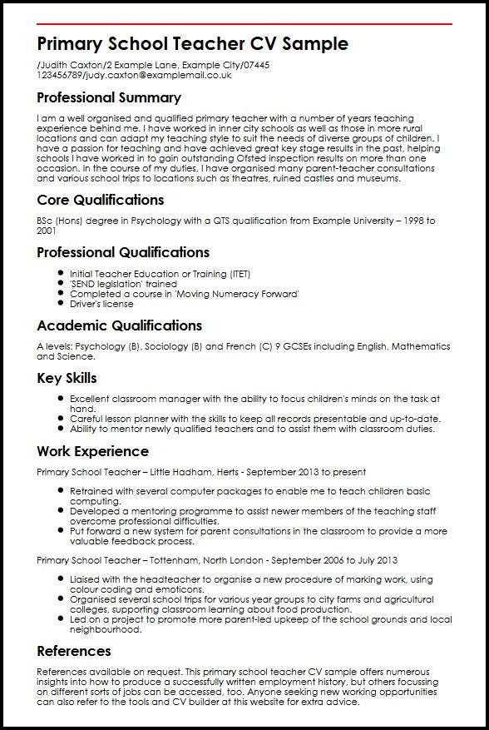
(https://www.myperfectcv.co.uk/cv-examples/primary-school-teacher-cv-sample/)
From the CV and the cover letter the applicant should show personality, individuality and a good understanding of what is required of them in this particular job role. The formatting and clear structure will show non-verbal communication skills.

Interview.
Below are some questions that are generally asked in an interview:
• Why do we teach x in schools?
This is where the candidate will be given an opportunity to show their knowledge and should point out the positive aspects of teaching a particular subject.
• Can you tell me about a successful behaviour management strategy you have used in the past that helped engage a pupil or group of pupils?
This is where the candidate can refer to theoretical process with personal adaptations.
• Why do you want to work in this school?
Candidate needs to show they have done good levels of research into what the school stands for, how it operates, even previous visits to the school will show the level of commitment.
• What are the key qualities and skills that students look for in teachers?
Show an understanding of what the pupil’s look for, authority, sense of humour and leadership.
• If we decided not to appoint you, what would we be missing out on? (Career Advise, 2018)
This is simply asking the candidate for one last push to sell themselves.
The interview will be conducted by a panel, which will include the headteacher, deputy head, school governor. Selected candidate will have the required qualifications, personality that fits the job, show willingness to work with others be it pupils or colleagues. Enthusiastic about the job school and its pupils.

Conclusion

By doing this assignment I have learnt first a lot about my self and what is required as in personality and character. How to plan and process the plan, breaking down tasks into more achievable goals. Looking at learning styles such as SWOT and GOMAD I have looked at my strengths and weakness in black and white, though this might have seen obvious but until you see it in black and white you don’t take appropriate action to rectify the issues. (Morgan, P 2017)
As for recruitment process well, I chose the Teacher role to investigate in this section, the main reason being is that is my ambition, to become a teacher, so by looking at the whole process it has helped me to understand and see what is required. Makes me ready and teaches me what I can expect in my near future. (Morgan, P 2017)

Recommendations

I would have like to look into more learning style, its and interesting concept and teaches you a lot about yourself, even the styles I have looked at I would have like to expend on them with further research and exercises.
Given more time and more words to play with would have aloud me to expand on this report. As a whole I can recommend this to anyone as it will teach them so many important facts about themselves and important processes.

Bibliography

Aguinis, H. 2007. Performance Management, 2nd Edition, Upper Saddle River, NJ: Pearson Prentice Haall
www.bartleby.com
https://www.communicationtheory.org
https://www.communicationtheory.org
http://continuingprofessionaldevelopment.org
Durai, P. 2010. Human Resources Management, New Delhi: Pearson Education India
https://www.gomadthinking.com
https://jobs.derbyshire.gov.uk/recruit/attachments/2111/Weston%20on%20Trent%20Pers%20spec%20for%20class%20teacher.pdf).
http://www.jobresponsibilities.org/primary
(http://www.knowsley.gov.uk/docs/Hope%20Primary%20Teacher%20Person%20Spec.pdf
https://www.mindtools.com/pages/article/newTMC_05.htm
(https://www.myperfectcv.co.uk/cv-examples/primary-school-teacher-cv-sample/
(https://www.prospects.ac.uk/job-profiles/secondary-school-teacher)
https://www.reed.co.uk/career-advice/how-to-write-a-cover-letter/
https://www.sage.com
https://www.skillsyouneed.com
(https://targetjobs.co.uk
https://www.theguardian.com/careers/2016/oct/19/cv-cover-letter-examples-for-teachers)
(https://www.theguardian.com/teacher-network/teacher-blog/2014/jan/29/teacher-job-interview-questions-top-ten
Torrington, D. Hall, L. and Taylor, S.2005. Human Resource Management, Essex: Prentice Hall/Financial Times

Appendices

Some of the research I had to do to find out my learning style.


