

MODULE CODE: ACCC5004
WEB DEVELOPMENT

Lecturer Name: Suneth Fernando

Name: Octavian Cristian Libotean
Student ID: 1815958
Table of Contents
Research 3
Introduction 6
Testing 8
Evaluation 13
References 14
Appendix 15

List of figures
Figure 1: Test Case 1 9
Figure 2: Test case 2 9
Figure 3: Test case 3 10
Figure 4: Test case 4 10
Figure 5: Index.php 11
Figure 6: Registration.php 11
Figure 7: Course.php 12
Figure 8: Logout.php 12
Figure 9: Studetails.php 12
Figure 10: Coursedetails.php 13
Figure 11: Course page 16
Figure 12: Login page 16
Figure 13: Registration page 17
Figure 14: Course registration admin page 18
Figure 15: admin studetails page 19
Figure 16: admin update course page 20
Figure 17: admin update student details page 21
Figure 18: student course details page 22
Figure 19: student details page 23

Research
This assignment is related to a website based on the course registration management that is developed for the students. This website supports dynamic content utilising programming language based on server-side such as PHP. There are defined various frameworks or models related to PHP which are utilised for development to execute web solutions or applications. Though the latest evolving web technologies based on server-side are becoming much more famous, PHP still knows how to keep 79 percent of the high share on technologies utilised for developing web applications. The research section presented critical evaluation and research of certain utilised frameworks or models of PHP for developing web applications.
1. CodeIgniter: - This is known as the framework of PHP and suitable for interactive website creation. It provides various prebuilt modules that support developing reusable and robust components. This framework of PHP is straightforward and lightweight PHP framework that is hassle open and free to load. It is perfect for beginners because of an easy setup method and highly detailed documents. Key features involve the architecture of MVC, built-in security tools, top-notch errors management and excellent & simple documentation. Furthermore, CodeIgniter builds scalable software. Compared with some other frameworks of PHP, CodeIgniter is significantly quicker. Since it often provides solid performance, when the developer wants to build a lightweight application to operate on moderate servers. In contrast to another framework of PHP, this framework is also simple to read, utilise and customize. The CodeIgniter performance factor is very good since this has a limited footprint that can be utilised to build portable web applications (Das and Saikia, 2016).
2. Laravel: - This is the most famous open-source, free framework of PHP as Laravel can manage complicated web application safely, at a significantly faster rate than other architectures. Laravel optimizes the process of development by easing standard tasks including routing, caching, authentication, and sessions. Laravel framework of PHP is suitable for designing software, whether large or small with specific backend specifications. Downloading the Laravel framework of PHP has been created simpler by adding Homestead, all-in-one and a prepackaged vagrant box. The Laravel framework of PHP is perfectly adapted for applying the pattern of the MVC (Model View Controller) for designing complicated web applications (Prokofyeva and Boltunova, 2017). This framework helps developers to handle code for complicated applications effectively. With the pattern of MVC of creation, data control, as well as data manipulation regarding the web application, can be best applied. The layout helps developers to produce a clear and clean code with a much smaller risk of glitches. It focuses on performing routine tasks more accurately and easily.
3. Symfony: - This framework of PHP is a robust PHP MVC system & the only structure proven to obey PHP and internet specification to tee. This framework of PHP is also the best option for large-scale business growth programs. For most systems, it’s simple to install and customize. Symfony is considered the best option for designing large-scale business ventures. It is simple to customize and install most systems or platforms. Symfony also has independence from the database engine and it is robust, complies with other best practices as well as architecture patterns on the web and enables integration with the other product libraries. This framework of PHP comes with advanced review features which make it easier to evaluate web applications as this is optimized into the structure itself. This helps developed to validate web apps while they are concurrently being created (Laaziri, et al., 2019).
4. Yii: - For creating modern web apps, this is high performance element based on the framework of PHP. Yii is an idea for web applications thus, it is also considered a universal programming framework of the web. This framework of PHP provides a simple installation method. Besides, the robust security capabilities make the system ideal for highly protected operations including projects in e-commerce, CMS, portals, forums & many others. This has outstanding reliability as well as the speed that is highly extensible & helps developers to escape the difficulty of writing redundant SQL statements since they can design object-wise database data. This framework of PHP allows developers to reduce implementing repetitive statements of SQL. This framework of PHP comes with appropriate and powerful software such as GII (Global information infrastructure) that automatically creates the code (Latif and Kusumasari, 2018).
5. CakePHP: - This framework of PHP can help the developer to build feature-loaded website that is visually stunning. Furthermore, this framework of PHP is the best to understand easily due to its framework for CRUD (create, update, read and delete). CakePHP is easy and simple to install because the developer only requires web server & a copy of the framework. CakePHP makes a better option for commercial apps because of security features that involve input validation, SQL injection protection, CSRF (cross-site request forgery) protection and, XSS (cross-site scripting) protection. This framework of PHP has a broad library as well as components features that make it easier to implement complicated web applications. CakePHP has built-in functionality that boosts web application stability such as anti-CSRF, input validations & SQL injections.
6. Phalcon: - This framework of PHP employs the web architecture of MVC design pattern. This framework was written in C++ and C. This framework of PHP is also simple to install & suitable for developing highly configurable applications of web that are following the requirements for enterprise growth. Increased execution speed, top security & caching, asset management and universal autoloader are the main features of this framework of PHP. Considered to the other frameworks, this improves performance because of its effective memory utilization. Phalcon has a drawback in which developers of this framework are a bit late to fix bugs, which does not match the reality with the requirements for high-security standards (Njenga, 2018).

Introduction
This assessment is focused on website creation related to course registration management system for students that promote complex content using programming language based on server-side. The website related to this system is developed and introduced via a university & on this system, separate programs are introduced. Students can apply for courses from the internet that are linked to the 4 CertHE course level (two courses) where students are participating in this course for the workplace, social care and health. In every course, 8 modules are included and considered. Students can just apply for a particular course as well. The website admin verifies and validates the submission after the student is eligible for the course. Students should pass the assessment about grades and consequences concerning every module. Students are allowed to re-sit missed modules up to 2 times at the most through the utilise of this system. Once the whole module of the courses is done then the student can request the certificate.
This website of course registration management system for students is created with the utilise of certain web technologies as well as tools including CSS, PHP, HTML, and MySQL. This website follows such criteria as the navigation bar that includes home, student details, course details, log in, contact and logout), university name, logo, footer section, details of university and slide show display etc. More specifications are often provided on this website, such as records that should be stored in an acceptable structured database. This website can connect to the servers to view material and include it on the pages of the website. On the web page related to the course, the details of the course and module are shown. On the web page related to home, the logo, university name, slide show, navigation bar, university regarding details are shown. Students and admin can use the website to log in. On the web page related to login, a login form is presented and it can be done by establishing the login webpage for the customer. The process of verification, as well as validation, is significant for checking the login details of the students that allow the students to migrate to the corresponding web page (such as the student web page).
On the web page related to student details, students may change their private details and retrieve details of the course where they have enrolled. On the web page related to admin, the admin may edit, add, and delete details of the courses & also verify the student submission. This assignment discusses various sections such as research, testing and evaluation. In the research section, this assignment presents the framework or modules related to PHP web technology. In the testing section, this assignment presents all valid test cases that are applied in the developed website.

Testing
The most important aspect of the production cycle is testing. This is the step where all of the specifications and criteria are tested to check whether all of the website’s functionalities are working correctly or not. This phase of testing checks the errors and bugs that are managed such that the users will not face any issue while operating on the website as well as performing a lot of tasks. There are discussed various test cases regarding the website (Lakshmi and Mallika, 2017).
Test Case 1: - The below-mentioned screenshot shows that if the user does not enter the proper email address then a message will be displayed that please include an @ in the email address.
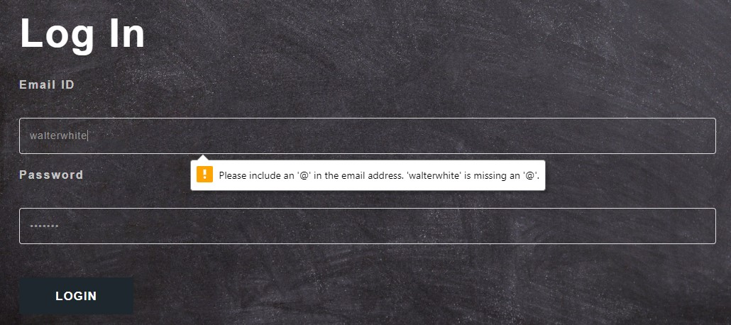
Figure 1: Test Case 1
Test Case 2: - The below-mentioned screenshot presents that the user should sign up for the website, without the signup, the user cannot log in to the website.
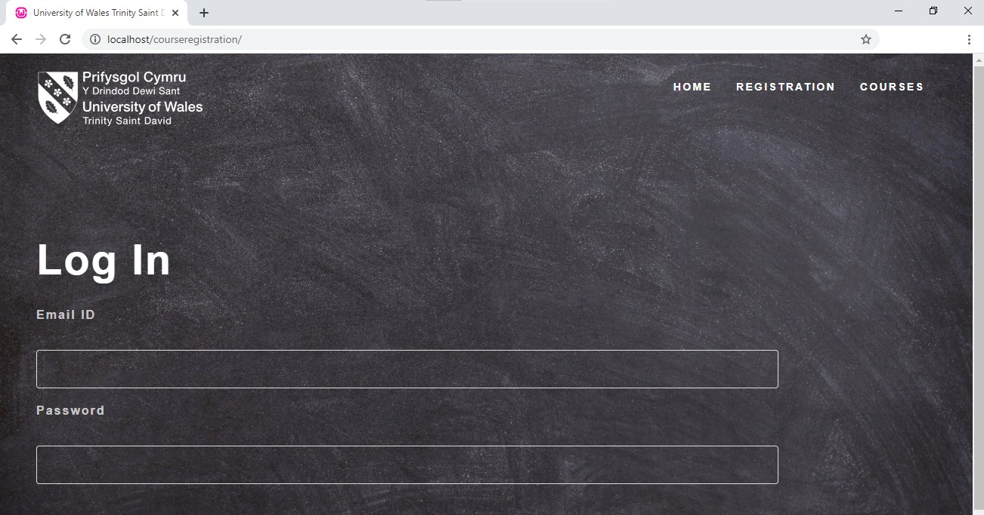
Figure 2: Test case 2
Test Case 3: - The below-mentioned screenshot shows that please enter the proper email id and password.

Figure 3: Test case 3
Test Case 4: - The below-mentioned screenshot shows a registration page in which if the user does not enter the proper email address then a message will be displayed that please include an @ in the email address.
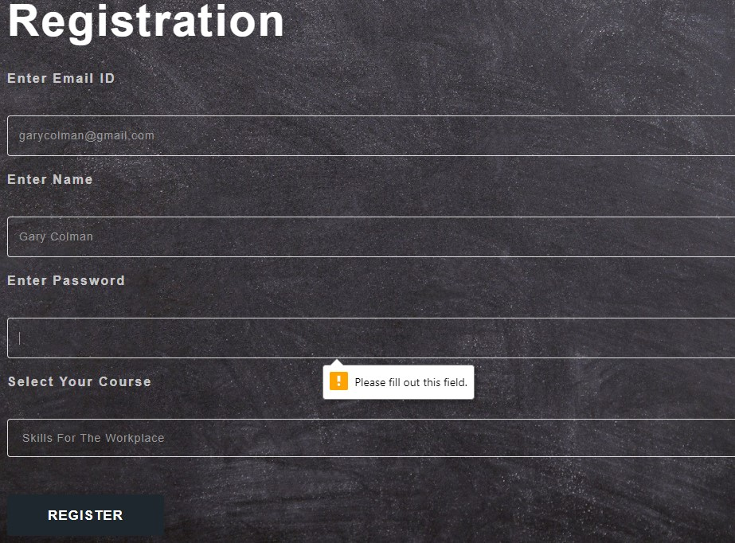
Figure 4: Test case 4

Screenshots of Code
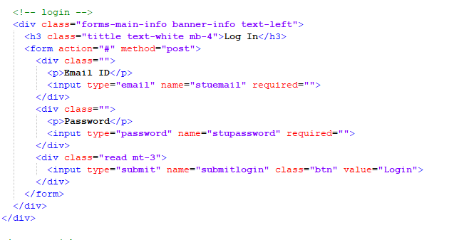
Figure 5: Index.php
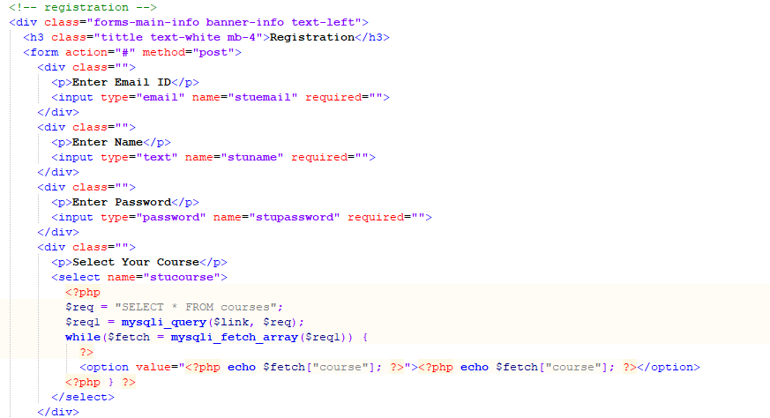
Figure 6: Registration.php
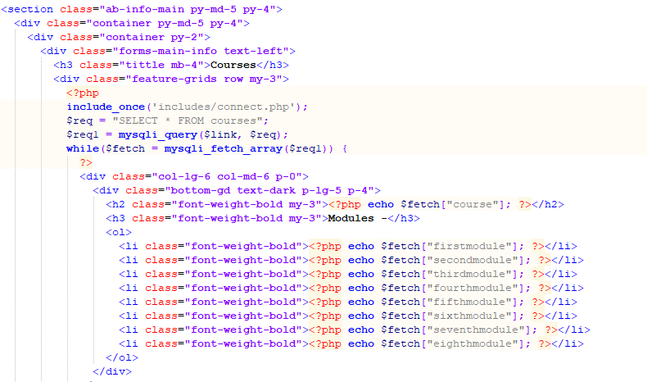
Figure 7: Course.php
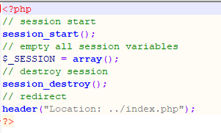
Figure 8: Logout.php
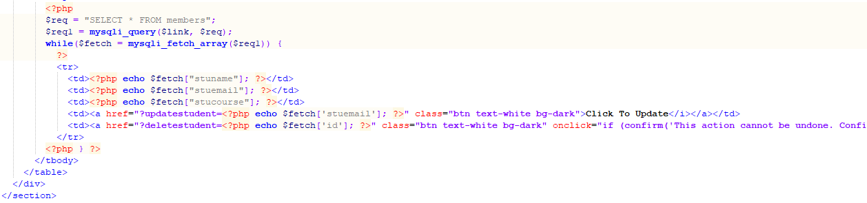
Figure 9: Studetails.php
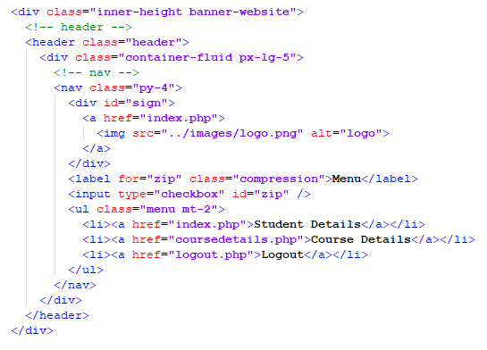
Figure 10: Coursedetails.php

Evaluation
A web app is a full solution for student course registration and selection. A website has been developed for the university which has good efficiency and tremendous promise. It has also fantastic architecture and execution of features that satisfy the specifications. The website also has all of the functionalities as well as features regarding the university-related web application which can be installed on webserver to utilise it. Although this has been developed as a prototype in which the website has tremendous potential for real-world execution to better understand and measure the web application’s capabilities. Both the features that are stable and suitable in performance & the specifications for accessibility have been introduced. The potential changes will be to enhance the UI (user interface) & UX (user experience) regarding the web application (Marenkov, et al., 2016).
The login and signup procedure can be optimized and rendered more protective by incorporating two-factor verification to encrypt the user credentials. The web app can be expanded a lot using applying various features. The functionality and the design can be altered when the features are viewed at the moment. The website can be developed more user-interactive by applying the latest user interfaces and layouts. To make the website more efficient and quicker, the implementation of the feature may be changed. This website design can be developed modular to improve the performance of the website.

References
Laaziri, M., Benmoussa, K., Khoulji, S., Larbi, K.M. and El Yamami, A., 2019. A comparative study of laravel and symfony PHP frameworks. International Journal of Electrical and Computer Engineering, 9(1), p.704.
Prokofyeva, N. and Boltunova, V., 2017. Analysis and practical application of PHP frameworks in development of web information systems. Procedia Computer Science, 104, pp.51-56.
Das, R. and Saikia, L.P., 2016. Comparison of Procedural PHP with Codeigniter and Laravel Framework. International Journal of Current Trends in Engineering & Research, 2(6), pp.42-8.
Latif, U.K. and Kusumasari, T.F., 2018. Comparison Between Yii Frameworks and Laravel In 3 Different Version For Viewing Large Data of Shipyard Industry in Indonesia. International Journal of Innovation in Enterprise System, 2(01), pp.13-18.
Njenga, A 2018, 10 Popular PHP frameworks to consider, Raygun Blog, Raygun Blog, viewed 28 December 2020, <https://raygun.com/blog/top-php-frameworks/>.
Lakshmi, D.R. and Mallika, S.S., 2017. A review on web application testing and its current research directions. International Journal of Electrical and Computer Engineering, 7(4), p.2132.
Marenkov, J., Robal, T. and Kalja, A., 2016, July. A study on immediate automatic usability evaluation of web application user interfaces. In International Baltic Conference on Databases and Information Systems (pp. 257-271). Springer, Cham.
‌

Appendix
Course page
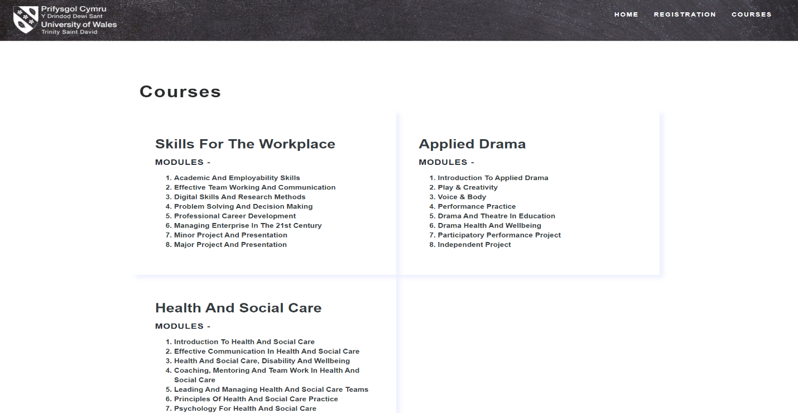
Figure 11: Course page
Login Page

Figure 12: Login page
Registration Page
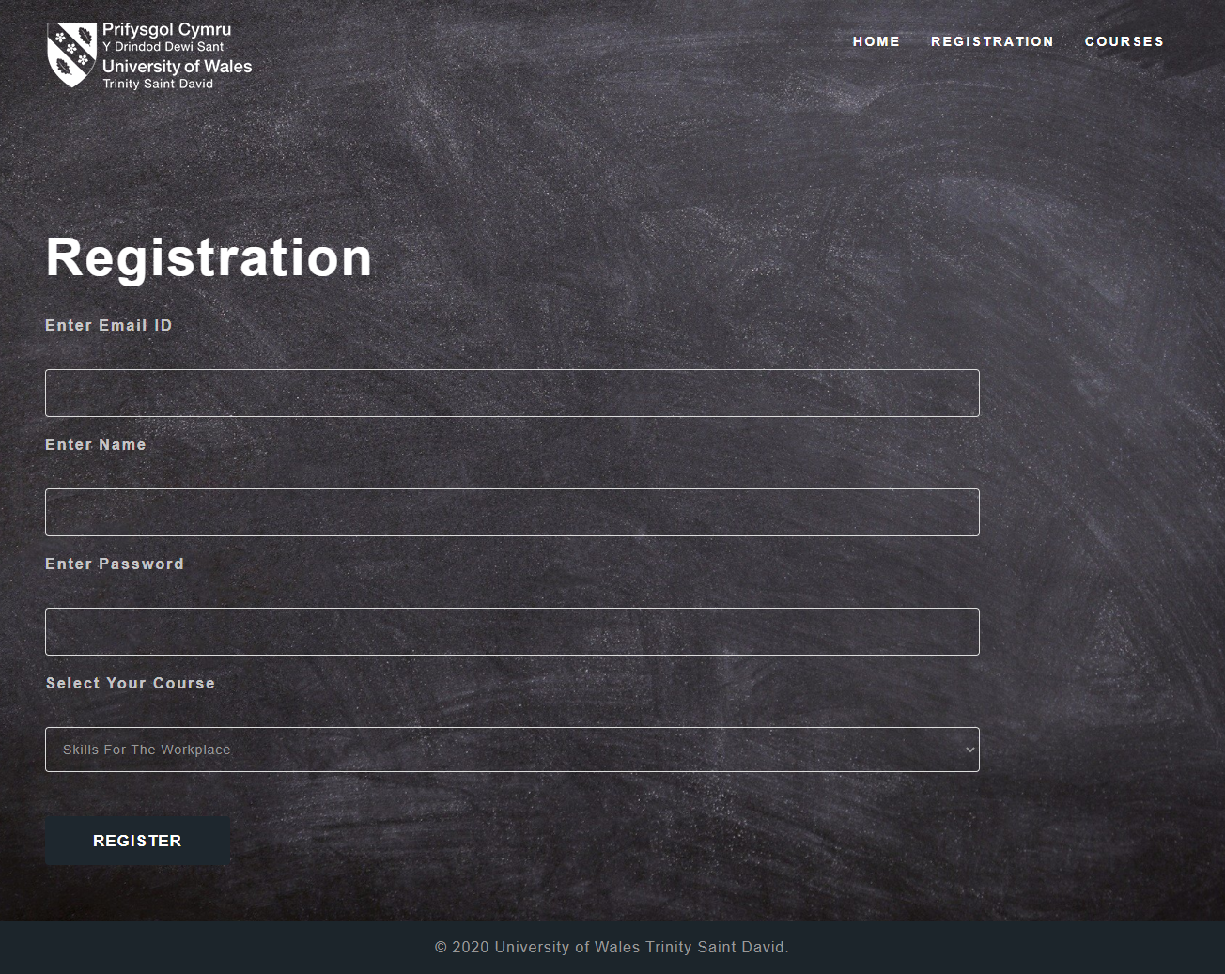
Figure 13: Registration page
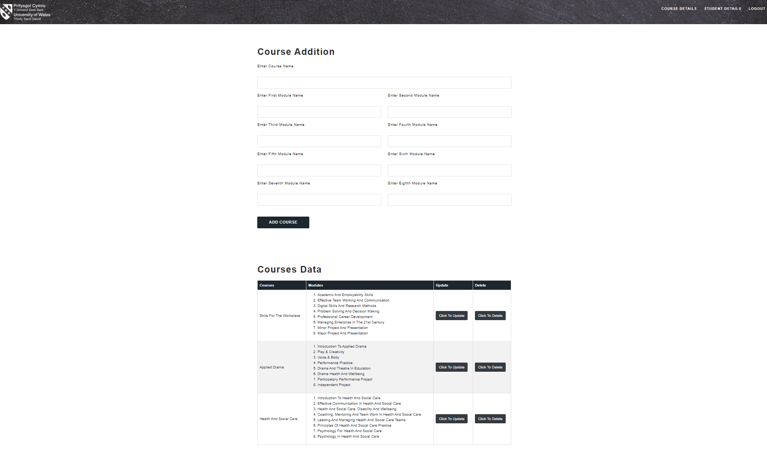
Figure 14: Course registration admin page
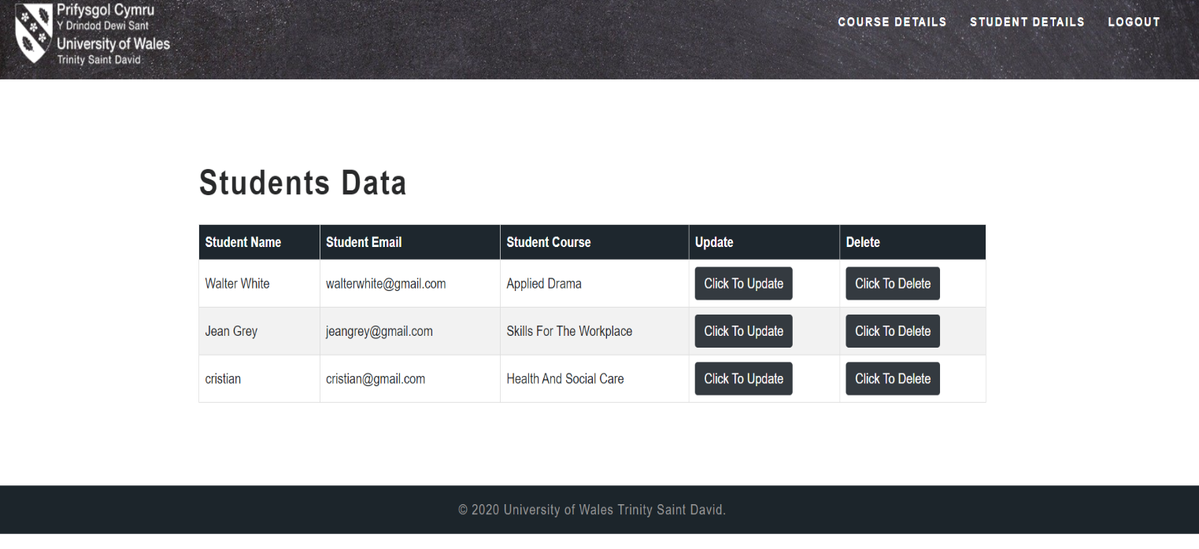
Figure 15: admin studetails page
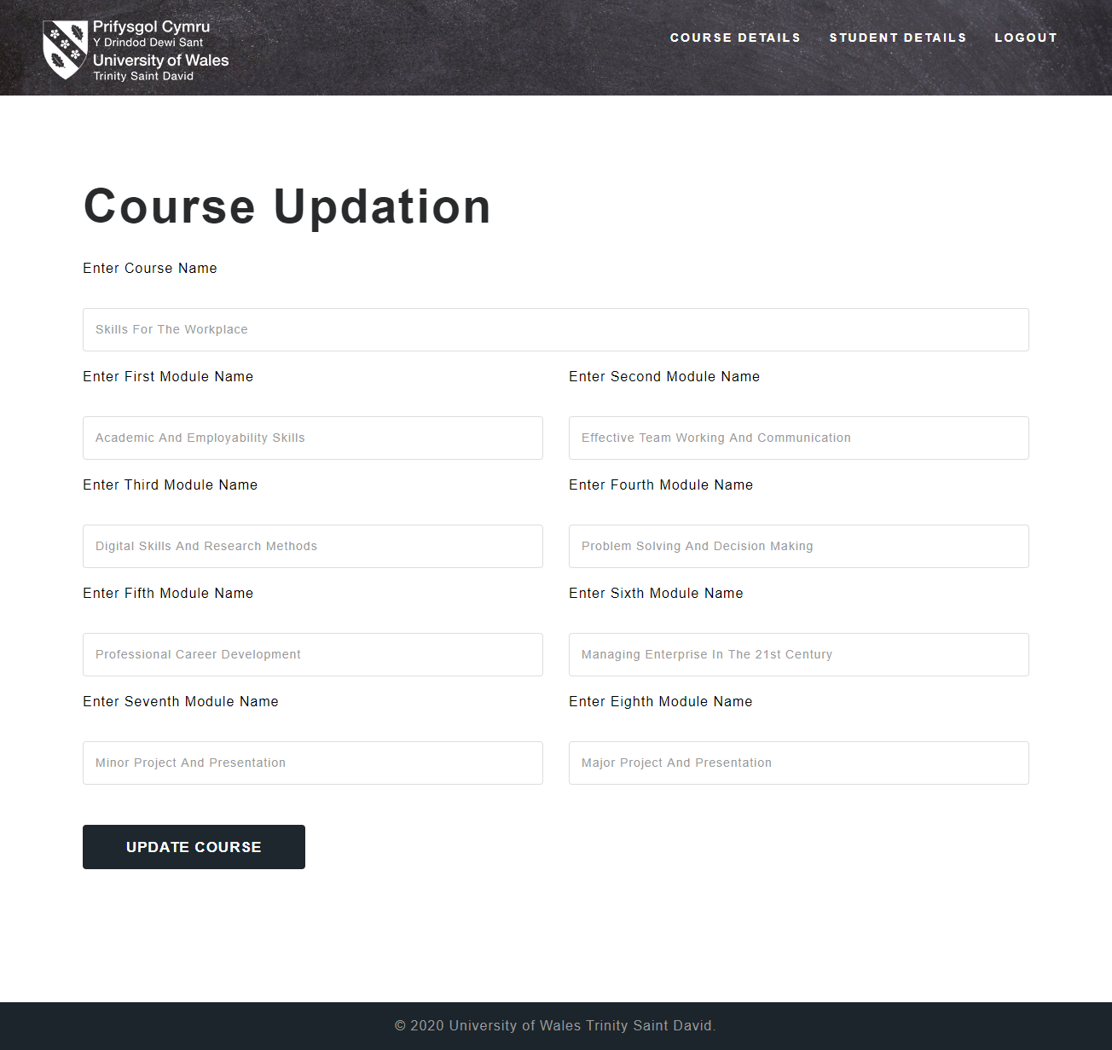
Figure 16: admin update course page
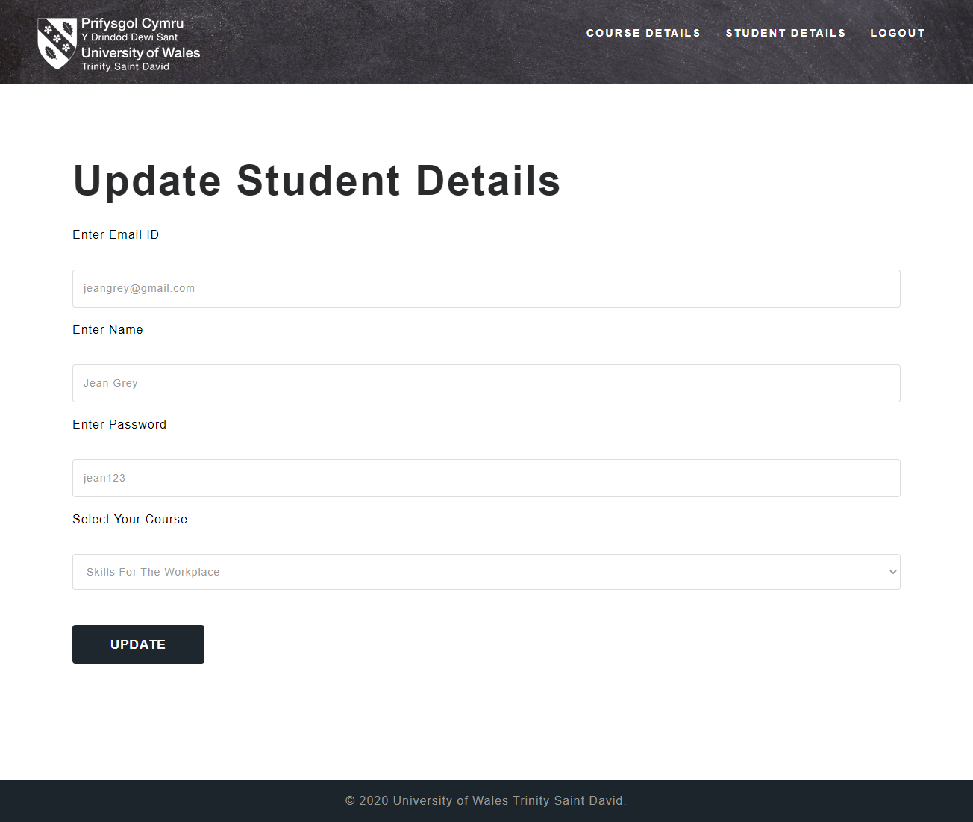
Figure 17: admin update student details page
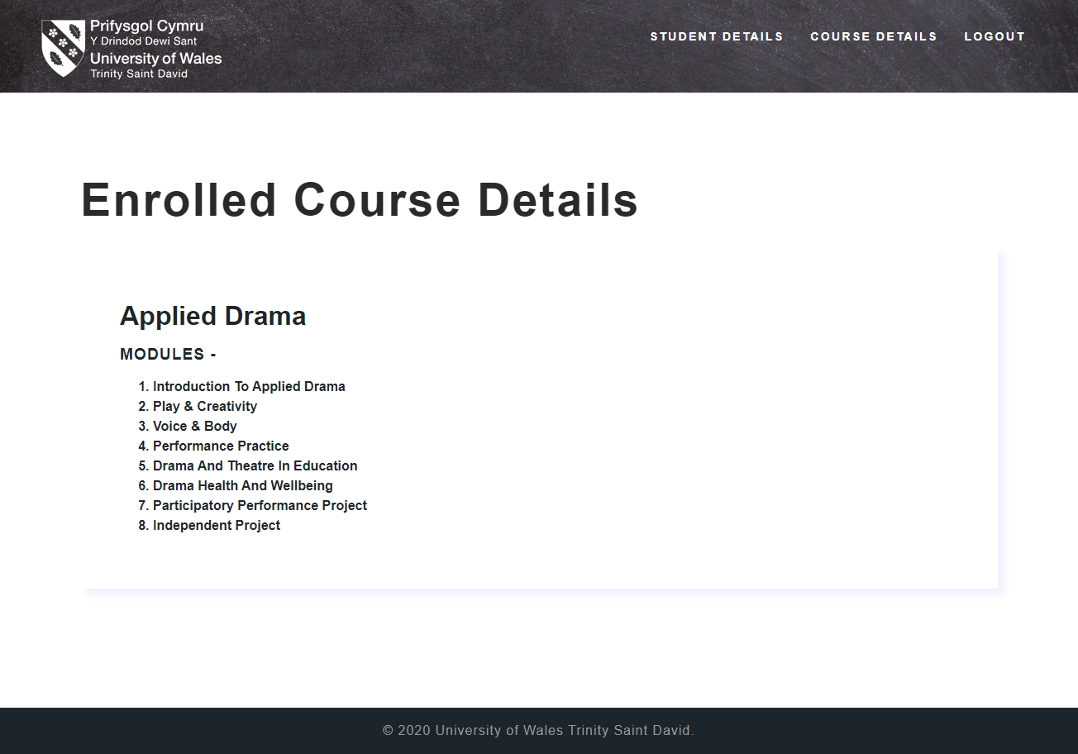
Figure 18: student course details page
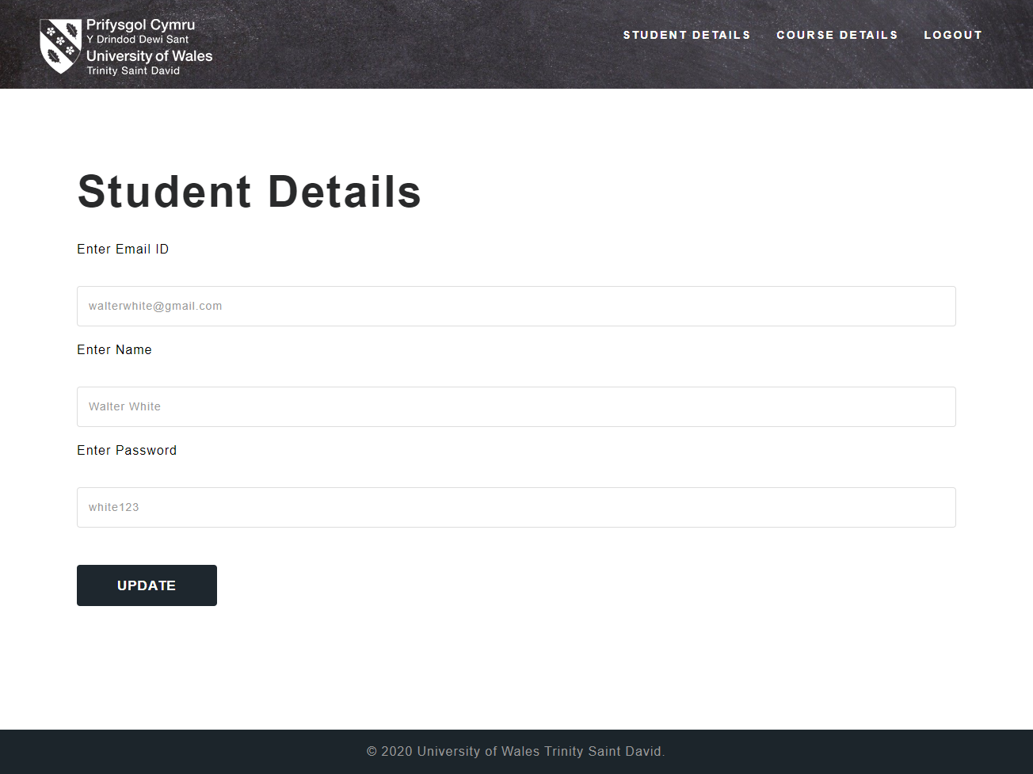
Figure 19: student details page

