Theory of the Spiritual Suprematist
Tariq Marley Bushara
Submitted in partial fulfilment of the requirements for the degree of BA (Hons) University of Wales Trinity Saint David, Swansea
Photography in the Arts BA
Hamish Gane
11th December 2019
5525 Words

Table of Contents
Pages:
III. Introduction
IV - VIII. Essay One: Philosophy of Suprematism
VIII - XII. Essay Two: De Stijl, Modernism
XII - XVI. Essay Three: Psychological implications of Spiritual Suprematism
XVI – XXI. Essay Four: The nature of artistic expression
XXI – XXIII. Essay Five: The Future of Spiritual Suprematism
XXIII. – XXVI. Bibliography

The following essays form a philosophical introduction of Spiritual Suprematism, deconstructing the ideology of the 1914, Suprematist Composition Manifesto, and the unquestionable link between spirituality and creativity. Provoking the collective comprehension of art, this text shall propose a re-evaluation of the Suprematist philosophy and creative expression. It will revive the theoretical views of Kazimir Malevich and evoke a shift of spiritual awareness through the adherence of spiritual supremacy, ultimately leading to an idealistic proposition on creative therapeutic practices. Beginning with the exploration of the Suprematist Manifesto and its originator Kazimir Malevich, I will analyze the philosophical and creative qualities of Suprematism. Secondly, I will review the undeniable similarities of the Suprematist theory and the philosophy of De Stijl, the mathematically poignant art movement introduced by Theo Van Doesburg and Piet Mondrian. Individually, these revolutionary and radical views of art modernized the contemporary mind. And equally represented a beautifully lucid relationship between mindful serenity and raw artistic energy. De Stijl presented to the world, the imminent consequence of the Cubist ideology, resulting in the pseudonym of Neoplasticism. I will examine the parallels of Suprematism and De Stijl, as well as the like-minded individuals who valiantly advocated such radical movements of their respective time. Essentially, the key features of this text will define the rules of conformity to the ever-present energy of organic composition. To define the importance of creative mindfulness, through the theory of Suprematism. The third essay will address the psychological benefits imposed by this ideological practice and encourage the artist of today to seek an internal recognition of spiritual activity and creative expression. Analyzing further into the artistic development of the human experience, the fourth essay identifies the curative act of Painting as the principal manifestation of this creative energy. Ultimately, I will conclude with the apprehensive notion of the future of Spiritual Suprematism, acknowledging the complex nature of this philosophy and its undetermined potential.

Philosophy of Suprematism
The supremacy of pure artistic feeling
The concept of Suprematism is particularly difficult to define. It contradicts and persistently re=evaluates non-objective meaning. It advocates creative expression through the composition of venerated colour and form; however, it neglects to address the powers of the emotional or spiritual state-of-mind as a conductor of such artistic supremacy. Suprematism lasted little more than two decades but paved a future for artistic evolution and radical abstract expression. In the review of Malevich’s paintings, his denial of meaning and condemnation of symbolic gesture directing his practice falls short of the truth in the eyes of the viewer. What Malevich evidentially understood was the organic compulsion of artistic expression. He utilized Suprematism as a language of the universal consciousness. The inborn energy in all of us that seeks to find clarity of life. The omnipresent veil of curiosity and experience of self.
The philosophy of the Spiritual Suprematist defines the matrimony of Suprematism and the creative collective consciousness. Acting on behalf of past creeds, the Spiritual Suprematist seeks to engage with the act of creativity. He seeks to engage with the act of poetry and painting, expressive speech and imaginative evaluation of the consistent present. He seeks to find serenity through abstraction, courage through composition, and in the finality of each creative endeavor, he may find meaning. The Spiritual Suprematist acknowledges the authenticity of nothing, other than the unforeseen destination of time.
Malevich theorized the following principle; emotional engagement and spiritual enlightenment were fundamental in the eyes of the viewer to understand the composition. Evidential in his 1915 oil painting, Aeroplane in Flight, (Fig.1) in which Malevich interprets the pictorial power of pure abstraction through spiritual Suprematism. In the time of Malevich, the cultural consciousness of liberty and avant-gardism escalated without apology. Suprematism presented an ideology that was deeply rooted in the philosophy of spiritual artistic unification.
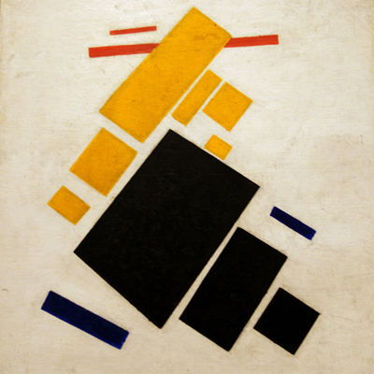

Fig 1: Aeroplane in Flight

However radical the philosophy, however controversial the theory, Spiritual Suprematism will continuously pursue a vision of utopia. In the footsteps of its ancestral theories of the artistic world, it will combine the rule of The Suprematists with the dignification of De Stijl’s geometric methodology. It will engage the enlightenment of mindfulness through the medium of therapeutic art practice. It will arouse a spark in the individual Suprematist.
Just as Suprematism yielded revelation after revelation for artists in the earlier 20th century, so shall Spiritual Suprematism for the future of creative expression, as was prophesied by the avant-gardist. Russian writer and art historian, Aleksandra Shatskikh (2013) points out,
The artist (Malevich) was convinced of the inevitability of the world’s renewal through Suprematism. He had been called upon to bring this belief to humanity. The texts that Malevich could not help but write are filled with prophetic pathos that fuse biblical style and Old and New Testament images with the Futurist rhetoric.
The absolute exclusivity of Suprematism lies in its primordial and enigmatic discovery. Suprematism recognized the individual perception, harnessing form and colour as the collective linguistic. Proposing to unite the world in a concept of artistic engagement and authority. Eradicating hierarchy in the creative world, to educate mankind of liberation of the physical self. Engaging with the act of artistic thought engages with the act of natural creation, organic output, articulation of the mind.
Suprematism unearthed an unfamiliar yet deeply divine approach to an artist of the avant-garde era, only it was far too abstract for the public at the time of its inception. The collective consciousness required time to explore and experiment, adapt and develop. And now, in the time of the contemporary artist, we can fully submit ourselves to the philosophical supremacy of emotional creativity. Surely leading to a cognitive re-evaluation of the cultural implications that art must govern. The fundamental success of a universal, abstract language accepting differences of perception and reality. Fusing humanitarian principles to the artistic evaluation of the mind. In other words, The Spiritual Suprematist seeks to find meaning and illumination through this therapeutic art practice, and in doing so shall individually contribute to the collective acknowledgment of composed form and colour, composed nature and reality.
In his book, The Non-Objective World: The Manifesto of Suprematism, Malevich (1927) mentions “By ‘Suprematism’ I mean the supremacy of pure feeling in creative art. To the Suprematist the visual phenomena of the objective world are, in themselves, meaningless; the significant thing is feeling.” Openly speaking of such abstraction has become shrouded by the essence of materialism and currency, the longevity of worth over-expressive rehabilitation. Kazimir Malevich founded a universal language of the human collective and employed his efforts to advocate this pure artistic process through The Suprematist Manifesto, seeking to free this world from the restraint of social/political depiction.
To unconditionally submit oneself to the supremacy of pure artistic feeling, one must first acknowledge its rightful place in the abyss of our imaginations. For example, to enter a state of creative awareness, one must first succumb to the power of artistic engagement, in other words, evaluate and perceive the framework and utensils of any art form. One must then evaluate the individual perception of each colour and form in the arsenal of artistic tools. And in the union of these factors, the artist sincerely engages with the inner Suprematist, the supreme artistic feeling.
The theory of Suprematism describes a harmonious relationship between composition and abstract self-expressionism. Malevich did not believe in the use of decorative excessiveness or symbolic representation, but in his efforts to engage with his inner spiritual Suprematist he could not escape the interdependent abilities of individual perception and cognitive experience of the world. It is in this simple element we find the liberating truth of expression. Regardless of wealth or poverty, reality and perception, experience and age, a Square is, has been and forever shall remain, a Square.
This unassuming, unpretentious and unstoppable truth of composition represents the balance of life itself. The equilibrium of shape and reverence of colour exposes the spiritual correlation of creativity, and so in humanity.
Malevich embraced Suprematism as the rightful ruler of artistic inspiration, surpassing Cubism and Futurism, endeavoring to go break away from reason and rationality. Malevich's creative instincts were to his philosophy what Mondrian's concept of the world was to De Stijl. Truly enigmatic entities, attempting to restructure the future. And so, perhaps a more exquisite functionality of art should be addressed in the historic re-evaluation of such prophetic artists.

De Stijl, Modernism
and the enduring ascension of Abstraction

In the era of emerging radical art movements, the plastic sovereignty of De Stijl gained a faithful following of painters, sculptures and architects. De Stijl artists practiced the cognitive engagement of precisely composed colour and orthogonal forms, demonstrating mathematical logic entwined with abstract expression. The small group swiftly acquired its recognition in the eyes of the world through its new and geometrically beautiful artistic language.
December 1920 saw the combination of De Stijl artists Piet Mondrian, Theo van Doesburg, and Vilmos Huszár, as well as various notable others, exhibiting work in Berlin, Germany, alongside the particularly comparable Russian avant-gardist Kazimir Malevich. The European artists of Neo-Plasticism saw in Malevich an equally kindred spirit. Both parties accepted one and another as an abstract expression of the contemporary mind. Both parties exhibited passion in the territory of universal understanding and unification. Transcending artistic theory into philosophical doctrine.
The exposition of intersectional shapes on a white background is the fundamental aspect of comparison that the neo movements of Suprematism and De Stijl share. Suprematism advocated that an artist should permit 'the supremacy of artistic thought' to compose their image. De Stijl however, promoted an engagement of geometry and a significant orientation of colour to produce an abstract depiction of the actual. In the book ‘Piet Mondrian: Life and Work’, author Michel Seuphor incorporates a comment from Mondrian (1914) stating,
Art is higher than reality and has no direct relation to reality. To approach the spiritual in art, one will make as little use as possible of reality, because reality is opposed to the spiritual. We find ourselves in the presence of abstract art. Art should be above reality, otherwise, it would have no value for man.
The great error of our modern world is in the ever-present assumption of meaning in the concrete reality of a work of art, rather than its spiritual and natural implications of artistic truth. What Suprematism and De Stijl equally presented to the world was a dynamic morphosis of spiritual and meaningful representation of true human experience through the non-objective. The indisputable delicateness of such theories undoubtedly ignites fury in the mind of the realist. The mind of those who want to experience the world for what it is over the opportunity to define what it could be. To define and absorb the very existence of organic creativity.
De Stijl’s romantic view of art became a spiritual embodiment of abstract expression in the minds of the artists who signed the manifesto. Seeking to revoke the celestial energy emitted from the act of painting or sculpture, De Stijl artists became infatuated with the direct discharge of emotion and creative energy. In an article of the Avondpost Series released on the 28th February 1914, De Stijl artist and creator of the magazine, Theo Van Doesburg (1914), expressed his principled view of ‘new art’ in the following statement, “The contemporary artist must express the emotions of mankind. The new art will only have one place to grow from, the world... In the future, there will only be one art. It will be a language that everybody will understand. This common language will carry the message of love.”
Theo Van Doesburg communicated far more than an art theory; Van Doesburg intended a re-evaluation of our collective understanding of art. As Suprematism authorized the establishment of supreme artistic thought, both parties exhibited a divine equilibrium between the act of creativity and the spirituality of universal harmony. The distinction of Suprematism and De Stijl, aside from the many prominent art theories of their respective time, is the insatiable pursuit of pure artistic freedom in both canvas and spirit. Artists of the contemporary mind often tend to search for the financial expenditure of their practice, egotistically attempting to convert canvas into cash. But the philosophy of De Stijl and Suprematism, in all their abstract glory, educates the mind on the necessity of spiritual practice. The therapeutic and mystical energy of creativity must be acknowledged at the heart of the collective consciousness. To bestow absolute authority of creativity and universal understanding down to the power of spiritual artistic thought.
An examination of early 20th century De Stijl paintings demonstrates the neo-plastic approach of representation. Let us examine Theo Van Doesburg’s 1918 oil painting, titled, Horseman, (fig. 2) whereby Van Doesburg has represented the ideal image of a man on horseback, composed in a manner of geometrically balanced forms and meticulously chosen colours. The concept of abstraction no longer remains bound to the contemporary, it has renounced the inevitability of time to serve wherever needed. Abstraction has become a tool for artistic emancipation and universal linguistic advancement. It has become a beacon of liberation in the creative world, a unification of numerous observations of art. Abstraction can be associated with painting and sculpture, illustration and architecture, but most prominently, the genesis of imagination.
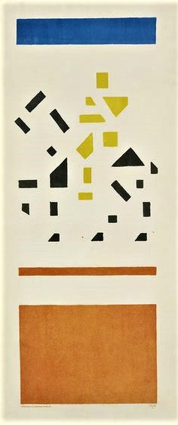

Fig 2: Horseman
The organization expired almost as fast as it developed, reaching only around one hundred official members at the height of its establishment between 1917-1931. The theory of De Stijl audaciously implies the existence of an underlying reality, defined by a harmonious relationship between form and colour. In the revelation of minimalist creative practice, De Stijl artists evaluated the exterior world with an internal perspective of self. The neo-plastic band of artists appeared as bad boys of the contemporary past, opposing the transparency of actual representation with the wildness of supreme artistic vision. Essentially, the De Stijl group began as a seed of supreme artistic thought, gained a following which resulted in the formation of a magazine, finally, exceeding its originality of thought into a philosophy of serene intention and universality.
The asymmetrical style and subverting regular grid formations of typical De Stijl designs represent a clear formulation of colour on background. That is to say that De Stijl design, and De Stijl philosophy consisted of 'the background' bearing as much importance as 'the form'. Understandably, the ease at which one can access said philosophical mindset is not easy to comprehend. But in simpler terms, consider the universal plane of imagination to be the canvas, as the instinctual act of creativity composes into form, both represent the supreme equilibrium of the human experience.

Psychological implications of Spiritual Suprematism
And a proposition on modern therapeutic methods

‘ Between the two states of bodily relaxedness on the one hand and spiritual freedom on the other there is a difference of level which cannot be overcome by breath-control alone, but only by withdrawing from all attachments whatsoever, by becoming utterly egoless: so that the soul, sunk within itself, stands in the plenitude of its nameless origin.
Recited from the book, Zen in the Art of Archery, further discovery of Spiritual Suprematism is evident in the review of Eugen Herrigel’s (2004) encounter with the sacred doctrine of Zen. Much like the enigmatic power of supreme artistic thought, that Malevich confessed drove him to create his abstract masterpieces, so did the unpretentious freedom of Zen belief allow the western educated author to devote six years of his life on liberation of spirituality. To the ambitious and dispirited, the artist and the critic, we are inherently enslaved to the singular perception of nature and the desire for imaginative exploration. That is to say, the authentic matter of reality is equally universal and individual, it is singular and collective, past, present, future and eternally supreme. Take this into thoughtful consideration. Submit to the divine energy of Spiritual Suprematist in every aspect of yourself. Surrender to the organic inquisitiveness of colour and form, line and sphere, the infinite, timeless adaptation of the present experience of being.
Painter or photographer, architect or illustrator, designer or poet, spiritual engagement with the act of artistic expression results in the emancipation of mindful thoughts. This may be applied philosophically or physically, both or either, the radical attractiveness of this theory rests exclusively in the mind of the participant.
As an expressive medium, art can be utilized to communicate emotion through perception and experience through interpretation. The use of artistic methods to treat psychological disorders and enhance mental health is known as art therapy. We understand this practice of creative rehabilitation through the professionalism of Art Psychotherapy, but perhaps a more internal view should be addressed. That is to advocate the individual discovery of artistic expression as a means of natural treatment and spiritual exertion. The philosophy of Spiritual Suprematism promotes the supremacy of artistic thought, and in the act of doing so, you will engage with the supremacy of spiritual enlightenment. Enlightenment that exerts emotional pressure, soothes the mind of negative interference and uncovers the individual perception of internal tranquillity.
This therapeutic practice is deeply rooted in the idea that creative expression can encourage healing and mental well-being. It can be used as a powerful tool capable of helping people explore their emotions, develop a sense of mindfulness and deal with things such as trauma, depression, anxiety by focusing on their creative vitality. And so, what I am attempting to convey is the reflection of human experience through the therapeutic path of Spiritual Suprematism. As the word of God has amassed a doctrinaire of submission and fidelity, so shall the purity of creative consciousness liberate the theorist. The philosopher and the poet, the artist and the writer, the architect, and the designer.
Spiritual acknowledgment and creative consciousness. These concepts are undeniably challenging to understand and harder still, to apply to the order of socio-political climates of the modern world. But the prominence of this theory remains calmly in the perception of the interpreter. In other words, the outcome of the engagement of art as a naturally therapeutic practice matters not, the spiritual enlightenment of the duration of said method, illuminates the path to creative autonomy.
The hierarchy of angels have vanished from the sky
And folk aver that Heaven was but a cunning lie
And curates out of college
Like the poets of the plains stand up for all things modern
But Nemesis remains

Cited from, The Collected Poems of Idris Davies, Davies (2000), we observe that the true glory of existence remains in the acquiescence of collective creative energy. The precursor to expression and perception, evident in the manifestation of Malevich’s Suprematism, De Stijl’s creed of form over function, Wassily Kandinsky’s theory of abstract expressionism, the stimulus of Salvador Dali’s surrealism and unto the future of superior artistic development. Abstraction as a means of metamorphizing emotional information is by no means a modern approach. Studying as far back as 78,000 BC, we find a prehistorical indication of abstraction in the cross-hatched pattern depicted on the sacred walls of The Blombos Cave, Cape Town, South Africa (fig.3).
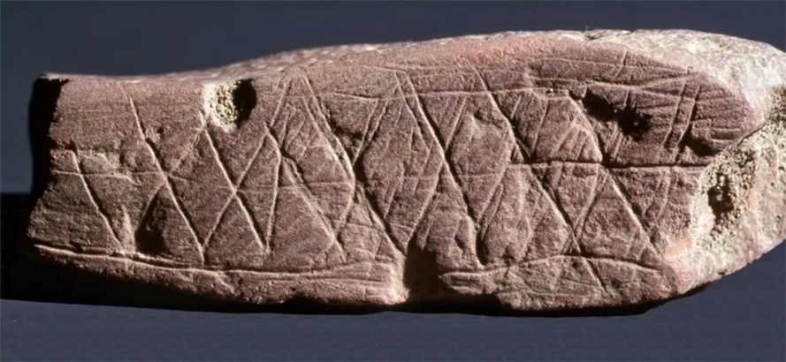

Fig 3: Blombos Cave Paintings

In 2002, through the use of microscopic and chemical analyze, a team of archaeologists and scientists from the SFF Centre for Early Sapiens Behaviour (SapienCE), University of Bergen, Norway and the Evolutionary Studies department of the University of Witwatersrand, Johannesburg, South Africa, confirmed that a red pigmentation was originally applied to the Blombos Cave carving with the use of an ochre crayon, signifying further intellectual cognition of colour and form far before the advancement of the intellectual mind. The depiction demonstrates an early human ability to produce an artistic representation of the perception. The design itself consists of interweaving lines encased in a rectangular structure. Let us consider for a moment, the smooth-faced rock, as the canvas of the primitive artist. At the disposal of the contemporary hand, the canvas can be converted into any number of creative methods. For the prehistoric hand, the canvas is limited to the preference of material functionality. The defined rockface of the Blombos Cave, presumably encountered in the necessity of human sanctuary, presented an opportunity for the compulsion of artistic thought to materialize. Perhaps not so intrinsically comparable to the current exploration of creativity, the ancient design nevertheless provides us with spiritual consolidation of the universality of supreme artistic thought. The interconnection of spiritual and cognitive awareness, when participating in the righteous act of Suprematist idealism, may ultimately lead to the conception of a truly universal language.

The nature of artistic expression
And the pursuit of creative enlightenment

In the book, Concerning the Spiritual in Art, Russian painter and Art Theorist, Wassily Kandinsky, describes his inspiring review of universal artistic communication. Assessing the nature of the primitive and contemporary creative consciousness, he declares “These two possible resemblances between the art forms of today and those of the past will at once be recognized as diametrically opposed to one another. The first being purely external has no future. The second, being internal contains the seed of the future within itself.” (Kandinsky, 1977).
The significance of Kandinsky’s proclamation of futurist artistic theory, reinforces the collective impression of Spiritual Suprematism, defined by the enduring potential of artistic expression. For Kandinsky, the drive for creative composition was channeled through his spiritual connection with music (see fig.4), the power as to which he believed guided his abstract, colourful works of art.
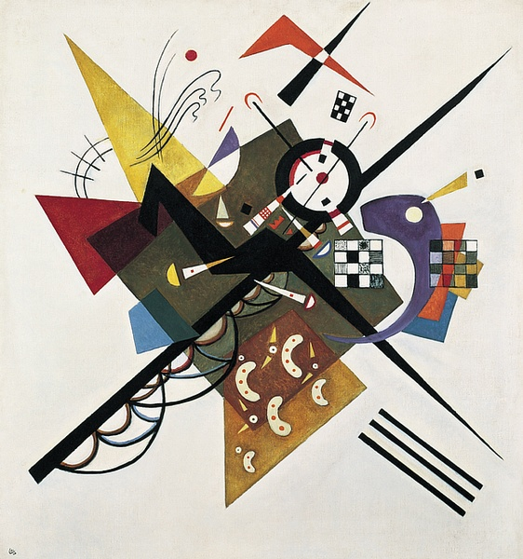

Fig 4: On White II
The relevance of colour, most notably in the art of painting, has forever expressed emotional energy; the blue of the great oceans validates its divinity as the green of leaves confirms the presence of life. According to Johann Wolfgang Goethe’s, Theory of Colours, he states; “we shall not be surprised to find that its effects are at all times decided and significant and that they are immediately associated with the emotions of the mind.” (Goethe, 1810)
Artists of the post-modern era are uniquely fortunate in the ever-expanding diversity of creative expression. Spiritual consciousness resides in the internal acceptance of individual perceptive experience. That is to indicate the pure energy of art is the eternal experience of the universe itself, manifested through the hand of man. The omnipresent power that the great Welsh poet, Dylan Thomas aptly named; “The force that through the green fuse drives the flower” (Thomas, 1978). It is within the rendition of control, that the artist shall summon the indescribable ‘force’. Call it mystical profanity, call it abstract radicalism or theoretical insanity. The depth of this inconceivable entity exceeds even our deepest thoughts. It is to be questioned but never known, to be expressed but never deciphered, explored but never completed. It is continuously adapting, consistently metamorphizing throughout the human experience.
In the dynamic realm of Art, man developed the art of Photography and so harnessed the power of time and energy. He now wields an instrument of light, an unnatural means of transcending the concept of the now, capable of encapsulating the fragility of memory. Consider the spiritual and insightful work of the late American photographer, Robert Michael Mapplethorpe, and his masterfully choreographed images.
Mapplethorpe executed his perception of Spiritual Suprematism in the comprised engagement of photography. He utilized the camera to personify and exhibit the charming energy of natural objects, such as Orchids, (see fig. 5).
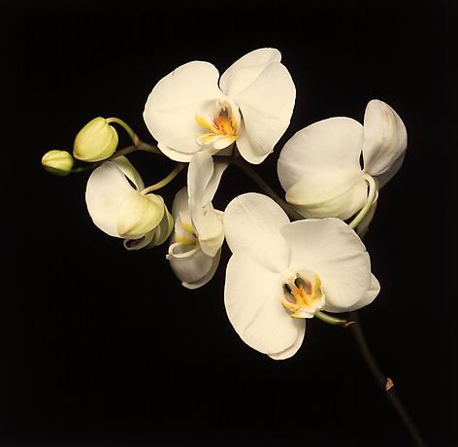

Fig 5: Orchids

When one examines one of Mapplethorpe’s many photographs of flowers, he encounters the intriguing correlation of photography and painting, challenging the internal perception of the viewer. How could such technology produce this wonderfully organic composition? Is it truly a photograph or a magnificent deception? How is it possible that a mechanized system of light, could be so impeccably engineered, as to alter the perception of reality? The American artist undoubtedly influenced the liberation of photography, into a more artistically free practice, and in doing so, permitted future generations to explore the lucidity of photographic art and fine art.
Of the multitude of artistic resources that man has tamed, the art of painting, it seems, evokes the highest sense of Spiritual Suprematism. The beneficial elements of this creative practice present to the participant a spiritual state of mindfulness and serenity. The authenticity of imagination, when applied to canvas, (In this case the nature of ‘a canvas' referring to any object deemed appropriate for the artist to adorn), inevitably comprises of the two principles of painting, colour, and form.
Through the enlightened act of painting, void of standard and compelled representation, the participant channels the great unknown force. He now enters the celestial state of creative consciousness, the green fuse, the supreme artistic thought, the seed of the future within itself. In a 2018 online article reporting on a recent study of, Reliability and validity of the inner correspondence questionnaire for painting therapy (ICPTh), included in the 42nd volume of, Complementary Therapies for Medicine, the publishers emphasize; “Art therapy as mindfulness-oriented intervention is commonly used in Anthroposophic medicine.” (Sciencedirect, 2018). The ICPTh research (Kemper, 2018) revealed,
Objectives Art therapy (ArT) such as mindfulness-oriented painting therapy is increasingly used in psychosomatic, oncological integrative and rehabilitative medicine. Though it remains unknown how ArT works, we hypothesize that an engaged participation with painting (‘Inner-Correspondence’) contributes to improved symptom scores.
The study was introduced to several breast cancer survivors with prolonging fatigue to examine the remedial powers of mindfulness in creative expression, however, the context in which this rehabilitative method can be employed is infinite. It is evident from the ICPTh research that the Inner-Correspondence, (the physical act of applying paint to canvas, thought to reality, genesis of creation), beholds a truly evolutionary method of manifesting the spiritual creator. The internal orchestrator of artistic expression and celestial experience. The organic need for creative expression, channeled by way of painting, is evidentially beneficial and therapeutic in the outcome of this study. Furthermore, it reinforces the ideology of painting as a naturally occurring act of Spiritual Suprematism. That being the most anthroposophical of methods towards inducing the internal validity of mindful practice. A procedure of spirituality if you will. Comparably mindful as to that of author Julia Cameron (1992) and her inquisitive text on higher creativity,
We undertake certain spiritual exercises to achieve alignment with the creative energy of the universe. If you think of the universe as a vast electrical sea in which you are immersed and from which you are formed, opening to your creativity changes you from something bobbling in that sea to a more fully functioning, more conscious, more cooperative part of that ecosystem.

The Future of Spiritual Suprematism
Unlocking the power of creative freedom

Within the rigid construct of our post-modern society, a deterioration of spiritual individualism has been continuously imposed by the profitable and distracting evolution of modern materialism and consumerism. In the era of Suprematism, De Stijl, Surrealism and many other radical art movements, the contributing artists and critics exhibited the resilience of artistic energy. Kazimir Malevich hypothesized the existence of, supreme artistic thought, liberating the artist from the burden of representation and objective reason, proposing that the artist surrender himself entirely to the power of organic creativity.
In the book, Creativity, Spirituality and Mental Health: Exploring Connections, university professor of Classics and Religious Studies cross-appointed Psychiatry, Dr. Kelley Raab Mayo explains (2009):
Although creativity, it was found, does not prevent one from developing a mental illness, creative expression can play a healing role in helping one express a more authentic self. Creativity allows unconscious dynamics to surface, facilitates an experience of flow and perhaps transcendence. One's spiritual life also becomes an avenue for expression of the deep self.
The research Dr. Mayo assembled, exquisitely defined in her publications, evidentially identifies the spiritual expression of self as the essence of the human experience in its emotional entirety. Referring to the recuperative process of Art Psychotherapy, we recognize the established study of creative expression as a methodology of emotional insight and understanding, moreover, we discover the spiritual resemblance of Suprematism and the participation of ‘Inner-Correspondence’. Furthermore, in Dr. Kelley Mayo's book (2009), she adds,
In the lives of artists, musicians, and scientists, for example, we saw a link between the search for the sacred and the search for the self, suggesting that spirituality can assist in negotiating identity issues expressed in the tension between self and other.
Essentially, the philosophy of the Spiritual Suprematist is as follows; The supreme nature of artistic expression, internal and collective, individual and universal, is the truest force of matter and time, the great conductor of creation. The Spiritual Suprematist eternally pursues the universality of self, seeking to ignite the collective consciousness and advocate the quintessential expression of the human experience. Art therapist and author, Mimi Farrelly-Hansen describes in her book Spirituality and Art Therapy: Living the Connection, “Art, much like meditation, invites me inward as far as I wish to go. It is here that the Voice of the self, the divine inner realm, can be entered, observed and expressed in manifest form.” (2001)
To conclude, the collected opinions of creative expression that we have discussed in this paper, articulate the philosophical concept of Spiritual Suprematism, perhaps more appropriately categorized as, Neo-Suprematism... The re-assessment of Kazimir Malevich’s ideology reveals its existential position of spiritual enlightenment, inviting the contemporary mindset to continue the divine pursuit of supreme artistic thought. As a student of Spiritual Suprematism, and enthusiast of creative expression as a function of emotional interpretation, my experience of art, that is, so far, and its multitude of manifestations has presented the universal need for spiritualization in the anticipated future of creative evolution.
The social and creative measures artists such as Piet Mondrian, Kazimir Malevich, Robert Mapplethorpe, Wassily Kandinsky, Idris Davies, and Dylan Thomas are but a few names that represent the organic evolution of artistic expression. They unanimously embody the celestial impression of the unknown composer, the indescribable force of creation. They individually symbolized the organic structure of artistic evolution, pure, spiritual, the sincere experience of being.

Bibliography
Reference List:

- Cameron, J. (1992). The Artist's Way: A Spiritual Path to Higher Creativity. Tarcher Perigee.
- Davies, I. and Jenkins, I. (2000). The collected poems of Idris Davies. Cambridge, England: Chadwyck-Healey (a Bell & Howell Information and Learning Company), p.63.
- Doesburg, T. V (1914). The Avondpost Series.
- Goethe, J. (2019). Goethe’s Theory of Colours. [S.I] Routledge, p. 304.
- Hansen, M. (2001). Spirituality and Art Therapy: Living the connection. p.97.
- Herrigel, E. (2004). Zen in the Art of Archery. 30th ed. Penguin Books.
- Kandinsky, W. and Sadler, M. (1977). Concerning the spiritual in art. New York: Dover Publications, p.26.
- Kemper, K. (2018). Reliability and first validity of the inner correspondence questionnaire for painting therapy (ICPTh) in a sample of breast cancer patients. Complementary Therapies in Medicine, 42.
- Malevich, K. (2003). The non-objective world. Mineola, N.Y.: Dover Publications.
- Raab, K. (2009). Creativity, Spirituality, and Mental Health: Exploring Connections (Ashgate new critical thinking in religion, theology, and biblical studies). Ashgate Publishing Group. P.131
- Seuphor, M. (1956). Piet Mondrian; life and work. Abrams, N.D.
- Shatskikh, A. (2013). Black square. New Haven, Conn.: Yale University Press.
- Thomas, D. and Jones, D. (1978). The poems [of] Dylan Thomas. London: Dent.

Reading Material:
Books
- Art Therapy and Postmodernism: Creative Healing Through a Prism - Edited by Helene Burt Foreword by Joy Schaverien, 2011
- Color Psychology and Color Therapy; A Factual Study of The Influence of colour on human life – Faber Birren, 1950
- Concerning the Spiritual in Art – Wassily Kandinsky, 1977
- Creativity, Spirituality, and Mental Health: Exploring Connections, Ashgate new critical thinking in religion, theology and biblical studies - Dr. Kelley Raab Mayo, 2009
- De Stijl: 1917-1931 Visions of Utopia -Collected Essays Edited by Mildred Friedman, 1982
- Design and Emotion: The Experience of Everyday Things – Edited by Deana McDonagh, Paul Hekkert, Jeroen van Erp and Diane Gyi, 2003
- Expanded Painting: Ontological Aesthetics and the Essence of Colour – Mark Titmarsh, 2017
- Goethe's Theory of Colours - Johann Wolfgang von Goethe, 1810
- Kazimir Malevich - Gilles Netret, 2003
- Spirituality and Art Therapy: Living the Connection - Mimi Farrelly-Hansen, 2001
- The Artist's Way: A Spiritual Path to Higher Creativity – Julia Cameron, 2009
- The Non-Objective World: The Manifesto of Suprematism - Kazimir Malevich, 2003
- Zen in the Art of Archery - Eugen Herrigel, 2004

Websites
- https://www.widewalls.ch/suprematism-kazimir-malevich/ - Accessed on 7th Oct 2019.
- https://www.ideelart.com/magazine/kazimir-malevich - Accessed on 18th Nov 2019
- https://www.stedelijk.nl/en/exhibitions/kazimir-malevich-and-the-russian-avant-garde - Accessed on 22nd November
- https://www.bridgetnielsen.com/spiritual-art/ - Accessed on 9th Oct 2019
- https://www.sciencedirect.com/science/article/abs/pii/S0965229918301213#! - Accessed on 19th November 2019
- https://www.moma.org/collection/terms/29 - Accessed on 15th Nov 2019

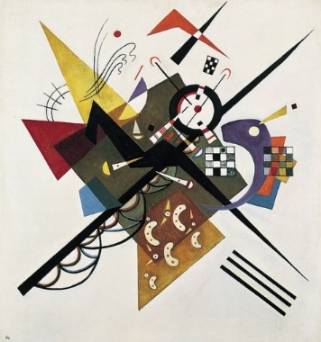
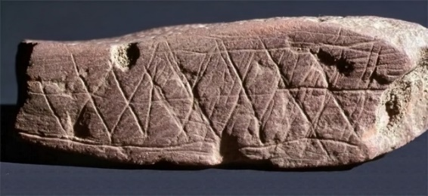
Illustration List
(Figure. 1)

Airplane Flying
Kazimir Malevich, 1914
Oil painting on canvas

(Figure 2)

Horseman
Theo Van Doesburg, 1918
Oil Painting on canvas

(Figure 3)
Blombos Cave Paintings
South Africa
Digital Photograph

(Figure 4)
On White II
Wassily Kandinsky, 1923
Oil on Canvas

(Figure 5)
Orchids
Robert Michael Mapplethorpe, 1989
Colour Film Photograph, Medium Format

