Jack Kennedy
2003924@student.uwtsd.ac.uk
Data security report
Data security and compliance ACCA5034

Contents
Introduction 2
Research 2
Discussion 2
Conclusions 2
References 2

Task One:

Abstract
This research paper explores the role of physical security and security tools and technologies in protecting modern organizations from both physical and cyber threats. Physical security involves implementing measures to prevent unauthorized access to sensitive areas, such as locks and alarms, as well as conducting vulnerability assessments to identify and address potential risks. Security technologies and tools, such as virtual private networks (VPNs) and firewalls, are used to protect networks and data from cyber threats. The paper also evaluates and discusses the sources used to provide a comprehensive overview of the importance of creating a secure environment for organizations to protect their assets, infrastructure, and personnel.

Introduction
Within information and data security, there are many areas that can be considered. Physical security is a crucial component of protecting an organization's assets, infrastructure, and personnel. Effective physical security measures, such as locks, alarms, and surveillance cameras, can prevent unauthorized access to sensitive areas and prevent or deter potential threats. In addition to these traditional security measures, modern organizations also rely on security technologies and tools such as virtual private networks (VPNs) and firewalls to protect their networks and data from cyber threats as well as more complicated tools, that can facilitate intrusion detection and prevention. This research paper will explore the role of physical security and security tools and technologies in protecting organizations from both physical and cyber threats as well as evaluate and discuss the sources used.

The importance of creating a secure environment

  - overview
Modern organizations rely heavily on their IT systems and infrastructure to conduct business and operate efficiently. As a result, it is important for these organizations to create a secure environment that protects against threats and vulnerabilities. This includes implementing measures to prevent unauthorized access to sensitive information, detecting potential security breaches, and having a plan in place to quickly react and mitigate any damage in the event of an attack. By creating a secure environment, organizations can safeguard their applications and protect their sensitive data, which is crucial for maintaining the trust of customers and stakeholders. Additionally, having strong security measures in place can help prevent costly disruptions to business operations and protect the organization's reputation. A secure environment within a business therefore helps to safeguard sensitive data like intellectual property, protect the functionality of said business by limiting attacks as well as reduce the damage done by attacks to the business [1].
The security of the data collected by an organisation is also paramount, as that is sensitive data that could cause loss to the company in the form of both the customer’s trust as well as legal issues involving breaches of data protection [1]

  - Physical Security
Physical security is a large topic, protecting from disgruntled employees or attackers attempting to gain unauthorized access to a physical location to do damage, bypassing other security measures are both examples of areas that fall within physical security. A large part of implementing physical security is a vulnerability assessment [2]. A vulnerability assessment is where a company will seek to assess the risks to a company’s assets, in this context risks that are related to the physical location of data, and then seek to address said risks. Risks can be addressed in the following ways: “reduction, spreading, transfer, elimination, and acceptance”[2]
Cyber security can be described via CIA, which is a acronym for Confidentiality, integrity, and availability, this trifactor is considered in physical security, “Within cyber-physical security, CIA is refined. … all begin to take on equal priorities”. [3] Within physical security, it is obvious all parts of this triad must apply, denying unauthorised access to the site where the company is based stops an attacker from stealing sensitive information, which falls under confidentiality, denying such access also stops an attacker from, for instance, installing malicious software on a computer that is on that company site, which would fall under integrity. Finally, if an attacker were to have access to a site, they could do physical damage to machines, such as the destruction of equipment, which would stop the company from being able to function, effecting the availability of the company’s services.
Physical security is often thought of as being in levels, these levels of physical security determine the degree of measures taken to ensure physical security of assets, this would normally be determined during risk management, specifically in a risk assessment. For instance, a high security facility, might make use of biometric identification systems and thorough access controls, but a site that uses a lower level of security may only use key cards to determine where employees can go on the site, this depends on many factors, like the size of the company, and how likely attacks are, as well as how damaging they would be. Security measures need to be viable for the Business.

  - Security technologies and tools
Companies and their employees rely on security technologies to ensure that sensitive data is kept within the company, and to ensure that the company’s systems are not as vulnerable to attacks. This includes tools like firewalls or VPNS. Similarly, companies use security tools like intrusion detection and prevention systems to ensure that attacks and the damage from attacks can be minimised. “Traditional intrusion prevention techniques, such as firewalls, access control or encryption, have failed to fully protect networks and systems from increasingly sophisticated attacks and malwares”. [4] For this reason it is necessary for multiple tools, technologies, and practices to be implemented in tandem with each other, to ensure that the amount that systems are compromised is minimised, an invaluable part of that is and IDPS or intrusion detection and prevention system. These systems have become more and more important as time passes and threats and attacks become more sophisticated[5], [6]. An IDPS can not only focus on detecting intrusions into a system, but also prevent such attacks, by mitigating them as it is detected, stopping the detected attack from succeeding, however IDPS do suffer from false positives, and reducing said false positives is a priority in improving the technology to help further mitigate attacks[6]
IDPS systems, however, are not the only tools used to prevent attacks, companies, as mentioned can also employ firewalls, and enforce policies that require employees to use tools like VPNS, taking these steps can drastically improve a company's data security and help to create a secure environment for said company.

Policies play a crucial role in information security as they provide guidelines and standards for employees to follow to protect sensitive data and company assets. These policies can include rules for password management, data handling and disposal, and access controls. They can also outline acceptable use of company resources and outline consequences for policy violations. By implementing and enforcing these policies, companies can create a culture of security within the organization and reduce the risk of data breaches and cyber-attacks. It is important for employees to understand and adhere to these policies to maintain the confidentiality, integrity, and availability of company information. Regular training and reminders on these policies can also help to ensure that they are followed consistently.

Discussion and analysis of research sources
  - Principles of Information security [1]
This book gives a general overview of the topic of information security, providing an insight into the many different categories of information security, including physical security, technologies used in information security, and IDPS systems, the topics of this research paper. It is written by very accomplished authors, and the information provided is backed up by a list of acknowledgements, however, since it is simply an introduction to the topic it does not seek to answer a question, nor does it make use of citations. Since it covers the entire topic of information security it is not as precisely focused on the topic of this paper, although this is not inherently negative, sources that directly discuss on of the topics could be considered more useful, as they are more in scope. This source is recent, which means the information in it is more likely to be up to date, which is beneficial especially in a field that is so rapidly evolving, this was mentioned in this edition, as a way in which it had improved upon the last edition, alongside increasing the depth of the glossary, and making it an easier introduction to the topic.
  - Effective Physical Security [2]
This is an incredibly detailed book on physical security, it goes into massive detail about multiple aspects of the topic, including risk assessment, and analysis of what needs to be done to ensure security, as well as going over levels of security, and how they can be implemented. While It does use references, often whole pages are taken from other works, and marked as such, it also uses a lot of terms that seem to only be used within the book itself. It does touch on the fact that this is due to a lack of standardisation in the industry, that is still a weakness of it as a source of information. As a source it is incredibly useful, and provides a wealth of information on physical security, however, since it does not seek to answer a question, its scope is very broad. This source was published in 2016, and while that is not as recent as some sources, it is still likely to be a relevant source of information.

  - Cyber-Physical Security and Privacy in the Smart grid [3]
This source is a book, it is the 21st book in a series of works on information security it is makes abundant use of references and provides a deep dive into cyber physical security in a specific use case. It has many, well accomplished editors and looks to provide insight into the future of the field. Being published in 2017, it is likely to be up to date, and contain useful information, although since it did look to provide suggestions for the future, it is possible that some areas of it are dated, as the suggestions could have been acted upon or issues could have been found with them since its publication, so it is important to consider the age of the source when using it for reference
  - The use of computational intelligence in intrusion detection systems [4]
This journal article covers intrusion detection systems, specifically the use of CI in IDPS, the source is from 2010, which means some of the information might be outdated. It was published by two authors under a university. The article provides a review of both IDPS and CI and how they can be used to further prevent attacks. It is a valuable source of information about IDPS and is overall an excellent source, publication date aside. It makes use of references to back up its points.
  - The cyber threat landscape: Challenges and future research directions [5]
This is a journal article that covers the fact that threats to cybersecurity threats are advancing and looks at a way of mitigating some of these attacks, this article is cited within 301 other works, which suggests that it is an incredibly useful source on the topic. However, since it was published in 2011, it is possible that the information contained is out of date. It provides a useful insight into the threats posed by security vulnerabilities and those who would exploit them. It is immensely useful with regards to conducting research on the subject, as evidenced by the many times it has been cited in other works.

  - An intrusion detection and prevention system in cloud computing: A systematic review [6]
This journal article combines a large bank of citations, and the authors own knowledge to provide information on IDPSs within cloud computing, it is a useful demonstration of the technology within a certain setting and helps to provide information on the topic, as well as a allow a greater understanding via a practical example. The article is cited in 303 other works, which is a testament to how valuable it is as a source. However, as with many sources this well-established, it was published comparatively long ago, in 2013, once again meaning that the information the source provides could be dated, and therefore not as useful as perhaps it could be if the date of publication was earlier.

Conclusions

To conclude, physical security and security technologies and tools play a crucial role in protecting modern organizations from physical and cyber threats. By implementing effective measures, such as locks and alarms, and utilizing tools like VPNs and firewalls, organizations can safeguard their sensitive information and protect their assets, infrastructure, and personnel. It is essential for organizations to create a secure environment to maintain the trust of customers and stakeholders and prevent disruptions to business operations. Conducting vulnerability assessments and staying up to date on the latest security technologies and practices can help organizations stay one step ahead of potential threats and vulnerabilities. In today's digital age, it is imperative for organizations to prioritize security to protect their valuable assets and maintain their reputation.

References
[1] Mattord Herbert J and Whitman Michael E, Principles of information security, 4. ed., International ed. Boston, Mass: Course Technology, 2012.
[2] L. Fennelly and L. J. Fennelly, Effective Physical Security. Oxford, UNITED STATES: Elsevier Science & Technology, 2016. Accessed: Dec. 12, 2022. [Online]. Available: http://ebookcentral.proquest.com/lib/trinity/detail.action?docID=4730827
[3] “Cyber-Physical Security and Privacy in the Electric Smart Grid.” https://ieeexplore-ieee-org.ezproxy.uwtsd.ac.uk/document/8025534/ (accessed Dec. 12, 2022).
[4] S. X. Wu and W. Banzhaf, “The use of computational intelligence in intrusion detection systems: A review,” Appl. Soft Comput., vol. 10, no. 1, pp. 1–35, Jan. 2010, doi: 10.1016/j.asoc.2009.06.019.
[5] K.-K. R. Choo, “The cyber threat landscape: Challenges and future research directions,” Comput. Secur., vol. 30, no. 8, pp. 719–731, Nov. 2011, doi: 10.1016/j.cose.2011.08.004.
[6] A. Patel, M. Taghavi, K. Bakhtiyari, and J. Celestino Júnior, “An intrusion detection and prevention system in cloud computing: A systematic review,” J. Netw. Comput. Appl., vol. 36, no. 1, pp. 25–41, Jan. 2013, doi: 10.1016/j.jnca.2012.08.007.

Task Two:

Acknowledgements
As well as including its own sources, this report makes use of research conducted in Part One, and as such makes use of information originally derived from the sources used in part one, these sources are listed in the references section for Part Two but are not directly cited within the report.

Introduction
This report will cover SwanTech’s new information security unit, and what this unit’s needs will be when operating within the company it is being set up in. The report will look at aspects of cybersecurity regarding the unit’s operations and evaluate the needs of the unit. The report will cover many aspects of cybersecurity, such as risk management, policies that the company needs to observe, contingency planning in case of attacks or natural occurrences that could be a threat to the company’s data and how SwanTech will set up the unit within the company.

Main Body
SwanTech’s new information security unit will be set up to help the company manage its cybersecurity procedures, its main objectives within the company would include:
- Risk Management
- Data Protection
- Incident response
- Ensuring Compliance within the company
- Threat Intelligence

The unit will seek to carry out these goals within the company to ensure that the company maintains a secure environment, which will in turn help reduce the potential for attacks, and mitigate the damage done when an attack does occur. The unit would use tools and technologies available to them to ensure that these functions are carried out and that the company’s data security is ensured. Such tools would include, but not be limited to IDPS, VPNS, Firewalls, Software to manage employee’s activity on computers that operate within the company as well as key cards and other access controls. The unit however would not be limited to these tools, it is important the Information Security Unit be allowed room to adapt to changes in the way in which attacks are carried out and therefore defended against, since the cybersecurity landscape is ever changing.
  - Risk Management
Risk management is a key responsibility of the new information security unit at SwanTech. This involves identifying potential risks to the company's data and systems, evaluating the likelihood and impact of those risks, and implementing controls to mitigate those risks. This would involve conducting regular risk assessments to identify vulnerabilities within the company's systems, as well as implementing measures such as access controls and encryption to protect against unauthorized access or data breaches. “A risk assessment evaluates what could go wrong, the probability of occurrence of such an incident, and the harm if the incident did occur”[7]
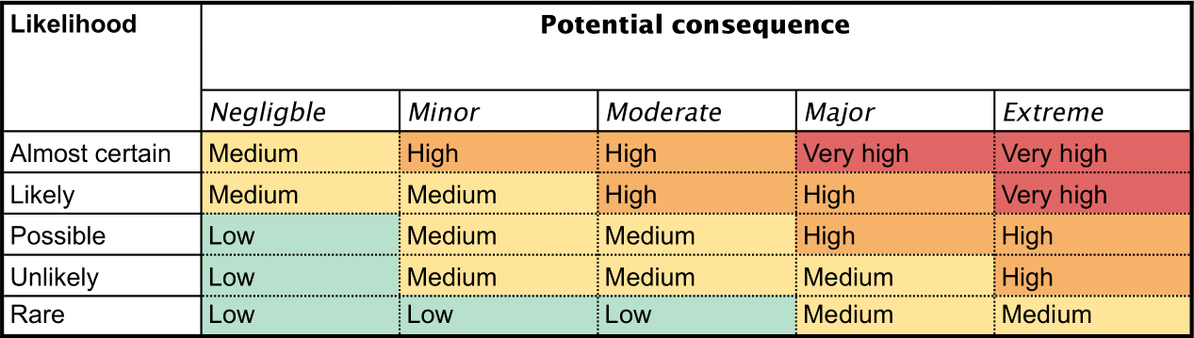
Figure 1: example of a risk management table
The unit would also be responsible for the development of a risk management plan. This plan would outline the process for identifying and evaluating risks, as well as the steps that will be taken to mitigate those risks. It should also include a process for regularly reviewing and updating the plan to ensure that it remains effective in addressing the changing landscape of cybersecurity threats.
This could include deciding on what levels of security are needed in areas, versus the cost of putting in place such security measures, based on the size of the company, and how vulnerable they are to attacks, this is a large part of physical security, where physical security is often thought of as having levels of security, which determine what measures are put in place, but can apply to other areas of cyber security as well.

The goal of risk management is to ensure that the company's data and systems are protected from potential threats, and that the company can respond effectively in the event of an attack or data breach, this ties into every other aspect of the unit’s responsibilities, as in every aspect an assessment of the potential risks is necessary. Risk Management would be the first priority of the unit, and a risk assessment would likely be their first task within the company.
  - Data Protection
Data protection is a key responsibility of SwanTech's new information security unit. This involves implementing measures to protect the company's sensitive data from unauthorized access, use, or disclosure. This can include measures such as encryption, access controls, and backup systems to ensure that data is not lost in the event of an attack or system failure.
A key aspect of data protection is the development of data protection policies and procedures. These policies should outline the steps that employees should take to protect the company's data, as well as the consequences for not following these policies. This can include measures such as password management policies, procedures for handling sensitive data, and guidelines for accessing and sharing data. These policies help to avoid accidental breaches of data protection, or breaches of data protection that come from a lack of knowledge on what is and is not sensitive data.
In addition to implementing data protection measures, the unit will also be responsible for regularly reviewing and updating these measures to ensure that they remain effective in protecting the company's data. This can involve conducting regular audits to identify potential vulnerabilities and implementing new controls as needed, this is a ongoing theme of all of the responsibilities of the unit, since the ways in which companies must protect themselves is constantly changing. The unit must be able to adapt to changes in the needs of the company, as the cyber security landscape itself changes.
Part of ensuring data protection is the use of physical security as a means of limiting the damage done by insider threats, such protections include the use of access controls like key cards, or other physical security measures. In risk assessment it would be determined what level of physical security is necessary, and that would determine what measures were put in place. For instance, if the site of the company needed an extremely high level of cybersecurity, it may be necessary for all employees to carry key cards and matching IDs or for the employees to use biometrics to access certain areas in the company. These would be enforced by policies, to ensure that the measures put in place could not be bypassed via attacks that utilise social engineering.
“In organizations where employees are aware of explicit information security policies, employees have more appropriate beliefs about their organizational norms, threats and coping appraisals, and report better protective behaviours” [8]. Making sure that employees are briefed on the policies and information surrounding policies is paramount in ensuring that the company’s data is protected, and part of the unit’s task is providing that training to employees.
Overall, the goal of data protection is to ensure that the company's sensitive data is secure and that the company can maintain the confidentiality, integrity, and availability of its data always.
  - Incident response
Incident response is a key responsibility of SwanTech's new information security unit. This involves developing and implementing a plan for how to respond in the event of a security incident, such as a data breach or cyber-attack. The goal of incident response is to minimize the impact of the incident and to restore normal operations as quickly as possible.
The first step in the incident response process is to identify the cause of the incident. This involves gathering and analysing information about the incident to determine how it occurred and what systems or data were affected. This information can help the unit determine the appropriate steps to take to contain the incident and prevent similar incidents from occurring in the future.
Once the cause of the incident has been identified, the unit will work to contain the incident to prevent further damage. This can involve taking steps such as disconnecting affected systems from the network, implementing additional security controls, or restoring data from backup systems.
Finally, the unit will work to restore normal operations and repair any damage that was done. This can involve repairing affected systems, restoring data via backups, and implementing new controls or procedures to prevent similar incidents from occurring in the future. Once the company has moved back to normal operations there is an opportunity for the unit to learn from the incident to both help to mitigate it in future and respond more effectively if there is a similar incident again, this ties into threat intelligence, another of the unit’s responsibilities.
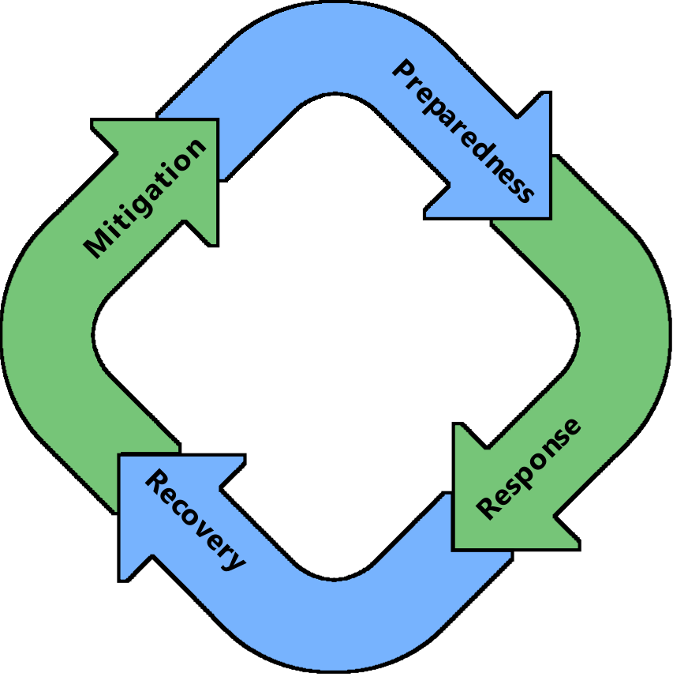
Figure 2: visualisation of incident response cycle.
Overall, the goal of incident response is to ensure that the company can quickly and effectively respond to security incidents and minimize the impact of those incidents on the company's operations, to this end, incident response would also include Business Continuity, business continuity involves ensuring that a company can keep its operations going in the case of an attack or natural disaster. The unit could also be responsible for ensuring that the company remains operational during an attack, and can swiftly recover from an attack, as part of incident response.
  - Compliance
Ensuring compliance with relevant regulations and standards is a key responsibility of SwanTech's new information security unit. Depending on the industry that the company operates in, there may be specific regulatory requirements for data security that the unit will need to ensure the company is compliant with. This could include requirements related to data privacy, such as the General Data Protection Regulation (GDPR) in the European Union, or industry-specific standards such as the Payment Card Industry Data Security Standard (PCI DSS) for companies that handle credit card transactions.
To ensure compliance, the unit will need to develop and implement policies and procedures that meet the requirements of relevant regulations and standards. This can involve implementing specific security controls, conducting regular audits to verify compliance, and providing training to employees on how to comply with these requirements, the unit would work alongside relevant departments to develop policies that not only safeguard the company’s security, and help to develop a secure environment, but are not so restrictive that it impedes on the company’s ability to perform its functions, since that would be counterintuitive.[9]
In addition to meeting regulatory requirements, compliance can also help to protect the company's reputation and reduce the risk of financial penalties or legal action. Ensuring compliance is therefore an important part of the unit's overall responsibilities.
Overall, the goal of compliance is to ensure that the company is meeting all relevant regulatory requirements and standards for data security and can demonstrate its commitment to protecting the security and privacy of its data.
  - Threat Intelligence
Threat intelligence is the process of collecting, analysing, and disseminating information about potential cybersecurity threats. SwanTech's new information security unit would be responsible for collecting and analysing information about potential threats, such as new malware or vulnerabilities in the company's systems and using this information to inform the company's cybersecurity strategies.
The unit would also be responsible for sharing this information with relevant stakeholders within the company, such as the IT department and senior management, to ensure that they are aware of potential threats and can take appropriate action to protect the company. This can include measures such as implementing patches or updates to fix vulnerabilities or implementing new controls to mitigate potential threats.
Because cyber threats are continuously changing and adapting, there is always a need for threat intelligence, the unit would need to consider what it finds out in this process when performing any of its other duties, especially Risk Management, where having knowledge of current threats is critical to developing a strategy to mitigate those risks.[10]

  - How the unit would initially be set up
The new unit should perform an initial, in-depth review of how it should operate within the company given the responsibilities discussed, this would allow the unit to be more acutely aware of the needs of the company, and therefore be better suited to operate within the company. This review would be like a risk assessment and would cover any extra responsibilities that are not immediately obvious, as well as inform the unit how best to tackle the needs of the company that have already been discussed. The unit would determine from this what tools it initially needs to have available, as well as what the priorities would be, which of the unit’s responsibilities would it need to perform first, and which could be worked on in time. For instance, the unit may find that Incident Response may initially take a backseat, as it is something that is much more long term, or conversely, that it is something that needs to be considered from the start, for it to be kept in mind throughout the entire operation of the unit.
The unit would be comprised of employees, that would need training in the existing policies of the company, and training around the regulations and standards by which companies conduct themselves, so the unit could ensure compliance within the company. Once the unit begins operating it will be important to measure the success it is having within the company, so the unit can adapt and fit the needs of the company better going forwards. SwanTech would advise both the unit and company on how best they can work together, based on the unit’s performance in the first month of working with the company and going forwards, and assess what tools and information could be provided to the unit to increase their efficiency.

Conclusion
To conclude the new Information Security Unit set up by SwanTech will need to perform a wide variety of tasks to meet the need of the company, these tasks will help to create and maintain a secure environment, which will help to reduce the risks posed by cybersecurity threats. The unit will need to have tools made available to it, such as IDPS and be able to set up the company to use these tools to ensure its measures against attacks are effective. The unit would initially focus on setting up, and then maintaining the company’s cybersecurity. The unit will take a targeted approach to risks and vulnerabilities in the company and seek to maintain an environment within the company that is conducive to the company’s information security, upholding the trifactor of information security.

References
[1] Mattord Herbert J and Whitman Michael E, Principles of information security, 4. ed., International ed. Boston, Mass: Course Technology, 2012.
[2] L. Fennelly and L. J. Fennelly, Effective Physical Security. Oxford, UNITED STATES: Elsevier Science & Technology, 2016. Accessed: Dec. 12, 2022. [Online]. Available: http://ebookcentral.proquest.com/lib/trinity/detail.action?docID=4730827
[3] “Cyber-Physical Security and Privacy in the Electric Smart Grid.” https://ieeexplore-ieee-org.ezproxy.uwtsd.ac.uk/document/8025534/ (accessed Dec. 12, 2022).
[4] S. X. Wu and W. Banzhaf, “The use of computational intelligence in intrusion detection systems: A review,” Appl. Soft Comput., vol. 10, no. 1, pp. 1–35, Jan. 2010, doi: 10.1016/j.asoc.2009.06.019.
[5] K.-K. R. Choo, “The cyber threat landscape: Challenges and future research directions,” Comput. Secur., vol. 30, no. 8, pp. 719–731, Nov. 2011, doi: 10.1016/j.cose.2011.08.004.
[6] A. Patel, M. Taghavi, K. Bakhtiyari, and J. Celestino Júnior, “An intrusion detection and prevention system in cloud computing: A systematic review,” J. Netw. Comput. Appl., vol. 36, no. 1, pp. 25–41, Jan. 2013, doi: 10.1016/j.jnca.2012.08.007.
[7] F. A. Shaikh and M. Siponen, “Information security risk assessments following cybersecurity breaches: The mediating role of top management attention to cybersecurity,” Comput. Secur., vol. 124, p. 102974, Jan. 2023, doi: 10.1016/j.cose.2022.102974.
[8] L. Li, W. He, L. Xu, I. Ash, M. Anwar, and X. Yuan, “Investigating the impact of cybersecurity policy awareness on employees’ cybersecurity behavior,” Int. J. Inf. Manag., vol. 45, pp. 13–24, Apr. 2019, doi: 10.1016/j.ijinfomgt.2018.10.017.
[9] G. A. Francia III and J. S. Zanzig, Global Perspectives on Information Security Regulations: Compliance, Controls, and Assurance. IGI Global, 1AD. Accessed: Dec. 22, 2022. [Online]. Available: https://www-igi-global-com.ezproxy.uwtsd.ac.uk/gateway/book/270400
[10] J. Soldatos, I. Praça, and A. Jovanović, Eds., Cyber-Physical Threat Intelligence for Critical Infrastructures Security: Securing Critical Infrastructures in Air Transport, Water, Gas, Healthcare, Finance and Industry. Now Publishers, 2021. doi: 10.1561/9781680838237.

