TITLE PAGE

NAME: NDEY YASSIN LOWE

STUDENT ID NUMBER: 1815270

PROGRAMME: BA LEADERSHIP AND MANAGEMENT SKILLS FOR THE WORKPLACE

MODULE: DEVELOPING INNOVATION AND CREATIVITY FOR BUSINESS ADVANTAGE

MODULE CODE: BMSW6102

LECTURE: KHAZA AHMED

ASSIGNMENT TITLE: INNOVATION SERVICE PLAN

TABLE OF CONTENT

- Title Page…………………………………………………..Page 1

- Table of Content…………………………………………....Page 2

- Introduction………………………………………………...Page 3

- What is Innovation………………………………………… Page 4

- Innovation service plan……………………………………Page 5

- Unique Selling point (USP)……………………………….Page 6

- SWOT analysis…………………………………………….Page 7

- E-Commerce……………………………………………….Page 8

- Marketing……………………………………………………Page 9

- Summary……………………………………………………Page 10

- References………………………………………………….Page 11

INTRODUCTION
Companies are always evolving towards offering services to meet emergent market needs. The world has seen drastic changes in its everyday lives. We have seen the demand for masks, hand sanitisers, and online shopping when off the roof. Some companies have taken advantage of the demand in the market and invested in those products or services. Nevertheless, most other companies like the hospitality department were brought to a standstill during the lockdown and many businesses were forced to close down. The best product innovation was the covid-19 vaccine. This innovation was vital in helping to bring hope and normalcy to people’s lives.
My task is to come up with a service that has either changed or emerged as a result of the novel technological solution by recognising and critically reflecting and analysing the concept of innovation. I will be discussing my innovation ideas, target customers, marketing, and other important criteria needed to make the innovation successful. I critically reflect on the innovation concept and decided to help people become more aware of cancer and to get help speedily without waiting for hospital appointments. My idea will be sold to major cancer funders like the National Health Service (NHS), Cancer Research UK, local Government, donations through lobbying as well as personal finance.

WHAT IS INNOVATION
”Innovation is the process and outcome of creating something new, which is also of value. It involves the whole process from opportunity identification, ideation, or invention to development, prototyping, production marketing, and sales, while entrepreneurship only needs to involve commercialisation.” (Schumpeter, 1934). Before any innovation, critical thinking is necessary to recognise the problems that might arise. Prioritizing and recognising problems is essential in these circumstances. There are four types of innovation: breakthrough, sustaining, basic and disruptive innovation. An innovation matrix helps a company choose the right innovation method. The question to first ask yourself first is “ How well can you define the problem and the best place to solve it”. (Satell, 2013)
Adequate research on the product or service you want to sell and consider factors like finance, shareholders, market and demand, risks of failure, time involved, resources, incentives and rewards, technologies, demographics, autonomy, and freedom as well as having a clear idea of the do’s and don’ts of the concept of innovation is important before embarking on new or existing business.
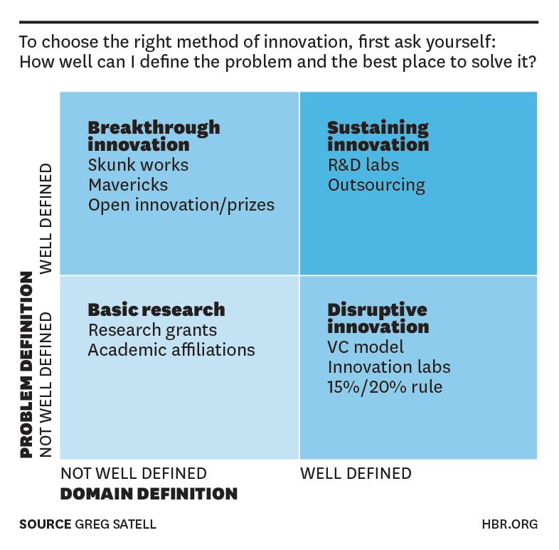

INNOVATION SERVICE IDEA
According to Trott (2008), innovation is equal to theoretical conception plus technical invention and commercial exploitation. My innovative service idea is a postcode-to-postcode cancer screening service in Birmingham. Cancer is a deadly disease that when detected early, can be cured. Early detection helps to avoid cells from invading and destroying the surrounding healthy tissues. Many cancer patients are dying unnecessarily because of no symptoms, ignoring signs and symptoms or merely lack of knowledge about the disease. The delay to see a doctor or getting an appointment for a scan, especially during the pandemic period when many hospital appointments were cancelled resulted in many deaths. (Cancerresearchuk.org, 2022) The shortage of hospital staff due to BREXIT also contributes to the treatment and test delays and decreased diagnosis. The feeling of uncertainty as to whether your lump or mole is cancerous or benign is depressing as I have experienced it. For that reason and to ease some of the burdens off the NHS hospitals, I come up with the idea of innovating a saleable service to the NHS, Cancer Research and the government by offering postcode to postcode mobile cancer screening service to the people of Birmingham as a trial that when successful will be phased to other cities. This demanding innovation service can save lives as well as help with the massive backlog on the National Health Service (NHS). The NHS offers three yearly intervals Cervical Screening for 25 to 49 years old, breast cancer screening offered to women aged 50 to 70 years, and bowel cancer screening offered to everyone aged 60 to 70 years every 2 years but more should be done. (NHS,2022) There are already existing mobile cancer screenings but are stationed mostly in hospitals. However, I used the brainstorming technique acronym SCAMPER (substitute, combine, adapt, modify, purpose, eliminate, reverse) for our service to stand out. (Litemind, 2015)
My innovation service will be part of the campaign to fight cancer called #ERADICATECANCER. It will screen people in their areas as well as a regular campaign at shopping centres and busy areas 7 days a week from 8 am to 7 pm. It will be made available to everyone in Birmingham instead of waiting for the long National Health Service queue.
The screening can either be administered at your home or by our team of health experts specialising in all kinds of cancers who will be mobilising in different postcodes every day. The innovation service will help to detect cancer cells in more detail and if any abnormality in the body cell is detected, a hospital appointment will be accelerated thus increasing the survival rate and reducing unnecessary deaths of cancer patients. Although the cancer survival rate has doubled in the last 40 years, there is still room for improvement, especially after the pandemic.

UNIQUE SELLING POINT(USP)
As coined by McCarthy (1960), described Unique Selling Proposition (USP) as a way for businesses to set themselves apart from their competitors. The unique selling point of my service will be that it will be screening people in their streets instead of going to their doctors or hospital and my value proposition will be that it will be easily accessible to the general public at no cost. Competitors in this area are low as there is no service of this kind available at your doorstep unless you meet certain criteria for a home delivery swap test. Even though there are cancer screening centres, they are not within easy reach like our mobile screening service. Target clients will be everyone over the age of 18 years or people who are at high risk of having the disease either by history or age. As part of an initiative to eradicate cancer sponsored by Cancer Research, NHS, funding from the government, and generous corporations who offer volunteer grants to find a cure and early detection of the disease, my service will be marketed to them. The NHS and Cancer Research will fund 50% of the initiative and the remaining fund will be lobbied through government allocation of tax funds, donations, and personal loans from banks. Cancer Research UK is the largest independent funder of cancer research in Europe. They invested £413millions in research in 2017/18 to different institutions around the UK. With the collaboration and funding of the stakeholders, a contract will be signed to offer my service to third parties who are the end users on behalf of the investors free of charge. Continuous funding and collaboration are needed to sustain this innovative service proposition. www.cancerresearchuk.org.
The types of equipment needed are ultrasound and X-ray machines, positron emission tomography( PET) scan, computerized tomography( CT) scan, bone scan, and tumour marker among others. A customised mobile unit designed with our logo #ERADICATECANCER boldly visibly will be needed to install all the necessary equipment mentioned above. Second-hand refurbished equipment will be bought to start with until the business prospers. The total cost is approximately half a million pounds as the types of equipment are costly.

SWOT ANALYSIS
It is vital to do a SWOT analysis around the proposed innovation service for any company or individual who developed a product or service beginning from product development, introduction, growth, maturity, and the declining stage.
Strength | Weaknesses | Opportunity | Threats
Funding is available from the central government, NHS, Cancer Research and others. | Sustainability of the service | Innovation service | New entrant to the market
Demand for the service. | Lack of autonomy | To get a grant from charities like Cancer Research or generous corporation | Government policies
 | Lack of resources and Manpower |  | Legal matters

There are many barriers to innovation such as the legal factor, excessive financial constraints, experiences or knowledge, lack of resources, and fear of failure. Insufficient incentive, lack of time or resources, insufficient training or talent, and lack of autonomy. The enablers of innovation are the opposite of the barriers like setting up the right team, autonomy, and freedom, incentives, and rewards, tolerance of failure, management support, ample resources, excellent networking, and dedicated manpower.

E-COMMERCE
Kalakota and Whintons 1997 defined the term E-commerce as a communication method for business processes and services online. A marketplace for your service or product can be controlled either by the sellers or buyers or a neutral. To compete in the technology market, a website is necessary to promote sales. Hiring a website designer will cost £5000 upfront fee and £1000 annually to maintain. Our website will be launched and accessible through search engines like google and available at: http://www.eradicatecancer.co.uk. The website will have a clear description of the service being offered and who we are, easy navigation, interesting content, up-to-date and quality information, the business logo, user friendly, contact details, secure and good appearance. The website will state how our service stands out from other services that are already in the market using the SCAMPER (substitute, combine, adapt, modify, put to another use, eliminate, reverse) technique.
S - Substituting station cancer screening units based in hospitals to a mobile unit. Instead of coming to us, we come to you!
C - Combining all equipment in one place without the need to go from one hospital room to another. Our service is quick and efficient!
A - Adapting from the pandemic crises to help ease the backlog and long waiting time to get a diagnosis. Best the NHS waiting time!
M – Modifying and reducing the number of deaths from cancer due to late diagnosis. Cancer is a curable disease if diagnosed early!
P – Plans to extend our services to other towns and cities if successful. Help us help you!
E – Eliminate or reduce the negativity surrounding cancer. Cancer is not a death sentence!
R – Reverse the way treatment is given. No need for an appointment!

Total staff employed will be 15 comprising of health experts at the beginning with a total of 5 staff working a 12 hours shift daily. The business will offer training to people on a voluntary basis. I will be investing my time and resources in order for my innovative idea to be a success. Since we don’t deal with the consumers financially as the tests are provided to the people for free, there is no payment method used. Instead, the funding provided by the NHS, Cancer research and the government is paid through the company’s account to enable me to pay staff.

MARKETING
A robust campaign will be needed to sensitise people about the advantage of early cancer diagnosis and encourage them to come out and test themselves. Marketing will be on NHS websites, hospitals, GP surgeries, radios, leaflets, and social media as well as campaigning in areas we are visiting. Our mobile cancer screening bus will have a special sound to alarm people of our present.
A business plan is important as it is the blueprint for turning a service or product into a commercially viable reality. The business plan should address the 4 Ps of marketing (product, price, promotion, and place) when defining the scope of your marketing strategy. (McCarthy, 1960)
Product/Service - The product or service that is being offered is a mobile cancer screening for the population in Birmingham.
Price – The service will be will expensive as I will be dealing with novel technologies and a lot of manpower.
Promotion – Knowing how to promote your service or product helps a business to be successful. In our case, the promotion will be mostly through social media, state-sponsored Television and radio station.
Place – The location of a business should be near its target consumers. It should be easily accessible with good parking space. Being mobile gives our service the opportunity to reach people easily.
MARKETING STRATEGY
The following marketing strategy can be done to promote sales.
- Phase out the weak products and develop strengths
- Cut prices if you can afford to
- Increase your distribution outlets or phase out those not doing well
- Strategies advertisements to cut down cost
- Promotion and sales at minimal reduce the price.

SUMMARY
Innovations and productivity brought by knowledge have caused more than 50% of historical economic growth. New innovations are emerging all the time and existing ones have to adapt to suit consumer’s needs and demands. Novel technologies and the pandemic has changed the ways businesses strategies their innovation orientation. It is crucial to continuously emerge with new ideas and better ideas to succeed in a competitive market. Social media and eCommerce websites are helping businesses reach their targeted consumers without the need to pay for expensive advertisements.
Since my innovative service is already in the market, I used the SCAMPER technique to improve the service I will be selling to meet the needs and demands of my stakeholders. Business success depends on the continuous flow of funds and on transforming business opportunities into tangible products or services. Understanding customer’s needs and how best to meet these needs may be profitable.
Marketing is important in a new business start-up and I will be focusing on how to brand my service so that it will be successful and fit for purpose. The fact that it is to save humanity makes it more worthwhile. Deducing the waiting time for cancer diagnosis and encouraging people to seek help before it is too late. My caring nature and genuine desire to help people will a bonus to this service that I will be innovating.

REFERENCES
- Cancer Research UK (2021). Available at: https://www.cancerresearchuk.org. (Accessed: 28/11/2021).
- National Health Service (2021). Cancer NHS. Available at: http://www.nhs.uk/cancer. ( Accessed: 28 November 2021).
- Cook, P. (2016) ‘Lending Innovation: Creativity and enterprise. ISSN: 00197858
- Enrique, J. and Portilo, P. (2018) Application of conscious innovation in organizations. Business Science Reference: Hershey, Pennsylvania
- Kotler, P. (2012) Marketing Management. Pearson Education. p.25.
- Leigh, D. (2009) Handbook of Improving Performance. Wiley Online Library
- McCarthy, E.J. (1960) “Basic Marketing – A Managerial Approach.” 1st edn. Homewood, IL: Irwin
- Morris, E, et al. (2021) Impact of COVID-19 pandemic on the detection and management of colorectal cancer in England: a population-based study. Lancet 2021. Doi:10.1016/S2468-1253(21)00005-4. (Accessed: 14 August 2022).
- National Health Service (2021). Cancer NHS. Available at: http://www.nhs.uk/cancer. ( Accessed: 28 November 2021).
- Satell, G. (2013) Before you Innovate, Ask the Right Questions. Available at: http://www.bbr.org/innovation. (Accessed: 12 August 2022).
- Troll, P. (2017) Innovation management and new product development. 6th edition. Pearson: Harlow, England.
- Watkins, R, Meiers, MW and Visser, Y. (2012) ‘A guide to assessing needs: Essential tools for collecting information, making decisions, achieving development results. Avalable@http:www.books.google.com. World Bank Publication, Accessed: 24/12/2021.

