MARKETING FUNDAMENTALS

ASSESSMENT 2: ANALYSIS AND EVALUATION

NAME: MIHAELA MUSAT
STUDENT NUMBER: 1915928
MODULE LECTURER NAME: TUSHARA BALENDRAN
Table of Contents
Introduction 3
Main Body 3
Overview 3
Processes of marketing 4
Stages of marketing 5
Role of marketing mix 6
STP analysis of Apple 9
Identification of the major stakeholders 11
Stakeholder engagement procedure 13
Influence of the stakeholders on marketing activities 16
Conclusion 17
References 18

Introduction
The process of marketing by every organisation is unique and exclusive. An organisation needs to develop and analyse the market condition before targeting a group of audience in the global market. In this given assignment, the overview of the chosen organisation is made along with the various initiatives taken by the organisation to contribute to the CSR and maintain a sustainable position in the society. Besides, the process and various stages of Marketing utilised by the organisation are discussed. The role of the Marketing Mix (7Ps) is also mentioned in this assignment. The segmentation, targeting and positioning strategies followed by Apple is also described in this assignment. The assignment will also discuss the major stakeholders of apple and the way they influence the employees of the organisation. In addition, the assignment will also briefly discuss the stakeholders' engagement in the organisation and their influence in the marketing techniques applied by the institution.

Main Body

Overview
In this given portion of the assignment, the overview of the chosen organisation will be provided. Apple is one of the leading America based multinational company that provides tech services to its customers. The organisation has it's headquartered in Cupertino, California and is responsible to design and innovate latest technologies in their electronic services provided. The company was founded by three individuals, with Steve Jobs pioneering the foundation and structure of the company and supported by his peers Steve Wozniak and Ronald Wayne (Apple, 2020). The company aims at empowering humans, by making technology achievable to individuals and easing the technicalities required by a person whilst gathering knowledge and information related to work, research or study. The high quality and the effective utility of the products produced by Apple in comparison to the rival brands have resulted in the success of Apple across the course of all these years (Apple, 2020).
In this contemporary era, where every new rotates in a flick of touch, in the mobile screens, it is extremely important for the organisation like Apple to maintain a responsible position in the Global Market. According to Shieber (2020), the organisation has opted to invest $100M for the racial equity and Justice initiative on June 11, 2020. In addition, the company aims at being a contributing force to incur changes in the society, which by far have been very slow. This has helped the company to earn huge respect from its customer base and aided the company to develop a constant position in the competitive business market. In addition, the R&D (Research and Development) department of Apple is constantly planning to develop 5G services for the products created by the institution (Wangfi, Wang and Tan, 2020). The application of 5G on the various electronic gadgets will surely contribute in developing a quick and easy lifestyle for the customers, using the process. This will support Apple's initiative to bring change and comfort to people's life.

Processes of marketing
The process of Marketing majorly contains strategies developed by the industry to maintain and create acceptance of a product to the targeted audience along with the maintenance of the satisfaction level of the targeted customers. In the present market scenario, where most of the organisations practice and provide services internationally to its audiences, the process of marketing has seen a slight shift to the digital and social medium compared to the traditional marketing techniques. According to Peng, (2018), Apple has been observed to promote the brand using unique marketing policies. The products created by Apple are simple and classy and classy with latest features encrypted to maintain and look after the needs of the customers and the advancing technologies.
The company has often been noticed to collaborate with leading influencers and spread the details about the brand, its product and its image. Besides, the company also creates meaningful advertisements to affect the customer's emotional state as well as create social awareness about the brand and develop its overall sale. Along with this, the company also promotes the brand online, using its website and other official business accounts made by the company to constantly stay in touch with the customers and understand their requirements (Zhang, et al., 2020). The company also maintains 24-7 customer care services, to take note of the customer’s requirement and complains. This in turn helps the institution to develop a loyal connection with its customer. To conclude, the brand image of Apple is immense and people generally look forward to the next product launch by this institution, which in turn supports the company to maintain a constant position amongst the competitors present in the international market.

Stages of marketing
The process of marketing happens with the succession of several interrelated stages, that helps support the complete process of Marketing. According to Chernova, et al., (2019), the process of marketing begins with the research made based on the customer needs and their requirements. Customers are the major concerning factor in an organisation and their requirements play a pivoting role in the sales statistics of the organisation (El-Adly, 2019). The consideration of the needs of the customers helps the organisation, Apple to develop the product s as per the customer requirements. The research made on customer demands is further conveyed to the internal marketing department that develops the services based on customer needs. Once the service is produced, the Sales department advertises the various specifications and details of the product to engage with the customers and motivate them towards purchasing.

Figure 1: Stages of Marketing
(Source: Created by the learner)
The smooth and flexibility of the organisational structure play a major role in the development of the products and its marketing. It is certain that every department of an organisation are interrelated and the maintenance of a mutually respectable and understanding organisational culture helps institutions like Apple to develop and maintain a successful relationship with not only the employees but also with the customers. According to Colicev, Kumar and O'Connor, (2019), the reciprocated and respected attitude of every employee to the other one helps in the maintenance of a successful brand position, creation and development of authentic product and there sufficient distribution to the customers resulting in a continuously progressing yearly revenue collection by the company.

Role of the marketing mix
As stated by Išoraitė (2016), marketing mix is mainly comprised of 7ps but generally, it is referred with 4ps i.e. products, pricing, placements, and promotions. It helps businesses in formulating a comprehensive marketing plan. As denoted by Yaghoubian et al. (2018), marketing mix plays a crucial role in initiating, analysing, and maintaining the business operations as it helps the firms to formulate an effective marketing strategy that can enhance the performance of the business in the marketplace. Apple can use its 7ps to analyse and maintain its position in the marketplace and to formulate a detailed strategy that can help the firm in initiating 5G technology.
The marketing mix of Apple
- Product: According to Rebecca and Maharani (2018), Apple offers large varieties of commodities to its consumers through its online and offline platforms of which the most popular product of the firm is iPhone. iPhone has a global market share of 20% and Apple was the foremost corporation in the world that introduced multi-touch in its Smartphone, which made the product more valuable and helped the firm in value creation. As denoted by Apple Support (2020), the firm launched four variants of iPhone 12 with 5G cellular services in 2020. This highlights how serious Apple is for the 5G technology project. Moreover, the firm is also eyeing to incorporate 5G services to its other valuable commodities Mac, iPad, Apple Watch, Apple TV, and so on. The firm has predicted that the inclusion of 5G technology will give a major boost to its performance and will help the firm to capture a large chunk of market share in future.
- Price: As per Tunjungsari, Syahrivar and Chairy (2020), the premium pricing strategy of Apple Inc. is still relevant in the bigger marketplace like the UK because of its brand loyalty. Apple uses premium-pricing strategies while placing its products in the marketplace. It offers superior quality of commodities and services and it has gained customer loyalty through its wide range of attractable services. Thus, it is necessary for the brand to enhance its products and services to remain relevant to its premium pricing strategies. As denoted by Knight (2020), Apple is the zoo of technologies and it spends a large chunk of money in R&D. The development of 5G will not only help the company to remain stable with its premium pricing policies but will also help the company to tackle its rivals in the UK during the pandemic.
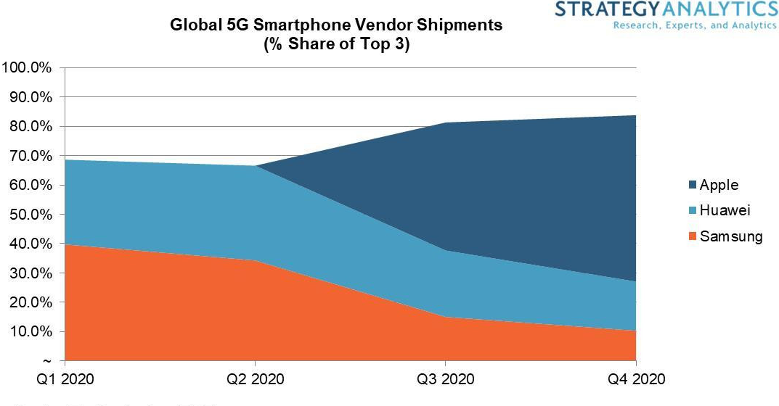
Figure 2: Global 5G Smartphone vendor shipments
(Source: Bicheno, 2019)
- Place: As reported by Amin and Munsi (2020), Apple inc. uses both the online and offline platforms to channel its product to its consumers. The place plays a significant role in marketing strategy and currently, Apple is dominating the UK marketplace through its online stores. The firm is using online stores Apple.com, Amazon, and so on to place its 5G products amidst the pandemic. This has also helped the firm to enhance its profitability.
- Promotion: As stated by Jackson and Ahuja (2016), Apple uses the tactics of elegant promotions to lure consumers into their stores. The firm provides an innovative and different market commodity than its rivals like Samsung, Huawei that makes the firm stand-out in the global market. The firm uses a white and black background in its promotions, which makes the product look more atheistic. Moreover, it specifies all the specifications loud and clear through its advertisement and uses premium media to signify its product variants in the marketplace. The firm can use these same tactics while promoting 5G variants in the UK as this will not only aware consumers regarding the 5G devices but will also help the firm in creating value so it can attain competitive advantage in the UK sector.
- People: According to MarBoss DM (2018), consumers that prefer Apple are majorly its past loyal consumers as the firm is famous for its consumer retention policies. The major people in Apple Inc. are its staff members that play a crucial role in providing efficient experience to Apple’s consumers. Apple can use its staff members to aware its consumers regarding its 5G products so it can drive its sales. It can also collaborate with famous influencers like Jennifer Aniston, Selena Gomez, and so on to aware consumers regarding its 5G technologies.
- Process: As opted by Digital Marketing (2018), the process defines the overall experience of the consumer regarding the commodity. Apple is famous for providing customer services through its several service channels. The firm can use this medium to interact and aware of its audience regarding 5G technology and can even motivate them to provide feedback so it can enhance its future 5G goods.

Figure 3: Marketing Mix
(Source: Created by the Learner)
- Physical evidence: Apple majorly opens its offline stores in renowned and historical places like Regent Street, UK (MarBoss DM, 2018). It stores are majorly minimalist and atheistic, which helps the firm to attract consumers. Moreover, the firm uses attractive technology and innovation both in its product and store to stand out in the market. Apple should infuse its new 5G technologies in its offline stores to attract and create momentum regarding its 5G technologies in the marketplace. The firm should display its beta 5G versions in its stores to gain momentum in the marketplace, as this will increase excitement in the consumers regarding the future 5G products.

STP analysis of Apple
Market Segmentation
Demographic | According to Proctor (2020), demographic segmentation targets family, class, and so on. Apple should develop its 5G technologies for every age, class, ethnicity, and so on. Moreover, the firm should develop its future iWatch and iPad with 5G technologies so anyone can access and enjoy its services.
Geographic | Apple should segment its 5G technologies by analysing the demand of the 5G in the UK region. This will help the firm to target its consumers effectively. It should also sell its 5G product through online mediums, as it will help the firm to drive sales in the pandemic times in the UK.
Psychographic | According to Camilleri (2018), psychographic segmentation involves lifestyle, values, and traits. Apple should develop 5G Mac and IPad and should target the young generation of the UK mainly as they will love to use the advance product of Apple.
Behavioural | As denoted by Andaleeb (2016), behavioural segmentation displays product knowledge. Apple is a renowned brand in the world and can use the stage to provide product knowledge regarding 5G technologies. This will help the firm in driving its sales and will increase the value creation of the brand in the UK.

Table 1: Segmentation analysis of Apple
Target: Apple should mainly target the premium consumers for its 5G technologies as 5G is very new in the market and it has stable demand. Moreover, it should mainly target the young generations, as they are energy driven and shows better potential in using the 5G opted products and services.

Figure 4: STP Analysis
(Source: Created by the Learner)
Positioning: According to Adeola, Ehira and Nworie (2019), positioning focuses on advertising and promotion for driving the product. Apple should collaborate with renowned influencers such as Jennifer Aniston and Selena Gomez to announce its future 5G technologies. Moreover, the firm should use its brand identity to communicate the effectiveness of 5G technology to its consumers. This will help the firm to attain a better place in the market.

Identification of the major stakeholders
As reported by Apple Investor Relations (2020), the major stakeholders of Apple Inc. are Tim Cook, Arthur Levinson, Vanguard Group Inc., and so on. Apple majorly focuses on a multi-supply chain model having relations with investors, consumers, employees, and suppliers. As denoted by Reiff (2020), Tim Cook with 847969 shares acts as the CEO of the firm after the death of Steve Jobs. However, the firm has made important relations with third-party suppliers to Wistron to produce some of its commodities. This has helped Apple to produce a large number of commodities at lesser labour rate too. The leaders and managers of Apple also play a crucial role in Apple's supply chain network as they guide the workforce towards the intended goals. Thus, the board of control, Managers/leaders, and the workforce are the key internal stakeholders of the firm while the investors, suppliers, and consumers are the main external stakeholders of the firm.
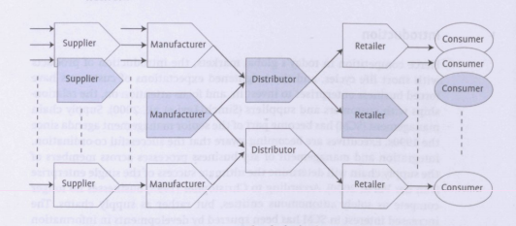
Figure 5: Supply Chain model
(Source: Jack, 2016 pp.106)
According to Centobelli, Cerchione and Ertz (2020), the agile supply chain model is ideal for management that provides unique commodities to its consumers. Apple can use the agile supply chain model to produce or incorporate 5G technologies into its commodities and services. As denoted by Bicheno (2019), Apple had forecasted to produce 5G techs in 2020 at a speedy rate. However, the covid-19 has hampered the operations of the Apple and it may suffer a loss if it does not carry its operations without proper supply model.
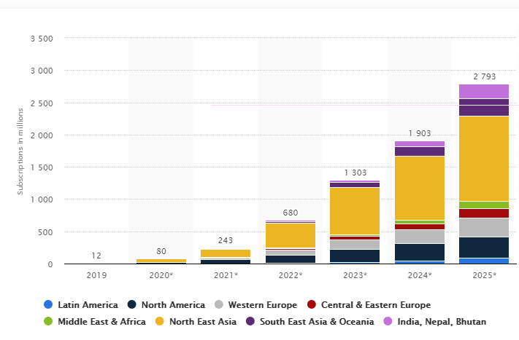
Figure 6: Forecast of 5G subscriptions by region
(Source: Statista, 2020)
The agile supply chain model uses decoupling points to develop any commodities as per the preferences of the consumers. This means that Apple can produce 5G tech after getting orders about 5G products in the marketplace. This way it can easily cope with the pandemic situation as it will have the idea of the demand for 5G commodities in the current marketplace. As denoted by Lockamy (2017), the supply chain helps to place finished product efficiently in the market. However, Apple is facing continuous criticism because of its Chinese involvement and this has even hampered its supply chain model. The firm should communicate the effectiveness of 5G technologies to its external and internal stakeholders and should formulate an effective marketing plan that can help the firm to drive its sales.

Stakeholder engagement procedure
It is very crucial for the firm to facilitate changes in the management and this proposed change comes through efficient stakeholders’ engagement process. As stated by Lane and Devin (2018), the stakeholders’ engagement model identifies key stakeholders, evaluates the stakes, and facilitate whether the stakes are necessary for the management or not. Apple can use the stakeholder engagement model to evaluate and determine policies regarding 5G technologies and the firm can even determine opportunities and problems that can arise from 5G technologies through the proposed model. The stakeholder engagement model has sex steps. These are:
- Identify Stakeholders: As stated by Hawrysz and Maj (2017), stakeholders are the backbone for every business operations and management. Apple should identify key external and internal stakeholders as they can help the firm in developing stakes related to 5G technologies and transforming these stakes into action. The board of control, employees, and leaders are the internal stakeholders of Apple while consumers, suppliers, and investors are the external stakeholders of the firm.
- Describe the stakes: It is crucial for Apple to describe its 5G policies to the stakeholders so they can understand the importance and relevance of the proposed policy. The firm can call zoom meetings for providing presentations regarding the effectiveness of 5G technologies to internal stakeholders amidst the pandemic and can evaluate how 5G is the next big thing in the field of technologies. Moreover, the firm can also share revenue result of its latest 5G product i.e. iPhone 12 variants to display the profitability aspect to the external stakeholders (Yun, Lee, and Aoshima 2019). Apple should communicate the effectiveness of 5G technology with external stakeholders through advertisements and by providing sneak-peeks of its latest developments. It should evaluate the strategy regarding 5G technologies through the presentation to its investors so they can understand the market demand for the product.
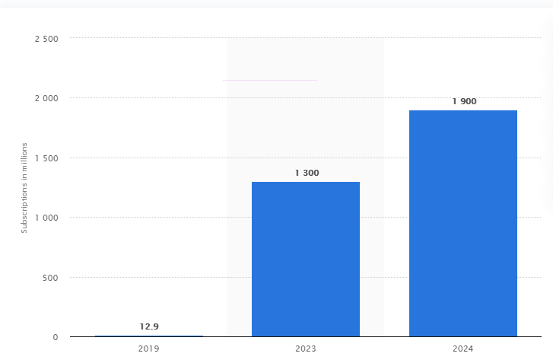
Figure 7: Mobile 5G subscriptions forecast (2019-2024)
(Source: Statista, 2020)
- The significance of the stakes: As denoted by Bocu (2020), the 5G technology will bring ease in the day-to-day lifestyle of human beings. Apple should communicate with its internal and external stakeholders regarding the effectiveness of 5G technologies. The 5G technology has already generated enough buzz in the global sector and the sales of the latest iPhone are proof for its successful future. Apple should provide internal stakeholders with 5G subscriptions related forecast so they can understand its profitability aspect and to evaluate the significance of 5G technology to its external forecast the firm should display the life-changing benefits like fast internet service along with other aspects.
- Evaluate opportunities: According to Valanarasu and Christy (2019), the 5G networks are the next big thing for the future of the internet and other technologies. Apple should describe how much beneficial 5G technology is to its stakeholders by displaying the ease-lifestyle that 5G can create and how AI can become more powerful through the inclusion of 5G. Moreover, it should also display opportunities like employment, fast services less lag to its stakeholders through this element.
- Responsibilities of stakeholders: As stated by Okai-Ugbaje, Ardzejewska and Imran (2020), stakeholders are responsible for managing and facilitating the operations of the management. Apple should assign its internal stakeholders with responsibilities related to 5G technologies through plans and strategies so they accomplish their tasks. The firm should generate awareness through its suppliers and investors so consumers can understand why 5G is crucial for the coming generation. This way it can easily direct its goals and can even attain a competitive advantage in the global markets such as the UK.
- Relationship Enhancement: The last step in the stakeholder engagement model is to consider the policies and actions that Apple can take to enhance its relations with stakeholders. The firm should provide initial sneak-peeks to its consumers to drive momentum regarding 5G technologies. Moreover, it should motivate its employees and leaders to incorporate 5G technology in their daily lifestyles to set a benchmark for the others.

Influence of the stakeholders on marketing activities
According to Jurgens et al. (2016), secondary stakeholders majorly influence the marketing activities of the firm through opinions and feedbacks. On contrary, as denoted by Charan and Murty (2018), primary stakeholders influence the marketing activities through their strategies and policies, which eventually affect the opinion and feedbacks of the secondary stakeholders. Apple should effectively discuss the benefits of the 5G technologies to the primary stakeholders so they can formulate an effective plan that can help both the management and the consumers. The board of directors should initiate different meetings for the implementation of 5G technology and leaders and managers should drive policies and guide the workforce to attain the goals related to 5G technology.
As denoted by Barnett (2018), stakeholders influence the management and the whole world. Apple should hold meetings with its investors and suppliers to aware them about the effectiveness of the 5G technology and how big changes it can bring for the next generation. This way supplier will initiate in producing 5G related commodities and investors will invest in the company so it can attain a competitive edge in the marketplace.

Conclusion
The report has provided a comprehensive take on marketing fundamentals of Apple Inc. The framework has discussed how Apple can use 5G technologies for its beneficial and has highlighted the processes involved in marketing. The framework has displayed the stages of marketing and has given the focus on the marketing mix and STP analysis of the apple. It has also provided a comprehensive take on Apple's stakeholders and has displayed how agile supply chain model can be beneficial for Apple while choosing the 5G technology. Moreover, the study has evaluated the stakeholder engagement process and the influence of the stakeholders on the marketing activities of Apple.

References
- Adeola, O., Ehira, D. And Nworie, A., 2019. 5 Segmentation, Targeting, and Positioning in Healthcare. In Health Service Marketing Management in Africa (pp. 45-55). Productivity Press.
- Amin, M.R. and Munsi, M., 2020. Motivational Techniques for Business Organization–A Case Study of Apple Inc, pp.22.
- Andaleeb, S.S., 2016. Market segmentation, targeting, and positioning. Strategic Marketing Management in Asia, pp.179-207.
- Apple - Investor Relations (2020) Apple - Investor Relations, Investor.apple.com. Available at: https://investor.apple.com/investor-relations/default.aspx (Accessed: 30 December 2020).
- Apple Support (2020) Use 5G with your iphone, Apple Support. Available at: https://support.apple.com/en-us/HT211828 (Accessed: 30 December 2020).
- Apple (2020). Available at: https://www.apple.com/ (Accessed: 30 December 2020).
- Barnett, M.L., 2018. Influence stakeholders, influence the world. In Social Movements, Stakeholders and Non-Market Strategy. Emerald Publishing Limited. Pp.247-258. Https://doi.org/10.1108/S0733-558X20180000056010
- Bicheno, S. (2019) Apple forecast to dominate the 5G smartphone market next year, Telecoms.com. Available at: https://telecoms.com/500954/apple-forecast-to-dominate-the-5g-smartphone-market-next-year/ (Accessed: 30 December 2020).
- Bicheno, S. (2019) Apple forecast to dominate the 5G smartphone market next year, Telecoms.com. Available at: https://telecoms.com/500954/apple-forecast-to-dominate-the-5g-smartphone-market-next-year/ (Accessed: 30 December 2020).
- Bocu, R., 2020, April. A Constructive Review Regarding the Significance of 5G Networks for the Internet of Things. In Workshops of the International Conference on Advanced Information Networking and Applications (pp. 280-298). Springer, Cham.
- Camilleri, M.A., 2018. Market segmentation, targeting and positioning. In Travel marketing, tourism economics and the airline product (pp. 69-83). Springer, Cham.
- Centobelli, P., Cerchione, R. And Ertz, M., 2020. Agile supply chain management: where did it come from and where will it go in the era of digital transformation?. Industrial Marketing Management, 90, pp.324-345.
- Charan, P. And Murty, L.S., 2018. Secondary stakeholder pressures and organizational adoption of sustainable operations practices: The mediating role of primary stakeholders. Business Strategy and the Environment, 27(7), pp.910-923.
- Chernova, D.V., Sharafutdinova, N.S., Novikova, E.N., Nasretdinov, I.T., Xametova, N.G. and Valeeva, Y.S., 2019, April. Evaluation of Event Marketing in IT Companies. In International Scientific Conference “Digital Transformation of the Economy: Challenges, Trends, New Opportunities” (pp. 487-493). Springer, Cham.
- Colicev, A., Kumar, A. And O'Connor, P., 2019. Modeling the relationship between firm and user generated content and the stages of the marketing funnel. International Journal of Research in Marketing, 36(1), pp.100-116.
- Digital Marketing (2018) Apple 7Ps of Marketing Mix, Digital Marketing. Available at: https://nikdigital2018.wordpress.com/2018/08/15/apple-7ps-of-marketing-mix/ (Accessed: 30 December 2020).
- El-Adly, M.I., 2019. Modelling the relationship between hotel perceived value, customer satisfaction, and customer loyalty. Journal of Retailing and Consumer Services, 50, pp.322-332.
- Hawrysz, L. And Maj, J., 2017. Identification of stakeholders of public interest organisations. Sustainability, 9(9), p.1609.
- Išoraitė, M., 2016. Marketing mix theoretical aspects. International journal of research granthaalayah, 4(6), pp.25-37.
- Jack (2016) Supply Chain Management: Theory and Practices, Edepot.wur.nl. Available at: https://edepot.wur.nl/357992#:~:text=Van%20der%20Vorst%20and%20Beulens,supply%20chain's%20decision%2Dmaking%20processes. (Accessed: 30 December 2020).
- Jackson, G. And Ahuja, V., 2016. Dawn of the digital age and the evolution of the marketing mix. Journal of Direct, Data and Digital Marketing Practice, 17(3), pp.170-186.
- Jurgens, M., Berthon, P., Edelman, L. And Pitt, L., 2016. Social media revolutions: The influence of secondary stakeholders. Business Horizons, 59(2), pp.129-136.
- Knight, W. (2020) How Apple Built 5G Into Its New iphones, Wired. Available at: https://www.wired.com/story/how-apple-built-5g-new-iphones/ (Accessed: 30 December 2020).
- Lane, A.B. and Devin, B., 2018. Operationalizing stakeholder engagement in CSR: A process approach. Corporate Social Responsibility and Environmental Management, 25(3), pp.267-280.
- Lockamy III, A., 2017, July. An examination of external risk factors in Apple Inc.’s supply chain. In Supply Chain Forum: An International Journal (Vol. 18, No. 3, pp. 177-188). Taylor & Francis.
- Marboss DM (2018) Apple’s Marketing Mix, marboss DM. Available at: https://marbossdigitalmarketing.wordpress.com/2018/10/23/apples-marketing-mix/ (Accessed: 30 December 2020).
- Marboss DM (2018) Apple’s Marketing Mix, marboss DM. Available at: https://marbossdigitalmarketing.wordpress.com/2018/10/23/apples-marketing-mix/ (Accessed: 30 December 2020).
- Okai-Ugbaje, S., Ardzejewska, K. And Imran, A., 2020. Readiness, roles, and responsibilities of stakeholders for sustainable mobile learning adoption in higher education. Education Sciences, 10(3), p.49.
- Peng, X., 2018, January. Study on Apple Marketing Model Based on Modern Aksu Region in Xinjiang. In 2017 5th International Education, Economics, Social Science, Arts, Sports and Management Engineering Conference (IEESASM 2017) (pp. 94-97). Atlantis Press.
- Proctor, T., 2020. Segmentation, Targeting and Positioning. In Absolute Essentials of Strategic Marketing (pp. 71-79). Routledge.
- Rebecca, I.T. and Maharani, A., 2018. Exploration of Methods for Small Businesses in Determining The Brand Positioning through Marketing Mix Concept. The Winners, 19(1), pp.1-7.
- Reiff, N. (2020) Top Apple Shareholders, Investopedia. Available at: https://www.investopedia.com/articles/markets/120115/top-5-apple-shareholders.asp (Accessed: 30 December 2020).
- Shieber, J. (2020) Apple Commits $100M to its new racial equity and justice initiative, Techcrunch.com. Available at: https://techcrunch.com/2020/06/11/apple-commits-100m-to-its-new-racial-equity-and-justice-initiative/#:~:text=Apple%20commits%20%24100M%20to%20its%20new%20Racial%20Equity%20and%20Justice%20Initiative,-Jonathan%20Shieber%40jshieber&text=Apple%20announced%20today%20a%20new,initiatives%2C%20will%20lead%20the%20initiative. (Accessed: 30 December 2020).
- Statista (2020) Forecast number of mobile 5G subscriptions worldwide from 2019 to 2024, Statista.com. Available at: https://www.statista.com/statistics/760275/5g-mobile-subscriptions-worldwide/ (Accessed: 30 December 2020).
- Statista (2020) Forecast number of mobile 5G subscriptions worldwide from 2019 to 2024, Statista.com. Available at: https://www.statista.com/statistics/760275/5g-mobile-subscriptions-worldwide/ (Accessed: 30 December 2020).
- Tunjungsari, H.K., Syahrivar, J. And Chairy, C., 2020. Brand loyalty as mediator of brand image-repurchase intention relationship of premium-priced, high-tech product in Indonesia. Jurnal Manajemen Maranatha, 20(1), pp.21-30.
- Valanarasu, M.R. and Christy, A., 2019. Comprehensive Survey of Wireless Cognitive and 5G Networks. Journal of Ubiquitous Computing and Communication Technologies (UCCT), pp.23-32.
- Wangfi, S., Wang, W. And Tan, Y., 2020. Internet Cross-Border Service Model Based on 5G Environment and Cloud Computing Data Platform. Microprocessors and Microsystems, p.103520.
- Yaghoubian, S., Jahani, M.A., Yazdani-Charati, J. And Mahmoudi, G., 2018. The role of marketing mix (the 7 Ps) in patients’ attitudes to Iranian hospitals based on their kind of ownership (case study in Iran). International Journal of Healthcare Management, pp.1-5.
- Yun, B.S., Lee, S.G. and Aoshima, Y., 2019. An analysis of the trilemma phenomenon for Apple iphone and Samsung Galaxy. Service Business, 13(4), pp.779-812.
- Zhang, L., Wu, J., Chen, H. And Nguyen, B., 2020. Does one bad apple ruin a firm’s green brand image? Examining frontline service employees’ environmentally irresponsible behaviors. European Journal of Marketing. Https://www.emerald.com/insight/content/doi/10.1108/EJM-11-2019-0844/full/html

