Business Plan C1

Program of study: BA (Hons) Business Management
Module name and code: Entrepreneurship LCBB5001
Student name: Paul-Silvian Vornicescu
Student ID: 2246785
Lecturer: Dr. Amer Kareem

TABLE OF CONTENT

1. | Overview of the business idea | 3
2. | Products and services | 3
3. | Legal format of the startup company | 4
4. | Management of the company | 5
5. | SWOT Analysis | 6
6. | 4Ps of Marketing | 8
7. | One-year cashflow forecast | 9
8. | References | 11

Overview of the business idea

Essex Fast Recovery Ltd. is a modern vehicle recovery and roadside assistance business operating in Essex and surrounding areas, designed to deliver fast, reliable, and transparent services to motorists in need. The company distinguishes itself from traditional recovery services by offering an innovative mobile app that allows customers to book services and receive instant quotes without the need for a phone call. This unique feature provides a seamless and stress-free customer experience, streamlining the process of vehicle recovery during what is often a challenging time for drivers.
We are targeting both private motorists and business clients such as fleet operators and local car dealerships. The service’s unique app-based booking system, combined with competitive and upfront pricing, positions it as a customer-centric alternative to competitors.
By leveraging technology and prioritizing customer convenience, Essex Fast Recovery Ltd. Operates as a service-based business model and aims to redefine the vehicle recovery industry in the Essex region, setting a new standard for accessibility, reliability, and innovation in roadside assistance (Barringer, 2019).

Products and services

Essex Fast Recovery Ltd. offers a comprehensive range of vehicle recovery and roadside assistance services designed to provide swift and efficient support to motorists in need. Our key services include minor roadside repairs, such as jump-starting batteries, tire changes, and delivering fuel to stranded drivers. These quick fixes aim to get our customers back on the road as soon as possible, minimizing inconvenience and delays.
For more severe situations, our breakdown recovery service ensures that vehicles can be safely transported to a preferred garage or destination. We also provide specialized accident towing, catering to vehicles involved in collisions, ensuring their secure handling and transport to repair facilities or safe storage locations. Additionally, our vehicle transportation service offers convenient solutions for individuals and businesses needing to relocate vehicles, whether for sales, repairs, or other purposes.
What sets Essex Fast Recovery Ltd. apart is our cutting-edge mobile app, which streamlines the booking process and allows customers to receive instant quotes tailored to their specific needs. The app also offers real-time tracking, enabling users to monitor the progress and arrival of their recovery vehicle. With rapid response times, transparent pricing, and technology-driven convenience, Essex Fast Recovery Ltd. ensures a reliable and stress-free experience for every customer.

Legal format of the Startup company

Essex Fast Recovery Ltd. will operate as a Private Limited Company (Ltd) in the UK, a legal structure that aligns well with the nature of the business. This format offers significant advantages, including the protection of shareholders' personal assets through limited liability, ensuring their financial responsibility is confined to their investment in the company (Smithson, 2018).
The Private Limited Company structure also enhances the business's professional standing, fostering trust and credibility among both individual clients and corporate partners, such as fleet management firms and vehicle dealerships. This credibility is essential for establishing strong partnerships and competitive positioning in the industry.
Essex Fast Recovery Ltd. will be officially incorporated through registration with Companies House, with all required documentation, including the Articles of Association, submitted as part of the process. The company will adhere to all regulatory obligations, such as maintaining accurate financial records and registering for Value Added Tax (VAT) should the business surpass the applicable turnover threshold.
Furthermore, the company will secure comprehensive insurance policies, including public liability, employer’s liability, and fleet vehicle insurance. These measures ensure full compliance with legal requirements, safeguard the business against potential risks, and provide reassurance to customers and stakeholders regarding operational reliability and accountability.

Management of the company

Essex Fast Recovery Ltd. is managed by its owner and general manager, Paul Vornicescu, who oversees all aspects of the business, including strategic planning, marketing, and customer relations. Paul brings a strong vision for combining traditional recovery services with modern technology to enhance customer satisfaction and operational efficiency. His dual role as the head of marketing and customer relations ensures the company maintains strong communication with clients, builds brand recognition, and delivers exceptional service experiences.
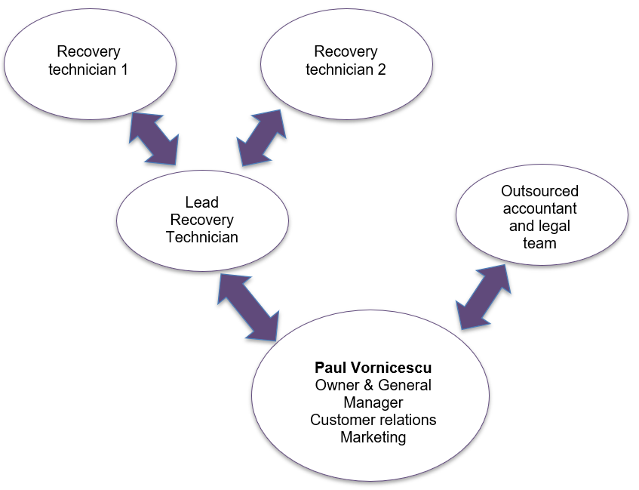
The operational team is led by a Lead Recovery Technician, responsible for managing day-to-day recovery operations and ensuring service quality. The lead technician supervises two Recovery Technicians, who handle vehicle recoveries, roadside repairs, and accident towing.
As a startup, Essex Fast Recovery Ltd. recognizes the importance of flexibility and resourcefulness during the initial stages of operation. The business plans to purchase three recovery vehicles to ensure adequate coverage for service demands. However, given the lean structure of the team, operational support will be managed dynamically to maintain service efficiency. If necessary, the Lead Recovery Technician will actively attend operations alongside the recovery technicians, providing hands-on support for vehicle recoveries, roadside repairs, and towing services. To accommodate this, the General Manager, Paul Vornicescu, will step in to cover the lead technician’s day-to-day management responsibilities. This team structure ensures that operations run smoothly, and response times remain rapid, meeting the company’s commitment to efficiency and reliability.
Accounting and legal advisories are outsourced to an external accounting firm, which ensures compliance with tax regulations, accurate financial reporting, and efficient bookkeeping. Outsourcing accounting functions allows the company to focus resources on its core services while benefiting from professional financial expertise (Williams, 2022).

SWOT Analysis
SWOT analysis is a strategic framework employed to systematically evaluate the internal and external factors that influence an organization’s performance. By examining Strengths, Weaknesses, Opportunities, and Threats, this tool provides a comprehensive overview of a business's competitive position and potential challenges (Gürel, 2017). The analysis is particularly valuable for startups, such as Essex Fast Recovery Ltd., as it facilitates the identification of core advantages, areas requiring improvement, and external trends or risks that may impact operations
Strengths
Essex Fast Recovery Ltd. has several key strengths that provide a competitive advantage in the vehicle recovery industry. The company’s innovative mobile app streamlines the customer experience by offering instant quotes, easy bookings, and real-time tracking of recovery vehicles, setting it apart from traditional competitors. A fleet of three recovery vehicles ensures broad coverage and reliable service delivery, while the operational flexibility of the team allows for efficient resource allocation during peak demand. Additionally, the company’s dynamic management structure ensures that operational challenges are swiftly addressed, with senior team members stepping in when needed to maintain seamless service quality.
Weaknesses
As a startup, Essex Fast Recovery Ltd. faces several inherent weaknesses that could impact its operations and growth potential. The company’s reliance on a small team limits its capacity to handle a high volume of service requests, potentially leading to delays during peak demand. Additionally, the initial purchase of three recovery vehicles, while sufficient for early operations, may constrain service coverage in the event of mechanical issues or increased demand. Furthermore, as a new entrant, the company may face challenges in establishing brand recognition and customer trust (Puyt, et al., 2023).
Opportunities
Essex Fast Recovery Ltd. is well positioned to capitalize on several promising opportunities in the vehicle recovery industry. The increasing reliance on technology presents an opportunity to further enhance and promote its innovative mobile app, attracting tech-savvy customers seeking convenience. Partnerships with local garages, insurance companies, and fleet operators could expand the client base and secure recurring revenue streams. The growing number of vehicles on UK roads also signals a steady demand for recovery services, providing Essex Fast Recovery Ltd. with opportunities for long-term growth and market expansion (SMMT, 2024).
Threats
Essex Fast Recovery Ltd. faces several external threats that could challenge its operations and market position. Intense competition from established recovery companies with larger fleets and wider geographic reach poses a significant risk. Rising fuel costs could impact operational expenses, reducing profit margins. Regulatory changes in the vehicle recovery sector or increased licensing requirements may introduce additional compliance costs. Furthermore, reliance on a small fleet increases vulnerability to vehicle breakdowns or maintenance delays, which could disrupt services. Inflation or reduced consumer spending, may also affect demand for non-essential services, posing a threat to consistent revenue generation.

4Ps of Marketing

The 4Ps of marketing, consisting of Product, Price, Place, and Promotion, serve as a foundational model for developing effective marketing strategies (AMA, 2024). Product focuses on meeting customer needs, Price ensures competitiveness and profitability, Place addresses accessibility, and Promotion involves strategies to attract and engage customers. For Essex Fast Recovery Ltd., applying the 4Ps supports a customer-focused approach to building visibility and driving growth.
Product
The product offered by Essex Fast Recovery Ltd. is a comprehensive range of vehicle recovery and roadside assistance services designed to address customer needs efficiently and reliably. Key services include breakdown recovery, accident towing, minor roadside repairs, and vehicle transportation. A standout feature is the innovative mobile app, which enhances the customer experience by providing instant service quotes, real-time vehicle tracking, and seamless booking functionality (Carrasco Ramirez, 2023). By offering a combination of traditional recovery services and modern technological solutions, the company ensures convenience, transparency, and high service quality. This customer-centric approach positions Essex Fast Recovery Ltd. as a dependable and innovative provider.
Price
Essex Fast Recovery Ltd. adopts a competitive pricing strategy to attract a broad customer base while ensuring profitability. Prices start from £10 per mile for vehicle recovery, reflecting affordability and transparency in the cost structure. The company also offers tailored discounts and pricing packages for corporate partners, such as fleet operators and local businesses, fostering long-term relationships and consistent revenue streams (Jiuru, 2019). This approach balances accessibility for individual customers with value-driven solutions for business clients. By combining clear pricing, cost-efficiency, and incentives for high-volume users, the company ensures its pricing strategy aligns with market expectations and customer satisfaction.
Place
Essex Fast Recovery Ltd. will establish its operational hub in the Chelmsford area, strategically positioned to provide efficient coverage across Essex. Chelmsford’s central location in Essex, offers excellent transport links, enabling the company to respond quickly to service requests from surrounding towns and rural areas. As the business does not require customers to visit the premises, a remote office space will be rented. This allows for a larger and more cost-effective location outside premium commercial zones, supporting administrative tasks and fleet coordination without unnecessary expenses. This strategic choice maximizes geographic reach, operational efficiency, and resource utilization, ensuring reliable service delivery across Essex.
Promotion
Essex Fast Recovery Ltd. will implement a focused and cost-effective promotional strategy to increase visibility and attract customers. The primary channels will include targeted marketing on Facebook and Instagram, leveraging these platforms’ advanced audience segmentation tools to reach local motorists effectively. Engaging content, such as service demonstrations and customer testimonials, will enhance brand awareness and trust. Additionally, search engine optimization (SEO) will be prioritized to ensure the company ranks highly on Google searches for vehicle recovery services (Usmany, 2024). This approach will drive traffic directly to the mobile app, simplifying the booking process and fostering seamless customer engagement and retention.

One-year cashflow forecast

Essex Fast Recovery Ltd. requires an initial investment of £50,000 to cover the essential startup costs needed to launch the business successfully. The owner, Paul Vornicescu, will contribute £25,000 of personal funds. To meet the remaining financial requirements, the company will seek an additional £25,000 from investors, providing them with an opportunity to support a scalable and innovative business. This combined funding will ensure the company is adequately equipped to begin operations and establish itself in the competitive vehicle recovery market.
The largest portion of the budget, £30,000, will be allocated to the purchase of three reliable used recovery vehicles. An additional £5,000 will be invested in the development of the company’s mobile app, a critical component of its customer-centric approach. The app will streamline bookings, provide instant quotes, and enhance transparency through real-time vehicle tracking, offering a competitive edge in the market.
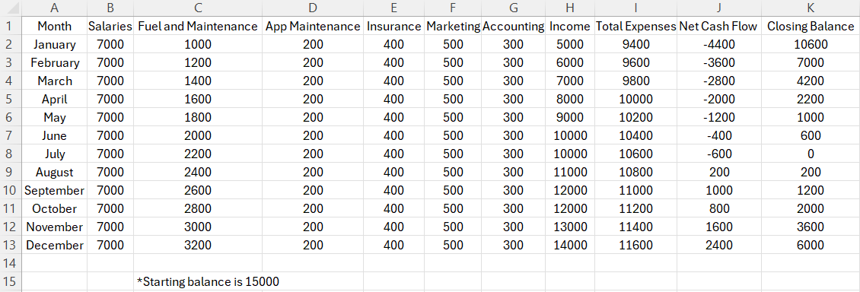
The remaining £15,000 will be used to cover initial operational costs, such as office setup, insurance, marketing, and licensing. This allocation also provides the business with a financial buffer, ensuring positive cash flow during the initial months. By carefully managing these startup costs, Essex Fast Recovery Ltd. is positioned for sustainable growth and the ability to deliver exceptional service from its launch.

References

American Marketing Association (2024) The Four Ps of Marketing. https://www.ama.org/marketing-news/the-four-ps-of-marketing/ (Accessed: November 23, 2024).
Barringer, B.R. (2019) Entrepreneurship : successfully launching new ventures . Sixth edition, global edition. Harlow, England :, Pearson.
Carrasco Ramirez, J. G. (2023) “How Mobile Applications can improve Small Business Development”, Eigenpub Review of Science and Technology , 7(1), pp. 291–305. Available at: https://studies.eigenpub.com/index.php/erst/article/view/55 (Accessed: 23 November 2024).
Gürel, E. (2017) 'SWOT ANALYSIS: A THEORETICAL REVIEW,' Journal of International Social Research, 10(51), pp. 994–1006. https://doi.org/10.17719/jisr.2017.1832.
Jiuru, Z. (2019) ‘Comparative Study on the Service Pricing Strategy of Car Wash Industry’, in 2019 Chinese Control And Decision Conference (CCDC). IEEE, pp. 6098–6103. Available at: https://doi.org/10.1109/CCDC.2019.8833180.
Puyt, R.W., Lie, F.B. and Wilderom, C.P.M. (2023) ‘The origins of SWOT analysis’, Long range planning, 56(3), pp. 102304-. Available at: https://doi.org/10.1016/j.lrp.2023.102304.
Smithson, B. (2018) Choosing the right business structure. https://companieshouse.blog.gov.uk/2018/07/18/choosing-the-right-business-structure/ (Accessed: November 23, 2024).
SMMT (2024) Two straight years of growth for new car market. https://www.smmt.co.uk/2024/08/two-straight-years-of-growth-for-new-car-market/ (Accessed: November 23, 2024).

Usmany, P. et al. (2024) 'The Effectiveness Of Search Engine Optimization (SEO) In Marketing: A Meta-Anlysis Study,' Journal of Economic Bussines and Accounting (COSTING), 7(5), pp. 807–811. https://doi.org/10.31539/costing.v7i5.11446.
Williams, S. (2022) The Financial Times guide to business start up 2021/23 : the most comprehensive guide for entrepreneurs . 32nd edition. Harlow, England :, Pearson.

