DS 1 Template

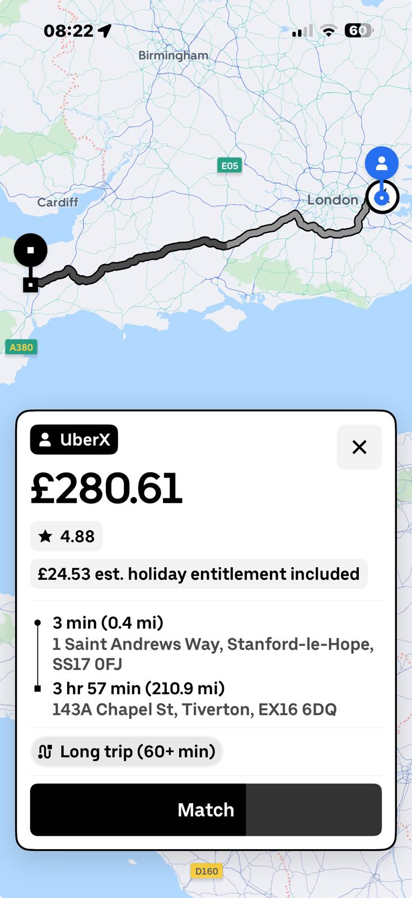
The attached screenshot is from the uber app ,I use for my daily work and forms part of my digital life.

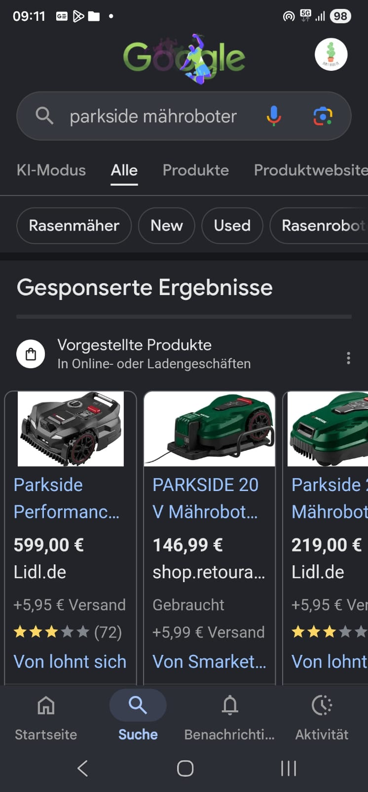
Screenshot is from the google application, which I use on a daily basis to locate information online .

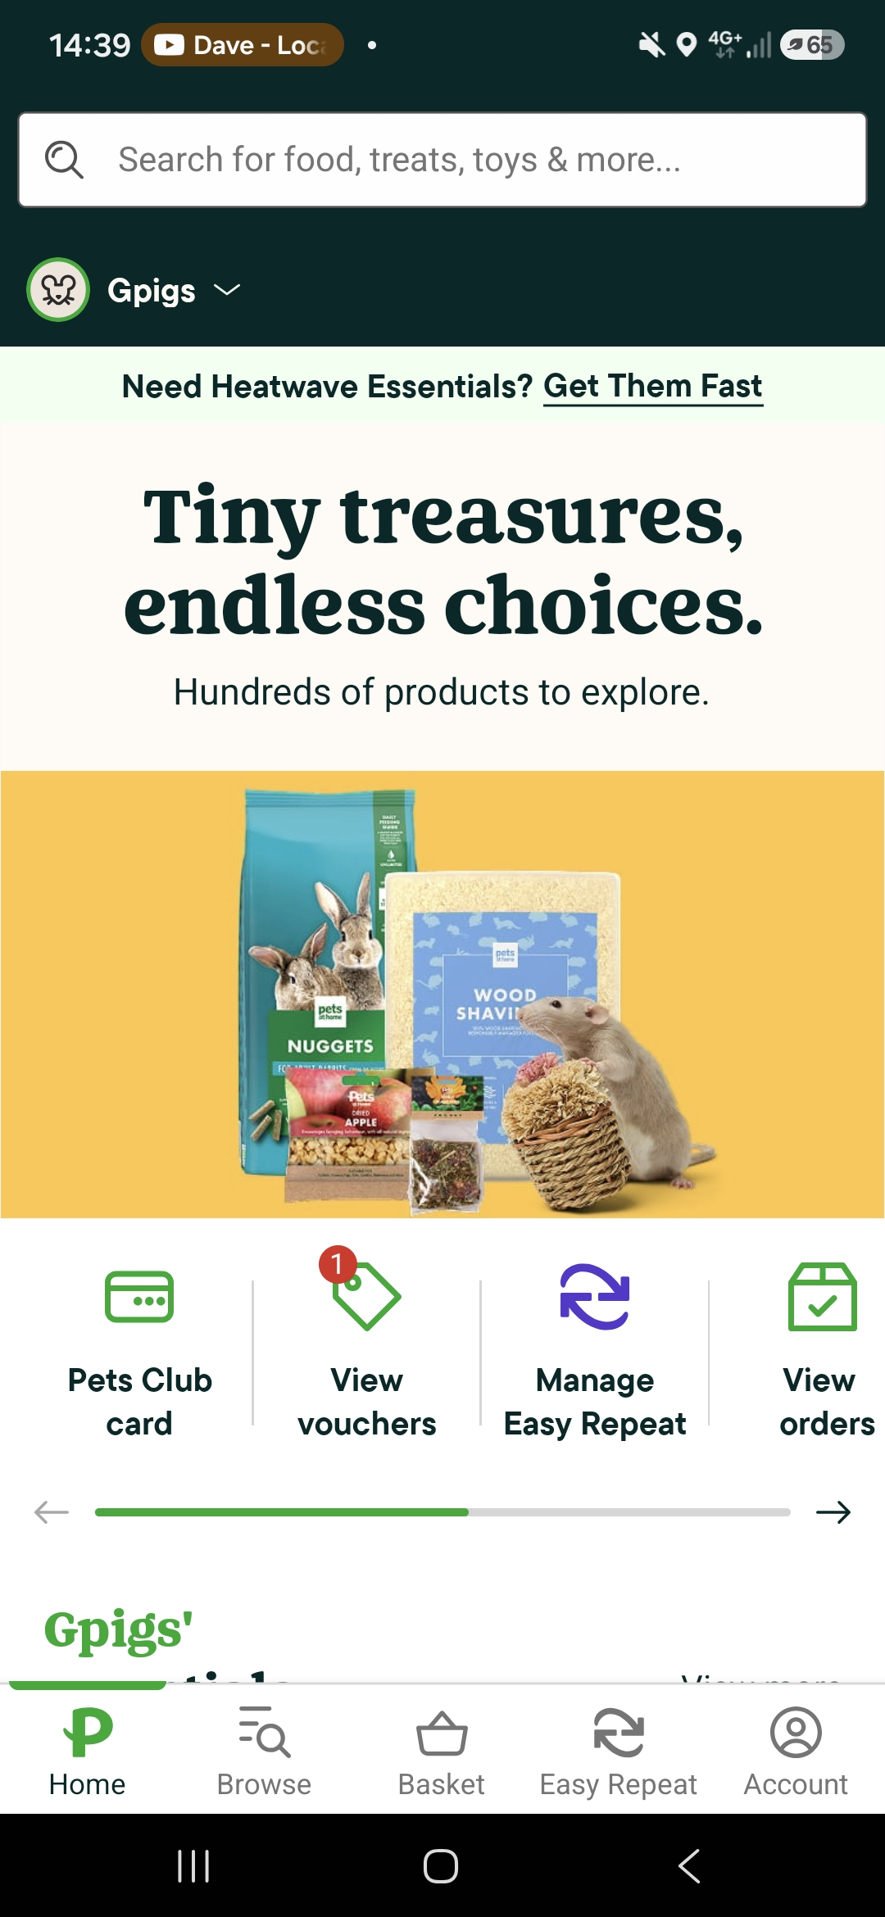
The image above is from an app called Pet at Home ,which I use regularly to purchase food for my dog.

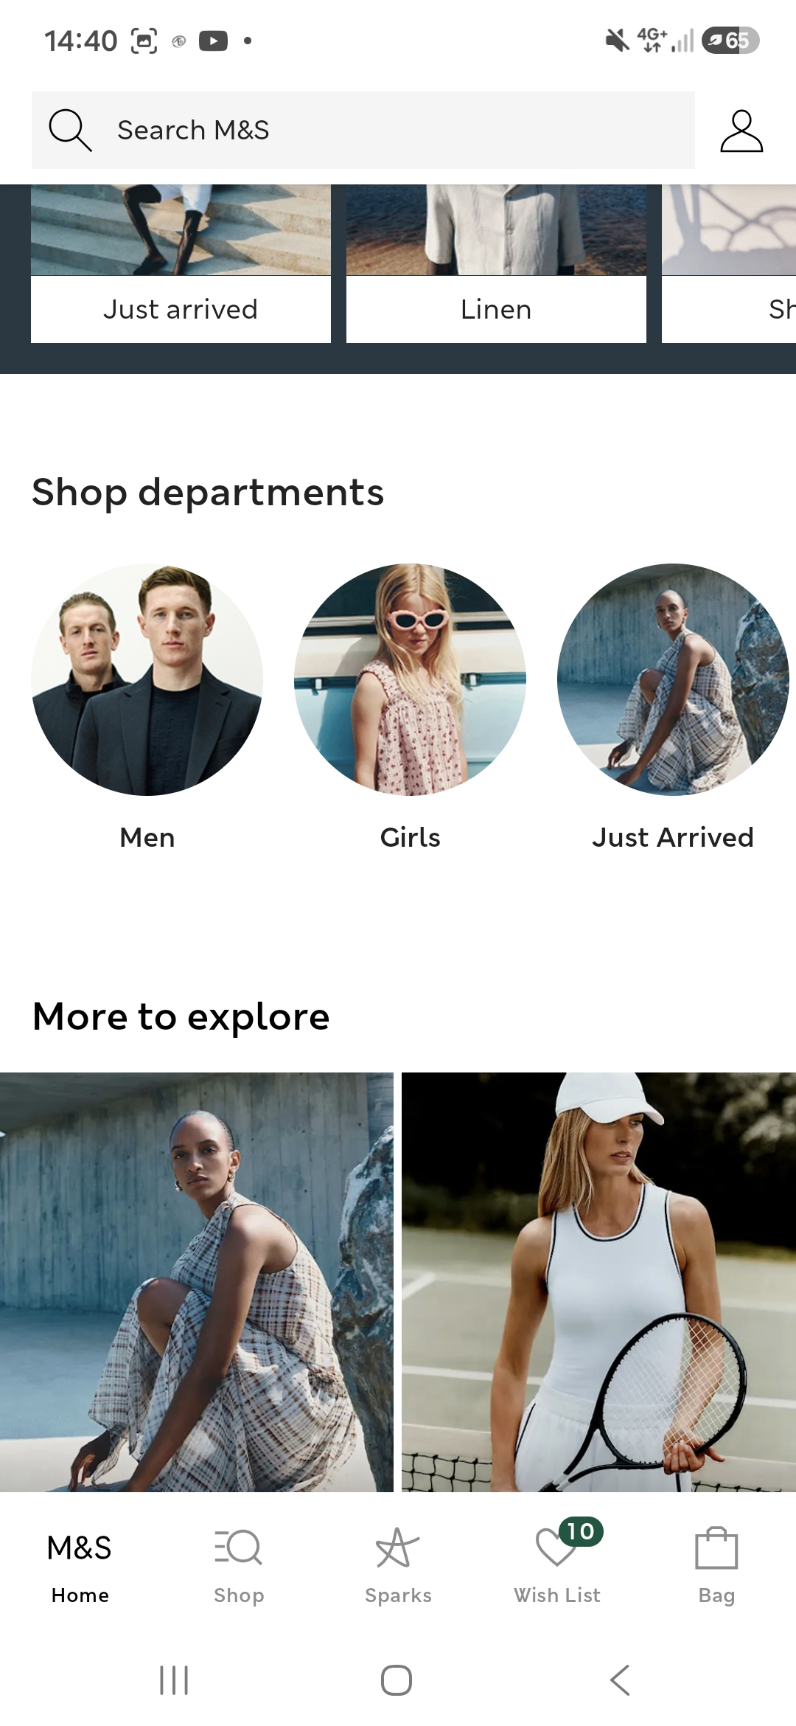
My M&S app is very useful for my daily shopping, checking upcoming promotion, collecting and using Sparks rewards offers.

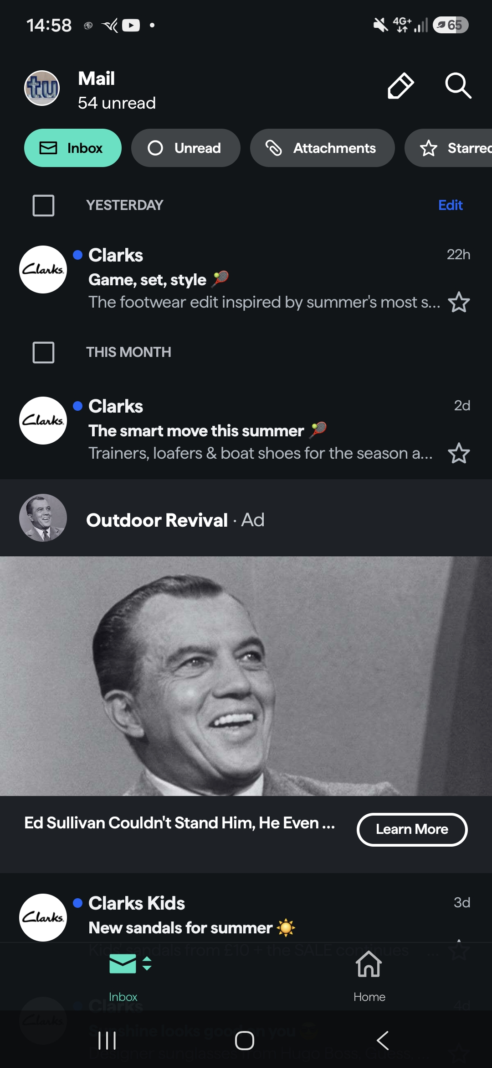
Using my email app daily to improve on communication, improve the speed of response withing organisations, family, work and my teachers. I use the instant access, smart sorting, and build-in tools to keep my inbox under control with minimum effort.

Screenshot/Photo 6
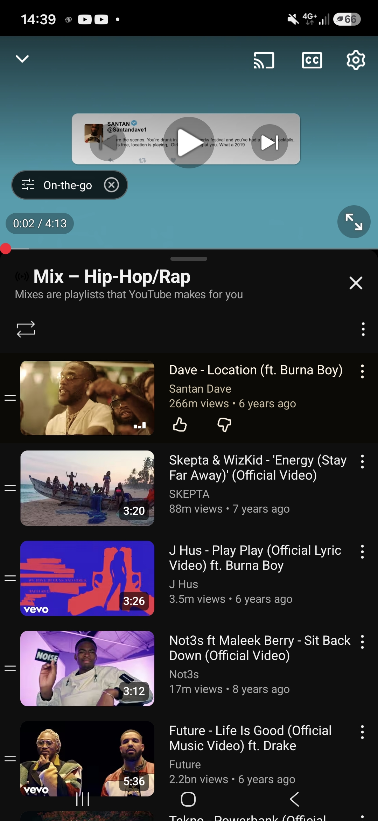
The screenshot above is a YouTube app
YouTube is an essential app in my digital life, as I use it regularly to listen to music, discover new artists, and enjoy my favourite songs.

My Short Reflection
My digital life has a positive impact on my education and personal interests.
Digital tools boost my confidence by helping me complete tasks more efficiently and find information quickly.
I want to improve my digital life by learning more digital skills and using technology more productively.
I often use these digital tools in my daily life.
I sometimes feel nervous about using digital tools because of the risk of exposing my personal data.
I hope this module will help me learn how to protect my personal data and use digital tools safely and responsibly.
The importance of using digital skills in my daily life is utilizations of technology in my studies and business safely.

