

Isabel Colela – 23/10/2026

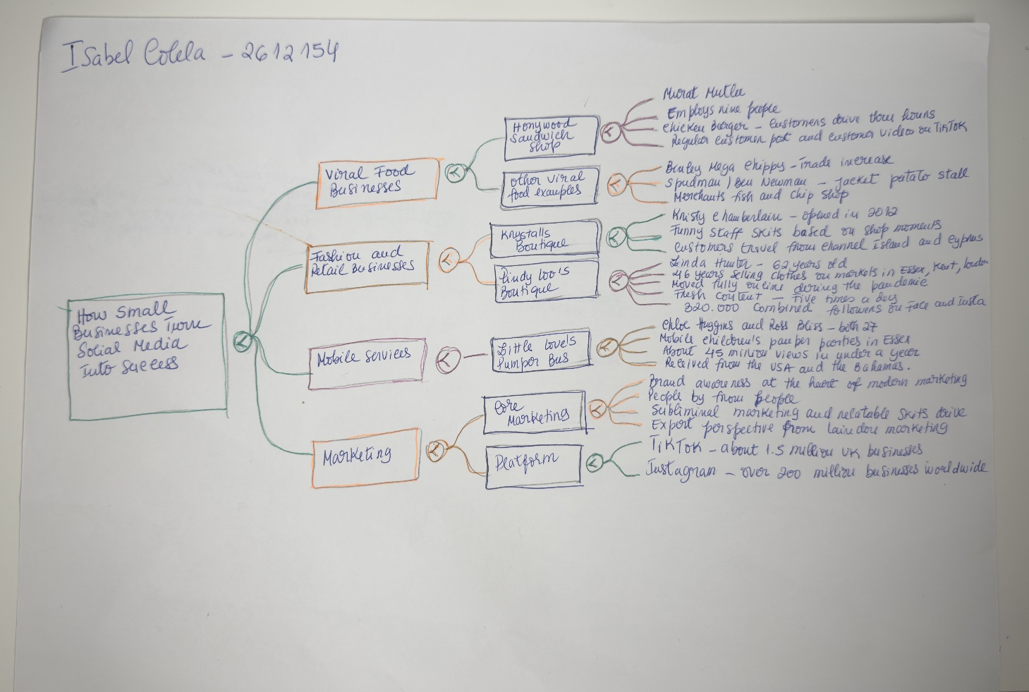

PART 2:
- Answer every question below in 1-3 full sentences.
- Use your own words. Do not use generative AI to answer these questions.
- Include a specific detail from the text when asked.
REMINDER
- The main idea is the overall message of the whole text.
- A key point helps to explain the main idea.
- A specific detail or example from the text shows that the key point is true.

- What is the main idea of the whole text?

The main idea of the whole text, it’s how small business grow through social media. Platforms such as Instagram, TikTok, Facebook, etc. And with these platforms, an innocent video can go viral in a split second, helping to ensure the business’s long-term visibility.

- What is one key point that supports the main idea, and which specific example from the text shows this?

The key point that supports the main idea, is the social media posts enable small local businesses to expand their reach far beyond their immediate geographic area, converting viral online visibility into long distance customer traffic.

Specific examples from the text show this, Honywood Sandwich Shop in Besildon Essex, the shop primarily served local regulars for breakfast, while the shop posts its own video on TikTok, was the massive boost in business.

Murat Mutlu was surprised to find out that customers were driving up to Three Hours to try their viral chicken burger.

- What is a different key point that supports the main idea, and which specific example from the text shows this?

The different key point that supports the main idea, is traditional markets stalls or minor side hustles into full time, global enterprises. Social Midea allows entrepreneurs to fundamentally transform and scale their business models.

The text shows specific examples like Linda Hunter spent 46 years selling clothes on physical market stalls across Essex, Kent and London. The Social Midea pivot was in the lockdown her grandson suggested filming a video to begin posting regularly on Social Midea.

It was the business transformation, the online success enabled her to pack up her market stalls entirely and move into an online warehouse.

- Which part of the text do you think is most important, and why?

The most important part of the text is the expert commentary section titled “People by from People”, featuring marketing expert Faye Martin.

Modern consumers recognize traditional advertisements and not want to be sold to. The key for strategy for modern marketing, it is established that success in platforms comes down to authenticity.

Reflection:
- What did you find difficult in this task (including in-class components), and why was it difficult?

I didn’t find difficult in this task, we can identify the main idea from the paperwork. In my opinion maybe we need to discuss more about the Social Midea, with realistic examples to understood clearly who the platform helps us with business.

- What helped you with this difficulty, and how did it help you?

It helped me understand better, how Social Midea can improve our business in nowadays. Today, with a platform, we can get ourselves noticed anywhere in the world. It’s important to understand how these platforms work so that we can use them to make our business growing.

