Developing and Refining Pell and Fibonacci Sequence Generation in R: A Project Summary

1. Code Implementation & Explanation
The overall flow is as Chart 1:

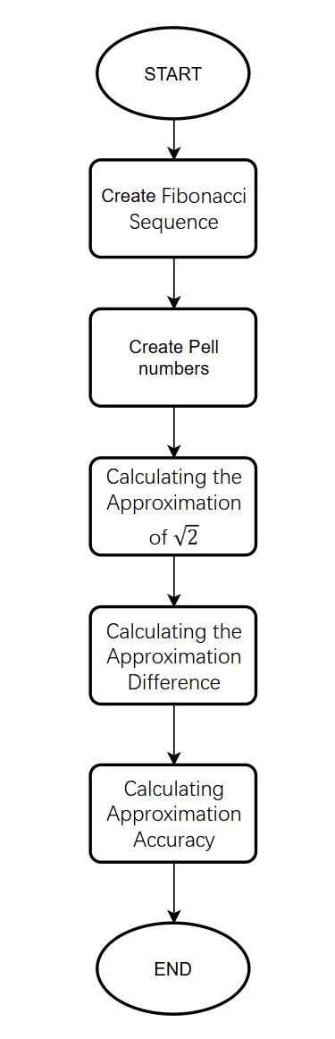
Chart 1. Overall Flowchart

1.1 Initializing Index and Calculating Fibonacci Numbers
This section of the code creates the index sequence and calculates the first 200 Fibonacci numbers.

1.1.1 Index Creation
index <- 1:200
Creates a vector named index containing an integer sequence from 1 to 200. This serves as the row index n for the data frame.

1.1.2 Fibonacci Sequence Calculation
Initializes the Fibonacci sequence vector f with the first two terms: $F_{1}$=0 and $F_{2}$=1.

for (n in 1:198){
fibonacci <- c(fibonacci, fibonacci[length(fibonacci)]+ fibonacci[length(fibonacci)-1])
}
A ‘for’ loop calculates the remaining 198 Fibonacci numbers, reaching a total of 200 terms. In each iteration, it sums the last two terms of the vector and appends the result to the end of the vector f. The flowchart is Chart 2:

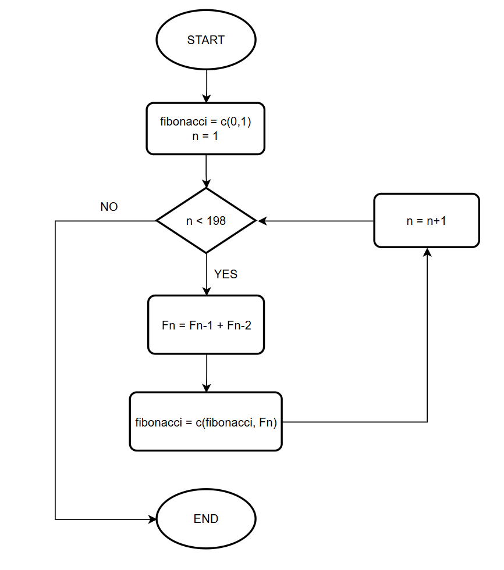
Chart 2. Fibonacci Sequence Calculation

1.2 Calculating Pell Numbers and Initializing Data Frame
This section calculates the first 200 Pell numbers and creates the base data frame containing the index, Fibonacci numbers, and Pell numbers.

1.2.1 Pell Sequence Calculation
Initializes the Pell sequence vector p with the first two terms: $P_{1}$=0 and $P_{2}$=1.

for (n in 1:198) {
pell <- c(pell,2*pell[length(pell)]+p[length(pell)-1])
}
A ‘for’ loop calculates the remaining 198 Pell numbers. Based on the Pell sequence definition ($P_{n}$=2$P_{n-1}$+$P_{n-2}$), each iteration adds the second-to-last term to two times the last term, and appends the result to the end of the vector p. The flowchart is as Chart 3:

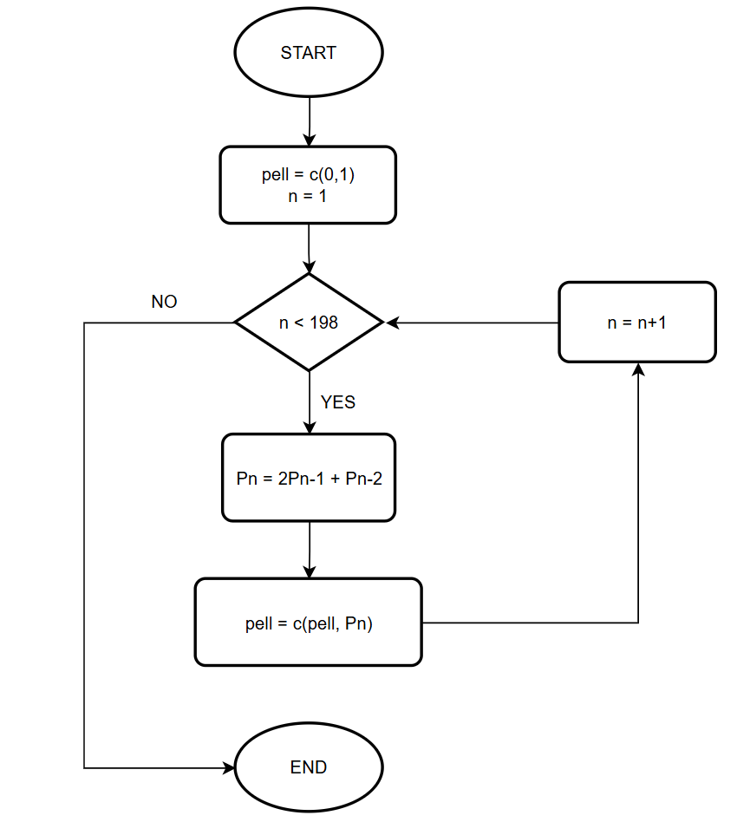
Chart 3. Pell Sequence Calculation

1.2.2 Defining the Data Frame
Creates a data frame named pelldata with three columns:
1. index_n: The sequence index n (from 1 to 200).
2. Fn: The Fibonacci number $F_{n}$.
3. Pn: The Pell number $P_{n}$.

1.2.3 Test of the first 3 columns
Print pelldata directly, and I search online for the actual values of Pell numbers or the Fibonacci sequence and compare them one by one (First 20 numbers) with the sequence I generated to ensure the results are correct. The actual values of the Fibonacci sequence and the Pell numbers obtained from online sources are shown in the Fig 1 and Fig 2, and my output is shown in the Fig 3:

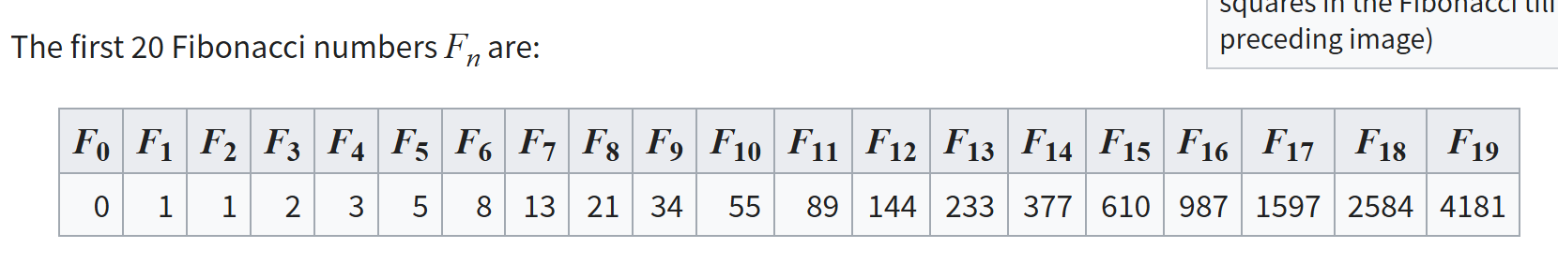
Fig 1. Real Fibonacci sequence

Fig 2. Real Pell numbers

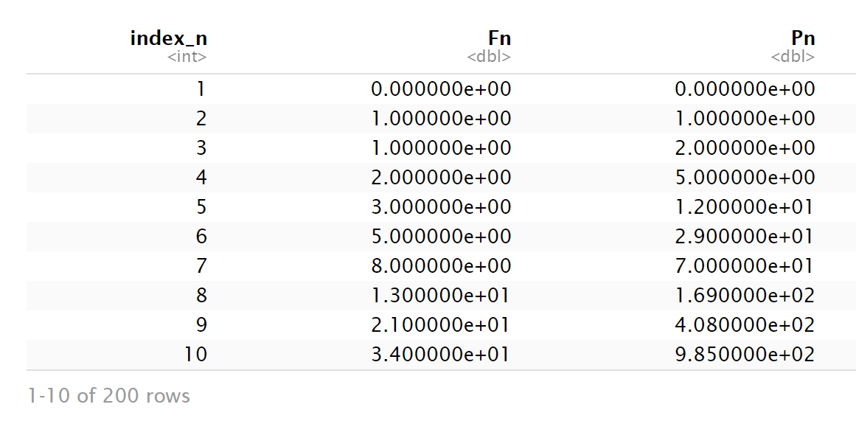
Fig 3. First output

1.3 Calculating the Approximation of $\sqrt{2}$
This section calculates the rational approximation of $\sqrt{2}$ using Pell numbers and adds it as a new column to the data frame.

1.3.1 $\sqrt{2}$ Approximation Calculation
Initializes the approximation vector sqrt2_approxi, with the first element set to 0 as a placeholder (since the approximation formula starts from n=2 in the loop logic).

for (n in 2:200){
sqrt2_approxi <- c(sqrt2_approxi,(pelldata[n-1,3]+pelldata[n,3])/pelldata[n,3])
}
A ‘for’ loop iterates from n=2 to n=200, calculating the $\sqrt{2}$ approximation for terms n-1 to n, which is $\frac{P_{n-1}+P_{n}}{P_{n}}$. Here, pelldata[n,3] refers to $P_{n}$.

Adds the calculated approximation vector to the pelldata data frame with the column name pell_sqrt2. The flowchart is as Chart 4:

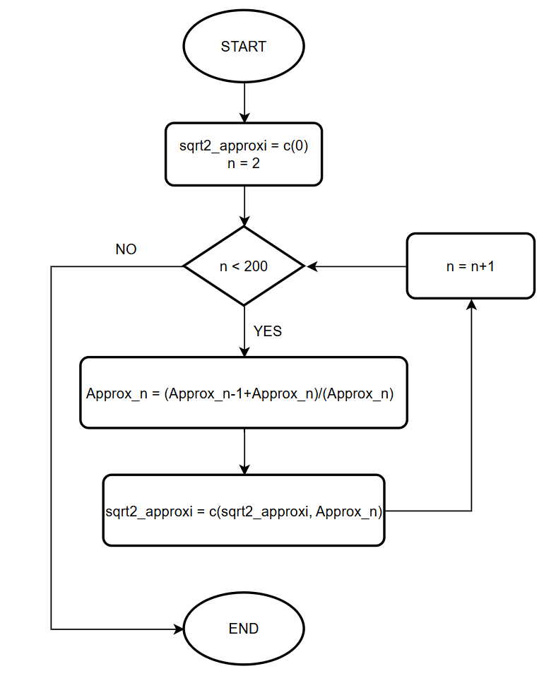
Chart 4. $\sqrt{2}$ Approximation Calculation

1.3.2 Test of Approximation Calculation
Print pelldata right now, manually calculate the first 5 approximation values, and compare them one by one with the values generated using R code to ensure they correspond exactly, indicating that this task has been completed. And result of approximation is shown in Fig 4:
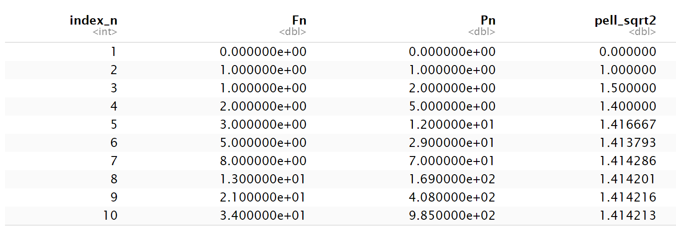
Fig 4. Result of approximation

1.4 Calculating the Approximation Difference
This section calculates the absolute difference between the Pell approximation and R's built-in $\sqrt{2}$ value, and adds it to the data frame.

1.4.1 Difference Calculation
Initializes the difference vector differs.

for (n in 1:200){
differs <- c(differs, round(abs(pelldata[n,4]-sqrt(2)),5))
}
A ‘for’ loop iterates through all 200 indices. It calculates the absolute difference between the Pell approximation of $\sqrt{2}$ (column 4) and the R built-in sqrt(2). The round(..., 5) function rounds the result to five decimal places.

Adds the calculated difference vector to the pelldata data frame with the column name differs. The flowchart is as Chart 5:

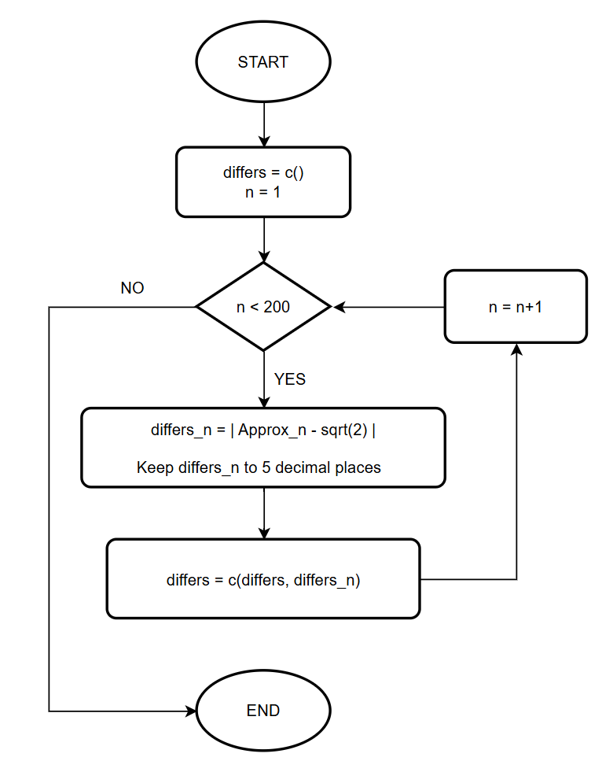
Chart 5. Difference Calculation

1.4.2 Test of Difference Calculation
Print pelldata, compare them with the first 5 manually calculated differences. If they correspond one by one, it indicates that the task has been successfully completed. The result of differs is shown as Fig 5.
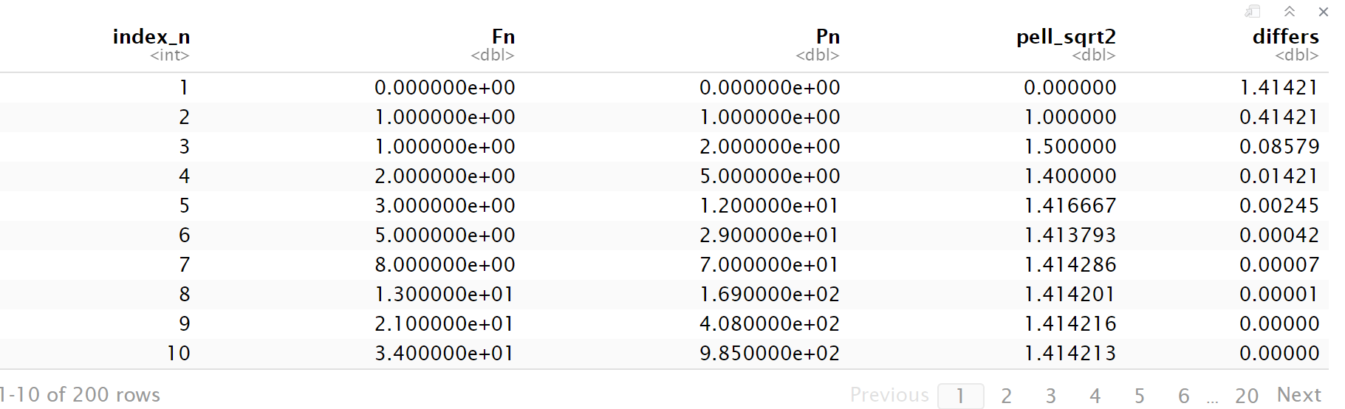
Fig 5. Result of Differs

1.5 Calculating Approximation Accuracy
This section calculates the consecutive number of correct decimal places of the Pell approximation compared to the true value and adds it to the data frame.

1.5.1 Accuracy Calculation
Initializes the accuracy vector accuracy.

Formats R's calculated $\sqrt{2}$ value into a string, disabling scientific notation and ensuring at least 15 digits after the decimal point for precise comparison.

dec_sqrt2 <- strsplit(standard, "\\.")[[1]][2]
Uses the strsplit function to split the formatted $\sqrt{2}$ string at the decimal point and extracts the part after the decimal (index [2]) as the baseline decimal string dec_sqrt2.

for (n in 1:200){
... }
Starts the ‘for’ loop to iterate through all 200 indices and calculate accuracy for each Pell approximation.

str_pell <- format(pelldata[n,4], scientific = FALSE, nsmall = 15)
Formats the current Pell approximation (column 4) into a string, preparing it for comparison with the $\sqrt{2}$ baseline using the same format settings.

dec_pell_sqrt2 <- strsplit(str_pell,"\\.")[[1]][2]
Extracts the decimal part string dec_pell_sqrt2 of the current approximation.

for (location in 1:min(nchar(dec_sqrt2),nchar(dec_pell_sqrt2))){
... }
A nested ‘for’ loop that compares the two decimal strings digit by digit, starting from the first digit after the decimal point, up to the minimum length of both strings.

if (substring(dec_pell_sqrt2,location,location) == substring(dec_sqrt2,location,location)) {
same_num <- same_num + 1 }
else{
break }
Comparison Logic, Uses substring to extract and compare the digits at the current position.
1. If the digits match, same_num is incremented.
2.If the digits differ, the inner loop is exited (break) because the sequence of correct consecutive digits has been broken.

Appends the calculated number of consecutive correct digits, same_num, to the accuracy vector. Adds the calculated accuracy vector to the pelldata data frame with the column name accuracy. The flowchart is as Chart 6:

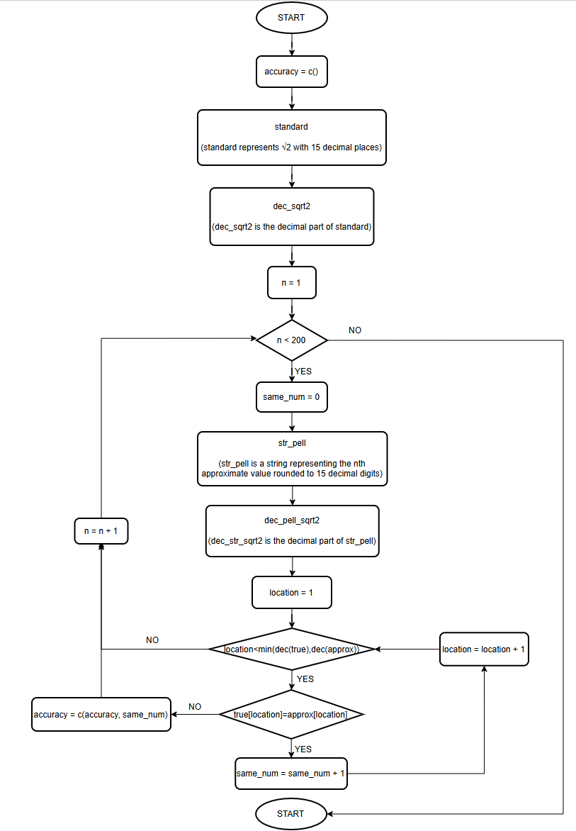
Chart 6. Accuracy Calculation

1.5.2 Test of Accuracy
Print pelldata, use a counting method to check whether the first 10 results are correct. If they are correct, it indicates that the task has been completed. The result of accuracy is shown as Fig 6.
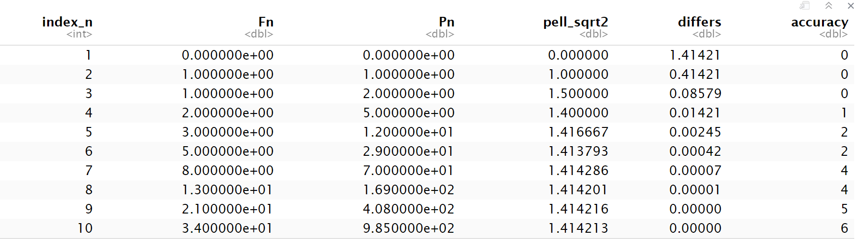
Fig 6. Result of Accuracy

1.6 Final Output
Prints the final pelldata data frame to the console, showing all calculated results. And the overview of running result as Fig 7 below:
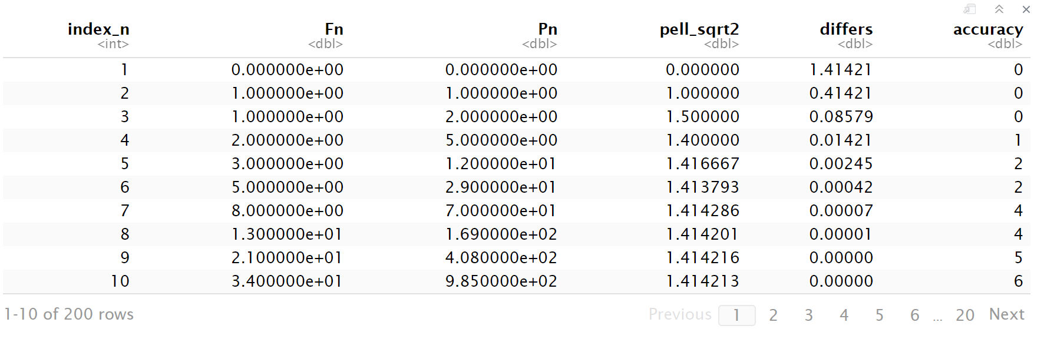
Fig 7. Result Overview

1.7 Test Summary
In addition to the one-to-one correspondence testing method explained above, I also inserted temporary print() statements at key points in the loop structure to monitor core variables in real time and verify the correctness of the control flow and calculation results. This allows me to view the variable contents inside the loop structure and promptly and correctly modify the code when errors occur. A test example as shown in Fig 8.
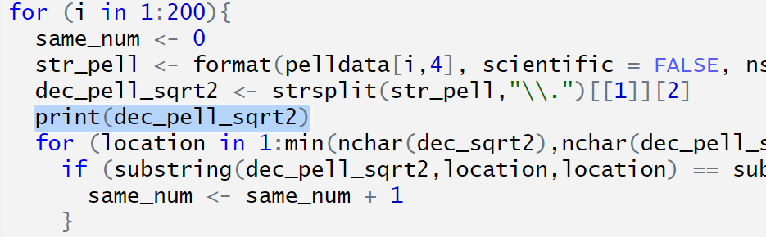
Fig 8. Example of Print Test

This detailed internal debugging, especially targeting the critical string comparison and break logic in the accuracy calculation, ensured that the values in the accuracy column accurately reflect the number of consecutively correct digits.

2. Challenges, Gains and Prospects

2.1 Challenges Encountered
The primary technical difficulties encountered during the development of the pell.r script centered on R's data type limitations and numerical precision issues.

Large Number Overflow: Attempting to cast results to an integer type using as.integer() caused data to exceed R's integer limit due to the rapid growth of Fibonacci and Pell numbers, resulting in overflow and NA values. Result as Fig 9.

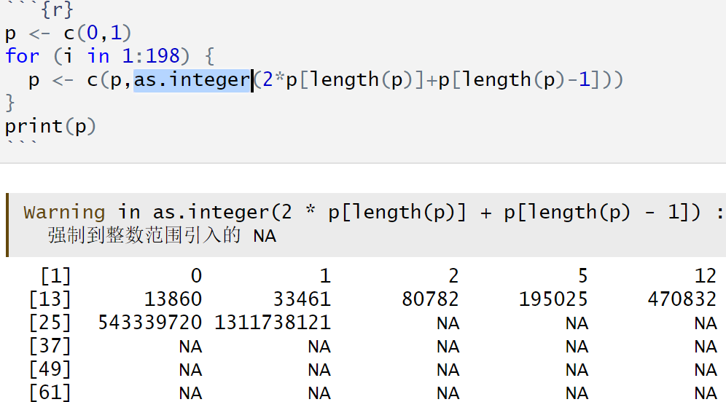
Fig 9. Result of Using ‘as.integer()’

Precision Loss: When converting floating-point approximations to strings for accuracy comparison, using as.character() directly resulted in insufficient significant figures, compromising the final accuracy calculation. Result as Fig 10.

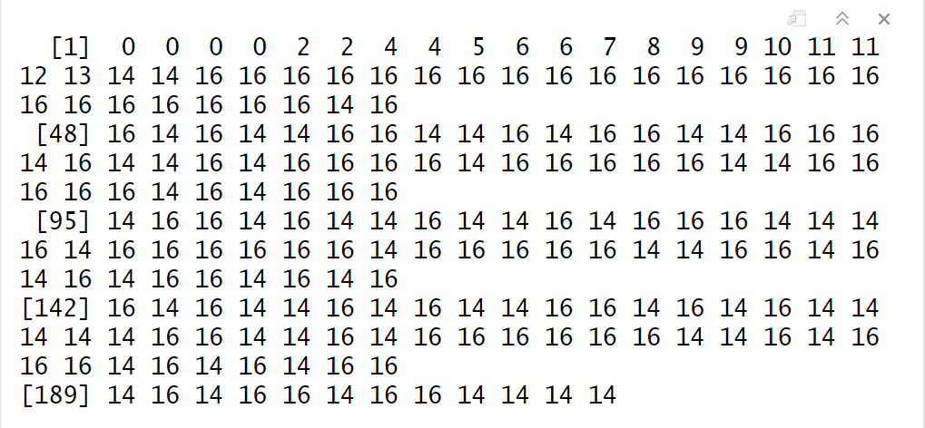
Fig 10. Result of Using ‘as.character()’

Comparing method choose: In the accuracy task, I confused that should I use numeric or string to calculate. After few times experiments on my draft papers, I determined that string type is better, because a string can be seen as a special vector, and I can compare with 2 characters in the same location by using the same index, this is more accurate.

Loop Control: In the accuracy task, I used a lot of loops and conditions to reach the target, in that case, there were some challenges about how to use break correctly, when should it break, which loop should break first. If I set a wrong break time, the result is totally different. It takes me a lot of time to debug and finally I overcome it.

2.2 Key Takeaways
By resolving these challenges, I gained a deeper understanding of R's numerical handling and string manipulation capabilities.

Float Display and Precision: I learned that the console defaults to displaying only six decimal places for floats, and that R's maximum floating-point precision is approximately 15 decimal places. Incorrect precision settings can lead to automatic value estimation by the system, causing computation errors.

String Handling: I became proficient in using the strsplit() function and its application with regular expressions for string splitting, which was essential for extracting the decimal part of the approximation.

2.3 Prospects
Based on this programming experience, future iterations of the code can be optimized for efficiency and debugging through the following methods.

Debugging Methodology: For debugging complex nested loops, a more professional method using breakpoints should be adopted instead of relying on temporary print() statements, allowing for more efficient and cleaner debugging.

Code Efficiency Improvement: Since the vector length is known to be 200, future code should pre-allocate the required vector size (e.g., fibonacci <- numeric(200)) instead of using vector concatenation (similar to Python's append) to improve execution efficiency.

Numerical Precision Management: More rigorous handling and control of floating-point precision are required in all calculations involving floating-point numbers.

