
Master of Business Administration (MBA)
Module Title: International Marketing: Principles and Practices
Module Code: LCMB7026

Assessment Title: A Comparative Analysis of Toyota's International Market Entry Strategy and Marketing Mix in Japan and India
Company Selected: Toyota
Home Country: Japan
Host Country: India

Student Name: Rachitkumar Barot
Student ID: 2531441

Lecturer Name: Dr Piyumika Gamage
Table of Contents
1. Introduction 4
Section 1: International Market Entry Strategy and Marketing Mix Analysis of Toyota in Japan and India 5
2. Comparative Market Analysis 5
2.1 Pestel Analysis 5
2.2.1 Political Factors 5
2.2.2 Economic Factors 6
2.2.3 Social Factors 6
2.2.4 Technological Factors 7
2.2.5 Environmental Factors 7
2.2.6 Legal Factors 7
2.2.7 Comparative Opportunities, Threats and Strategic Implications 8
2.2 Hofstede Cultural Comparison 9
3. Comparative Analysis of Segmentation, Targeting and Positioning (STP) Strategy 10
3.1 Segmentation 10
3.2 Targeting Strategy 11
3.3 Positioning Strategy 12
4. Comparative Analysis of Toyota's International Marketing Mix (7Ps) 13
4.1 Product 13
4.2 Price 14
4.3 Place (Distribution) 14
4.4 Promotion 15
4.5 People 15
4.6 Process 16
4.7 Physical Evidence 16
5. Market Entry Strategy of Toyota in India 17
6. Ethical Issues 19
7. Recommendations 20
Section 2: Reflective Account Using Gibbs' Reflective Cycle 21
8. Gibbs Reflective cycle 21
Description 21
Feelings 22
Evaluation 22
Analysis 23
Conclusion 24
Action Plan 24
9. References 26

1. Introduction
Toyota Motor Corporation is one of the world's leading automobile manufacturers, recognised for its innovation, quality, reliability and commitment to sustainable mobility. Operating in more than 170 countries, Toyota has successfully expanded its global presence by adapting its international marketing strategies to meet the economic, cultural and regulatory requirements of different markets (Toyota, 2025). Rather than applying a standardised approach, the company balances global brand consistency with local market adaptation to enhance customer value and maintain a competitive advantage.
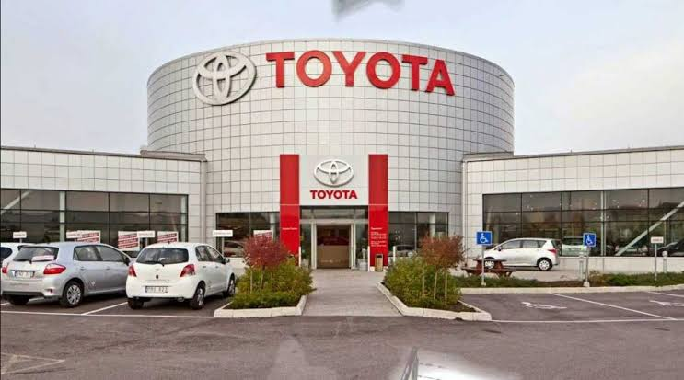
This report compares Toyota's international marketing strategies in Japan, its home country, and India, one of its most significant and rapidly growing host markets. These two countries provide an appropriate basis for comparison due to their contrasting economic conditions, consumer preferences, cultural values and automotive market characteristics. While Japan represents a mature and technologically advanced automotive market with strong demand for hybrid and electric vehicles, India is an emerging market characterised by rising disposable incomes, rapid urbanisation and increasing demand for affordable, fuel-efficient passenger vehicles. These differences require Toyota to modify its marketing strategies to suit local market conditions.
The primary aim of this report is to critically evaluate Toyota's international market entry strategy and marketing mix by comparing its operations in Japan and India. The report analyses the macro-environment using the PESTEL framework and examines cultural differences through Hofstede's cultural dimensions. It further compares Toyota's Segmentation, Targeting and Positioning (STP) strategies and the international marketing mix (7Ps), evaluates the company's market entry strategy and ethical considerations in one selected market, and concludes with evidence-based recommendations for strengthening Toyota's future international marketing performance.

Section 1: International Market Entry Strategy and Marketing Mix Analysis of Toyota in Japan and India

2. Comparative Market Analysis

2.1 Pestel Analysis

2.2.1 Political Factors
The political environment plays a significant role in shaping Toyota's international marketing strategy in both Japan and India. Japan offers a highly stable political system, transparent governance and consistent industrial policies that encourage innovation and technological development. Government support for research and development, hydrogen technology and carbon neutrality has enabled Toyota to maintain its global leadership in the automotive industry (Konovalov et al., 2025).
India also provides favourable conditions for international automobile manufacturers through initiatives such as Make in India and the Production Linked Incentive (PLI) Scheme, which encourage domestic manufacturing and foreign investment (Wandhe, 2024). Toyota entered India through a joint venture with Kirloskar, enabling the company to establish local production and strengthen market presence.

2.2.2 Economic Factors
Japan represents a mature, high-income economy with stable purchasing power and a saturated automobile market (Liu et al., 2025). Consumers prioritise product quality, advanced technology and environmentally friendly vehicles. Consequently, Toyota concentrates on hybrid vehicles, premium features and technological innovation.
In contrast, India is one of the fastest-growing automobile markets, driven by rising disposable incomes, urbanisation and an expanding middle class. However, consumers remain highly price-sensitive and seek affordable, fuel-efficient vehicles with low maintenance costs. Toyota has responded by manufacturing models such as the Glanza, Urban Cruiser Hyryder and Innova Hycross locally to reduce costs and improve accessibility (Sarangal et al., 2023).

2.2.3 Social Factors
Social characteristics significantly influence Toyota's marketing strategy. Japan has an ageing population with high expectations regarding quality, reliability and environmental sustainability (De Marco, 2024). Consumers generally demonstrate strong brand loyalty and value long-term product performance. India has a younger population, rapid urbanisation and increasing aspirations for private vehicle ownership. Many consumers view automobiles as symbols of family security and social achievement while placing greater emphasis on affordability and practicality.
Toyota therefore promotes technological innovation, safety and sustainability in Japan, whereas its Indian marketing focuses on spacious family vehicles, fuel efficiency and value for money (Favaro, 2020). Promotional campaigns in India also make greater use of digital media and emotional advertising to attract younger consumers.

2.2.4 Technological Factors
Technology remains one of Toyota's strongest competitive advantages. Japan possesses advanced manufacturing capabilities, robotics, artificial intelligence and extensive research in hybrid and hydrogen fuel-cell technologies (Niazi et al., 2026). Toyota uses its domestic market as a platform for testing innovative mobility solutions.
India has made considerable progress in automobile manufacturing and digital transformation, although electric vehicle infrastructure remains less developed (Rajendran et al., 2025). Toyota therefore focuses on affordable hybrid technology, digital customer engagement and local manufacturing improvements instead of introducing high-cost technologies on a large scale. Digital platforms, virtual showrooms and online customer services have improved consumer engagement in both countries, although technological adaptation remains greater in India due to differing infrastructure and customer requirements.

2.2.5 Environmental Factors
Environmental sustainability is central to Toyota's international marketing strategy. Japan has strict environmental regulations and ambitious carbon neutrality targets, encouraging the adoption of hybrid and hydrogen-powered vehicles (Urwah, 2022). Toyota actively promotes sustainable manufacturing and environmentally responsible transportation within its domestic market.
India also faces growing environmental concerns, including pollution and increasing carbon emissions (Borkhade et al., 2022). Government policies such as Bharat Stage VI emission standards encourage cleaner mobility, although electric vehicle adoption remains slower due to limited charging infrastructure. Toyota positions hybrid vehicles as a practical solution in India while continuing to invest in advanced green technologies globally. This demonstrates the company's ability to balance global sustainability objectives with local market conditions.

2.2.6 Legal Factors
Legal regulations affect Toyota's marketing and operational decisions in both countries. Japan maintains strict standards regarding vehicle safety, environmental protection and consumer rights, supporting Toyota's reputation for quality and reliability (Gibrilla, 2023).
India has strengthened emission standards, safety regulations and consumer protection laws, although regulatory implementation remains more complex than in Japan (Borkhade et al., 2022). Toyota adapts vehicle specifications, manufacturing processes and marketing communications to comply with local legal requirements. Maintaining compliance with national regulations enables Toyota to reduce operational risks while strengthening customer trust and protecting its international brand image.

2.2.7 Comparative Opportunities, Threats and Strategic Implications
The PESTEL analysis demonstrates that Japan and India present Toyota with different opportunities and threats, requiring the company to adapt its international marketing strategy according to local market conditions. Japan provides a technologically advanced and stable environment, supported by strong purchasing power, advanced manufacturing capabilities and increasing demand for sustainable mobility. These conditions create significant opportunities for Toyota to strengthen its leadership in hybrid, hydrogen and other advanced automotive technologies. However, Japan is also a mature and saturated automobile market, while its ageing population and strict environmental and legal requirements create pressure for Toyota to maintain continuous innovation and high product standards.
India provides greater opportunities for market expansion because of rising disposable incomes, urbanisation, an expanding middle class and government initiatives such as Make in India and the Production Linked Incentive scheme. Toyota can benefit from increasing demand for affordable, fuel-efficient and hybrid vehicles, while local manufacturing can improve cost efficiency and market accessibility. However, the Indian market also presents threats including high price sensitivity, infrastructure limitations, regulatory complexity and strong competitive pressure. These factors require Toyota to carefully balance affordability, technological development and profitability.
Market | Key Opportunities | Key Threats | Implications for Toyota
Japan | Advanced technology, strong purchasing power, sustainability focus and demand for hybrid and hydrogen mobility. | Mature and saturated automobile market, ageing population, strict regulations and high customer expectations. | Toyota should prioritise technological innovation, premium quality, advanced hybrid and hydrogen technologies and sustainable mobility solutions.
India | Rapid market growth, rising middle class, localisation opportunities and increasing demand for affordable and fuel-efficient vehicles. | High price sensitivity, limited EV infrastructure, regulatory complexity and strong competition. | Toyota should prioritise localisation, cost efficiency, affordable products, hybrid technology, wider distribution and digital customer engagement.
Japan represents an opportunity for Toyota to strengthen its technological leadership and sustainability credentials, whereas India provides greater potential for sales growth and long-term market expansion. Therefore, Toyota should not apply an identical strategy across both markets. Instead, the company should maintain consistent global values of quality, reliability and sustainability while adapting its products, pricing, technology and promotional activities to local conditions. This balance between global standardisation and local adaptation would enable Toyota to exploit market opportunities, manage country-specific threats and strengthen its long-term competitive position in both Japan and India.

2.2 Hofstede Cultural Comparison
Hofstede's cultural dimensions explain why Toyota adopts different marketing strategies in Japan and India. Japan demonstrates relatively lower Power Distance, where consumers value equality, transparency and product quality. India has a higher Power Distance, meaning purchasing decisions are more influenced by social status and brand reputation. Consequently, Toyota positions certain premium models as aspirational products within the Indian market (Sarangal et al., 2023).
Japan scores highly on Masculinity, reflecting a competitive society that values achievement, innovation and product performance (Sedita, Blasi, and Yang, 2022). Toyota therefore emphasises engineering excellence, technological leadership and reliability. In India, although achievement is valued, consumers place greater importance on affordability, practicality and family-oriented benefits.
Japan also exhibits very high Uncertainty Avoidance, indicating that consumers prefer reliable and proven products. Toyota reinforces this through its reputation for durability, safety and excellent after-sales service. Indian consumers display relatively lower uncertainty avoidance, making them more receptive to new vehicle models and promotional strategies (Rafiq et al., 2023).
Both countries score highly on Long-Term Orientation, encouraging Toyota to invest in innovation, customer relationships and sustainable mobility. However, Indian consumers respond more positively to emotional advertising and family-centred marketing, whereas Japanese consumers value rational information and technological superiority.
It has been critically analysed that Hofstede’s framework demonstrates that Toyota successfully combines global brand consistency with local cultural adaptation. Rather than applying a standardised marketing strategy, the company modifies its products, communication and customer value proposition according to cultural differences, enabling Toyota to strengthen its competitive position in both Japan and India.

3. Comparative Analysis of Segmentation, Targeting and Positioning (STP) Strategy
Toyota adopts different Segmentation, Targeting and Positioning (STP) strategies in Japan and India to address variations in consumer demographics, purchasing behaviour, economic conditions and cultural preferences. While the company maintains a globally consistent brand identity based on quality, innovation and reliability, its STP strategy is adapted to meet the specific needs of each market.
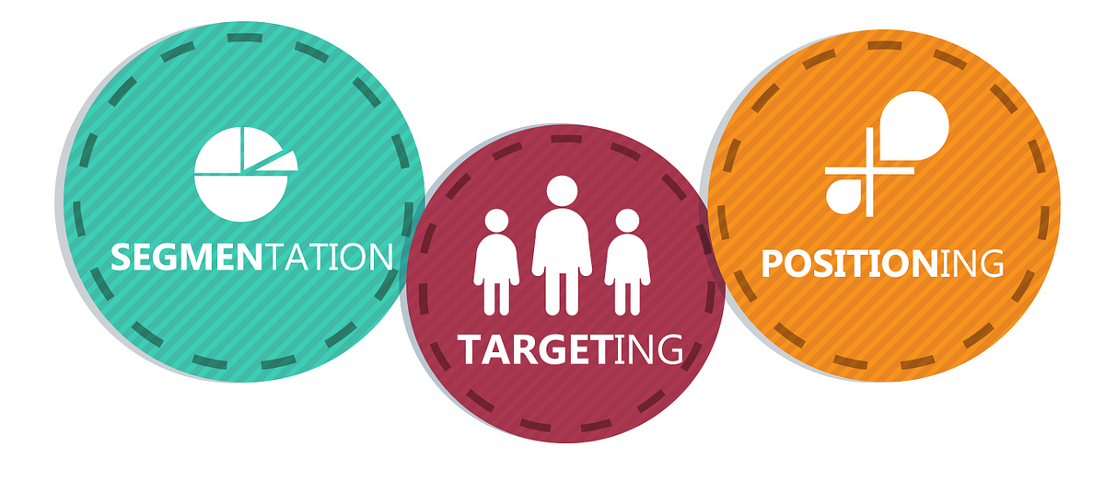

3.1 Segmentation
Toyota segments both the Japanese and Indian markets using demographic, geographic, psychographic and behavioural variables.
Demographic segmentation differs considerably between the two countries. In Japan, Toyota primarily targets middle- and high-income professionals, older consumers and environmentally conscious buyers who seek technologically advanced and premium vehicles. In contrast, India's younger population and expanding middle class create demand for affordable family vehicles, making Toyota focus on middle-income households, working professionals and first-time car buyers.
Geographic segmentation also influences Toyota's strategy. In Japan, the company serves both urban and rural customers with a strong nationwide dealership and service network. In India, Toyota concentrates on metropolitan cities and rapidly developing urban regions where disposable income, infrastructure and automobile demand are higher while gradually expanding into Tier-2 and Tier-3 cities (Desai, 2020).
Psychographic segmentation reflects differences in consumer lifestyles and values (Akkaya, 2021). Japanese consumers prioritise quality, safety, technological innovation and environmental sustainability. Indian consumers value practicality, affordability, fuel efficiency and spacious vehicles suitable for family use. These differences influence Toyota's product portfolio and promotional messages in each country.
Behavioural segmentation is based on purchasing behaviour and brand loyalty (Naim, 2023). Japanese consumers generally demonstrate high brand loyalty and seek long-term vehicle ownership with premium after-sales service. Indian consumers compare price, maintenance costs and fuel efficiency before purchasing, making value-for-money an important purchasing criterion.

3.2 Targeting Strategy
Toyota follows a differentiated targeting strategy by offering different vehicle categories to specific customer groups in each country.
In Japan, Toyota targets environmentally conscious consumers, professionals and premium vehicle buyers through technologically advanced hybrid vehicles, luxury models and innovative mobility solutions (Shigeta and Hosseini, 2020). The company also focuses on customers seeking high safety standards, superior performance and sustainable transportation.
In India, Toyota primarily targets middle-income families, urban professionals, business owners and fleet operators (Bhaskar et al., 2020). Popular models such as the Innova Hycross, Urban Cruiser Hyryder and Glanza are designed to meet the needs of customers seeking affordability, reliability, spacious interiors and fuel efficiency. Toyota also targets the growing demand for hybrid vehicles as fuel prices continue to increase.
The contrasting targeting strategies demonstrate Toyota's ability to respond to differences in consumer purchasing power and market maturity while maintaining its global reputation for quality.

3.3 Positioning Strategy
Toyota positions itself differently in Japan and India while maintaining its core brand values of quality, reliability and innovation.
In Japan, Toyota is positioned as a global technology leader that delivers advanced engineering, environmental sustainability and premium quality (Hyun, 2025). Marketing communications highlight innovation, hybrid technology, hydrogen fuel-cell vehicles and superior safety features, reinforcing Toyota's reputation for technological excellence.
Conversely, in India, Toyota positions itself as a trusted and dependable automobile brand that offers durable, fuel-efficient and family-oriented vehicles with excellent resale value and low maintenance costs. Promotional campaigns emphasise practicality, reliability and long-term ownership benefits rather than luxury or advanced technology alone (Dinarsuci et al., 2026).
Positioning Map (Conceptual)
Japan | India
Premium quality | Value for money
Advanced technology | Fuel efficiency
Innovation and sustainability | Family-oriented vehicles
High-performance mobility | Reliability and affordability
It has been critically analysed that Toyota effectively adapts its STP strategy to reflect the different demographic characteristics, cultural values and economic conditions of Japan and India. This balance between global brand consistency and local market adaptation enables Toyota to strengthen customer satisfaction, improve competitive advantage and sustain long-term growth across both markets.

4. Comparative Analysis of Toyota's International Marketing Mix (7Ps)
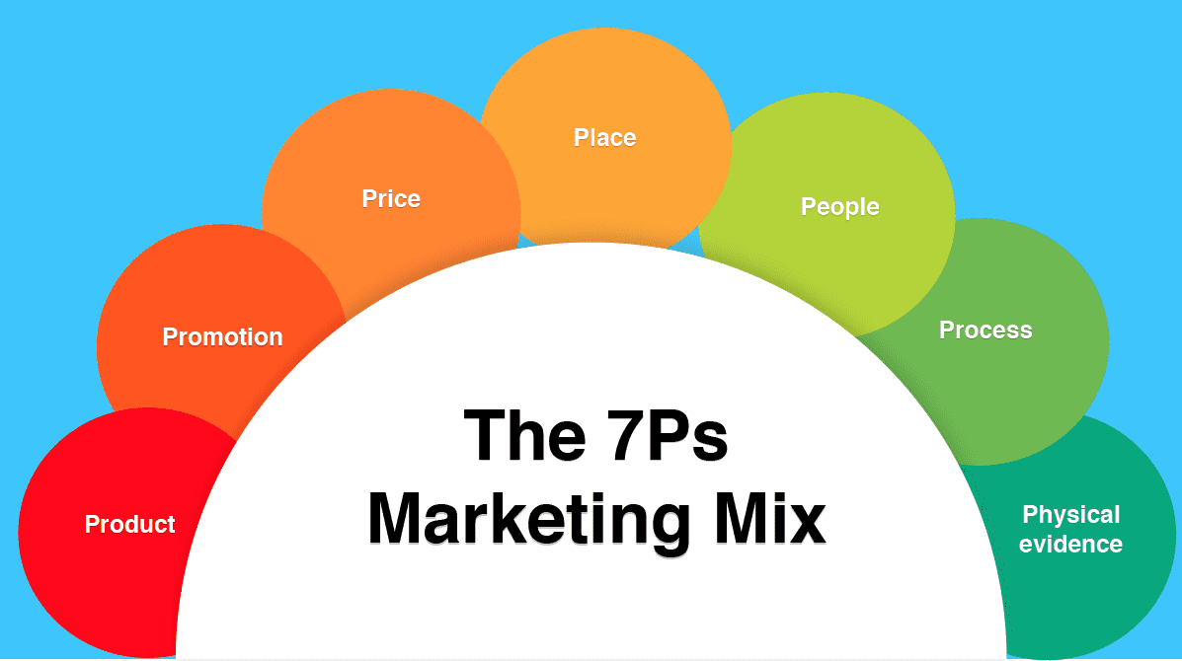

4.1 Product
Toyota adopts a product adaptation strategy by maintaining a globally recognised reputation for quality while modifying its product portfolio to satisfy the distinct needs of consumers in Japan and India (Hyun, 2025). In Japan, Toyota offers a wide range of technologically advanced vehicles, including battery electric vehicles (BEVs), hybrid electric vehicles (HEVs), hydrogen fuel-cell vehicles and premium models under Lexus. The company's multi-pathway strategy focuses on providing diverse mobility solutions that address varying customer needs while supporting carbon neutrality. Toyota also emphasises Software Defined Vehicles (SDVs), advanced safety technologies and connected mobility, reinforcing its position as an innovation leader (Ji et al., 2020).
In contrast, Toyota's product strategy in India is designed around affordability, fuel efficiency and family-oriented mobility. The Indian product portfolio includes models such as the Innova Hycross, Innova Crysta, Fortuner, Glanza, Urban Cruiser Hyryder, Hilux and Urban Cruiser Taisor, which are tailored to meet local consumer preferences. Toyota Kirloskar Motor also continues expanding hybrid technology in India as part of its sustainable mobility strategy while increasing domestic manufacturing capacity to meet growing demand (Kumar, 2025).
The comparison demonstrates that Toyota applies product adaptation rather than complete standardisation. While Japanese consumers demand cutting-edge innovation and premium technology, Indian consumers prioritise reliability, practicality and long-term value.

4.2 Price
Toyota's pricing strategy differs considerably between Japan and India because of differences in purchasing power, market maturity and competitive intensity. In Japan, Toyota primarily follows a value-based pricing strategy, where customers are willing to pay premium prices for advanced technology, superior safety features, environmental performance and product reliability (Saragih and Muharam, 2023). Premium pricing also reflects Toyota's continuous investment in innovation, electrification and research and development.
Conversely, Toyota adopts a more competitive and market-oriented pricing strategy in India. The company locally manufactures several vehicles, enabling cost reductions through localisation and economies of scale while offering competitive prices to middle-income consumers. This strategy allows Toyota to compete effectively against domestic and international manufacturers operating within India's highly price-sensitive automobile market. Furthermore, the company's expanding manufacturing investments support cost efficiency and long-term market growth.

4.3 Place (Distribution)
Toyota's distribution strategy combines an extensive dealership network with advanced digital channels to ensure convenient customer access in both markets (Ianenko et al., 2022). In Japan, Toyota benefits from a mature nationwide dealer network supported by efficient logistics systems and highly integrated supply chains. The company further strengthens customer convenience through digital platforms, connected services and mobility solutions that enhance the overall purchasing experience.
In India, Toyota has expanded its distribution network through Toyota Kirloskar Motor by strengthening dealerships, authorised service centres and customer support services across metropolitan and emerging cities (Swati, 2020). The company is also investing in expanding production capacity through the third manufacturing plant at Bidadi and a new facility in Maharashtra, supporting both domestic demand and export growth. These investments align with Toyota's "Grow India & Grow with India" strategy and improve product availability across the country.

4.4 Promotion
Toyota maintains a consistent global brand image based on quality, safety, innovation and sustainability while adapting promotional activities to local market expectations (Hassan and Rukiman, 2025). In Japan, promotional campaigns primarily highlight technological leadership, carbon neutrality, hybrid and hydrogen mobility, product safety and Toyota's long-term vision of becoming a mobility company. The Integrated Report emphasises the company's commitment to "Producing Happiness for All", expanding the value of mobility and delivering sustainable transportation through its multi-pathway strategy.
In India, promotional strategies focus more strongly on trust, family values, fuel efficiency and sustainable mobility (Arora and Singh, 2024). Toyota Kirloskar Motor reinforces its customer-centred approach through initiatives such as T-Care, digital customer engagement and sustainability campaigns while emphasising hybrid technology and local manufacturing. The company also promotes responsible business practices through community development, education, skill development and environmental initiatives, strengthening its corporate reputation beyond product advertising.

4.5 People
Toyota recognises that employees, dealers and customer service personnel are fundamental to delivering a consistent global brand experience. While the company's core philosophy remains the same across all markets, its people strategy is adapted to reflect the needs of local employees and customers. In Japan, Toyota's people strategy is guided by The Toyota Way, which emphasises continuous improvement (Kaizen), respect for people, teamwork and long-term employee development (Morgan and Liker, 2020). The Integrated Report highlights that Toyota considers human resource development as a key driver of organisational success, believing that "making people" is equally as important as manufacturing vehicles. This philosophy supports employee empowerment, innovation and customer satisfaction while maintaining Toyota's global reputation for quality.
In India, Toyota Kirloskar Motor applies similar principles while placing greater emphasis on workforce diversity, employee training and skill development. The Sustainability Report highlights over 630,000 employee skilling hours, increased participation of women in manufacturing operations and job-specific overseas training programmes, reflecting Toyota's investment in building a skilled and inclusive workforce. The company also strengthens dealer capabilities through customer service initiatives such as T-Care, ensuring a seamless ownership experience and high levels of customer satisfaction.

4.6 Process
Toyota's process strategy is designed to deliver a consistent customer experience through efficient manufacturing, sales and after-sales services (Titu and Pop, 2025). In Japan, the Toyota Production System (TPS) remains the foundation of operational excellence, incorporating Just-in-Time (JIT) production, Kaizen, quality management and waste reduction. These practices improve manufacturing efficiency while ensuring high-quality vehicles and reliable customer service. Toyota further integrates digital technologies, connected mobility solutions and software-defined vehicles to enhance customer convenience throughout the ownership journey.
In India, Toyota has adapted these operational principles to suit the country's growing automotive market. Toyota Kirloskar Motor integrates lean manufacturing practices with digital transformation initiatives across production, supply chain management and customer services. Customers can access online vehicle information, digital booking, financing options, authorised service centres and after-sales support, making the purchasing process more efficient. The Sustainability Report also highlights the company's ongoing investment in digital transformation, manufacturing expansion and localisation to improve operational efficiency and customer responsiveness (Toyota, 2026).

4.7 Physical Evidence
Physical evidence represents the tangible elements that influence customer perceptions of Toyota's brand quality and reliability. In Japan, Toyota reinforces its premium brand image through modern dealerships, technologically advanced showrooms, clean manufacturing facilities, consistent corporate branding and high-quality service centres. These physical elements communicate innovation, safety and professionalism, supporting Toyota's positioning as a global mobility leader. The Integrated Report further demonstrates Toyota's commitment to creating future mobility through investments in advanced manufacturing, sustainable facilities and customer-focused innovation (Toyota, 2026a).
Similarly, Toyota Kirloskar Motor maintains consistent physical branding across India through authorised dealerships, service centres, customer lounges and digital service platforms. The Sustainability Report highlights the company's expanding manufacturing facilities in Bidadi and Maharashtra, which strengthen production capacity while supporting sustainable manufacturing practices. In addition, Toyota reinforces its physical presence through environmentally responsible facilities, renewable energy initiatives and customer-oriented dealership environments that enhance overall brand credibility.
It has been critically analysed that the comparative analysis of Toyota's People, Process and Physical Evidence demonstrates that the company successfully balances global standardisation with local adaptation across Japan and India. Toyota's core values, including quality, continuous improvement, customer satisfaction and sustainability, remain consistent in both markets. However, their implementation varies according to differences in economic development, workforce characteristics and customer expectations.

5. Market Entry Strategy of Toyota in India
Toyota adopted a Joint Venture (JV) as its primary market entry strategy when entering India by establishing Toyota Kirloskar Motor (TKM) in 1997 in partnership with the Kirloskar Group (Moonan, 2021). This strategy enabled Toyota to combine its advanced automotive technology, global manufacturing expertise and financial resources with Kirloskar's knowledge of the Indian market, regulatory environment and local business networks. Over time, Toyota has strengthened its presence by expanding local manufacturing facilities, increasing localisation and investing in production capacity to support both domestic demand and exports. The Toyota Kirloskar Sustainability Report highlights ongoing investments in the expansion of the Bidadi manufacturing facility and the development of a new greenfield plant in Maharashtra, demonstrating Toyota's long-term commitment to the Indian market.
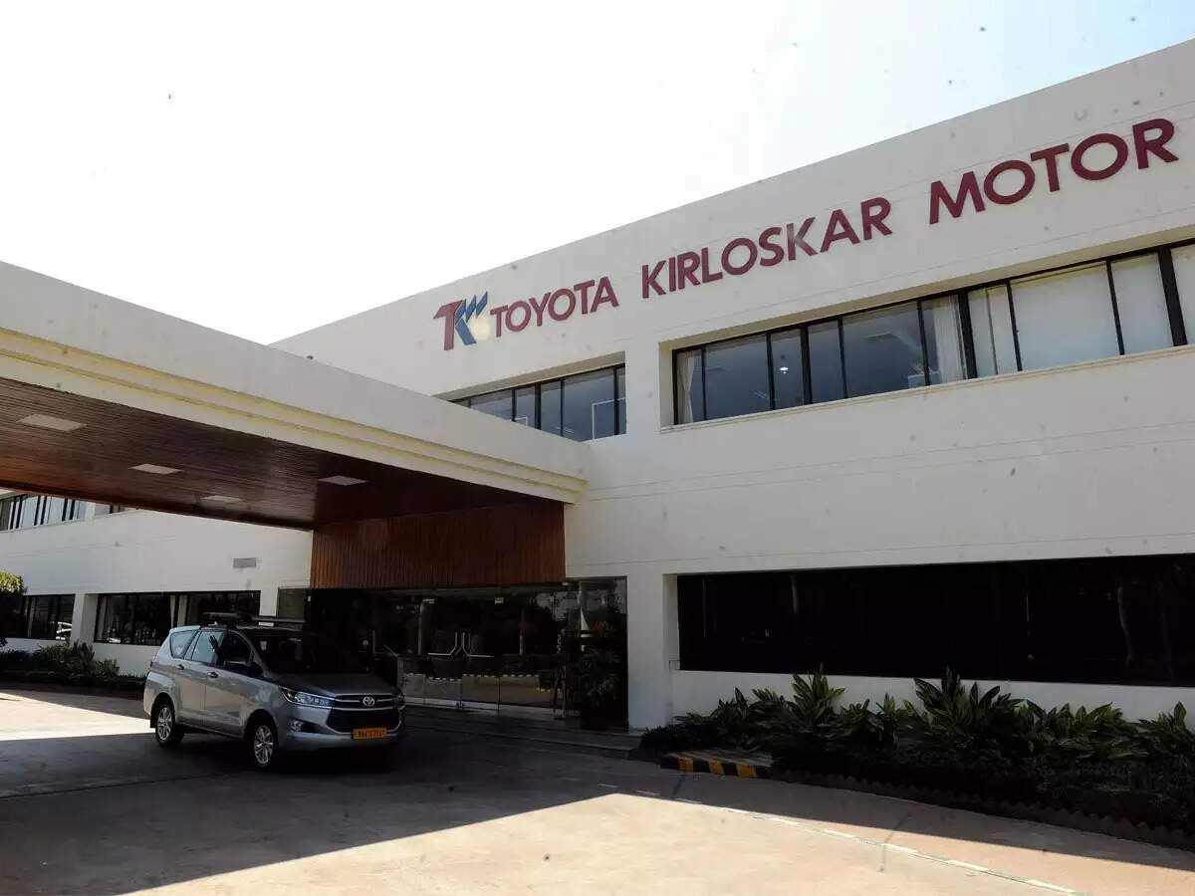
The selection of a joint venture was appropriate because India represents a highly competitive and price-sensitive automobile market with diverse consumer preferences and complex regulatory requirements. Collaborating with a local partner reduced the risks associated with entering an unfamiliar market while enabling Toyota to establish supplier relationships, improve distribution networks and enhance customer understanding (Ike et al., 2021). Increasing localisation has allowed Toyota to reduce production costs, strengthen supply chain resilience and improve price competitiveness through locally manufactured models such as the Innova Hycross, Glanza and Urban Cruiser Hyryder.
Toyota's entry strategy can be effectively explained through Dunning's Eclectic Paradigm (OLI Framework). The company possessed strong Ownership advantages, including globally recognised technology, strong brand equity, manufacturing expertise and continuous innovation. India provided significant Location advantages, such as a large consumer market, skilled labour force, supportive government initiatives including Make in India, growing demand for passenger vehicles and opportunities for export-oriented manufacturing (Kumar, 2023). Internalisation advantages encouraged Toyota to retain control over production quality, technology and operational standards through its joint venture rather than relying solely on licensing or exporting (Hidayatullah and Novica, 2024). This combination of ownership, location and internalisation advantages explains why direct manufacturing through a strategic partnership represented the most suitable market entry approach.
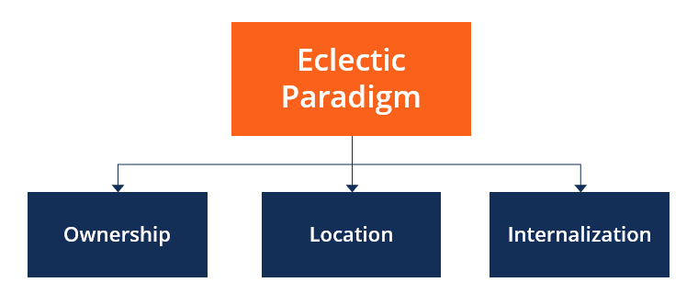
Transaction Cost Theory supports Toyota's decision. Establishing local manufacturing reduced transportation expenses, import tariffs and coordination costs while improving operational efficiency (H Abdelati and A Abdelwali, 2024). Producing vehicles within India also enabled Toyota to respond more rapidly to changes in customer preferences and market demand, reducing the transaction costs associated with exporting finished vehicles from Japan.
Despite these advantages, the joint venture strategy also presents several limitations. Decision-making may become slower because strategic decisions require coordination between partners, while cultural differences and management priorities may occasionally create operational challenges. Additionally, substantial investment in manufacturing facilities and supply chain development increases financial risk, particularly during periods of market uncertainty or declining consumer demand.

6. Ethical Issues
Ethical considerations play a vital role in Toyota's international marketing strategy, particularly in balancing business growth with environmental responsibility, corporate governance and stakeholder expectations. Toyota has integrated sustainability into its global operations through its commitment to carbon neutrality, product safety and responsible business practices. The Integrated Report 2025 identifies key priorities including carbon neutrality, product safety, human rights, privacy and responsible value chain management, demonstrating that ethical principles are embedded within the company's long-term strategy (Toyota, 2026a).
In India, Toyota Kirloskar Motor reinforces these commitments by adopting renewable energy, promoting hybrid mobility, reducing manufacturing emissions and investing in community development. The Sustainability Report highlights the achievement of 100% Scope 2 emission reduction in manufacturing through renewable electricity, extensive employee training, waste recycling initiatives and programmes that support education, healthcare and skill development (Toyota, 2026). These initiatives reflect Toyota's commitment to environmental sustainability and social responsibility while strengthening its corporate reputation.
Toyota continues to face ethical challenges. The company's global operations require effective monitoring of suppliers to ensure compliance with labour standards, human rights and environmental regulations across its extensive supply chain. In addition, increasing scrutiny over vehicle emissions and environmental claims means Toyota must ensure that its sustainability communications remain transparent and evidence-based to avoid allegations of greenwashing.
It has been critically analysed that Toyota's marketing practices are largely consistent with the principles of ethical international marketing because the company prioritises sustainability, product safety, transparency and stakeholder value. Nevertheless, maintaining ethical leadership will require continuous improvement in supply chain governance, environmental reporting and responsible communication to sustain customer trust and long-term competitive advantage.

7. Recommendations
Based on the comparative analysis of Toyota's international marketing strategies in Japan and India, the following recommendations are proposed to strengthen the company's long-term competitiveness and global market position:
Expand Affordable Electric Vehicle (EV) Offerings in India
Toyota should accelerate the introduction of affordable battery electric vehicles while continuing its multi-pathway strategy. Although hybrid vehicles currently suit Indian market conditions, rising government support, environmental regulations and consumer awareness indicate that demand for EVs will increase significantly. Expanding the EV portfolio and collaborating with charging infrastructure providers would strengthen Toyota's market position and support its carbon neutrality objectives.
Increase Localisation and Manufacturing Capacity
Toyota should continue expanding local manufacturing and supplier development in India to reduce production costs, improve supply chain resilience and respond more quickly to changing customer preferences. Further localisation would also minimise import dependency and enhance long-term profitability. The planned expansion of the Bidadi facility and the new Maharashtra manufacturing plant provide strong opportunities to achieve these objectives.
Strengthen Digital Customer Engagement
Toyota should invest further in digital technologies such as artificial intelligence, online vehicle configurators, personalised marketing, predictive maintenance and connected after-sales services. These innovations would improve customer experience, strengthen long-term relationships and increase brand loyalty, particularly among younger and digitally active consumers.
Enhance Sustainability Communication
Toyota should communicate its sustainability initiatives more transparently by highlighting achievements related to carbon neutrality, renewable energy, hybrid technology and circular economy practices. Clear sustainability reporting and responsible marketing communication would strengthen stakeholder trust while differentiating Toyota from competitors in increasingly environmentally conscious markets.

Section 2: Reflective Account Using Gibbs' Reflective Cycle

8. Gibbs Reflective cycle

Description
Throughout this assessment, I critically analysed Toyota's international marketing strategies by comparing its operations in Japan and India. The report required me to evaluate the macro-environment using the PESTEL framework, analyse cultural differences through Hofstede's cultural dimensions, compare Toyota's Segmentation, Targeting and Positioning (STP) strategy and examine its international marketing mix (7Ps). I also evaluated Toyota's market entry strategy in India, identified ethical issues and developed recommendations for improving the company's future international marketing performance.
To complete the report, I relied on academic journal articles, international marketing theories, Toyota's Integrated Report, Toyota Kirloskar Motor Sustainability Report and other credible business sources. The assessment required more than simply describing Toyota's strategies; it involved critically comparing how the company adapts its marketing decisions to suit different economic, cultural and competitive environments. Completing this report enhanced my understanding of how multinational organisations combine global standardisation with local adaptation to achieve sustainable competitive advantage in international markets.

Feelings
At the beginning of the assignment, I felt both interested and slightly overwhelmed because international marketing involves numerous theories, frameworks and real-world business practices. Initially, I found it challenging to determine which models would best explain Toyota's international success and how they could be applied critically rather than descriptively. I was also concerned about integrating academic literature with practical business evidence while maintaining a logical structure.
As I progressed with the research, my confidence gradually increased. Analysing Toyota's strategies through PESTEL, Hofstede and the 7Ps enabled me to understand how marketing decisions differ across countries. I became more comfortable evaluating business strategies rather than simply describing company activities. By the end of the assignment, I felt satisfied that I had developed stronger analytical and critical thinking skills that will benefit my future academic studies and professional career.

Evaluation
Reflecting on the overall experience, I believe several aspects of my work were successful. One major strength was my ability to integrate theoretical concepts with practical examples from Toyota's international operations. Rather than discussing marketing theories in isolation, I applied them to evaluate Toyota's strategies in both Japan and India. This approach improved the depth and relevance of my analysis.
Another positive aspect was the use of credible academic literature and official company reports, which strengthened the reliability of my arguments. Comparing two countries also enabled me to understand how cultural, economic and political differences influence marketing decisions.
However, I also identified areas for improvement. Initially, I spent too much time collecting information before organising my ideas, making the research process less efficient. I also realised that some sections required stronger critical evaluation instead of simply presenting company practices. Developing balanced arguments supported by evidence proved more challenging than expected.

Analysis
This assignment helped me recognise that successful international marketing depends on understanding both global business strategy and local market conditions. Before undertaking this assessment, I viewed international marketing primarily as promoting products in different countries. However, analysing Toyota demonstrated that successful global companies carefully adapt their products, pricing, distribution and promotional strategies according to local economic conditions, consumer behaviour and cultural expectations.
Applying PESTEL analysis enabled me to understand how political stability, economic development, legal regulations and technological advancement influence strategic marketing decisions. Similarly, Hofstede's cultural dimensions highlighted that consumer values differ significantly across countries, requiring companies to modify communication strategies and product positioning.
The most valuable learning experience was analysing Toyota's marketing mix. I realised that although Toyota maintains consistent global brand values such as quality, innovation and reliability, it adapts individual marketing elements according to local customer needs. This reinforced the concept of balancing standardisation with adaptation, which is a fundamental principle of international marketing.
The assignment also improved my critical thinking skills. Instead of accepting company strategies as automatically successful, I learned to evaluate both their strengths and limitations using established marketing theories. Furthermore, researching official company reports alongside academic literature enhanced my ability to assess information from multiple perspectives rather than relying on a single source. This experience has strengthened my confidence in conducting evidence-based business analysis and presenting balanced academic arguments.

Conclusion
Reflecting on this assessment, I recognise that I have developed a stronger understanding of international marketing principles and their practical application within multinational organisations. The assignment improved my ability to apply marketing theories critically, evaluate international business strategies and support arguments using credible academic and corporate evidence. Although I experienced challenges in managing extensive research and maintaining critical analysis throughout the report, these difficulties enhanced my learning. Overall, this experience has strengthened my academic writing, analytical thinking and research skills while increasing my confidence in evaluating complex international marketing issues.

Action Plan
Area for Development | Specific Action | Measurable Target | Achievable & Relevant | Time-Bound | Expected Outcome
Time Management | I will create a weekly study timetable and divide each future assessment into smaller tasks. | Complete at least 90% of planned weekly tasks. | This is realistic alongside other academic commitments and directly addresses difficulties with research organisation. | For the next 8 weeks and before the next major assessment. | Better organisation, timely submission and reduced last-minute pressure.
Critical Thinking | I will compare different academic viewpoints rather than relying mainly on descriptive information. | Critically compare at least 3 peer-reviewed sources for each major assessment. | This is manageable and directly supports the need to strengthen critical analysis. | From the next assessment onwards. | Stronger critical evaluation and more balanced academic arguments.
Academic Writing Skills | I will practise developing analytical paragraphs and integrating theories with practical business examples. | Complete at least 2 analytical writing exercises per week. | Regular short practice is achievable and relevant to improving report-writing ability. | Over the next 8 weeks. | More coherent, analytical and professionally written academic reports.
Research Skills | I will use academic journals, company reports and credible business databases when developing arguments. | Use at least 5 peer-reviewed sources and 2 credible company/business sources in each major report, where relevant. | This target is achievable and strengthens the evidence base of future assignments. | For the next 3 assessments. | Improved research quality and stronger evidence-based analysis.
International Marketing Knowledge | I will regularly review international marketing cases and current multinational-company reports. | Review at least 1 relevant case study or company report per week and record key learning points. | This requires limited weekly time and directly supports the development of international marketing knowledge. | For the next 8 weeks. | Greater understanding of international marketing strategies and improved ability to apply theory to real-world situations.

9. References
Akkaya, M., 2021. Understanding the impacts of lifestyle segmentation & perceived value on brand purchase intention: An empirical study in different product categories. European research on management and business economics, 27(3), p.100155.
Arora, S.C. and Singh, V.K., 2024. Transition to green mobility: a twin investigation behind the purchase reasons of electric vehicles in the Indian market. The Bottom Line, 37(3), pp.277-308.
Bhaskar, M.G., Narahari, N.S. and Guptha, C.K.G., 2020. Consumer Preferences for mid-Segment electric cars—An Indian Perspective. Int. J. Eng. Res. Technol, 9, pp.1303-1309.
Borkhade, R., Bhat K, S. and Mahesha, G.T., 2022. Implementation of sustainable reforms in the Indian automotive industry: from vehicle emissions perspective. Cogent Engineering, 9(1), p.2014024.
De Marco, R., 2024. Social and Economic Sustainable Developments in Japan's super-ageing society.
Desai, H.B., 2020. Study on the Automotive Car Industry in India: scenario analysis and new future Business models (Doctoral dissertation, Politecnico di Torino).
Dinarsuci, G., Yulianah, Y., Diforama, M.N., Pratiwi, P., Amanda, S.K. and Pertiwi, R.D., 2026. Analysis of the Development of Electric Car Marketing in Indonesia in Encouraging Consumer Purchasing Interest. Advances: Jurnal Ekonomi & Bisnis, 4(3), pp.732-745.
Favaro, N., 2020. Has the green economy revolutionized the car industry and customers choices?.
Gibrilla, T., 2023. Peculiarities of automobile corporation’s activity in the global market (based on the company Toyota Motor Corporation) (Doctoral dissertation, Полтавський університет економіки і торгівлі).
H Abdelati, M. and A Abdelwali, H., 2024. Evaluating the impact of transportation costs, supply chain reliability, and operational efficiency on global import decisions. International Journal of Advanced Engineering and Business Sciences, 5(3).
Hassan, M.N. and Rukiman, Z., 2025. International Marketing Strategy.
Hidayatullah, A.F.R. and Novica, D.A., 2024. Joint Venture VS. Wholly Owned Subsidiary: Strategic Adaptation of Toyota Motor Corporation. PERCIPIENCE International Journal of Social, Administration, & Entrepreneurship, 3(2), pp.67-82.
Hyun, J.H., 2025. The Role of Transnational Strategies in Advancing Quality Management: A Case Study of Toyota Motor Corporation. Journal of Korean Society for Quality Management, 53(1), pp.93-108.
Ianenko, M., Ianenko, M. and Shevchuk, E., 2022. Digital transformation of marketing activities in transport systems management during COVID-19: experience, problems, prospects. Transportation Research Procedia, 63, pp.878-886.
Ike, P.N., Ogbuefi, E., Nnabueze, S.B., Olatunde-Thorpe, J., Aifuwa, S.E., Oshoba, T.O. and Akokodaripon, D., 2021. Supplier relationship management strategies fostering innovation, collaboration, and resilience in global supply chain ecosystems. International Journal of Multidisciplinary Evolutionary Research, 2(2), pp.52-62.
Ji, Y., Zhu, X., Zhao, T., Wu, L. and Sun, M., 2020. Revealing technology innovation, competition and cooperation of self-driving vehicles from patent perspective. IEEE Access, 8, pp.221191-221202.
Konovalov, D., Tolstorebrov, I., Iwamoto, Y. and Lamb, J.J., 2025. Hydrogen and Japan’s energy transition: A blueprint for carbon neutrality. Hydrogen, 6(3), p.61.
Kumar, N., 2023. Manufacturing-led Transformation for Realizing India’s Development Aspirations in the Context of a Fractured Trading System.
Kumar, N., 2025. Harnessing India–Japan economic partnership for supply chain resilience in the context of global trade policy uncertainties. India–ASEAN–Japan Cooperation for Diversified and Resilient Supply Chains, 62.
Liu, X., Zhao, X. and Zhao, F., 2025. Why Some Countries Can Survive the Middle-Income Trap–Based on an Empirical Analysis of Different Countries and Regions. Journal of Competitiveness, 17(3), p.222.
Moonan, C., 2021. The transfer of Japanese human resource management in the Indian automotive industry (Doctoral dissertation, University of Leeds).
Morgan, J. and Liker, J.K., 2020. The Toyota product development system: integrating people, process, and technology. CRC Press.
Naim, A., 2023. Consumer behavior in marketing patterns, types, segmentation. European Journal of Economics, Finance and Business Development, 1(1), pp.1-18.
Niazi, H., Taghizad-Tavana, K., Esmaeel Nezhad, A., Canani, A., Tarafdar Hagh, M. and Paidar, P., 2026. Green Hydrogen in Integrated Multi-Energy Systems: Technological Pathways, Policy and Market Perspectives, and the Role of Artificial Intelligence. Fuels, 7(2), p.37.
Rafiq, F., Parthiban, E.S., Rajkumari, Y., Adil, M., Nasir, M. and Dogra, N., 2023. From thinking green to riding green: A study on influencing factors in electric vehicle adoption. Sustainability, 16(1), p.194.
Rajendran, S., Prakash, C., Shakir, M., Alwetaishi, M., Dhairiyasamy, R., Rajendran, P. and Lee, I.E., 2025. Enhancing competitiveness in India’s electric vehicle industry: impact of advanced manufacturing technologies and workforce development. Scientific Reports, 15(1), p.15647.
Saragih, D.A. and Muharam, H., 2023. The Impact of Price, Promotion, and Service Quality on Customer Satisfaction: The Mediating Role of Brand Image in Toyota Car Product. Journal of Social Studies Arts and Humanities (JSSAH), 3(3), pp.134-138.
Sarangal, R., Kumar, A., Bathla, D., Chauhan, P., Dangwal, A. and Mehta, M., 2023. Strategic Alliance Between Toyota and Suzuki: Is It a Win for Toyota or a Loss for Suzuki?. In Cases on the Resurgence of Emerging Businesses (pp. 206-214). IGI Global Scientific Publishing.
Sedita, S.R., Blasi, S. and Yang, J., 2022. The cultural dimensions of sustainable development: A cross‐country configurational analysis. Sustainable Development, 30(6), pp.1838-1849.
Shigeta, N. and Hosseini, S.E., 2020. Sustainable development of the automobile industry in the united states, europe, and japan with special focus on the vehicles’ power sources. Energies, 14(1), p.78.
Soliman, M.H.A., 2023. A Complete Guide to Just-in-Time Production: Inside Toyota's Mind. Personal Lean Publications.
Swati, P., 2020. Strategy formulation for unconventional media in the rural areas of Central Uttar Pradesh.
Titu, A.M. and Pop, A.B., 2025. Integrated quality management for automotive services—Addressing gaps with European and Japanese principles. Sustainability, 17(20), p.9100.
Toyota, 2025. Contents toyota integrated report 2024. [online] available at https://global.toyota/pages/global_toyota/ir/library/annual/2024_001_integrated_en.pdf
Toyota, 2026. TOYOTA Sustainability Bond Report January 2026. [online] available at https://global.toyota/pages/global_toyota/ir/library/sustainability-bond/sustainability-bond_202601_en.pdf
Toyota, 2026a. INTEGRATED REPORT 2025. [online] available at https://global.toyota/pages/global_toyota/ir/library/annual/2025_001_integrated_en.pdf?utm_source=openai
Urwah, K., 2022. Investigating Hydrogen Fuel Cell Vehicle Adoption in Japan: Realization of a Concept of Hydrogen Economy.
Wandhe, D.P., 2024. An overview on production linked incentive (PLI) scheme by the government of India. Available at SSRN 4693578.

