University of Wales Trinity Saint David
BA Business Management
Community Engagement (LCBB4002)

Reflective Essay
Topic: Theoretical and practical approaches of reflection

Student: Vasile Turcanu, Student nr 2127548
Tutor: Zahra Mohammadnazari

Introduction
Regardless of the profession or field of activity, people are put in the situation to analyze their own experiences, their own actions, and inactions, to review their thoughts and beliefs. This cognitive process is realized through reflection. Thus, in the following reflective report, I decided to approach the phenomenon of reflection itself and reflective practice. For a better understanding of reflective practice, I will describe Gibb's learning cycle followed by a reflective essay on the community engagement module, structured according to this learning style.
- General aspects of the reflection
Everyone of us has the possibility to reflect on our experiences, learn from them, and develop a plan of action for what to do next. The reflective practice method was developed as a way to draw lessons from real-world events in a variety of professions, such as teaching, medicine, and social work. Universities are just one of the many sectors that have absorbed the ideas of reflective practice over time. For example, when studying, we can use reflection to organise group work. Along with academics, it serves as a valuable professional qualification when applying for jobs. It is ideal to regularly reflect because doing so will help us form the habit and allow us to build on what we are learning.
To begin reflecting on an experience, it is simplest to ask some of the following questions:
What did I learn? What do I need to learn more about? What was easy? What was difficult? What went well? How can I improve in the future?
Anytime, for whatever cause, might be a good moment to reflect. It need not be official, documented, or even adhere to a set protocol in order to be beneficial to our learning.
Whether it is better to well on positive or negative experiences depends on the situation. There is no right answer to this question, as what we choose to reflect on will depend on our individual circumstances and tastes, although most people would undoubtedly benefit from finding a balance between the two.
"Studying and understanding both include reflection. The expression "reflective learning" underlines the goal to learn from present or previous experiences. We reflect in order to learn something, or we learn as a result of reflecting." (Moon 2004).
- Gibbs’ learning cycle
The Gibbs Reflective Cycle was developed by Graham Gibbs in 1988 to provide structure to learning from experiences. It offers a framework for analysing experiences and is particularly well adapted to social contact due to its cyclical nature. This gives you the opportunity to learn from both positive and negative endeavours and to develop strategies for the future.
According to Graham Gibbs having an experience alone won't help you learn, as the saying goes. Without reflection, the learning potential of this experience may be lost or forgotten fast,
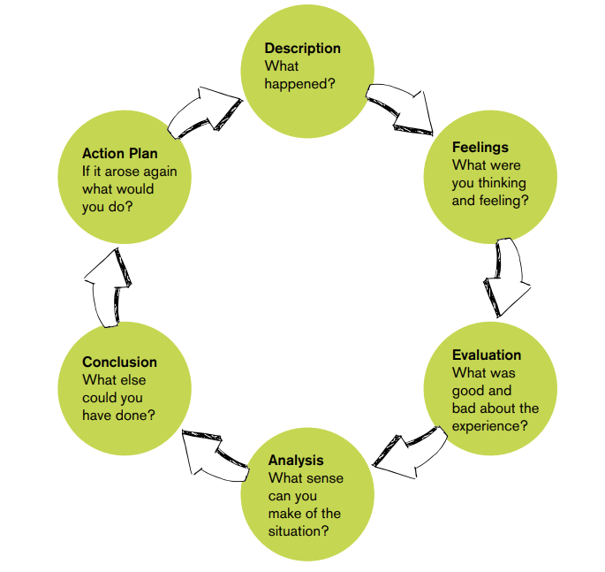
Fig 1. Gibbs’ learning cycle. University of Birmingham
Gibbs’ Cycle is probably One of the most popular cycles for reflection, which guides you through 6 phases of analysing an experience:
- Description of the situation
You get the opportunity to fully describe the scenario at this point. What, where, when, how, and why it happened, is the major topic to cover here.
- Feelings-Reflections regarding the event.
In this section, you are encouraged to reflect on any feelings or concepts you may have had at the time of the incident. Here, you must explain how you feel and give particular examples related to your study. It is crucial to be open and truthful about your sentiments, even if they are adverse. You can only put these tactics into action once the feelings have been identified.
- Evaluation-experience, both positive and negative
You have the chance to discuss what went well and examine practice in the assessment area. The need for improvement in certain places and situations that did not go according to plan should also be considered.
- Analysis-to comprehend the circumstance
In this section, you must describe the experience. They consider various variables that may have promoted or inhibited learning. To help make sense of the occurrence, you should now review any relevant literature or study. If you think your instructions were confusing, for instance, you can research academic papers on successful communication.
- Conclusion- Discuss what you learned and how you might have responded differently. At this point, you combine all your ideas. You should now be aware of where you should develop and have a few ideas for how to do so based on your thorough analysis.
- Action plan- for any general improvements you might deem essential, or on how you could approach such situations in the future.
You recapitulate all preceding steps of this cycle in this last stage. For the innovative learning situation, they develop a thorough plan. You make a list of what you'll maintain, what you'll modify, and what you'll make better. The strategic plan may also include the subsequent measures required to overcome any difficulties, such as enrolling in a course or monitoring others.
In phases, one, two, and three of Gibb's cycle, the circumstances of the experience are described. The remaining phases deal with understanding the problem and how you, as a practitioner, can make it better.
- The reflective essay based on Gibbs’ learning cycle:
- Description
In September 2022, I started the second quarter of the first academic year at UWTSD in Birmingham. One of the two courses in the student's program was community engagement. In this module, I addressed general aspects regarding community engagement, such as the definition, benefits, manifests, standards, and tools for the community and business. During the lessons, the teacher presented us with the theoretical part and challenged us to study bad examples of companies and their involvement in social activity. After the individual or group analysis of the case studies, they were discussed and debated by the whole class. As a result of the knowledge accumulated in this class module and through self-study, my colleagues and I developed an individual report on the analysis of the social involvement of an economic agent (Mark and Spencer).
- Feelings
I was feeling comfortable discussing in the classroom over the whole course. During the classes, engaging with other participants gave me the chance to improve my ability to think, understand, and communicate. My experience has also been enhanced by several of the jobs that called for teamwork. The inspiration and encouragement we provided one another were invaluable. By sharing their feelings and views on various subjects, allowing me to observe things from different perspectives, and motivating me to hone my personal viewpoints, I believe they have taught me a lot about professionalism.
- Evaluation
I decided to do the tasks for a variety of reasons. First, we had 2 mandatory tasks to complete, and then we were left to decide for ourselves which of the remaining tasks we would do. I opted to complete most of the projects because I believed they would be interesting to me, but I also selected others because I thought they would be challenging. For instance, Canvas business model, Mark and Spencer individual report. Since I don't have much expertise in such fields, I believe I thought that they would push me, advancing my skill learning.
- Analysis
These jobs were generally enjoyable to perform. Most of the assignments ended in November. The process continued all across the whole module. I believe that accomplishing them during the module helped to relieve some of the strain of finishing the complete assignment. I also wanted to challenge myself once more while starting to gather information and focus on my future career progress. Having all materials online on Moodle and stored on my computer ensures that I'll always have access to the data I have learned.
For instance, the first assignment challenged me to analyze the social implication of Mark and Spencer in social and environmental activity. I started the report with a general presentation of the company, and the notion and importance of Community Engagement. Next, I presented what are the main directions and approaches of activity of M&S in the context of Community Engagement. I also emphasized the chronological scale of the company's successes so far in this field and the future plan for improving the environment and reducing social problems. Thanks to this individual report, I strengthened the knowledge gained during the lessons, and it trained my critical thinking skills on the importance of business involvement in social processes and the way it can manifest itself positively in the community.
- Conclusion
I would say that the module had both good and poor aspects as I look back on it. The huge amount of knowledge, information, and skills I have acquired have been really useful in motivating me to put all the community engagement features I have learned into practice. It has also stimulated me to consider locations, problems, and subjects I had never truly addressed because of the limited opportunities I had to confront them in academic and professional life. Additionally, I believe it has inspired me to keep improving in my job. But given university life, sometimes this could be difficult!
- Action plan
I liked the module as a whole. I simply wish that the institution offers more opportunities to discuss such business approaches in the social life of the community. With so many students walking away with little understanding or awareness, I think this should be included more often. The knowledge gained in this module will serve in the future to lay the foundations of your own business that is socially active and involved in solving community problems.
Conclusion
Even if we are not given a specific reflection task, reflection is still a useful exercise. It is beneficial to understand and learn from our experiences. In this reflective essay, I tried to analyze the experience lived during the Community Engagement module. I brought examples of things learned and feelings experienced. Reflective writing helped me to be capable to show that I can analytically evaluate my personal skills or practices willing to develop and learn. It is crucial to analyze our thoughts, rather than describe them and emphasize how we will use what we have learned.

Reference list
1. Cambridge University Libraries. Reflective Practice Toolkit. https://libguides.cam.ac.uk/reflectivepracticetoolkit/whatisreflectivepractice.
2. Cambridge International Education Teaching and Learning Team. Getting started with Reflective Practice. https://www.cambridge-community.org.uk/professional-development/gswrp/index.html.
3. The University of Birmingham. (2015). A short guide to reflective writing. https://www.intranet.birmingham.ac.uk/.
4. Effective Learning Service, Queen Margaret University. Reflection. www.qmu.ac.uk/ELS
5. The University of Edinburgh. (2020). Gibb’s Reflective Cycle. https://www.ed.ac.uk/reflection/reflectors-toolkit/reflecting-on-experience/gibbs-reflective-cycle.
6. The University of Portsmouth. Reflective writing introduction. https://www.port.ac.uk/student-life/help-and-advice/study-skills/written-assignments/reflective-writing-introduction.
7. Gibbs, G (1988). Learning by doing: a guide to teaching and learning methods. Oxford: Further Education Unit, Oxford Polytechnic.
8. MOON, J., 2004. A handbook of reflective and experiential learning. London: RoutledgeFalmer.

