
STUDENT NAME:Muntakim Ali
STUDENT ID NUMBER:1817589
MODULE: PRINCIPLES AND CONCEPTS OF FINANCE
MODULE CODE: BMBM5017
LECTURER: BADIR MIFTAH
ASSIGNMENT TITLE: BUDGETING PRINCIPLES AND APPROACHES

EVALUATING BUDGETING PRINCIPLES AND APPROACHES: CHALLENGES, SOLUTIONS, AND STRATEGIC INSIGHTS FOR BLUE THREAD LTD

TABLE OF CONTENTS
1. Introduction 3
2. Budget Preparation and Financial Analysis 3
2.1 Stock Budget for June to November 2025 3
2.2 Cash Budget for June to November 2025 4
2.3 Budgeted Profit & Loss Account (Six-Month Overview) 5
3. Financial Challenges and Management Strategies 7
a. Cash flow problems and overdraft reductions 7
b. Excessive Stock Purchases and Inventory Management 8
c. High credit card charges and sales policy adjustments 8
d. Loan repayments 9
e. Rising operating expenses and cost control 9
4. Budgeting and Budgetary Control in Organisations 10
4.1 Essential Conditions for Effective Budgeting and Budgetary Control 10
4.2 The Role of Budgeting in Strategic Planning and Performance Measurement 12
4.3 Behavioural Considerations in Budgeting Systems 13
5. Evaluation of Traditional Budgeting Methods 14
5.1 Overview of Traditional Budgeting Approaches 14
5.2 Weaknesses of Traditional Budgeting in a Dynamic Business Environment 15
5.3 Alternative Budgeting Methods for Enhanced Financial Performance 16
6. Conclusion and Recommendations 17
7. References 18
Bibliography 22

1. Introduction
High-quality clothing retailer Blue Thread Ltd, which operates ten stores, is potentially on the brink of becoming bankrupt, having a £25,000 overdraft that must be cleared by November 30. If financial constraints are going to be addressed and long-term stability is to be maintained, then effective budgeting will be needed. Within this report, budgeting principles and approaches should be measured, financial forecasts should be evaluated, and appropriate strategic solutions should be recommended. It discusses stock and cash budgeting, profit analysis, budgeting problems and alternative models in a dynamic business as an environment. This report critically examines the traditional and modern budgeting techniques as well as manages to provide insights on improving financial decision making and operational efficiency at Blue Thread Ltd.

2. Budget Preparation and Financial Analysis

2.1 Stock Budget for June to November 2025
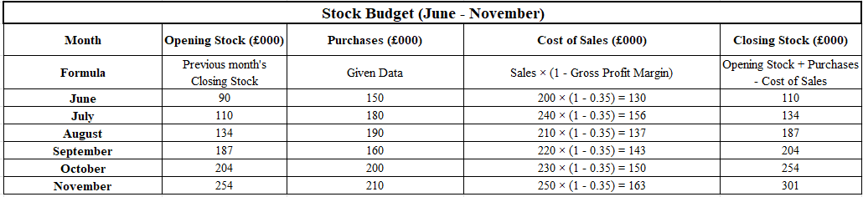
Figure 1: Stock budget
(Source: Self-Created)
The stock levels, purchases, and cost of sales are projected from the stock budget for June to November. The opening stock begins at £90,000 in June. During the month, the company spent £150,000 on stock. By applying a 35% gross profit margin, we can determine the cost of sales as £130,000 (i.e., £200,000 x 0.65). After accounting for purchases and sales, the closing stock for June is £110,000. In July, purchases totalled £180,000, and the opening stock was £110,000. With total sales of £240,000, the cost of sales amounts to £156,000. Therefore, the closing stock increases to £134,000. Next is August, with an opening stock of £134,000 and purchases of £190,000. However, the closing stock has significantly risen to £187,000, with a cost of sales of £137,000 (Referred to Figure 1).
The moderate purchase cost is £160,000 in September with a stock of £187,000. Closing stock is £204,000 and this month’s cost of sales is £143,000. In October, purchases are up to £200,000 and the cost of sales stands at £150,000, the trend continues. As a result, a stock of £254,000 is closed. In November stock purchases surpassed £210,000, the highest figure in this period. As sales increase, the cost of sales also reaches £163,000 (Referred to Figure 1). The closing stock at the end of November totals £301,000, which shows that inventory is being steadily accumulated. The steady inventory rate addressing stable financial conditions that supports business proceeding steadily (Catalano et al., 2024). In general, the stock budget exhibits an increasing trend in stock levels with closing stock rising from £110,000 in June to £301,000 in November. This indicates purchases leading to sales, perhaps for preparation for higher demand in the coming months or perhaps a strategic inventory buildup. Between £130,000 and £163,000, the cost of sales is equal to the sales. Maintain closing stock for a company indicates unsold inventory a company retains at the end of an accounting period (Bukh et al., 2024).

2.2 Cash Budget for June to November 2025
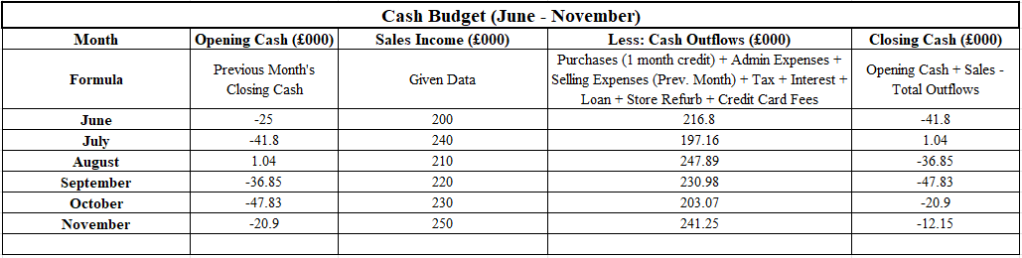
Figure 2: Cash budget
(Source: Self-Created)
The cash budget for this period from June to November is based on the company’s cash flow and follows sales income and flows of cash balance in the whole period. The June opening cash balance is -£25,000 which indicates that there is a deficit from the start. The total sales income for this month has been £200,000 but cash outflows have included the purchases, administration expenses, selling expenses, tax, interest, loan payments, store refurbishments, and credit card fees at the rate of £216,800. Banaag (2024), address diverse budgeting techniques such as cash management strategies, rational financial decision making, including cashflows maintain financial performance of company. This will arrive at closer to a £41,800 deficit in cash. In July, the company had a sales income of £240,000 (Referred to Figure 2). The business is now in a positive cash position and now has £1,040 in its cash account at the end of the month after reducing total outflows to £197,160. This makes it appear like cash management has improved or expenses have fallen off a little since June.
What’s more, the cash position was reversed in August. Sales income for the month is £210,000 and the opening cash balance is £1,040. This though small, cash outflows increase weighing to £247,890 bringing the closing balance down to -£36,850. Higher purchase costs or more operation expenses may manifest in this increase in expenses. In September, total outflows remained high at £230,980 while sales income only went up £220,000 (Referred to Figure 2). This means the company finished the month with a £47,830 deficit in its pocket, which suggests more financial strain.
The total cash outflows are down to £203,070 as sales increased to £230,000 in October. Since the company can reduce its expenses thereby reducing a cash deficit of -£20,900 at the end of the month cash recovery is a positive trend. Kostanyan and Harutyunyan, (2024), stated that positive trends in cash flow statements are indicates good financial health for a company that supports in business management process.
By November sales income was £250,000, the highest in the period. However, cash flow has improved, but only up to £241,250 outflows. At the end of the period, it remained in deficit at -£12,150, but recovery is occurring more gradually than in the nearest months. In sum, the cash budget reveals financial stability that increasingly fluctuates despite strong growth in sales. Outflows are too high for the company and they consistently exceed income in several months. Changing pattern in outflows may create challenges for company to maintain its stable financial health (Amalia et al., 2024). Although things picked up in July and October, there is potential for financial recovery if some expenses are curbed. Progress entails a better trend towards a lower cash deficit by November, though additional measures may be required to get the cash position back to at least a stable positive position.

2.3 Budgeted Profit & Loss Account balance sheet (Six-Month Overview)
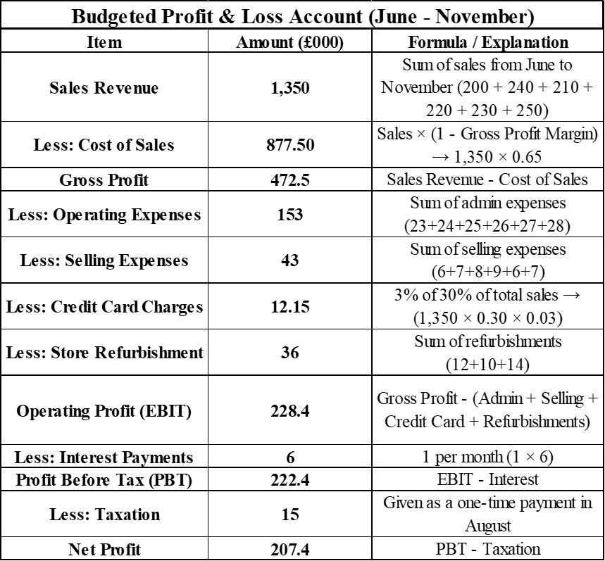
Figure 3: Budgeted balance sheet of Profit & Loss Account
(Source: Self-Created)
The Profit & Loss account for June to November is very detailed and that is a projection of the financial performance. The monthly sales figures indicate that the company expects total sales revenue of £1,350,000 based on the above figures in June £200,000, July £240,000, August £210,000, September £220,000, October £230,000 and November £250,000 (Referred to Figure 3). If this applies to a gross profit margin of 35 then, 65 percent of sales revenue is the direct cost of sales. As a result, the total cost of sales comes up to £877,500 (£ 1,350,000 ÷ 0.65). Therefore, the company’s Gross profit is £472,500 (£1,350,000 - £877,500), profit before the expense of operation. Stable Gross profit indicates company operating in a positive environment that supports business of company, for that reason maintain a good gross profit is essential (Azka and Aisyah 2024).
Administrative costs, selling expenses, credit card charges, and store refurbishing expenses are part of operating expenses. Total administrative expenses over the six months amount to £153,000, which includes each monthly expense added together (£23,000 in June, £24,000 in July, £25,000 in August, £26,000 in September, £27,000 in October, and £28,000 in November). The total sales expenses are £43,000, with costs in June of £6,000, £7,000 in July, £8,000 in August, £9,000 in September, £6,000 in October, and £7,000 in November. This estimated credit card charges at £12,150 as 3% of 30% of (total sales revenue – £1,350,000 × 0.30 × 0.03). Furthermore, store refurbishment cost is £36,000 as £12,000 in June, £10,000 in September and £14,000 in November (Referred to Figure 3).
Operating profit (EBIT) is £228,400 (£472,500 less the deduction of all operating expenses: £153,000, £43,000, £12,150, and £36,000). Total interest payments during the period amount to £6,000, paid at £1,000 per month. After accounting for interest, the profit before tax is £222,400 (£228,400 - £6,000). Only the one-time tax payments of 15000 were deducted in August, resulting in a net profit of 207400. All these effective methods represent the final profit available after all expenses and taxes have been accounted for. The overall budget [profit and loss account] reflects strong financial performance, demonstrating solid profit margins that have effectively controlled operating expenses. The total net profit of 207400 indicates healthy profitability, despite some significant outflows for store refurbishments and tax payments. The company's financial health has remained stable, supported by consistent revenue growth that enhances overall profitability.

3. Financial Challenges and Management Strategies
Blue Thread Ltd is facing some very critical financial situations which require immediate management interventions. The whole calculation indicates several challenges, including cash flow shortages, high stock levels increasing debt obligations, and extensive capital expenditures. While the entire company remains profitable these issues pose the most significant risk to its liquidity and overall financial stability. This report analyses the key methods of financial concerns and provides some strategic management actions to mitigate these risks.

a. Cash flow problems and overdraft reductions
Issues:
Blue Thread Ltd began June with a 25000 overdraft and the entire bank has requested that all of these will be eliminated by the end of November. However, despite showing a net profit of 166350 the company cash flow does not necessarily reflect the profitability due to high stock purchases and some effective methods of cost and repayment obligations. The timing of payments and receipts plays a crucial role in the company's liquidity position.
Analysis:
- Stock purchases consume a colossal amount of cash per month, £181,667 per month on average (£1,090,000 stock purchases over the past six months).
- Further building up cash flow is the cost of the store refurbishments in June, July and August - £36 000.
- £4,000 is repaid to the bank every month of which £1,000 is seen as interest, which results in withdrawing £24,000 from available liquidity over a six-month period.
- High purchases in November tie December’s cash flow too close to the ground, making it difficult for so in paying for stock, which the business pays for one month after purchase.
Management Actions:
- Rather than paying off the overdraft by November, management should try and negotiate an Extended Overdraft Repayment Plan, by which the bank will be able to extend the repayment date (Abu Huson et al., 2024).
- Delay or Scale Down Refurbishments – Delaying non-essential refurbishments until the latter part of 2016 would enhance cash liquidity (Hrytsenko, 2024).
- Reduce the Cash Held in Stock – By moving proportionally smaller stock levels but just above the minimum required (£40,000 instead of purchasing enough to pay back a huge overdraft), cash would be freed up (Moosa et al., 2024).

b. Excessive Stock Purchases and Inventory Management
Issue:
The company wants that the stock does not lag below £40,000 but on 1st June it has £90,000 in stock and continues buying large quantities of stock each month. It ties up cash in inventory that could otherwise be employed elsewhere.
Analysis:
- Losses might be due to poor forecasts or inefficient inventory turnover.
- Due to a gross profit margin of 35%, purchases should match actual demand. It leads to excessive buying further causing stock build, storage, and loss due to unsold inventory.
Management Actions:
1. Analyse sales trends to match stock purchases with actual sales performance and purchasing above necessary levels.
2. Extend Payment Terms with your Suppliers – With the payment terms provided by the suppliers extending past 1 month, this cash flow pressure would be reduced (Ranjan, 2025).

c. High credit card charges and sales policy adjustments
Issue:
Since 30% of the sales are through credit cards and a 3% processing fee applies Blue Thread Ltd loses a significant portion of revenue to transaction fees.
Analysis:
- Over six months the credit card fees amount to 12150
- These charges while necessary for customers' convenience reduced some net cash inflows and impacted profitability.
Management actions:
Encourage cash and debit card payments: offering incentives like small discounts for cash payments which can reduce credit card usage (Akinwande et al., 2024).
Renegotiate credit card processing fees: some of the providers offer some lower fees for bulk transactions.
Introduced loyalty programs: encouraging new forms of customers with some exclusive discounts or reward points which can increase direct sales (Akinwande et al., 2024).

d. Loan repayments
Issues:
The entire company has paid 4000 per month towards its loan through which 1000 (25%) is interest. Over six months 6000 is lost to interest payments loans.
Analysis:
- The high-interest components have reduced funds that are available for operations.
- The entire company could benefit from refinancing options to some lower monthly payments or secure a lower interest rate.
Management actions:
Refinance the loan: negotiating some lower interest rates or extending repayment terms can ease monthly cash flow pressure.
Make extra loan payments: if the whole surplus cash becomes available, reducing the loan principal faster would decrease the total interest paid over time.

e. Rising operating expenses and cost control
Issue:
Blue Thread Ltd administrations and selling expenses have continued to rise with total admin expanses of 195000 and selling expenses of 42000 for six months.
Analysis:
- All of the costs of admin have increased each month mainly due to salaries, utilities, and other fixed costs.
- Selling expenses vary but are significant especially when combined with credit card fees.
Management actions:
Implement cost-cutting measures: reviewing some unnecessary administrative costs and reducing overheads where possible (Bartik et al., 2024).
Optimise marketing spend: if selling expenses include advertising, focusing on cost-effective digital marketing strategies could yield better results.

4. Budgeting and Budgetary Control in Organisations
Financial management for all organisations includes budgeting and budgetary control, which are vital to get the organisation to allocate resources wisely, monitor performance, and attain its strategic goals.

4.1 Essential Conditions for Effective Budgeting and Budgetary Control
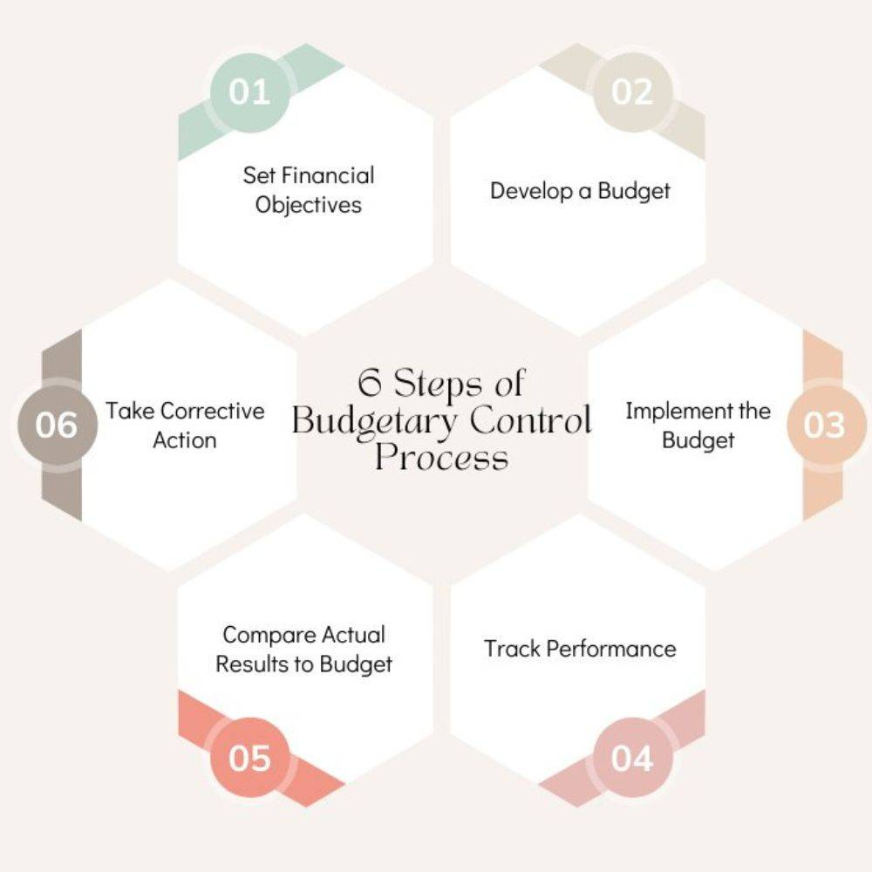
Figure 4: Budgetary Control
(Source: Aggarwal, 2020)
A budgeting system must be effective for an organisation; thus, there are several key conditions which must be met in any organisation (‌Drury, 2021).
1. Clear Organisational Objectives
Budgeting needs to be in line with the overall strategic objectives of the organisation (Refer to Figure 4). In the case of Blue Thread Ltd, the core aim for the end of November is to reduce the £25,000 overdraft. This goal should be supported by all decision-making regarding budgeting, including cost control, stocking or revenue generation.
2. Accurate and Reliable Data
Budgeting requires historical data, market trends and financial forecasts (Gibbs et al., 2025). The sales and expense figures given to Blue Thread Ltd enable them to build realistic budgets. Despite that, forecasting inaccuracies may cause mismanagement of the financial aspect. For instance, if the sales income (e.g. projected £250,000 in November) is overinflated for the sales with no allowance made to market conditions, then there would be a cash flow shortfalls.
3. Participation and Commitment from All Levels
Successful budgeting is a process that involves the department head, finance team and operational managers. Employee buy-in guarantees realistic and achievable budgets. This lack of involvement in budgeting may lead the store managers of Blue Thread Ltd to have less motivation to control expenses or increase sales performance.
4. Effective Communication and Training
It should be known to employees what budgeting decisions affect their role. If the objective of Blue Thread Ltd is to lower the amount of the admin expenses that shall be made available, then the staff has to be informed of the cost-cutting measures (Erickson, 2021). By training employees regularly on financial literacy, they will be able to contribute to the budgetary control effectively.
5. Flexibility and Adaptability
Unforeseen change may not fit in with rigid budgets; for example, if economics go down or supply chain disrupts. In the case of Blue Thread Ltd, this firm should use a flexible budgeting technique to adjust stock purchases or store refurbishment plans when required.

4.2 The Role of Budgeting in Strategic Planning and Performance Measurement
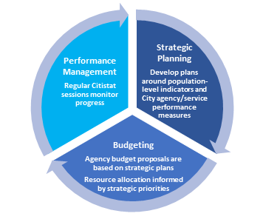
Figure 5: Role of Budgeting in Strategic Planning
(Source: Schmidt, 2023)
Budgeting is a fundamental planning and measuring of financial performance instruments.
1. Planning for Financial Stability
Planning its financial activities, rather than eliminating its overdraft, is what the budgeting process allows Blue Thread Ltd. The cash budget facilitates the forecasting of cash inflows and outflows and aids the company in the recovery of its liquidity (Costa-Agmon and Gendel-Guterman, 2025). On the other hand, the company can control stock purchases (GBP 1.190.000 over the six months), which should be aligned with expected sales (GBP 1.350.000) so that the positive cash flow occurs.
2. Performance Benchmarking and Variance Analysis
The entry clause was that of budgetary control for the comparison of the results between the actual ones and the budgeted figures (Refer to Figure 5). Variance analysis can help explain the cause of sales shortfall when Blue Thread Ltd budgets £230,000 in sales for October and ends up with only £200,000, possibly due to lower demand, supply chain issues or marketing inefficiency.
3. Resource Allocation and Cost Management
Budgets help in spending resources in priority areas for an organisation. Such is the budget availability for refurbishment (£36,000 across June, July and August) that it should not reduce working capital when compared (‌Seixas et al., 2021). And sold expenses are to be watched as they are paid out in the next month, and it’s a factor of cash flow management.
4. Facilitating Decision-Making
A budget is a financial base to make a decision. For instance, the stock level on the opening of June is £90,000, but the minimum required level is £40,000, so the company must decide what to do with purchasing plans. A good budget is structured in a way that facilitates the making of data-oriented decisions that are consistent with financial targets.

4.3 Behavioural Considerations in Budgeting Systems
Human behaviour is significantly involved in the effectiveness of a budgeting system. However, if budgetary controls are going to be implemented at Blue Thread Ltd, the following behavioural aspects need to be addressed.
1. Goal Congruence and Employee Motivation
As the link between budgeting targets and the role is not seen by employees, they will not understand monetary value and the resources required (Umo, 2022). Sales will not care to get higher sales if sales staff do not know that raising the sales is critical to eliminating the overdraft. Motivation to hit budget goals can be improved by setting targets that are achievable yet challenging and providing incentives for meeting budget goals.
2. Budgetary Slack and Gaming the System
A phenomenon that happens in the budgetary slack is that managers may intentionally under or over-estimate revenues and costs, respectively, to make their budget target easier to achieve (‌Santos et al., 2022). For instance, a store manager of Blue Thread Ltd. who would overstate stock purchase needs to get more inventory and squeese cash flow.
3. Resistance to Change and Budgetary Stress
New budgeting processes may be resisted by employees if they feel they are restrictive or unrealistic (Aragão and Fontana, 2021). This can be observed in the example of cutting the administrative expenses that may cause dissatisfaction among the office staff. Resisting change can be addressed by issues and create less stress if employees have open communication and are involved in budgeting decisions.
4. Short-Term vs. Long-Term Focus
A budget should balance the short term, controlling the finances, with the long term, strategic growth. Blue Thread Ltd does not want to have an overdraft, but if the company just cuts costs to get rid of the overdraft, it may simply ignore investments in marketing and store improvements that will make it long-term profitable. It deals with the sustainability of financial health.
There are four elements to be addressed when budgeting and budgetary control is effective: clear objectives, reliable data, employee involvement, and a measure of flexibility.

5. Evaluation of Traditional Budgeting Methods
Budgeting is a financial management tool that has both advantages and disadvantages and is necessary to any operation of a business (Iacuzzi, 2021). Nevertheless, traditional budgeting methods, those of incremental budgeting and the annual budget model, are being routinely criticised for their inadequacy in a fast-changing business world.

5.1 Overview of Traditional Budgeting Approaches
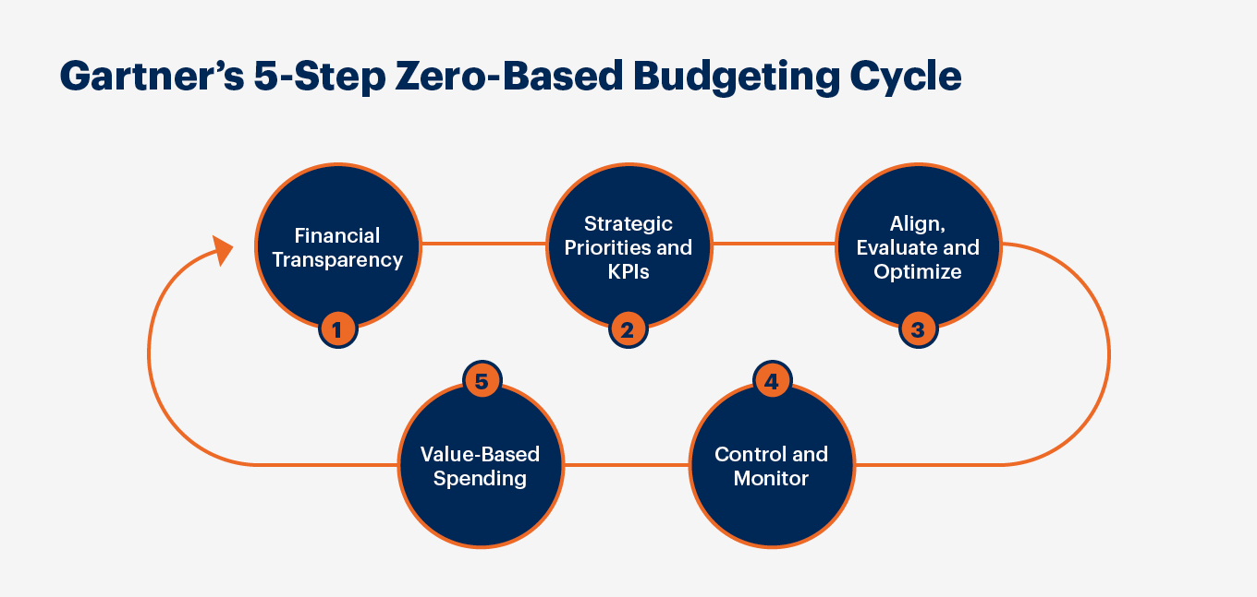
Figure 6: Zero-Based Budgeting (ZBB)
(Source: Gartner, 2025)
There are commonly traditional methods of budgeting financial resources in an organisation. The key approaches include:
Incremental Budgeting
The most commonly used approach is incremental budgeting, where the current budget is incremented with some percentage of the past financial performance (‌Ortynsky et al., 2021). For instance, the administrative expenses of Blue Thread Ltd increase from £22,000 in May to £28,000 in November, then an incremental budgeting system of adjusting these costs may rely on a fixed percentage increase. The advantage of this method is its simplicity; however, it is a not very flexible method.
Zero-Based Budgeting (ZBB)
Zero-based budgeting demands that all expenses need to be justified from a zero base. In contrast to incremental budgeting, ZBB does not assume that past budgets are a reference point (Allen and Clifton, 2023). ZBB is more rigorous but time-consuming and resource-intensive (Refer to Figure 6).
Beyond Budgeting
A modern approach that goes beyond budgeting is one where the notion of a fixed budget is eliminated and replaced by rolling forecasts and flexible allocation of resources (Bhimani et al., 2024). This one focuses more on decentralisation and real-time adjustment of the financial to meet the company changes.

5.2 Weaknesses of Traditional Budgeting in a Dynamic Business Environment
Lack of Flexibility
Incremental budgeting is based on the presupposition of a stable business environment. For example, Blue Thread Ltd.’s sales revenue fluctuates significantly over six months. An inflexible budget cannot accommodate unforeseen changes in the market, such as fluctuations in the consumer demand or chain of supply market disruptions.
Incentivises Dysfunctional Behaviours
There are a lot of gaming behaviours in budgets, such as managers manipulating figures to achieve budgeted targets (Mohr and Kearney, 2021). For example, departments may spend "use it or lose it" on purchasing items near the end of a budget cycle to avoid losing money, hence wasting money. However, managers may also shorten revenue forecasts or inflate costs because they want to meet budgetary expectations easily.
Limited Strategic Alignment
Traditionally, money budgets do not relate to the purpose of the organisation related to broader strategic goals but rather to operational expenses. In comparison to Dynamic Decision Support, it does not provide sufficient support in dynamic decision-making and therefore outperforms in industries that require little adaptability, like technology, retail, and e-commerce.
Inability to Respond to Market Changes
The retail clothing industry is a competitive one, and the consumer's preference changes quickly. Traditional budgeting does not allow for fast adaptation in the process of financial planning (de Zarzà et al., 2024). For example, if a company suddenly finds itself with excess demand for its line of clothing, it may have a hard time reallocating funds as it should.
Time-Consuming Process
Traditional budgets are difficult to create and monitor. According to incremental budgeting, the finance managers may spend more time adjusting historic data rather than taking part in strategic decision making.

5.3 Alternative Budgeting Methods for Enhanced Financial Performance
Rolling Forecasts
The rolling forecasts involve creating budgets, making them live, and updating budgets from actual performance and market trends (Bhimani et al., 2024). Unlike, the company does not set up a fixed annual budget instead, but they can change their financial plans every quarter or month. This method enables the company to respond more effectively to operations in response to fluctuations in the sales revenue.
Activity-Based Budgeting (ABB)
ABB allocates funds according to business activities rather than historical spending patterns (Amin and Nengzih, 2021). A better aid could analyse, for example, which operational areas generate the most revenue and, therefore, should be allocated resources.
Forecast-Based Budgeting
Forecast-based Budgeting does not rely on a static budget as much as the real-time financial data and predictive analytics that is used. In the modern time, companies are using rolling forecasts for the preparation of the financial plans dynamically, offering a better foresight of market trends and risks.
Beyond Budgeting for Strategic Agility
The focus of beyond budgeting is on distributed, bottom-up decision-making and real-time financial management (Ramlall and Grobbelaar, 2024). The centralised fixed budget could promote store managers to have more autonomy to change the budget at a company so that budgets can be changed in line with local sales trends.
Zero-Based Budgeting for Cost Control
Although ZBB is difficult, it will aid the operation and control fixed costs. It allows the company to evaluate the need of every cost that is to be incurred by the company so that they can identify the inefficient expenditure incurred on administrative as well as selling expenses and channelise the funds being utilised in high-priority areas.

6. Conclusion and Recommendations
Blue Thread Ltd faces several financial challenges as outlined in the budgeting analysis. Liquidity issues are also found; the company initially has an overdraft to the value of £25,000 and bad cash flow. Adding to this is high stock purchases and refurbishment of stores. Administrative and selling expenses, however, are fixed while sales revenue does not change properly. They can further reduce profit margins with the use of credit card processing fees (3%), and loan repayment obligation limits financial flexibility. At the same time, the company needs to work hard to balance stock levels and make sure that money is available to eradicate the bank overdraft by November.
Blue Thread Ltd should optimise its stock purchasing strategy or reduce excessive inventory and buying stock whenever the sales tend to spike to improve its financial stability. The company might leverage extended credit terms with suppliers to alleviate cash flow problems. Profitability could be improved through the implementation of cost-cutting measures, such as on administrative and selling outlays. The company must be reluctant to do non-essential refurbishments. Reducing reliance on credit card transactions may be achieved through offering discounts for immediate payments and a surge in cash sales to reduce fees when processing the credit cards. There is no doubt that for financial control and strategic planning, a good budgeting system is very important. Therefore, to adapt to a volatile market, Blue Thread Ltd should implement dynamic budgeting like rolling or zero-based budgeting.

7. References
Abu Huson, Y., Aljawarneh, N.M., Obeidat, A.M. and Alqudah, M., (2024). ‘Insights into corporate tax evasion and its ramifications on overall budget revenue: An empirical study’. In The AI revolution: Driving business innovation and research: Volume 2 (pp. 107-122). Cham: Springer Nature Switzerland. Available at: doi: 10.20944/preprints202403.0404.v2
Aggarwal, C. (2020). Budgetary Control: Steps, Objectives, and Advantages. Available at: https://www.shiksha.com/online-courses/articles/budgetary-control-steps-objectives-and-advantages/. (Accessed: 1st March 2025)
Akinwande, M., Lopez, A., Yusuf, T., Unuriode, A., Yusuf, B., Yussuph, T. and Okoro, S., (2024). ‘Data analysis on credit card debt: Rate of consumption and impact on individuals and the US economy’. arXiv preprint arXiv:2407.11146. Available at: https://doi.org/10.5121/csit.2024.140401
Allen, R. and Clifton, R., (2024) 'From zero-base budgeting to spending review–achievements and challenges,’ Development Southern Africa, 41(5), pp.849-865. Available at: https://doi.org/10.1080/0376835X.2023.2226164
Amalia, M.M. and Siahaan, D.L., (2024). ‘Cash Receipts and Disbursements Accounting Information System at an Education Center’. Indonesian Journal of Sustainability Policy and Technology, 2(2), pp.78-90. Available at: https://doi.org/10.61656/ijospat.v2i2.233
Amin, M.N. and Nengzih, N., (2021) 'Proposed application of the use of Activity-Based Budgeting (ABB) method for cost control of daily and casual workers (A case study at PT XYZ),’ 'Saudi J. Econ. Fin, 5(9), pp.411-420. Available at: https://doi.org/‌10.36348/sjef.2021.v05i09.007
Aragão, J.P.S. and Fontana, M.E., (2022) 'Outsourcing strategies in public services under budgetary constraints: analysing perceptions of public managers,’ Public Organization Review, 22(1), pp.61-77. Available at: https://doi.org/10.1007/s11115-021-00517-5.
Azka, A.F. and Aisyah, N., (2024). ‘ERPNext for Effective Budgeting: Overcoming Project Financial Management Challenges in System Integrator Company’. Adpebi Science Series, 1(1). Available at: https://adpebipublishing.com/index.php/AICMEST/article/download/371/149
Banaag, F., (2024). ‘Predicting business performance: The role of budgeting techniques, cash management strategies and rational financial decision making’. International Journal of Business and Management (IJBM), 3(2), pp.16-36. Available at: https://iessociety.org/index.php/IJBM/article/download/45/22
Bartik, A.W., Rhodes, E., Broockman, D.E., Krause, P.K., Miller, S. and Vivalt, E., (2024). ‘The impact of unconditional cash transfers on consumption and household balance sheets: Experimental evidence from two US states (No. w32784)’. National Bureau of Economic Research. Available at: https://www.nber.org/system/files/working_papers/w32784/w32784.pdf
Bhimani, A., Sivabalan, P., Soonawalla, K. and Wakefield, J., (2024) 'Annual budgets and rolling budgets use in UK and Australian firms,’ Journal of Management Control, 35(4), pp.509-561. Available at: https://doi.org/10.1007/s00187-024-00382-5.
Bukh, P.N., Ringgaard, A. and Sandalgaard, N., (2024). ‘Moving beyond Budgeting: A case study of the dynamic interrelationships between budgets and forecasts’. European Accounting Review, pp.1-27. Available at: https://www.tandfonline.com/doi/pdf/10.1080/09638180.2024.2362681
Catalano, F., Nasello, L. and Guterding, D., (2024). ‘Quantum computing approach to realistic ESG-friendly stock portfolios’. Risks, 12(4), p.66. Available at: https://doi.org/10.3390/risks12040066
Costa-Agmon, O. and Gendel-Guterman, H., (2025) 'Life in Perpetual Overdraft: Are Poor Households Doomed to Always be in Debt?,’ Journal of Family and Economic Issues, pp.1-11. Available at: https://doi.org/10.1007/s10834-024-10013-9.
De Zarzà, I., de Curtò, J., Roig, G. and Calafate, C.T. (2024) 'Optimized Financial Planning: Integrating Individual and Cooperative Budgeting Models with LLM Recommendations,’ AI, 5(1), pp.91–114. Available at: https://doi.org/10.3390/ai5010006.
‌Drury, C. (2021) Management and Cost Accounting, (Eleventh Edition), London: Prentice Hall
Erickson, S. (2021) 'Communication in a Crisis and the Importance of Authenticity and Transparency,’ Journal of Library Administration, 61(4), pp.476–483. Available at: https://doi.org/10.1080/01930826.2021.1906556.
Gartner. (2025). Zero-Based Budgeting for Non-Finance Executives. Available at: https://www.gartner.com/smarterwithgartner/use-zero-based-budgeting-to-rightsize-tight-budgets (Accessed: 1st March 2025)
Gibbs, R., Carr, M., Mulcahy, M. and Walshe, D., (2025) 'Planning for business cycle fluctuations in budgeting: The application of innovative data sources and techniques,’ The British Accounting Review, p.101576. Available at: https://doi.org/10.1016/j.bar.2025.101576
Iacuzzi, S. (2021) 'An appraisal of financial indicators for local government: a structured literature review,’ Journal of Public Budgeting, Accounting & Financial Management, ahead-of-print(ahead-of-print) 'Available at: https://doi.org/10.1108/jpbafm-04-2021-0064.
Kostanyan, G. and Harutyunyan, G., (2024). ‘Observations on the statement of cash flows’. Economics, Finance and Accounting, 1(13), pp.75-75. Available at: https://doi.org/10.59503/29538009-2024.1.13-75
Krushinska, A.V., Samaricheva, T.A., Arziantseva, D.A., Zakharkevych, N.P. and Hrytsenko, O.M., (2024), ‘December. Concession as a tool for improving the budget and tax incentives for investment attractiveness of the tourist complex in Ukraine’. In IOP Conference Series: Earth and Environmental Science (Vol. 1415, No. 1, p. 012106). IOP Publishing. Available at: doi:10.1088/1755-1315/1415/1/012106
Mohr, Z. and Kearney, L. (2021) 'Behavioral-Experimental Public Budgeting and Financial Management: A Review of Experimental Studies in the Field,’ Public finance and management, 20(1), pp.11–44. Available at: https://doi.org/10.1177/152397212102000102.
Moosa, I.A., Al-Saad, K. and Khatatbeh, I.N., (2024). ‘The quantity theory of money, quantitative easing and the missing inflation phenomenon’. Journal of Central Banking Theory and Practice, 13(2), pp.71-88. Available at: DOI: 10.2478/jcbtp-2024-0013
‌Ortynsky, S., Marshall, J. and Mou, H., (2021) 'Budget practices in Canada's K‐12 education sector: Incremental, performance, or productivity budgeting?,’ Canadian Public Administration, 64(1), pp.74-98. Available at: https://doi.org/10.1111/capa.12402.
Ramlall, R. and Grobbelaar, S., (2024) 'Deficiencies in the traditional budgeting process cause the negative behaviour of budgetary slacking,’ South African Journal of Business Management, 55(1), p.4348. Available at: https://doi.org/10.4102/sajbm.v55i1.4348.
Ranjan, R., (2025). ‘Behavioural Finance in Banking and Management: A Study on the Trends and Challenges in the Banking Industry’. Asian Journal of Economics, Business and Accounting, 25(1), pp.374-386. Available at: https://doi.org/10.9734/ajeba/2025/v25i11657
‌Santos, V.D., Beuren, I.M. and Skrepitz, S., (2022) 'Influence of budgetary slack and elements of the budgetary process on perceptions of justice,’ Revista Contabilidade & Finanças, 33, pp.200-215. Available at: https://doi.org/10.1590/1808-057x202113780
Schmidt, J. (2023). Budgeting. Available at: https://corporatefinanceinstitute.com/resources/fpa/budgeting/. (Accessed: 1st March 2025)
‌Seixas, B.V., Dionne, F. and Mitton, C., (2021) 'Practices of decision making in priority setting and resource allocation: a scoping review and narrative synthesis of existing frameworks,’ Health Economics Review, 11, pp.1-11. Available at: https://doi.org/10.1186/s13561-020-00300-0.
Umo, U.P. (2022) 'Goal Internalization: An Innovative Management Strategy for Budgetary performance in 21st Century Firms of Developing Economies,’ European Journal of Business and Management Research, 7(3), pp.194–199. Available at: https://doi.org/10.24018/ejbmr.2022.7.3.1048.

‌
‌

Bibliography
Seal, W., Garrison, R.H, and Noreen, E. (2018), Management Accounting, (Sixth Edition), UK: McGraw Hill
Horner, D. (2020), Accounting for Non Accountants, (Twelfth Edition), London; Kogan Press
Kolitz, D. (2017), Financial Accounting – A Concepts-based Introduction, Oxon: Routledge
Marr, B. (2013), Key Performance Indicators (KPI), Harlow: Pearson
Walsh, C. (2008), Key Management Ratios, (Fourth Edition), UK: Prentice Hall
Atrill, P. and McLaney, E. (2021), Management Accounting for Decision Makers, (Tenth Edition), Harlow: Pearson Education Limited
Atrill, P. and McLaney, E (2018) Accounting and Finance for Non-Specialists, (Eleventh Edition), Harlow: Pearson Education Limited
Bhimani, A. (Ed) (2006), Contemporary Issues in Management Accounting, Oxford: Oxford University Press
Datar, S.M and Rajan, M.V. (2017), Horgren’s Cost Accounting, A Managerial Emphasis – Global Edition, (Eleventh Edition), London: Pearson
Dyson, J. R. (2020), Accounting for Non Accounting Students, (Tenth Edition), London: Pearson

