

WASTE MANAGEMENT AT UK MOD ALDERGROVE FLYING STATION CAMP

MSc LOGISTICS

AKWASI KWAKYE

Faculty of Architecture Computing and Engineering

April 2019

DECLARATION

I, Akwasi Kwakye declare as the sole author of this research. All references cited have been well consulted. I have conducted all work necessary for this study of which this is a record, and I declare that the finished work lies within the prescribed the UK academic standard.

This has not previously been accepted as part of any other submission.

Signature: …………………….……. Date: ……………………
AKWASI KWAKYE
P146938

FORM OF CONSENT

I, Akwasi Kwakye hereby consent that my study, submitted in candidature for the Masters in Logistic of School of Engineering Faculty, if successful, it may be made available for inter-library loan or photocopying (subject to the law of copyright) and that the title and abstract may be made available to outside organisations.

Signature: …………………….……. Date……………………………
AKWASI KWAKYE
P146938

ACKNOWLEDGEMENT

I would like to use this opportunity to extend my heartfelt appreciation to several people who in diverse ways generously contributed, inspired and supported me towards the successful completion of the study. There is no way I could have ever completed this work without their invaluable support.
Firstly, I am grateful to the Almighty God for making it possible for me to complete this study and to accomplish my aim at the UNIVERSITY OF WALES TRINITY SAINT DAVID (UWSTD). I also, wish to express my sincere appreciation to the UK MOD (Education Fund) for sponsoring 80% on my MSc Funding. My third honest gratitude goes to my Supervisor, Mr. Andrew Thon (MSc in Engineering, PGDip, BSc in Engineering) of the Faculty of Architecture, Computing and Engineering for his patience, guidance, useful and constructive feedback which led to the success of this work.
To all the respondents, friends and everyone who contributed in any way toward the success of this study, I say a very big thank you.
Finally, I like to express my profound gratitude to my family, especially my wife Mrs. Evelyn Kwakye for the unwavering moral and emotional support throughout this research. I couldn’t have done it without you.

EXECUTIVE SUMMARY
This research was conducted on Ministry of Defence (MOD) Aldergrove Flying Station based in Northern Ireland. Due to Aldergrove daily operational activities (Aircraft Engineering), waste management on station has being of a question for the researcher. The Researcher studied how wastes at the Station are being managed like food waste, papers waste, cardboard waste, metal waste, wood waste, oil waste etc. Furthermore, the study tested whether the researcher Hypothesis statement is be Accepted or to be Rejected by the sample population feedback (data collected) that’s: H₀: Aldergrove Flying Station does not manage its waste effectively? H₀a: Aldergrove Flying Station manages its waste effectively?
The study also researched into other secondary data sources for waste management reports across industries from UK environmental waste management report, waste pyramid concept, recycle waste and energy, EU waste regulations, food waste, plastic waste, MOD Strategy on waste management, merit and demerit on waste management etc.
For Primary data, the study administrated 150 surveys to 5 Regt AAC (sample population), conduct semi-structured interviews with three Aldergrove waste expertise. They are Station Recycle Deputy Manager (Mr. Paddy Lynn), Quartermaster (Maj. John Linegar) and Catering Manager (Sgt. Daryl Patterson). The researcher conducted Field Experiment on three nominated outside Metal Bins for a period of 3 months. Methodologically, the study applied quantitative and qualitative research approached to interrupt all data collected. Its utilised Chi square, T-test and P-Test for data analysis.
Conclusion, the results produced by the data analysis and other interviewees opinion suggested or proved to ACCEPT the H_{Oa} and REJECT H_{o}. Meaning, Aldergrove Flying Station manages its waste effectively. The study also made some significant findings from its. Like: The study also found that waste management processes are not always cheaper as previously thought. Actually, the process sometimes needs huge funds, time and land to set up a plant, not forgetting operational costs. The study revealed that recycled products have a shorter lifespan than unrecycled products. More so, the research found that more than 80% of the Aldergrove workforce falls within the youthful age groups, thus between 18-40 years. This demonstrates that, there is a higher youthful workforce at Aldergrove Camp. It was revealed that respondents to this were dominated by male (¾) than female (¼)proving the imbalance of gender equality within the UK MOD recruitment paradigm. It was also found that the study engaged with mix of personal where by 57.5% were Junior Non-Commissioned Officer (JNCO), 22.5% were Senior Non-Commissioned Officer (SNCO), 8.8% were Commissioned Officers and 11.3% were Civil Servant/Contractors. The study proved that There is no significant difference between males and females in finding mix of recycle and non-recycle waste in their office bins. As Pearson Chi-square test result was (x= 0.741, p=0.389, df=1) because the probability value (P Value) 0.389 > 0.05 (Alpha Value). The study revealed that Aldergrove’s total waste produced from January 2018 to April 2018 was 395.378t. which amounted to £50,829.38 see Table 4.6 and its landfill tax incurring per month reduced from £608 to £560.88. Major Linegar a member of Aldergrove waste management committee scored Aldergrove waste management effectiveness at 7/10, accepting that there are 3/10 as rooms for improvement due to lack of proper industrial bin lid that sometime cause aviation FOD and etc. Finally, the research made ten profound recommendations to the study beneficiaries (Aldergrove Barracks).

List of Contents: Pages
Chapter One: Introduction 13
1.1 The Background To The Study. 13
1.1.1 Background In General. 13
1.1.2 Background In Detail (Mod). 14
1.2 The Rationale Of The Study. 16
1.3 The Objectives Of The Study 16
1.4 Hypothesis To Be Tested. 17
1.5 The Scope Of The Study. 17
1.6 Methodology. 17
1.7 Beneficiaries Of The Study. 18
1.8 Organisation Or Layout Of The Study. 18
Chapter Two: Review Of Literature 19
2.1 Introduction. 19
2.3 Definition Of Waste And Waste Management. 21
2.4 The Classification Of Waste. 22
2.5 The Waste Hierarchy. 23
2.5.1 Application Of The Waste Hierarchy. 25
2.5.1.1 Stages 1: Prevention 26
2.5.1.2 Stages 2: Preparing For Reuse. 27
2.5.1.3 Stages 3: Recycling 30
2.5.1.4 Stages 4: Other Recovery 32
2.5.1.5 Stages 5: Disposal 34
2.6 The Disposal Waste And Their Decomposition. 35
2.7 The Waste Management (Disposal) Legislations. 36
2.8 The General Food Waste. 37
2.9 The Aim Of Electrical Waste Directive. 40
2.10 The Uk Deposit Return Scheme (DRs). 40
2.11 The Uk Mod Waste Management Sustainable Strategy. 41
2.12 The Benefits (Advantages) And Disadvantages Of Waste Management. See Appendix K. 43
2.12.1 The Benefits (Advantages) Of Waste Management. 43
2.12.2 The Disadvantages Of Waste Management. 46
2.13 Conclusion 47
Chapter Three: Research Methodology 48
3.1 Introduction. 48
3.2 Research Methodology Philosophy. 49
3.3 Quantitative And Qualitative Techniques. 50
3.5 The Sample Of The Study. 52
3.7 The Source Of Data. 53
3.8 Primary And Secondary Research. 53
3.8.1 Advantages Of A Primary Data. 53
3.8.2 Disadvantages Of A Primary Data. 53
3.8.3 The Study Primary Data. 54
3.9.1 The Secondary Data. 57
3.9.2 Advantages Of Secondary Data. 57
3.9.3 Disadvantages Of Secondary Data. 58
Chapter 4: Analysis And Interpretation Of Data / Results 59
4.1 Introduction 59
4.2 Analysis And Presentation Data Tools. 60
4.2.1 Reliability And Validity Before (Data Analysis). 60
4.2.2 Question One: Respondents Analysis By Age. 61
4.2.4 Question Three: Rank Of The Respondents. 62
4.2.5 Question Four: Corp Of The Respondents 63
4.2.6 Question Eight: Chi-Square Test Analysis On Mix Of Recyclable & Non-Recyclable Waste Of In Office Bin Verses Gender. 63
4.2.7 Question Twelve: T-Test Analysis Of Respondents Who Attend The Mod Waste Management Brief And Correctly Dispose Waste At Work. 66
4.2.8 Question Sixteen: Analysis Of Respondents On Mod Waste Management Policy Implement Effectively At Aldergrove. 68
4.2.9 Question Eighteen: Chi-Square Test Analysis On Aldergrove Barracks Is Environmentally Focused Verse Age. 69
4.3 The Semi-Structured Interview With Aldergrove Catering Manager (Sgt. Daryl Patterson). 71
4.4 The Semi–Structured Interview With Aldergrove Recycling Deputy Manager (Mr. Paddy Lynn). 73
4.5 The Semi-Structured Interview With Major. John Linegar Quarter Master (Qms) Of Aldergrove. 76
4.6 The Field Experiment At Aldergrove Barrack From 1/02/2018-21/04/2018. 79
Chapter 5: Conclusion And Recommendations 80
5.1 Introduction. 80
5.4 Findings From A Semi-Structured Interview With The Aldergrove Catering Manager. 84
5.5 Findings From Semi-Structured Interview At Aldergrove Recycle Deputy Manager. 85
5.6 Findings From The Quarter Master On A Semi-Structured 85
5.7 Findings From The Field Experience At Aldergrove. 86
5.8 Addressing The Significant Objectives And The Hypotheses Of The Study Which Was Set In Chapter One. 87
5.9 Limitations Of The Study. 88
5.10 Recommendations Of The Study. 89

List of Figures: Pages
Figure 1: Ancient UK Waste Disposal Carrier (Horses) 21
Figure 2: Waste Classification Framework. 23
Figure 3: The Initial UK Waste Management Hierarchy. 24
Figure 4: New Waste Hierarchy 25
Figure 5: Vertical Hanging Garden. 29
Figure 6: Reuse of Newspaper Ship. 30
Figure 7: China’s Importation of Waste Record. 32
Figure 8: The Cycle of Anaerobic Digestion. 33
Figure 9: Estimated Decomposition Rates for Waste. 35
Figure 10: Food Waste of initial Global Production Lost or Wasted. 38
Figure 11: Food Losses and Waste at Consumption and Pre-Consumption Stage per Continent. 38
Figure 12: The Language of Food Waste Along the Supply Chain. 39
Figure 13: MOD Waste Pyramid Hierarchy. 42
Figure 14: Recycling Saves Energy. 45
Figure 15: Research Sequential Designs. 51
Figure 16:This Pie Chart of Respondents Age Group. 62
Figure 17: Respondents by MOD Corp Group. 63

List of Tables: Pages
1. Table 4.1: SPSS Cronbach’s Alpha Test (Validity & Reliability) for Descriptive Test (Demographic). 61
2. Table 4.2: The Output of Male’s and Female’s vs mix recycle and non-recycle waste in office bin Chi-square test. 64
3. Table 4.3a: SPSS Independent Sample T-Test on variables “waste management” and “dispose of waste correctly”. 67
4. Table 4.3b: Independent Sample Test Box. 68
5. Table 4.4: SPSS Frequency Test on Respondents who thinks that MOD Waste Management Policy is implemented affectively at Aldergrove camp. 68
6. Table 4.5a: Chi-square Test Analysis on Aldergrove Barracks is Environmentally focus verse Age. 69
7. Table 4.5b: SPSS Chi-square test on if Age influences the acknowledging that Aldergrove Barracks is environmentally friendly or focused or not. 70
8. Table 4.6 The Total Cost of Waste that goes to Landfill after Aldergrove waste recovery (Jan 2018-Apr2018). 75
9. Table 4.7: The Research one-month Field Experiment Output. 79
10. Table 4.8 Proposed Waste Management Resources and Cost Centres 90

Appendix Lists: Pages
1. Appendix A: History UK Defence spending from FY 2000 to 2017. 92
2. Appendix B: Aldergrove Barracks offices waste bins 93
3. Appendix C: Modern office Recycle Bins 93
4. Appendix D: Index of GVA over time of the Waste Management Sector and the Whole Economy in Constant Prices (CVM Measure). 94
5. Appendix E: Historical trend of methane (CH4) emissions from landfill and waste management sector, UK, 1990 – 2015 (Waste Prevention Metric). 94
6. Appendix F: DIY No-Sew Zipper cases. 95
7. Appendix G: Plastic Bottles Drip Irrigators. 95
8. Appendix H: Plastic Bottle made Birds Feeders. 96
9. APPENDIX I: The UK Exports of Scrap Materials from 2001-2015 in Tonnes and £m included is Textiles, rubber, Plastic, Paper, Copper, aluminium, Nickel, Lead, Zinc, Tin and Ferrous metals. 97
10. Appendix J: The Ten Categories of WEEE Within The 2013 WEEE Regulations. 98
11. Appendix K: Benefits and Disadvantages of Reduce, Reuse and Recycle. 99
12. Appendix L: UK Employment in Waste collection, Recycling and Reuse, ‘000s, 1998-2008. 100
13. Appendix M: Potential New Jobs from increased UK recycling (2025 compared to 2006basline2006) 101
14. Appendix N: The Research Onion Process (Saunders et’ al 2012). 101
15. Appendix O: A survey questionnaire for Aldergrove Barracks respondents. 102
16. Appendix P: A semi-structured interview questionnaire for Aldergrove Station Recycling Center manager. 107
17. Appendix Q: A semi-structured interview questionnaire for the Aldergrove Catering manager. 111
18. Appendix R: A semi-structured interview questionnaire for the Aldergrove Quarter Master (QM). 115
19. Appendix S: Field Experiment sheet for the three Aldergrove compound large waste skips. 118
Chapter 4. 20. Appendix T: Aldergrove Station Waste Statistical data for January 2018. 120
21 Appendix U: Aldergrove Station Waste Statistical data for February 2018. 121
22. Appendix V: Aldergrove Station Waste Statistical data for March 2018. 122
23. Appendix W: Aldergrove Station Waste Statistical data for April 2018. 123
24. Appendix X: SPSS DATA View of the Study questionnaire data collected board. 124

Reference: 125
Bibliography: 131

CHAPTER ONE: INTRODUCTION
This study will commence with chapter one, as its introduction which constitutes of the study Background (general and detail), Rationale of the subject, Objectives, Hypothesis, Scope, Methodology, Beneficiaries to the study and chapters organisation (arrangement).

1.1 THE BACKGROUND TO THE STUDY.

1.1.1 BACKGROUND IN GENERAL.
The making of waste is a natural result of social activities by consumers and businesses and has been throughout human history (DEFRA, 2013 p1). Burcea (2015), put forward that, prehistoric man was wandering from one end to another searching for shelter and food on the earth. These men started to hunt and fish, cooking food daily, this resulted in an accumulation of waste. These wastes increased in large quantities close to their human settlement, which gave out unpleasant smells, then they must move to different caves to avoid the unpleasant smell. Around 9000BC, there was a slow shift from a nomad lifestyle to getting organised in stable and permanent communities. Mankind developed better skills to provide and prepare food by shifting into agriculture and crafting for the purpose to improve their hunting and fishing activities (Burcea, 2015). Pitchtel (2005) said that this was the beginning of civilisation and urbanisation. As a result, the environment started becoming polluted, which affected human health and water bodies. Archaeologists have been researching the piles of litter, kitchen tools and tombs to back numerous analyses and reports of ancient settlements. William and Murphy (2001) revealed that the archaeological findings have identified certain aspects of prehistoric human diets, customs and manner to organise their settlements. These archaeologists discovered certain categories of waste were reused. For examples, broken vessels, pieces of glass and other ceramic objects, which were used for the reconstruction of walls. This proves that in prehistoric times, waste recycling and reuse activities were in existence.

1.1.2 BACKGROUND IN DETAIL (MOD).
In May 1918, Aldergrove Station was officially established and commenced its operation as a flying station in May 1925. In January 1936, the station was renamed RAF Aldergrove and operating as a Coastal Command Station for British force in World War Two (WW2). Its operation at that time was to provides air support to protect Allied shipping in the Atlantic during WW2. On 20th September 2009, the Station was handed over from the RAF to the Army Aviation Corp under the Joint Helicopter Command (JHC) (RAF Family, 2018). Currently, the Station is made up of the 321 Explosive Ordinance Disposal (EOD) Squadron, Special Reconnaissance Regiment and 5 Regiment Army Air Corp (AAC) which mainly comprises of 651 Sqn and 665 Sqn. These Aviation engineering Sqns provide maintenance for over 20 Military aircrafts including Gazelle, Islander and Defender Aircrafts used for reconnaissance intelligence support in Northern Ireland. As a result of this, Troops stationed at Aldergrove. Therefore, Aldergrove population has increased to approximately 2500 people. Consequently, it has also elevated the waste levels at camp which requires effective management.
Today, higher consumption rates in our world mean, greater levels of waste are produced, thus more waste to dispose of. And no matter how advanced society is, there will always be waste products.
Appendix (A) shows that due to this increase, the UK Ministry of Defence (MOD) spending has risen from £28 billion in 2002 to £45 billion in 2011.
Due to continued MOD operations, it is necessary that day to day waste is considered and properly managed. Kimberleo (2017) revealed that we now live in a world where everything is considered disposable. Merely, He defined wastes disposal as
“… the process of collecting and removing of waste and relocating them to a place to be recycled”.
Idoceonline (2017), also defines the term waste disposal as the process of getting rid of unwanted materials or substances. Hence, in layman term’s, it is an act of taking items that no longer have value to be destroyed. At this point, end users of the waste items must be determined, if the items have other inherent value? Therefore, this decision can be accurately made only if the user is fully aware of the strategies(policies) of how to dispose of waste.
The first MOD waste strategy was published under the 1997 to 2001 Labour government (MOD 2010, p2)
The MOD has a waste management policy governing defence. It’s the Waste Management Strategy (WMS). This strategy aims at “...to become a zero waste to landfill organisation”. The purpose of this strategy is:
“…Defence needs to procure, use and dispose of its estate, equipment, goods and services in a way that meets Government and MOD sustainable development objectives and targets, whilst ensuring the continued effective delivery of defence capability”
MOD (2010, p4)
Proper waste management starts from the disposal action being taken by the consumer after utilising products. The MOD waste management policy has been established for general users. However, the MOD day to day waste management practices is in question due to poor waste practices on the camp. The background of the study is also based on how MOD camps are cooperating with the UK National Environment Regulation. The Environmental Protection Agency in the defence institution is governed by Joint Service publication (JSP) 418. This publication is aimed to be the lead publication on the MOD environmental protection management. It is intended that it can be utilised by all forces employees as guidance to regulate its waste. These regulations are published in different media including electronic and paper forms. The paper form is mostly made as a leaflet entitled: Pollution prevention, controlled waste, statutory Nuisance and hazardous substance and restricted matter (MOD 2014).

1.2 THE RATIONALE OF THE STUDY.
The researcher of this study was inspired by numerous factors and they are also the motivational concept behind this research. Aldergrove Flying Station is one of the major UK military Air bases in Northern Ireland which utilises its Air capability to support military activities happening in Northern Ireland and its provinces, like operations and other exercises for SLR. On the 14 November 2016, the researcher arrived at Aldergrove for a three years military posting and found that in every office there was just one black metal bin. This prevents workers from segregating their waste for recycling. The bins have no lids cover and no waste symbols on them (see Appendix B). The researcher felt disheartened and this was the major rationale behind the study on the entire station waste management. In other words, poor initial waste management practices at its offices (see Appendix C). Secondly, Aldergrove’s population are predominately Army Air Corps engineers, their role creates aircraft waste (oil and metals), it also has support workers in other departments like the cookhouse and military families living in their quarters who also produce general waste on camp. The researcher felt the need to understand how the Aldergrove population deals with their daily waste on camp. More so, the researcher found that some metal skips in the camp have only general waste signs without other recycling signs to aid the population to segregate waste. In summary, these facts inspired the researcher to find out how effective waste is managed on Aldergrove camp.

1.3 THE OBJECTIVES OF THE STUDY
This study sets to find out answers to some of the following issues:
RQ 1. To investigate how well waste is disposed of on camp and whether current facilities are adequate.
RQ 2. To find an effective method for Aldergrove authorities to improve its waste Management system.
RQ 3. To determine the total annual cost of waste produced at Aldergrove.

1.4 HYPOTHESIS TO BE TESTED.
This is the key research question to be answered. It will be derived from the study objectives mentioned above:
H₀: Aldergrove Flying Station does not manage its waste effectively.
H₀a: Aldergrove Flying Station manages its waste effectively.

1.5 THE SCOPE OF THE STUDY.
This study shall be conducted at the Aldergrove Barracks. Choosing Aldergrove camp for the study was the researcher’s personal decision. That is (To assist the Camp CoC to determine whether Aldergrove waste management require improvement). On the other hand, the research findings could be associated or applied to other MOD camp waste management, but it would not give a fair representation of the entire UK Military waste management efficiency.

1.6 METHODOLOGY.
This study utilises two main research approaches, quantitative and qualitative. Through the application of these approaches, it applied the three major research techniques were used; a survey questionnaire, a semi-structured interview, and a field experiment to collect primary data for the data analysis (thesis).
Firstly, the primary source of data will be collected through the administration of 150 survey questionnaires to sample groups including Aldergrove camp soldiers, officers and civilian workers, like cleaners and civil engineers (see Appendix O).
Secondly, the study shall gather qualitative data through semi-structured interviews (see Appendix P, Q and R) with the Aldergrove Recycling Center Manager, The Quarter Master (QM) and the Cookhouse Manager. The duration of the interviews will last for at least 15 minutes per interviewee.
Thirdly, a field experiment will be conducted for a month (field work) by employing three big waste bins (metal skips) on camp to monitor categories of waste being disposed of weekly by the general population at Aldergrove camp.

1.7 BENEFICIARIES OF THE STUDY.
The main benefactors of this research will be Aldergrove soldiers, civilian workers, the Catering personal and the station recycling centre. The outcome of the study will be given to the Aldergrove authorities as a proposal for waste strategies. This waste strategy recommendation might bring improvements to Aldergrove waste management paradigm and may help improve ways of deploying waste resources to minimise cost.

1.8 ORGANISATION OR LAYOUT OF THE STUDY.
The research has been laid out into five main chapters.
Chapter Two deals with the reviewing of literature, which is the opinion of other writers on waste management from secondary materials (books, journal, article, newspapers, electronic source (online), etc). It covers the history of waste, the definition of waste, waste management and classification of waste. It captures the 5 Stages of the Waste Hierarchy in detail: Prevention, Reuse, Recycling, Recovery and Disposal. This chapter explores the legalities of waste management, landfill treatment, food waste, deposit return schemes, etc.
Chapter Three will discuss the methodologies used and why they were selected. More so, it will cover how this study will be acquiring its primary and secondary data through both qualitative and quantitative approaches. It will define the sample and population of the study. It will explain in detail both the advantages and disadvantages of the methods how many questionnaires are to be administered to respondents and will explain how the semi-structured interview and the field experiment will be conducted.
Chapter four will explain how statistical tools such as analysis apparatuses will be used to interpret the collective data for the study. Data will be presented in percentages, tables (cumulative frequency table), histograms, pie charts, bar charts and Chi-square tables.
The study will use the Statistical Package for the Social Science (SPSS) and Pivot table application (software) to produce its data analysis for presentation. The data will interpret the non-diagram data to the study beneficiary and presented in a visualised form such as charts and histograms
Chapter five will present the summary, conclusions, and recommendations of the study. Finally, it will confirm the researcher stand to the study hypothesis and draw a conclusion based on chapter four (data analysis).

CHAPTER TWO: REVIEW OF LITERATURE

2.1 INTRODUCTION.
This chapter will reveal some significant general literature opinions behind the waste management concept. It will explain what other writers have written about the term waste management and its relative effect globally. Firstly, it will explore the history of the Waste Management (Waste Disposal) in the UK. Furthermore, it will define waste, waste management and classification of waste. It will explain the waste hierarchy structure and why the old waste hierarchy was turned down, whereby prevention became the most preferred and disposal became the least preferred. It would analyse the 5 Stages of the Waste Hierarchy in detail: Prevention, Reuse, Recycling, other Recovery and Disposal. It will review how landfill sites are treated and it will briefly examine the types of UK Waste Management Legislation. It will explain Food waste and other general wastes produced from various sectors like households, retail, manufacturing etc. and by continent. It shall appraise the proposed scheme Deposit Return Schemes. This chapter will expose the Waste Electrical and Electronic Equipment (WEEE) Directive and its effect on waste management treatment. Finally, it will discuss the in-depth advantages and disadvantage of waste management.

2.2 THE HISTORY OF THE UK WASTE MANAGEMENT.
The Greek and Persian authors were part of the earlier association which campaigned on personal hygiene, polluted water, food waste, pestholes and outbreaks of epidemics due to bad waste disposal (Alexander, 1993). The first ancient evidence of public littering was found in Athens around 500 B.C. This triggered the law to be passed by the Greek authorities for waste to be dumped at least a mile from the city centre (Waste Disposal Hub, 2018a). In the 14th Century, the population of the UK was increasing which caused waste levels to rise. As a result of this, the authorities of England passed legislation to stop the throwing of rubbish and other waste into waterbodies and streets (Waste Disposal Hub, 2018b) See Figure 1. In 1751, Mr Corbyn Morris, an English Customs Officer, suggested that the UK Government should place the cleaning of London under a public management scheme so that they could better manage and control the tidiness of London and its surroundings. At that time, nothing was done about the proposal. In the middle of the 19th Century, there was an epidemic of cholera in London. In 1842, Sir Edwin Chadwick drafted a report called “The Sanitary condition of the Labouring Population”. Based on Chadwick’s report, the UK Metropolitan Board developed a new waste programme called the Municipal Waste Service in the UK capital. As time went by, other cities joined the programme (The Waste Disposal Hub, 2018c). 247 Waste Removal (2014a), revealed that in 1846 the Nuisance Removal and Disease Prevention Act was passed, also called for waste management via waste collection in bins. In the 19th century, horse-drawn carts were first used to collect waste. This was followed by steam-driven trucks with hydraulic rams, which has been evolved over the years until today’s modern waste trucks. The Waste Disposal Hub(2018d) explained the functions of the Municipal Waste Programme service to its households by:
a. Collection of Waste Bins and containers from residents’ doorsteps.
b. Regular collection of waste from streets.
c. Building Central Recycling facility where non-standard waste can be disposed of by residents
d. Providing facilities for handling garden and food waste for composting or anaerobic digestion.
In 1874, the UK authorities continued with other means of disposal of human waste and rubbish collected from the street and homes. The first incinerator was built in Nottingham and at that time, the public campaigned against it because of the amount of ash it produced into the atmosphere.
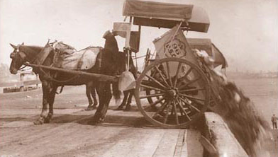
Figure 1: Ancient UK Waste Disposal Carrier (Horses)
Source: 24/7 Waste Removal(2014), A Brief History of Waste Management[online] https://247wasteremoval.co.uk/blog/a-brief-history-of-waste-management/ accessed on 01/03/2018.

2.3 DEFINITION OF WASTE AND WASTE MANAGEMENT.
Inskipp (2005, p6) defined waste as “materials we don’t need or want in our life”. Another simple definition made by the Environmental Association for Universities and Colleges (EAUC) (2018), on the term waste is “anything which you decide to, or are required to, throws away”. From an academic perspective, waste is fully described as:
“Any Resources consumed by inefficient or non-essential activities, unwanted material left over from a production process, or output which has no marketable value. It’s also a process or material that does not add value to a good or service. It’s a material discharged to, deposited in, or emitted to an environment in such amount or manner that causes a harmful change.” Business Dictionary (2018).
Waste is made by various human activities in the homes and industries. It’s then released into our environment, which sometimes can become a death trap for us if proper care is not taken. Iken Edu (2015) cited a typical example that an accumulation of wastewater in the surrounding areas breed mosquitoes. Lettie (2016) also identifies waste control or management as the process of collection, segregation, transportation, treatment and disposal. Waste management came to exist when man decided to take control of its surrounding waste and make their environment clean.
According to Business Dictionary (2018), waste management is defined as
“the collection, transportation and disposal of garbage, sewage and other waste products. It encompasses management of all processes and resources for proper handling of waste materials, from maintenance of waste transport trucks and dumping facilities to comply with health codes and environment regulations”.
The oldest waste practices are the collection of rubbish from door to door by the UK local councils. These local authorities are paid by tenant and landlord via council tax for the collection and disposal of public waste. However, in recent years, waste legislation has been published by European Directives and Regulation through framework waste directives. This EU Directive has enforced national waste strategies in England and Wales (DEFRA, 2013 p4), Scotland (SEPA, 2003) and Northern Ireland (DOE, 2001). In England, there were other subsequent Waste Review strategies which fall under the Waste Management Plan for England such as Anaerobic Digestion Strategy and Action Plan 2011, the UK plan designed for shipments of wastes, hazardous waste treatment and renewable energy infrastructure and quality action plan for recycles (DEFRA, 2013 p5). The above strategies were waste management campaigns which the UK intends to use to accomplish its annual waste target from households and industries. Furthermore, the UK Government give incentives to support its local authorities to change their waste operation, including increasing taxes on waste sent to landfill and financial penalties for failing to meet the statutory targets (Cap).

2.4 THE CLASSIFICATION OF WASTE.
The classification of waste is difficult as waste comes in different variations. Simply, waste is categorised by its source of collection and of its originality (production materials). Waste can mainly be categorised into two; controlled and non-controlled waste sees Figure 2. Controlled wastes are defined as all household, industrial, clinical and commercial waste that require a waste management licence for treatment, transfer and disposal (Williams, 1998 p56). All sewage sludge disposed of at landfill and incineration is classed as controlled waste (CIPS, 2007). On the other hand, non-controlled waste includes agriculture, businesses, industry, mining and quarrying which is produced in large tonnages and are not control by any legislation. Other uncontrolled wastes like radioactive and explosive waste come under separate legislation.
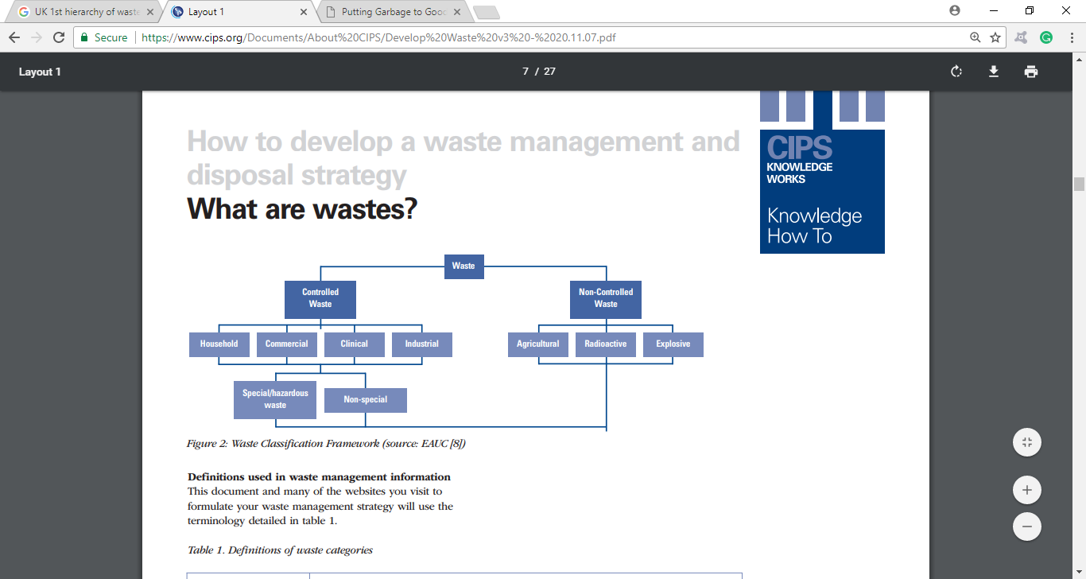
Figure 2: Waste Classification Framework.
Source: CIPS(2007), How to develop a waste management and disposal strategy,[online]https://www.cips.org/Documents/About%20CIPS/Develop%20Waste%20v3%20-%2020.11.07.pdf accessed on 24/03/2018

2.5 THE WASTE HIERARCHY.
The European Union produced the EC Waste Framework Directive (75/442/EEC), a national waste strategy which requires all member states to identify the type, quantity and origin of waste to be recovered or disposed of and technical requirements plus any special arrangement needed for waste with suitable disposal sites or installations provided (Williams 1998, p5). In 1995, the UK incorporated its national waste strategy into its Environment Act as a statement made by the secretary of state for the Environment England and Wales. In Scotland, a similar statement was written by the Scottish Environmental Protection Agency (Lane and Peto, 1995). According to this Common Inheritance (1996), the national waste strategy was developed from the idea of sustainable development launched at the UN Rio Conference 1992 on Environment and Development (the Earth Summit). The Environment and Welsh office (1995) stated that the EC strategy has been adopted by the UK authorities as the hierarchy of waste management. This has the reduction on the uppermost of the pyramid followed by minimisation, reuse, recycling and disposal on the larger portion at the bottom, see Figure 3. This means that most of the waste will go to landfill or incineration for disposal instead of better waste prevention, re-use and recycling. This structure increased the UK landfill waste rather than campaigning on prevention of waste to landfill.
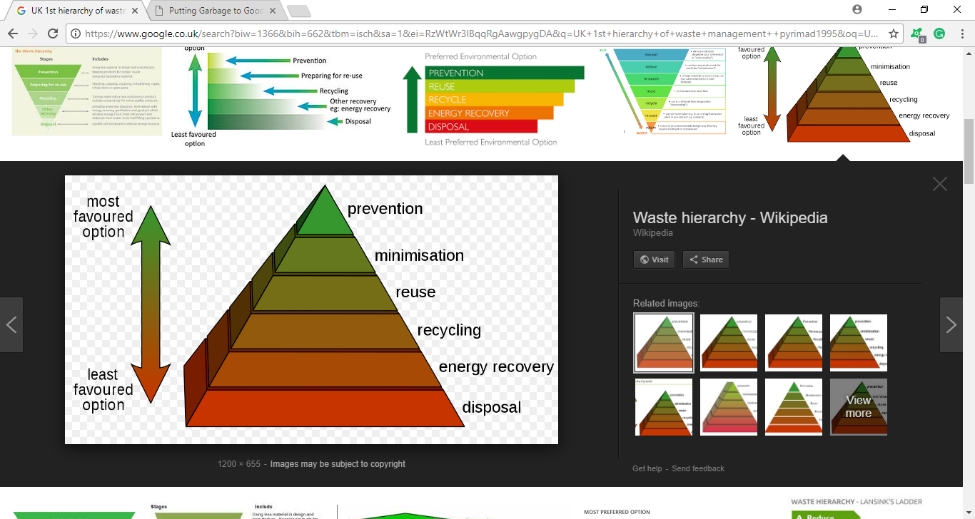
Figure 3: The Initial UK Waste Management Hierarchy.
Source: Disposal List (2018), Improper Waste Management Effects [online] http://disposallist.com/improper-waste-management-effects/ accessed on 14/03/2018.
Defra (2011, p3) provided new guidance for environmental waste which is an upside down of figure 3 as shown in Figure 4. This was designed under regulation 15(1) of the waste Act (England and Wales) which came into force on 29th March 2011. Nevertheless, according to Wrap (2011, p3) Article 4 of the revised EU Waste Framework Directive (WFD) (Directive 2008/98/EC) set out a new step for dealing with waste in priority order. It indicates the order of waste preference that waste producers must manage their waste to create a sustainable environment (Waste-free environment). It is also a tool to be used to evaluate the process of protecting the environment from being polluted. According to Defra(2011b), the new waste hierarchy: “Ranks waste management options according to what is best for the environment”. See below
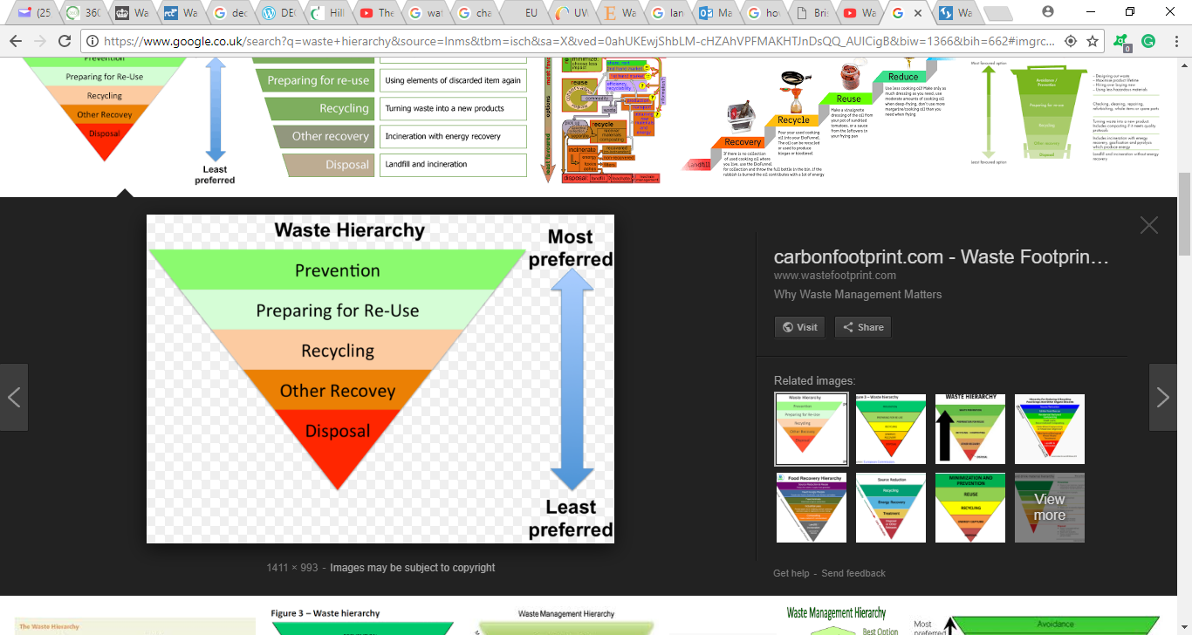
Figure 4: New Waste Hierarchy
Source: Carbon Footprint(2018), Waste Footprint Services[online] http://www.wastefootprint.com/ accessed on 07/03/2018.
The new waste hierarchy brought great awareness of waste prevention and financial benefit to waste producers. It assisted firms in determining the best choice for managing waste. More so, it acted as a legal duty for waste producers to take all measures to control their circumstance in order to ensure the new waste hierarchy ideals are applied (360environmental, 2011).

2.5.1 APPLICATION OF THE WASTE HIERARCHY.
Currently, UK businesses are still throwing away huge profits due to the amount of waste they produce. Most of them are not aware of the new waste hierarchy principle. Other’s don’t know where or who to contact for waste management confidential advice to assess the best usage of their resources (360environmental, 2011). Anytime waste management commence, the waste producers have to focus on waste prevention at the initial stage. When unpreventable waste is created, priority must be given to; segregating it for re-use, sent to a recycling centre, then recovery and the rest of the unwanted waste disposal to the landfill (DEFRA, 2011, p3). To understand the waste hierarchy, each stage of the hierarchy must be explained in detail. Section 2.5.1-5 provides an explanation on the hierarchy stages.

2.5.1.1 STAGES 1: PREVENTION
This is the initial and preferred stage of reducing waste (see Figure 4). Waste producers must concentrate on this stage in order to avoid creating waste which will go into the public landfill. DEFRA (2011, p12) specified that its aim is to support the UK economy to grow through the reduction of waste produced across the country by advising firms to adopt prevention practice. The government always measure the number of raw materials used and waste products produced commercially in industrial and in homes per unit of Gross Value Added (GVA). Kane (2015) explained DEFRA’s 2013 report on UK GVA as its core waste sector provides up to £6.8 billion GVA and supported 103,000 jobs than the national Economic GVA. Nevertheless, if repair, re-use and leasing activities were added to its waste management could raise funds up to £41billion, while providing 672,000 jobs (see Appendix D). DEFRA (2011, p3), proposes that businesses can prevent waste production by using less material in designing and/or manufacturing their products. They should produce goods that can be kept for longer, reuse packaging and use less hazardous materials. Wrap (2011) identifies prevention as measures taken before a substance, material or product becomes waste. The importance of the prevention phase, therefore, is to reduce:
- The quantity of waste including re-use and extends the product lifecycle.
- The adverse impact of waste on human health and the environment.
- Harmful substances from polluting the nearby waters and stream.
The Waste Prevention Team (2013 p1), states that “prevention is better than cure”. It further explains that the prevention role is to switch the public attention towards being resourced efficient in order to reduce waste to boost the economy. It stated that in 2010, the total waste generated in England was as 177mt₃ and it cost UK business £885 million to manage it. Between 2011 and 2012, it was estimated at £3.2 billion. Finally, the waste prevention programmes have led UK business to save around £18 billion and avoid 16 million tonnes of carbon dioxide (greenhouse gas emissions) annually. They also proved that UK homes spend £12.5 billion yearly on food that ends up being thrown away. It was estimated that £140 million worth of clothing ended up in landfill each year and £200 million gross value of electrical products are taken to household waste recycling centres annually (Waste Prevention Team, 2013 p10). Despite the numerous benefits this prevention campaign has brought into the UK economy there are other challenges raised against it, they are:
- Environmental Externalities: This is a human concept of decision making on consumption. It’s very difficult for the waste prevention campaign to convince some individuals and business owners on how to consume only what they need.
- Unfair Split Incentives: Many a time, manufacturers invest in redesigning a product to reduce waste (e.g. Long-life product) but most benefit will go to the consumer and little financial incentive will be returned to the producer. Therefore, most manufacturers recognise redesigning their produces as a waste of investment and continue to avoid the prevention campaign to save their capital (Waste Prevention Team, 2013 p11).
- Information Failures: The UK public sometimes feel that information is too costly in terms of time and resources to acquire, which makes them unaware of the preventive actions and the benefits associated with it (Waste Prevention Team, 2013 p11).
- Behavioural Barrier: In the business world, most business aim at making a profit (behaviour). Some behaviours contradict and underrate the value of long-term benefits versus short-term costs. They place more emphasis on the forefront investment cost on preventing waste rather than being a late benefit. They call it a risk as they believe that they might not gain the benefits of the prevention programme (Waste Prevention Team, 2013 p12).
- Financial Barrier: As the above point has elaborated on, initial investment cost. SME companies and individual have constrained access to credit that will affect the capacity to practise the prevention programmes to prevent waste. Though most SMEs have the passion to invest they do not have the financial credibility to attract financial support (loan) to embark on their waste prevention programme (Waste Prevention Team, 2013 p12).

2.5.1.2 STAGES 2: PREPARING FOR REUSE.
The word “reuse” in the waste management paradigm means to use an item again after it has been already utilised for its original purposes, without any significant changes to its physical status of the product (see Figure 4 stage 2). However, the European Legislation also defines:
“reuse as any operation which encourages un-waste item to be used again for the same or similar purpose” (PRISCA, 2017a).

PRISCA (2017b), reports further explanation that re-using is different from recycling because recycling involves an operation that can change the physical waste status into a different product. Hall (2005, p4) also reviewed the history of reusing of waste and found that since the first Earth Day was celebrated in America in 1970, recycling and reusing have become familiar global household words. These two words are often used to mean the same, however, there is an imperative difference between them. In brief, reusing mean’s people reuse their possessions in two major ways.
Firstly, a single-use item such as a toothbrush, pan, dish, tools and televisions are not just used once but is used repeatedly but only for a purpose. The purpose for which it was initially designed (Hall, 2005 p4). Hall (2005, p5) said that another way of reusing waste is when items are reused for a different purpose after its initial use. For example, an old toothbrush may become a tool to clean a tile at home, or a worn-out T-shirt may end up as a dust cloth. Sometimes, reusing objects or materials does not change the object but the original purpose changes. Which means that the toothbrush will still look like a toothbrush and the T-shirt will also look like a T-shirt but are used for a different purpose for which it was originally manufactured. Pal (2016a), exclaimed that approximately 100 million plastic bottles are used and discarded each day, 80% of them are non-biodegradable. As a result; our environment has been highly poisoned by significant carbon from plastic. Due to the environmental deprivation of plastic bottles, Art-creative groups have produced a new perception to encourage the consumer to reuse them. Pal (2016a) advised that:
“when you’re done with that plastic drink bottle, don’t just throw it away, use it to make something awesome”.

Pal’s (2016a) report, depicted clearly on images in Appendix F, G and H which shows the low cost, creative and functional craft projects of transforming plastic bottles into decorated household use. See Figure 5, a Vertical garden, it depicts an inspirational, beautiful hanging garden allowing urban residents who have limited garden space to enjoy horticulture in their backyard. To make a vertical garden from reuse plastic bottles always choose thick, durable bottles such as soft drink bottles rather than thin water bottles. Some believe plastic and glass waste can be reused, however, newspapers can also be reused too. Striepe (2011) reviewed that the US Publishers have been publishing on paper which has been reused over 24 every year. Practically, newspapers can be used by kids to create a model ship to prove the concept of floating (see Figure 6).
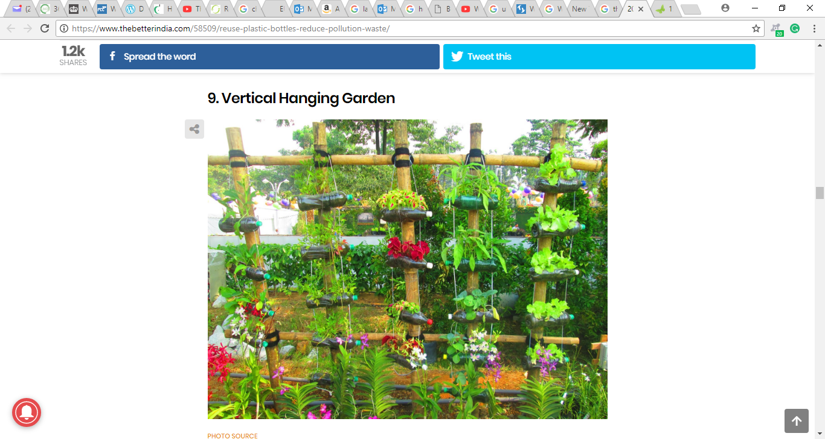
Figure 5: Vertical Hanging Garden.
Source: Pal (2016), Green Living: 20 Ingenious Ways to Reuse Plastic Bottles Instead of Trashing Them, published on 16/06/2016,7:27 pm [online] https://www.thebetterindia.com/58509/reuse-plastic-bottles-reduce-pollution-waste/. Accessed on 26/03/2018
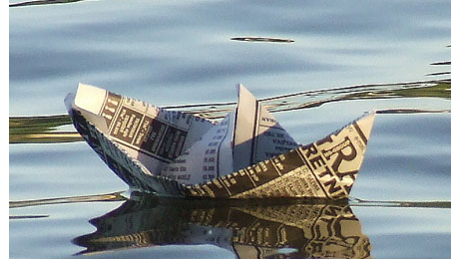
Figure 6: Reuse of Newspaper Ship.
Source: Striepe B.(2010), 15 Ways to Reuse Newspaper, published on 29/01/2017 https://www.care2.com/greenliving/15-ways-to-reuse-newspaper.html accessed on 11/02/2019

2.5.1.3 STAGES 3: RECYCLING
Recycling is a process while reusing is an act, though it’s a complicated process in which old products are changed into new ones by mechanical or chemical methods. In other words, recycling is a process that breaks down waste products into their original materials before new products are created (see Figure 4 stage 3). For instance, used aluminium cans are shredded, melted, and then reformed to make new cans or other aluminium objects such as ladders. Plastic bottles also can be shredded or crushed into small pieces. Which are then changed into a thick, gooey liquid by heating or by treating with a chemical. Eventually, liquid plastic is formed into new bottles or spun into a fibre to make clothing and carpets (Hall, 2005, p6). The difference between recycling and reuse is simple, reuse can be processed at home whereas recycling cannot, furthermore it requires time, money and energy to convert recyclable waste into new products. Most of the time it requires the participation of other organisations to recycle waste, to produce new products. The Economist (2017), stated in its recent report that China has dominated international trade by importing more than half of the world’s waste (see Figure 7). DEFRA (2017 p19) proved that the UK exports more scrap waste than it imports. In 2015 the UK exported 14million tonnes of scrap materials worth over £3.5billion. In 2011, there was a massive increase in the UK’s waste export’s and in 2009 there was a massive decrease in export’s, this proved how the UK economy income has increased as result of selling off recycling waste to other countries like China (see Appendix I). the Economist (2017), similarly stated that, China spent over $16billion on the importation of rubbish last year. In 2016, America Chung Nam company which is based in California, supplied waste paper amounting to 333,900 containers to China. China’s import of rubbish helped them to fill the raw material short gap plus it’s cheaper to recycle scrap copper, iron, steel and paper than extracting and manufacturing from the raw material. On the 18th July 2017, the Ministry of Environmental protection said that China has stopped it’s import on 24 categories of solid waste as part of its campaign against” foreign garbage” into the country because recycled waste is often dirty, poorly sorted, poor quality waste or contaminated with hazardous substance like lead or mercury. Another reason was that waste recycling companies in China have been dumping the toxic remains into Chinese river bodies (Economist, 2017). The impact of this waste ban has left a heavy burden on their trade partners especially the UK with a loss of £ 3.5billion income. Webster (2017), believed that the UK may burn its plastic via incineration rather than recycle due to the cost of recycling waste in the UK.
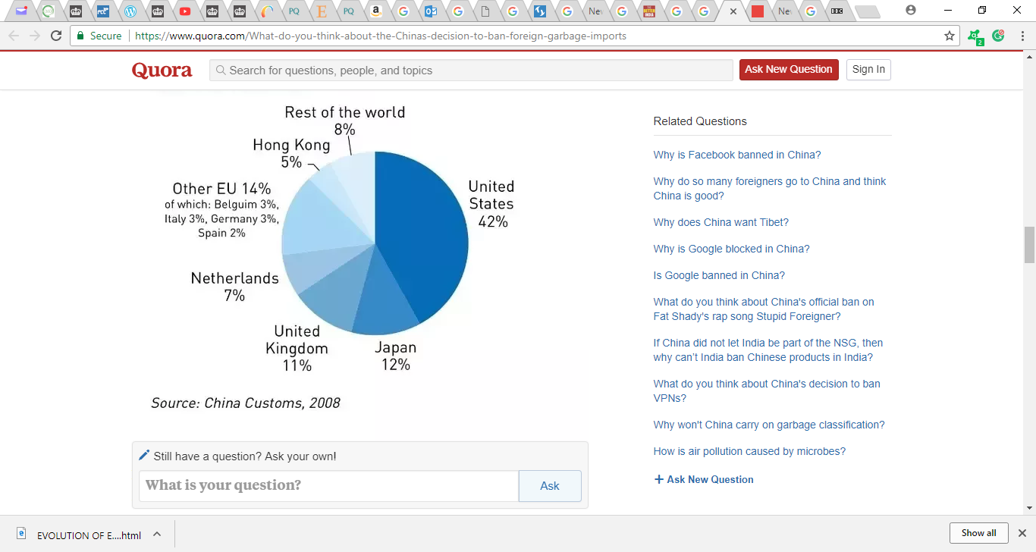
Figure 7: China’s Importation of Waste Record.
Sources: China Customs, (2008), https://www.quora.com/What-do-you-think-about-the-Chinas-decision-to-ban-foreign-garbage-imports accessed on 10/03/2018

2.5.1.4 STAGES 4: OTHER RECOVERY
Other recovery is the fourth level of the waste hierarchy, and popularly known as energy recovery (DEFRA 2011, p8). The aim of recovery is to get the most energy from genuine residual waste while reducing the amount of waste in landfill sites. In fact, recovery in the Waste Management hierarchy comprises of:
“anaerobic digestion, incineration with energy, gasification and pyrolysis which produce energy (fuel, heat and power) and materials from waste: some backfilling operations”.

- Recovery from Anaerobic Digestion:
Buekens (2005) defined Anaerobic Digestion (AD) as the natural process whereby waste component like food waste, are stored in a digester for a period and then specialised bacteria are added to break down organic waste to convert it into biogas (see Figure 8). Roopalall (2017) said that biogas is a gas produced by the decomposition of organic waste in the absence of oxygen. This biogas consists of mainly carbon dioxide the AD truly sustains the carbon cycle. In contrast with incineration or landfilling, anaerobic digestion does not fully represent a potential polluting process when the produced biogas is adequate. Anaerobic digestion is a hopeful and sustainable process for the treatment of biological waste. In the cause of biogas, there is a net drop of methane released into the atmosphere, declining greenhouse emissions and unpleasant smells and the sanitary disadvantages of landfills are avoided (Digiesi et’ al, 2017).
Stream Bioenergy (2010) said that the main driver for the UK to develop it’s Anaerobic Digestion systems was to meet Landfill Directive (1993/31/EC) cap by EPA Pre-treatment of MSW to Landfill, Food Waste Regulations 2009 and Landfill in incineration levies etc. Some of the advantages of AD are; it is a renewable source of energy, it produces less pollution, usage of cheaper technology, creates job opportunities, less capital investment needed, and it reduces greenhouse emission (International Research Journal of Engineering and Technology (IRJET), 2007). Despite all the advantage of AD, it also has other few demerits like it is unstable in nature, it’s unattractive on large scale and it consists of impurities through its process.

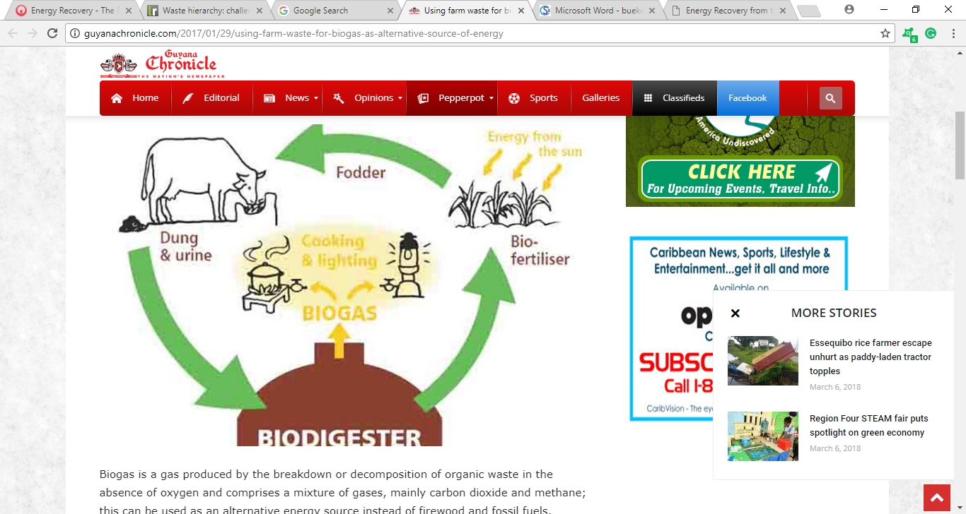
Figure 8: The Cycle of Anaerobic Digestion.
Source: Rooplall, R. (2017), Using farm waste for biogas as alternative source of energy, published by Guyana Chronicle on 29-01-2017 http://guyanachronicle.com/2017/01/29/using-farm-waste-for-biogas-as-alternative-source-of-energy accessed on 30/03/2018
b. Waste Recovery through incineration:
Incineration of waste is where organic substances are put combusted, to convert the waste into ash and flue gas (see Figure 9). Becklake (1991, p12) said that UK landfill sites are becoming scarce and expensive. Incineration is another means of dealing with piles of waste which has passed through the 3R’s. The burning of rubbish in an incinerator reduces the amount of solid waste approximately 80 and 90%. In Denmark, it was used to burn 75% of waste and half of the household rubbish in Japan, Sweden and Switzerland. When the burning process is happening, the heat produced is used to generate electricity for national electricity grid. The BBC News (2006) said that UK ministers are ready to increase. The waste incineration process from 9% to 25% by 2015. It emphasised that the energy produced from the incineration process is utilised to power electricity generation plants (see Figure 9). Though burning of waste seems to be a great solution to the UK import waste ban from China, it’s the most expensive form of waste disposal being 3 times the cost of landfill dispose. Anytime ten tonnes of waste are burned, one tonne of ash remains This may still contain harmful substances which pollute the environment when the ash is buried in landfill sites. It also causes air pollution when the gas from the burning rubbish is released.

2.5.1.5 STAGES 5: DISPOSAL
Disposal is the last preferred level in the waste hierarchy whereby waste which could not be prevented and converted into reuse, recycle or energy. DEFRA (2013, p13) stated that landfill tax was made to deter waste producers and to reduce or divert waste from landfill. Eventually, there are some waste residuals which can be avoided from disposing into the landfill and must be disposed of properly such as:
- Hazardous waste like asbestos
- Certain process residues, such as pre-treated industries waste with no future recovery.
- Waste which has not alternative waste recovery apart from disposal in a landfill.
NDA (2018) said that radioactive waste cannot be safely, and cost-effectively reused, and must be disposed of carefully. It defines this disposal as placing radioactive waste into special facilities and store it permanently. To clearly understand the word “Waste Disposal” the Free Dictionary defines it as:
“Removing and destroying or storing damaged, used or other unwanted domestic, agricultural or industrialproducts and substances. Disposal includes burning, burial at landfill sites or at sea.” (The Free Dictionary, 2017).
Landfills have become the most common solution in the UK waste management paradigm. ARIC, DEFRA (2017) said that every year roughly 111million tonnes of all UK controlled waste (industrial, household, and commercial waste) are disposed of into its landfill’s sites (see Figure 12). More so, the UK sewage, mining and quarrying companies also dump their waste in landfill sites.

2.6 THE DISPOSAL WASTE AND THEIR DECOMPOSITION.
In many communities, most of their waste is dumped in big holes just to fill up the ground, or waste valley at landfill sites. Unfortunately, some of the waste finds itself on the ground on our surroundings. Some of the waste rots away quickly, other types such as plastics may take hundreds of years to decompose, see Figure 09 (Inskipp, 2005 p10).
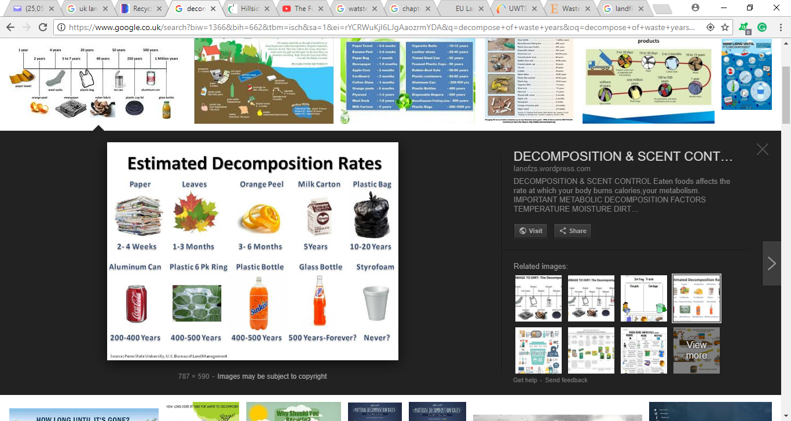
Figure 9: Estimated Decomposition Rates for Waste.
Source: Lanofzs (2013), Penn State University U.S Bruceu of Land Management, published on 12/02/2013 [online] https://lanofzs.wordpress.com/2013/12/12/decomposition-scent-control/ accessed on 15/03/2013
NWRWMG (2011) explains the reason behind the EU authority stipulated Landfill regulation for most European nations. According to Appendix E, the CH₄ emissions have diminished because between 1995 and 2015 waste sending to landfill site has reduced drastically due to landfill Tax, growth in recycling programmes and the waste PFI programme, as well as improvements in landfill management and the introduction of CH₄ capture technology (DEFRA 2017, p68).

2.7 THE WASTE MANAGEMENT (DISPOSAL) LEGISLATIONS.
In the UK, waste management is controlled via a diverse waste regulation and planning regime which has been developed over the years. Consequently, waste treatment and disposal of waste is protected by several different controlling authorities. The Local authorities have had strong powers via many statutes since medieval times to control waste as it was causing public health problems. Williams (1998, p19) also said that the local authorities’ powers were established through the Public Health Acts of 1875 and 1963, the Alkali Act 1906 and the Town and Country Planning Acts of 1947 and 1971. As the environment became polluted with toxic waste and dumping incidents increased which led to the public demand for much tighter waste disposal legislation increased.
The late 1980s and 1990s saw the additional development of waste management legislation and some influence of European Community legislation on the UK environment laws. Most of the legislation came from the European Directives. These are some of the major legislation affecting UK waste management (Williams, 1998, p21):
- The Control Pollution Act 1974. Part 1: Waste on Land.
- The Control of Pollution (Special Waste Regulations) 1980.
- The Special Waste Regulations 1996.
- The Controlled Waste (Regulation of Carriers and Seizure of Vehicles) Regulations 1991.
- The Control and Disposal of Waste Regulation 1998.
- Town and Country Planning (Assessment of Environment Effect) Regulations 1988.
- Town and Country Planning Act 1990.
- Planning and Compensation Act 1991.
- The Environmental Protection Act 1990. Part 1: Integrated Pollution Control and Air Pollution Control by Local Authorities.
- The Environmental Protection Act 1990. Part II: Waste on Land.
- The Environmental Protection (prescribed Process and Substances) Regulations 1991 (and subsequently amended regulations).
- The Controlled Waste Regulations 1992.
- The Environmental Information Regulations 1992.
- Animal By-Products Order 1992.
- The Waste Management Licensing Regulations 1994.
- The Trans-frontier Shipment of Waste Regulations 1994.
- The Environment Act 1995.

2.8 THE GENERAL FOOD WASTE.
According to Fusion (2017), food waste defined as:
“any food, and inedible parts of food removed from the food supply chain to be recovered or disposed of (including composted, crops ploughed in/not harvested, anaerobic digestion, bio-energy production, co-generation, incineration, disposal to sewer, landfill or discarded to sea)”
This simply means any food which is suitable for being eaten by humans discarded, whether kept beyond its expiry date or left to spoil. Often it’s seen as rotten food, but it can be for other reasons such as oversupply due to lower market demand, or individual consumer shopping/eating habits (Fusions 2017).
Priestley (2016, p12) said that the Food Agriculture Organisation (FAO) estimated that 1/3 of food produced in the world is lost or wasted globally and valued at 1.3 billion tonnes each year. FAO (2018) confirmed that up to 1/3 of all food got wasted (spoiled) and unconsumed. It clearly defined food waste as the decrease of food in the food supply chain process intended for human (household) consumption. Sometimes, the waste could be intentional or accidental, however, it all leads to food reduction. Food waste also happens due to poor harvesting, storage, packing, transport, infrastructure and market /price mechanisms. The FAO researched into some specific waste food production processes on consumption, distribution, processing, post-harvest and agriculture. It was proved that fruit & vegetables have the highest global food waste, and dairy products have the least (see Figure 10). The FAO also researched into consumer, production and retail food waste per continent. It found that North America and Oceania was the continent which produced the most food waste, with Europe coming second (see Figure 11).
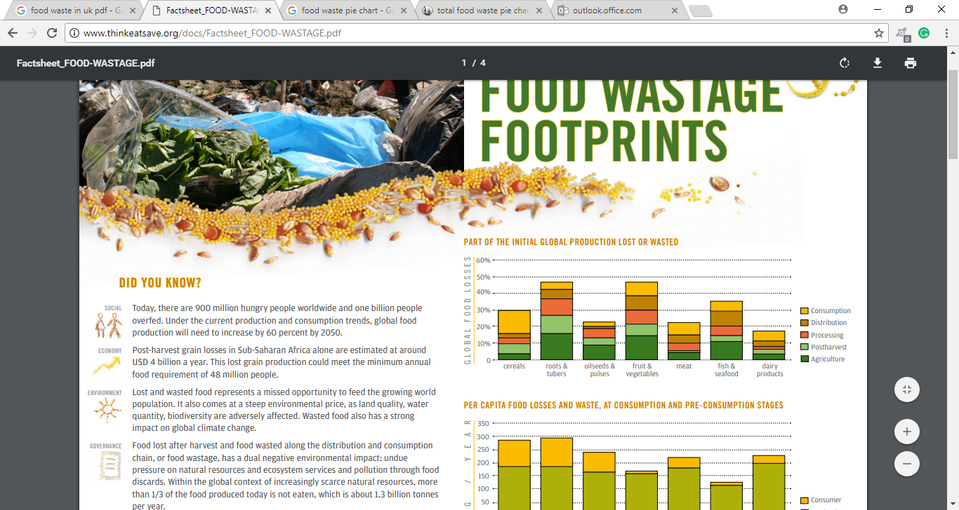
Figure 10: Food Waste of initial Global Production Lost or Wasted.
Source: FAO(2012), Food Wastage Footprints, [online]http://www.thinkeatsave.org/docs/Factsheet_FOOD-WASTAGE.pdf on accessed 24/04/2018.
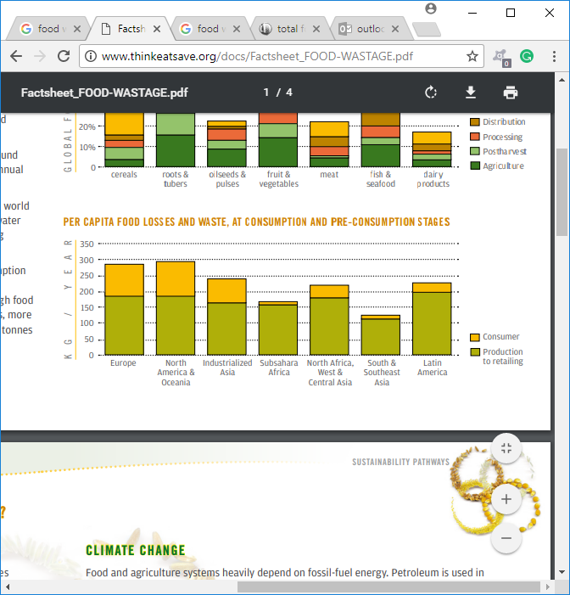
Figure 11: Food Losses and Waste at Consumption and Pre-Consumption Stage per Continent.
Source: FAO(2012), Food Wastage Footprints,[online]http://www.thinkeatsave.org/docs/Factsheet_FOOD-WASTAGE.pdf on accessed 24/04/2018.

Priestley (2016) said that each year the UK incurred £17 billion as the total food waste cost, including £12.5 billion for its households. The summary report from the UK Lords Committee has briefly shown numerous reasons why food gets wasted throughout the supply chain; like waste from harvesting, pests, manufacturing process, storage and theft at retail shops etc (see Figure 12).

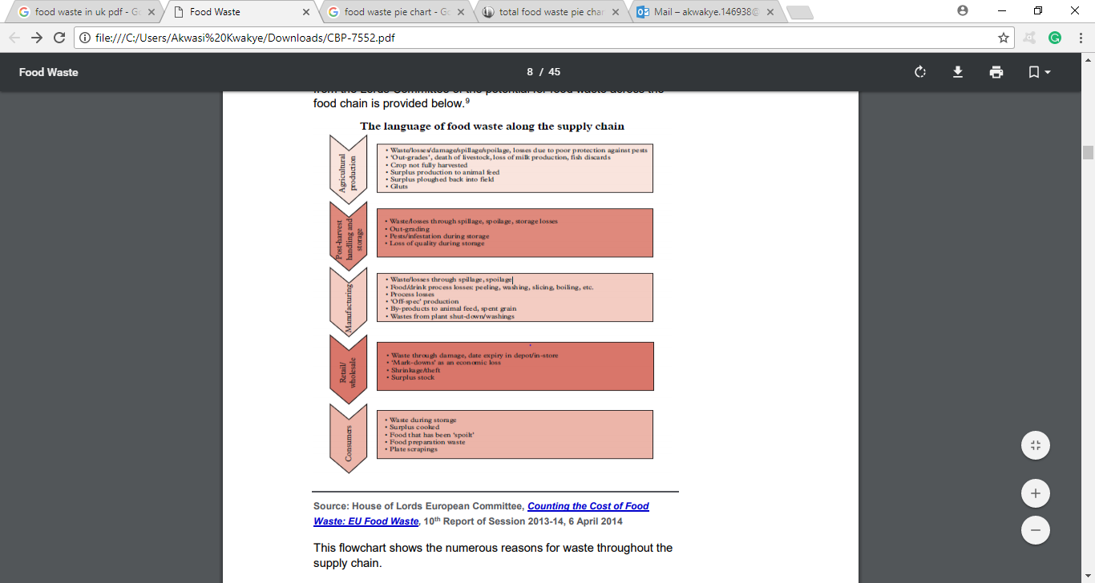
Figure 12: The Language of Food Waste Along the Supply Chain.
Source: Briefing Paper (2016) [online]file:///C:/Users/Akwasi%20Kwakye/Downloads/CBP-7552.pdf. accessed on 25/04/2016.

2.9 THE AIM OF ELECTRICAL WASTE DIRECTIVE.
In 2002, the EC introduced the WEEE Directive (Directive 2002/96/EC) which addresses the environmental impacts of waste electrical and electronic equipment at their end life disposal. It covers either household or non-household WEEE, and it included most products that have a plug or need a battery (HSE, 2018). Simply, this directive stated that electrical producers must be responsible for any environmental impact of their products sold on the market when they become waste. The optimal aim of this regulation is to promote recycling, reduce waste and stimulate the development of environmentally friendly electrical products in the future. Each year around 2 million tonnes of WEEE items are disposed of by citizen and companies in the UK. On the 1st January 2014, the WEEE Regulation 2013 was made law in the UK and replaced the 2006 Regulations. This UK 2014 WEEE Regulation covered all the provision of directive 2012/09/EU WEEE which superseded the Directive 2002/96/EC (HSE, 2018). Eventually, the Directive posted ten board categories of WEEE which have been outlined in the New Regulations for public knowledge, see Appendix J.

2.10 THE UK DEPOSIT RETURN SCHEME (DRS).
DEFRA (2018) said that the UK government has announced plans for the implementation of DRS to fight environmental pollution in near the future. It analysed that 13 billion plastic drink bottles are consumed per year and more than 3 billion plastic drink bottles end up incinerated, sent to landfill or left in our environment (marine, countryside and street). Laville and Zhou (2017a) said that Dominic Hogg, the chairman of Eunomia environmental consultant said that for the UK to address the impact of litter in the UK, it needs to reduce plastic entering the marine environment. In Europe Germany, Norway and Sweden are now operating with the DRS which has made their environment cleaner than the UK environment. South Australia has been implementing DRS for the past 40 years, now it has announced that 76.5 % rate of its waste bottles are returned via DRS. DRS operates on an installation of a reverse vending machine, which scans the barcode and gives consumers vouchers for their shopping or donates to charity in return for bottles. Laville and Zhou (2017b) said that this scheme sounds good for consumers, but the British Plastic Federation (BPF) has opposed any forms of taxes or charges on plastic bottles and believes that the degree of recycling is not guaranteed, nor its impact on litter clearance costs and reduction of plastic in the oceans is not assured. Furthermore, researchers believe that DRS may undermine the UK kerbside schemes which aim to improve recycling. Carrington (2018) said that with the evidence on tidiness from other DRS practising countries in Europe, the UK Government must listen to public opinion and implement DRS to end the use of avoidable single-use plastic by 2025.

2.11 THE UK MOD WASTE MANAGEMENT SUSTAINABLE STRATEGY.
The MOD (2010, p2) stated that the UK MOD produces an estimated 170,000 tonnes of waste annually. Of this, 52% got recycled (reused) and 42% ended up in landfills. Waste produced from MOD camps is disposed of by numerous civilian waste contractors via MOD Top level budget (TLB) and Trading Fund Agencies (TFA). In addition, these contracts cost the MOD £13million per year. Based on the 42% waste with goes to the landfill and contractual cost, UK Taxpayers find it very difficult to comprehend how effectively the MOD manages its waste.
Eventually, this observation from the UK public charged the MOD to develop a waste management strategy in order to prevent, recycle and reuse its waste to minimise landfill waste. The MOD (2010, p3) called the strategy, Waste Management Strategy (WMS).
This WMS is to provide a single source of direction required by all MOD camps, so that all units can improve their waste management effectively, to become a more sustainable organisation and meet the government waste targets (MOD 2010, p3).
According to the MOD (2010, p3), the WMS aimed to transform MOD units to:
“Become a zero to waste landfill organisation”
The strategy ensured that the MOD would meet its targets, which was set to:
1. Reduce the total amount of waste produces by 5% by 2010/11 and 20% by 2016/17 mentioned in the Sustainable Development in Government (SDIG) targets.
2. Increase waste recovery (re-use, recycling, composting and energy from waste by 40% by 2010/11 and 80% by 2016/17.
The MOD (2010, p11) stated that one of the MOD strategies was to embed the waste management concept throughout all defence units. To ensure that MOD staff comprehend the significance of reducing waste and the impact on their daily work. This brought into play the change of behaviour of staff (working culture). Therefore, addressing the behaviour of MOD staff is critical in reducing the quantity of waste generated by the MOD. Through educating its soldiers (MOD servants) and publishing waste best practices within departments as a waste management campaign, to promote waste minimisation.
The MOD (2016, p4) explained how the UK Defence sustainable MOD strategy for 2015-2025 to improve the MOD waste management strategy. This new ten-year strategy has included the EU waste pyramid hierarchy see Figure 13, into how the MOD will operate in its waste management.
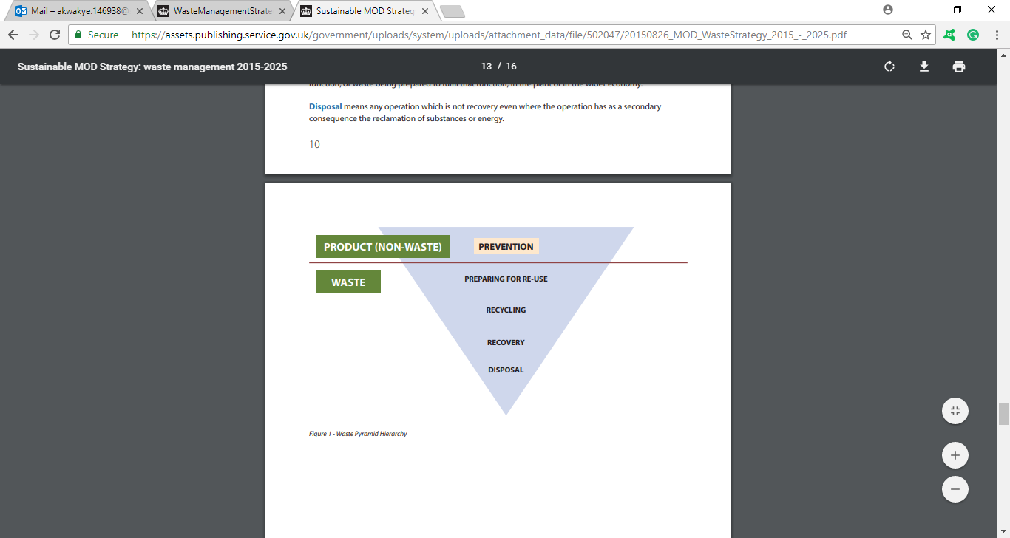
Figure 13: MOD Waste Pyramid Hierarchy.
Source: MOD (2016), Sustainable MOD Strategy: Waste Management 2015-2025, Published 19 February 2016 [online] https://www.gov.uk/government/publications/mod-waste-management-2015-to-2025 accessed on 28/04/2018.
The MOD new current waste strategy has a vision which is:
“To be an organisation where resources are fully valued, financially and environmentally and where we continually drive and incentivise improvement to maximise resource efficiency” MOD (2016, p5a).

The MOD (2016, p5b) explained that the UK MOD can only achieve its vision for waste strategy via attaining these four objectives:
1. Baselining: This means that MOD units must collect all the dairy waste data and analyse them to identify the crucial waste trends to permit improving waste programmes. Based on this information all new contracts for waste must stipulate on waste hierarchy as a key deliverable (MOD 2016, p6).
2. Waste Prevention: The new waste strategy was to ensure that, operational and tactical levels of the all MOD department must consider waste prevention in their day to day business. MOD Office line managers have to make decisions without the embodiment of waste prevention (MOD 2016, p7).
3. Driving Behavioural: The MOD (2016, p9) stated that the waste strategy brings a change of thought and staff attitude towards waste management. This strategy is to encourage MOD staff to be appreciative of their environment and the social and economic value of the resources. It explains how their daily activities can influence and impact the efficient use of their resource (wasting office papers).
4. Resource Efficiency: Many MOD departments use their resources effectively but not efficiently. It explained that departments must work in line with waste hierarchy. More so, it must foresee that waste stream and trend are set to identify resources opportunities. When opportunities arise to allow waste loops to be closed and resources to be recycled or reused, these must be taken.

2.12 THE BENEFITS (ADVANTAGES) AND DISADVANTAGES OF WASTE MANAGEMENT. see Appendix K.

2.12.1 THE BENEFITS (ADVANTAGES) OF WASTE MANAGEMENT.
There are numerous merits that waste management processes bring to firms in the entire Nation, this research will expose some significant advantages:
1. Reduce Pollution and Environmental protection: Most industries create new products by transforming raw materials into finished goods using combustion, which increases the level of air pollution which affects the environment. Recycling and reusing as part of the waste management process reduces the demand for new products and decreases the amount of CO₂ released into the atmosphere. Furthermore, it helps to reduce the amount of landfill waste that contribute to environmental damage. The primary benefit of recycling is that it helps protect the environment from damage, such as global warming.
2. Lower costs: Waste management create a huge financial benefit to manufacturing companies as well as a greener environment for the community. In the perspective of financial benefit, the cost of using recycled materials in manufacturing is cheaper than the cost of manufacturing from the natural raw material. In support of, the lower cost perspective, Kaskey and Koh (2017) analysed that the Chinese imported 51% of the world’s plastic scrap in 2016, the biggest imported came from the US. This imported plastic (polyethylene) was utilised to produce many rubber products. The income from the products boosted the Chinese economy.
3. Cultivating of a Green Image (Environment): The UK community has come to acknowledge that recycling is a way of life. Therefore, society expects all business to campaign for recycling, reusing and less disposal of waste to landfill, because they are increasingly conscious of environmental damage caused by landfill waste. So, firms which are embarking on better waste management are receiving awards from Green Partners which boosts their goodwill image in their communities. Laville & Zhou (2017), said that if the UK adopted the DRS, it would take away more than 4 million plastic bottles a week from littering its street and marine environments. Currently, Germany, Norway & Sweden are implementing DRS and are benefiting from the scheme. Therefore, waste management via DRS could make the UK environment tidier than today.
4. Saving Energy: Manufacturing firms consume the highest amount of the National Gird than households in the energy sector. In order to mitigate this, waste management programmes have helped to reduce demand rate for goods in the market which has affected the supply rate from manufacturing and consequently reducing energy consumption. These reducing chains diminish the amount of energy utilised from the national grid. It’s said that recycling saves energy. For example, new products made from recycled aluminium use 97% or less energy whereas recycled steel products use 75% less energy. Finally, it’s proving that less energy leads to fewer fossil fuels burned leads to a reduction of CO₂ (a greenhouse gas) emissions into the atmosphere (see Figure 14).
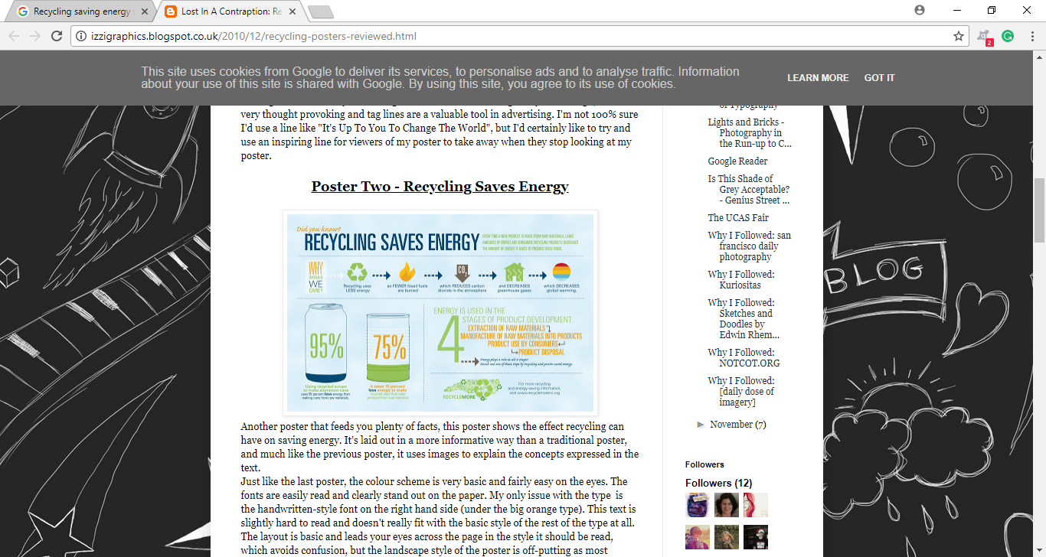
Figure 14: Recycling Saves Energy.
Source: izzigraphis (2010) Recycling Posters – Reviewed, published on 20/12/2010 [online] http://izzigraphics.blogspot.co.uk/2010/12/recycling-posters-reviewed.html accessed on 29/04/2018.
5. Creation of Employment and Income: The waste management campaign has brought a lot of great opportunities to our community predominantly in the creation of employment. According to Friends of the Earth (2010), at the European level, 70% of recycling waste materials could roughly create up to 322,000 direct Jobs, 160,900 new indirect jobs and 80,400 induced jobs. Therefore, among the 27 EU countries, 563,000 net new jobs could be created by waste management. The UK Conservative political party estimated that, if 70% of its municipal waste recycled is achieved by 2025, then they create 29400 new direct jobs via recycling, 147,00 indirect jobs in waste supply chains and 7300 induced jobs. Simply 51,400 total potential new jobs could be created, as 42,300 might be in England, 4700 in Scotland, 2,600 in Wales and 1,800 in Northern Ireland. Friends of the Earth, (2010) & Reddy, (2016) stated that in 2018, $60milion has been generated from waste management via either recycling or reusing processes. This has encouraged many firms to follow or associate their core mission to waste management and ready for long-term investment see Appendix L & M.
6. Community Building: Waste management is an act of which can bring people together. A typical example is when a town cleaning exercise and companies planning to build a modern recycling centre (improve existing centres). These decisions bring the community together as they work towards a green environment achievement. All households feel that their collective effort has contributed to the neatness of the community. Laville (2017) stated that the ASDA boss encouraged all supermarkets to stop using plastic packing to help build a green community by reducing waste plastic to landfill and to the bottom of the UK ocean. Our water bodies and seas form part of every community, therefore waste management helps in the cleanness of our environment.
7. Stimulate Technology: With technology, waste is converted into many finished products which are highly sellable in the global market and increase the technology manufacturing firm’s income. Therefore, it can be explained that waste management is one of the elements that inspire or influence many firms to develop the tool to convert waste into reusable finished products. Enerkem (2018) announced that it has developed an Enrkem’s game-changed technology, which uses waste material like textiles wood residues, recyclable plastics and solid food containers to produce Biofuels and renewable chemicals. It also changes the old means of exploring fuel into the circular economy with fuels and chemical from waste. Tilley (2017) said that some Australian firms have developed a great desire in creating technology to convert wastes into reusable goods and it’s really a competition paradigm. An example is an inventor convert waste plastic into fertilizer and energy(fuel) using anaerobic digestion. This clearly shows that waste management as a core has an impact on technology development.

2.12.2 THE DISADVANTAGES OF WASTE MANAGEMENT.
Despite the numerous merits of waste management process that brings benefits to firms and nations. There are other disadvantages it comes with; this research will expose some of the significant disadvantages:
1. Waste management process is not always Cheap: Waste management looks lucrative these days to many firms and national agenda in terms of its income returns and legal forces. In fact, sometimes the process needs huge funds, time and land to build a plant and operations. More so, as waste increases in certain councils their waste management plants must expand to accommodate their waste, and all is costly. Setting up, big waste facilities require huge funds from the council budget even though it’s a national asset for long-term investment, it absorbs council funds and stops other needed council development (projects). For example, it costs $50 per ton to dump trash in landfill whereas it costs $150 per ton to recycle it. Which is cheaper? Waste dumping is 3 times cheaper and less time consuming than waste management (Tilley, 2017).
2. The Recycle products have a short life: Through realism and research, it has been proved that recycled products do not have a durable shelf life as compared to products manufactured from the original raw material. Despite this, it’s eco-friendly and sometimes cheaper in the market but they have a shorter life than the intended original products (Tilley, 2017). Due to this fact customers are not patronising recycling product to encourage waste management.
3. Waste Management Sites are dangerous: Most waste is deadly and poisonous, some are explosive and toxic. For instance, radioactive waste produced by nuclear power industries can cause mass destruction via body contact (inhaled). All these dangerous them go into the atmosphere which poses a high amount of danger to human health & community hospitality.
4. Incineration Create Inherent (Environment) problem: Waste researchers believe that incineration is one of the cleaner ways of disposing of waste, but it has inherent disadvantages. Becklake (1991, p19) said that when toxic waste is burned at sea, the smoke and gases can escape, polluting the air and the water. The ash is also dumped into the ocean, causing more water pollution. There was an outcry among global environmentalists, which lead to incineration being banned in the North Sea. Incineration caused a lot of air-borne problems and it’s a detrimental to the ozone layer (Hall, 2017).

2.13 CONCLUSION
This chapter has explained the originality of waste and waste management from the ancient days as man accumulated waste after hunting, fishing and preparing food (Burcea, 2015). Man became very conscious of their surroundings due to waste smell and then decided to keep waste far from their surroundings when they recognised that waste was harmful to them. In 1874, the UK built its first incinerator at Nottingham to burn disposable waste. It found that waste is anything we don’t need or want in our life and waste management as the process from collection, transporting to the disposal of waste including the associated legalisation (Inskipp, 2005, p6). Waste comes in many different kinds, classified into two main form: controlled and non-collected waste. It enlightened the history behind the waste hierarchy from EC and how the UK incorporated into this concept to strategised environment issues across Wales, Scotland and Northern Ireland. It explained that the old hierarchy did not benefit the UK because it prioritised disposal of waste into landfill sites rather than prevention. So, the new hierarchy was adopted which promoted prevention and discouraged waste disposal. It explained in-depth the 3Rs and part of the waste hierarchy application. Finally, waste management undoubtedly has become a household vision for businesses, societies and nations because they believe that it has great benefits. On the other hand, some firms and individuals still believe that waste management costs more than its worth. Therefore, they have less interest in it, that’s why some companies prefer dumping waste at landfill sites rather than recycling because it’s more expensive to recycle rather than dumping it. It explained how the UK MOD has incorporated the EU Waste Pyramid into its waste management strategy. This strategy is to reduce waste from disposing in landfill via baselining of waste data, educating its staff to change their attuite towards waste prevention and resources valued. Despite the difficulties and disadvantages in waste management like pollution (sea, air and land) and high investment capital, its benefits outweigh its demerits like creating employment, stimulating technology, lucrative, cost saving, makes the environment greener, and production of energy (electricity) is reduced. On a final note, this report recommends the UK proposed Deposit Return Scheme (DRS) should be implemented now to help the UK reduce its waste sent to landfill or left to pollute streets, countryside, and marine environment.

CHAPTER Three: RESEARCH METHODOLOGY

3.1 INTRODUCTION.
A research methodology is a systematic idea for conducting research. The methods vary by the sources of information that are drawn on, how that information is sampled, and the types of approaches that are used in data collection. The study methodology and data reporting are always carried out as an exploratory study. According to Cooper D.R. and Emory C.W (1994 p117), exportation is particularly used when a researcher lacks a clear idea of the problems they will meet in the study. Through exploration the researcher develops the concepts more clearly, establish priorities and improve the final research design. Svatko (1989), said that before any organisation set up its strategy, it must understand its competitors(rivals) strengths, weaknesses and overall their business strategies. The key note is to identify where to gather relevant information on these competitors and how to combine separate pieces of data into a coherent profile decision or find an answer to the hypothesis question. In simple terms, this is known as research methodology. Ghauri and Gronhaug (2005) also described research method in an exclusive way by referring to it as a systematic, focused, and orderly collection of data for obtaining information from them, to solve/answer a research problem or question.
In this context, this chapter will denote the researcher philosophy behind the study, research techniques to be applied, the population, sample nominated, source of data and its analysis (benefits and limitations) and methods of collecting data for the research.

3.2 RESEARCH METHODOLOGY PHILOSOPHY.
Bryman (2012), said that each scholastic research methodology has a philosophical mentality. This mindset is of convictions concerning the idea of what is investigated by the researcher. Flick (2011) uncovered that philosophy is the stay to the methodology being utilized in chapter 3. This study will be based on the interpretivism philosophy.
The motivation behind why the interpretivism idea being utilized is that the investigation is exceptionally founded on how individuals' in public activities have influenced their condition (environment) by waste disposal. See Appendix N, the Saunders et al Onion Theory, considering the substantial population size of Aldergrove, the sample is comprised of Military specialists (Engineers) and Civilian workers. It would group information through an empirical frame by qualitative and quantitative analysis approaches, notwithstanding, this will help bridge the gap between positivism and realism.
Besides, the researcher will apply the inductive methodology approach, on the grounds that the hypothesis must be tested, in view of data gathered and analysed to prove the hypothetical claim. “That’s shifting from data to theoretical approach”.

3.3 QUANTITATIVE AND QUALITATIVE TECHNIQUES.
Maanen et al (1982), clarify the contrast between the two strategies. They said that a qualitative technique depicts the basic character, analogy, nature, or metaphor portraying something while a quantitative procedure clarifies the importance and alludes to an estimation of an idea in rate or figures.
This research will be founded overwhelmingly on the two strategies (mixed techniques).
A survey is the most famous technique and it regularly utilised for numerous studies. Eventually, in large-scale projects, a circular sequence in which investigation is trailed by estimation, which thusly is trailed by a qualitative analytical phase to reveal more insight into the scientific discoveries (Davies 2007) is embraced.
The study will implement the successive logical technique, whereby a blended method design that frequently offers to the researcher with solid quantitative knowledge. Right of that, it will gather and examine of quantitative data and ultimately analyse the qualitative in the second stage to erect on the result of the underlying quantitative outcomes. In Figure 15, the word Quan remain for quantitative and qual remains for qualitative. The interpretation of the whole analysis will result from qualitative or subjective data analysis and quantitative data analyses 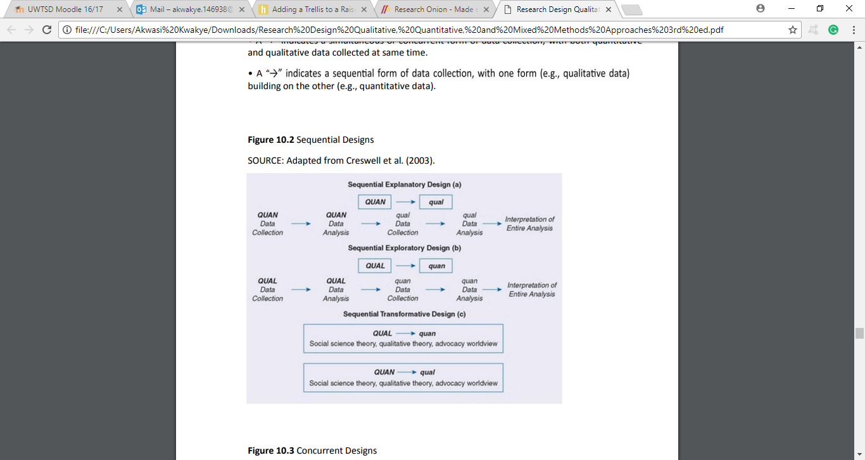
Figure 15: Research Sequential Designs.
Source: Adapted from Creswell et al. (2003) Advanced mixed methods research design. In A. Tashakkori & C. Teddlie (Eds.), Handbook of mixed methods in social and behavioral research. Thousand Oaks, CA: Sage.
3.4 The Population of the Study.
Finding the population of your study is vital and as the initial step to be considered by the researcher.
According to Ghauri and Gronhaug (2005), Population is;
“…the universe of units from which the sample is to be selected. The term ‘units’ is employed because it is not necessarily people who are being sampled-the researcher may want to sample from a universe of nations, cities, regions, firms, etc. thus, ‘population’ has a much broader meaning that the everyday use of the term, whereby it trend, to be associated with a nation’s entire population”
Therefore, the population to be considered for this study is the MOD- Aldergrove Flying Station. According the Aldergrove Warfare department, the entire population census of Aldergrove is around 1900-2200 people as of March 2018. This includes soldiers and their families in married quarters, soldier living-in single block accommodation and civilian workers.

3.5 THE SAMPLE OF THE STUDY.
Sample is a subset of a populace picked. The researcher will used it to represent the entire population because it has a solid association with the population. Samples are required in numerous studies because frequently it’s unrealistic or not practical to get information from the entire population. Cooper and Emory (1994), uncovered that a sample is the chosen section from the population. Therefore, the essential thought of sampling is that by selecting some portion of the component in a population, conclusions may be acquired about the whole population. Cooper and Emory kept on clarifying in depth that a component is the subject on which the measurement is being taken.
To a layman, a sample is a subsection or fraction of the population that has been chosen for investigation (data collection). Because it’s exceptionally difficult for a researcher to collate data on an entire population for a researcher. Generally, data collection has numerous disadvantages like cost or expense and time therefore a sample must be selected to represent the study population.
Nonetheless, in view of a probability or a non-probability (random) approach the researcher selects the sample of the study population.
It was utilized to zero down the target group from the population picked on the MOD camp. More so, is will assume that a representative sample will probably be the out-come. Along these lines, every unit of the population has a known possibility or chance of being selected.
The research sample selection and data collection techniques to be deployed by the researcher are:
- Military and Civilian Worker (Engineers)- Questionnaires
- The Regimental Cook House Department- Semi-Structured Interview.
- The Regimental Recycling Centers. Semi- Structured Interview
- Compound Skip Bins- Field Experiment
However, the above areas were chosen as research sample zones for data collection because of factors like time limitation and accuracy of information to represent the entire Aldergrove population (waste management). The sample population of the study is estimated at around 220 people, which is 10% of the population.

3.7 THE SOURCE OF DATA.
The study will focus on two areas for data. Kinds of data it will utilised are:
- Primary Data
- Secondary Data

3.8 PRIMARY AND SECONDARY RESEARCH.
Primary data research is a demonstration of engaging respondents directly and collecting raw data. This can be done from multiple points of view, such as group discussions that are organised and semi-structured and experiments on mentors. Typical examples are recording of cars breaking the speed limits on motorways and using survey questionnaires on people in the street or a working environment and so on. The most widely recognised of these is the collection of data from people in the form of a survey which can be done on the street, workplace, and via the phone, internet or by post.
60% of data in this study will be primary and 40% will be secondary data.

3.8.1 ADVANTAGES OF A PRIMARY DATA.
- It shows a replication and a re-questioning of interviewees/ respondents.
- It enables speculation to a larger population survey.
- Its coding empowers numerous correlations among variable factors.
- Primary data can be immediately analysed and forecasted to diagrams.
- Sometimes it is a cheaper and less demanding technique to use for data collection.

3.8.2 DISADVANTAGES OF A PRIMARY DATA.
- Under Primary Data, utilising an extensive sample population can be time-consuming or tedious.
- It’s reliance on computed (statistical) analysis loses singular implications or meanings and contextual study data.
- Sometimes closed questioning may restrain the respondents.
- Respondents may interpret the questions differently; this makes correlations of the appropriate responses troublesome.
- Response rates can be low and selections are non-random. This affects the validity of any inferred generalisations.
- It is difficult to check if individuals are responding sincerely or honestly.
- Sometimes researchers can bias or predisposition in the data by preconception definition and question cultivating.

3.8.3 THE STUDY PRIMARY DATA.
The primary data is raw data which has not been published by any author but instead obtained from the respondents by the researcher. Ghauri and Gronhaug (2005 p102) likewise said that secondary data is not accessible or unfit to help answering the question been inquired. The primary data source has turned into an exceptionally critical source to be explored by study.
This study will explore its primary data from Aldergrove Barrack in Northern Ireland. Areas of concentration are: Military and Civilian workers (Engineers), the Regimental Cook House Department and Regimental Recycling Center.
How the research collects or gathers the primary data from respondents will be in a form of:
- A Survey (Questionnaire)- A questionnaire consisting of a series of questions with the aim of gathering information from respondents. Questionnaires can be assumed as a form of written enquires. They can be accomplished by face to face, by phone, online(internet) or post. The questionnaire is sent to the respondents and they are required to peruse, comprehend the questions, and write down the appropriate response in the space provided. Questionnaires are a transparent means of collecting public opinion on national matters. This is useful for large populations when interviews would be impractical. (McLeod 2018).

The researcher of the study will send an official notification for the conducting of survey to the chosen sample departmental heads. Initially, there will be 10 questionnaires pilot survey, which will serve as a preliminary questionnaire distribute to random respondents to test the precision and effectiveness of the questionnaires. After the pilot questionnaires are received, they will be checked and re-drafted. Secondly, the researcher will distribute over 150 questionnaires to the respondents within the sample population (see Appendix O).

The Advantages of Questionnaires:
- It’s a practicable approach for gathering data.
- Economical way of gathering information.
- Can be completed by the researcher or by any number of individuals with restricted effect on its legitimacy and dependability.
- Large amounts of data can be gathered from many people in a short period of time.
The Disadvantages of Questionnaires:
- Lack of validity
- Dishonest respondents cannot be determined.
- Difficult to determine a mistake or an error answer.
- Respondents may read differently or may not get the full understanding of questions asked. Therefore, they may reply base on their own understanding to the questions.

- An Interview- The researcher will conduct a semi-structured interview with Aldergrove Station Recycling Center manager (see Appendix P), the Cookhouse manager (see Appendix Q) and Aldergrove Quartermaster (see Appendix R). It assumed that, these interviews would last for at least 15 mins per interviewee. The reason why this method of data collection has been selected is because of face to face communication. Interviewees expression of their emotions and gestures may reveal more comprehensive information to the researcher.

Strength of interview:
1. Good cooperation from respondent.
2. The interviewer can help interviewee to understand the question.
3. Special visual aids and scoring devices can be used.
4. Interviewer can prescreen respondents to ensure he/she fits the population.

Weakness of Interview:
1. High Cost
2. Sometimes it needs a highly trained interviewer.
3. Requires a longer period in the field collecting data.
4. Interview length may be limited.
5. Some respondents may be unwilling to talk to strangers.
6. The interview environment may affect the interviewee answers.

- Field Experiment – These are done in everyday life, such as a classroom, the workplace or even high streets. It attempts to examine an intervention in the real world in a naturally occurring environment. The experimenter still manipulates the independent variable but in a real-life setting.
Field experiments, like lab experiments, generally randomize subjects into action and control groups and compare outcomes between these groups (McLeod, 2012).

The Strength of Field Experiment:
Behaviour in a field experiment will probably reflect genuine because of its natural setting, which implies higher environmental legitimacy.

Field Experiment Limitation: There is less control over unessential variable factors that may predisposition the outcomes. This makes it difficult for another researcher to repeat the study similarly.

The researcher of this study will conduct a field experiment at 3 locations within Aldergrove on larger waste skip-namely: waste skip at Navy, Army and Air Force Institutes (NAAFI) park, waste skip at guard room and waste skip at JNCO accommodation park. The field experiment will be conducted within a time frame of one month. The reason why the researcher elected this method of collecting data was to gather accurate information on waste disposal on camp in from the general population (see Appendix S).

3.9.1 THE SECONDARY DATA.
This is documentary source data which has been published already to the general public by different other essayists or writers, in any case, still has pertinence and relates to the research study. It comes in two forms; internal and external secondary sources:
The Internal secondary data source for this study are:
- Aldergrove Journals, daily papers and monthly newspapers.
- 38 Bridge MOD internal web site(moss).
- MOD catalogues, journals, DII website, MOD Gov publication -JSP.
- UK Defence online library.
The External secondary data source for this study are:
- Previous waste management research reports.
- Public libraries material (Belfast City and Lisburn library).
- Waste management journals, articles and Books
- Waste management videos from online internet (YOUTUBE).
- Environmental legislation or legal reports (UK and EU).
Secondary data, which was obtained from the above sources was gathered into chapter 2 (literature View) of the study. More so, its findings will be utilised as supplementary evidence to be embedded into the finding section in the conclusion (chapter 5). The reasons why the researcher utilised secondary data are by academic good practice and to assist the researcher to develop in-depth waste management knowledge on the overview study. The study will clarify the advantages and limitation of sourcing secondary data for the study.

3.9.2 ADVANTAGES OF SECONDARY DATA.
- It's less expensive and effortlessly accessible to acquire, particularly from a library sources includes magazines, journals, textbooks, computers and etc.
- It helps the researcher to examine trends in large scale research.
- It’s the only traditional resource method for obtaining data from a historical document.

3.9.3 DISADVANTAGES OF SECONDARY DATA.
- It has an absence of consistency or perspective.
- Sometimes, researchers feel that it’s one-sided (biased) and inaccurate utilising secondary data because it’s obsolete and a study made five years ago may not be pertinent today.
- It became a worry over whether the data is completely separated from the context of its collection and the current study.
- There are many published statistics (secondary data), frequently raise more questions than answers by critics.
- In most imperative moment, secondary source data does not meet the researcher’s specific needs.

CHAPTER 4: ANALYSIS AND INTERPRETATION OF DATA / RESULTS

4.1 INTRODUCTION
The objective of this chapter is to elucidate in-depth the data collected, data analysis and interpretation of its results. It also explores three semi-structured interviews conducted by the researcher with Aldergrove waste management specialists: (Quarter Master (Qm)-Maj. John Linegar, Recycling Deputy-Manager-Mr. Paddy Lynn and Catering Manager – Sgt. Daryl Patterson)
On the 01st April 2018, the researcher administered 150 questionnaires out to the sample population which included 5 Regiment AAC engineers, civil servants and contractors. On the 2nd April 2018, the researcher was able to collect 90 questionnaires out of the 150.
After the collection of all data, the researcher went via the following process:
- Editing- Sorting out the respondent’s feedback, exploring for errors and mistakes to be removed by the researcher. According to Ghauri and Gronhaug (2005 p156) the basic purpose of editing “…is to secure a quality standard for the data”. Editing happened in a form of vetting the questionnaires. In the context of this study, the researcher found 60 questionnaires out of the 90 questionnaires to be in a good form for analysis of the study.
- Coding- The researcher collated all the best data (60 questionnaires) onto a data board and converted them into numeric codes into the SPSS Data View and Variables View (see Appendix X).
- The researcher utilised the collapsing approach to simplify some of the complex response received so that they can be tested or exploited by the analysis tools easily.
- The researcher tested the collected data reliability and validity with SPSS before analysis any other Descriptive analysis.
The study utilised the Statistical Package for the Social Science (SPSS) and Pivot table application(software) to produce the below data analysis for presentation. The researcher would interpret the non-diagram data to the study beneficiary and present the diagrams (chats, histogram) in a visualised form.

4.2 ANALYSIS AND PRESENTATION DATA TOOLS.
This study will use descriptive statistical tools as analysis tools to interpret most of the collected data for the research. They are; tables (cumulative frequency table), histograms (Pie chart and Bar chart), percentages, fractions, Chi-square analysis and T-Test analysis
This chapter will also report the semi-structured interview (face-face interview) conducted with Aldergrove Catering Manager (Sgt Daryl Patterson), Aldergrove Quarter Master (Major John Linegar) and Aldergrove Recycling Centre Deputy Manager (Mr. Paddy Lynn) on waste management. The researcher elected these two managers because their daily work relates to a large quantity of waste production and they are also well trained on waste management. It will also finally analyse the outcome of the Field Experiment events conducted by the researcher on the three vital locations (NAAFI, Guard Room and JNCO Mess Accommodation) at Aldergrove.

4.2.1 RELIABILITY AND VALIDITY BEFORE (DATA ANALYSIS).
Before conducting analysis on the sorted collected data, the researcher tested the reliability and validity of the data collected. The reason behind the Test is that:
a. To prove that, data collected from respondents are not biased. This would enhance the confidence of the benefactors (see Table 4.1).
The researcher utilised the Cronbach’s Alpha Test to ascertain the reliability and validity of the descriptive data (Age, Gender, Rank, Corp and Trade Qualification).

1. Table 4.1: SPSS Cronbach’s Alpha Test (Validity & Reliability) for Descriptive Test (Demographic).
Item-Total Statistics
 | Scale Mean if Item Deleted | Scale Variance if Item Deleted | Corrected Item-Total Correlation | Cronbach's Alpha if Item Deleted
Age | 7.91 | 9.043 | .674 | .721
Gender | 10.03 | 14.278 | .396 | .814
Rank | 9.54 | 9.948 | .735 | .704
Corp | 9.28 | 10.177 | .476 | .798
Trade Qualification | 8.35 | 9.623 | .713 | .707

Reliability Statistics
Cronbach's Alpha | N of Items
.794 | 5

The research scored 0.794 on Cronbach’s Alpha Test using 5 variables from the demographic data. This mean that, these 5 variables are VALID and reliable to be used for the rest of the study analysis. According to statistic rules: IF CRONBACH’S ALPHA IS LESS THAN 0.700, then the questions (variables) are INVALID. Therefore, the researcher could not use those variables and they must be deleted from the data analysis. However, the researcher of this study can utilise these 5 descriptive data because they are VALID by SPSS reliability test.

4.2.2 QUESTION ONE: RESPONDENTS ANALYSIS BY AGE.
The reason why the researcher wanted to determine the age distribution was to identify the employment age group within Aldergrove. Because age proves the Labour strength of every population sample. And it also represents that the entire organisation (Aldergrove) workforce at large. Finally, the researcher also believed that the respondents age could influence their waste management opinions.
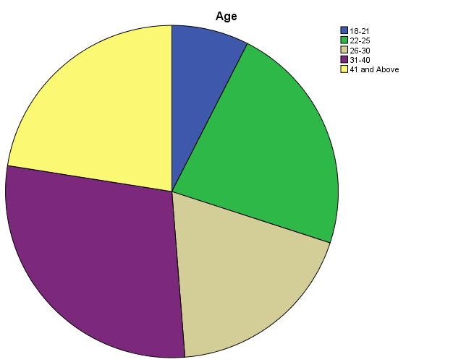
Figure 16:This Pie Chart of Respondents Age Group.
The lowest age groups were 18-21years which is 7.5% and 26-30 years which is 18.8% of the survey respondents, respectively. From the pie chart, it shows that more than 80% of the Aldergrove workforce falls within the youthful age groups, thus between 18-40 years. This depicts that, the study respondents were a mix of ages. Hence, this will enrich the data analysis of different opinions on waste management as data is from diverse age groups.

4.2.4 QUESTION THREE: RANK OF THE RESPONDENTS.
The question of rank was substantial to the study, as it could represent the level of experience and knowledge of the respondents. The survey result showed that 57.5% were Junior Non-Commissioned Officer (JNCO), 22.5% were Senior Non-Commissioned Officer (SNCO), 8.8% were Officers, and 11.3% were Civil Servant/Contractors. Hence, this indicates that the higher respondents were JNCO of 57.5%, which would not have any impact on the remaining answers to the questions within the survey because the study is a general camp waste issue, which does not require higher knowledge or working experience to understanding it.

4.2.5 QUESTION FOUR: CORP OF THE RESPONDENTS
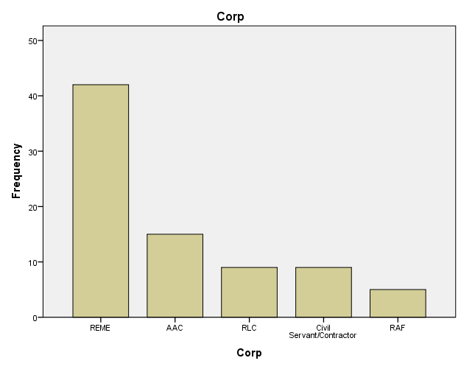

Figure 17: Respondents by MOD Corp Group.
The Figure 17 shows that, the Royal Air Force (RAF) has the lowest number of members at Aldergrove with 6.3%, 11.3% were Royal Logistic Corp (RLC) and Civil Servant/Contractors respectfully. The Air Army Corp (AAC) were 18.8% and 52.5% of Royal Electric and Mechanical Engineers (REME) depict that this survey mainly covered MOD REME Corp soldiers at Aldergrove. It means that on average every other respondent was from REME because the sample population chosen by the researcher was predominantly Aircraft engineers.

4.2.6 QUESTION EIGHT: CHI-SQUARE TEST ANALYSIS ON MIX OF RECYCLABLE & NON-RECYCLABLE WASTE OF IN OFFICE BIN VERSES GENDER.
There are numerous ways of identifying the effectiveness of waste management like waste contracting, correct disposal and segregation of waste. Here the researcher determined to test a claim that “incorrect disposal of waste in Aldergrove offices correlates with gender”. To conduct a Chi -square test, the researcher must make a claim and prove it. (By rejecting or accepting the claim).
H_{1:} There is No difference between males and females in finding mix of recycle and non-recycle waste in their office/workplace bin.
H_{1a:} There is a difference between males and females in finding mix of recycle and non-recycle waste in their office/workplace bin.
The researcher conducted a chi-square test to determine whether there is significant relationship between males and female’s finding mix of recycle and non-recycle waste been disposed in office bins or not see Table 4.2 for the SPSS output.
2. Table 4.2: The Output of Male’s and Female’s vs mix recycle and non-recycle waste in office bin Chi-square test.

Gender * Mix_Waste_in_a. Bin Crosstabulation
 |  |  | Mix_Waste_in_a. Bin |  | Total
 |  |  | Yes | No | Total
Gender | Male | Count | 53 | 7 | 60
Gender | Male | Expected Count | 54.0 | 6.0 | 60.0
Gender | Female | Count | 19 | 1 | 20
Gender | Female | Expected Count | 18.0 | 2.0 | 20.0
Total |  | Count | 72 | 8 | 80
 |  | Expected Count | 72.0 | 8.0 | 80.0

Chi-Square Tests
 | Value | df | Asymptotic Significance (2-sided) | Exact Sig. (2-sided) | Exact Sig. (1-sided)
Pearson Chi-Square | .741ª | 1 | .389
Continuity Correction^{s} | .185 | 1 | .667
Likelihood Ratio | .845 | 1 | .358
Fisher's Exact Test |  |  |  | .672 | .355
Linear-by-Linear Association | .731 | 1 | .392
N of Valid Cases | 80
a. 1 cells (25.0%) have expected count less than 5. The minimum expected count is 2.00.
b. Computed only for a 2x2 table
The Result of the Pearson Chi-square is (x= 0.741, p=0.389, df=1): x= chi square statistical value, p= significant(probability) value and df= degree of freedom. This result is statistically significant because the p value of 0.389 is > the Alpha value of 0.05. Therefore, we must Accept the Null Hypothesis: There is no significant difference between males and females in finding mix of recycle and non-recycle waste in their office receptacles and reject the Alternative Hypothesis.
The researcher wants to back up the above statistical result with percentage evidence that 88.3% male said they found mix of recycle and non-recycle waste in their office bins whereas 95% Female gave similar responses. Both percentages are close figures therefore there is No significant difference between gender in finding incorrect disposal of waste in their office bins proving that segregation process is very poor at the Aldergrove office level.

4.2.7 QUESTION TWELVE: T-TEST ANALYSIS OF RESPONDENTS WHO ATTEND THE MOD WASTE MANAGEMENT BRIEF AND CORRECTLY DISPOSE WASTE AT WORK.
The researcher utilised T-test this time to diversify the quaility of study data analyis and also to introduce the mean (standard devition) approach of indenpendent and dependant variables.
The researcher carried out an SPSS on independent Two-sample T-test on respondents who did and did not attend the MOD waste management brief and who correctly dispose of waste at work in order to compare two averages (means) to tell if they are different from each other. In other words, it let’s you know if those differences could have happened by chance.
The researcher’s thought behind this test is:
Does attending the MOD Waste Management Brief create a siginfcant difference between the number of respondents who disposed of waste correctly at work?
Before conducting the T-test on the SPSS, the researcher sampled two groups:
Group 1 ( “1 in our dataset”) is respondents who did not attend waste brief.
Group 2 (“2 in our dataset”) is respondents who did attend waste brief.
The researcher then set up a Hypothesis for the T-test is :
H₂: mean number of respondents who correctly dispose of waste for Group 1 ≠ mean number of visitors for who correctly dispose of waste for Group 2?
H₂a: mean number of respondents who correctly dispose of waste of for Group 1 = mean number of respondents who correctly dispose of waste of for Group 2?

3. Table 4.3a: SPSS Independent Sample T-Test on variables “waste management” and “dispose of waste correctly”.
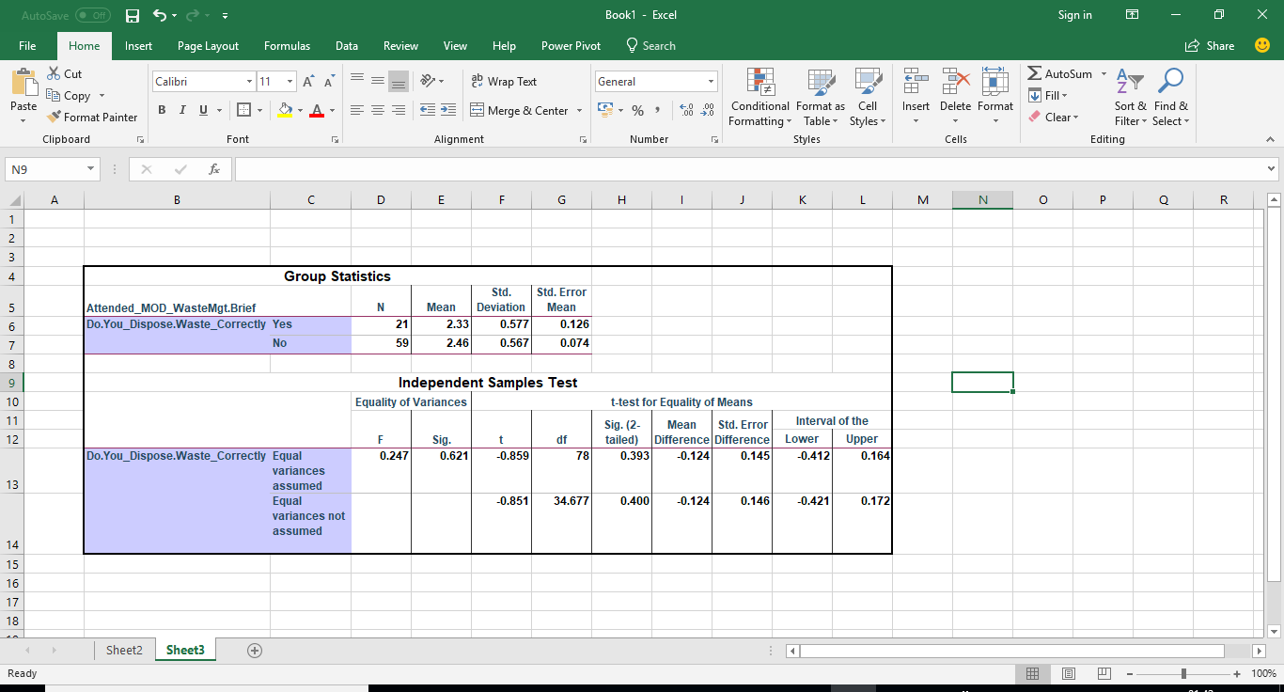

Looking at the Group Statistics Box (See Table 4.3a). The mean number of respondents who attended the MOD Waste Management Briefs which allowed them to dispose of waste correctly is 2.33 whereas the mean number of respondents who did attend MOD Waste Management brief, but it had No impact on their waste disposal was 2.46. Therefore, the research proves that there is a No significant difference between (2.33 and 2.46). Because there is a close mean, the researcher Accepts the Null Hypothesis and Rejects the Alternative.
To determine the conclusion of the T-test, the analysis must apply the rules below Table 4.3b as the sig (2 tailed) for the F-test.
The T-Test rule is, if the Alpha value ≤ P value then the researcher must Reject the Null Hypothesis and Accept the Alternative.

4. Table 4.3b: Independent Sample Test Box.
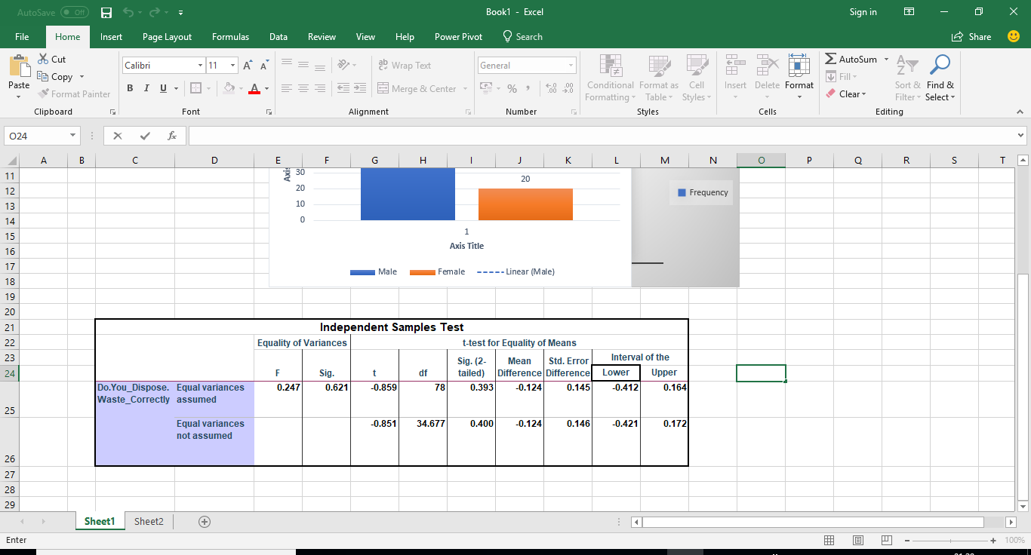
Then if Alpha = 0.05 using the bottom row, t=-0.851, p-value for this t-test is 0.400 see Table 4.2. Because the p-value 0.40 > 0.05, then the researcher must Reject the Null Hypothesis and Accept the Alternative. Therefore, the study can conclude from its T-test that there is significant evidence to support that attending the MOD waste management Brief does not affect the attitude of respondents to dispose of waste correctly at Aldergrove Barracks.

4.2.8 QUESTION SIXTEEN: ANALYSIS OF RESPONDENTS ON MOD WASTE MANAGEMENT POLICY IMPLEMENT EFFECTIVELY AT ALDERGROVE.
5. Table 4.4: SPSS Frequency Test on Respondents who thinks that MOD Waste Management Policy is implemented affectively at Aldergrove camp.
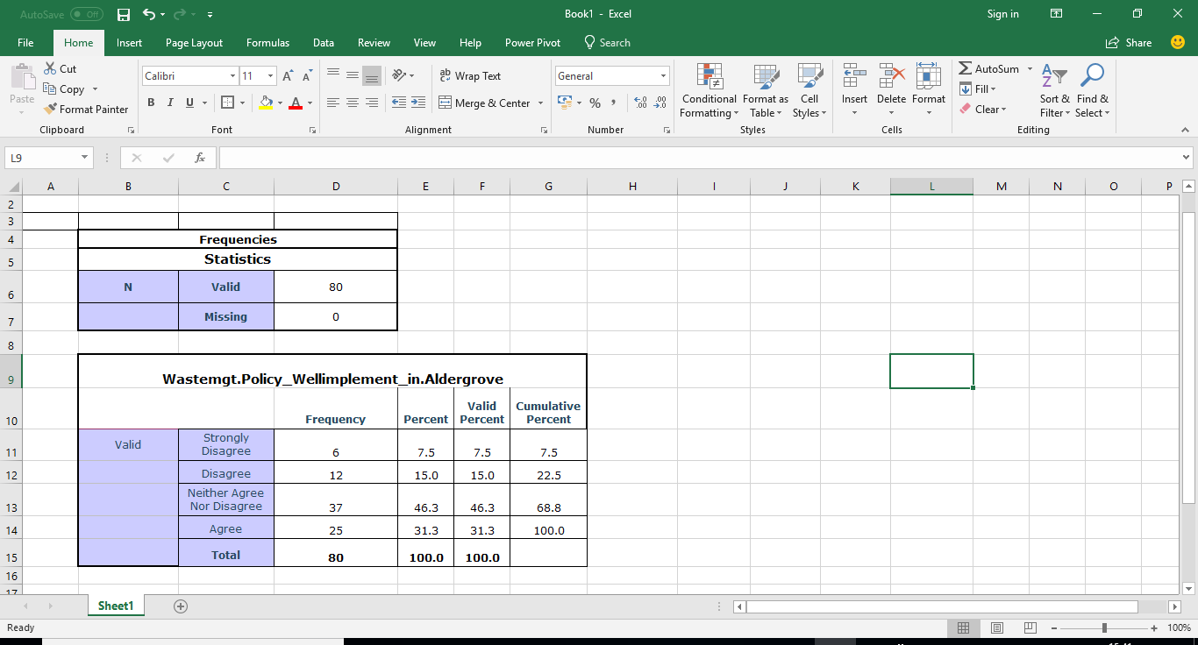
According to above analysis, 0% of the respondents strongly agreed that Aldergrove camp implements the MOD Waste Management policy well. However, 31.3% agreed that Aldergrove barrack implement MOD waste Management policy well and 46.3% which was the majority respondent neither agreed nor disagreed. The significance of this test proves that the exitance of the waste management policy to workers and if they are aware of that policy. It will serve as guide to their behavior towards waste management practice on camp.

4.2.9 QUESTION EIGHTEEN: CHI-SQUARE TEST ANALYSIS ON ALDERGROVE BARRACKS IS ENVIRONMENTALLY FOCUSED VERSE AGE.
H₃: There is an age influence on acknowledging that Aldergrove Barracks is environmentally friendly or focused.
H_{3a}: There is no age influence on acknowledging that Aldergrove Barracks is environmentally friendly or focused.
The researcher conducted a chi-square test to determine whether there is an association of Age influence on acknowledging that Aldergrove is environmentally friendly or focused or not (see the SPSS Output).
6. Table 4.5a: Chi-Square Test Analysis on Aldergrove Barracks is Environmentally focus verse Age.
Chi-Square Tests
 | Value | df | Asymptotic Significance (2-sided)
Pearson Chi-Square | 5.844ª | 4 | 0.211
Likelihood Ratio | 6.095 | 4 | 0.192
Linear-by-Linear Association | 4.551 | 1 | 0.033
N of Valid Cases | 80
a. 2 cells (20.0%) have expected count less than 5. The minimum expected count is 2.33.
The result of the Pearson Chi-square test is (x= 5.844, p=0.211, df=4). This is statistically significant and indicates that the Null Hypothesis must be Accepted: There is No influence of Age on acknowledging that Aldergrove is environmentally friendly or focused and Reject the Alternative.
According to table 4.5, 63.1% of respondents across various age groups said Aldergrove Barracks is environmentally focused based on its waste management practice whereas 38.8% of respondents said it’s not environmentally focused. Above all, the Chi-square test proven that the probability value is 0.211 is > the Alpha value 0.05. Therefore, on this test, the researcher must Reject the Null Hypothesis and Accept the Alternative because there is no significant relationship between age and acknowledged Aldergrove waste management (environmentally focused).
Age * Is_Aldergrove_Environmentally_Friendly Crosstabulation
 |  |  | Is_Aldergrove_Environmentally_Friendly |  | Total
 |  |  | Yes | No | Total
Age | 18-21 | Count | 5 | 1 | 6
Age | 18-21 | Expected Count | 3.7 | 2.3 | 6.0
Age | 18-21 | % within Age | 83.3% | 16.7% | 100.0%
Age | 22-25 | Count | 14 | 4 | 18
Age | 22-25 | Expected Count | 11.0 | 7.0 | 18.0
Age | 22-25 | % within Age | 77.8% | 22.2% | 100.0%
Age | 26-30 | Count | 8 | 7 | 15
Age | 26-30 | Expected Count | 9.2 | 5.8 | 15.0
Age | 26-30 | % within Age | 53.3% | 46.7% | 100.0%
Age | 31-40 | Count | 14 | 9 | 23
Age | 31-40 | Expected Count | 14.1 | 8.9 | 23.0
Age | 31-40 | % within Age | 60.9% | 39.1% | 100.0%
Age | 41 and Above | Count | 8 | 10 | 18
Age | 41 and Above | Expected Count | 11.0 | 7.0 | 18.0
Age | 41 and Above | % within Age | 44.4% | 55.6% | 100.0%
Total |  | Count | 49 | 31 | 80
 |  | Expected Count | 49.0 | 31.0 | 80.0
 |  | % within Age | 61.3% | 38.8% | 100.0%
7. Table 4.5b: SPSS Chi-square test on if Age influences the acknowledging that Aldergrove Barracks is environmentally friendly or focused or not.

4.3 THE SEMI-STRUCTURED INTERVIEW WITH ALDERGROVE CATERING MANAGER (SGT. DARYL PATTERSON).
Aim: The purpose of this interview was to engage directly with the Aldergrove catering house manager, who is a specialist in food waste management for 20 minutes. In order to attain his knowledge on Aldergrove Kitchen waste issues and potential solution to those issues. Finally, to seek his opinion on whether Aldergrove catering department manages its waste effectively or not.
Q1. Interviewer: Which kinds of waste does your cookhouse produce and how do you dispose of them?
Interviewees: Answer
From the manager answers, the researcher confirmed that the cookhouse always produces three kinds of waste categorised into FOOD, WASTE OIL and GENERAL WASTE.
- FOOD: The researcher noticed that the kitchen staff ensure that all food wastes are separated into storage and disposed of daily. All wasted food is bagged, disposed of into the brown rood Receptacle and quarantined for collection.
- WASTE: The researcher detected that kitchen staff dispose of all the waste oils into empty oil drums waiting for waste collecting company for collection.
- GENERAL WASTE: Sgt Patterson said that the kitchen staff separate all their general waste into two groups (recyclable and non-recyclable). This means that, all the recyclable waste like bottles, cardboards, cans and plastics are disposed into a blue receptacle for disposal, whereas the non-recyclable’s put into the general receptacle for disposal. This waste segregation practice is clear evidence of a good waste management by Aldergrove kitchen staff.

Q2. Interviewer: Do the kitchen staff practice waste prevention and recycle their waste? If Yes, how do they practise it?
Interviewees: Answer
According to his formal answer, it was clear that the Aldergrove Cookhouse staff recycles a lot of waste, nonetheless they practise less prevention of waste. On the waste prevention, he said that they DO practice it based on the HOT PLATE RECOVERY principal (HPR). In addition, the staff annual training from Aramark company re-enforces them to apply waste prevention by reusing of food by testing the food condition. Most of the time, this prevention practice must be satisfied by the cookhouse managers and recorded.
Q3. Interviewer: Do you have a waste policy? If Yes, how do you comply with it?
Interviewees: Answer
Sgt Patterson said YES, they do. He further explains that all their waste policies can be found on the Aldergrove Mosses site. It enforces him to conduct Weekly checks, Monthly checks and an Annual check (LSI) which is conducted by 38 Brigade Chief Officers or Food Service Warrant Officer (FSWO).
Q4. Interviewer: How Much do you pay the waste Disposal Company for disposing of your Kitchen waste?
Interviewees: Answer
Based on Sgt Patterson answer, the researcher concluded that he is not sure of the financial or any contractual agreement between the MOD-Aldergrove and their disposal companies. But according to the researcher’s study, the Defence Infrastructure Organisation (DIO) pays Aramark for all kitchen waste disposal.
Q5. Interviewer: How often does the company collect your waste?
Interviewees: Answer
Waste Food- Collection of food waste is done on a weekly basis. The manager calls DIO office and they arrange with the company for collection.
Oil Waste-This waste is disposed by the VEOLIA third party waste disposal company on a call basis. No time arrangement.
General Waste- weekly or twice weekly collection. The general waste is disposed by third party waste collection via the Aramark company.
Q6. Interviewer: If Aldergrove Flying Station were to improve its waste management System, which areas would you recommend for improvement?
Interviewees: Answer
Analytically the researcher founds that Sgt Patterson has few waste management setbacks which can be looked at and improve on:
- The Problem on dealing with new contractors, most time they delay on the collection of kitchen waste.
- Mis-contractual agreement between DIO, Aramark and third party.
- Aldergrove Security Group requires 72hours notice to allow waste disposal companies to enter the barracks for collection. This has become a problem for waste disposal. The Commanding officer of the Barracks must investigate on this area for the solution to improve the Aldergrove waste management because it may affect the camp Health and safety in general.
- After waste has been collected, his kitchen staff have to wash the empty food waste receptacles but according to the Food Safety and Health. They must avoid cleaning waste bins in the kitchen. The Barracks need to task another department to embark on this job. He recommended that the Aldergrove recycling Department must deal with that.

4.4 THE SEMI–STRUCTURED INTERVIEW WITH ALDERGROVE RECYCLING DEPUTY MANAGER (MR. PADDY LYNN).
Aim: The purpose of this interview was to engage directly with the Aldergrove Recycle Center management on waste disposal for 15 minutes. Also, to attain their opinions on disposal waste issues and possible solution to those issues. Finally, to seek his opinion on whether Aldergrove managed its waste effectively or not.
Q1. Interviewer: Which Kinds of waste do people dispose of here?
Interviewees: Answer
According to Mr. Lynn’s response, the researcher analysed that most of the waste disposed of at the centre was cardboard/paper, metal, wood, general household waste and electronic waste.
Therefore, it was noticed that there is NO food waste metal skip at the centre. The study will recommend to the authorities that they should install a food waste skip at its centre.
Q2. Interviewer: Which days do you operate and how often do people visit this centre for disposal?
Interviewees: Answer
Based on Mr Lynn’s feedback, the center operates from Monday to Thursday from 08:00-15:00 but on Fridays 08:00-12:00. He further said that most of the time the centre is busy receiving waste from its costumers (department and House). Based on Lynn’s response the researcher recommends that Friday half day opening timing must be extended to 15:00 because most workers clear their workshop and office on Fridays before closing for the weekend. Then, 15:00 closing will create availability for users.
Q3. Interviewer: Do you have a waste policy? If Yes, how do you comply with it?
Interviewees: Answer
Mr Lynn said YES, they do. Further responses prove that, the waste policy is manually held at the site. MOD rule enforce the centre personnel to conduct weekly checks, monthly check. More so, an annual check is conducted by the MOD Health and safety Team from England yearly.
Q4. Interviewer: How many tonnes of waste does Aldergrove produce? Of this, how much is recovered waste or goes to landfill? What was the total cost of the first quarter of this 2018?
Interviewees: Answer
Mr Lynn didn’t have the information at hand however, he referred the researcher to the 38x Brigades environmental officer, Mr Jim Patterson. After speaking to Mr Patterson on 14/05/2018, he said in brief that Aldergrove’s quarterly waste produced costing over £50,000 (1st quarter 2018). See Table 4.6 and Appendix T, U V AND W for full details. The approximate Landfill diversion Rate were Jan (93%), Feb (92.67%), Mar (93.21%) and Apr (92.92%). This means that Aldergrove had made waste management progress in minimising its tonnes waste that convey to Landfill by 0.08% in the 1st Quarter2018.

8 Table 4.6 The Total Cost of Waste that goes to Landfill after Aldergrove waste recovery (Jan 2018-Apr2018).
Month/ Year | Total Waste (Tonnes) | Waste Recovered (Tonnes) | Waste to Landfill (Tonnes) | Total Cost
Jan,2018 | 102.296t | 95.13t | 7.16t | £13,363.16
Feb,2018 | 98.414t | 91.2t | 7.21t | £12,472.04
Mar,2018 | 100.822t | 93.98t | 6.84t | £12,702.52
Apr,2018 | 93.846t | 87.2t | 6.64t | £12,261.66

Q5. Interviewer: How often do the Waste Disposal company collect the waste?
Interviewees: Answer
The researcher identified that the RIVER Ridge Recycle collectors are the camp waste collector and they are very effective on waste collection. They collect the general waste skip each week and the other skips are collected when they are full through the center manager arrangement collection with Defence infrastracture Organistion (DIO)

Q6. Interviewer: Is MOD-Aldergrove Barracks waste Management System effective, if not, which areas would you recommend for improvement?
Interviewees: Answer
According to his feedback, the reseacher analysised that Aldergrove Barracks manages its waste effectively because standard waste management actitives are implementated and it passed it’s recent waste inspection. However it’s authorities have to educate new workers about waste segragation because most of waste disposed of the centre were a mix of recyclable and general waste. Meaning, some new workers are uneducuated on camp waste management policies.

4.5 THE SEMI-STRUCTURED INTERVIEW WITH MAJOR. JOHN LINEGAR QUARTER MASTER (QMS) OF ALDERGROVE.
Aim: The purpose of this interview seeks Maj. Linegar -QM (Chairman member) of waste committee, 24 years of MOD experience, knowledge and opinions on Aldergrove waste management which lasted for 12 minutes.
Finally, to answer whether Aldergrove Station manages its waste effectively or not.
Q1. Interviewer: As the QM of Aldergrove, what are your primary roles in waste management for the camp?
Interviewees: Answer
According to Major Linegar repsonse, the researcher analysied that he ensures that all areas of Aldergrove under his responsbility are kept clean and up to standard by creating platforms to educate soldiers on waste. Furthermore, ensuring that all departments are managing their waste effectively and also that waste contractors are delivering their service efficiently by disposing certified landfill waste to Northern Ireland landfill sites corrcetly in order to avoid landfill charges.
Q2. Interviewer: In which areas at Aldergrove do you think waste has been undermanaged and how could Aldergrove authorities must improves on them?
Interviewees: Answer
Major Linegar said that there are a few areas of concern. He mentioned that the lid covers of the camp industrial bins, which are plastic, are not strong enough to withstand the weather (wind). According to his feedback the research analysed that some have rusted, and these bins lids cannot close properly. Anytime its windy they open and waste paper and plastic fly out. Meaning, this can cause danger to an aircraft as Foreign Object Debris (FOD) causes fight safety issue. In solution, camp emergency cleaning staff respond hastily to the situation and clear the area. He also cited that the authorities are fully aware of the situation (7 years old bins) and they are looking at procuring new industrial Bins. The researcher recommended that they should purchase bins with specific waste information not only general waste information to assist waste segregation.
Q3. Interviewer: A New company has taken over our waste management on Camp. Could you please explain: Why did it happen and What are your expectations from the new company?

Interviewees: Answer
Major Linegar confirmed that Aldergrove waste management has been handed over to a civilian company (Carillon Aramark) as a National order from UK MOD HQ. This transition started four years ago across England MOD camps, but camps in Northern Ireland and Scotland have only experienced this change recently. He further explained that this contracting was not on waste management alone but for catering, cleaning, stationary materials supply and other services purposely to be more effective, and cost saving.
Q4. Interviewer: This study has reviewed that all offices at this camp utilising black metal bins and it has recommended for a change to modern office bins (Waste segregation). What are your views (Necessary or Unnecessary) and if necessary, how would you advise that change?
Interviewees: Answer
He admitted that even the MOD is behind many modern implementations. He categorically mentions health and safe policies. He justifies the delay as a lack of funds from the Government. On the office black metal bins, he confirmed that they must immediately change to modern bins. He encouraged the researcher to input a proposal for office bin change by promising to give out an insert to support it. The researcher asked him about funding in case the proposal is accepted. Major Linegar advised that, one of these: Joint Helicopter Command (JHC), 38x Brigade and Aldergrove Budget funds accepted proposals. Or the researcher must publish the proposal via defence Gems or Kits magazines, so that it could be selected for implementation.
Q5. Interviewer: On a scale of 1- 10, how would you score the effectiveness of the current waste management on camp?
Interviewees: Answer
According to Major Linegar, he scored the effectiveness of waste management on camp at 7/10. Meaning that it has effective waste management but 3/10 leaves room for improvement on reasons like:
1. Lack of good industrial bin lid that sometime causes aviation FOD.
2. Lack of modern office bins for segregating waste to reduce cost of mixed waste and landfill charges.
3. Lastly, Major Linegar could not score Aldergrove waste management above 7 points because of a lack of recruit or posted soldier’s knowledge on waste management.

4.6 THE FIELD EXPERIMENT AT ALDERGROVE BARRACK FROM 1/02/2018-21/04/2018.
Aim: A Field Experiment was set up by the researcher for a one-month period at three waste skip positions to observe the disposal behaviour of the public at ALdgerove Barracks (see Table 4.6).
9. Table 4.7: The Research one-month Field Experiment Output.
Skip Number | Areas | Finding/Output
Waste Skip 1: | NAAFI Car Park | The researcher found that the skip gets full quickly.It mainly gets filled with plasctic, cardboard and food packaging waste.
Waste Skip 2: | Guard Room | The researcher identified that this skip does not get full quickly. He found some glass, paper, cardboard and wood in this skip. Those who dispose of Waste in this skip are the Millitary Police Guard Service MPGS Guard personals and a few public padestrians.
Waste Skip 3: | JNCO Accommondation Park | The researcher found that skip 3 get full every week. He found that the waste was made up of everything like glass , food, cardboard, broken chairs, mattresses, clothing and sensitive information(books/ Papers). This wastes was disposed of by the JNCO soldiers posted out from the Barracks as they clear their personal holding from their room for the Quarter Master to hold over.

CHAPTER 5: CONCLUSION AND RECOMMENDATIONS

5.1 INTRODUCTION.
This chapter is categorised into two main parts namely: Conclusions and Recommendations. The conclusion part will consist of substantial findings from the literature review, survey testing (questionnaire), semi-structured interviews and field experiment observations. It will then draw its conclusion on each result of various opinions and sample testing on the main study hypothesis as the general result of the study. This chapter will also highlight the numerous hindrances (limitations) encountered in the process of the research and analyse its impact on the overall research and findings. The final part puts across a set of recommendations for effective waste management which, if properly implemented by the main beneficiaries of the study, such as UK MOD and Aldergrove Barracks CoC, would improve waste management across most MOD Establishments. Furthermore, it can also be seen in the recommendation section, that further study on this subject is necessary to enhance knowledge and understanding and increase awareness which would in turn help improve waste management by the MOD.
5.2 FINDINGS FROM SECONDARY DATA.
This research study has thrown more light on what various writers had said on the importance of establishing waste management in a community and in an organisation (Army). It revealed the benefit of Waste Management as saving energy because new products manufactured from recycled aluminium consumed 97% or less energy whereas recycled steel products use 75% less energy. This proves that manufacturing from recycled waste saves energy and lowers cost.
It revealed that waste management brings to the MOD the acknowledgement of cultivating a green environment for its community. Furthermore, it emphasises the need to increase awareness on waste management within the UK Military.
The study revealed that waste management is one of the greatest job creation sectors across Europe. To put this in perspective, it is projected that some 322,000 direct jobs, 160,900 indirect jobs, and 80,400 induced jobs could be created in the waste management sector across Europe if an estimated target of 70% recycling was met. Firstly, this is an estimate of over half a million potential new jobs in waste management and the economy at large. Most importantly, it is a fact that these potential new jobs would directly improve waste management by assisting the processing of an additional 115 million tonnes of recyclable waste across the continent of Europe. In relation to this study Aldergrove’s waste management sector contributes to UK waste management Jobs, so it needs sustainability.
It was revealed that waste management processes are not always cheaper as previously thought. In fact, the process sometimes needs huge funds, time and land to set up a plant, not forgetting operational costs. For example, its cost £50 per ton for dumping waste in the landfill whereas it cost £150 per ton to recycle it. It’s clear from that waste dumping as three times cheaper and less time-consuming than waste management (Tilley, 2017).
Furthermore, the study revealed that recycled products have a shorter lifespan than unrecycled products via realism and other researchers. The durability of recycled products have shorter shelf lives however they are more environmentally friendly or cost-effective than products manufactured from the original direct raw materials.
This study found that waste management sites like recycling centres are the most dangerous places posing a high risk to human health. These high health and safety risks associated with these sites is directly related to the amount of deadly and poisonous substances like explosive and toxic waste handled there. Waste sites are highly vulnerable to developing fungal and bacterial growth, which are the causative agents of many diseases. Therefore, Aldergrove camp has to monitor the level of dangerous substances dispose of at its recycle. By providing personal protective Equipment (PPE) to site workers and displaying Health and safety information & directives for visitors.
It was revealed that the MOD has a well-structured waste strategy called Waste Management Strategy. In which, it aims that all camps shall: “Become a zero to waste landfill organisation” (MOD 2010, p3). The primary target of this strategy was to reduce the total amount of waste produced by 5% by 2010/11 and 20% by 2016/17 as mentioned in the Sustainable Development in Government. Furthermore, it aims to increase waste recovery, re-use, recycling, composting and energy production from waste by 40% by 2010/11 and 80% by 2016/17.
5.3 FINDINGS FROM THE SAMPLE SURVEY DATA ANALYSIS.
It was revealed that more than 80% of the Aldergrove Flying Station’s workforce falls within the youthful age groups, thus between 18-40 years. This demonstrates that there is a higher youthful workforce, which the MOD can tap as resources and Aldergrove can depend on in future. In relation to the camp waste awareness, the CoC has to concentrate on educating the youthful generation.
It was also revealed that 3/4 of the respondents were male and 1/4 of the respondents were female. Showing that the study was gender biased and proved the imbalance of Gender equality of UK MOD Recruitment System. Therefore, the research results are highly influence by Male opinion than Female.
When it comes to the rank structure in the sample population, the research revealed that 57.5% were Junior Non-commissioned Officer, 22.5% were Senior Non-commissioned Officer, 8.8% were Commissioned Officers, and 11.3% were Civil Servant/Contractors. This implied that Aldergrove JNCO were the majority population who participated in the questionnaire survey compared to other ranks.
The study used the SPSS to conduct Chi-square test on the mix of recycle and non-recycle waste disposed of in bins verses gender. The study found that: There is no significant difference between males and females in finding mix of recycle and non-recycle waste in their office bins. Therefore, it will accept the Hypothesis and reject the alternative hypothesis. Statistically, the SPSS result of the Pearson Chi-square was (x= 0.741, p=0.389, df=1) because the probability value (P Value) 0.389 > 0.05 (Alpha Value). The researcher must reject other opinions that (H_{1a:} There is a significant difference between males and females in finding mix of recycle and non-recycle waste in their Office/Workplace Bin).
Though, the T-Test Analysis proved the mean number of respondents who did not attend the MOD Waste Management Brief which caused them to dispose of waste correctly was 2.33 whereas the mean of respondents who did attend MOD Waste Management brief affected their decision to dispose of waste correctly was 2.46. There was no significant difference between means (2.33) and (2.46). As there is a close mean, the study must accept the Null Hypothesis and reject the Alternative. Additionally, if the P-value 0.40 > 0.05, then the researcher must accept the Null Hypothesis and reject the Alternative. Therefore, the study can conclude from its T-test that, there is significant evidence to support the fact that attending MOD waste management brief does not affect the attitude of respondents to dispose of waste correctly at Aldergrove.
The study discovered that 31.3% of the respondents agreed that Aldergrove implements the MOD Waste Management policy well while 46.3% of the respondents neither agreed nor disagreed. Nevertheless, none of the survey respondents strongly agreed that Aldergrove station implements the MOD Waste Management policy well. This means, most of the respondents are not fully aware of waste management policies at camp although they are aware of its general normal practices. Therefore, the study will recommend the implementation of the Waste Management Policy Publicity Strategy to the Aldergrove CoC.
Furthermore, the study tested if age has influence on the environmental friendly questions. Via the Pearson Chi-square, it resulted that (x=5.844, p=0.211, df=4) is statistically significant and indicates that the Null Hypothesis must be accepted: There is no significant influence of age on acknowledging that Aldergrove Barracks is environmentally friendly or focused and reject the Alternative because the research proved that the probability value is 0.211 which is > 0.05.

5.4 FINDINGS FROM A SEMI-STRUCTURED INTERVIEW WITH THE ALDERGROVE CATERING MANAGER.
The research revealed that the Aldergrove kitchen produces food and general waste. This waste is always collected by the private disposal company via a subcontracting from the Aramark Company contracted by MOD Defence Infrastructure Organisation (DIO). It was also revealed that kitchen waste oils were collected by VEOLIA, a third-party waste disposal company on an ad-hoc basis.
It was revealed that some waste disposal companies sometime refuse to collect kitchen oil waste due to misapprehension of the waste disposal contract between DIO, Aramark and third-party.
It was also revealed that 72 hours notification to enter the Aldergrove Station due to Northern Ireland security reasons has had negative impact on the waste collection programme (cookhouse waste collection). This caused some of the camp receptacles and skips to overflow as waste collectors are waiting to meet 72hours entrance clearance.
Finally, it was discovered that, the kitchen staff wash their food waste receptacles after collection but according to the Food Health and Safety it should be done by different personnel.

5.5 FINDINGS FROM SEMI-STRUCTURED INTERVIEW AT ALDERGROVE RECYCLE DEPUTY MANAGER.
There was not much found during the semi-structured interview with the Aldergrove recycle deputy manager. However, one significant discovery was that, the centre does not have a food waste metal skip. This is affecting the general household waste skip, making it overflow its capacity.
Furthermore, it was found that Aldergrove’s total waste produced from January 2018 to April 2018 was 395.378t. Which amounted to £50,829.38 see Table 4.6.
It was also revealed that Aldergrove recovers approximately between 92% to 93% of its waste produced per month. Therefore, this waste recovery helps it to avoid over £7,000 landfill tax per month.
It was revealed that the landfill tax incurring per month has reduced from £608 to £560.88. This proves that Aldergrove’s waste management is improving.

5.6 FINDINGS FROM THE QUARTER MASTER ON A SEMI-STRUCTURED
INTERVIEW:
This interview unveiled a lot of information on Aldergrove’s waste management and it interrogated Major Linegar who has the role as the QM of the station.
It was found that the weather has affected most of the compound’s bin lids making them weaker. Due to this, waste is exposed which cause FOD for aircraft. It was discovered that emergency cleaners respond swiftly to those incidents to clean the surrounds. Major Linegar mentioned that the authorities are aware of the situation and they are in the process of procuring new industrial bins
He fully supported the office bin change proposal (from old metal bins to modern office bins) and advices it to be published in Defence Kits Magazine or Gem. It was revealed that funding would be generated from the 38x bridges, JHC or the Aldergrove Budget.
It was also revealed that in the past 4 years a lot of changes have happened at MOD camps at England. However, Scotland and Northern Ireland managerial changes like pay as you dine, and stationary support have been delayed. The waste management of Aldergrove has been contracted to Carillion Aramark purposely for cost saving.
Finally, He scored Aldergrove waste management effectiveness at 7/10, accepting that there are 3/10 as rooms for improvement due to reasons like:
1. Lack of proper industrial bin lid that sometime cause aviation FOD.
2. Lack of modern office bins for segregating waste to reduce cost of mixed waste and landfill charges.
3. Lack of newly recruited /posted soldier’s knowledge on waste management.

5.7 FINDINGS FROM THE FIELD EXPERIENCE AT ALDERGROVE.
Waste Skip 1: The study found that this skip gets full quickly due to the high volume of use by customers who purchase goods from the NAAFI shop. It particularly gets filled with plastic, cardboard and food packaging waste.
Waste Skip 2: This skip is being used by the MPGS personnel, Guard visitors and a few road pedestrians. It was found that, a mix of food waste and plastics were disposed into it. Because its located at near the front guard room, therefore must be highly monitered due to security reason (it could be used to smuggle security weapons from the MPGS to the Northen Ireland Public).
Waste Skip 3: This skip is filled with glass, food, cardboard, broken chairs, mattresses, clothing and sensitive documents (Bank statement, personal letters and telephone bills). It was found that the JNCO soldiers posted out from the Barrack’s disposed of their waste as they clear their personal belongings from their room.

5.8 ADDRESSING THE SIGNIFICANT OBJECTIVES AND THE HYPOTHESES OF THE STUDY WHICH WAS SET IN CHAPTER ONE.
Objective 1: To investigate how waste is disposed of on camp and whether current facilities are sufficient. The study discovered that most of Aldergrove’s waste is disposed of via smaller receptacles and larger skips. They get collected by the office cleaners from offices to the station recycling centre. Currently, there are over 60 larger waste skips around camp. Every office has at least a metal bin and access to one station recycling centre. These facilities are not sufficient to accommodate the waste on camp. This objective was achieved based on the study findings.
Objective 2: To investigate what training and development programmes are necessary to improve waste management on camp. The research found that currently there is no waste management training conducted at Aldergrove to help develop its personnel and to improve camp waste management. The study recommends regular waste training from MOD waste management team to Squadron waste representatives. This objective was partially achieved due to lack of waste management expertise and waste management training development information.
Objective 3: To investigate the total annual cost of waste produced at Aldergrove. The study establish that the cost of waste produces at Aldergrove Flying Station was £50,829 per first quarter 2018. This objective was achieved based on the study findings.
Considering all the above findings from the study. The study must accept that:
H₀a: Aldergrove Flying Station manages its waste effectively.
And REJECTS the Hypothesis NULL (H₀: Aldergrove Flying Station does not manage its waste effectively).

5.9 LIMITATIONS OF THE STUDY.
Although there was adequate planning and preparation for this study, and the research objectives have been largely met, there were a number of unavoidable limitations encountered in the course of the research.
First of all, it was discovered early on that there is inadequate waste management literature which relates to MOD Operations at the university, online and in local libraries. This meant the research could rely only on very limited sources for information. Therefore, this made the research utilised mostly online news articles and journals as its main source of the study information extracted. Though it was limitation however, it did not have negative impact on the study information quality.
The second limitation relates to time management. The study was conducted by a full time employed military person, who is sometimes tasked to go on military duties and exercise. This meant that the researcher sometime failed to follow the research proposal planner due to work commitments. The effect was; Most of the study was therefore carried out on unplanned schedule.
The third has to do with the distribution and collation of questionnaires. Although, there were a total of 150 questionnaires distributed, only 90 questionnaires were received back. Out of these, only 60 were in good shape to be used for the data analysis. This drastically reduced the original intended sample size by 47%.
The fourth limitation was a geographic problem. The researcher, based in Northern Ireland, could not have face to face discussion with the supervisor who is situated in England due to distance. All discussions were therefore done by telephone and emails, which sometimes limited the intent of some suggestions.
Measuring the waste found in the designated assigned skips on the field Experiment was extremely difficult. Therefore, this very important part of the methodology had to be substituted with field observation plans instead for the study Field Experiment Analysis.
Finally, the main manager for the Aldergrove recycling centre who had agreed to be interviewed for the study was on his Annual leave, which constrained the researcher to interview the Deputy manager (Mr, Paddy Lynn) in his place.

5.10 RECOMMENDATIONS OF THE STUDY.
Based on the data analysis and findings of the study, I would like to put forward Ten recommendations to the main study beneficiaries i.e. Aldergrove Barracks CoC, MOD DIO and Employees. There are also other recommendations for students who would intend to conduct a similar research with respect to the MOD or in other industries.
These recommendations are:
1. The Station QM must ensure that waste management publications such as Waste Management Posters are distributed around the camp to educate and improve prevention of waste. The Aldergrove waste committee has to conduct a frequent waste training session or encourage all workers (soldiers) to complete waste disposal training on DLE as it’s cheaper form of waste management education.
2. Aldergrove CoC must replace its office old waste bins with the modern waste receptacles which display recycle disposal symbols and texts like papers, can and food). Major Linegar predicted that it will be costly. Then to reduce the suggested new modern waste receptacles, they can provide some modern waste receptacles at advantage points (office corridors).
3. Repaint all Aldergrove rusted metal skips with a display disposal waste specific information on them. These will create opportunity for users to segregate primary wastes which will lead to less disposal charges for mixed waste (cost saving).
4. All working departments (Squadrons) should appoint their own waste management representative with the responsibility of managing waste in their areas and reporting to the Regimental QM.
5. The Aldergrove CoC and QM must nominate different personnel to wash up the empty Food waste Bins at the Kitchen to avoid breaching MOD Food Safety Policy.
6. The JNCO Accommodation waste area must be frequently inspected by the Aldergrove QM. Secondly, it’s recommended that the Aldergrove CoC must provide larger metal skips for wood, metal and general household at the Aldergrove JNCO accommodation area to avoid overflow of waste. Due to Cost implication for the acquiring of new larger skips to avoid waste overflow. It’s also recommended that; the QM should pre-book for more frequent waste collection at the JNCO accommodation area.
7. The UK DIO must set up some key performance indicators to monitor waste disposal contractors in order to determine the annual waste appraisal for the various military camps.
8. Ensure external waste receptacles are always covered when not being used. This is key for flight safety and to prevent the contents getting wet which increases the price of disposal. Additionally, all broken skip lids must be replaced.
9. There must be a waste management arrival briefing for new contractors, visitors, civil servants and newly posted soldiers on their responsibilities to camp waste management.
10. Other students could research whether the cost of running waste management at Aldergrove camp by Military personal is higher and more inefficient than civilian contractors or vice versa. Also, they could research on the estimated cost of replacing the office bins with modern waste receptacles across entire Aldergrove against the costing of mix wastage to landfill charges.
11. For the above research recommendation to be implemented in order to in the Aldergrove effectively. It’s also highly recommended to Aldergrove CoC to implement or provide these proposed resources and cost centres in below table:

10. Table 4.8 Proposed Waste Management Resources and Cost Centres
Proposed resources and cost Centers | Estimated costing per annual
Provision of Personal Protective Equipment (PPE)for the cleaners, recycle site workers and other wastes user on camp. | £ 2,000
Payment of meeting allowances to Aldergrove waste management committee per each quarter (4 Times x 12 Pax x £80/member) | £3,840
The hiring of waste management training expertise to train the Aldergrove waste users and soldiers. (Hiring and other training costs) | £4,000
Cost for waste management publication like a leaflet, journal, poster, and magazine to inform and educate Aldergrove population | £2,500
Acquisition (hiring) of additional metal skips (8 yards) and larger plastic bins for the compound waste. Hiring Cost (£213 x 6 skips) | £1,278
Procurement of new modern office bins for office areas i.e. over 30 office (£54.99 x 30) | £1,759.68
Maintenance of metal skips by repairing of broken lids, repainting of its rusting bodies and rewriting of recycling instructions. | £1,500
Creating of waste management Incentive Scheme Programme to mutative the recycle site staff and other wastes user like soldiers and contractors. Cost of annual recycling awards | £200
ESTIMATED TOTAL COSTING per annual | £ 17,077.68

Chapter 1: Appendix Lists:
1. Appendix A: History UK Defence spending from FY 2000 to 2017.
Source:http://www.ukpublicspending.co.uk/uk_defence_spending_30.html.
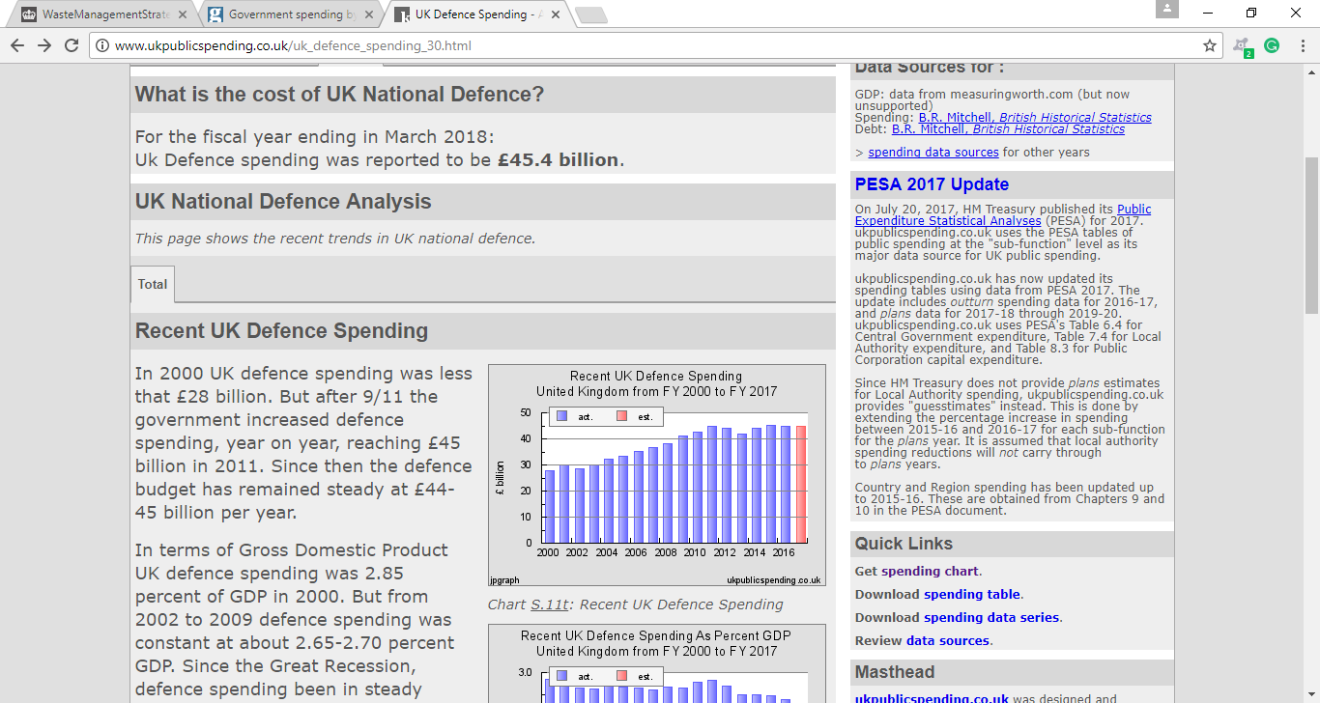
2. Appendix B: Aldergrove Barracks offices waste bins
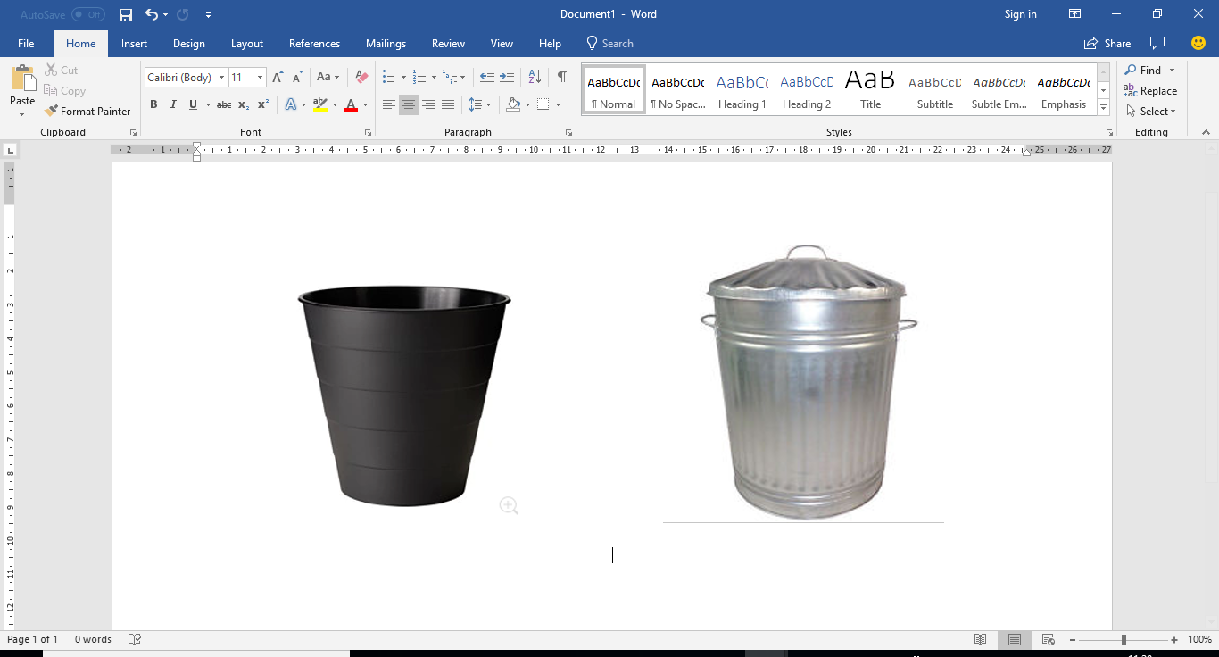

3. Appendix C: Modern office Recycle Bins
Sources: https://www.workspacedesigns.co.uk/office-recycling-bins-c102x2318468 andhttps://www.flexiform.co.uk/products/recycling-units
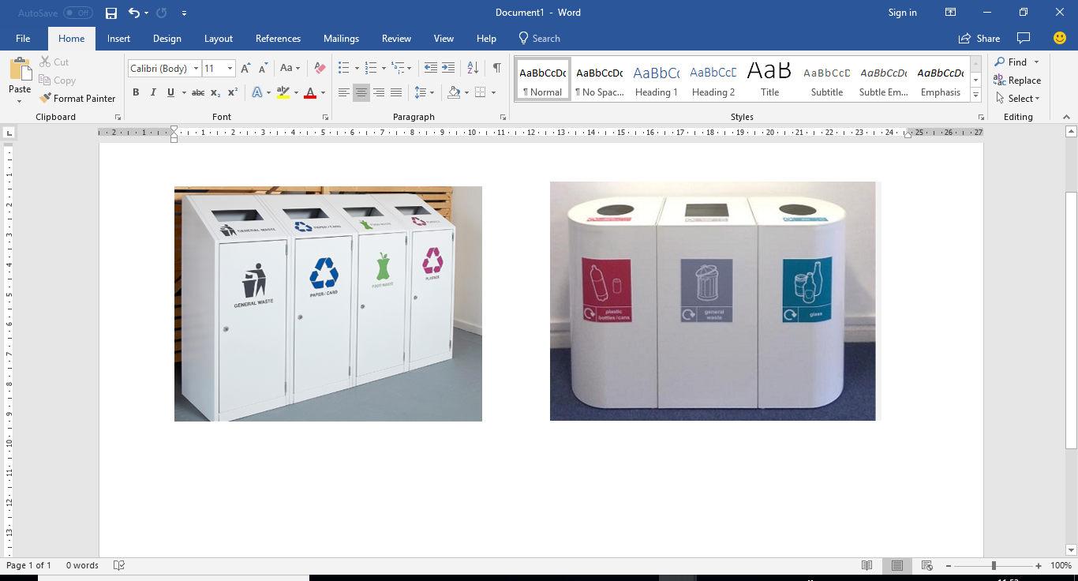
Chapter 2: Appendix Lists:
4. Appendix D: Index of GVA over time of the Waste Management Sector and the Whole Economy in Constant Prices (CVM Measure).
Source : https://resource.co/article/waste-and-resources-sector-brings-41-billion-uk-economy-9822
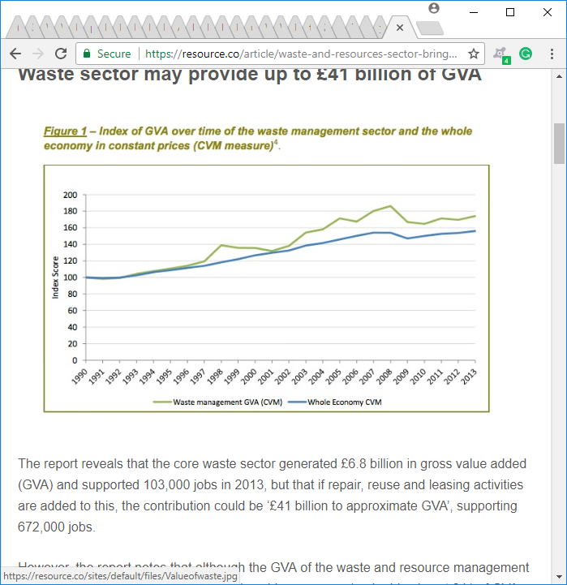
5. Appendix E: Historical trend of methane (CH4) emissions from landfill and waste management sector, UK, 1990 – 2015 (Waste Prevention Metric).
Source: https://www.gov.uk/government/statistics/final-uk-greenhouse-gas-emissions-national-statistics-1990-2015.
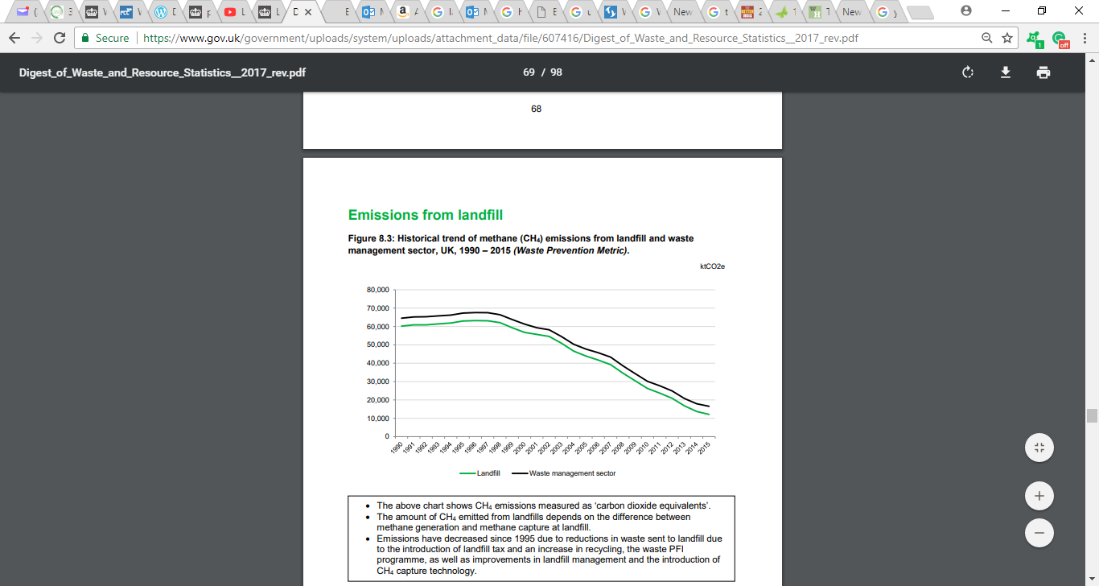
6. Appendix F: DIY No-Sew Zipper cases.
Source: Pal (2016), Green Living: 20 Ingenious Ways to Reuse Plastic Bottles Instead of Trashing Them, published on 16/06/2016,7:27pm [online] https://www.thebetterindia.com/58509/reuse-plastic-bottles-reduce-pollution-waste/. Accessed on 26/03/2018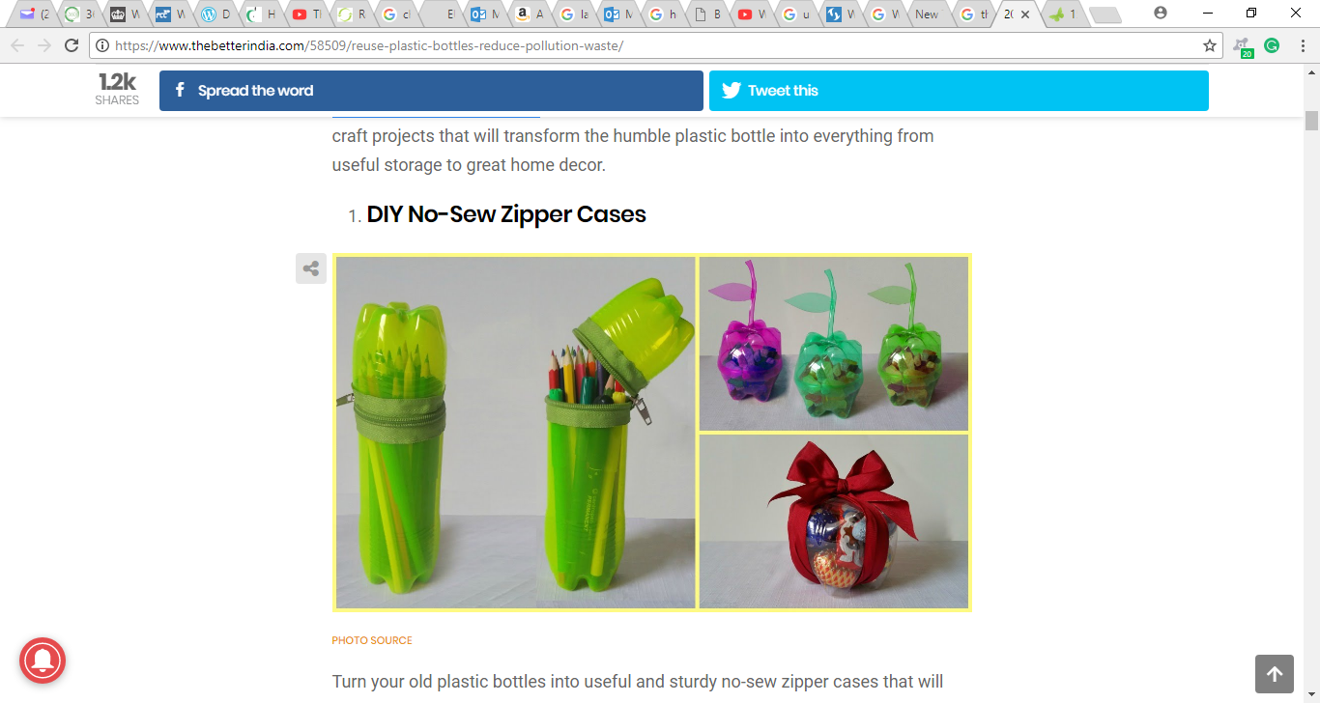

7. Appendix G: Plastic Bottles Drip Irrigators.
Source: Pal (2016), Green Living: 20 Ingenious Ways to Reuse Plastic Bottles Instead of Trashing Them, published on 16/06/2016,7:27pm [online] https://www.thebetterindia.com/58509/reuse-plastic-bottles-reduce-pollution-waste/. Accessed on 26/03/2018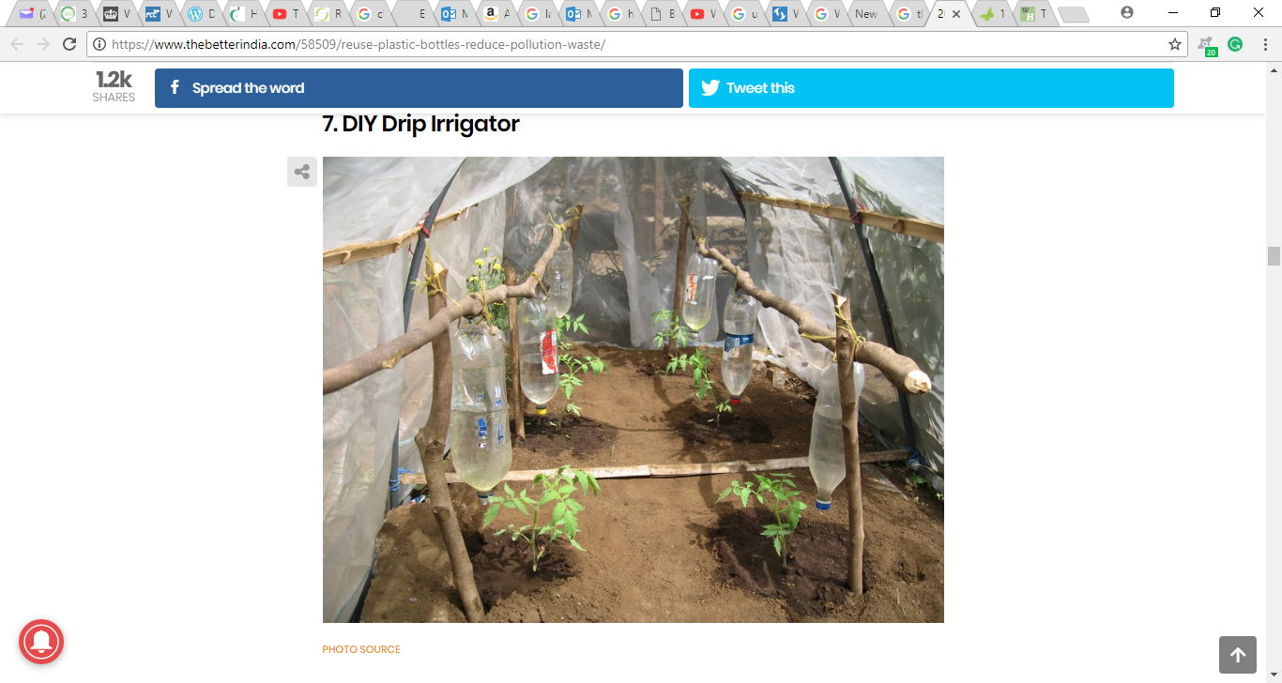

8. Appendix H: Plastic Bottle made Birds Feeders.
Source: Pal (2016), Green Living: 20 Ingenious Ways to Reuse Plastic Bottles Instead of Trashing Them, published on 16/06/2016,7:27pm [online] https://www.thebetterindia.com/58509/reuse-plastic-bottles-reduce-pollution-waste/. Accessed on 26/03/2018.


9. APPENDIX I: The UK Exports of Scrap Materials from 2001-2015 in Tonnes and £m included is Textiles, rubber, Plastic, Paper, Copper, aluminium, Nickel, Lead, Zinc, Tin and Ferrous metals.
Source: DEFRA(2017), Digest of Waste and Resource Statistics – 2017 Edition. [online]https://www.gov.uk/government/uploads/system/uploads/attachment_data/file/607416/Digest_of_Waste_and_Resource_Statistics__2017_rev.pdf.25/03/2019
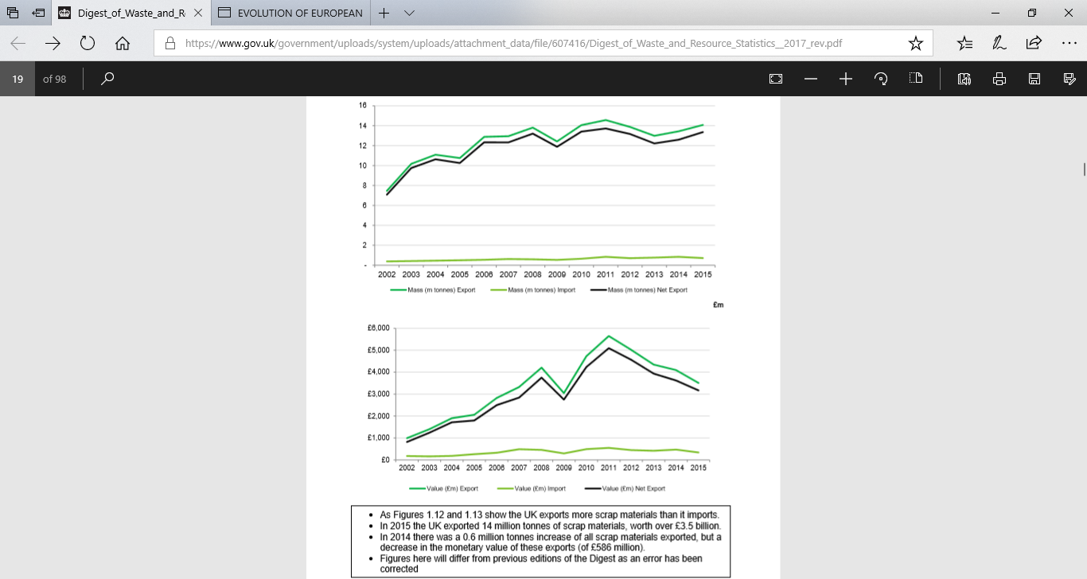

10. Appendix J: The Ten Categories of WEEE Within The 2013 WEEE Regulations.
Source: HSE (2018) Waste Electrical and Electronic Equipment recycling (WEEE) [online] www.hse.gov.uk/waste/waste-electrical.htm accessed on 20/03/2018
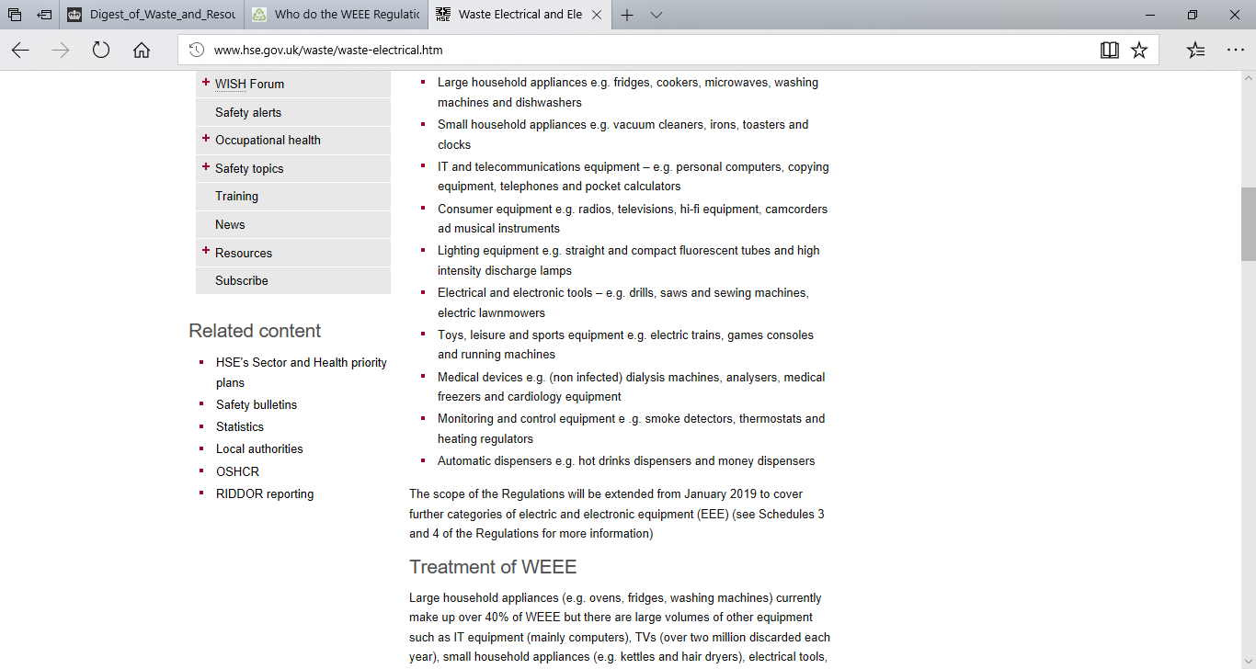

11. Appendix K: Benefits and Disadvantages of Reduce, Reuse and Recycle.
Source: https://2trrr.wikispaces.com/Benefits+and+disadvantages.
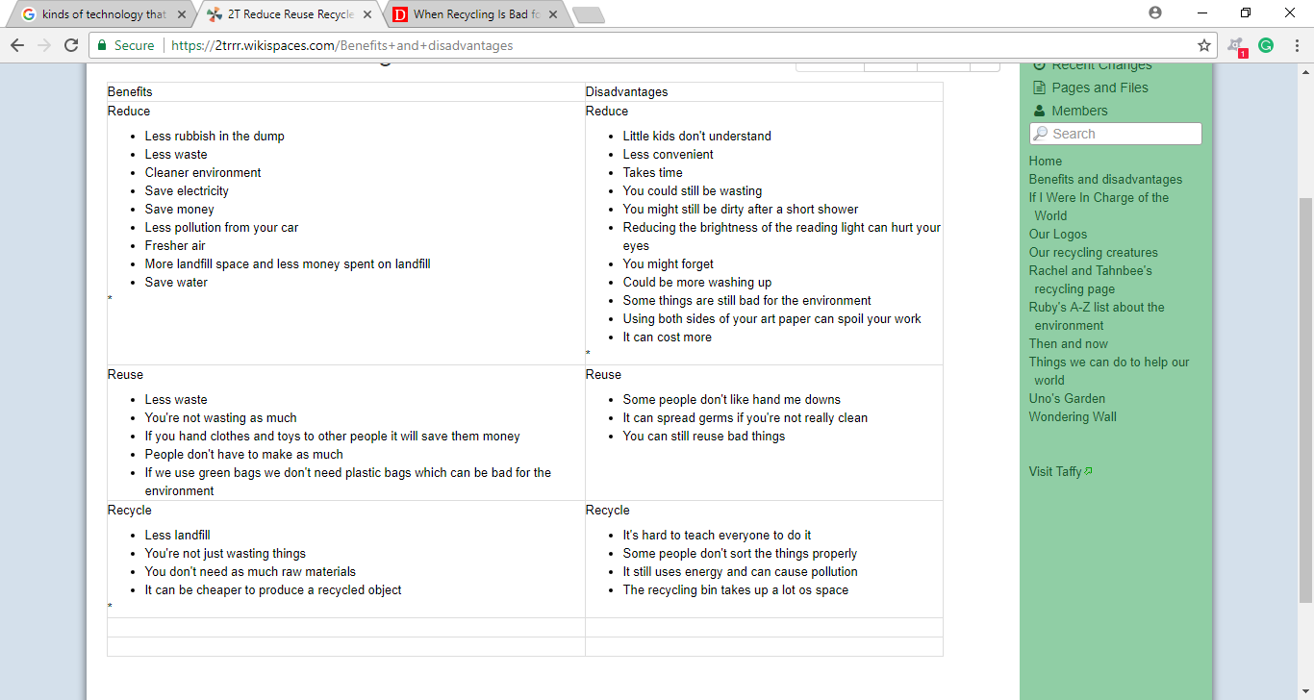

12. Appendix L: UK Employment in Waste collection, Recycling and Reuse, ‘000s, 1998-2008.
Source: ONS (2010), Labour market statistics, Office for National Statistics.
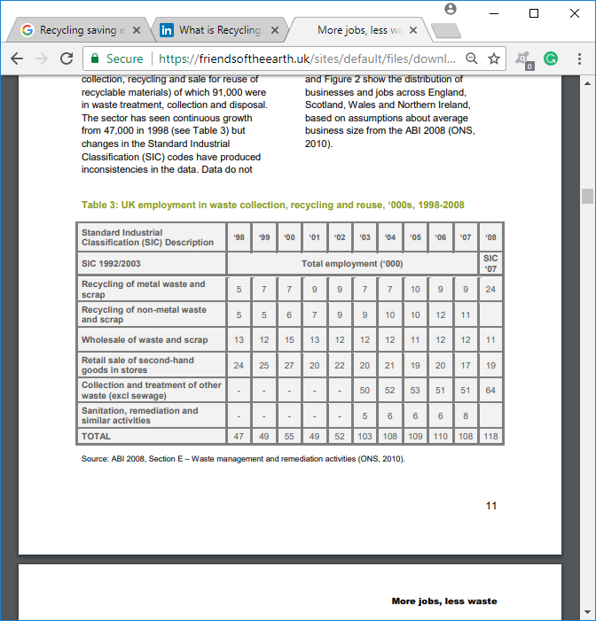
13. Appendix M: Potential New Jobs from increased UK recycling (2025 compared to 2006basline2006)
Source:https://friendsoftheearth.uk/sites/default/files/downloads/jobs_recycling.pdf . 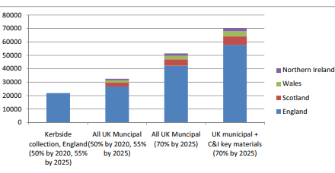

Chapter 3: Appendix:
14. Appendix N: The Research Onion Process (Saunders et’ al 2012).
Source: Saunders, M. Lewis, P. and Thornhill, A. (2012). ‘Research Methods for Business Students’, 6th Edition, Pearson Education Limited, London, U.K.
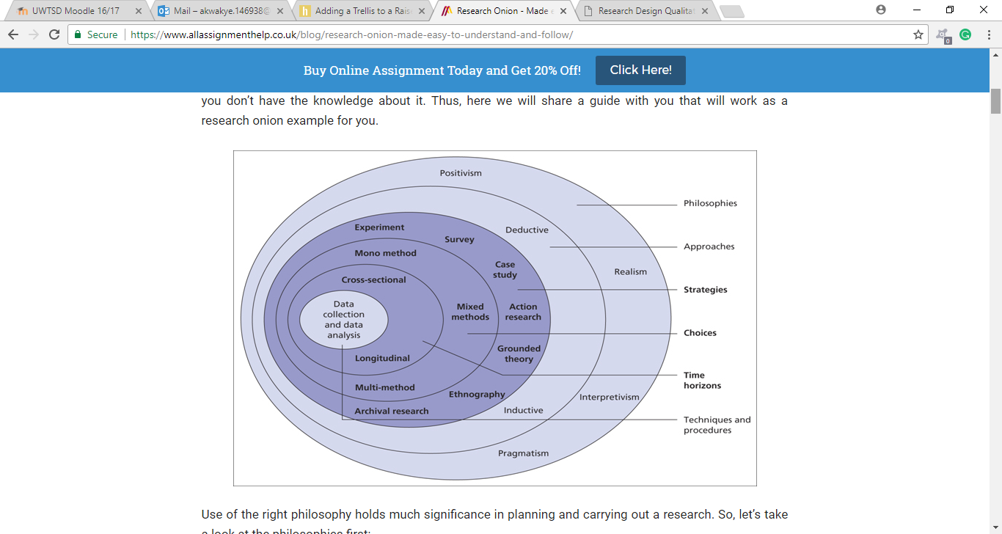

15. Appendix O: A survey questionnaire for Aldergrove Barracks respondents.
MSC IN LOGISTICS
UNIVERSITY OF WALES TRINITY SAINT DAVID (SWANSEA CAMPUS)

QUESTIONNAIRE FOR THE MILITARY PERSONNEL, CIVIL SERVANT WORKERS AT 5 REGIMENT ALDERGROVE.
These questions have been drafted to seek data and information for research work which will be submitted to the School of Engineering, FACULTY of Architecture, Computing and Engineering at the University of Wales Trinity Saint David. Data and information provided will be treated as strictly confidential and wholly utilised for academic pursuit.
SECTION A:
Q1. Your age
18 – 21
22 – 25
26 – 30
31 – 40
41 – Above
Q2. What is your Gender?
Male
Female
Q3. What is your Rank?
Pte/Sac L/Cpl Sgt
SSgt/Flt Sgt WO2&1 above WO1
Civil Servant Other

Q4. What is your Corp?
REME
Army Air Corp (AAC)
Royal Logistic Corp (RLC)
Civil Servants / Contractors
Other( RAF)

Q5. Which Trade Qualification/ Class /level are you?
Qualification/ Class /level Class 3
Qualification/ Class /level Class 2
Qualification/ Class /level Class 1
Qualification/ Class /level Seniors & Officers
Other (please write your class/level here)

SECTION B:
Q6. How many Trash/Rubbish Bins are there in your office or work shop floor?
None 1 2 3 4- above

Q7. Does your office or work shop wastes Bins have any waste information advising users on which waste to dispose in them? Please tick one.
Yes No

Q8. Have you ever found any mix of Plastics, Glass, Can, Papers and Food in your Office/ Work shop Bin? Please tick one
Yes No

Q9. How many large Trash/Rubbish Bins can you find on camp? Please tick one
0-5 6-10 11-15 15-20 25- above

Q10. How accessible (distance) is the Regimental Compound Waste bins (Metal skip) to you?
Very Close Not Far Too Far

Q11. Do you dispose Trash/Rubbish correctly at work? Please tick one.
Never Sometime Always
Q12. Have you attended a waste management presentation (Brief) since you join the MOD? Please tick one
Yes No

Q13. If Yes, was the presentation informative (Educative)? Please tick one
Yes No N/A

Q14. Does your department have a waste management representative? Please tick one
Yes No I am Not Sure

Q15. How many MOD waste management (Recycling) posters have you seen displaced around your office, work place or at Camp?
None Few Many

Q16. In a scale of rating: Overall, the MOD waste management policy has been implemented well on Aldergrove (is it effective)? Circle one
I I I
1 2 3 4 5
Strongly Disagree Neither Agree Strongly
Disagree Agree Nor Disagree Agree

Q17. Which of these (recycle wastes) do you think MOD has been campaigning about in your units?
Papers Food Oil
Glass Batteries All Above
Plastic Cardboard None of the Above

Q18. Do you think UK (MOD -Aldergrove Barracks) is Environmentally focus/friendly?
Yes No

16. Appendix P: A semi-structured interview questionnaire for Aldergrove Station Recycling Center manager.
MSc IN LOGISTICS AND TRANSPORT
UNIVERSITY OF WALES TRINTY SAINT DAVID (SWANSEA CAMPUS)

SEMI-STRUCTURED INTERVIEW (FACE-FACE INTERVIEW) WITH THE ALDERGROVE RECYCLE CENTRE MANAGER
These questions have been drafted to seek for data and information for research work which will be submitted to the School of Engineering, FACULTY of Architecture, Computing and Engineering at University of Wales Trinity Saint David. Data and information provided will be treated as strictly confidential and wholly utilised for academic pursuit.
This interview contains just 6 questions and may last for at least 15 minutes.
Q1. Which kind of Waste do People dispose of here?
Answer box:

Q2. Which Days do you operate and How often do people visit this centre for disposal?
Answer box:

Q3. Do you have any waste policy? If Yes, how do you comply to it?
Answer box:

Q4. How much do MOD Aldergrove authorities have pay to the Council for its waste to be disposed of?
Answer box:

Q5. How often do the council waste collectors collect bulk waste from here (center)?
Answer box:

Q6. If the MOD-Aldergrove Barracks were to improve its waste management Systems, which areas would you recommend for improvement?
Answer box:

17. Appendix Q: A semi-structured interview questionnaire for the Aldergrove Catering manager.
MSc IN LOGISTICS AND TRANSPORT
UNIVERSITY OF WALES TRINTY SAINT DAVID (SWANSEA CAMPUS)
SEMI-STRUCTURED INTERVIEW (FACE-FACE INTERVIEW) FOR THE ALDERGROVE COOKHOUSE(CATERING) MANAGER
These questions have been drafted to seek data and information for research work which will be submitted to the School of Engineering, FACULTY of Architecture, Computing and Engineering at University of Wales Trinity Saint David. Data and information provided will be treated as strictly confidential and wholly utilised for academic pursuit.
This interview contains just 6 questions and may last up to 15 minutes
Q1. Which kind of Waste does your cookhouse produce? And how do you dispose of them?
Answer box:

Q2. Do your workers practice waste prevention and recycle of waste? If yes How do they practise?
Answer box:

Q3. Do you have a waste policy? If Yes, how do you comply to it?
Answer box:

Q4. How much do you pay the waste Disposal Company to dispose of your General and Recycle waste?
Answer box:

Q5. How often the company does collect your waste?

Answer box:

Q6. If MOD-Aldergrove Barracks were to improve its waste management Systems, which areas would you recommend for improvement?
Answer box:

18. Appendix R: A semi-structured interview questionnaire for the Aldergrove Quarter Master (QM).
MSc IN LOGISTICS AND TRANSPORT
UNIVERSITY OF WALES TRINTY SAINT DAVID (SWANSEA CAMPUS)

SEMI-STRUCTURED INTERVIEW (Face-Face INTERVIEW) FOR THE ALDERGROVE QUARTER MASTER (QM)
These questions have been drafted to seek for data and information for a research purposes which will be submitted to the School of Engineering, FACULTY of Architecture, Computing and Engineering at University of Wales. Data and information provided will be treated as strictly confidential and wholly utilised for academic pursuit.
This interview contains just 6 questions and may last for at least 15minutes.
Q1. As the QM for 5 REGT AAC ALDERGROVE. What are your Roles in Waste Management for Aldergrove Station?
Answer box:

Q2. Which areas at the Aldergrove do you think waste has been undermanaged and how could Aldergrove authorities must improves on?
Answer box:

Q3. A New company has taken over our waste management on Camp? Could you please explain: Why did it happen and What are your expectation from the new company?
Answer box:

Q4. This study has reviewed the all offices at Camp utilised the old metal bin and it has recommended for a change to modern office bin (Waste segregation). What is your view (Necessary or Unnecessary) and if Necessary, how would you advise that change?
Answer box:

Q5. On a scale of 1- 10, how would you score the effectiveness of waste management on camp?
Answer box:

19. Appendix S: Field Experiment sheet for the three Aldergrove compound large waste skips.
MSc IN LOGISTICS AND TRANSPORT
UNIVERSITY OF WALES TRINTY SAINT DAVID (SWANSEA CAMPUS)
Field Experimental Form for 3 Metal Skips on Camp
This Form has been drafted to seek for data and information for a research work which will be submitted to the School of Engineering, FACULTY of Architecture, Computing and Engineering at University of Wales. Data and information provided will be treated as strictly confidential and wholly utilised for academic pursuit. The Researcher would be visiting these compound waste skips situated around Aldergrove Station and record types of wastes to be finding in them once in a week for a month.
Waste Skip 1 (Situated at NAAFI Park):
Types Waste | 1 Week | 2 Week | 3 Week | 4 Week
Glass
Papers
Food
Cardboard

Waste Skip 2: (Located at Guard Room)
Types Waste | 1 Week | 2 Week | 3 Week | 4 Week
Glass
Papers
Food
Cardboard

Waste Skip 3: (Located at JNCO Accommodation Park)
Types Waste | 1 Week | 2 Week | 3 Week | 4 Week
Glass
Papers
Food
Cardboard

Chapter 4. 20. Appendix T: Aldergrove Station Waste Statistical data for January 2018.
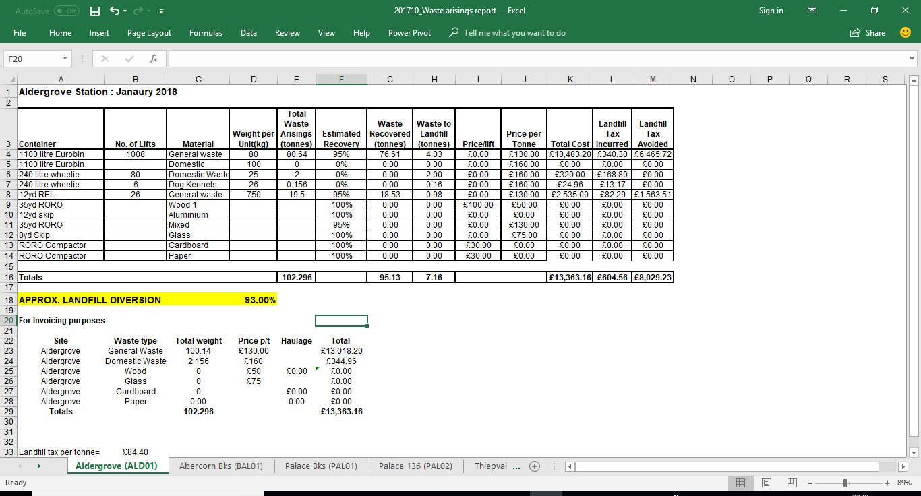
Source: 38x Brigade Environmental Health and Safety Moss site, published 30 January 2018 accessed 14/05/2018.
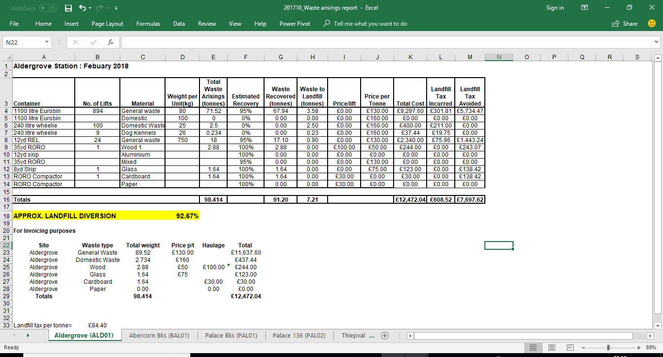
21 Appendix U: Aldergrove Station Waste Statistical data for February 2018. Source: 38x Brigade Environmental Health and Safety Moss site, published 28 February 2018, accessed 14/05/2018.
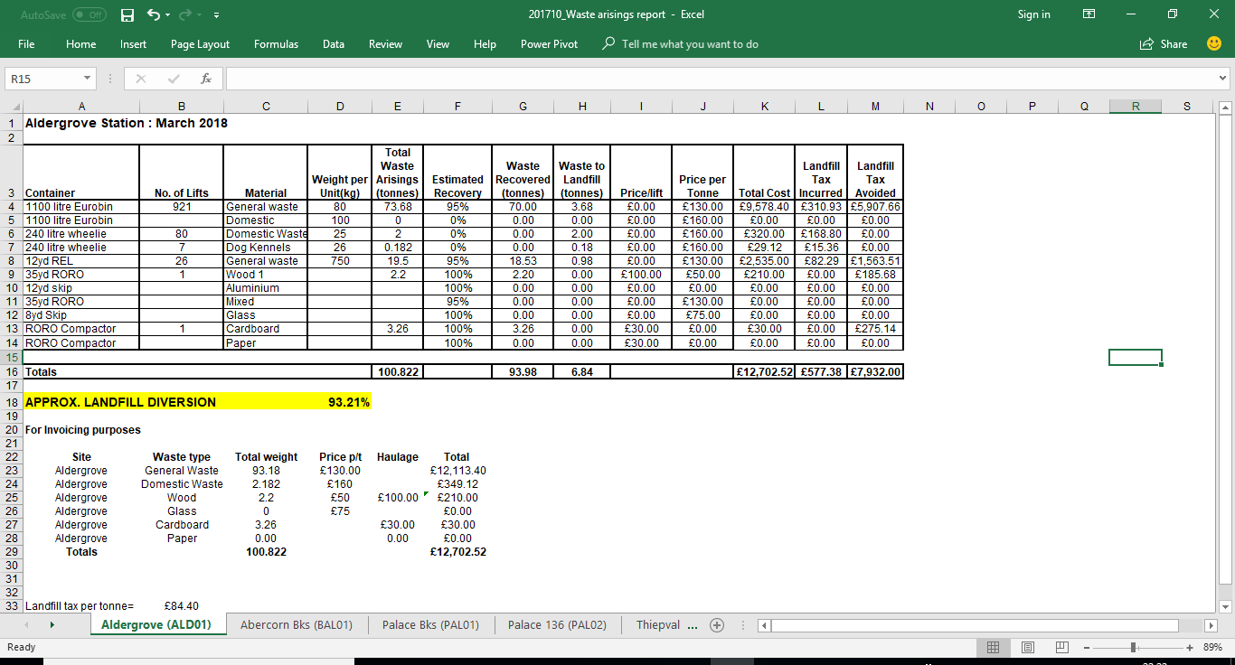
22. Appendix V: Aldergrove Station Waste Statistical data for March 2018. Source: 38x Brigade Environmental Health and Safety Moss site, published 31 March2018, accessed 14/05/2018.

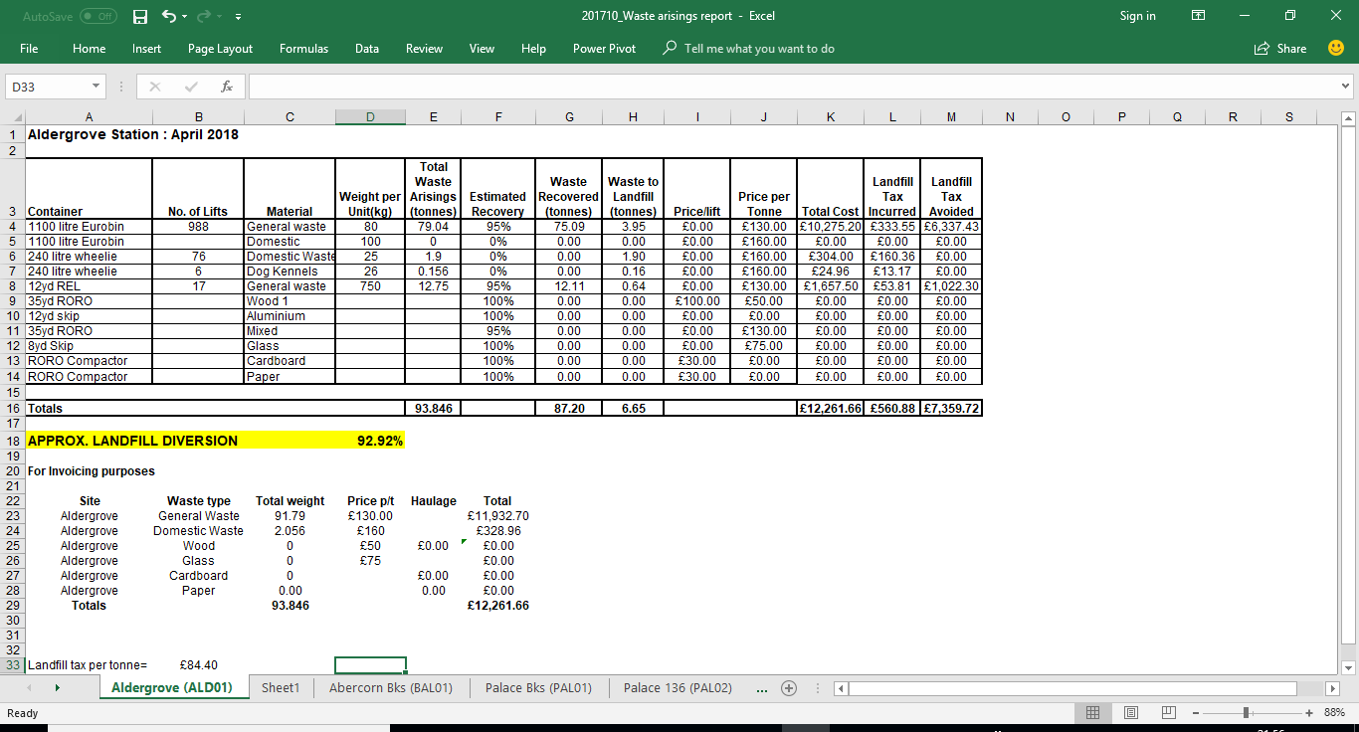
23. Appendix W: Aldergrove Station Waste Statistical data for April 2018.Source: 38x Brigade Environmental Health and Safety Moss site, published 30 April 2018, accessed 14/05/2018.
24. Appendix X: SPSS DATA View of the Study questionnaire data collected board. Source: Researchers collated data SPSS Application. 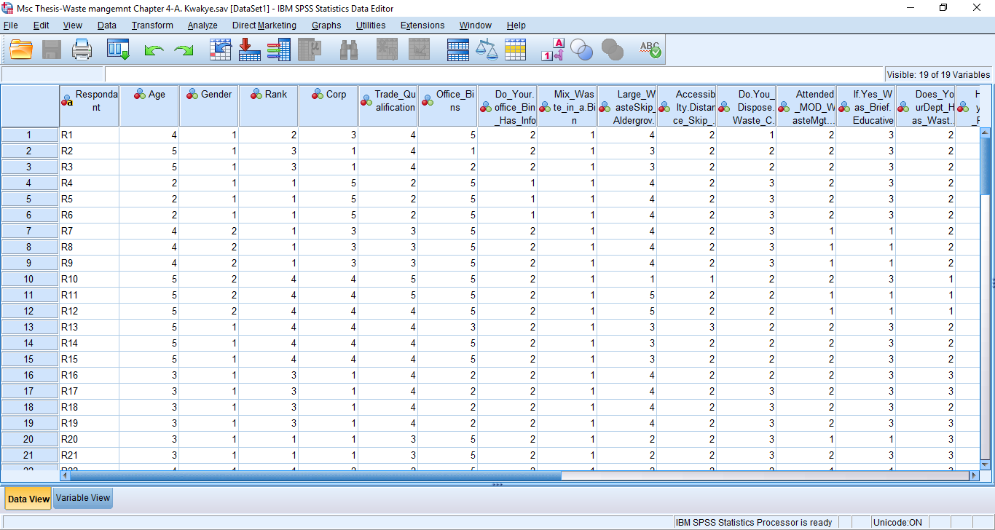
Word Count: 20,786 Words.

Reference:
247 Waste Removal (2014), A brief History of Waste Management. [online] https://247wasteremoval.co.uk/blog/a-brief-history-of-waste-management/. Accessed on 17/02/18.
360 Environmental (2011), Defra Publish Guidance on applying to waste Hierarchy, [online] http://www.360environmental.co.uk/news/375/ . Accessed on 24/02/2018.
Alexander, J. H. (1993), In Defense of Garbage, Praeger Publishers.
Archdeacon, K. (2011), Sustainable cities net, Brisbane to construct second landfill gas plant. [online] http://www.sustainablecitiesnet.com/models/brisbane-to-construct-second-landfill-gas-plant/. Accessed on 25/02/2018.
ARIC/DEFRA (2017), Waste, Fact Sheet Series for Key Stage 4 and A-Level.[online] http://www.lordgrey.org.uk/~f014/usefulresources/aric/Resources/Fact_Sheets/Key_Stage_4/Waste/03.html. Accessed on 10/03/2018.
BBC News (2006), Waste incineration 'set to rise, [online] http://news.bbc.co.uk/1/hi/uk/4621710.stm. Accessed on 07/03/2018.
Becklake, S. (1991), Waste Disposal and Recycling, the problems with waste, chapter 2, published by Franklin Watts ltd, London.
Bryman, A. (2012), Social Research Methods (5th ed.). Oxford: Oxford University Press.
Buekens, I., A. (2005), Conference” The Future of Residual Waste Management in Europe,[online] http://citeseerx.ist.psu.edu/viewdoc/download?doi=10.1.1.477.3406&rep=rep1&type=pdf Accessed on 02/03/2018.
Burcea S., G. (2015), Evolution of European Waste Management Practices: An informal Sector Perspective Management Research and Practice Vol. 7 Issue 1 (2015) pp: 80-93.
Business Dictionary (2018), definition of dioxins, [online] http://www.businessdictionary.com/definition/dioxins.html. Accessed on 07/03/2018.
Business Dictionary (2018), Definition of Waste. [online] http://www.businessdictionary.com/definition/waste.html. Accessed on 16/02/2018.
Carrington, D. (2018), Bottle and can deposit return scheme gets green light in England.[online] https://www.theguardian.com/environment/2018/mar/27/bottle-and-can-deposit-return-scheme-gets-green-light-in-england . Accessed on 03/04/2018
Chitra Reddy (2016), waste Management, advantage and disadvantage [online] https://content.wisestep.com/advantages-disadvantages-waste-management/ Accessed on 29/03/2018.
CIPS (2007), How to Develop a Waste Management and Disposal Strategy.[online] https://www.cips.org/Documents/About%20CIPS/Develop%20Waste%20v3%20-%2020.11.07.pdf. Accessed on 17/03/2018.
Cooper D.R. and Emory C.W (1994), Business Research Methods, Design Strategies, chapter 5, published by Irwin Professional Publishing, ISBN: 0-256-13777-3
Davies (2007), Doing a Successful Research Project: Using Qualitative or Quantitative Methods. ISBN-13 978-1-4039-9379-3, Chap 9, Page 141, Para 2. published by Palgrave Macmillan.
DEFRA (2011), Guidance on Applying the Waste Hierarchy, [online] https://www.gov.uk/government/uploads/system/uploads/attachment_data/file/69403/pb13530-waste-hierarchy-guidance.pdf. Accessed on 25/02/2018.
DEFRA (2013), Waste Management Plan for England. [online] https://www.gov.uk/government/uploads/system/uploads/attachment_data/file/265810/pb14100-waste-management-plan-20131213.pdf . Accessed on 17/02/18.
DEFRA (2017), Digest of Waste and Resource Statistics 2017 Edition [online] https://www.gov.uk/government/uploads/system/uploads/attachment_data/file/607416/Digest_of_Waste_and_Resource_Statistics__2017_rev.pdf . Accessed on 02/03/2018.
DEFRA (2018), Deposit return scheme in fight against plastic [online] https://www.gov.uk/government/news/deposit-return-scheme-in-fight-against-plastic. Accessed on 03/04/2018.
Enerkem (2018), Sustainable Waste Management, promote a circular economy with clean fuels and chemicals made from waste, [online] http://enerkem.com/waste-diversion/sustainable-waste-management/ . Accessed on 29/03/2018.
FAO (2018), Food Loss and Food Waste, [online] http://www.fao.org/food-loss-and-food-waste/en/. Accessed on 26/03/2018.
Flick, U. (2011). Introducing research methodology: A beginner's guide to doing a research project. London: Sage.
Friends of the earth (2002), Fact Sheet, EU Landfill Directive and Waste Strategy [online] https://friendsoftheearth.uk/sites/default/files/downloads/eu_landfill_directive.pdf . Accessed on 22/02/2018.
Friends of the Earth (2010), More less Potential through hi recycling e jobs, waste al for job creation higher rates of ng in the UK and on d EU,[online] https://friendsoftheearth.uk/sites/default/files/downloads/jobs_recycling.pdf . Accessed on 24/03/2018.
Fusions (2017), Food Waste Definition [online] http://www.eu-fusions.org/index.php/about-food-waste/10-food-waste-wiki/280-food-waste-definition?highlight=WyJkZWZpbml0aW9uIl0. Accessed on 17/03/18.
Ghauri, P. and Gronhaug, K. (2005), Research Methods in Business studies, A practical Guide, Data Collection, Chapter 8. Published by Pearson Education Limited, Essex, England.
Hall, C. (2017), The Disadvantages of Waste Disposal [online] https://classroom.synonym.com/the-disadvantages-of-waste-disposal-12533871.html. Accessed on 29/03/2018.
Hall, E. J. (2005), Our Environment, Recycling, what is Recycling? Chapter 7, Published by KidHaven Press. USA.
HSE (2018), Waste Electrical and Electronic Equipment recycling (WEEE) [online] www.hse.gov.uk/waste/waste-electrical.htm. Accessed on 28/03/2018.
Idoceonline (2017), Waste Disposal in Environment & waste topic. [online] http://www.ldoceonline.com/Environment%20&%20waste-topic/waste-disposal. Accessed on 04/04/2018
Iken Edu (2015), Importance of Waste & Recycling, [online] https://www.youtube.com/watch?v=mc4x35Bn4oc. Accessed on 16/02/2018.
Inskipp C. (2005), Waste and Recycling, Downing in Waste, published by Hodder Wayland.
IRJET (2017), A Review: Advantages and Disadvantages of Biogas, [online] https://www.irjet.net/archives/V4/i10/IRJET-V4I10155.pdf. Accessed on 24/02/2018.
Kane A. (2015), Waste and Resources Sector Brings £41 Billion To UK Economy, [online] https://resource.co/article/waste-and-resources-sector-brings-41-billion-uk-economy-9822. Accessed on 02/03/2018.
Kaskey, J. and koh, A. (2017), China’s Blow to Recycling Boosts U.S.’s $185 Billion Plastic Bet. [online] https://www.bloomberg.com/news/articles/2017-12-06/china-s-blow-to-recycling-boosts-u-s-s-185-billion-plastic-bet . Accessed on 24/03/2018.
Kimberleo (2017). Definition of Waste Disposal, [online] https://www.hunker.com/12233631/definition-of-waste-disposal. Accessed on 04/04/2018.
Lane, P. and Peto, M. (1995), Blackstone’s Guide to The Environment Act 1995, published by Blackstone at London.
Laville, S. & Zhou, N. (2017), The Guardian, could a money-back scheme clean up the UK’s plastic bottle plague. [online] https://www.theguardian.com/environment/2017/jun/29/could-a-money-back-scheme-clean-up-the-uks-plastic-bottle-plague. Accessed on03/04/2018.
Laville, S. (2017), The Guardian, Supermarkets must stop using plastic packaging, says former Asda boss [online] https://www.theguardian.com/environment/2017/oct/12/supermarkets-stop-using-plastic-packaging-former-asda-boss-andy-clarke . Accessed on 24/02/2018.
Letstute (2016), Introduction To waste/Environmental Science/EVS LetsTute. [online] https://www.youtube.com/watch?v=_NkqwMitQ8o . Accessed on 16/02/2018.
Maanen, et, al. (1982), Varieties of qualitative research (Vol. 5). Sage Publications, Inc.
McLeod, S. A. (2008). Case study method. [online], www.simplypsychology.org/case-study.html, Accessed on 12/04/2018.
MOD (2010), MOD Waste Management Strategy 2010, [online] https://assets.publishing.service.gov.uk/government/uploads/system/uploads/attachment_data/file/27612/WasteManagementStrategy2010.pdf. Accessed on 28/04/2018.
MOD (2010), MOD Waste Management strategy 2010. [online] https://www.gov.uk/government/uploads/system/uploads/attachment_data/file/27612/WasteManagementStrategy2010.pdf. Accessed on 06/04/2018.
MOD (2014), JSP 418 Management of Environmental Protection in Defence https://www.gov.uk/government/uploads/system/uploads/attachment_data/file/390150/20141209-JSP_418_Part1_Final-U.pdf. Accessed on 04/04/2018.
MOD (2016), Sustainable MOD strategy: waste management 2015-2025, Published on 19 February 2016, [online] https://www.gov.uk/government/publications/mod-waste-management-2015-to-2025. Accessed on 28/04/2018.
NDA (2018) , UK Radiative waste inventory ,[online] https://ukinventory.nda.gov.uk/about-radioactive-waste/what-is-the-waste-hierarchy/. Accessed on 07/03/2018
NWRWMG(2011), The Future of Waste Resource Management.[online] https://www.youtube.com/watch?v=XGqrNi3kTLc . Accessed on 24/02/2018.
Pal, S. (2016), The Better India, Green Living: 20 Ingenious Ways to Reuse Plastic Bottles Instead of Trashing Them, [online] https://www.thebetterindia.com/58509/reuse-plastic-bottles-reduce-pollution-waste/ . Accessed on 02/03/2018.
Pichtel, J. (2005), Waste Management Practices: Municipal, Hazardous and Industrial, CRC Press.
Priestley, S. (2016), Briefing Paper, Food Waste [online] file:///C:/Users/Akwasi%20Kwakye/Downloads/CBP-7552.pdf . Accessed on 07/03/2018.
PRISCA, (2017), Re-use and preparing for Reuse. [ online] http://www.progettoprisca.eu/en/reuse . Accessed on 24/02/2018.
RAF Family (2018), Royal Air Force, JHC FA Aldergrove, History, [online] https://www.raf.mod.uk/our-organisation/stations/jhfs-aldergrove/ . Accessed on 22/09/2018.
Roopalall, R. (2017), Using farm waste for biogas as alternative source of energy, [online] http://guyanachronicle.com/2017/01/29/using-farm-waste-for-biogas-as-alternative-source-of-energy . Accessed on 02/03/2018
SEPA(2003) , Scottish Environment protection Agency [online] https://www.sepa.org.uk/regulations/water/ Accessed on 16/02/2018.
Stream Bioenergy (2010), Government Initiatives and Drivers for AD [online] http://www.streambioenergy.ie/government-initiatives.html. Accessed on 24/02/2018.
Svatko, J. E. (1989), ‘Working with consultants’, Small Business Report, 14(2), pp.58-68.
The Economist (2017), China Tries to keep foreign rubbish out. [online] https://www.economist.com/news/china/21725815-how-new-rule-could-wallop-recycling-industry-china-tries-keep-foreign-rubbish-out. Accessed on 05/03/2018.
The Environment and Welsh Office (1995), HMSO, London.
The Free Dictionary (2017), definition for waste disposal, [online] https://www.thefreedictionary.com/waste+disposal. Accessed on 10/03/2018.
The Waste Disposal Hub(2018), History of Waste Management [online] https://www.wastedisposalhub.com/history-of-waste-management.html .Accessed on 17/02/18.

Common Inheritance (1996), UK Annual Report 1996, Reporting the UK’s Sustainable Strategy of 1994. HMSO, Published in London.
Tilley, K. (2017), Inventor converts waste plastics to fertilizer, fuel.[online] http://www.plasticsnews.com/article/20170913/NEWS/170919960/inventor-converts-waste-plastics-to-fertilizer-fuel Accessed on 24/03/2018.
Ukpublicspending (2017), UK National Defence, Recent UK Defence Spending [online]http://www.ukpublicspending.co.uk/uk_defence_spending_30.html. Accessed on 05/04/2018.
Waste Prevention Team (2013), HM Government, Prevention is better than cure .[online]https://www.gov.uk/government/uploads/system/uploads/attachment_data/file/265022/pb14091-waste-prevention-20131211.pdf . Accessed on 24/02/2018.
William, R. and Murphy, C. (2001). Rubbish! The Archaeology of Garbage, University of Arizona Press.
Williams, P., T. (1998), Waste Treatment and Disposal, introduction, chapter 1, published by John Wiley & Sons Ltd in England.
Wrap (2011), Material change for a better environment, applying the waste hierarchy. [online] http://www.fccenvironment.co.uk/assets/files/pdf/content/wrap-applying-wastehierarchy.pdf . Accessed on 24/02/2018.

Bibliography:
BBC (2017), Island's rubbish density 'world's worst' - BBC News [online] https://www.youtube.com/watch?v=bQCReet5oyA Accessed on 06/04/2018.
United Nations (2017), Plastic Ocean [online] https://www.youtube.com/watch?v=ju_2NuK5O-E Accessed on 04/04/2018.
Yogi (2018), OCEAN TRASH: 5.25 Trillion pieces and Counting, [online] https://www.youtube.com/watch?v=k-F-gvRO1vE Accessed on 06/04/2018.
Lairpoliticans2(2018), China doesn't want any more UK crap for recycling, [online] https://www.youtube.com/watch?v=edoQ2jc9SHU Accessed on 01/04/2018.
France 24 English (2018) How Sweden is turning its waste into gold. [online] https://www.youtube.com/watch?v=14r7f9khK70 Accessed on 06/04/2018.
Simpson, J. (2015), Livestrong.com, what are the side effects of Dioxin? [online] https://www.livestrong.com/article/141022-side-effects-herbicides/ . Accessed on 06/03/2018.
Renewable Energy Association (REA)(2013), Gasification and pyrolysis [online] http://www.r-e-a.net/upload/rea_gp_leaflet_june2013_final.pdf . Accessed on 07/03/2018.
Friends of the earth (2002), Fact Sheet, EU Landfill Directive and Waste Strategy [online] https://friendsoftheearth.uk/sites/default/files/downloads/eu_landfill_directive.pdf Accessed on 22/02/2018.
Archdeacon, K. (2011), Sustainable cities net, Brisbane to construct second landfill gas plant. [online] http://www.sustainablecitiesnet.com/models/brisbane-to-construct-second-landfill-gas-plant/ Accessed on 25/02/2018.
Ghauri, P. and Gronhaug, K. (2005), Research Methods in business studies, sampling in empirical research, chapter 9, published by Pearson Education Limited, England.

