Student Number: 2219297
Learning in the Digital Era
ECGE4005P/C
Assignment number: Two

Link to Video:

New channel meeting-20221102_124528-Meeting Recording.mp4

PowerPoint:

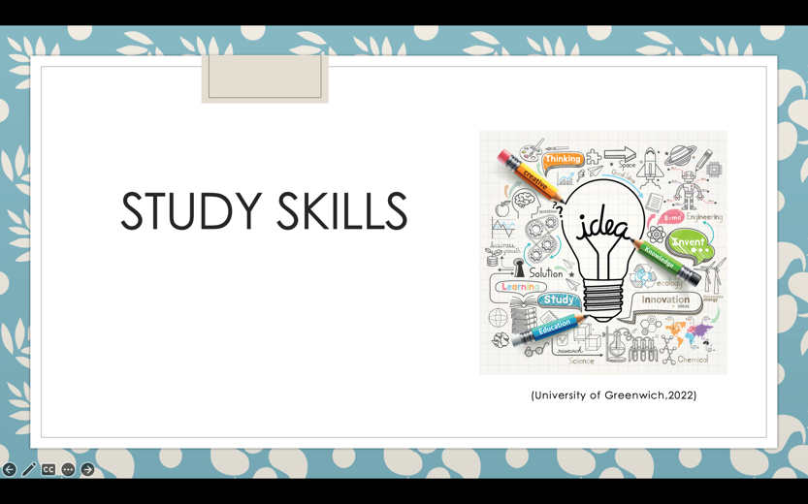
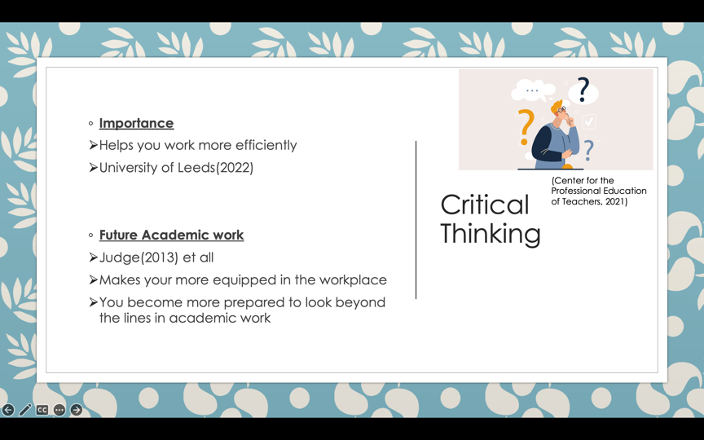

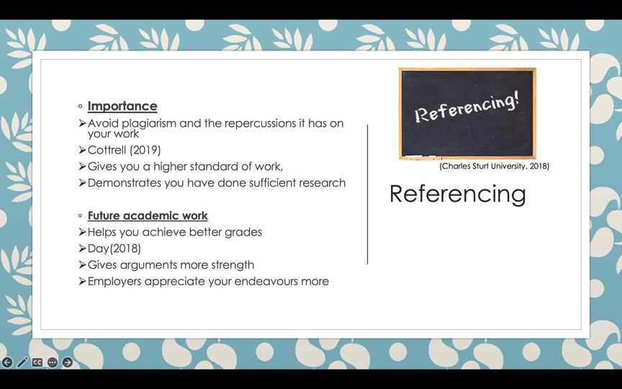

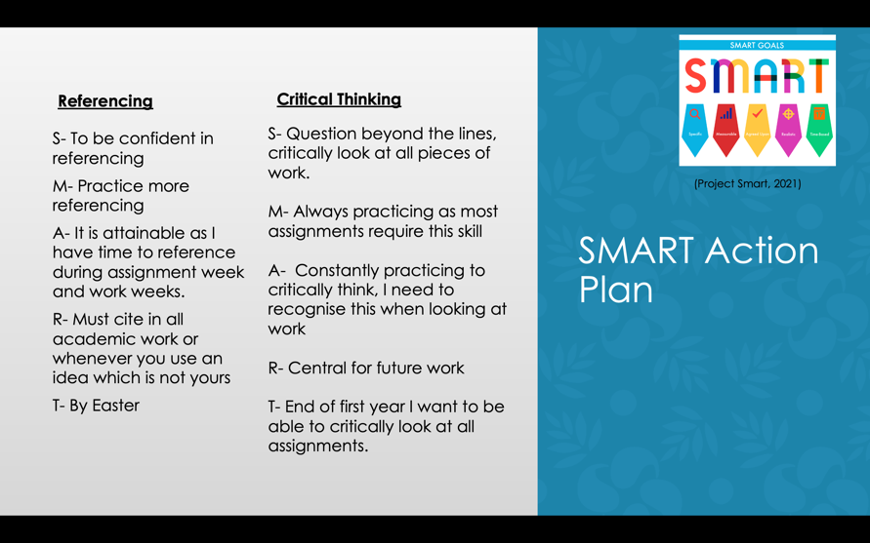

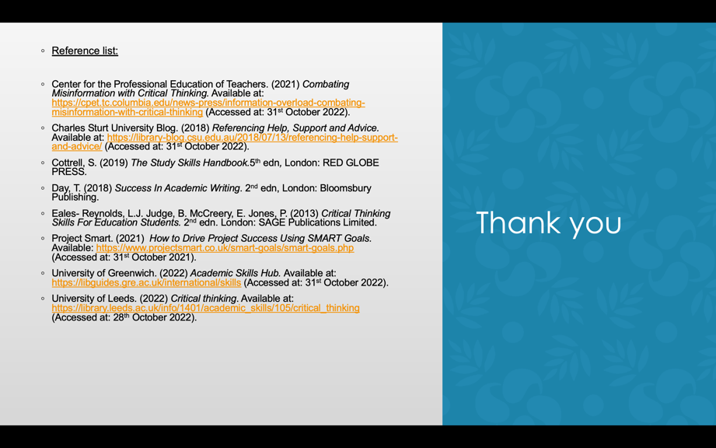

Reference List:

Center for the Professional Education of Teachers. (2021) Combating Misinformation with Critical Thinking. Available at: https://cpet.tc.columbia.edu/news-press/information-overload-combating-misinformation-with-critical-thinking (Accessed at: 31st October 2022).

Charles Sturt University Blog. (2018) Referencing Help, Support and Advice. Available at: https://library-blog.csu.edu.au/2018/07/13/referencing-help-support-and-advice/ (Accessed at: 31st October 2022).

Cottrell, S. (2019) The Study Skills Handbook.5th edn, London: RED GLOBE PRESS.

Day, T. (2018) Success In Academic Writing. 2nd edn, London: Bloomsbury Publishing.

Eales- Reynolds, L.J. Judge, B. McCreery, E. Jones, P. (2013) Critical Thinking Skills For Education Students. 2nd edn. London: SAGE Publications Limited.

Project Smart. (2021) How to Drive Project Success Using SMART Goals. Available: https://www.projectsmart.co.uk/smart-goals/smart-goals.php (Accessed at: 31st October 2021).

University of Greenwich. (2022) Academic Skills Hub. Available at: https://libguides.gre.ac.uk/international/skills (Accessed at: 31st October 2022).

University of Leeds. (2022) Critical thinking. Available at: https://library.leeds.ac.uk/info/1401/academic_skills/105/critical_thinking (Accessed at: 28th October 2022).

