

Student name: Isabel Keller
Student ID:2516809

Module name:Introdution to Health and Social Care
Module code:LCHS 4003_London
Lecturer name: Muhammad Aliyi

Community Mental Health Service
Isabel Keller, Health and Social Care, 2516809@student.uwtsd.ac.uk

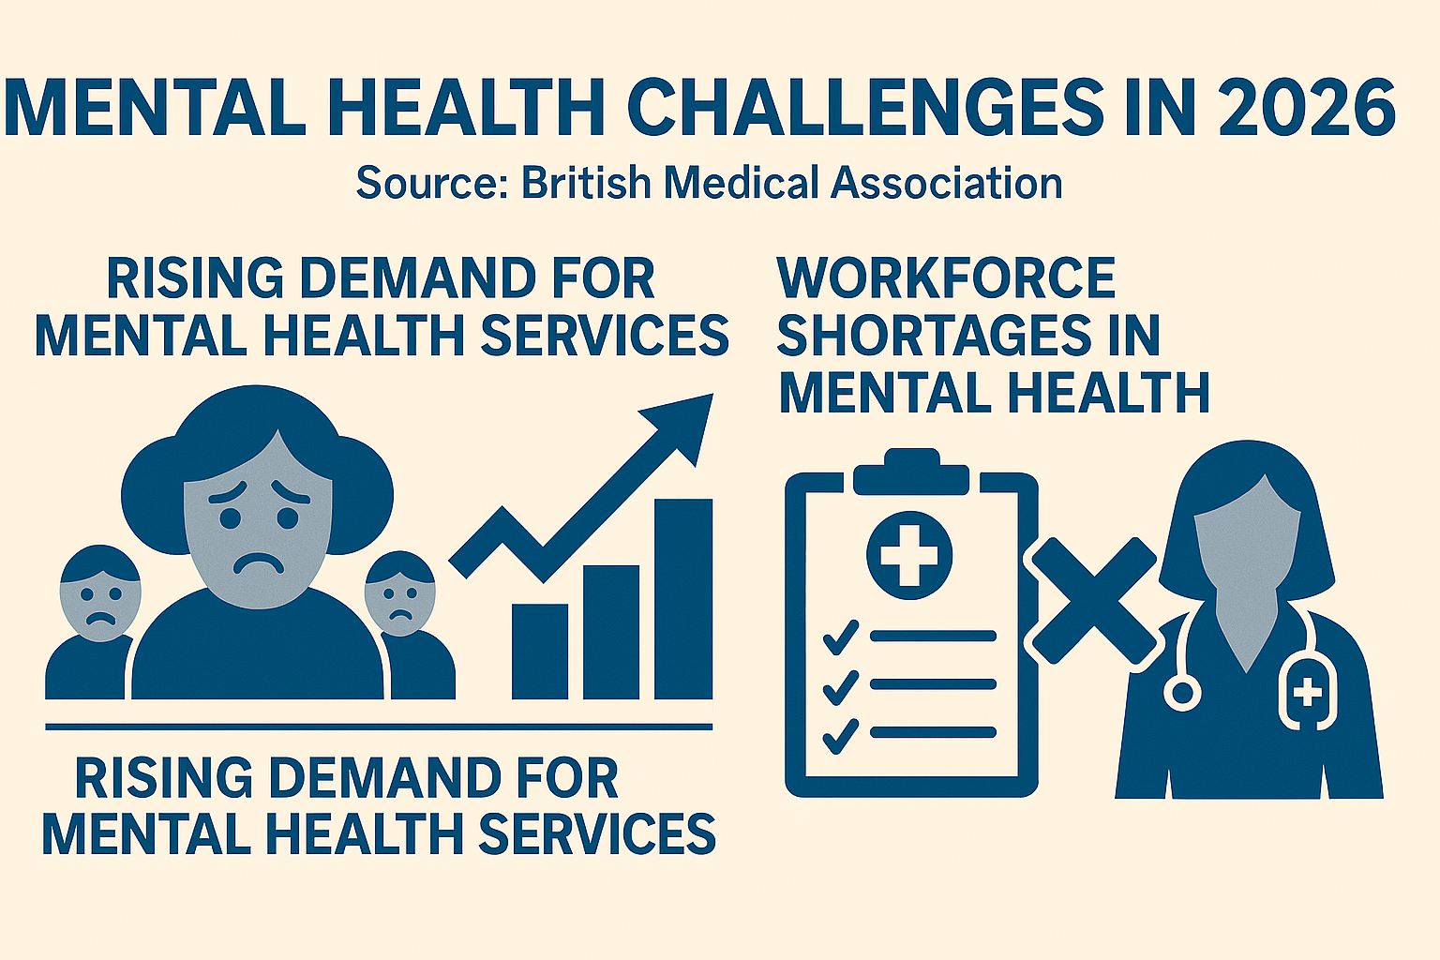

Mental health services provided by the NHS and partners include support for citizens facing psychiatric, psychological, or emotional problems, promoting mental well-being, preventing mental health crises, diagnosing and treating mental disorders, and social inclusion.
NHS Confederation (2025)

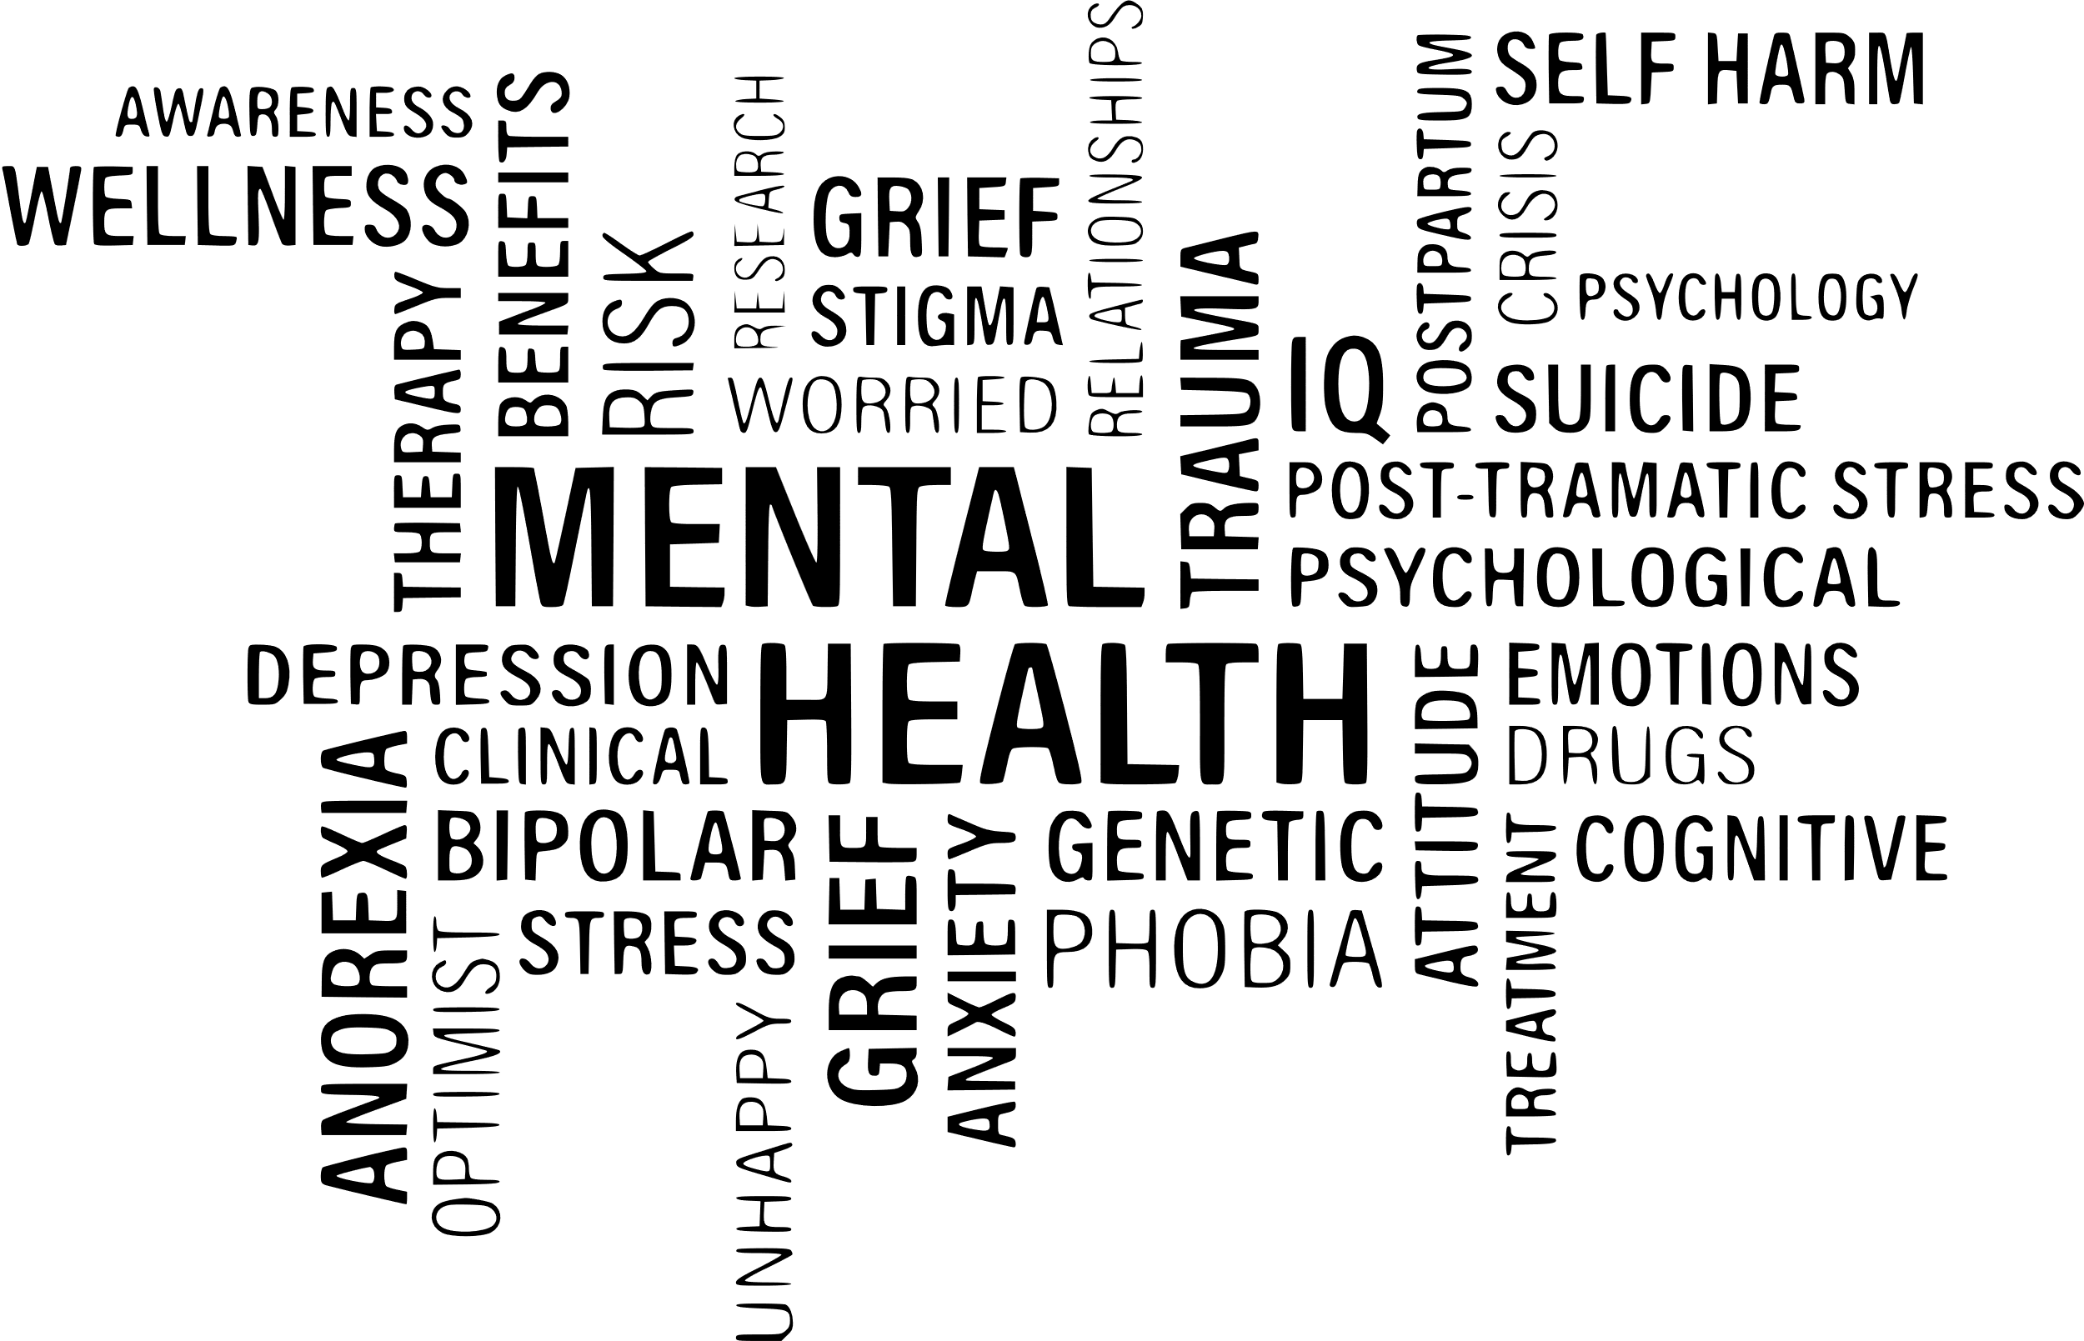

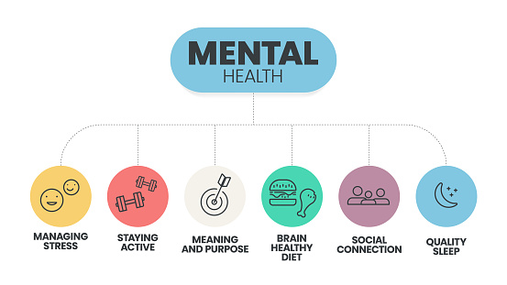
Dentistry services:
The purpose of this essay is to investigate the origin of dentistry in England, its historical context, its current functioning, and its significance.
Before becoming a complex profession, dentistry is among the oldest forms of intervention in human health. Focusing on prevention, oral health care results in a better quality of life, with great relevance to society.
Dentistry is one of the most ancient therapeutic modalities of humanity.
In 7000 BC, perforated molars were discovered in the Indus Valley, denoting the first incursions into the manual removal of dental caries processes.
Around 5000 BC, we find writings that evidenced a distinct concern with oral health, reporting on caries and its remedies.
In its beginnings, dental practice focused on pain relief through tooth extraction, evolving to restoration and artificial reconstruction of its physical structure.
The influential work of Pierre Fauchard in 1728, was revolutionary, as it was not common for dentists to share knowledge about their practices.
The 20th century witnessed a crucial transition with the institutionalization of preventive measures and the use of fluoride, consolidating strategies aimed at continuous oral preservation.
These developments show a clear trajectory: from rudimentary pain relief to a science-based profession focused on prevention, restoration, and holistic health.
At the moment, modern dentistry transcends the surgical act; it constitutes a technological and specialized service that systematically articulates the preventive, diagnostic, and educational spheres.
The main characteristics include: preventive care, advanced diagnosis, specialization as aorthodontics, periodontics, endodontics, oral surgery, dental prosthetics, etc.
Even as technological innovation and holistic approach.

Making a critical assessment, I want to talk about the strengths.
Contemporary advances are driven by scientific rigor and increased accessibility to prophylactic care, resulting in a substantial reduction in the prevalence of oral pathologies.
Moven on to the challenges,economic barriers and segregation in access to services accentuate the health gap between different social groups, perpetuating unfavourable oral health indicators, predominantly affecting vulnerable strata such as children, the elderly, and low-income populations. Many regions report difficulty finding NHS dentists, leading to unmet need. (NHS 2024)
NHS charges can still be prohibitive for some groups; private care is often expensive.
Looking at the daily context, the evidence suggests that even in privileged regions with high-income residents, it is very rare to find dental care through the NHS, resulting in low-income patients living in these regions not having quick access to the service and ending up in a long waiting list.
Workforce pressures, recruitment and retention issues affect service capacity.
Promoting the integration of oral health into primary care and public health strategies, expanding community dental service networks are fundamental to promote equity in access to services.
Increasing preventive outreach in schools and care homes.
For individuals to experience quality of life in the psychological, physical and social spheres, dentistry plays a crucial role.
Discussing psychological well-being, the recovery of orofacial harmony, made possible by aesthetic and reconstructive procedures, positively impacts self-image and confidence in social interactions. It interrupts the cycle of persistent discomfort linked to untreated dental problems, eliminating chronic biological and sensory stressors.
About physical well-being,dental intervention acts in the prophylaxis and management of pain, infectious processes, and structural losses. Preservation of teeth enables effective mastication, a determining factor for adequate nutritional absorption and maintenance of metabolic health. The oral clinical examination is a strategic tool in the early detection of systemic oral pathological manifestations, such as diabetes and cardiovascular disorders, highlighting the inseparability between oral and systemic health.
In the sphere os social well-being, supports speech, communication, and social interaction. Reduces the stigma associated with poor oral health, which can affect employment and relationships.
For individuals to experience quality of life in the psychological, social, and physical spheres, dentistry plays a crucial role. Preventive dental care helps to lower long-term costs for the healthcare system. Community-based dental initiatives play an important role in tackling oral health inequalities. Oral health is now widely acknowledged as an essential element of public health and healthy ageing.
In the UK, dentistry has progressed from basic tooth-extraction practices to a well-regulated, prevention-oriented profession that contributes substantially to both public health and individual wellbeing. Its influence extends beyond oral structures, supporting nutrition, self-confidence, communication, and overall social participation.
We can conclude that, although there has been significant progress in dentistry in the United Kingdom, moving from basic extraction practices to a regulated profession focused on prevention, important challenges persist. With unequal access to NHS (National Health Service) dental services, a shortage of NHS dentists in several regions, and long waiting lists, a two-class system is evident: individuals with high purchasing power can easily access private care, while the vulnerable class faces greater risks of untreated oral diseases.
Even considering the robust public health structures, inequalities persist in the area of ​​oral health, particularly for vulnerable groups such as people with disabilities, the elderly, children, and low-income individuals. This highlights the limitations of current preventive strategies and makes integrated and community-based approaches imperative. Pressure on the workforce, funding constraints, and the structure of NHS dental contracts also limit the system's ability to provide equitable access with long-term viability.
In summary, technological and clinical advances in dentistry have an impact that goes beyond oral structure, also affecting nutrition, communication, self-confidence, and overall quality of life. However, persistent inequalities, access challenges, and workforce pressures demonstrate that further improvements are needed to ensure that all service users benefit equally from high-quality dental care. Strengthening community programs, reforming NHS (National Health Service of the United Kingdom) dental contracts, and expanding preventive initiatives will be essential to creating a more equitable and effective dental system in the future.
References
-Dentists Act 1921(11,12 Geo.5,c.21) London:HMSO
-Departament Of Healt and Social Care(2025) Major boost for millions of NHS dental patients.
-NHS Engalnde (2026) Preparing for NHS dental quality and payment contract reforms London; NHS England.
-Hunter, J.(1771) The natural history of the human teeth,London;J.Johnson.
Britsh Dental Journal.235(5),pp.335-343
-Tidman.S.(2023) UK dentistry;a timeline of events 1920-2020- Part 2:1946-1993;
-Webster,C.(1988) The Health Services Since the War;Volume 1, London:HMSO.

