Travel review on Iceland
Jade Thorpe Phillips
1902541
Attractions and about Iceland
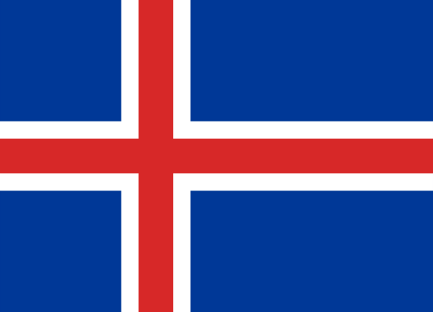
This article gives an opportunity to delve into the magical places of Iceland in order for you to have and understanding of the country without even visiting. To begin, Iceland is a country of immense geological contrasts. Popularly known as 'The land of fire and ice' also Iceland is the home to a number of the biggest glaciers and glacier lagoons in Europe, and a few of the world's most active volcanoes. The country is the land of the light and darkness, as it is close to 24 hour long summer days and then in winter it completely flips to be short winter days with only a few hours of daylight. It is a lonely island in the middle of the North Atlantic and has achieved a goal of being a popular spot for Hollywood blockbuster movies. It seems to be an unusual place with the unique landscapes as it can pass as other planets such as in the movie Star Wars - Rogue One or Prometheus, it can also camouflage as a fantasy island with a different setting lime in Game of Thrones. The unique land known for its powerful elements, fire and ice, has clawed their way through and made a mark upon. If your needs include witnessing the northern lights fly above on a winter night sky, seeing the sun still in the sky at midnight, visiting the geothermal areas where the geysers rule supreme, sailing in between huge icebergs on a glacial lagoon, experiencing anything new and different then Iceland is the place to go. The country's capital is Reykjavik, by international standards is a diminutive place, with around 217,000 people living there, which is more than half of the country's population, no need to worry though, the city may lack in size however it makes up for it in character. The atmosphere in this area is thriving with and arts and music scene, creative street art on every corner and is a host of festivals all through the year. There are many up to date bars and restaurants which catch your attention, contemporary art galleries one after the other, also brightly painted buildings begging for attention and to be in a picture. The nature here is very compact which means it is easy to get around as you can more or less walk everywhere, which makes it a great base in order for you to explore. A variety of hotels circular the city and each one is near a popular attraction which is great to get to different places. The majority of the population either lives in the city or in a neighbouring community. All across the country there a small picturesque villages such as the Hallsgrimskirkja church, which mainly relies on fisheries as they are the ones to draw attention to the docks. Even though Iceland is the perfect destination like any other nation there is always the best time to go and in this scenario there are a few times throughout the year that is best to head off there. Between May and August the weather is very cool and unpredictable however the long daylight hours means it is a perfect time for touring. If you aren't looking for a tour and are just travelling to have an experience of the northern lights then between September and April is the best time for you as the lights make more frequent appearances, new years is an amazing time to tour as they host major celebrations and offer festive lights and trendy music. When booking or after arriving at your destination there a places to go in order to have a travel guide so you don't, miss out on anything like the volcano tour, the blue lagoon, midnight sun or the most popular which is the golden circle, the tour guides are very flexible snd anything that you want to know they can answer or find out for you. On average, Iceland experiences a major volcanic event once every 5 years. Since the Middle Ages, a third of all the lava that has covered the earth's surface has erupted in Iceland. However, according to a recent geological hypothesis, this estimate does not include submarine eruptions, which are much more extensive than those on the land surface. The most famous and active volcano in Iceland is mount Hekla, which has erupted 18 times since 1104, the last time in 2000. Other active volcanos, measured in terms of the number of eruptions besides Hekla, are Grímsvötn, Katla, Askja and Krafla. Katla, has erupted about 20 times since the settlement of Iceland. These volcanoes are the cause of the popular natural baths in this country. Owing to its geographical position, Iceland is a country which has a lot of volcanic and geological activity which largely explains its landscape. One can find springs in the craters of volcanoes, in streams and in natural swimming-pool. There is thermal water everywhere, for you to take a bath. With this scenario, it’s not difficult to understand why, in Iceland, spas and thermalism are part of the nation’s DNA. Therefore, if you are ready for a natural bath anywhere and everywhere then Iceland is the right destination for you.
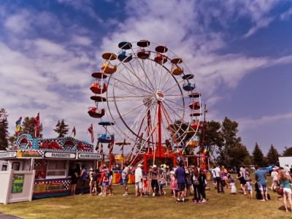

Population
The current Icelandic population is 364,260 people. The surface area of Iceland is around 103,000 square meters which makes it the 108th largest country. One of the reasons it's population remains so low is because of its geographical landscape. This country as a nation has the lowest population density of all European countries with 3 people per kilometre. Iceland has been through ups and downs throughout the years as their growth took a major miss after the economic crisis in 2008, in 2007 the growth rate was at a high of 2.53 percent, however by 2010 it had dipped majorly into the red figures. The main reason behind thus was that during the economic crisis unemployment increased massively, which would caused many Icelanders to move away in order to find employment somewhere else. Gross domestic product growth did not recover until 2011 where the fertility rate increased. Iceland's population increased by approximately 2.92 percent compared to the previous year. Due to high standard of living, Icelandic people tend to have a high life expectancy on average of 82 years old, one of the highest life expectancies in the world. The ethnic composition of Iceland today is 93% Icelandic. The largest ethnic minority is Polish at 3% of the population. There are about 8,000 Poles on the island, accounting for 75% of the workforce in Fjarðabyggð which is a municipality located in eastern Iceland. More than 13% of the population was born abroad while 6% hold foreign citizenship. The country its itself portrays a huge contrast as on one hand the unique landscape hasn't changed in millions of years with large mountains and very dangerous active volcanoes all over. On the other hand leads to a scattered populated country which is one of the richest and most highly developed in the world.
Accommodation
Iceland includes a wide selection of various accommodation options to suit a large spectrum of needs and budgets. It is possible to find cheap camping grounds and hostels, budget bed & breakfasts, a range of apartments, luxurious apartment hotels and 4 or 5-star hotels. There has also been a recent growth within the occurrence of igloo hotels. From these igloos, there is an option to be near the northern lights in which you can watch all while still staying cosy and warm. Many hotels are small, boutique hotels and five-star hotels are rare. This is especially true in the countryside where the local population may only be a few hundred people and where it is all local businesses which is why the country is one of the richest. Like everyone else you're probably wondering how it is even possible to stay in an igloo, well, Igloos are built from compressed snow. You saw it into chunks like building blocks, then stack the blocks around a circular terraced hole within the snowy ground. Snow is endlessly interesting considering it's simply semi-frozen water. it's amazing insulating properties that make it a preferred shelter-building material for hibernating animals additionally as humans, creatures like bears and raccoons. Solid ice isn't a awfully good insulator compared to compressed snow, just because ice is solid while snow is stuffed with miniature air pockets. While it's solid, the maximum amount as 95% of snow is truly air trapped inside tiny crystals. Because the air can't circulate all right inside the ice crystals, the warmth gets trapped in there. This shows and organisational structure within the igloo as they have successfully managed to create a reality from a dream. Therefore, there's no need to worry about being cold as the way it is built keeps you warm even if it is minus degrees outside. This creates a new experience for everyone as it is more than likely a once in a lifetime opportunity for the majority of visitors and everyone wants to experience anything they can if it’s new and unique.
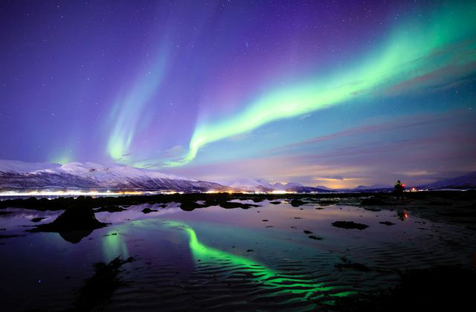
Travelling
When travelling around Iceland there are many ways to get about. You can begin with renting a car, or if not interested or do not have a licence the other options are endless from taking a bus, by boat, by taxi, you can carpool, or even hike. Iceland are very up to date and if travelling by bus there is an available app to download where it shows all the timetables and you can even by a ticket online if you have no money on you at the time. There is also and available map that can give you directions and highlights the bus routes if you rather to use paper instead of your device. Therefore, if ever you are lost you can easily figure out how to get from one place to another with all the available routes on the app. The majority of the bus companies offer bus passports where you can’t annually for your bus rides and have that on you at all times in order to get around if you travel often. Some places are only accessible by boat and if you are a culture vulture then this will be a given to use a boat. However, they say that you should book in advanced as it gets very busy and peak times. If you love adventure then hiking would be your best option for most places unless it’s too far, in Iceland there a many hiking trails that are easy to find. There is a large variety that can appeal to a different audience like the smaller ones might attract families where as the longer ones will definitely be more for you that like to adventure and take in your surroundings in peace. This is an effective way as some days Iceland have nearly 24 hours of daylight so it gives you the opportunity to not miss out on anything and to go at any time of the day if the weather conditions are okay. Therefore, when travelling to Iceland you won’t need to worry about getting for A to B as they have you covered.
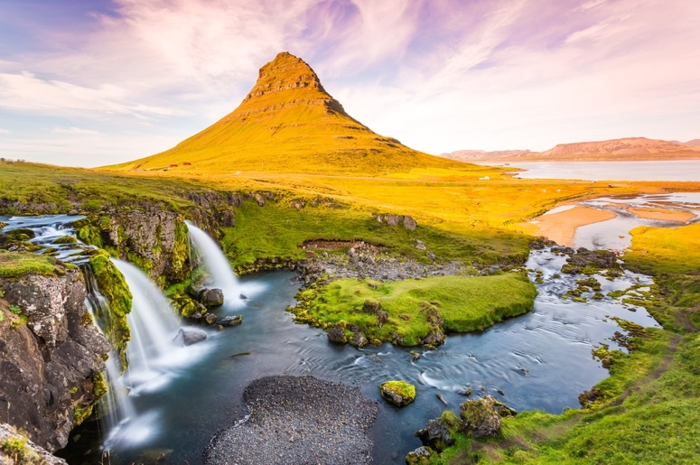
‘Leisure is much as a part of life as work’ G. Torkildsen. This quotes shows that leisure is essential in life and that you may as-well complete your life long dream to travel to Iceland.

Reference list
Torkildsen, G. (2005) Leisure and Recreation Management, London: Routledge
Sharpley, R. (2007) Tourism and Leisure in the Countryside, Huntingdon: Elm
Tillman’s 10
https://www.extremeiceland.is/en/blog/3113-how-to-get-around-in-iceland-without-a-car
https://guidetoiceland.is/accommodation
http://worldpopulationreview.com/countries/iceland-population/
https://www.audleytravel.com/iceland/places-to-go/
https://www.icelandtravel.ishttps://www.icelandtravel.is
https://www.transun.co.uk/blogs/how-does-an-igloo-work

