Manufacturing Design & Technology
Introduction
This assignment will look at the design of a 3-Jaw Gripper – end effector that will be used on co-bot systems with the aim of this study to optimise the manufacturability of the system that can produce between 1000 and 2000 units per week. There are a number of manufacturing processes that are considered to make the design changes in the most efficient way for the production process. The focus of this assignment will be to take the concept design and develop it so it is able to be assembled, making it more responsive to what the customers requirements would be and progressing the design from a manufacturing point of view. Design considerations will be made for this particular process, for example, looking at design for ‘X’, risk management, environmental factors, justifications for processes, design for assembly, design for manufacturing and a proposed design specification.
Concept Design Appraisal
The basic function of a gripper is described by Monkman et al (2007, p.2) as
Subsystems of handling mechanisms which provide temporary contact with the object to be grasped. They ensure the position and orientation when carrying and mating the object to the handling equipment.
Using the current design of the end effector to fit in with expected customer needs, environmentally, the design may be working in near vicinity to hot moulding instruments, when looking at performance, a 3 jaw gripper is used in operations for transferring, meaning it needs to uphold a level of positioning accuracy; not harm the parts and be suitable for future products from the same component type; handle hot, freshly moulded parts and be simple to set up or reconfigure (Saliba and Borg, 2009). The tool needs to have a service life that would allow it to be involved in the production of 1000 and 2000 units per week and the system has to be able to tolerate high accelerations in terms of kinematics. The 3-Jaw Gripper for an assembly system must be designed carefully in order to reduce errors and turnaround time. This is the component of the robotic parts picker or assembler that engages with the surroundings directly. While several factors might be responsible for work cell breakdowns, the grippers are frequently the problem. Grippers that are well-designed can boost throughput, improve reliability of the system, accommodate for robotic error, and provide value to the manufacturing process.
Furthermore, looking at the public perception of engineering, if engineers are the writers, engineering technology professionals are the actors. Engineering technology, while closely related to engineering, focuses on the development of knowledge, such as the construction of systems that engineers may create or the day-to-day implementation expected to maintain components of an organization (Lucietto, et al, 2020). However, a lack of reliable scientific facts on this issue can result in incorrect views, biased behaviour, and poor policy decisions. In this field of education, there is a lack of understanding of what students require from engineering education to be desirable in the industry later on due to the way engineering is perceived. In today's rapidly changing environment, the production of creative and successful products is essential. So we must consider why the aesthetics in this design study would be important. ‘Engineering today is by many seen as a scientific pursuit that investigates materials and processes in ways that are only slightly more applied than physics’ (Boelskifte, 2014, p.2.1). Tjalve's Product Synthesis is still extensively referenced in this area and has a large variety of diagrams relating to aesthetics, embracing it as a natural component in the creative process.
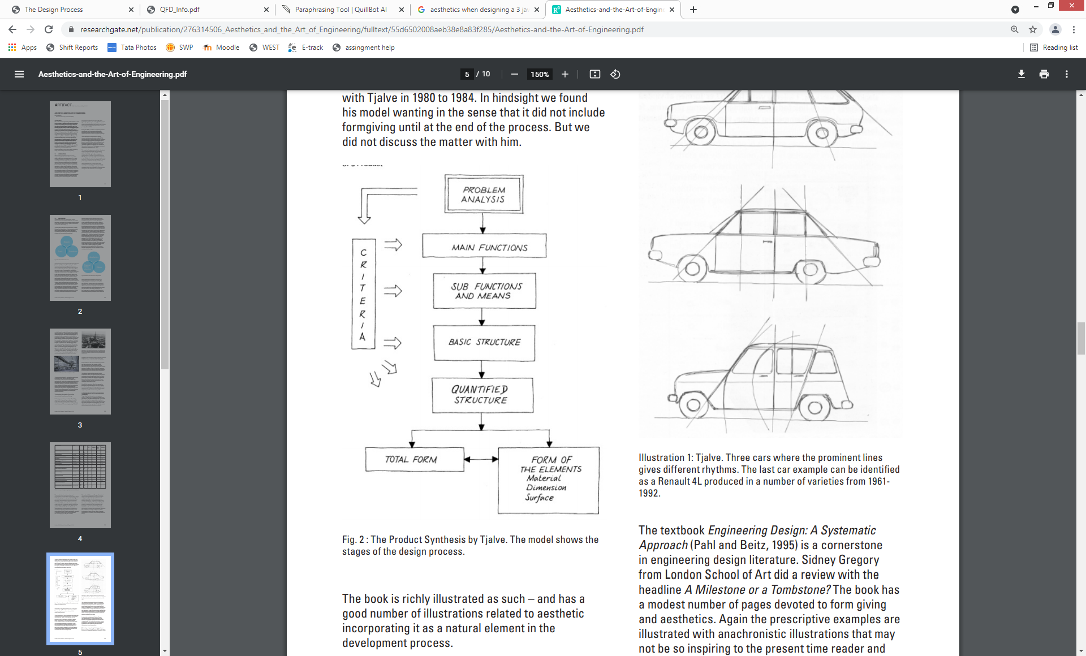
(Tjalve,1976)

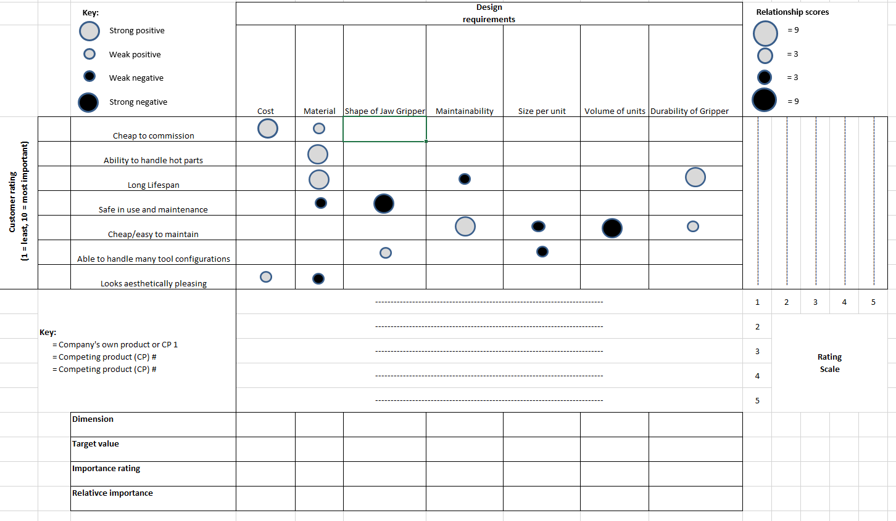
The first part of a QFD (Quality Function Deployment) chart has been created as shown below and includes a variety of technical, economic, and safety concerns, allowing for a broad range of criteria to be used to assess the design.

It makes a list of the customer's needs and wants and ranks them in order of significance. It also has a collection of client comments and concerns which would then be compared on a rating scale to see how the company’s product performs against other 3-jaw grippers on the market. As ReVelle, Moran and Cox (1998) state, it is a way to advance company developments without using too many resources at a faster pace. While helping to stay focused allowing for design activities to be peer-reviewed and organise information graphically. In the diagram above the material used in the design has a mixture of relationships with the customer requirements, for example, it had a strong positive correlation to its ability to handle hot parts and a weak negative correlation to it being safe in use and maintenance. The manufacturing and assembly control procedures would come in when an importance rating, dimensions and target values are developed.

Design Specification
A design specification is required in this assignment to highlight potential developments of the 3-Jaw Gripper. As Sudin, Ahmed-Kristensen and Andreasen (2010) state, A design specification is a representation of a problem's preferred solution. The importance of design specifications in the development process is well acknowledged. A set of requirements is used to describe the optimal output in the specification document. The process of selecting a practicable concept are established as part of a design specification, which is a collection of requirements that must be met by any solution to the problem once it has been found.
The design specification will be split into four areas. These are market requirements, life in service requirements, production requirements and conformance requirements. Market requirements would include marketing materials such as a product stand or leaflets, also the performance and appearance of the jaw gripper. Life in service is to do with the target life, recycling requirements, durability and commissioning for use. Production requirements include the size and weight targets, manufacturing costs, quantities, processes, materials, and assembly. Lastly the conformance requirements include, safety, company standards, industry standards, etc.
Proposed Project: Design study on 3-Jaw Gripper – end effector
Designer: Jessica Williams
Performance Requirement | Design Requirement | Design Specification
Must be easy to transport | Lightweight design | <5kg
Must be affordable | Low cost | <£1000 (purchase price)
Must be able to handle hot parts | Must be heat resistant | Use a coated steel
Must have positioning accuracy | Jaw must encompass friction and retention | Jaw must be secured to cylinder using fasteners
Do not damage parts when gripping | Gripper force considerations (no slipping or dropping parts) | Apply a safety factor to the gripper speed
Long lasting | Production volume of 1000-2000 units per week | Repeatability of (±in) 0.001
Withstand high accelerations | Robust design | <5kg and <250mm
Should be recyclable | Made from recyclable material | Use of steel
Components should be replaceable | Components are separate | Jaw arms, cylinder and drive plate will be made from specific manufacturing processes in house and other components bought in ready-made.
Safe to use | Include safety device | Would be used if there is a pressure loss when maintaining grip position, would require a pneumatic valve.

Manufacturing Process Proposal
Company Needs and Cost Drivers
Manufacturing has been transformed by strategic planning. Companies all over the world have cut turnaround time in their operations by analysing each step of the manufacturing process as well as workload variances to find solutions to reduce variance and minimize inefficiencies (Adler, et al, 1996). The goal of the business is to develop a 3-Jaw Gripper – end effector that will be fit for purpose and fit into design and performance requirements. Identifying the issues with the end effector is essential to get the outcome desired, optimising the manufacturability with relevant manufacturing processes. There are two types of cost drivers: resource drivers and activity drivers. As Osterman and Lundberg (2012) suggest, The first is the manufacture of the amount of resources employed to the cost of an activity, while the second is the accompanying costs by the operations required to implement a certain job or project. Cost drivers that may affect the development in this assignment:
- Components involved- the company can utilise this by using manufacturing processed to make components in house.
- Design choices based on the volume of units.
- Selecting tolerances that can offer better reliability ( also not using unnecessary tolerance boundaries)
Almost every cost driver, from appearance to utility to manufacturability, is closely entwined with wider design issues based on the nature of product development.
Manufacturing processes selected for production of components
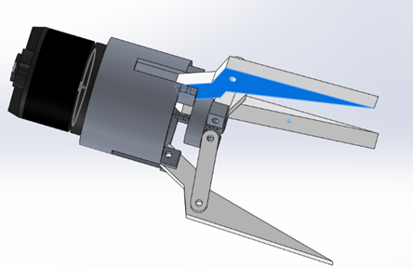
Some of the components for the 3-Jaw Gripper – end effector will be manufactured in-house and some will be elsewhere to a specific standard. For example, the motor on the gripper will be purchased to try and standardise the components as much as possible, to allow the design to function properly the gripper needs fasteners, nuts and bolts to attach the gripper arms the cylinder, housing , the drive plate all together, these attachments will be bought elsewhere. The components that will be manufactured are the:
- Gripper Jaws
- Drive Plate
- Cylinder
The manufacturing processes that will be considered in the design are die casting, forging and drilling.

This section will explain why these processes have been chosen and later on in this assignment the adjustments and assembly will be considered. Firstly, die casting will be used for the housing (cylinder) and the drive plate. In die casting, the molten metal in forced into a mould at high speed. These moulds, often known as dies in the business, are composed of high-quality tooling steel and can make exceedingly complicated parts with excellent precision and reproducibility (NADCA, 2021). Die casting generates more castings than any other casting technique because of its versatility. Die casting offers a variety of advantages when it comes to producing parts. Its rapid output makes it perfect for high- and ultra-high-volume production runs. Close tolerances can be maintained, items can be manufactured in net shape or near-net shape, and material characteristics are good. However, as Ruzbarsky (2019) states, die casting is costly because the moulds need to be produced and machines and equipment mean a high investment. The size of the cast would also be restricted to the size of the machines, also die casting would need working experience.
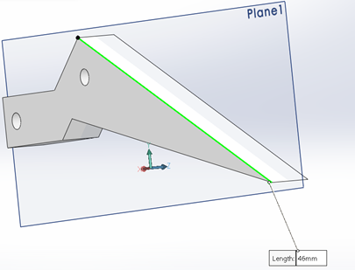
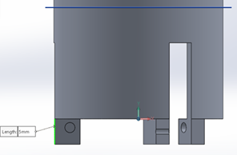
The gripper jaws would be manufactured using forging. Forged components allow for designs that can withstand the most extreme loads and pressures which is why it was chosen for the gripper arms design. The variety of qualities possible in forgings has been substantially expanded thanks to recent developments in forging technology. Forgings are more cost-effective than cast products because of their natural increased reliability enhanced tolerance capabilities, and the productivity improvements with which forgings may be machined and further processed using computational approaches (FIA, 2021). However, as Rajput (2004) expresses, the set up costs initially are high, some materials can get cracked or distorted if limits are breached meaning that tolerances can be affected. The holes that can be seen in the images need to be consistent for the fasteners that will be purchased elsewhere which will be the correct size for the gripper. The holes are 2mm in diameter and can be drilled with a drilling machine. In order for the holes to be in the correct place the drill will be aligned with a slot that fits exactly the length and shape of the jaw (46mm) so they are in the exact position every time. The same with the cylinder produced by die casting, however the components of the cylinder require the part that need to be drilled produced sperate and then attached. The slot of these parts being 5mm by 5mm with the drill set up in position off centre.

Design and Development work undertaken
Methods used to generate new design
In this assignment it is important to consider design for manufacturing and assembly. The manufacturing part contemplates the individual components and assembly is the linking of the parts to complete the product (Boothroyd, Dewhurst and Knight, 2011). It is used to simplify the structure of the product by easing manufacturing and assembly expenses and quantify improvements. It studies competitors goods can help control the costs including negotiating traders contracts.
Design for assembly will be carried out to develop the 3-Jaw Gripper – end effector using 9 guidelines. These are shown below:

1+2. Simplified design and standardisation- The gripper consists of 7 parts, the jaw(s), cylinder, drive plate, motor, join, shaft, worm. We do not want to introduce more parts as the cost will increase the more parts that are introduced so we want to reduce and consider the way they are manufactured to lessen costs. The parts that are going to be produced in house are the cylinder, drive plate and jaws, the other parts will be bought elsewhere. The parts all move how they should together, however there are no attachments to stop the gripper from opening too wide or closing down into each other, there is also not clearance between the jaw and the slot that the jaw fits into on the cylinder as they both measure at 5mm. When manufacturing the jaw components it is important to reduce the width for example 0.1mm either side for clean movement can take place without any friction that could cause damage to the part. The components being made of a different material will not be an issue, for example the motor will be manufactured to the required standards, also the steel used in the gripper has the multifunctionality to be used for the different applications on the gripper so the different properties can be sustained.
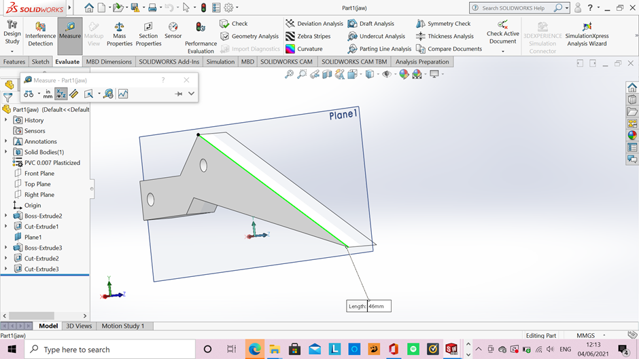
2. Ease of fabrication- The manufacturing processes I have chosen in the previous section are all capable of handling the production volume of 1000-2000 units per week. Avoiding any unnecessary steps in the manufacturing process is essential, so trying to keep the processes as efficient and choosing for example, die-casting for the cylinder housing as it will be processed in multiple parts due to the drilling needed. Also, minimizing the processing effort by using shape templates for components to fit into when drilling holes, keeping the diameter of the holes to 2mm as we do not want them too small to avoid the drill bits breaking and keep the holes a consistent size.
2mm
4. Poka – Yoke - The components will be made and assembled in one way to make sure the process is clear-cut.
5. Orientation - The product will be fitted with fasteners to avoid the parts becoming disorientated with smooth surfaces created with the processes used.
6+7. Minimize interconnections+ Ease of assembly- the material used for this design (steel) will make the parts easier to assemble and less liable to damage.
8. Efficient fastening- Fasteners are time consuming to assemble, however they are the best way to reduce variability.
9- Modular products- This method reduces storage and improves quality by lowering the total number of things to be produced (only manufacturing 3 components).
Design for X
As Kuo, Huang and Zhang (2001) explain design for X looks at the presence of each individual part questioning it using basic criteria, the designer is forced to explain why the part cannot be deleted or integrated with others. A database of real-time standards established expressly for this purpose is used to estimate the actual assembly time. By evaluating the current assembly time, the DFA index (design efficiency) is calculated and assembly issues are discovered, which could lead to production and quality issues. The supplied design standards, according to the analysis, address not just the design of a specific product, but also the interactions between multiple goods within a line of products.
Design for X would include elements of the product development cycle. Firstly, the architecture including component section which in the case of this assignment, the components have been developed to a basic standard to look at its product value. The design of the gripper is then developed into a design that can be manufactured, selecting the components that optimise the manufacturability. With design for X a prototype would be developed to get early feedback on the product, validating and testing the manufactured goods. The component is then tweaked and continuous process improvement will take place overtime (Morrison, 2015). By using design for X within the development of this product it allows the designer to target different phases of the product life style, trying to eliminate waste, problem identification, solution analysis, performance and efficiency optimization.

Risk Management
Risk management begins with a review of all necessary information, especially from collective risk assessment, which includes risk evaluation as well as concern analysis, with both based on risk perception studies, economic consequence assessments, and scientific classification of social responses to the risk source (Aven and Renn, 2010). This information, along with the decisions made during the characterisation of risks and project proposal, serves as the background for assessing, evaluating, and selecting risk management options. Failure Modes & Effects Analysis (FMEA) is a risk management tool that focuses on the process and is versatile to fit in with any development such as the 3-jaw gripper in this assignment. The table below shows a basic FMEA that has been carried out on the gripper to design the tool with more reliability that can be quantified.
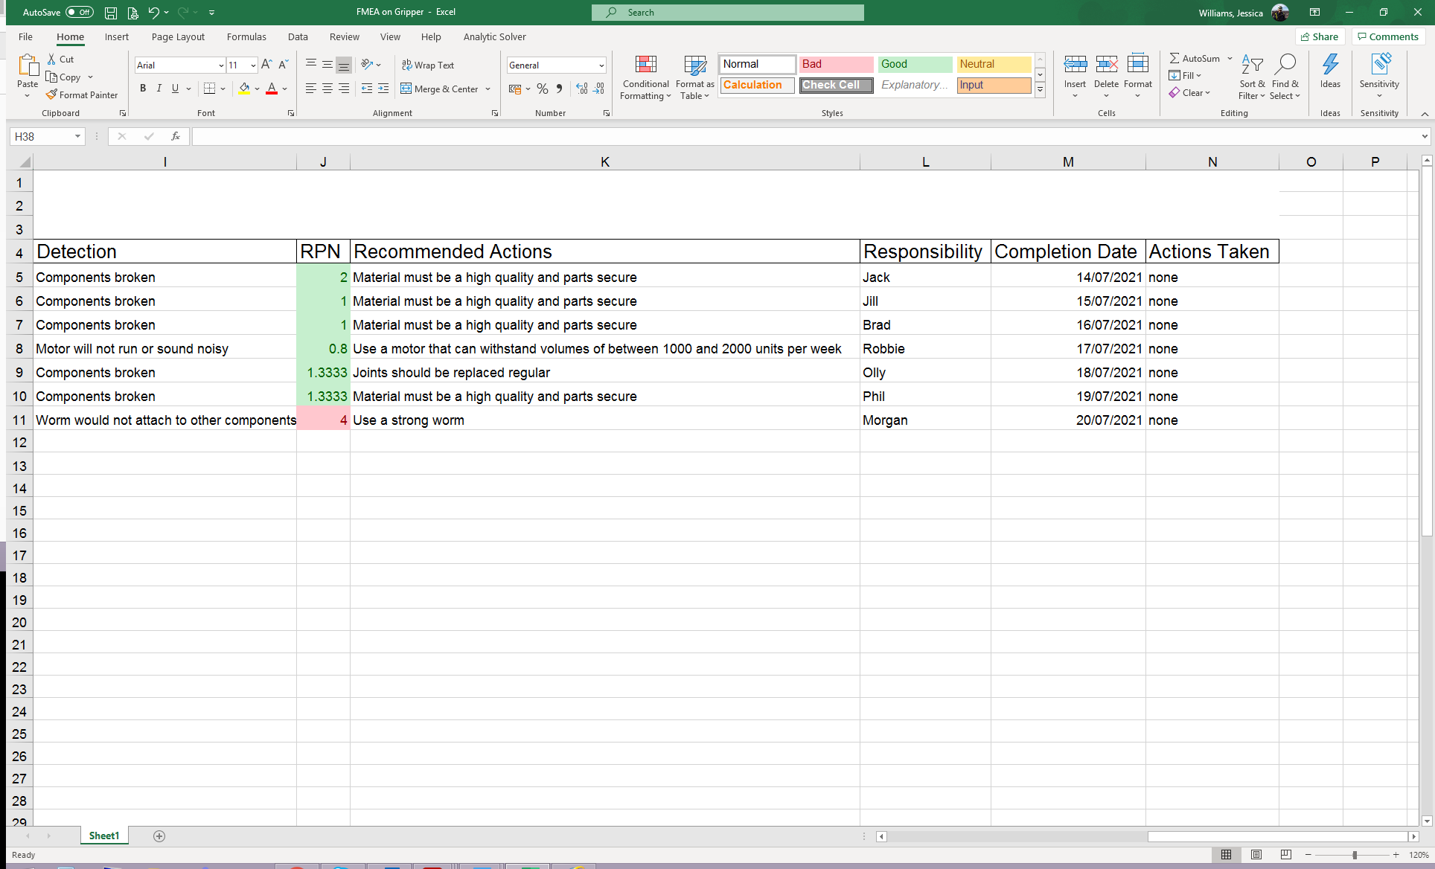
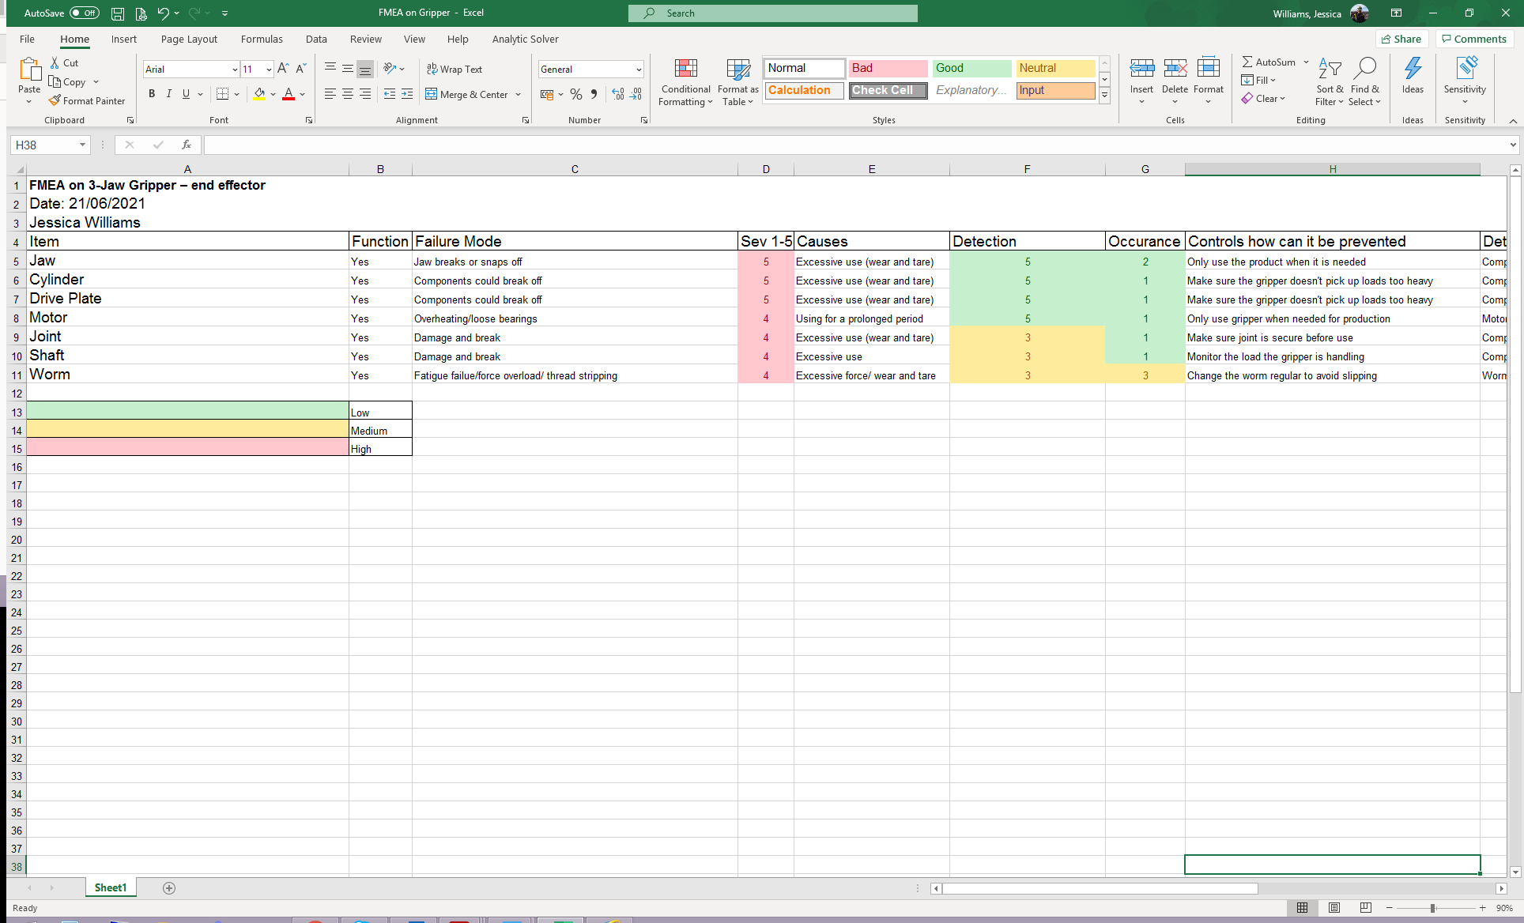
FMEA pre-emptively improves the quality, dependability, and safety of products and processes. It aids in increasing customer satisfaction by proactively addressing failures that prevent us from meeting essential customer needs in processes and products, reduces the time and cost of research and development, reduces operational risk, documents and tracks risk-reduction actions and makes a list of priority areas of interest. The FMEA above shows the possible failures of the components in this design and their severity, the possible causes and how often they may occur and the likelihood of them being detected. There is also a suggestion of some controls and actions that have been assigned to provide traceability.

Environmental
There need to be considerations for the environment and the product life cycle when designing a product or using any manufacturing process. As the Institution of Mechanical Engineers (2021) states,
- Product ideas are chosen that will attract consumers while also being profitable in the long run.
- The time between project approval and market launch is kept as short as possible.
- Goods are designed to be easy to manufacture and preserve through most of their lifecycle.
- Late changes are avoided as close to the market launch as possible.
- For optimal performance, allocation of resources at the appropriate time.
- The project and product costs are kept to a minimum.
Successful environmentally friendly design principles can centre on the three Ps of design choices: Product, Process, and Packaging. These include the materials used in the design and the environmental impact of the use, for example the steel used in the design can be recycled and disposed of in an environmentally safe way. The manufacturing processes chosen have taken the environment into account, e.g. Usually, metal casting is considered to be more eco sustainable than plastic moulding. The packaging and protective materials involved in the manufacturing process including shipping of components to customers’ needs to be considered as some of the worse pollution can come from packaging issues (Melnyk, Handfield and Calantone, 2001).
Process Design
The process in this assignment would be a batch process. The outcome of a batch process is represented by quantity of materials or lots. A batch process has a start and a finish. Batch processes feature aspects of both continual and discontinuous processes. The batch process is frequently repeated several times. Batch processes are most common in food processing and pharmaceutical formulations (Barker, Rawtani and Mackay, 2005). Having a batch process in the production of the 3 Jaw Gripper helps with he high variety of components including the manufacturing processes die casting, forging and drilling, it allows the process to be more flexible. However, this needs careful production preparation and intricate control.
Gripper Jaws- Forging
Drive Plate
Cylinder - Die Casting
Components from outside supplier –
Motor
Fasteners
Shaft
Worm
Assembly of components
Drilling of holes
Quality Check

Conclusion
This assignment has looked at appropriate manufacturing processes and design changes that are needed to make the 3 jaw gripper manufacturable. An understanding of production process in terms of risk analysis, environmental factors, design considerations have been explored to justify the process that would be used in the development process. The focus has been on the concept design and how it would be tweaked, altered and finished off to make it assemble able. As shown above, the design needed to be made more responsive to customer requirements and improved from a manufacturing stand point.
Reference List
Adler, P., Mandelbaum, A., Nguyen, V. and Schwerer, E. (1996) Getting the Most out of Your Product Development Process. https://hbr.org/1996/03/getting-the-most-out-of-your-product-development-process (Accessed: 05th June 2021).
Aven ,T. and Renn O. (2010) ‘Risk Management’, Risk Management and Governance, ( 13 August), pp. 121-158.
Barker, M., Rawtani, J. and Mackay, S. (2005) ‘Practical Batch Process Management’, Newnes, pp. 1-16.
Boelskift, P. (2014) ‘AESTHETICS AND THE ART OF ENGINEERING’, Artifact, 3 (2), pp. 2.1-2.10.
Boothroyd, G., Dewhurst, P. and Knight, W. (2011) Product Design for Manufacture and Assembly. 3rd edn. CRC Press: USA.
Forging Industry Association (2021) Forgings Where, Why, How? https://www.forging.org/forging/forgings-where-why-how.html (Accessed: 8th June 2021).
Kuo, T.C., Huang, S.H., Zhang, H.C. (2001) ’Design for manufacture and design for ‘X’:concepts, applications, and perspectives’, Computers & Industrial Engineering, 41, pp. 241–260.
Lucietto, A., Tan, S., Russel, L. and Johnson, M. (2020) ‘Public Perception of Engineering Technology: A Literature Review’, Asee’s Virtual Conference- At home with Engineering Education. June 22-26, 2020. American Society for Engineering Education, pp. 1-10.
Melnyk, S., Handfield, R. & Calantone, R., (2001) ‘Integrating Environmental Concerns into the Design Process: The Gap between Theory and Practice’, Engineering Management, IEEE Transactions,48, pp. 189 – 208.
Monkman, G., Hesse, S., Steinmann, R., and Shunk, H. (2007) Robot Grippers. Wiley: Germany.
Morrison, B. (2015) Design for Excellence (DFX) Driving Product Optimization Through Early Stage Supplier Engagement. SMTC Corporation: Canada.
North American Die Casting Association (2021) Die Casting vs Other Processes, https://www.diecastingdesign.org/advantages (Accessed:8th June 2021).
Osterman, S. and Lundberg, C. (2012) Development of performance indicators through cost driver identification – an IT department case study. KTH Industrial Engineering and Management: Stockholm.
Rajput, K. R. (2004) Comprehensive Workshop Practice. Laxmi Publications: New Delhi.
ReVelle, J., Moran, J. and Cox, C. (1998) The QFD Handbook. John Wiley and Sons: Arizona.
Ruzbarsky, J. (2019) Al-Si Alloys Casts by Die Casting. Springer: Slovakia.
Saliba, M. and Borg, J. (2009) Development of a Modular, Reconfigurable End Effector for the Plastics Industry: A Case Study. Department of Industrial and Manufacturing Engineering: Malta.
Sudin, M., Ahmed-Kristensen, S., Andreasen, M. (2010) THE ROLE OF A SPECIFICATION IN THE DESIGN PROCESS: A CASE STUDY. INTERNATIONAL DESIGN CONFERENCE: Croatia.
Tjalve, E. (1976) ‘A Short Course In Industrial Design’, Newnes-Butterworth, facsimile edition 2004 from Institute for Product Development, DTU.

