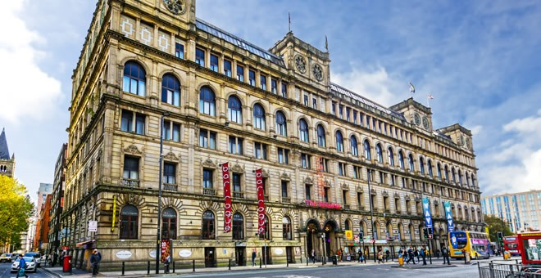
CONSULTING REPORT ON BRITANNIA HOTEL
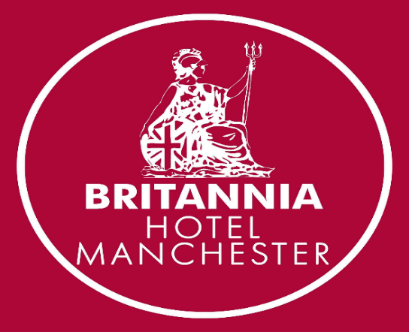

SUBMITTED BY: REETA KHATRY (2012521)
KHATRY CONSULTING GROUP
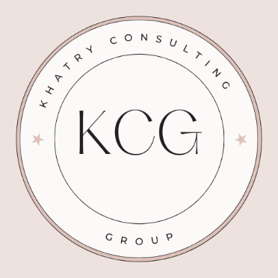

CLIENT: GENERAL MANAGER, BRITANNIA HOTEL MANCHESTER
DEC 2022

Content’s List:

- Executive Summary…………………………………………………………………………………………………. 2

- Introduction…………………………………………………………………………………………………………… 3

- Scope and Analysis…………………………………………………………………………………………………. 4

- Main Body……………………………………………………………………………………………………………. 9

- Findings & Results…………………………………………………………………………………………………… 15

- Action Plan …………………………………………………………………………………………………………… 16

- Recommendations…………………………………………………………………………………………………… 18

- Conclusion……………………………………………………………………………………………………………. 19

- References……………………………………………………………………………………………………………. 20

Executive Summary:

In this consultancy report, I am analysing Britannia Hotel located in central Manchester. This report aims to create a practical report to stimulate and create action. It offers competitive rates and is quite popular amongst guests who are either in business, leisure or travelling. These are very good strengths of this hotel.
While looking into this, I have come across some negative reviews online. They mostly revolve around staff’s behaviour / poor customer service or lack of good hygiene and outdated décor. The hotel hasn’t been renovated since September 2008. This presents lot of opportunities for the hotel to improve on so that it can compete with the revolving hospitality market and continue serving guests. The hotel needs to invest in new furniture, good quality beds and mattresses so that the guests using the rooms can have enjoyable stay. Guests need to have access to facilities such as mirrors, hair dryers, irons to get ready as most would pick this hotel due to its convenient location to all the bars, restaurants, and events. Hygiene is very important; therefore, housekeeping staff must be thoroughly trained. Clean, well-maintained bathrooms, frequently changed bed sheets can make a big difference. Guests who have previously stayed at the hotel have also stated that the indoor lighting is dark and have no windows in the rooms. It is wise to ensure all the bulbs are re fitted to provide good lighting. Guests who are staying overnight usually have luggage or two and if the lift isn’t always available then it doesn’t reflect positively on the hotel. So, Britannia needs to ensure the lifts are working and is well- maintained time to time.
Staff training is very important to ensure all these tasks are carried out properly. But no one wants to work in a space where they don’t feel respected and valued. Hence it is crucial to look after your staff as much as your guests. Statistics show that satisfied employees are 31% more productive and 3x more creative. There has been a 12% increase in a hotel’s profitability when operated by staff that are thriving and happy at their work place. Structured training programmes for the employees, assigning supervisors for new starters, monitoring their progress regularly with the manager can help with making sure staff are up to date and feel confident in doing their job. This way they can deliver their skills and services to their best ability. Rewards and recognition play an important role to keep the morale high within the team. Celebrating small or big wins, treating the team for lunch or dinner, making sure they feel valued and creating a safe space for them at work is key. This overall creates a positive environment within the employee’s that the guests will pick up on too. Satisfied guests eventually result in more popularity and success for the hotel.

Introduction:

As a part of my job description, I will be producing a consulting report for Britannia Hotel in Manchester. ‘‘A consulting report is usually prepared by an expert for a business or a client that doesn’t have the time, knowledge or the resources to carry out the necessary research and produce a detailed report.’’ I will be working with different members of the hotel to help businesses improve their services and operations. My consulting report aims to highlight the problems the client is facing, examine the problem from the consultant’s perspective and provide recommendations or solutions to the problems identified. The report will also help to lay out and professionally present these insights. As a result, this builds better communication and help maintain trust with the client. [42]
In this report I will be using two resourceful audit methods. One of them is SWOT which assesses the business’ key factors such as its strengths, weaknesses, opportunities and threats. SWOT analysis provides a simple four box framework and helps organisations assess the report and take actions to make any improvements in all these aspects. However, due to the lack of detailed structure, the process needs to be repeated on a regular basis to be effective. [34]
The other one for strategic business planning is PESTLE which analyses political, economic, social, technological, legal and environmental aspects. It can be used for workforce planning that aligns business and people strategies. Also, for market planning, product development and organisational changes PESTLE analysis can be useful. Not only the internal factors but PESTLE also focuses on the external factors and encourages strategic thinking as it works on a macro scale. However, these factors can change depending on the state of the country globally and can be uncertain. Due to the benefits and drawbacks of both methods, I will be combining both analyses to provide an in depth, balanced analysis. [2,3]

Scope and Analysis:

Britannia Hotel is located in Portland Street, the heart of Manchester that can accommodate over 300 guests. It is a traditional, well-established hotel since the 19th century. It known for its impressive architecture, cast iron staircase and grand chandelier. The location is fantastic for this hotel and it has everything on its door step, from shopping to sightseeing. [58,59] Manchester Arndale that has variety of department stores such as Selfridges, Marks and Spencer’s, Primark and many more are popular with shopping lovers, is only 0.4 miles away. There are many museums and galleries such as the Manchester Museum, the National Football Museum and the Museum of Science and Industry are all within 1 mile. Manchester also offers a lively nightlife and the hotel is located less than a mile away from popular bars and restaurants. It is located 0.6 miles away from the Printworks and 7- minute walk from the Northern Quarter, where there are many options for bars and restaurants. [32] This will appeal to foodies as there are a lot of choices on eateries, of different cuisines around the city.
Staying the night at Britannia Hotel in Manchester also opens up options for many events and shows as they are all within walking distance. The Palace Theatre is only eight minutes’ walk away, Opera House 14 minutes’ away and Manchester Arena 16 minutes. There are two popular football grounds, Old Trafford and Etihad Stadium both less than 3 miles away which offers football fans an affordable accommodation overnight. [4,41]
Due to its convenient location, it is quite easy to navigate to and from Britannia Hotel in Manchester. There is a great public transportation link that makes travelling around them city easier. Manchester Piccadilly is the nearest train station, 0.3 miles away and the trams run through the city centre quite frequently. The nearest tram stop is around 5 minutes’ walk to Market Street. There are also many bus routes, bus stops are located right in front of Portland Street and in Piccadilly Gardens. Britannia hotel in Manchester doesn’t offer guests its own car park, however, guests can receive discounted rates at car park located in Tariff Street which is around 10 minutes’ walk from the hotel. [4]
Aside from accommodation, Britannia hotel also provides conference and wedding venues. They have several function suites to cater for small occasion or a large wedding party. They offer variety of packages for drinks, room hiring, catering and personalised menus. The packages are flexible and affordable and due to its architecture and features the venue does provide a nice backdrop for wedding photos. The hotel is also pet friendly opening up options for dog owners and animal lovers. [5]
Although there are quite a few upsides, Britannia hotel has received some negative reviews. Going through the hotel’s recent reviews, this one from google reviews stands out:
‘‘The hotel was in a great location, very central and walking distance everywhere. It was clean as well. The shower was warm and good water pressure. That’s kind of where it ends. Our first room had a bad smell so we changed room and the second had no window. The room was very run down and had not been upgraded or refurbished recently. It was very hot in the room and there was no air con. The whole hotel stank of weed. The hotel was understaffed, so queues were very long at reception and they never answered the phone. The lifts were so slow as well. There was no housekeeping so we had to ask for toilet paper. Checkout was 10am…. outrageously early! Grand place to rest your head if you don’t plan on spending any time in the room, but I wouldn’t stay again. I’ve stayed in nicer hostels.’’ [18]
This shows that there is a lot of work that needs to be done to improve this hotel specially if it is to survive the competitive market in the city centre. The lack of basic requirements such as no air con, housekeeping facilities, cleanliness and being understaffed can be quite detrimental for the hotel’s reputation and business. [57]

To effectively analyse the external context, I have carried out a PESTLE analysis below (Figure 1.0) to consider the broad factors that may affect the business such as Britannia hotel and the changes that happen within this context. Political stability/ instability, government actions, changes in national policies can make a significant. Economic factors such as tax rates, inflation rates, exchange rates, population growth, levels of education are also critical factors to consider within an organisation. For example, if the income levels are generally lower, we need to revise the pricing strategy in the hotel in order to penetrate the market and generate sales/ profit. Socio-cultural aspects such as traditions, values and ethics play an important role in the external environment of the business. When the business values are aligned with the social, cultural and traditional values of the location, there is better performance and higher productivity. Socio- cultural factors needs to be considered before introducing new good and services in a hotel as many may be resistance to any changes. Technology has become a very important part of everyday business. New technologies, updated hardware and software aid in improving organisation and effectiveness of the decisions made. Social media and digital strategies, for instance, text/ email marketing, GPS marketing can be an important tool to help with marketing for Britannia hotel. A company needs to abide to the law, rules and regulations, and guidelines such as Consumer Affairs Related law, food service and quality. By doing so it promotes ethical business and is attractive to stakeholders as they see it as legally binding. Environmental factors such as carbon footprint, disposable mechanisms, pollution also plays a role with global warming and sustainability concerns. [3,6,33]

Figure 1.0

Political | Economic | Social | Technological | Legal | Environmental
- The political instability can mean quick changes in laws, regulations which the hotel has to respond to appropriately.  - Laws on CO2 emissions is becoming stricter that the hospitality industry need to abide to.  - Employment law may change which may mean higher wages affecting overall profitability.  Rate Impact (1-5): 3 | - Increasing inflation means that commodities and fuel prices also rise. The hotel has several overheads and each of these will rise in line with inflation meaning lower profitability. The hotel needs to be thinking of more efficient ways so that they can absorb the increasing costs.  - Bank of England interest rates increasing may mean that the rent/mortgage of the hotel will also increase, further increasing the risk of less profitability .and bankruptcy.  - Due to the rising costs of living, more people will have less disposable income and may affect revenue as they stay home or go somewhere cheaper  Rate Impact (1-5): 4 | - The culture will continually change, if there is an order to work from home again, customers will not be travelling to work and therefore not stay in hotels during the week. Customers may feel due to the cost-of-living crisis that they cannot afford going abroad but still want to enjoy themselves and may book into a hotel in the UK and therefore there may be a rise in bookings.  - Customers may now want aesthetically pleasing pictures and therefore may want to book hotels which are ‘Instagrammable’ and statement hotels.  - The rising awareness of hygiene and cleanliness will mean that potential customers will look at hygiene ratings and how the hotel is going above and beyond to meet this need.  Rate Impact (1-5): 3 | - More hotels are adapting to the increased rate of technological changes i.e., automation and competitors will need to keep up.  - Faster self-service check-ins, cards which unlock rooms are a few that is now expected in hotels for a better service.  - Social media and digital strategies to help with marketing.  - Computerised billing and online payments.  - Can the hotel collect data to inform strategic decisions in the future too.  Rate Impact (1-5): 2 | - Laws around employment, hygiene standards, food, fire regulations, public liability, music licences, extractor cleaning, health and safety will all affect how a hotel is run. Being non-compliant can result in closure but being compliant can also cost a lot of money. The hotel needs to be compliant and still make a profit considering laws changing quickly.  Rate Impact (1-5): 3 | - Recycling/ waste disposable mechanism such as eco-friendly, disposable bags.  - Energy efficient bulbs to lower costs and carbon dioxide emissions.  - As we learnt from COVID-19, a future virus/ pandemic can close hotels down and force people to stay home.  Rate Impact (1-5): 3

Additionally, this will also provide a baseline to understand the business’s strengths, weaknesses (internal) opportunities, and threats (external) (SWOT) factors. (Figure 1.1). Britannia hotel can use its strengths and opportunities as leverage for advantages and profit in the competitive market. On the other hand, the weaknesses and threats highlight problem areas and if minimised can lead to great success. [21, 23]

Figure 1.1

Strengths  - Well established, traditional hotel since the 19th century.  - Convenient location.  - Value for money providing an affordable overnight stay in the heart of city centre.  - Wedding and conference venues available.  - Pet friendly. | Weaknesses  - Poor reviews/ many rooms come without any windows.  - Out of date decor and poor hygiene.  - Late check ins and early check outs with no other facility to accommodate the guests’ luggage.  - Limited Wi-Fi.  - Limited breakfast choices.  - Doesn’t appeal to younger crowd.
Opportunities  - Huge space for a re-furnishment/ renovation to improve the hotel. | Threats  - Many other new city centre hotels are opening, increasing the competitive market.

Main Body:

There are several reasons why Britannia Hotel in Manchester appeals to its guests. As it is centrally located, it attracts lots of customers/ tourists seeking a convenient stay within a budget. [39, 51]
However, there are several aspects where the operations can be improved. One aspect that can be improved is supply chain management.
Supply chain management is how an organisation provides their services/ products to their customers. Key element of supply chain management is maintaining a good relationship between organisations which allows efficient flow of goods, information and finance to the customers. In order for this to be a success, there needs to be clear data information, goals, objectives, requirements and expectations set. There are also likely to have risks involved in supply chain management, which can be difficult to avoid but can be moderated and controlled. If the organisations fail to dedicate time and resources in risks management and continuity of operations, it can easily disrupt the supply chains. For example, during COVID-19 pan demic, Britannia Hotel, like many industries suffered significant financial (Figure 3) and operational challenges. There were many shortages of supplies such as personal protective equipment (PPE), chemical cleaners during the pandemic which meant that it was difficult to meet customers’ demands to the highest standards. Increased number of COVID cases and isolation period meant that there were staffing shortages. Therefore, creating a pressurised environment to work for the employees present. The pandemic also interrupted transportation which delayed the production and distribution process. COVID-19 highlighted the importance of risk management and supply chain resilience so that hospitality industry can endure, adapt and succeed during difficult times. [8] As shown in Figure 2, the effects of the pandemic were long lasting, even affecting the following year in 2021. The turnover in 2020 was £120,460, whereas in 2021 it was only £38,311. Gross profit was significantly lower in 2021 at £18,162. This shows that Britannia hotel needs to manage all their risks, operations in order to avoid future losses.
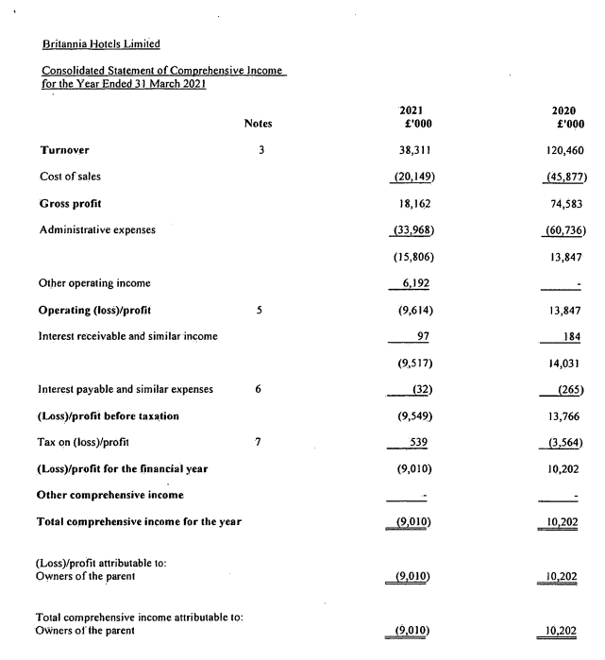

Figure 2. Consolidated statement of comprehensive income for the year end 31 March 2021 for Britannia Hotels Limited. [8]

It is wise for companies like Britannia hotel to revise their inventory strategies by increasing safety stock, using materials which has multiple uses. The hotel needs to work with different suppliers and not restrict itself to one supplier to avoid any risks of supplier dependency. Having a manufacturer in this country or nearby countries will reduce both the shipping costs and time. New technical advancements, digital tools, auto information and refinement in this information era allows hospitality industry to enhance resilience. Selecting and continually managing suppliers is also a vital part of operations. Suppliers should also be regularly monitored for their reliability, performance and accuracy. Britania hotel will benefit from monitoring the supplier’s price, quality, innovation and sustainability. It is important to note that the supplier performance may not always remain consistent so this should be carefully monitored in order to meet the business objectives of both business’ customers and stakeholders. [7,53]
Inventory management of a hotel is very important as it allows an accumulation of resources as they flow through operations and/or supply networks. This provides a foundation to the hospitality industry so that they can serve their customers. Common physical inventories for Britannia hotel includes food items, drinks, linens, toiletries, cleaning items. For example, if the restaurant in Britannia hotel runs out of food and beverages, customers may to it competing restaurants nearby. Hence it is important to manage the company’s inventory, regularly monitor and keep up to date. [40,44]

Within the hospitality sector, staff training is vital as it ensures that the employees are able to make maximum contributions to the business success. Managers also have an obligation to help their employees achieve pride in their work, gather necessary knowledge and skills to be successful on their jobs. When employees are happy within their jobs, it is reflected on their services, providing better customer services which can be echoed on customer reviews. Fully trained staff are less likely to make errors and their improved job performance reduces the hotel’s operating costs. Another benefit of staff training is that it results in low staff turnover which saves the business money re-hiring and re-training new staff continuously. The value-added, experienced staff also need to make sure they keep up with ever changing hospitality industry. Therefore, effective staff training is crucial to attain these goals for Britannia hotel. [10, 45]
Effective training can improve three main components that staff require to do their job effectively: knowledge, skills and attitude. Different training approach is required for each component. For example, lectures, films, talks can be used to improve staff’s knowledge. Practice is necessary to improve skills such as handling a knife in the kitchen/ setting up tables at the restaurant. The third component of an individual’s attitude can be the most challenging to change or improve on as it requires deep understanding of human behaviours. Some of the techniques that can help improve in this component are role plays, case studies and having open discussions. However, many behaviour experts recommend that because the human attitudes can be difficult to modify, it is better to select individuals with the right attitudes that align with the business’ objectives rather than attempt to train whose attitudes can be conflicting with their employer. This means that the work should begin from the beginning at the interview process to carefully select employees that can fit the business’ values and objectives.

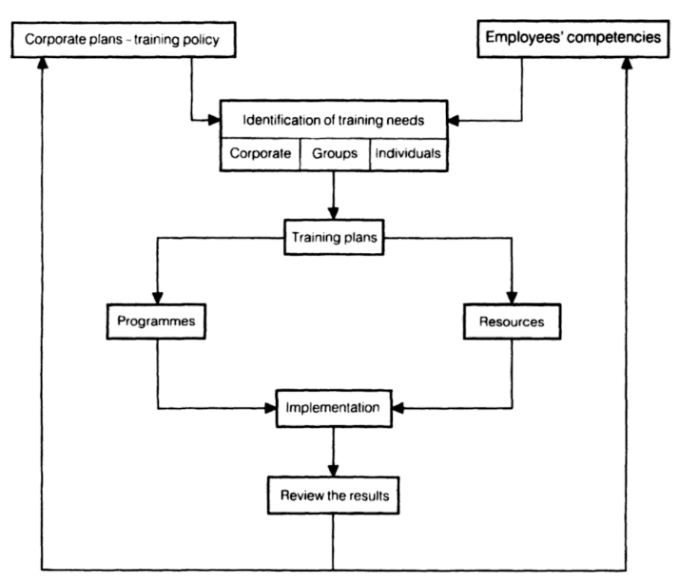

Figure 3. A suggested overview of the training process. [11]
Figure 3 gives a simple overview of designing and analysing the training process that can be used to train staff at Britannia hotel. To begin with we need to identify the training needs, often referred as ‘training needs analysis. This is usually done in consultation with line management by the person responsible for training. This allows to identify the problems and opportunities that can be solved by appropriate training in place. Appraisal reports and detailed discussions with the managers based on the staff’s job description, current performance, and potential for improvement can be produced. 80/20 principle helps to identify what is causing the majority of the problems/ which area needs to be focussed on more which will allow to focus limited resources on areas that will reflect the most benefits and improvement. [36] It is helpful to recognise what generates most profits. For example, since Britannia hotel is situated in the centre of Manchester, guests usually like to have few drinks at the bar before they head out, meaning the profits can be driven by liquor sales. In order to improve sales and promote sales of drinks, there needs to be effective training of waiters in product information, selling and serving techniques. Once the training is implemented then it is important to review the results. Staff training is one of the management tools that can be used to increase an employer’s efficiency. But it is important to note that training alone cannot solve all the problems that arise in the hospitality industry especially if it is poorly planned or situated. Managers should work with their staff to equip themselves with the knowledge, skills, attitude and the competencies to achieve the goals of a business. Some of the suggested ways to deliver effective training are personalised experiential learning for example, on the job training, supervisor ‘mentoring’; lectures and panel presentations, observational learning, interactive learning for example, role pays, games. [11,38] The use of social media and digital technology can also be appealing to younger group of staff. Combining face to face training with online training also means that staff can be learn from home and will have access to the information whenever they desire to refer back to.

As Richard Branson states, “Clients do not come first. Employees come first. If you take care of your employees, they will take care of the clients.” [15] It is important to recognise this at Britannia Hotel and ensure staff satisfaction leads to the success of the hotel. Britannia hotel needs to cultivate a supportive environment to all their employees and demonstrate that their well-being is well looked after. Employees feel valued when they know their work has been valued and are motivated and empowered to do their best. Simple things like taking a personal interest in staff’s likes, dislikes, verbal praises, greeting them with a smile makes a big difference. Engaging in meaningful conversations, a positive work environment and offering rewards contributed towards employee satisfaction and productivity. Work benefits and right perks can make a positive impact on each individual, for example, generous paid annual leave, authorising holiday requests on time, offering a gym membership. Some of the benefits that many competitive hotels provide includes Hilton hotel that offers good parental leave if an employee is expecting an arrive of a baby. Hotel Marriott, for instance, provides employee income protection and long-term staff who have been with the company for over 25 years receive unlimited free stays at the Marriott. Britannia hotel could incorporate these benefits and also offer the employees’ family members the option to stay overnight at reduced price. [55] Other incentives could include gift cards or end of year bonus to keep employees motivated throughout. Team rewards and recognition help promote team building and raise morale within the employees. For example, when the hotel gets a positive review online especially mentioning a colleague, printing it out and displaying it in the staff room helps boost their morale. Team lunch/ dinner treats to celebrate any set accomplishments keeps up the motivation amongst the team. [14,15,48]
Another way to manage the staff satisfaction within Britannia hotel is to provide them with the required tools to succeed. It can be helpful in any department, for example, the latest digital tools for marketing, upgrading all the vacuum cleaners for housekeeping helps to complete daily tasks faster and effectively. Use of artificial intelligence saves time and stress. Replacement of small, mundane tasks as checking tickets can be automated such as using automated ticketing system. [12,13] One of the complaints of guests in the reviews for Britannia hotel is that long waiting times for checking in and checking out even when there are about five staff members helping with this, especially during peak times like a Saturday night or during football matches. [17,18] Incorporating an automated self-check in and self-check outs would solve this issue and free up the staff to do other fulfilling jobs. This helps reduce stress, save time and the employees can spend their time doing more productive tasks instead. Overall, all these benefits will have a positive impact on the mindset, day to day performance and job satisfaction for the employees. [47,49]

Britannia hotel is known for its grand building with a lot of character located in very convenient location. However, this is a bit outdated to cater for guests in the competitive market, again highlighted by recent reviews. Britannia hotel’s reviews currently score 2.5-3 stars on average. The score is usually dragged down by its poor rated cleanliness, outdated décor and services. Guests have complained about damaged furniture such as poor bed and mattresses, no extra toiletries, no iron, no mirror for guests to get ready, poor lighting. There are missing bulbs in the main part of the bedroom in some of the rooms. Some guests even found stains in their bedsheets which reflects very badly on Britannia hotel’s hygiene. Carpets in the room is very outdated and the hotel uses black tape to hold some parts of the carpet together. This poses a trip hazard to the guests. Another inconvenience pointed out by the guests is that the 2 plug sockets are placed in opposite side of the room from the beds. This makes charging appliances such as mobile phones next to the bed tricky. Some of the bathroom tiles are cracked and there is rust by the taps and sinks. The lifts in the hotel are outdated and once the guests leave the lifts, they complain they are greeted with some unpleasant smell which usually portrays ill hygiene. Guests have to pay extra for rooms with windows but were disappointed since the upgraded rooms with windows are very small and around 8 foots above floor level, which restricts any possible view. Some guests even point out that lifts were out of order numerous times which meant that the guests had to drag suitcases several floors up and down. This can be inconvenient to the guests staying more than one night as their suitcases can be heavy or guests can have more than one luggage with them. [17,18, 56]
Considering all these negative reviews and the feedback from the guests, there is a lot of room for improvement for Britannia hotel which we will be considering in the action plan.

Findings & Results:

Looking at all the aspects of Britannia hotel, I have gathered that unsatisfied staff can reflect negatively on the hotel’s business. Staff in the hotel are the core of customer services and making sure the guests are looked after and satisfied with the services. Therefore, when the staff are motivated, their level of engagement with the guests will also improve, driving the business’ success. There have been many studies and the statistics show that satisfied employees are 31% more productive and 3x more creative than those who aren’t. There has been a 12% increase in a hotel’s profitability when operated by happy staff. Hotels with positive work environment also experience 24% less turnover rate. These numbers speak for themselves and can be beneficial for Britannia hotel to ensure they look after their staff. To create a positive work culture, need to ensure employees are supported, given rewards, recognition, provide tools to enable them to perform their best and hold everyone accountable. [26,54] After my analysis, I am suggesting a budget of £5,000 staff training and £10,000 to improve staff’s welfare at the organisation.
Redecorating a hotel every 10 years or so is usually considered a good practice to stay in the competitive market and we have concluded that this is overdue for Britannia hotel in Manchester. The last time the hotel had any refurbishment done was in September 2008 whereas other competitor hotels in central Manchester are upgrading their facilities. [31] This is reflected on all the negative reviews. Hotel renovation directly affects its marketability, values, functionality and overall profitability. To demonstrate this, there was a study carried on a sample hotel over the period of six years, with 3 years prior to the renovation, one during (November 2014 and April 2015), and the latter two years after the renovation was finished. During 2011-2013, this sample hotel had recorded decline in bookings, the hotel was looking tired and the average rate index also plateaued. Post renovation, there was an increase in net operating income of total revenue by 14.5% from 2014 to 2016. The trip advisor ratings also trended upwards, 0.20 points than the previous average. [35] This illustrates the positive impact a revamp can have and same can be applied to Britannia hotel. After my examination, I am suggesting a budget of £35,000 for all the work that needs to be done at this hotel. Renovations can be costly initially but it is an investment for the business and prioritising guests’ experience to the balance sheets can lead to more profitable future long-term. [52]

Action Plan:

Number | Problem | Solution | Desired Outcome | Time Scale | Completion Date | Planning Budget (single site)
 | Poor staff training | - Structured staff training in place  - Practice based training such as role plays or interactive training  - Review and feedback with line manager | - Fully trained staff with the required knowledge and skills | - 1 week for new employees  - Review during probation period in 3 months  - Ongoing training every year  - Access to online training from home/ information staff can access if they need to. | - Ongoing training to keep up to date with any changes within the business | £5,000
 | Unsatisfactory staff/ employees | - Employee benefits such as staff discounts, better pension schemes, bonus  - Authorising staff’s holiday requests on time  - Team lunch/ celebratory dinners to recognise accomplishment/ during holidays for example, work’s Christmas meals | - Satisfied employees who are motivated, on board with the mission of the business  - Positive work environment  - Team bonding | - Holiday requests approved within 1 week | - Ongoing for review and management within the organisation | £10,00
 | Outdated décor and poor hygiene | - Refurbishment/ modern redecoration  - Invest in brand new, good quality beds/ mattresses and furniture  - Mirrors, hair dryers, irons in rooms for guests to get ready  - Bed sheets to be changed frequently and better housekeeping for improved hygiene  - Clean, well-maintained bathrooms  - Functioning lights with eco-friendly bulbs to reduce CO2 emissions  - Replace all the outdated carpets and curtains  - Functioning lifts that are available 24/7 | - Brand new modern décor to attract guests/ clients  - Better hygiene, cleanliness to satisfy the guests  - Motivated staff to work in clean/ updated space | - 6 months | - 01/07/2022 | £35,000

Recommendations:

I have listed are my recommendations for Britannia Hotel Manchester as below:
- Structured staff training programmes in place to provide the tools and knowledge for all employees to be able to perform to their best ability. Training can be varied for example, role play of how to greet guests, or interactive team work. This is to be monitored with their line manager regularly so they can provide them with feedback.
- Employees are a very important part of a business and at Britannia hotel, we need to ensure they are looked after. This overall creates a positive environment within the employee’s that the guests will pick up on too.
- The more negative reviews for Britannia Hotel are currently revolved around its poor hygiene and outdated décor. This presents with opportunities and scope for renovation to ensure the hotel is more up to date. The hotel will need to invest in new carpets, curtains, good quality furniture, beds and mattresses. To provide guests with improved hygiene and cleanliness, staff will need to change bed sheets and clean rooms and bathrooms regularly. The interior appears dark and has no window access, so use of functioning lights will brighten up the interior but need to ensure it is eco-friendly to lower CO2 emissions. [37]
The hotel is located very centrally and the competitive prices is what appeals to all the guests staying over. With all the improvements listed above, Britannia Hotel has a huge space for success, reflected both on positive customer reviews and the business profit.

Conclusion:

In conclusion, Britannia hotel is well known for its fantastic location, tremendous amount of character with its grand architecture, and is available for a reasonable price. Most guests are looking for one or two night’s stay in Manchester either a for night out or a football match. So, first impression is very crucial. There are also some areas that need to be improved on. For instance, staff training and staff satisfaction. This generally gets reflected on their work especially if the guests are greeted poorly, customer service is not delivered properly. Regular staff training in place ensures that all staff have the resources and knowledge to perform to their best ability. It is also important to look after your employees and ensure they are happy in the workplace. Research has proven that staff that are pleased at work and to be at work show better work productivity. Tools such as automated check in/ check out, online payments take the work load and stress off the staff. Rewards and recognition boost the staff’s morale. Customers and guests staying in the hotel will also be able to pick up on the positive environment.
Britannia hotel in Manchester is overdue its renovation as reflected on recent reviews with comments such as ‘dated environment’ or ‘‘needs a refresh’’. This is a good opportunity to repaint the staircases, install new carpets and curtains, invest in good quality furniture and beds so the guest can have a more pleasant stay. Faster check in system and self-check outs will help reduce the queues at the entrance/ reception. All this will enable to drive more positive reviews and guests are more likely to stay at Britannia hotel again, driving sales and profit.
Lastly, I would like to take this opportunity to thank Britannia Hotel for inviting me to write up this consultancy report. I hope you find it useful and I look forward to working with you again.

References:
- Mary McMahon Last Modified Date: November 23, Mary McMahon Ever since she began contributing to the site several years ago and Mary McMahon Ever since she began contributing to the site several years ago (2022) What does a hospitality consultant do, Practical Adult Insights. Available at: https://www.practicaladultinsights.com/what-does-a-hospitality-consultant-do.htm (Accessed: November 21, 2022).
- Contributor, P.E.S.T.L.E. (2022) SWOT vs. Pest, and how to decide which one to use, PESTLE Analysis. Available at: https://pestleanalysis.com/swot-vs-pest-analysis/#:~:text=PEST%20analysis%20refers%20to%20Political,prime%20determinants%20of%20strategic%20planning (Accessed: November 21, 2022).
- Contributor, P.E.S.T.L.E. (2022) Pestle and SWOT analysis: When to use SWOT, PESTLE Analysis. Available at: https://pestleanalysis.com/pestle-and-swot-analysis/ (Accessed: November 21, 2022).
- The Britannia Hotel in Manchester. Britannia Hotels. Available at: https://www.britanniahotels.com/hotels/the-britannia-hotel-manchester (Accessed: November 22, 2022).
- The Britannia Hotel in Manchester. Britannia Hotels. Available at: https://www.britanniahotels.com/hotels/the-britannia-hotel-manchester/weddings (Accessed: November 22, 2022).
- The PESTLE Analysis. N.p., Nerdynaut, 2017.
- Operations Management in the Hospitality Industry. London, Emerald Publishing Limited, 2021.
- Britannia Hotels Limited Filing History - find and update company information. GOV.UK. Available at: https://find-and-update.company-information.service.gov.uk/company/01343600/filing-history (Accessed: November 20, 2022).
- Hayes, David K., and Ninemeier, Jack D..Human Resources Management in the Hospitality Industry. London, Wiley, 2009.
- Boella, M. J. Human Resource Management in the Hospitality Industry. London, Stanley Thornes, 2000.
- Boella, Michael J., and Goss-Turner, Steven. Human Resource Management in the Hospitality Industry: A Guide to Best Practice. London, Routledge, 2019.
- Boella, Michael J., and Goss-Turner, Steven. Human Resource Management in the Hospitality Industry: A Guide to Best Practice. London, Routledge, 2013.
- Endter, Claudia. Managing People in International Hospitality and Tourism Industries. Berlin, GRIN Verlag, 2011.
- User, G. (2021) 5 ways to Keep Your Hotel Staff Happy, Ameniti. Ameniti. Available at: https://www.ameniti.com/blog/5-ways-to-keep-your-hotel-staff-happy (Accessed: November 21, 2022).
- Sommerville, Kerry L. Hospitality Employee Management and Supervision: Concepts and Practical Applications. London, Wiley, 2007.
- Schmid, Anne M..International Hotel Redesign. New York, PBC International, 1989.
- MEN), (I. (2021) 'I paid £299 to stay at the Britannia Hotel in a bedroom with no windows', Manchester Evening News. Available at: https://www.manchestereveningnews.co.uk/whats-on/whats-on-news/paid-299-stay-britannia-hotel-21743244 (Accessed: November 21, 2022).
- Britannia Manchester hotel - updated 2022 reviews. Tripadvisor. Available at: https://www.tripadvisor.co.uk/Hotel_Review-g187069-d191562-Reviews-Britannia_Manchester_Hotel-Manchester_Greater_Manchester_England.html (Accessed: November 21, 2022).
- Management of Training and Development in Hospitality Industry. N.p., Archers & Elevators Publishing House.
- Reid, Robert D., and Bojanic, David C.. Hospitality Marketing Management. London, Wiley, 2009.
- Dale, Crispin, et al. Hospitality Business Development. Berlin, Butterworth-Heinemann/Elsevier, 2010.
- Walker, John R., and Miller, Jack E..Supervision in the Hospitality Industry: Leading Human Resources. London, Wiley, 2009.
- Morrison, Alastair M..Hospitality and Travel Marketing. London, Taylor & Francis.
- Worthington, Barry. Discovering Manchester: A Walking Guide to Manchester and Salford - Plus Suburban Strolls and Visits to Surrounding Attractions. Manchester, Sigma Leisure, 2002.
- Why hotels need to focus on employee satisfaction and happiness (2022) SiteMinder. Available at: https://www.siteminder.com/r/trends-advice/hotel-management/guest-service-staff-hotel-happy/ (Accessed: November 23, 2022).
- Reports of the Tax Court of the United States. New York, U.S. Government Printing Office, 1962.
- Van der Wagen, Lynn, and Goonetilleke, Anne. Hospitality Management, Strategy and Operations. Pearson, Sydney, 2015.
- Dale, Crispin, et al. Hospitality Business Development. Taylor & Francis, 2010.
- Mogelonsky, Adam, and Mogelonsky, Larry. More Hotel Mogel: Essays in Hotel Marketing & Management. London, AuthorHouse, 2020.
- Case Based Research in Tourism, Travel, Hospitality and Events. Singapore, Springer Singapore, 2022.
- Britannia Hotels unveil refurbished Manchester Hotel (2009) 24. Available at: https://www.24-7pressrelease.com/press-release/65286/britannia-hotels-unveil-refurbished-manchester-hotel (Accessed: November 28, 2022).
- The Britannia Hotel in Manchester. Britannia Hotels. Available at: https://www.britanniahotels.com/hotels/the-britannia-hotel-manchester (Accessed: November 22, 2022).
- PESTLE Analysis: Understand and Plan for Your Business Environment. Brussels, 50Minutes.com, 2015.
- Morrison, Alastair M. Hospitality and Travel Marketing. London, Taylor & Francis.
- Tophotelprojects (2017) The financial impact of hotel renovations, Hospitality Net. Hospitality Net. Available at: https://www.hospitalitynet.org/news/4080804.html (Accessed: November 30, 2022).
- Koch, Richard. The 80/20 Principle: The Secret of Achieving More with Less. London, Nicholas Brealey, 1998.
- Tumbo, Oliver. Concepts of Sustainable Development in the Tourism and Hospitality Industry. Berlin, GRIN Verlag, 2015.
- Nickson, Dennis. Human Resource Management for the Hospitality and Tourism Industries. Amsterdam, Butterworth-Heinemann, 2007.
- Britannia hotel city centre Manchester, Manchester, UK. Booking.com. Available at: https://www.booking.com/hotel/gb/britannia-manchester.en-gb.html (Accessed: November 25, 2022).
- Hotel Management and Operations. London, Wiley, 2010.
- Manchester Entertainment (2022) Visit Manchester. Available at: https://www.visitmanchester.com/things-to-see-and-do/entertainment (Accessed: November 23, 2022).
- Management Consulting: A Guide to the Profession. Geneva, International Labour Office, 2002.
- Pyo, Sungsoo, and Bouncken, Ricarda B. Knowledge Management in Hospitality and Tourism. London, Taylor & Francis, 2003.
- Muller, Max. Essentials of Inventory Management. Kyiv, AMACOM, 2011.
- Thomas, Odaine. Training and Development. Exploring the Effectiveness of Training on Worker Performance. Berlin, GRIN Verlag, 2018.
- Dyer, Chris. The Power of Company Culture: How Any Business Can Build a Culture that Improves Productivity, Performance and Profits. London, Kogan Page, 2018.
- Bari, Siddharth. The Potential of Benefits and Challenges Associated with Management of Wellbeing in the Hospitality Workforce. Accor Hotels as an Example. Berlin, GRIN Verlag, 2020.
- Goss-Turner, Steven, and Boella, Michael J. Human Resource Management in the Hospitality Industry: A Guide to Best Practice. London, Taylor & Francis, 2013.
- Kusluvan, Salih. Managing Employee Attitudes and Behaviors in the Tourism and Hospitality Industry. New York, Nova Science Publishers, 2003.
- International Encyclopedia of Hospitality Management 2nd Edition. Amsterdam, Taylor & Francis, 2012.
- Danny et al. (2022) Britannia Hotel Manchester (Manchester) – 2023 updated prices, Expedia.co.uk. Available at: https://www.expedia.co.uk/Manchester-Hotels-Britannia-Hotel-Manchester-City-Centre.h41523.Hotel-Information (Accessed: November 23, 2022).
- Harper, David. Hotels and Resorts: An Investor's Guide. London, CRC Press, 2016.
- Chen, Joseph S., et al. Sustainability in the Hospitality Industry 2nd Ed: Principles of Sustainable Operations. London, Taylor & Francis, 2013.
- Boella, Michael, and Goss-Turner, Steven. Human Resource Management in the Hospitality Industry. Amsterdam, Taylor & Francis, 2012.
- Cullen, John B., and Parboteeah, K. Praveen. Business Ethics. New York, Taylor & Francis, 2013.
- Gordon-Davis, Lisa. The Hospitality Industry Handbook on Hygiene and Safety: For South African Students and Practitioners. Juta, 1998.
- Jones, Thomas J. A. Professional Management of Housekeeping Operations. London, Wiley, 2007.
- Information and Communication Technologies in Tourism 2016: Proceedings of the International Conference in Bilbao, Spain, February 2-5, 2016. Berlin, Springer International Publishing, 2016.
- The importance of location in the hospitality industry (2016) Newgrove. Available at: https://newgrove.com/the-importance-of-location-in-the-hospitality-industry/ (Accessed: November 25, 2022).
- Boella, M. J. Human Resource Management in the Hotel and Catering Industry. London, Taylor & Francis, 2017.

