Managing Digital Identities - BMSP5004
Hannah Thomas – 1703882.
Assignment 1.

Introduction:
Social media has a massive influence on our generation today. Everyone is currently using the media, whether it is for personal or professional use. People use social media to portray a digital identity without realising.
Everyone who uses social media, has a digital identity. The meaning of this is, an identity that is created through social media platforms and linking it with a physical identity of an individual. A digital identity is identified by using a username or true name which can be found through search engines. An identity can also expose the user’s activity e.g. what they associate themselves with by liking a particular post. Monitoring your digital identity across different platforms is very important, as you leave a personal digital footprint and it could affect future opportunities e.g. careers. It is important to ensure that you are targeting the correct audience. (Brett Shavers, John Bair, in Hiding Behind the Keyboard, 2016)
Through using various platforms, people are creating their own personal brand. They use social media to promote their personal brand to the correct audience, ensuring that they target them appropriately. “A personal brand is a widely-recognized and largely-uniform perception or impression of an individual based on their experience, expertise, competencies, actions and/or achievements within a community, industry, or the marketplace at large.” (Personalbrand.com, 2019). Your personal brand is specific to what people say about you, taking into consideration what you promote to them and what you believe in. Personal branding is what you say and sell about yourself.
During this essay, I will critically evaluate how two celebrities use their digital identity to promote their personal brand and how they use personal branding. One has used their digital identity and personal brand very well, whereas the other hasn’t achieved to do so.
For the purpose of this essay, I have chosen two female celebrities to demonstrate how they have used their personal brand and digital identity. Katie Hopkins and Malin Anderson. Both women use social media to promote their brand and I will critically evaluate how they do so. During to the rise of social media, people have become reliant on it for news, content and connecting with other people. Celebrities no longer need to authorize content with their managers before releasing the content. The way that they do this (personal branding) through social media, has allowed celebrities to engage with their audience, followers, increasing their fame and enhancing their career in the spotlight. (Kristen Wright, 2015)
“How you present your brand on social media can directly affect your reputation. You may only be physically ‘on’ while in the room, but online, your brand is ‘on’ 24 hours a day” (Friend, 2014, p. 12).
Katie Hopkins vs. Malin Andersson:
Katie Hopkins, a controversial woman who speaks her mind, first became known through appearing on The Apprentice, 2007 and has caused controversy ever since. She was a columnist for British National Newspapers, writing content for The Sun, including other papers, with critical views on controversial topics such as, UK politics, obesity, migrants and race. (Wikipedia.com, 2019)
Many will argue that Katie Hopkins, hasn’t got the best personal brand, this is the result of her personal branding with critical views on controversial topics. Katie airs her opinions through the use of social media platforms such as: Twitter and Instagram.
Malin Andersson first became known to our screens through appearing on Love Island 2016. Over the years, Malin has gone through some hard times in her life, which she has aired on social media such as Twitter and Instagram. This has resulted in her becoming an advocate for raising awareness for mental health, domestic abuse, child loss and self-love. Due to her values and opinions, I believe that Malin has branded herself much better than Katie Hopkins. (Beril Naz Hassan, 2019)
What are the women’s values, goals, objectives and audience? :
Katie Hopkins’ audience is the whole of the UK. Katie has had many opportunities to voice her opinions on national TV e.g. This Morning with Phillip and Holly, Celebrity Big Brother, I’m a Celebrity Get Me Out of Here. People who hold racial opinions would agree with the majority of Katie’s content. However, looking at the broader picture, it has gotten her in major trouble. Due to her determined values and focus, Katie has been accused of being a racist, which has led her to lose two media jobs.
Mentioning the name Katie Hopkins never gets a positive reaction. Your identity is a feeling someone gets when they interact with you or your products (Deckers & Lacy, 2013, p. 7). Many would argue that she doesn’t have values as they are so negative and controversial. However, Katie successfully gets people talking about her brand, not for the correct reasons.
Her goals and objectives again are controversial. Katie rebranded herself as “Britain’s Most Controversial Columnist”
From the beginning, Malin’s audience has been women ageing from 13-30, possibly even older through appearing on Love Island. Her audience today remains the same on social media platforms. Becoming an advocate for raising awareness for mental health, domestic abuse, child loss and self-love, are known as her determined values and focus. Her goals and objectives are to raise awareness regarding these topics, which Malin does very well through using Instagram and Twitter.
Twitter:
Twitter is known as a popular networking site that originally launched in 2006. Today, there are 100 million active users with 500 million tweets being published daily. Twitter is used to publish news from all over the world and is easily used to follow high-profile celebrities. It is used to connect with people across the globe, sharing views with a bigger audience. This includes Katie Hopkins and Malin Andersson. They both use the platform the share their views. (Caroline Forsey, 2019)
“The qualities that make Twitter seem inane and half-baked are what makes it so powerful” (Jonathan Zittrain, Havard Law School Professor)
Katie determines her personal brand identity through her twitter bio, immediately initiating her goals. We gather that by phrasing “The Female Farage” that she may have content that we won’t always agree with, as Nigel Farage isn’t exactly liked within the public eye. (Twitter, Katie Hopkins, 2019)
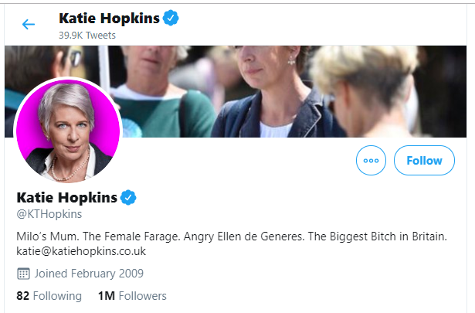

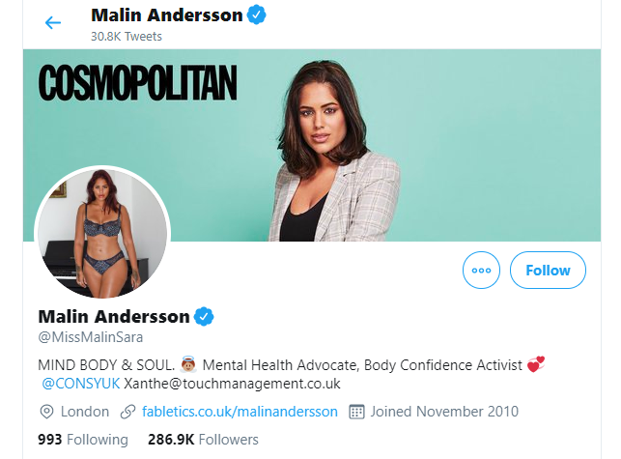

In the past, Katie’s tweets have gotten her in some trouble. During the time of the terrorist attack in Manchester in 2017, during Ariana Grande’s concert. Katie made a tweet (now deleted) that resulted in her losing two media jobs due to the tweet containing racial content. Her views are very critical and can upset a number of people, which she clearly did when she posted this tweet. People made police complaints as Katie alled for a “Final solution”. (YouTube, 2017)
Another controversial tweet made in 2013, was regarding children with red hair. The tweet contained content that discriminated against children due to their hair being red. How is this acceptable? This immediately doesn’t create good brand for herself. The public never has a good thing to say about Katie Hopkins, branding her as a racist and a horrible person. (Adam Payne and Thomas Colson, 2019)

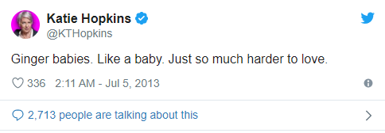

Recently in the public eye, there has been a documentary about Little Mix’s Jesy Nelson attempting to commit suicide due to online trolling. One thing that pushed her to the edge was a tweet made by Katie Hopkins. Katie commented on Jesy’s appearance, making her feel even worse about herself. This has drawn attention to Katie recently and has branded her as a bully. ‘Packet Mix have still got a chubbier in their ranks. Less Little Mix. More Pick n Mix.’(Alicia Adejobi, September 2019)
On the other hand, Malin Andersson has branded herself very well through the use of Twitter. She promotes awareness on taboo subjects such as domestic violence and body dysmorphia. These are topics that she can relate to. Malin has recently tweeted about domestic abuse, listing the traits and signs to look out for. Raising awareness to her audience and followers and urging people to speak out if they are experiencing abuse. Malin added the helpline for her audience to contact if needed. (Jabeen Waheed, 2019)
This instantly allowed her to build a relationship with her audience, showing her vulnerability, branding herself positively, unlike Katie Hopkins. By looking at both female’s bio on twitter, Malin’s is branded more positively than Katie’s, making it more approachable to her audience.
Instagram:

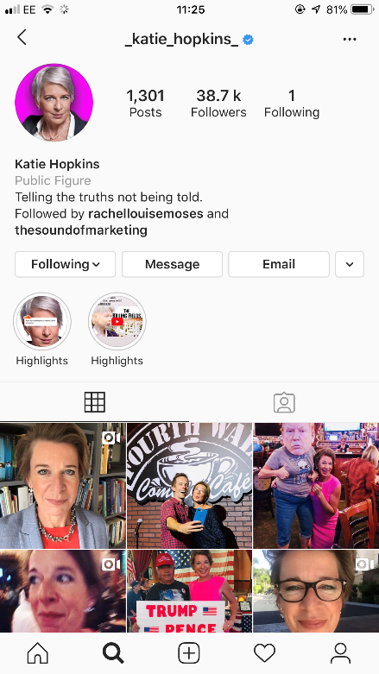
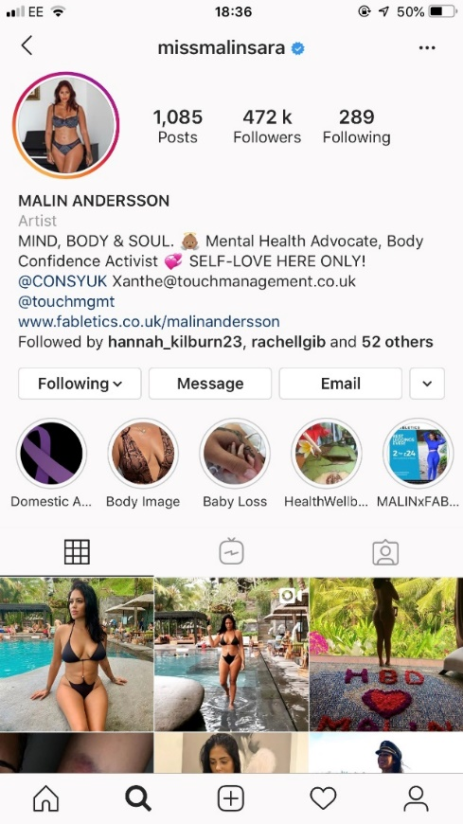

Instagram is one of the most popular sites that is used by todays generation. It is a free photo and video sharing app that allows people to share with their followers and audience. Allowing people to like the content and leave comments on the post. Users create a unique username to make them easily identified and using a profile picture. (Instagram, 2019)
Malin Andersson has branded herself very well through the use of Instagram and Twitter.
Malin’s Instagram bio states, that she is a body confidence activist. She successfully continues to use her popularity to change what young media users see on social media. Today, majority of celebrities that use social media portray an unrealistic image to young girls, which leads to more serious situations such as depression. (Instagram, Malin Andersson, 2019)

Malin Andersson has recently done a campaign to raise awareness regarding body dysmorphia. The result of this post on Instagram touched a number of her followers, resulting in over a 100 comments. Malin stated that she got trolled on Instagram, for no particular reason.
“I will not acknowledge it, but that’s due to me not giving a c**p about it anymore because I’ve been through far worse than a stupid comment.” (JJ Anisiobi, 2019)

Malin regularly uses twitter and Instagram, using continuity with her posts, portraying a realistic picture to her audience. In comparison to Katie Hopkins, Malin raises awareness about things that people can relate to. Whereas, Katie Hopkins is only concerned about her own critical views that easily upset her audience. Katie’s Instagram in comparison to Malin’s is again controversial, posting critical opinions on controversial topics which gets everyone talking.
Other Platforms and continuity:
Malin has recently shared a post to raise awareness for Domestic Abuse Month. Again, this is something that Malin herself has been able to relate to. Sharing her post on Twitter and Instagram, to ensure that she is sharing her content along both platforms. Showing continuity with her posts, whereas Katie Hopkins would not share the same content on the both platforms.

Another factor that shows that Malin holds continuity is that fact that she uses the same profile picture on both platforms, being easily identified. This is something that she and Katie Hopkins share in common. However, Malin shares the same bio on her Instagram and twitter whereas Katie Hopkins doesn’t manage to do so.
Malin’s personal branding is incredible for her values and focus, successfully portraying a strong digital identity, sharing and creating content that agrees with her values and focus. She associates herself well with realistic content and shows young users that not all celebrities live in a perfect world.
Katie Hopkins also shows her audience that it isn’t a perfect world, that we live amongst controversy. However, Katie has managed to contradict herself and cause controversy numerous times.
In July 2013, Katie was on This Morning, where she stated that she wouldn’t allow her children to play with other children with geographical names. However, during the debate Phillip Schofield stated that Katie had named her daughter India. This in its self is contradicting, and discriminating. Branding Katie and an “insufferable snob” (Matilda Battersby, 2013)
Katie also made racial content such as “Migrants are like cockroaches” writing this for The Sun paper, during her position as a columnist before losing the role. "Make no mistake, these migrants are like cockroaches. They might look a bit 'Bob Geldof's Ethiopia circa 1984', but they are built to survive a nuclear bomb. They are survivors,". (Adam Payne and Thomas Colson, 2019)
I have noticed, that Katie hasn’t got a profile on LinkedIn. Considering she began as an entrepreneur through The Apprentice you’d think that she would create herself a brand through this platform to connect with other people. This is a big negative to her brand. LinkedIn is a great social networking platform for business professionals to network, share ideas and recruit employers. (Chad Brooks, 2012)
Conclusion:
By evaluating the women’s social media accounts, Malin Andersson has done an incredible job to raise awareness for her goals and values. Targeting her audience carefully with sensitive content. Katie Hopkins, has been branded a racist and a bully. This in itself is enough to brand Katie negatively. It is extremely important to monitor your digital footprint and what content you associate yourself with on different platforms as it can have a massive impact on you. E.g. future career. “How you present your brand on social media can directly affect your reputation. You may only be physically ‘on’ while in the room, but online, your brand is ‘on’ 24 hours a day” (Friend, 2014, p. 12). The social media community is a very big place, being used by a variety of people and it’s important to consider your audience when sharing content and who it can affect. This has been proven through Katie Hopkins’ remark made against Jesy Nelson.

References:
(Adam Payne and Thomas Colson, 2019)
https://www.businessinsider.com/who-is-katie-hopkins-donald-trump-retweets-migrants-cockroaches-2019-7?r=US&IR=T
(Alicia Adejobi, September 2019)
https://metro.co.uk/2019/09/12/jesy-nelson-fans-slam-katie-hopkins-documentary-reveals-contributed-bullying-little-mix-star-10733537/
(Beril Nas Hassan, 2019)
https://www.thesun.co.uk/tvandshowbiz/8261433/malin-andersson-love-island-take-me-out/

(Brett Shavers, John Bair, in Hiding Behind the Keyboard, 2016)
https://www.sciencedirect.com/topics/computer-science/digital-identity
(Caroline Forsey, 2019)
https://blog.hubspot.com/marketing/what-is-twitter
(Chad Brooks, 2012)
https://www.businessnewsdaily.com/2489-linkedin.html
(Deckers & Lacy, 2013, p. 7).
Slide 5, Anthony Burns, PowerPoint, Your Personal Brand on Social Media Week Two
(Friend, 2014, p. 12)
https://pdfs.semanticscholar.org/820f/292a68570fb887e5235afad004edbac569be
(Instagram, Malin Andersson, 2019)
https://www.instagram.com/missmalinsara/
(Instagram, 2019)
https://help.instagram.com/424737657584573
(Jabeen Waheed, 2019)
https://www.dailymail.co.uk/tvshowbiz/article-7591465/Malin-Andersson-shares-image-bruised-arm-warns-dangers-domestic-violence.html
(JJ Anisiobi, 2019)
https://www.ok.co.uk/celebrity-news/love-islands-malin-andersson-strips-18958176

(Jonathan Zittrain, Havard Law School Professor)
https://blog.hubspot.com/marketing/what-is-twitter
(Kristen Wright, 2015)
https://pdfs.semanticscholar.org/820f/292a68570fb887e5235afad004edbac569be.pdf
(Personalbrand.com, 2019)
https://personalbrand.com/definition/

(Matilda Battersby, 2013)
https://www.independent.co.uk/arts-entertainment/tv/news/katie-hopkins-branded-an-insufferable-snob-after-this-morning-debate-on-childrens-names-8690468.html
(Twitter, Katie Hopkins, 2019)
https://twitter.com/KTHopkins
(Wikipedia.com, 2019)
https://en.wikipedia.org/wiki/Katie_Hopkins
(YouTube, 2017)
https://www.youtube.com/watch?v=OivUMPTYtHg

