Assignment – M5X01599 – Lens-based Image Making
Mark Hall 1606301
Photography In The Arts
1806 words
Paul Duerickx
“It is useless and tedious to represent what exists, because nothing that exists satisfies me…. I prefer the monsters of my fantasy to what is positively trivial.” Baudelaire, Salon Review 1859
Is Baudelaire’s position defensible in light of the case lens-based art-forms make to ‘represent what exists’? Or, from a contemporary perspective, do the ‘monsters of fantasy’ still allow artists to engage with ‘what exists’ creatively?

Baudelaire believes that the monsters of his fantasy are a better representation than other typical artforms. He may not be conversing this in a defensible way but instead to enlighten readers on a more abstract and expressive version of engaging with the existing reality. To an extent I agree with his point, I understand the tedium of still life or landscape paintings but would not go as far to say, ‘nothing that exists satisfies me’, this quote I find arrogant.
“Never have I had more ideas about Art in my head, and yet I am forced to do flowers. While painting them—standing before the peonies and roses—I think of Michelangelo. This cannot go on.” Henri Fantin-Latour (15 May 1862) Letter to Edwin Edwards
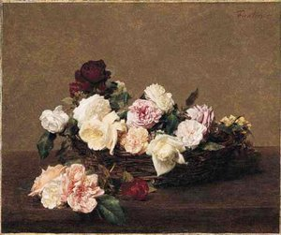
This idea that Fantin-Latour proposes is that of resemblance to what Baudelaire puts forward. The comparison Henri gives us is to Michelangelo. Perhaps his point is to show the difference of content when comparing his own work to Michelangelo’s? Latour’s works is optimised in one of his images to the right. Beautifully painted, yes, but obvious and arguably boring. His point maybe that he doesn’t like thinking of Michelangelo’s flamboyant and aesthetically descriptive work? That as an artist he his confined to the bore of still life? I feel, despite his own artwork, Latour would most likely agree with Baudelaire’s quote as he seems annoyed even going as far to say ‘forced’.
Baudelaire’s point seems like he is referring to realism or naturalism art. The way he describes this makes me think that he does not believe it to be art. The very definition of realism mentions ‘avoiding artistic conventions’ so Baudelaire clearly has a disinterest in the normality of reality and craves a more abstract representation of it.

Plato, when discussing our world and reality said- “…as we experience it, is an illusion, a collection of mere appearances like reflections in a mirror or shadows on a wall.” (Quoted by Rosalind Hursthouse in “Truth and Representation,” Philosophical Aesthetics.) Using his famous analogy he goes onto say we need to “escape from the cave and see…the real objects, the Forms… and gain true knowledge,” Plato believed that objects, man made as well as natural belong to the first forms created by god and so belong in an unchangeable world, therefore art that depicts reality is at an inconceivably low representation to what it attempts to portray. I think Plato’s point is essentially that representing our reality via artforms is unrealistic because we cannot comprehend god’s design.
This leads me back to the original quote and that, yes, case lens-based art-forms can represent what exists, which is to say what we observe and see with our eyes. But the monsters of fantasy do still allow artists to engage with what exists creatively, in our unobservable reality. I feel that studying Plato’s quote highlights this sense of boredom when simply copying from our reality and instead, to make sense of the reality we cannot perceive, we can use the monsters of one’s fantasy to try and seize any attempt to make sense of our reality.

I think that from a contemporary perspective, the ‘monsters of fantasy’ do still allow artists to engage with ‘what exists’ creatively. A perfect example is Nicolas Bruno’s photography. At first glance it’s bizarre, fantastical and even monstrous. His work is centred on his sleep paralysis, he recreates these disturbing scenes and captures them photographically, often playing a role in a scene himself.
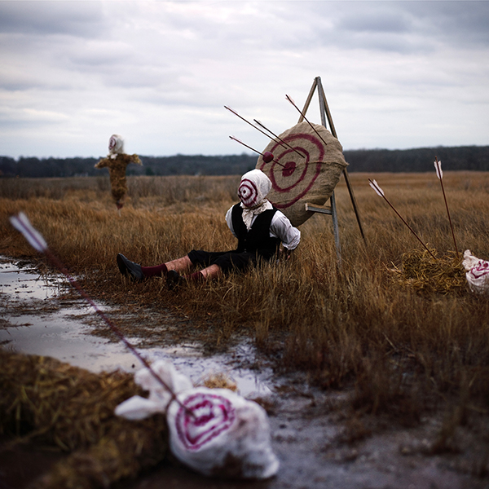
The image to the left speaks to me as if he feels helpless during his sleep paralysis, he’s an eventual target, just waiting and unable to affect his surroundings and the consequences. He is by far than in control and is made a victim to whatever horror may target his mind.
The other targets along with the scarecrow in the background are also prey to the horror that lies off screen. These targets may represent the fragility of his mind, even the items around him are being laid waste to by his ‘demons’.
“I saw the figures walking through my room as demonic entities, and I wanted a photo with the look of a Renaissance painting where people look monolithic and intimidating.“
This could explain why he is dressed in this manner. By placing himself in a past timeframe along with the entities he regains at least partial control. He also states that locations can trigger his memories and dreams which would explain why he is in a field, presuming that is where a dream came back to him, so he decided to recreate it there. Or perhaps he’s mirroring the feeling of being trapped, comparing himself to cattle or maybe being lost in a field in the middle of nowhere.
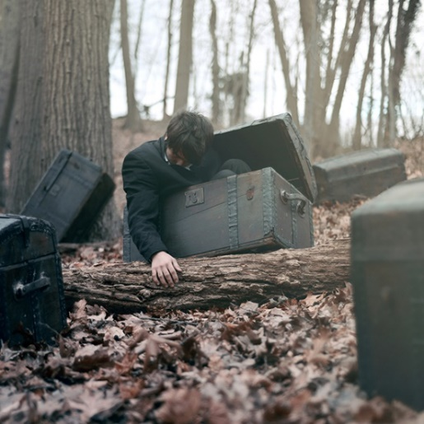
Bruno often creates images that aren’t describing a scene but a feeling, much like the image above. This image however is a bit clearer that it’s a depiction of a feeling. He’s representing entrapment in a very literal way here. However, he is not fully enclosed in the box, the others are all shut. Perhaps he trying to say he isn’t totally trapped by his dreams. I believe the other boxes are more of a representation of previous dreams where possibly he ‘lost’. Or perhaps they’re his trapped emotions that he feels he cannot articulate, locked in the very dream he wishes to express.
Bruno’s work certainly reflects on Baudelaire’s quote about ‘the monsters of my fantasy’. The images Bruno creates are quite literally the monsters of his fantasy and looking at this piece of work I feel myself leaning more toward agreeing with Baudelaire. To put into perspective if Bruno was to paint a landscape, no matter how beautiful it was it could never resonate with the viewer the way these images do.
After looking at the relevance of Baudelaire’s quote in the present day I read The Writer of Modern Life: Essays on Charles Baudelaire by Walter Benjamin.

“…because of the nature of earthly time and it’s apparatus, the photographer manages only to register the negative of that essence on his photographic plate.” (Walter 2006)

This text highlights Baudelaire’s point of depicting reality and hints at his loathing for photography. It’s hard to assess if his quote is still relevant in reference to lens-based imagery today as it has changed so much and evolved in the ways it attempts to illustrate reality. However, going by this piece of text it’s clear that the fact remains, a photograph can only capture reality in that click of the shutter and can never grasp a true sense of time. Today’s advanced photography with long exposures may be a way to challenge this view of photography but the same conclusion arises.

I think this is really his point, that no matter the talent or intent of representation a photographer and their photograph will forever be stuck in this unchanging and possible unrealistic portrayal of our reality. So, to better present that in a means of understanding and making sense of the world, Baudelaire perhaps could’ve chosen other art forms like his beloved poetry as a human response to the realism and a way that we can explain beauty, examine it and not simply copy it.

To further this point of realism I looked at John Constable’s work and his philosophy. He is famous for his landscape paintings, which is why I have decided to study his works and analyse what he has to say for landscape and reality. Judging from Baudelaire’s quote in the question title I don’t think he would’ve had much appreciation for Constable’s work, even more so if they were photographic landscapes.

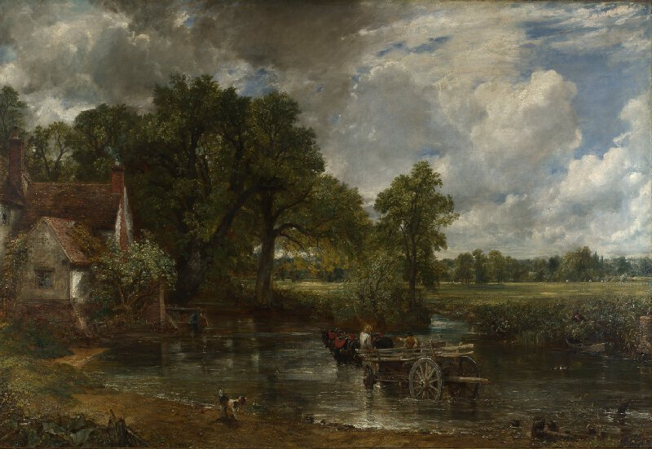
Constable’s The Hay Wain, to the right, is likely his most famous painting. This oil painting shows the scene of a Suffolk farm, Constable performed several open-air sketches before he complied this painting in London. This alone makes me question how good of a representation his work is of reality, when the actual painting is not of the scene but instead is of a sketch of the scene. So already this image is two steps removed from reality. He seems to admit to this as he says
“I am anxious that the world should be inclined to look to painters for information about painting. I hope to show that ours is a regularly taught profession; that it is scientific as well as poetic; that imagination alone never did, and never can, produce works that are to stand by a comparison with realities.”(Delphi Collected Works of John Constable, 2015)

For a landscape artist to say this it implies that he is aware of his inability to truly represent reality in its glorious form. So, if representing what exists cannot truly be shown it seems even more tedious, when looking back at Baudelaire’s quote. Despite Constable’s apparent agreement another one of his quotes seems to counter his previous statement. “We see nothing till we truly understand it” John E. Thornes, John Constable (1999). This quote, to me, makes it seem that he believes he has truly understood reality otherwise how else would he grasp this knowledge? Therefore, if he believes he’s able to understand reality is that then a good enough aspect to take into consideration when studying his own paintings, presenting us with the reality he sees before him. Again, if he truly understands his reality then his art is the best representation of reality we can have? Despite this argument we’re still presented with the possibility that reality, no matter how well it’s represented is still boring?

Taking into consideration the points made from the artists and philosophers discussed, I think Baudelaire’s point is appropriate when looking at lens-based art. However, to then totally dislike and disassociate it with the art world seems a step too far. I think we need to address that the ‘normal’ and tedious artworks can be overused but also can still be appreciated through its attempted depiction of our reality. Especially, as often these pieces are aesthetically beautiful. For example, Constable’s work provides us with that hint of dullness when viewing yet another landscape scene. Despite this the work is meticulously prepared and should be appreciated for as artistically representing reality.
And finally, from a contemporary perspective, of course the monsters of one’s fantasy still allow artists to engage with reality, because our definition of reality itself is so fragile it permits artists to twist the view of reality in an artistic way to make more sense of it. Bruno’s work shows us that he can share with us his versions of reality. Those images best present us with a depiction of his reality. Because, really, that’s all we can do as artists to try and engage with reality as well as our fellow human beings, by doing that we can then produce our version of reality.

Bibliography
J.Constable Delphi Collected Works of John Constable (Illustrated) Delphi Classics; 1 edition
J.E.Thornes, J.Constable, John Constable's Skies: A Fusion of Art and Science, University of Birmingham Press; First Edition edition
W.Benjamin (2006) The Writer of Modern Life, Harvard University Press

Decoded Past(2013) available at: http://decodedpast.com/platos-argument-art-imitation-imitation/2990 Accessed 19th November 2018
Decoded Past(2013) available at: http://decodedpast.com/platos-argument-art-imitation-imitation/2990 Accessed 19th November 2018
Denver Art Museum (2015) available at:https://denverartmuseum.org/article/appreciating-still-life-quotes-bloom-artists Accessed 19th November 2018
Denver Art Museum (2015) available at:https://denverartmuseum.org/article/appreciating-still-life-quotes-bloom-artists Accessed 19th November 2018
Nicolas Bruno (2018) https://nicolasbrunophotography.com/ Accessed 20th November 2018
Nicolas Bruno (2018) https://nicolasbrunophotography.com/Accessed 20th November 2018
Shutterbug(2018) https://www.shutterbug.com/content/waking-nightmares-how-photographer-nicolas-bruno-captures-his-darkly-beautiful-images Accessed 20th November
Shutterbug(2018) https://www.shutterbug.com/content/waking-nightmares-how-photographer-nicolas-bruno-captures-his-darkly-beautiful-images Accessed 20th

Figure 1: A Basket of Roses
Figure 2: From the series, Art in Sleep Paralysis
Figure 3: From the series, Art in Sleep Paralysis
Figure 4: The Hay Wain

Reference List
H.Fantin-Latour (1862) Letter to Edwin Edwards Available at: https://denverartmuseum.org/article/appreciating-still-life-quotes-bloom-artists Accessed: 19th November 2018
R.Hursthouse (2013) Decoded Past Available at: http://decodedpast.com/platos-argument-art-imitation-imitation/2990 Accessed: 19th November 2018
W.Benjamin (2006) The Writer of Modern Life: Essays on Charles Baudelaire Harvard University Press

