ECED7004 Assignment 3 – Portfolio for Funding Bid

By Emma-Louise Johnson

MA Equity and Diversity
Department: Social Justice and Inclusion
Lecturer: Sharon Cole
University of Wales Trinity Saint David

6th April 2023

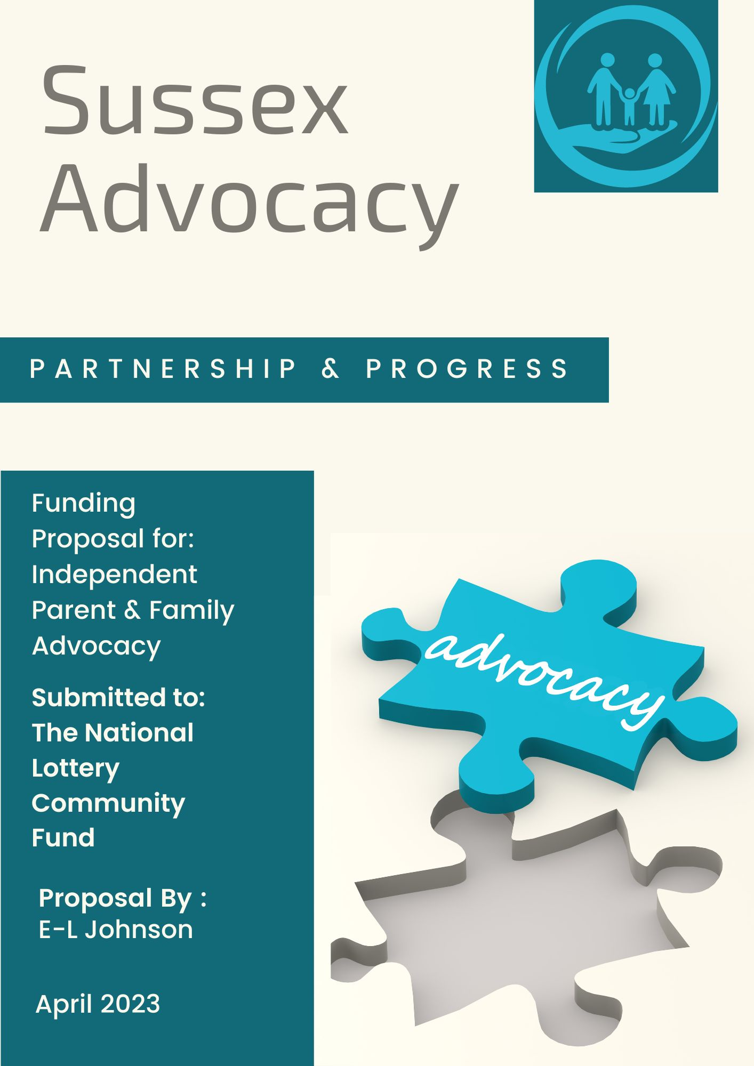

Layout and logo created in Canva (2023).
Sussex Advocacy is a free domain name available at GoDaddy (2019).

‘Executive Summary’ (Fagan, 2023)
Sussex Advocacy, a non-profit organisation, is submitting this funding request. Working in collaboration with other organisations and community groups, we have provided independent advocacy to people around the region since 2010. We are passionate about making our community a better place. The unique characteristics of independent advocacy (Mercer, 2016) make it well-suited to building a more equitable society (The National Lottery Community Fund, 2023a) in which all groups have a voice. A locally based service, we believe we are best placed to meet the growing need for non-statutory advocacy for parent carers and families with disabled children within Sussex. Evidence for the bid will be provided through a ‘community needs assessment’ (Taylor and Brunson, 2020) that gathers ‘primary and secondary data’ (Kumar, 2014, p. 171) from our client partners and stakeholders and which are supported by current or recent policies, events and legislation. To meet our goals, we request £106,400 (see Appendix 1) over two years, after which we will assess the project’s progress and seek additional long-term support.

Introduction:
The growth of legislation in the past twenty years has led to an increase in ‘statutory advocacy’ (The Advocacy Project, 2023), which our service has consistently provided at a local level for people with a range of needs and disabilities (ASIST, 2022a) and who struggle to have their voices heard and be part of decisions that affect them. The main difference between ‘statutory’ and ‘non-statutory advocacy’ (The Advocacy Project, 2023) is that in the first type, a person has a legal entitlement to an advocate. However, some of the most vulnerable groups in society still fall outside statutory advocacy’s strict criteria. One of these groups, which we have identified through working closely with our partners, is that of parent carers and families with disabled children. The issues they have told us about match those reported at national level and have been made worse by the pandemic and the rising living costs, which affected both the carers and the person they were looking after (Carers UK, 2022). This project could be the missing jigsaw piece in the bigger picture of community cohesion and development by providing independent community advocacy to a growing number of families in need.

‘Statement of Need’ (Fagan, 2023)
Historically, there has been a need for advocacy for families who have disabled children (Tirraoro, 2020). In recent times, the lockdown period added to the problems that carers had to cope with as part of their caring role. A recent report (Clements and Aiello, 2021) commissioned by the charity Cerebra (2023) suggests that parent carers struggle to get the help they need and feel unfairly judged and blamed for asking for that help. Such is the concern at the poor treatment of carers that there is a campaign for them to become the ‘10th protected characteristic’ (Carers UK, 2023) as defined in section 4(1) of the Act (Equality Act 2010). These concerns continue at community level, with the rise of children in West Sussex with special needs and having an ‘education, health and care (EHC) plan’ (GOV.UK, 2023a), which is higher than the national average (see Appendix 11), coinciding with cuts in family services (West Sussex County Council, 2021). We believe that as a respected and responsive local provider, we can provide the high-quality, independent community advocacy needed to help solve these issues by reaching out to families who have had their needs neglected.

Aims and Objectives:
Our mission is to promote equality, inclusion, and human rights for everyone in the community they live in and which they are part of. These are the ingredients of social justice, which are one of the main goals of advocacy. To do this, we must identify and engage those groups not fully included in the activities that most people take for granted. For this project, we focus on parent carers and other family members who are carers and ensure the children’s needs are supported. Often advocacy can be based on single issues and not see the whole context. By holistically advocating for the family, we can help the family unit live the best life possible. To do this, we must first secure funding to fulfil the following objectives:

- Provide independent non-statutory advocacy for parent carers and families with disabled children.
- Raise advocacy awareness and explain its role with key stakeholders, including potential client partners and public and private sector organisations.
- Secure further funding upon successful completion of the project to continue to help more families throughout the whole of Sussex.

Company Background & Structure
Sussex Advocacy was formed in response to our Founder and Chief Executive Officer, Emma Johnson, and her experiences of working with families for Family Support Work (nd), a well-known charity in the Sussex area. She had lived experience of her own and used that to understand what was needed for vulnerable groups who either were disabled or cared for a disabled child. Since then, the need for help and our reach has grown throughout West Sussex, and we have developed close ties with several community services. We are now a ‘private limited company by guarantee’ (Watson, 2021) and a registered (Charity Commission for England and Wales, 2023) and regulated charity (Fundraising Regulator, n.d.). We have twenty-four staff members, including six trustees and four volunteers covering the West Sussex area. Of these, we employ twelve advocates and two Lead Advocates trained in ‘statutory advocacy’ (MIND, 2023) for those who qualify under the relevant Acts. Annual expenditure for this year is expected to mirror last year’s figures of approximately £800,00k per annum (see Appendix 2), with most funds reinvested into providing services that benefit the community in line with our charitable status and our company ethos. Our high service standards are shown in our having the ‘Advocacy Quality Performance Mark (QPM)’ (Advocacy QPM, 2023).

‘Vision and Values’ (Indeed Career Guide, 2023)
Our vision is for a fairer society for all (see Appendix 3), with nobody to be left in the margins and unable to participate in community life. Our core values are related to ‘co-production’ (Social Care Institute for Excellence (SCIE), 2022a), which means ensuring that working together is at the heart of what we do. Partnership is embedded in our values, how we operate and recruit and how our advocates and volunteers work with their client partners. To feel equally treated, our client partners must know their views are important (see Appendix 3), and they should feel empowered within the advocacy relationship. As part of this, our recruitment is ‘values-based’ (Groothuizen, Callwood & Gallagher, 2018, p. 1), from the Leadership Team to the advocates working out in the field. Our advocates also follow the guidelines in ‘The Advocacy Charter’ (NDTi, 2018).

Geography
Sussex advocacy covers the county of West Sussex, which occupies an area of ‘768 square miles’ (see Appendix 4) and has a population of ‘882,700 people’ (see Appendix 5). Our Headquarters are based in the market town of Horsham (see Appendix 6). Although this region is considered one of the wealthiest in the country (see Appendix 7), pockets of deprivation exist throughout the area creating vulnerable groups that need advocacy.

A Tale of Two Towns
Two significant areas of deprivation lie in the adjacent West Sussex towns of Crawley and Horsham (see Appendix 8). We have chosen to focus the project in both places because they have identified needs for independent non-statutory advocacy, and they make an interesting comparison for evaluating the project’s success. Horsham is perceived as the more affluent town of the two, so the need becomes invisible. Crawley has wealthy areas but, as the ‘poor relation’ of the two, it is perceived as having a visibly greater need. Both towns have experienced a steep rise in population growth, increasing demand for all services (Office for National Statistics, 2022b; 2022c). Data collected at the end of the project may show that the need for advocacy is not limited to regional differences. That evidence may then be used to extend our reach into East Sussex.

‘SWOT & PESTLE Analysis’ (see Appendices 9 and 10)
To help with strategic planning and gain an overview of the project and our organisation’s ability to deliver it, we will conduct a ‘SWOT analysis’ (Shewan, 2020) to help ensure the project’s success. This planning method often works best with a ‘PESTLE analysis’ (Battista, 2021), which concentrates on factors outside the company and its control and can help identify opportunities and threats as they emerge.

Strengths:
Independent advocacy has a ‘unique value proposition’ (Reis, 2020) in that it is separate from the commissioning bodies. Unlike other professions, such as social work or nursing, which may include advocacy as part of their position, there is no conflict of interest while aiding the client partner to achieve their goals. As an established provider of advocacy in the area, with local knowledge and partnerships in place with other community services, we are best placed to deliver the type of advocacy to the population we serve. In addition, our service is free to those who need it. It will be more easily accessible for vulnerable groups currently not eligible for statutory advocacy unless they have ‘substantial difficulty’ (Social Care Institute for Excellence (SCIE), 2022b) in understanding and being involved in decisions about their care.

Weaknesses:
A significant project area for improvement is that our organisation needs more funding for non-statutory advocacy and will only be able to begin the project with it. In the current economic downturn, our larger competitors (POhWER, 2016) have more secure funding sources than we do. Before volunteers can work independently, they must undergo an initial training process supervised by a Lead Advocate. As a final point, most stakeholders in this project need to be made aware of the value of advocacy, but this may also be an opportunity.

Opportunities:
We have already identified a growing need for advocacy in West Sussex that has become more urgent with the increase in poverty in towns like Horsham and Crawley. There have also been demographic and social changes with the rise in children with special needs and disabilities in West Sussex greater than the national average (see Appendix 11). The surge in post-pandemic poverty for families creates a need and justification for the project as an opportunity, but this can become a threat, as defined in the next section. The project’s success will also increase advocacy awareness among all the stakeholders involved, including client and community partners, and potentially lead to further funding from local authorities or corporations. One of the positive developments of the lockdown period was the introduction of online advocacy sessions, which meant the service could continue during that time. Some of our client partners have told us they preferred this type of session due to their neurodiverse conditions, such as autism (NHS, 2022). It can also be used as a sustainability option rather than an alternative provision because of the inherent safeguarding issues of our advocates not being able to visit in person.

Threats
According to the two analysis types, the greatest threat appears to be economic and closely tied to political factors. These are also opportunities if we look at the following issues affecting the two project areas of Horsham and Crawley within West Sussex. The rise in post-pandemic poverty turns from opportunity to a threat if the need outstrips the company supply. Also, hidden dangers may include a surge in demand that meets the ‘perceived availability’ (Lipsky, 1980, p. 35) of the supply. The reduction in family services with the recent closures of family centres (Dunn, 2022) shows political and attitudinal barriers to gaining support for the project, and this, coupled with the political instability at the local level (Dunn and Bateman, 2023), leads to uncertainty for the project long term. Little thought of threats include political will, bias and finally and less obviously – apathy (see Appendix 12). Horsham is a mainly Conservative-led council (see Appendix 13), and Crawley is split between Labour and Conservative (see Appendix 14), with Labour only recently achieving a slim majority. Whether these political leanings will create a more receptive environment for social change remains to be seen. Other threats to the project, such as another lockdown or further regulation of advocacy, have been assessed as low risk.

Conclusion
West Sussex Council has recognised the need to help families at an early stage before they reach crisis (West Sussex County Council, 2021), and that help includes the parents as well as the children. Too often, parent carers and their children, who may have communication problems as part of their condition, feel they are not listened to by professionals (Ambitious about Autism, 2011) or, worse, they are made to feel bad for simply asking for help (Clements and Aiello, 2021). With adults and children suffering increasing anxiety during the pandemic (Office for Health Improvement & Disparities, 2021) and now, with added problems of rising costs, families with disabled children are more vulnerable than ever. Independent advocacy delivered in the community by us, an organisation dedicated and attuned to local needs, will help address these inequalities and overcome the barriers these families face in West Sussex. If parents are happier and more able to cope, that will positively affect their children. If marginalised groups are included, then that will benefit the whole community. In the second next section, we will look further into this funding bid in relation to the pen-picture of the organisation already presented and how this advocacy project fits into the bigger picture of community development and positive change.

Reference List
Advocacy Focus (2023) Advocacy manager. Available at: https://advocacyfocus.org.uk/careers/advocacy-manager/ (Accessed: 25 Mar 2023).
Advocacy QPM (2023) How QPM works. Available at: https://qualityadvocacy.org.uk/about-the-qpm/ (Accessed: 20 Mar 2023).
Ambitious about Autism (2011) Our voices: Giving a voice to parents of children with disabilities. Available at: https://www.youtube.com/watch?v=7gmKyy_gC8Y (Accessed: 8 Sep 2019).
ASIST (2022a) About | ASIST advocacy services in Staffordshire | Stoke-on-Trent. Available at: https://www.asist.co.uk/about (Accessed: 16 Mar 2023).
ASIST (2022b) Advocacy | ASIST advocacy services in Staffordshire | Stoke-on-Trent. Available at: https://www.asist.co.uk/ (Accessed: 12 Mar 2023).
Battista, M. (2021) PESTLE analysis CIPD. Available at: https://www.cipd.co.uk/knowledge/strategy/organisational-development/pestle-analysis-factsheet#gref. (Accessed: 26 Mar 2023).
BBC News (2022) Crawley election result. Available at: https://www.bbc.co.uk/news/election/2022/england/councils/E07000226 (Accessed: 20 Mar 2023).
Canva (2023) Homepage. Available at: https://www.canva.com/ (Accessed: 26 Mar 2023).
Carers UK (2022) Cost of living crisis. Available at: https://www.carersuk.org/news-and-campaigns/our-campaigns/cost-of-living-crisis/ (Accessed: 16 Mar 2023).
Carers UK (2023) Making caring the 10th protected characteristic. Available at: https://www.carersuk.org/news-and-campaigns/our-campaigns/making-caring-the-10th-protected-characteristic/ (Accessed: 16 Mar 2023).
Cerebra (2023) Cerebra – working with you and your amazing child. Available at: https://cerebra.org.uk/ (Accessed: 16 Mar 2023).
Charity Commission for England and Wales (2023) ASIST – Charity 1048075. Available at: https://register-of-charities.charitycommission.gov.uk/charity-search/-/charity-details/1048075 (Accessed: 12 Mar 2023).
CharityJob (2023) 35 Independent Mental Capacity Advocate jobs. Available at: https://www.charityjob.co.uk/mental-health-advocate-jobs?jobId=892194 (Accessed: 12 Mar 2023).
CharityJob (n.d.) Recruit with the charity sector specialists | CharityJob Recruiter. Available at: https://www.charityjob.co.uk/recruiters (Accessed: 12 Mar 2023).
Clements, L. and Aiello, A.L. (2021) Institutionalising parent carer blame. Leeds: University of Leeds, pp.1–53. Available at: https://cerebra.org.uk/wp-content/uploads/2021/07/Final-Parent-Blame-Report-20-July-21-03.pdf (Accessed: 3 Nov 2022).
Department for Education (2022) Local area special educational needs and disabilities report for West Sussex county council, pp.1–38. Available at: https://lginform.local.gov.uk/reports/view/send-research/local-area-send-report?mod-area=E10000032&mod-group=AllRegions_England&mod-type=namedComparisonGroup (Accessed: 19 Mar 2023).
Disclosure and Barring Service (2019) Fee changes for DBS checks. Available at: https://www.gov.uk/government/news/fee-changes-for-dbs-checks (Accessed: 12 Mar 2023).
Dunn, K. (2022) Children and family centre in Horsham to be sold ‘to highest bidder’ by council. Available at: https://www.moreradio.online/news/sussex-news/children-and-family-centre-in-horsham-to-be-sold-to-highest-bidder-by-council/ (Accessed: 20 Mar. 2023).
Dunn, K. and Bateman, N. (2023) New leader for Horsham district council. Available at: https://www.v2radio.co.uk/news/west-sussex/new-leader-for-horsham-district-council/ (Accessed: 15 Mar. 2023).
Equality Act 2010, c.1. Available at: https://www.legislation.gov.uk/ukpga/2010/15/part/2/chapter/1/enacted (Accessed 28 Mar 2023).
Fagan, B. (2023) How to write a grant proposal: Step-by-step guide (free templates). Available at: https://www.pandadoc.com/blog/grant-proposal/ (Accessed: 12 Mar 2023).
Family Support Work (n.d.) Homepage. Available at: https://www.familysupportwork.org/ (Accessed: 21 Feb 2023).
Fundraising Regulator (n.d.) Registration. Available at: https://www.fundraisingregulator.org.uk/registration (Accessed: 21 Feb 2023).
Gayler, E. and Thomas, N. (eds) (2016) About West Sussex. West Sussex County Council, pp. 1–76. Available at: https://www.westsussex.gov.uk/media/8996/01_about_west_sussex_2019.pdf (Accessed: 18 Mar 2023).
GetTheData. (2023) Where is Horsham? Horsham on a map. Available at: https://www.getthedata.com/horsham/where-is-horsham (Accessed: 18 Mar 2023).
GoDaddy. (2019) Domain names | The world’s largest domain name registrar - GoDaddy UK. Available at: https://uk.godaddy.com (Accessed: 2 Mar 2023).
GOV.UK (n.d.) ASIST. Overview - Find and update company information. Available at: https://find-and-update.company-information.service.gov.uk/company/03068125 (Accessed: 12 Mar 2023).
GOV.UK (2023a) Children with special educational needs and disabilities (SEND). Available at: https://www.gov.uk/children-with-special-educational-needs/extra-SEN-help (Accessed: 20 Mar 2023).
GOV.UK (2023b) Expenses and benefits: business travel mileage for employees’ own vehicles. Available at: https://www.gov.uk/expenses-and-benefits-business-travel-mileage/rules-for-tax (Accessed: 25 Mar 2023).
GOV.WALES (2019) Advocacy standards and outcomes framework for children and young people. Available at: https://www.gov.wales/advocacy-standards-and-outcomes-framework-children-and-young-people (Accessed: 14 Mar 2023).
Gray, B. (2016) How to effectively conduct a PESTLE & SWOT analysis. Available at: https://www.linkedin.com/pulse/how-conduct-pestle-swot-analysis-byron-gray/ (Accessed: 14 Mar 2023).
Groothuizen, J.E., Callwood, A. and Gallagher, A. (2018) ‘NHS constitution values for values-based recruitment: a virtue ethics perspective’, Journal of Medical Ethics, 44(8), pp. 518–523. Available at: http://dx.doi.org/10.1136/medethics-2017-104503 Accessed: (27 Mar 2023).
‌
Horsham District Council (2023a) Committee attendance – Community Matters Policy Development Advisory Group, 21 September 2022 – 16 March 2023. Available at: https://horsham.moderngov.co.uk/mgAttendanceSummary.aspx?RPID=286 (Accessed: 15 Mar 2023).
Horsham District Council (2023b) Committee details – Council. Available at: https://horsham.moderngov.co.uk/mgCommitteeDetails.aspx?ID=188 (Accessed: 15 Mar 2023).
Indeed Career Guide (2023) 10 Mission, vision and value statement examples (plus tips). Available at: https://www.indeed.com/career-advice/career-development/mission-vision-values-examples (Accessed: 19 Mar 2023).
Johnson, E-L. (2023) Estimated costs for the two-year project. Created in Excel.
Kumar, R. (2014) Research methodology a step-by-step guide for beginners. 4th edn. Los Angeles (Etc.): Sage.
Lenovo (2023) IdeaPad Slim 3 (15”, 8) | Lenovo UK. (online) Available at: https://www.lenovo.com/gb/en/p/laptops/ideapad/ideapad-300/ideapad-slim-3-gen-8-(15-inch-amd)/82xmcto1wwgb1 (Accessed: 18 Mar 2023).
Lipsky, M. (1980) Street-level bureaucracy: Dilemmas of the individual in public services. New York: Russell Sage.
Mercer, K. (2016) What is advocacy? Available at: https://www.youtube.com/watch?v=NnOk2tTz468 (Accessed: 19 Mar 2023).
Mercer, K. (2018a). Award in independent advocacy £250 + VAT. Available at: https://www.blackbeltadvocacy.com/blank-1/award-in-independent-advocacy (Accessed: 25 Mar. 2023).
Mercer, K. (2018b). Certificate in independent advocacy practice (1 specialist unit) £1100 + VAT. Available at: https://www.blackbeltadvocacy.com/blank-1/certificate-in-independent-advocacy-level-3 (Accessed: 25 Mar 2023).
Mercer, K. (2018c) What is black belt advocacy? Available at: https://www.blackbeltadvocacy.com/what-is-bba (Accessed: 25 Mar 2023).
MIND (2023) Legal rights to advocacy. Available at: https://www.mind.org.uk/information-support/guides-to-support-and-services/advocacy/legal-rights-to-advocacy/ (Accessed: 26 Mar 2023).
NDTi. (2018) New advocacy charter. Available at: https://www.ndti.org.uk/resources/new-advocacy-charter.
NHS (2022) What is autism? NHS. Available at: https://www.nhs.uk/conditions/autism/what-is-autism/ (Accessed: 20 Mar 2023).
NHS Data Model Dictionary (2023) Lower layer super output area. Available at: https://www.datadictionary.nhs.uk/nhs_business_definitions/lower_layer_super_output_area.html (Accessed: 18 Mar 2023).
Nokia (2023) Nokia C21 Plus mobile. Available at: https://www.nokia.com/phones/en_gb/nokia-c-21-plus?sku=719901189811 (Accessed: 18 Mar 2023).
Office for Health Improvement & Disparities (2021) Parents and carers spotlight. Available at: https://www.gov.uk/government/publications/covid-19-mental-health-and-wellbeing-surveillance-spotlights/parents-and-carers-spotlight (Accessed: 20 Mar 2023).
Office for National Statistics (ONS) (2022a) Distribution of individual total wealth by characteristic in Great Britain – Office for National Statistics. Available at: https://www.ons.gov.uk/peoplepopulationandcommunity/personalandhouseholdfinances/incomeandwealth/bulletins/distributionofindividualtotalwealthbycharacteristicingreatbritain/april2018tomarch2020 (Accessed: 14 Mar 2023).
Office for National Statistics (2022b) How the population changed in Crawley, Census 2021 – ONS. (Available at: https://www.ons.gov.uk/visualisations/censuspopulationchange/E07000226/ (Accessed: 20 Mar 2023).
Office for National Statistics (2022c) How the population changed in Horsham, Census 2021 – ONS. Available at: https://www.ons.gov.uk/visualisations/censuspopulationchange/E07000227/ (Accessed: 24 Feb 2023).
POhWER (2016) Homepage. Available at: https://www.pohwer.net/ (Accessed: 21 Feb 2023).
Reis, J. (2022) What is your non-profit’s value proposition? Available at: https://nonprofitfundraising.com/what-is-your-nonprofits-value-proposition/ (Accessed: 13 Mar 2023).
Shewan, D. (2020) How to do a SWOT analysis for your small business. Available at: https://www.wordstream.com/blog/ws/2017/12/20/swot-analysis (Accessed: 14 Feb 2023).
Social Care Institute for Excellence (SCIE) (2022a) Co-production in social care: what it is and how to do it (guide). Available at: https://www.scie.org.uk/co-production/what-how (Accessed: Jul. 2022).
Social Care Institute for Excellence (SCIE) (2022b) Commissioning independent advocacy. Available at: https://www.scie.org.uk/advocacy/commissioning#difficulty (Accessed: 18 Mar 2023).
Taylor, T. and Brunson, M. (2020) Community needs assessments | Learning to give. Available at: https://www.learningtogive.org/resources/community-needs-assessments (Accessed: 13 Mar 2023).
The Advocacy Project (2023) Types of advocacy. Available at: https://www.advocacyproject.org.uk/home/advocacy/how-we-work/types-of-advocacy/ (Accessed: 2 Mar 2023).
The National Lottery Community Fund (2023a) Our equality principles | The National Lottery Community Fund. Available at: https://www.tnlcommunityfund.org.uk/about/customer-service/equalities. (Accessed: 25 Mar 2023).
The National Lottery Community Fund (2023b) Reaching communities and partnerships | Untitled application | Equity, diversity and inclusion (EDI) monitoring information | What is equity, diversity and inclusion (EDI). Available at: https://account.tnlcommunityfund.org.uk/Application/Step/6-1 (Accessed: 25 Mar 2023).
The Public Health and Social Research Unit (PHSRU) (2019) Indices of Multiple Deprivation 2019. Available at: https://jsna.westsussex.gov.uk/updates/west-sussex-imd-2019/ (Accessed: 24 Feb 2023).
Thomas, N. (2022) West Sussex briefing 1: Population. https://www.westsussex.gov.uk/media/17852/census_briefing1_population.pdf, pp. 1–5. Available at: https://www.westsussex.gov.uk/media/17852/census_briefing1_population.pdf (Accessed: 18 Mar 2023).
Tirraoro, T. (2020) How has special education needs evolved in the 40 years since the Warnock Report? Available at: https://www.specialneedsjungle.com/how-has-special-education-needs-evolved-in-the-40-years-since-the-warnock-report/ (Accessed 30 Mar 2023).
Watson, A. (2021) Private companies limited by guarantee. Available at: https://harperjames.co.uk/article/private-companies-limited-by-guarantee/ (Accessed: 12 Mar. 2023).
Weller, J. (2022) Free Microsoft Word SWOT analysis templates | Smartsheet. Available at: https://www.smartsheet.com/content/swot-templates-microsoft-word (Accessed: 27 Feb. 2022).
West Sussex County Council (2021) Next steps in the Early Help Service redesign. Available at: https://www.westsussex.gov.uk/news/next-steps-in-the-early-help-service-redesign/ (Accessed: 15 Mar 2023).
‌

Appendices:
Appendix 1:
Estimated costs for the two-year project. The total figure has been rounded up to £106, 400 for the funding proposal.

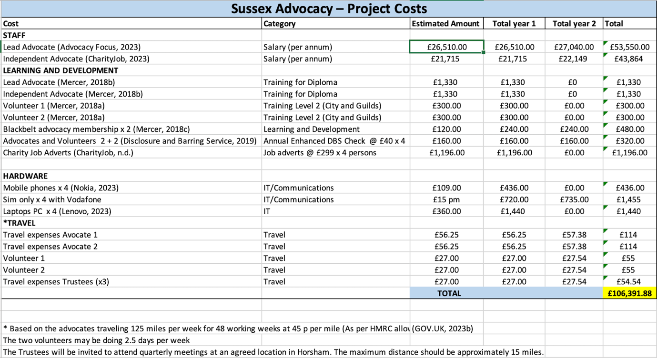

Above: The table is the author’s own, created in Excel (Johnson, 2023).

Appendix 2:
Based on the example of ASIST (2022a), a regional advocacy provider in Staffordshire and Stoke (Charity Commission for England and Wales, 2023).

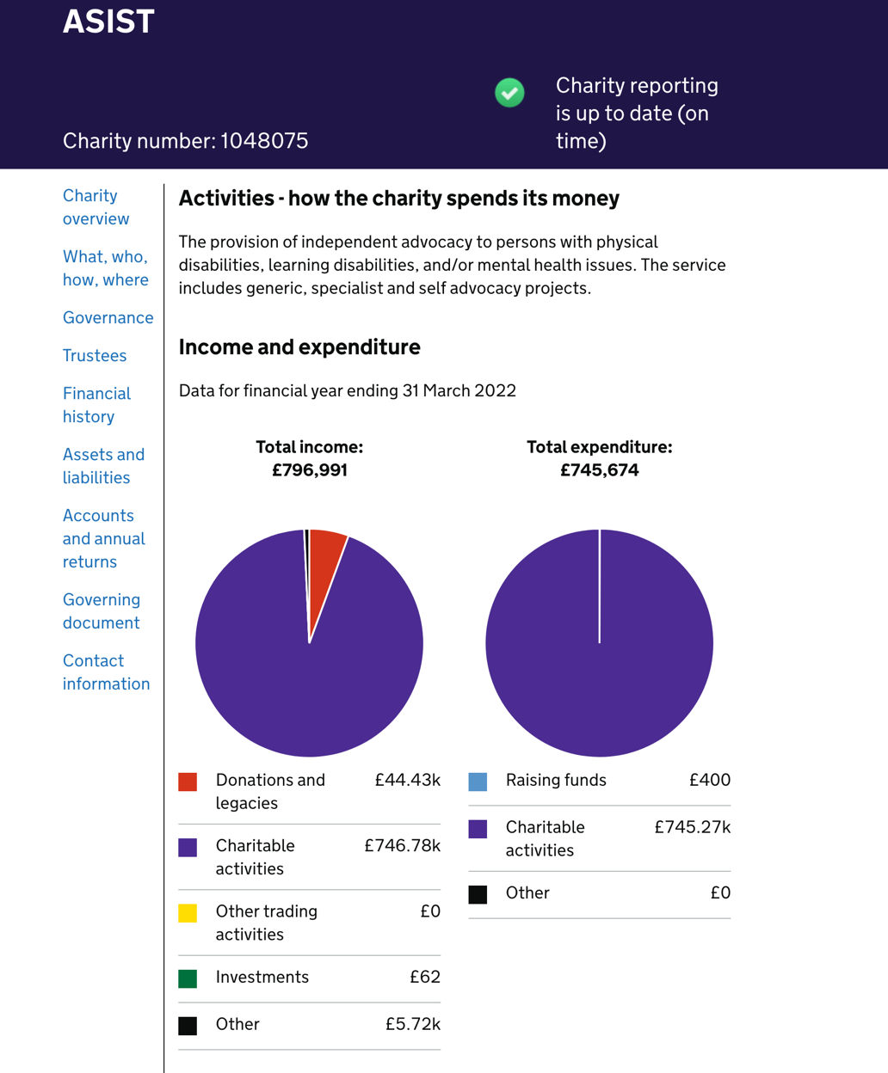
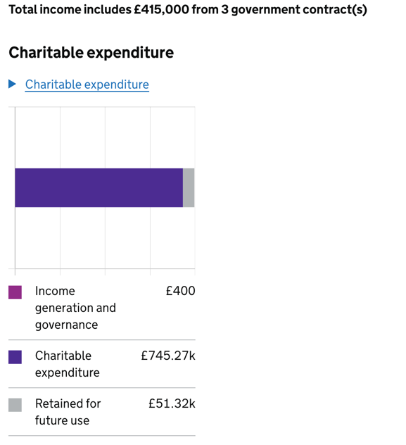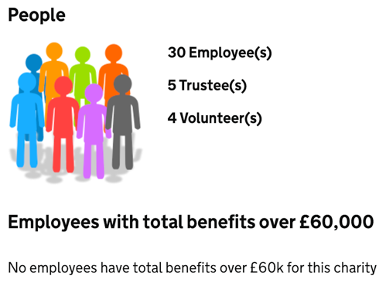

Appendix 3:
The National Lottery Community Fund’s interpretation of ‘Equity, Diversity and Inclusion (EDI)’ (The National Lottery Community Fund, 2023b) as part of the online application.

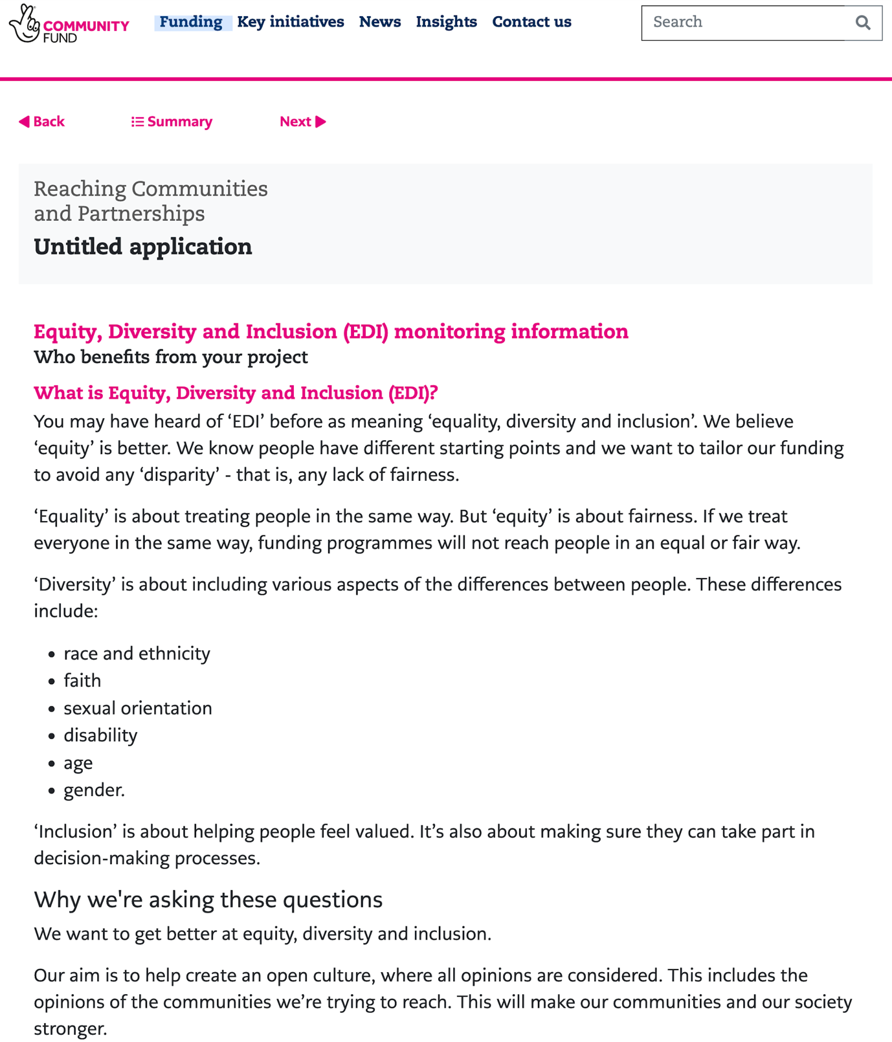

Appendix 4:
West Sussex information on size and population edited by Gayler and Thomas (2016, p. 8).

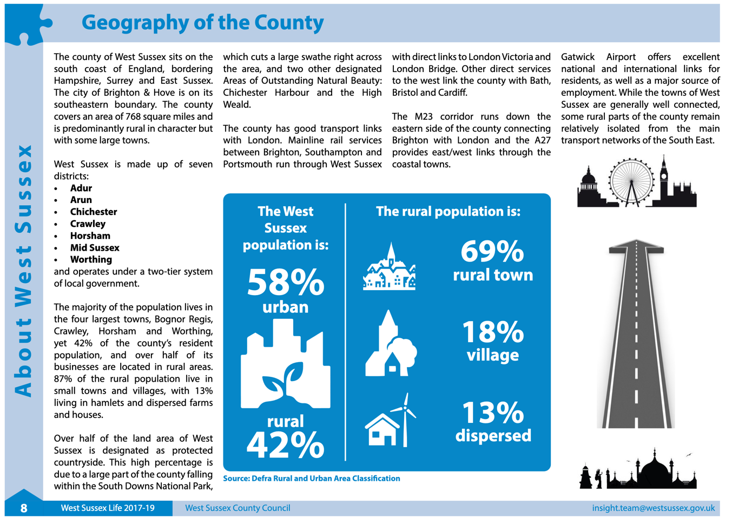

Appendix 5:
West Sussex County Council results from the 2021 Census show a population of 882,700 people, which has significantly increased since 2011 (Thomas, 2022, p.1).
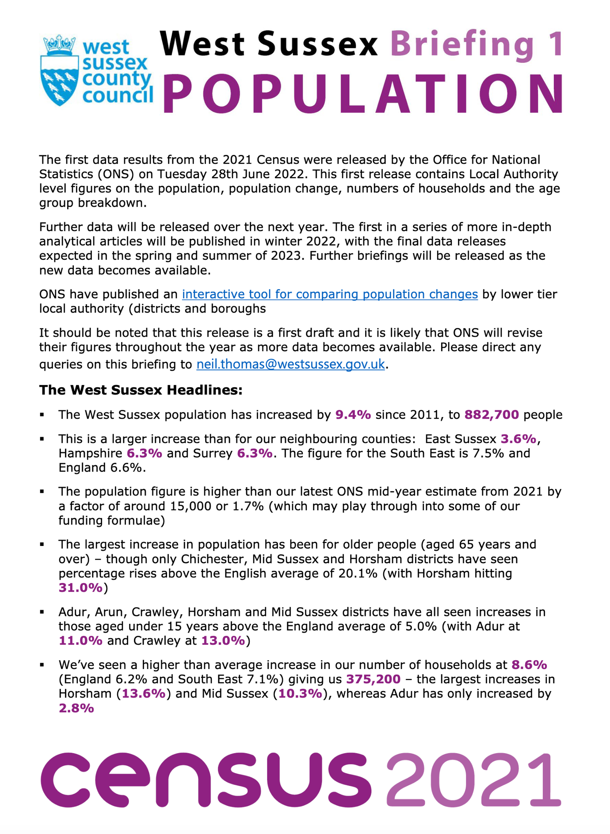

Appendix 6:
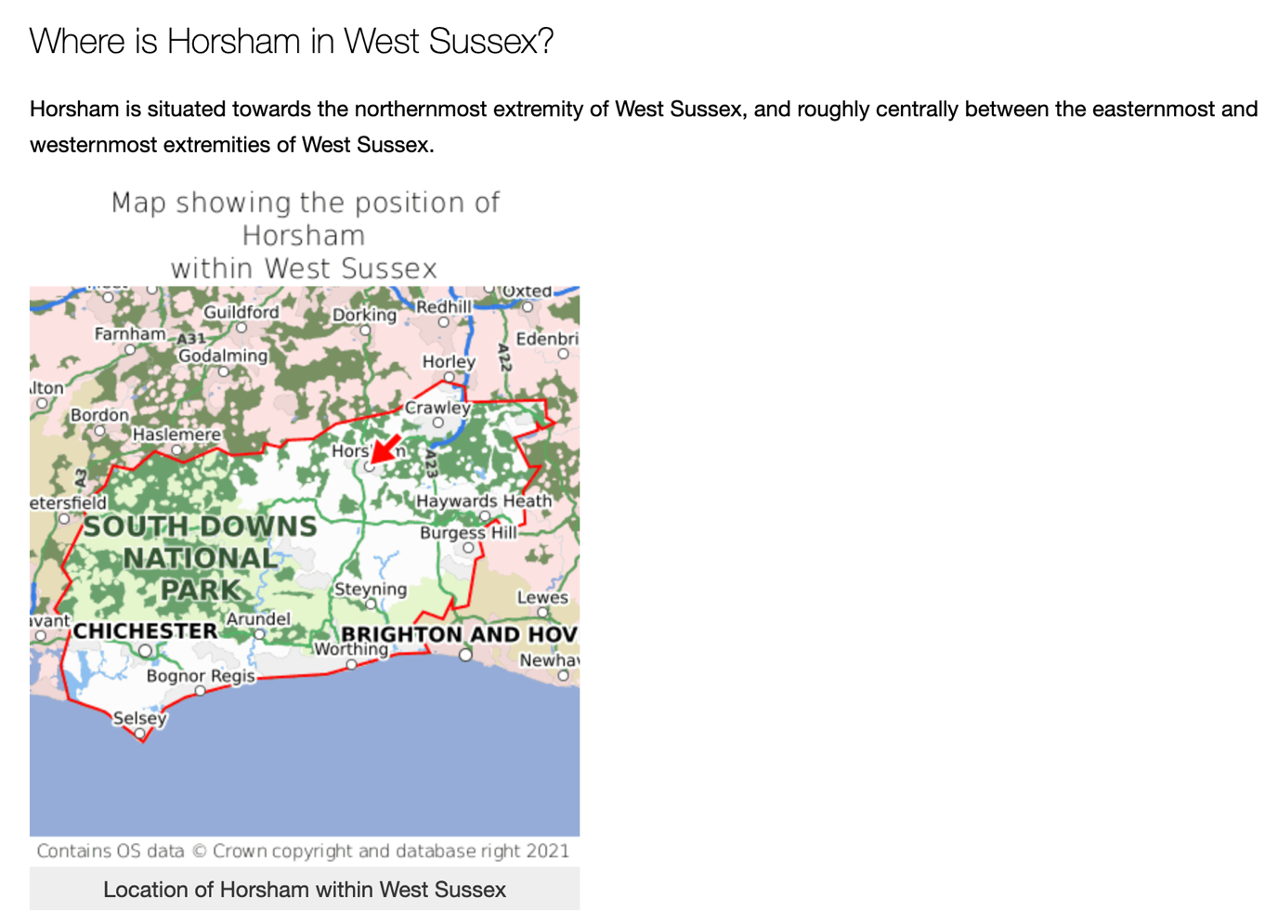

(GetTheData, 2023)

Appendix 7:
South East – Surrey, East and West Sussex wealth distribution (Office for National Statistics (ONS), 2022).

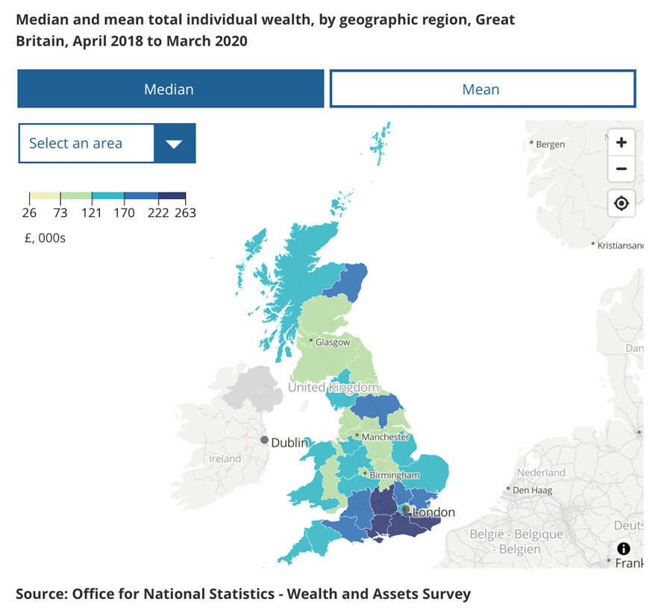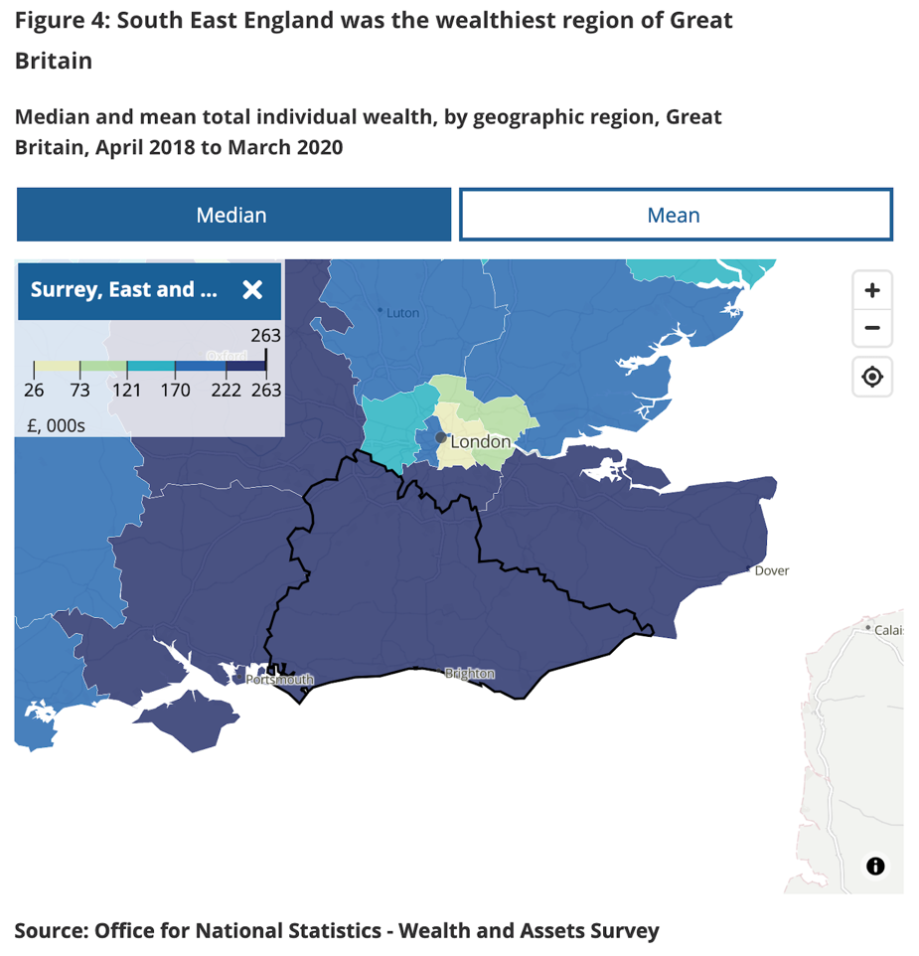

Appendix 8:
Horsham – The map below shows the Roffey area and its surroundings, ranking between deciles 7 and 4 as the most deprived areas in the country (The Public Health and Social Research Unit (PHSRU), 2019).

*The NHS defines a ‘Lower layer super output area’ (LSOA) as ‘a geographic hierarchy designed to improve the reporting of small area statistics in England and Wales’ (NHS Data Model Dictionary, 2023).
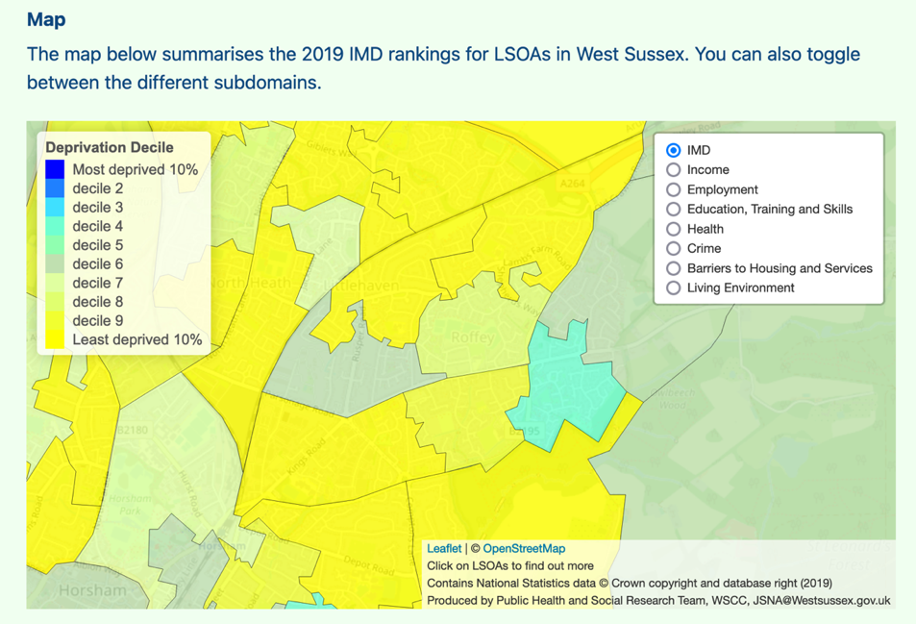
Crawley – The map below shows that Crawley’s most deprived areas, two of which are in the top 10% of the country, lie in the south. It also indicates Crawley’s location relative to Horsham (bottom left) (The Public Health and Social Research Unit (PHSRU), 2019).
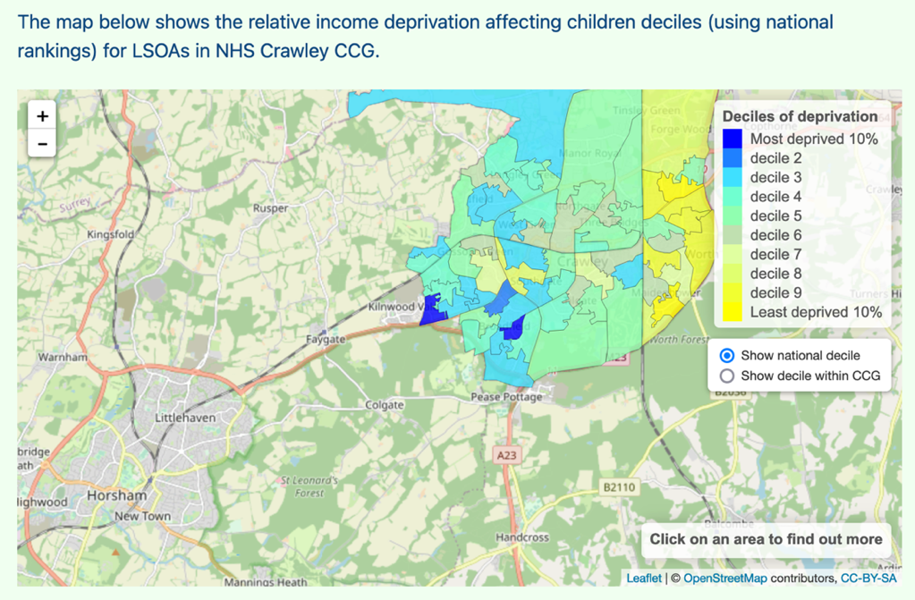
Appendix 9:
‘SWOT’ Analysis Table (Weller, 2022)
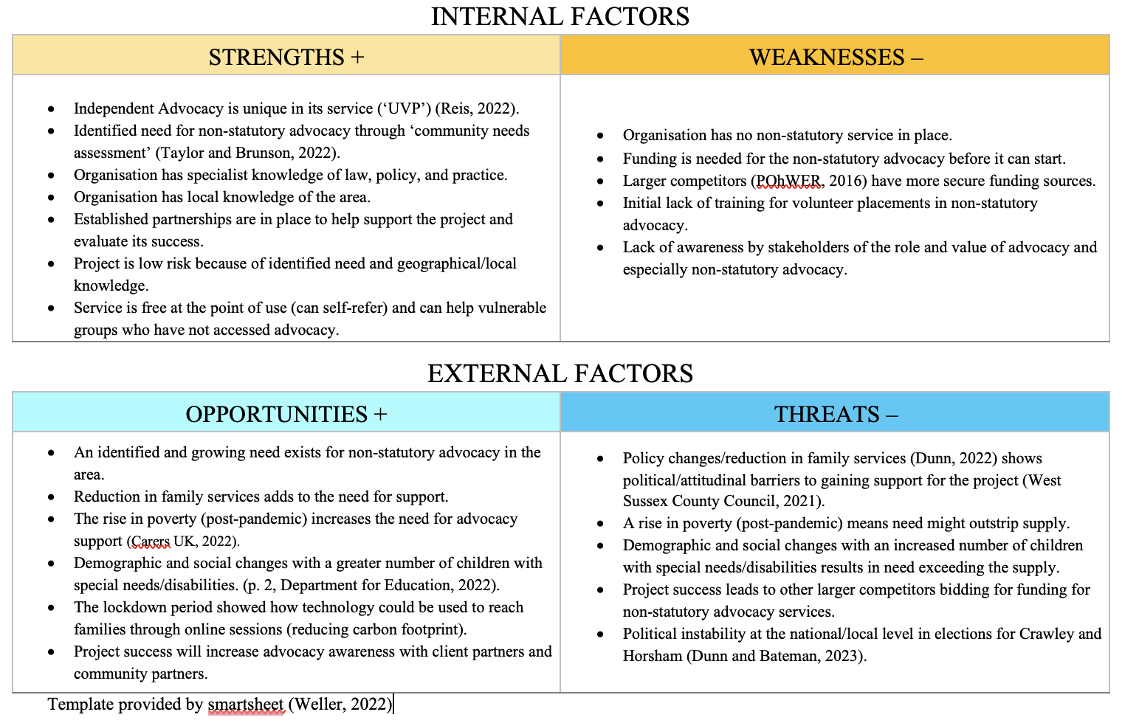

Appendix 10:
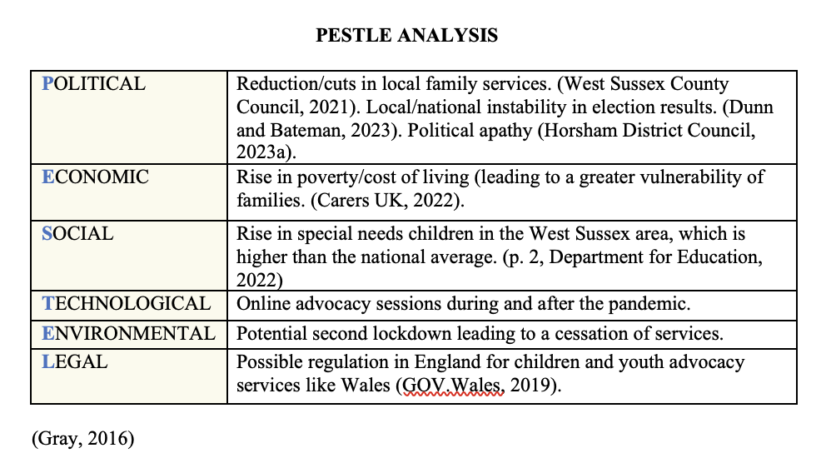

Appendix 11:
Local area Special Educational Needs and Disabilities report for West Sussex County Council (Department for Education, 2022, p. 2).

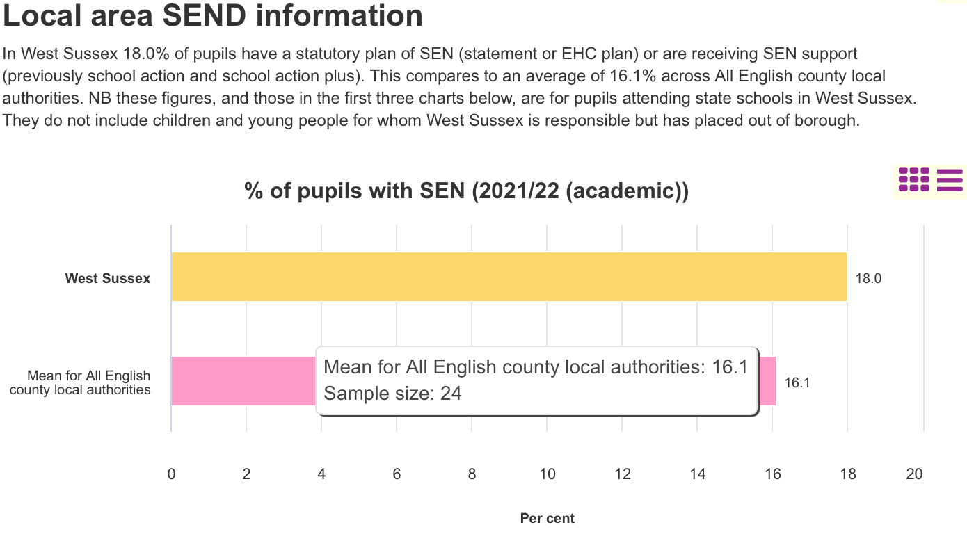
Appendix 12
Attendance figures for Horsham’s community advisory group have been low in the past year (Horsham District Council, 2023a).

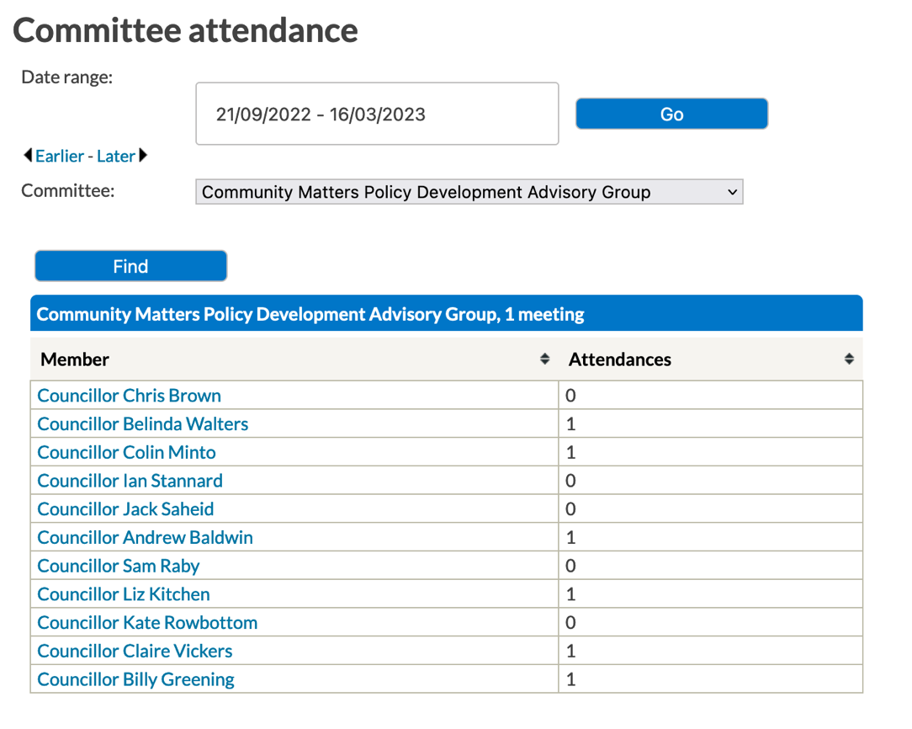

Appendix 13:
Horsham’s political balance of parties (Horsham District Council, 2023b).

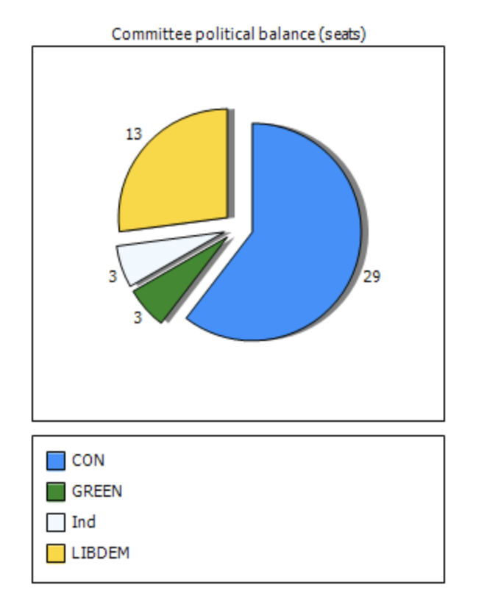

Appendix 14:
Crawley’s political balance of parties (BBC News, 2022).

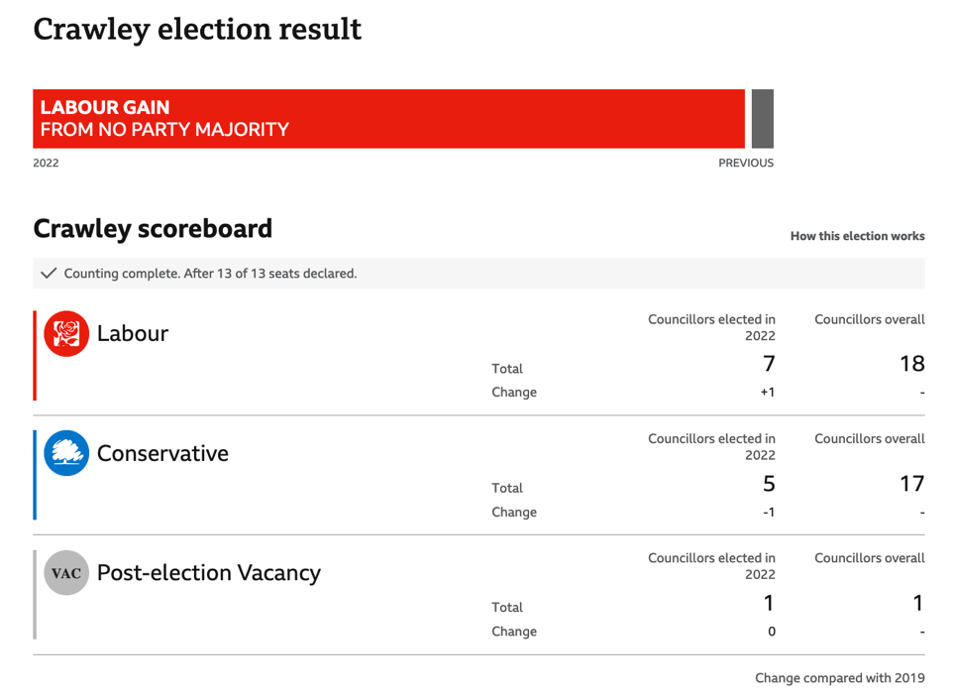

The term ‘client partner’ is used throughout this presentation to clarify the difference between the individuals we help, that is our ‘partners’ and the community services we partner with.

