ENTREPRENEURSHIP
(LCBB5001)

Assessment 1
Essay
( 2000 w.)

Student name: Lecturer name:
Angela Celac (2023256) John-Paul Okeke

Submission date:
05.08.2022
Table of Contents
1. Introduction 3
2. Evaluation of new ideas regarding entrepreneurship 3
Analysis of the industry 4
3. Self-reflection on Personal development 5
4. Conclusion 8
References 9
Appendices 12
Appendix 1 12
Appendix 2 12
Appendix 3 13

1. Introduction
Entrepreneurship business is the ability to organise, develop and run a business including many uncertainties in profit making in the sector of enterprise. As entrepreneurship is connected to labour, land, nature, and capital funds, it is intimately connected with economy of that country. This essay represents some ideas related to an enterprise for future growth and addition of value to the country's economy. Since pandemic, the economical growth of entrepreneurship has increased by 32.08%. The growth is helpful for a country as it helps to increase the capital revenue of the whole nation. Some market research has been included to find recent market positions of entrepreneurs and business opportunities.

2. Evaluation of new ideas regarding entrepreneurship
In case of solving the problems related to border community world and others arising regarding entrepreneurs' business, some steps need to be taken in a strategic way. Therefore first the issues and challenges need to be pointed out and then according to those issues planning will be done. So the major challenges are product shortage, high cost, and product and service quality which are facing customers. Besides this, some issues are also being faced by the entrepreneurs also are fund management, budget maintenance, staffing, and development of sale strategy (Vallaste et al. 2019). Information about all this is gathered from initial market research that is marketing situation of the Health and Harmony Inc Company before pandemic situation. The data of the initial market research and after pandemic research are totally different and that gap needs to be a bridge with a developed marketing strategy. The collected data from the research is stored and has been monitored to set some plan for solving those issues.
Evaluation of entrepreneurship means information about business growth and development. There are 3 major types of business development hiring evaluation, performance evaluation and approximate value of goods and services. On the other hand, challenges reading entrepreneurs can be solved by taking correct decisions by a knowledgeable and efficient head of that enterprise. Border community's issues can be solved by quick destination backup for market development of the company is Health and Harmony Inc (Geissdoerfer et al. 2020). As here the products are the AI-based cycles offered by the health care company in the UK that provides periodic relaxation for the company to attract customers to UK with their business development procedures. The border community and local people will get benefits from such a company, especially from an age group of 17 to 49 years (Gov. uk, 2021). Health care management should take decisions depending on the situation and capital investment.

Analysis of the industry
The threat of New Entrants is present. A new entry in any business plan can be a threat to it. But in the case of solar panel-powered bicycles, there is no new entrance has been found in the UK business. AI-powered chairs and solar bicycles help to increase customer satisfaction and are also beneficial to the global context. So the threat is not so effective regarding this. In the case of considering the pricing detail, there is a small chance of threats (McLennan et al. 2020). On the other hand, as the INC Company has been chaired for IoT and AI during the initial research. There is no such company that has used that function previously so there are fewer prices are mentioned which helps to reorganize the company even after the pandemic situation in the UK. Supplier Bargaining Power is high in this case of business. Higher use of the business programme has been adopted by UK in 10 big industries. According to the UK's planning, others have implemented AI mechanisms in a less systematic way than UK. Also, it can be seen that there is an increase in 36% witnesses in 2021 in comparison to 2020 (Brundage et al. 2020). Solar energy in UK has increased by 6.2% from previous year (Brundage et al. 2020).
No Internal Rivalry. In the Health and Harmony Inc. Company there are many competitors in the UK. No other company can use that many Systematic ways of using AI devices, IoT functional and other approaches across the globe so there is a wellness-related device that works in the UK. There is no threat to Substitutes present here as this business situation is not affecting the country as well as the company for now. "Eames Lounge Chair" is one of the most comfortable chairs that are produced by AI systems for aged people relief (Han et al. 2022). This is non-substitutable as there is no such brand who immediate can produce a similar chair with the same effect and affordability.
Customer Bargaining Power is not present as the whole UK has a huge demand for those products of the company. In case of bicycles rank of UK is 42.05 % within those 1 billion GBP spending (Gozes et al. 2020). On the other hand, it can be seen that a million people from UK have pain in the back Du to this reason the demand is high, and the production rate has been made higher. 60% of the population uses and desires this (Brundage et al. 2020). Sometimes a negative result also can be seen in this respect regarding those products such as comfortable chairs and bicycles. Adaptive models provide effective solutions by resolving the problem. This approach is suitable to aim for a continuous and stable solution. So, this model is applicable for any type of problem. Another one is Innovative model which is applied to innovation theory of entrepreneurship (Bakery et al. 2020). It includes creative approaches using technologies, especially which are unknown to the marketplace, and it brings advantages to that organization. It helps to think out of the box and make some novel decisions for permanent solutions to those challenges (Gozes et al. 2020). Novelty is a trait of creative entrepreneurship therefore entrepreneurs get gravitation toward this problem-solving method.
Health and Harmony Inc is a well-established idea of the UK founder. The control of the business and its operation is totally on the managing director and higher authority of the organisation. Accounts, marketing, structure, and HR functions are a part of successful business growth. This includes proper service with sales, manufacturing, marketing and advertisement which helps to run the organisation in a best way (Han et al. 2022). The uniqueness of hierarchical contribution is an essential part of success in any entrepreneur business and its functional loyalty. Supply chain management, stakeholder management and other departmental operation should go smooth at a regional level.

3. Self-reflection on Personal development

To be developed | Expected goal | Required actions | application | Required time
self-reliance | To solve people’s problem | Listen to other carefully and Making of solutions | To motivate employee | 2 weeks
communicating | To understand employee and make proper contact with them | Practising the language of a different culture to understand their words | During training or assisting them | 3 weeks
focusing | To achieve the final goal | Increasing concentration, sticking to the goal | Achieving short-term goals to earn final one | 1.5 weeks
maintaining transparency | To make stability among employees, leaders and all other workers | Discussion of every matter should be done in front of all | Capitalisation, investment, profit, operational structure | 1 week
Professionalism and planning | To build a strong relationship with employees and managers | financial statements that should be accessed with running a business for all general processes | Organisational working operation | 4 weeks

I have acquired entrepreneurial traits that can result in consideration of abilities with pattern thought and also successful character. By acquiring this skill anyone can develop an understanding of starting and thinking ability for a successful business. Further, business management can also result in accessing and venturing with a lead innovation and also process a market need with a business venture (Harun et al. 2018). I can enable new market development with better goods and services that can be accessed with higher earnings contributions with increased national income. This can also result in promotion of employment opportunities for considering national income. Entrepreneurial skill helps me to promote self-reliance and generate employment opportunities and innovation. This way I can resolve people’s problems and also result in addressing their needs.
A flexible schedule can also result in establishment of possible benefits that can be accessed with accommodation or freeing and improve physical and mental well-being (Rebrina et al. 2019). This can also result in consideration of a possible risk that can be accessed by establishing an organisation for understanding your own business. There also arises a general change that can align with values and beliefs for general change that can help in family-centred life. Using this knowledge in the correct way I can establish business more efficiently which can reduce business risk and also results in opportunity exploitation.
Customer acquisition can also result in developing proactive entrepreneurs with possible communication that can access with staff to improve all maintained products and services (Khin and Lim, 2018). This also helps in modification of products and services that can reduce problems for acquiring a better future. Inadvertently reducing risk also results in development of better products and services that can access general problems for effectively communicating, focusing, learning, and selling (Acton, 2018). The key entrepreneurial skill also develops for acquiring business requirements with strategic inherent business skills and sense. Adaptation of the above-mentioned skills only is helpful if I adequately implement them. This can be done with workers and managers for maintaining transparency in business policy. Further, I can gain more knowledge about the adaptation of work ethics in a proper working environment.
Opportunity recognition also results in consideration of an organisational change that can actively seek out to perceive services and new products (Filser et al. 2020). This includes opportunity development, opportunity evaluation, team assessment, and idea and opportunity identification. This can also be helpful for adaptation of an extension in business firms and organisations. This recognition will also be helpful for maintaining work ethic in the workplace and for adapting to venturing risk entitled (Kim et al. 2018). My ability and desire can result in establishment of a greater adaptation to start-up ventures along with entitled risk. This can also result in consideration of all possible changes with the overall success process.
Professionalism and planning helped me in dealing with effective processes that can be considered for building a strong relationship with employees and managers. These entrepreneurial traits result in learning with a better opportunity for adaptation in growth and profit margin (Khtere and Yousef, 2021). This can also be essential for Speaking Confidently with workers and accepting all feedback coming from workers. This can also be considered for networking with greatest assets. Maintaining a growth mindset also develops accessing a recognition pattern that can develop leadership skills and teamwork management process (Aseel, 2018). Further, I can gain all possible establishments that can access motivating employees for working effectively in the workplace.
Networking and communication also helped me with personal communication and professionalism to build a better connection in order to develop a career (Anders, 2018). This can also result in approaching individuals and organisational change with professional life. Communication also results in exchanging information with correctly receiving messages that can result in sending a better opportunity for maintaining a good relationship with others (Tugtekin and Koc, 2020). This can further build for enhancing an expansion of the market that can be acquired with possible goals for general consideration. This also considers for adaptation of a greater opportunity that can access with creation of all possible channelling with a wide variety of technology. This is also considered for building an enhanced process for all general considers in business market.

4. Conclusion
This study helps in understanding the opportunity in Entrepreneurship businesses such as Health and Harmony Inc that can be considered for developing and running a successful business. It may be concluded that adaptation of different skills also helped in accessing better opportunities that can be considered for maintaining a vision for wellness and healthcare of population of the UK. The industrial analysis also known as external analysis has been done and proper reason has been added to the analysis regarding keeping a link to assessment 2. Implementation and realisation of proper healthcare have been presented here with some images given in the appendix. Suitable theories have also been added as evidence for this report. All These above-discussed skills also helped in establishing a successful business firm and also for motivating employees to work efficiently.

References
Book
Baker, Ted, and Friederike Welter. Contextualizing entrepreneurship theory. 2020.
Journals
Anders, A.D., 2018. Networked learning with professionals boosts students' self-efficacy for social networking and professional development. Computers & Education, 127, pp.13-29.
Aseel, B., 2018. Professionalism for engineers: soft skills in engineering education to prepare for professional life.
Brundage, M., Avin, S., Wang, J., Belfield, H., Krueger, G., Hadfield, G., Khlaaf, H., Yang, J., Toner, H., Fong, R. and Maharaj, T., 2020. Toward trustworthy AI development: mechanisms for supporting verifiable claims. arXiv preprint arXiv:2004.07213.
Fayolle, A., 2018. Personal views on the future of entrepreneurship education. In A research agenda for entrepreneurship education. Edward Elgar Publishing.
Geissdoerfer, M., Pieroni, M.P., Pigosso, D.C. and Soufani, K., 2020. Circular business models: A review. Journal of Cleaner Production, 277, p.123741.
Gozes, O., Frid-Adar, M., Greenspan, H., Browning, P.D., Zhang, H., Ji, W., Bernheim, A. and Siegel, E., 2020. Rapid ai development cycle for the coronavirus (covid-19) pandemic: Initial results for automated detection & patient monitoring using deep learning ct image analysis. arXiv preprint arXiv:2003.05037.
Han, T.A., Lenaerts, T., Santos, F.C. and Pereira, L.M., 2022. Voluntary safety commitments provide an escape from over-regulation in AI development. Technology in Society, 68, p.101843.
Harun, M., Dalib, S., Yusof, N. and Ahmad, M.K., 2018. Intercultural communication competence: Educating students for global networking. Jurnal Komunikasi Borneo Edisi Khas (Konovokesyen ke-20 UMS), pp.1-17.
Khin, S. and Lim, T.H., 2018. Entrepreneurial opportunity recognition, exploitation and new venture success: moderating role of prior market and technology knowledge. International Journal of Entrepreneurship, 22(4), pp.1-6.
Khtere, A.R. and Yousef, A.M.F., 2021. The Professionalism of Online Teaching in Arab Universities. Educational Technology & Society, 24(3), pp.1-12.
Kim, J.Y., Choi, D.S., Sung, C.S. and Park, J.Y., 2018. The role of problem-solving ability on innovative behavior and opportunity recognition in university students. Journal of Open Innovation: Technology, Market, and Complexity, 4(1), p.4.
Kraus, S., Palmer, C., Kailer, N., Kallinger, F.L. and Spitzer, J., 2018. Digital entrepreneurship: A research agenda on new business models for the twenty-first century. International Journal of Entrepreneurial Behavior & Research.
McLennan, S., Fiske, A., Celi, L.A., Müller, R., Harder, J., Ritt, K., Haddadin, S. and Buyx, A., 2020. An embedded ethics approach for AI development. Nature Machine Intelligence, 2(9), pp.488-490.
Oztemel, E. and Gursev, S., 2020. Literature review of Industry 4.0 and related technologies. Journal of Intelligent Manufacturing, 31(1), pp.127-182.
Rebrina, F.G., Khakimova, S. and Ishkinyaeva, A., 2019. Networking cooperation in forming soft skills of a new type of teacher. Australian Educational Computing, 34(1).
Tugtekin, E.B. and Koc, M., 2020. Understanding the relationship between new media literacy, communication skills, and democratic tendency: Model development and testing. New media & society, 22(10), pp.1922-1941.
Vallaster, C., Kraus, S., Lindahl, J.M.M. and Nielsen, A., 2019. Ethics and entrepreneurship: A bibliometric study and literature review. Journal of Business Research, 99, pp.226-237.
Online articles
Acton, J.M., 2018. Escalation through entanglement: How the vulnerability of command-and-control systems raises the risks of an inadvertent nuclear war. International security, 43(1), pp.56-99. Available at: https://link.springer.com/article/10.1186/s13098-020-00583-7 [Accessed on 6th July, 2022]
Filser, M., Tiberius, V., Kraus, S., Zeitlhofer, T., Kailer, N. and Müller, A., 2020. Opportunity recognition: conversational foundations and pathways ahead. Entrepreneurship Research Journal. Available at: https://www.degruyter.com/document/doi/10.1515/erj-2020-0124/html [Accessed on 6th July, 2022]
Meyer, N. and de Jongh, J., 2018. The importance of entrepreneurship as a contributing factor to economic growth and development: The case of selected European countries. Journal of Economics and Behavioral Studies, 10(4 (J)), pp.287-299. Available at: https://ojs.amhinternational.com/index.php/jebs/article/view/2428 [Accessed on 6th July, 2022]

Appendices

Appendix 1
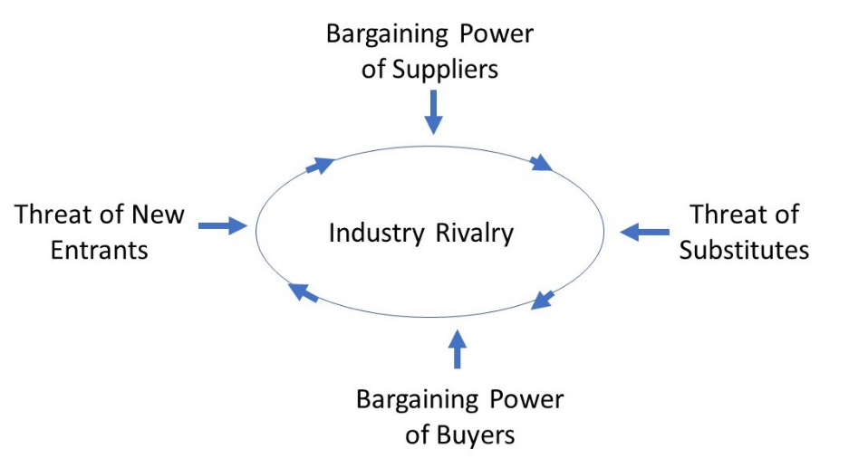
(Source: https://pvtscientist.files.wordpress.com/2019/10/porters-five-forces-chart.jpg)

Appendix 2
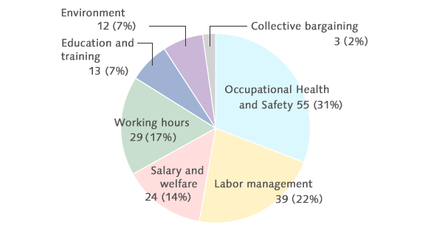
(Source: https://www.suntory.com/csr/activity/service/procurement/img/procurement_16.png)

Appendix 3
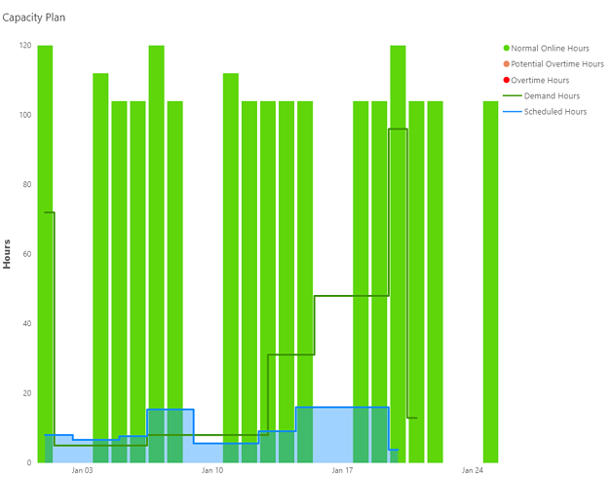
(Source: https://www.planettogether.com/hs-fs/hubfs/image-png-Jan-22-2021-01-30-30-44-PM.png?width=650&name=image-png-Jan-22-2021-01-30-30-44-PM.png)

