Portfolio 4 components (25%weighting per component)

Foreign Languages & Cultural Awareness BMIH5003 Lecturer: Antoinette Milne Student name: Razvan Cristian Nicolae Student ID: 2222787
Component 1 (479 words)
During my placement at Harboro Hotel, I encountered a cultural misunderstanding while working in the hotel restaurant during dinner service. I was in training at the time, shadowing an experienced server named Alex. One evening, a couple from Japan was seated at one of Alex's tables. They seemed polite but hesitant, and I noticed they were struggling with the menu. The guests tried to communicate their dietary restrictions, but there was a noticeable language barrier. Alex, while well-intentioned, seemed to become increasingly frustrated and spoke louder in English, assuming that would aid communication. Unfortunately, this only added to the guests' discomfort.
Cultural misunderstandings like this one often arise from differences in language, non-verbal cues, and cultural expectations around dining experiences. In this scenario, the guests' hesitance and the way they politely avoided direct confrontation were misinterpreted by Alex as indecision or lack of understanding. In Japanese culture, indirect communication is more common, and direct refusals are considered impolite (Kitao, 2000). Therefore, the guests' attempts to convey their needs subtly were not picked up by Alex, leading to confusion and frustration on both sides.
Reflecting on this experience, I realize several skills and behavioral changes are necessary to prevent such misunderstandings in the future. Firstly, developing intercultural communication skills is crucial. Understanding the basics of different cultural norms and communication styles can significantly enhance interactions with guests from diverse backgrounds (Gudykunst, 2003). For instance, recognizing that Japanese guests might avoid direct refusals can help anticipate and interpret their needs more accurately.
Secondly, language skills are vital. While it's impossible to learn every language, familiarizing oneself with key phrases in common guest languages and using translation tools can bridge communication gaps. Simple gestures such as using a translation app or having multilingual menus available can make a substantial difference (Kumar, 2013).
Furthermore, emotional intelligence and patience are essential. Being patient and maintaining a calm demeanor, even when communication is challenging, can prevent guests from feeling rushed or disrespected. Alex's frustration, though understandable, exacerbated the situation. Practicing active listening, which involves paying full attention to the speaker and showing empathy, can also improve interactions. For example, instead of speaking louder, Alex could have used visual aids or gestures to facilitate understanding.
Lastly, training and cultural sensitivity workshops should be emphasized in hospitality education and ongoing staff development. These trainings can provide practical strategies for managing cultural diversity and improving service quality (Lashley, 2008). During my placement, I realized the importance of such training in equipping staff with the knowledge and skills to handle cultural differences effectively.
In conclusion, my experience at Harboro Hotel highlighted the importance of intercultural competence in the hospitality industry. To prevent cultural misunderstandings, it is essential to develop intercultural communication skills, language proficiency, emotional intelligence, and participate in cultural sensitivity training. By making these changes, hospitality professionals can create a more inclusive and respectful environment for all guests.
Component 2 (543 words)
Training Plan: Enhancing Intercultural Communication and Service Quality
Introduction
During my placement at Harboro Hotel, I observed a situation where a cultural misunderstanding occurred between a server and Japanese guests. This incident highlighted the need for improved intercultural communication skills among the staff. To address this, I propose a comprehensive training plan to equip all employees with the necessary skills to handle similar situations effectively. This plan aims to enhance intercultural competence, language skills, emotional intelligence, and overall service quality.
Training Objectives
1. Develop intercultural communication skills
2. Improve basic language proficiency in common guest languages
3. Enhance emotional intelligence and patience in service delivery
4. Foster a culture of continuous learning and cultural sensitivity
Training Modules
1. Intercultural Communication Skills
- Objective: To understand and appreciate cultural differences and improve communication with guests from diverse backgrounds
- Content:
- Introduction to intercultural communication (Ting-Toomey & Chung, 2012)
- Cultural norms and dining etiquette of major guest demographics (e.g., Japanese, Chinese, European)
- Role-playing exercises to practice scenarios involving cultural misunderstandings
- Duration: 4 hours
- Method: Interactive workshop with role-playing, group discussions, and case studies
2. Language Skills
- Objective: To develop basic proficiency in common guest languages and effectively use translation tools
- Content:
- Basic phrases in languages such as Japanese, Mandarin, and Spanish
- Use of translation apps and multilingual menus (Cheng, 2009)
- Practical exercises with language partners
- Duration: 3 hours
- Method: Language workshops with practical exercises and the use of technology
3. Emotional Intelligence and Patience
- Objective: To cultivate emotional intelligence and patience in handling challenging situations
- Content:
- Understanding emotional intelligence and its importance in hospitality (Cherniss& Goleman, 2001)
- Techniques for active listening and empathetic communication
- Stress management and maintaining a calm demeanor
- Duration: 2 hours
- Method: Interactive seminar with real-life scenarios, mindfulness exercises, and stress management techniques
4. Continuous Learning and Cultural Sensitivity
- Objective: To foster an environment of continuous learning and cultural awareness
- Content:
- Importance of ongoing training and cultural sensitivity workshops (Hofstede, 2010)
- Encouraging feedback and sharing experiences among staff
- Regular updates on emerging cultural trends and guest preferences
- Duration: 2 hours initially, followed by quarterly refresher sessions
- Method: Seminars, feedback sessions, and cultural update briefings
Implementation Plan
- Phase 1: Needs Assessment
- Conduct a survey among staff to identify specific areas of improvement
- Analyze guest feedback to pinpoint recurring cultural issues
- Phase 2: Development and Customization
- Collaborate with intercultural communication experts to develop tailored training materials
- Create multilingual resources and translation toolkits
- Phase 3: Training Delivery
- Schedule training sessions during off-peak hours to ensure maximum participation
- Use a blend of in-person workshops, online modules, and practical exercises
- Phase 4: Evaluation and Feedback
- Collect feedback from participants after each training session
- Monitor guest satisfaction and track improvements in service quality
- Make necessary adjustments based on feedback and evaluation results
Conclusion
This training plan aims to equip Harboro Hotel staff with the skills necessary to handle cultural misunderstandings effectively. By focusing on intercultural communication, language proficiency, emotional intelligence, and continuous learning, we can enhance the overall guest experience and create a more inclusive and respectful environment.
Component 3 (Words 538)
Self-Reflection on Cultural Awareness in the Hospitality Industry
For my self-reflection, I will use Gibbs' Reflective Cycle, a structured framework that helps examine experiences through a series of six stages: Description, Feelings, Evaluation, Analysis, Conclusion, and Action Plan (Gibbs, 1988).
Description
During my placement at Harboro, I observed a cultural misunderstanding between a server and Japanese guests. The guests, who were struggling with the menu and dietary restrictions, experienced discomfort due to a language barrier and differing cultural norms around communication. This incident made me realize the significant role cultural awareness plays in providing quality service in the hospitality industry.
Feelings
Initially, I felt frustrated and helpless, as I could see the guests' discomfort and the server's growing frustration. I empathized with the guests, knowing they must have felt unwelcome. This situation also made me anxious about my future interactions with guests from different cultural backgrounds. However, it motivated me to learn more about cultural competence and its importance in hospitality.
Evaluation
Reflecting on the incident, I realized that the server's lack of cultural awareness led to a negative guest experience. The server's frustration stemmed from a lack of understanding of Japanese communication norms, where indirectness and politeness are valued (Kitao, 2000). This situation highlighted the gaps in our training and the need for better preparation to handle such interactions.
Analysis
Over time, my understanding of cultural awareness evolved significantly. Initially, I thought good service was about efficiency and friendliness. However, I learned that cultural competence is equally important. Understanding different cultural norms, communication styles, and preferences can greatly enhance guest satisfaction (Reisinger & Turner, 2003). For example, knowing that Japanese guests may avoid direct refusals could help anticipate their needs and prevent misunderstandings.
I also realized that language barriers could be mitigated by learning basic phrases in common guest languages or using translation tools. This approach can make guests feel more comfortable and respected, improving their overall experience (Kumar, 2013).
Action Plan
Moving forward, I plan to:
1. Enhance Intercultural Communication Skills: I will participate in workshops and training sessions focused on intercultural communication. This will help me understand different cultural norms and improve my ability to interact with guests from diverse backgrounds (Gudykunst, 2003).
2. Learn Basic Phrases: I will make an effort to learn basic phrases in languages commonly spoken by our guests, such as Japanese, Mandarin, and Spanish. This will help bridge communication gaps and show guests that we value their culture.
3. Use Translation Tools: I will familiarize myself with translation apps and encourage their use among colleagues. This will help ensure effective communication, especially in situations involving complex requests or dietary restrictions.
4. Practice Empathy and Patience: I will work on enhancing my emotional intelligence by practicing empathy and patience. This will help me remain calm and understanding in challenging situations, improving the guest experience.
Conclusion
Reflecting on my experience, I now understand the critical importance of cultural awareness in the hospitality industry. By developing intercultural communication skills, learning basic phrases in other languages, using translation tools, and practicing empathy, I can provide better service to guests from diverse backgrounds. This will not only enhance guest satisfaction but also contribute to a more inclusive and respectful environment in the hospitality industry.

Component 4 (Words 453)
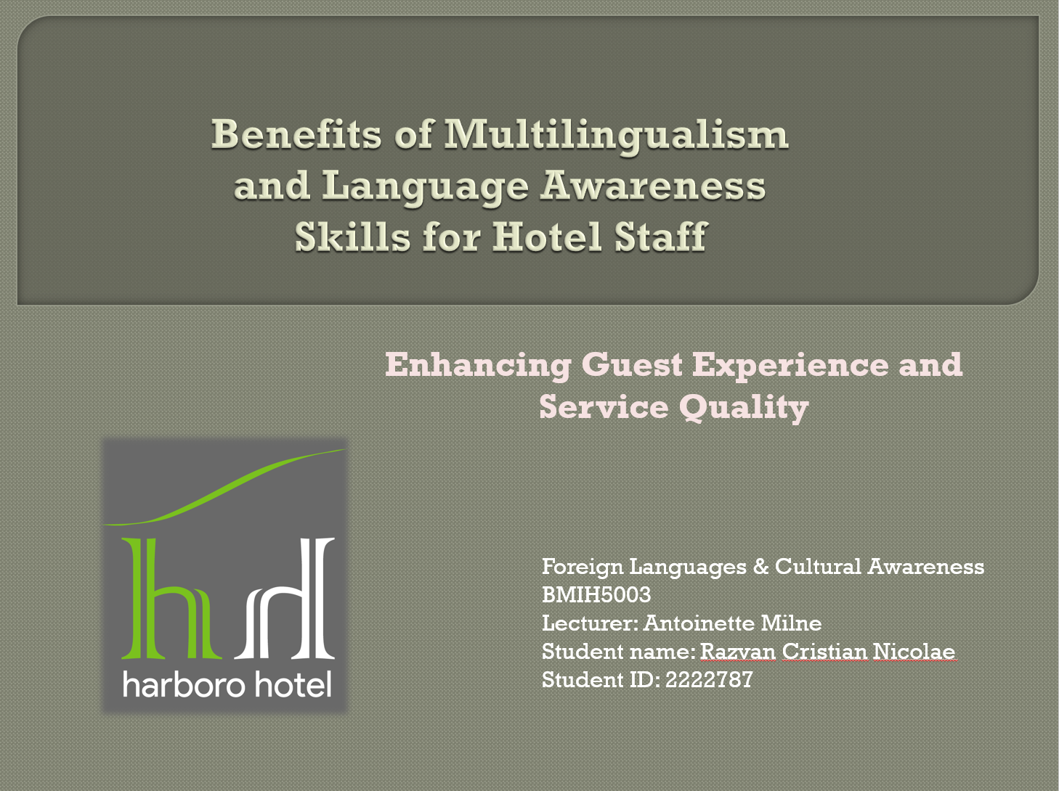

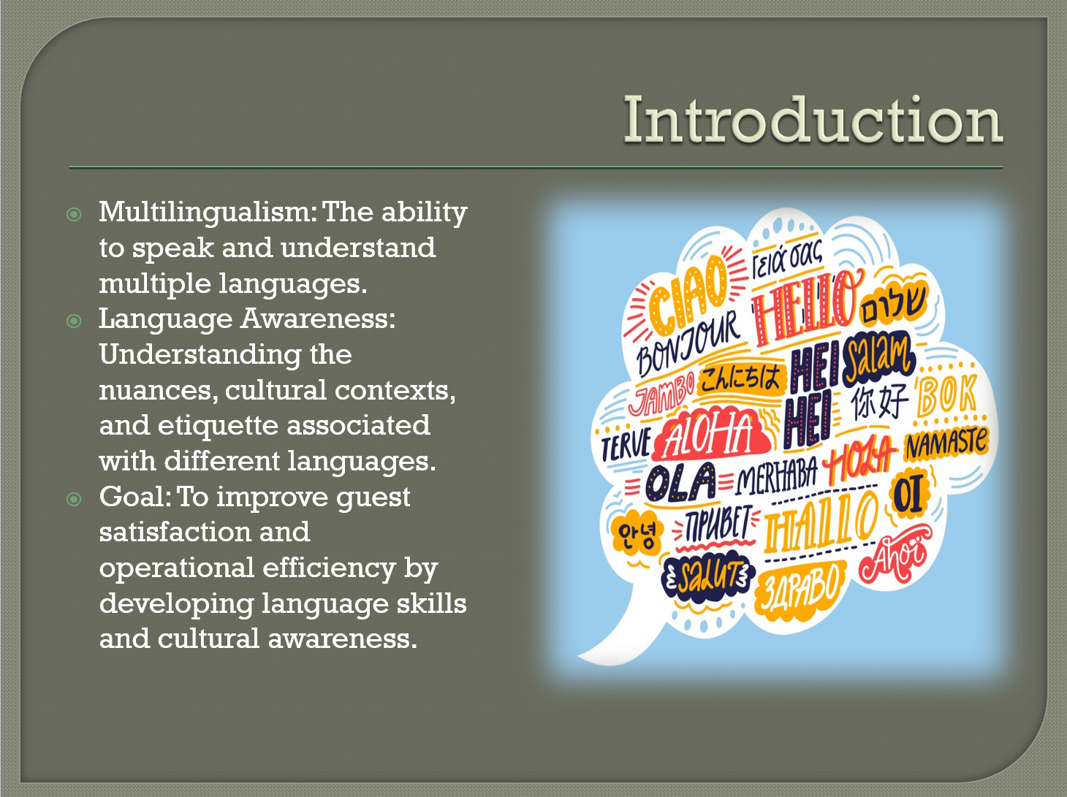
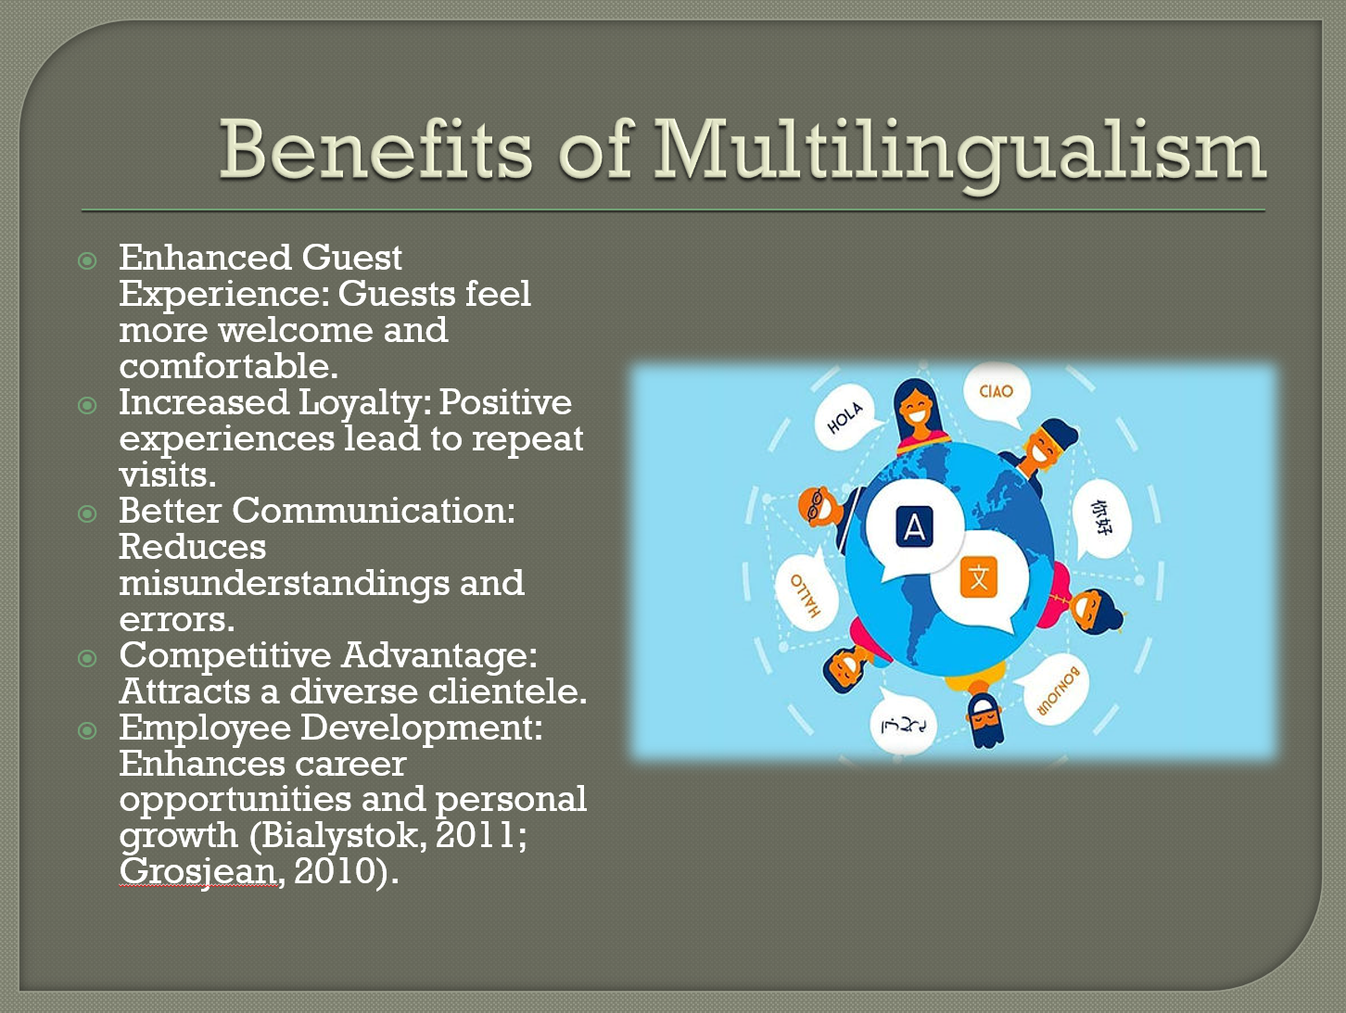
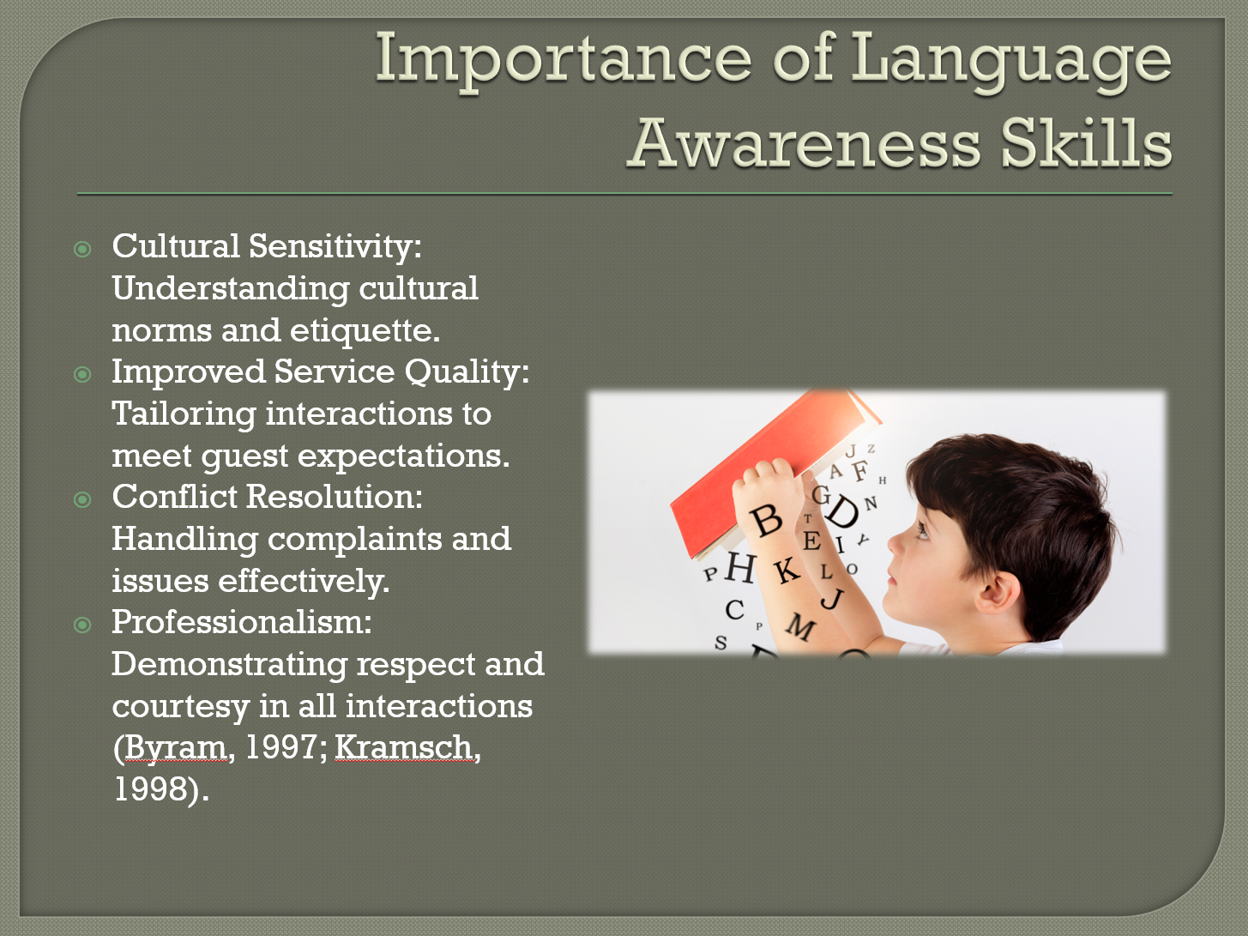
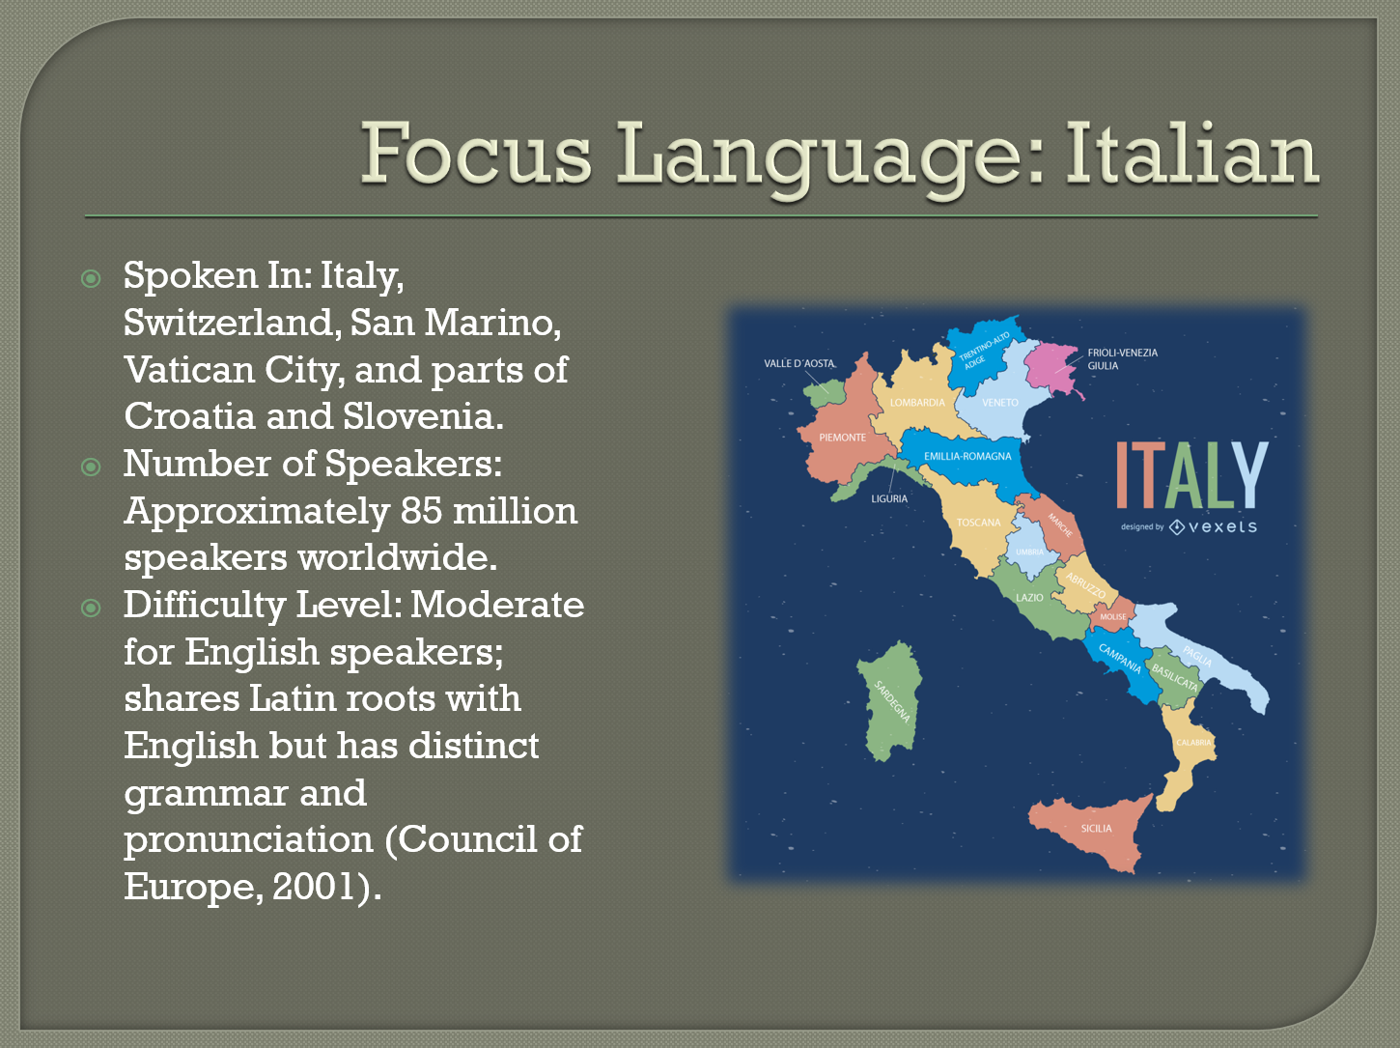
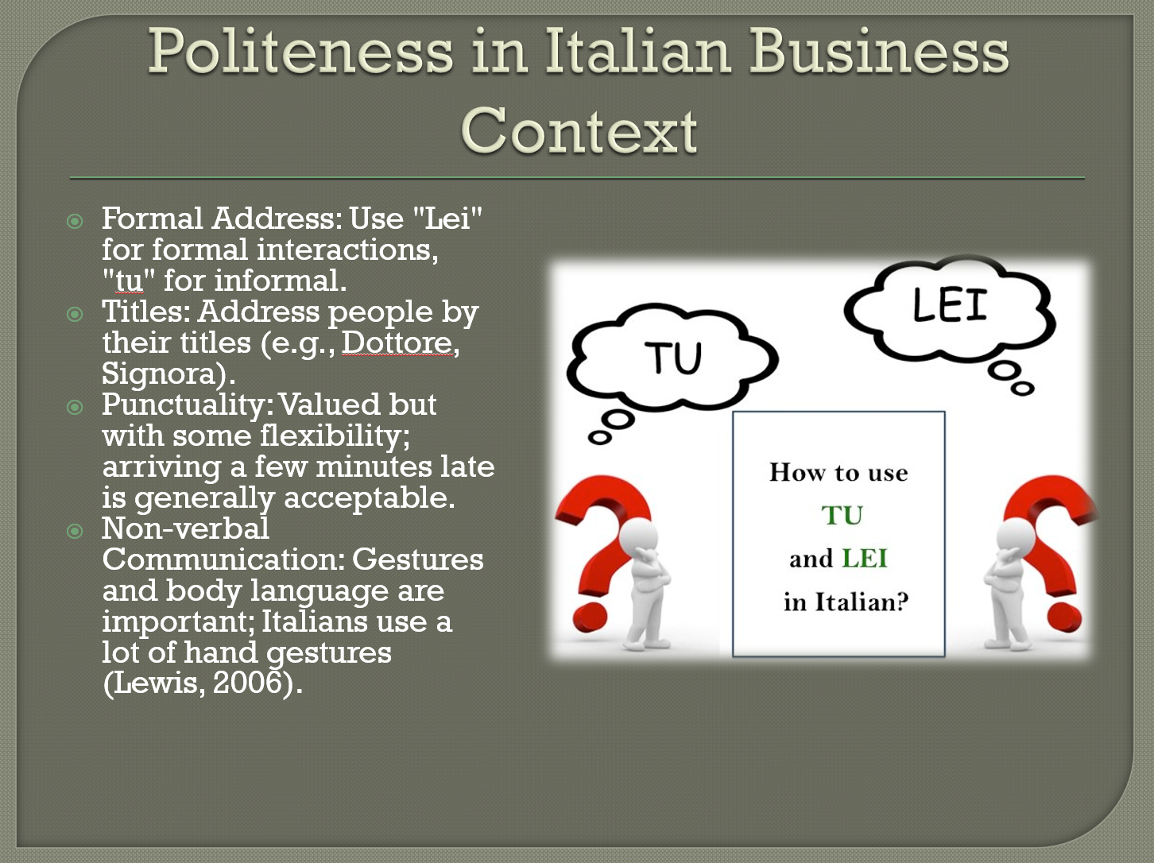
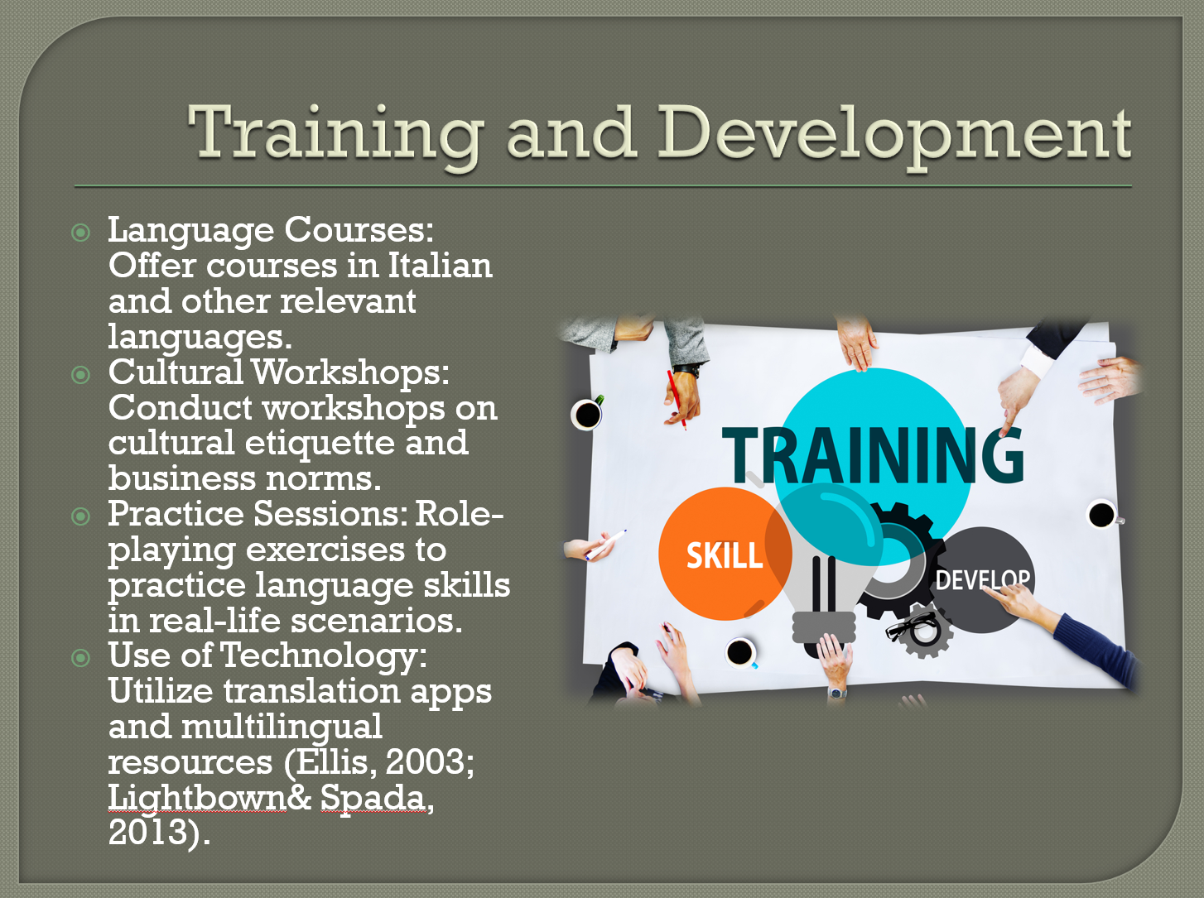
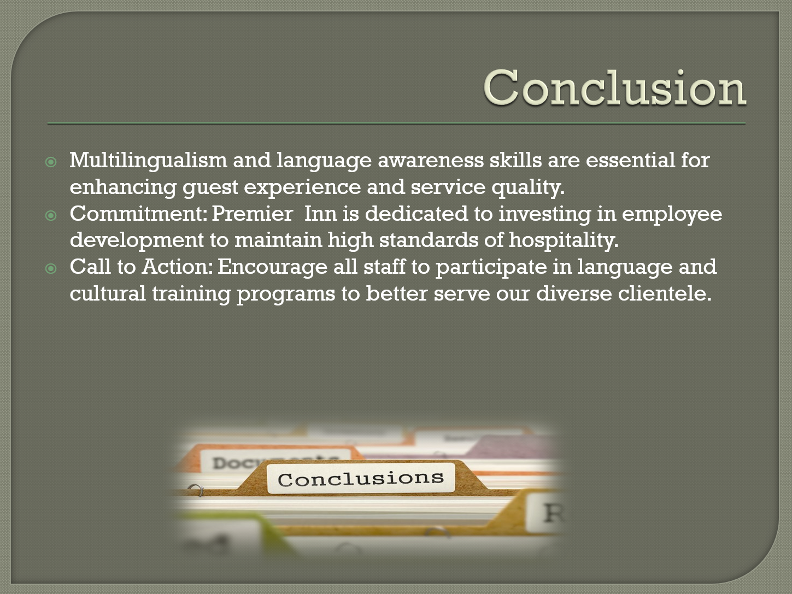
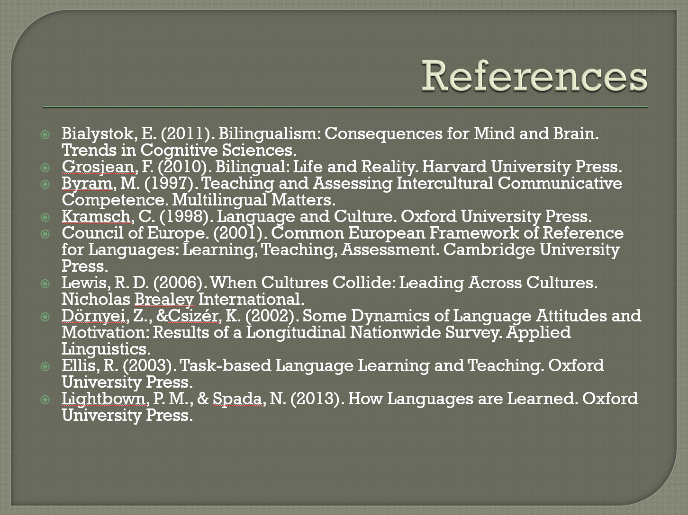

References
Bialystok, E. (2011). Bilingualism: Consequences for Mind and Brain. Trends in Cognitive Sciences.
Grosjean, F. (2010). Bilingual: Life and Reality. Harvard University Press.
Byram, M. (1997). Teaching and Assessing Intercultural Communicative Competence. Multilingual Matters.
Kramsch, C. (1998). Language and Culture. Oxford University Press.
Council of Europe. (2001). Common European Framework of Reference for Languages: Learning, Teaching, Assessment. Cambridge University Press.
Lewis, R. D. (2006). When Cultures Collide: Leading Across Cultures. Nicholas Brealey International.
Dörnyei, Z., &Csizér, K. (2002). Some Dynamics of Language Attitudes and Motivation: Results of a Longitudinal Nationwide Survey. Applied Linguistics.
Ellis, R. (2003). Task-based Language Learning and Teaching. Oxford University Press.
Lightbown, P. M., & Spada, N. (2013). How Languages are Learned. Oxford University Press
Cheng, L. (2009). The Importance of Language in Intercultural Communication. Journal of Intercultural Communication Research, 38(2), 105-120.
Cherniss, C., & Goleman, D. (2001). The Emotionally Intelligent Workplace. Jossey-Bass.

Council of Europe. (2001). Common European Framework of Reference for Languages: Learning, Teaching, Assessment. Cambridge University Press.
Dörnyei, Z., &Csizér, K. (2002). Some Dynamics of Language Attitudes and Motivation: Results of a Longitudinal Nationwide Survey. Applied Linguistics.
Ellis, R. (2003). Task-based Language Learning and Teaching. Oxford University Press.
Grosjean, F. (2010). Bilingual: Life and Reality. Harvard University Press.
Gudykunst, W. B. (2003). Cross-Cultural and Intercultural Communication. Sage Publications.
Hofstede, G. (2010). Cultures and Organizations: Software of the Mind. McGraw-Hill.
Kitao, K. (2000). Intercultural Communication between Japan and the United States. Keio Communication Review.
Kramsch, C. (1998). Language and Culture. Oxford University Press.
Kumar, R. (2013). International Hospitality Management. Cengage Learning.
Lewis, R. D. (2006). When Cultures Collide: Leading Across Cultures. Nicholas Brealey International.
Lightbown, P. M., & Spada, N. (2013). How Languages are Learned. Oxford University Press.

